Supplementary Information

PLIN2-PGAM5-regulated lipid droplet-mitochondria contacts drive microglial neuroinflammation after spinal cord injury via fatty acid metabolic reprogramming
Daoqiang Huang et al.
Corresponding authors: Mao Pang (pangmao6@mail.sysu.edu.cn), Senyu Yao (yaosy27@mail.sysu.edu.cn), Limin Rong (ronglm@mail.sysu.edu.cn), Bin Liu (liubin6@mail.sysu.edu.cn).

This PDF file includes:
Supplementary Figures and Legends S1 to S10
Supplementary Table 1. Key Resources Table

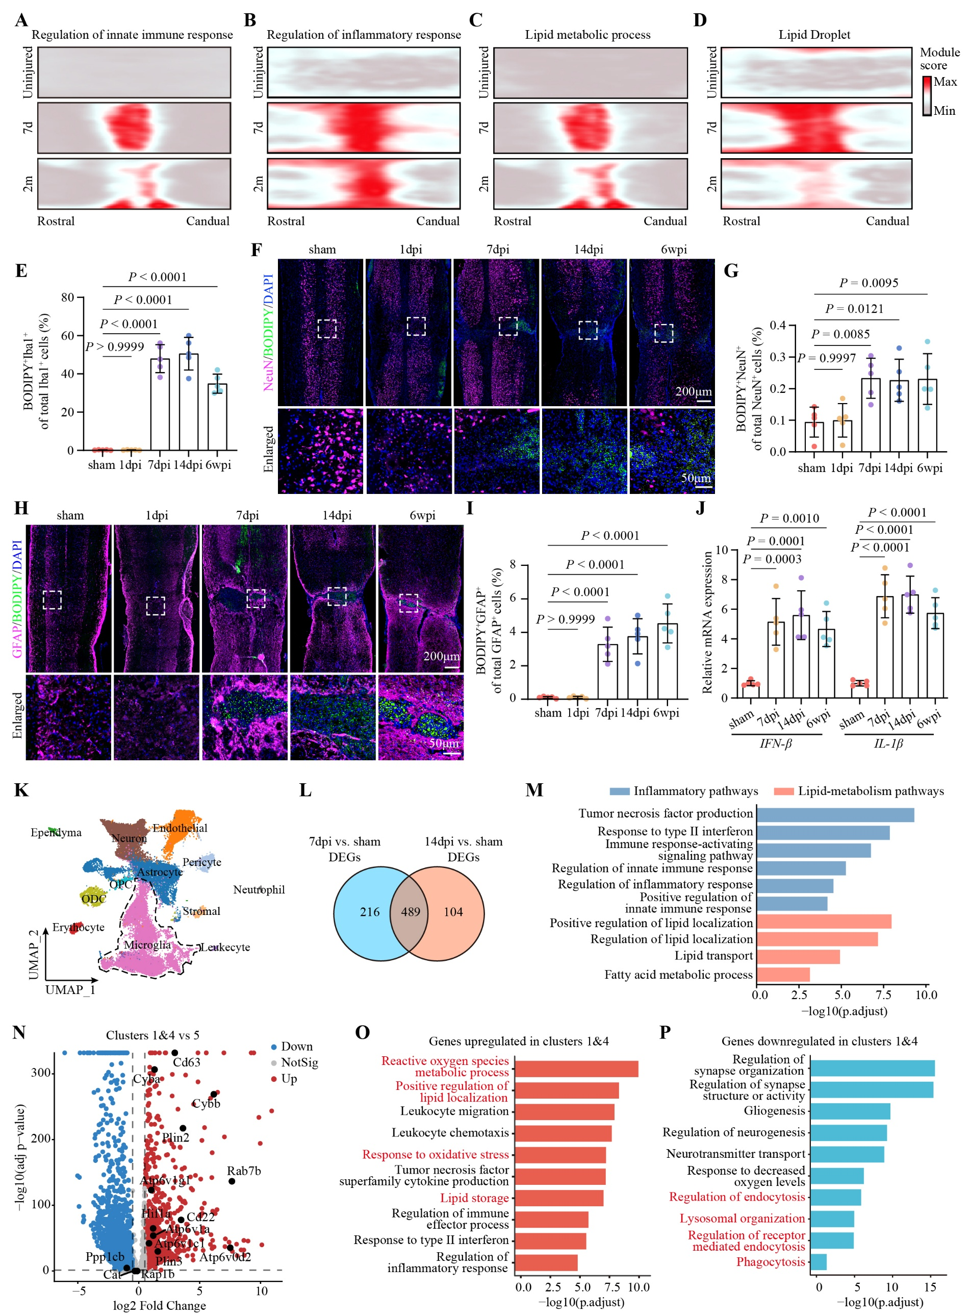
Fig. S1 Characteristics of inflammation and lipid metabolism following spinal cord injury.
(A, B, C, D) Gene Ontology (GO) enrichment analysis based on spatial transcriptomic data (http://tabulaeparalytica.com/) showing pathways associated with inflammation (A, B) and lipid metabolism (C, D) at 7 days and 2 months after spinal cord injury (SCI).
(E) Percentage of BODIPY⁺ Iba1⁺ cells within total Iba1⁺ microglia in sham mice (laminectomy without spinal cord crush injury) and SCI mice at 1, 7, 14 days post injury (dpi) and 6 weeks post injury (wpi) (n = 5 mice per group).
(F, G) Representative fluorescence images (F) and quantification (G) of BODIPY and NeuN co-staining in sham mice and SCI mice at 1, 7, and 14 dpi and 6 wpi (n = 5 mice per group).
(H, I) Representative fluorescence images (H) and quantification (I) of BODIPY and GFAP co-staining in sham mice and SCI mice at 1, 7, and 14 dpi and 6 wpi (n = 5 mice per group).
(J) RT-qPCR analysis of IFN-β and IL-1β mRNA levels in spinal cord tissues from sham and SCI mice (n = 5 mice per group).
(K) Uniform manifold approximation and projection (UMAP) visualization of different cell types from scRNA-seq data (https://doi.org/10.6084/m9.figshare.17702045) from sham and SCI mice.
(L) Venn diagram showing the intersection of differentially expressed genes in microglia at 7 and 14 dpi.
(M) GO enrichment analysis of intersecting genes in microglia at 7 and 14 dpi.
(N) Volcano plot of differentially expressed genes comparing clusters 1 and 4 versus cluster 5.
(O, P) GO enrichment analysis of genes upregulated (O) or downregulated (P) in clusters 1 and 4.
Data are presented as mean ± SD, and were analyzed by one-way ANOVA (E, G, I, J). Statistical significance defined as P < 0.05 and exact P values are indicated in the figures.
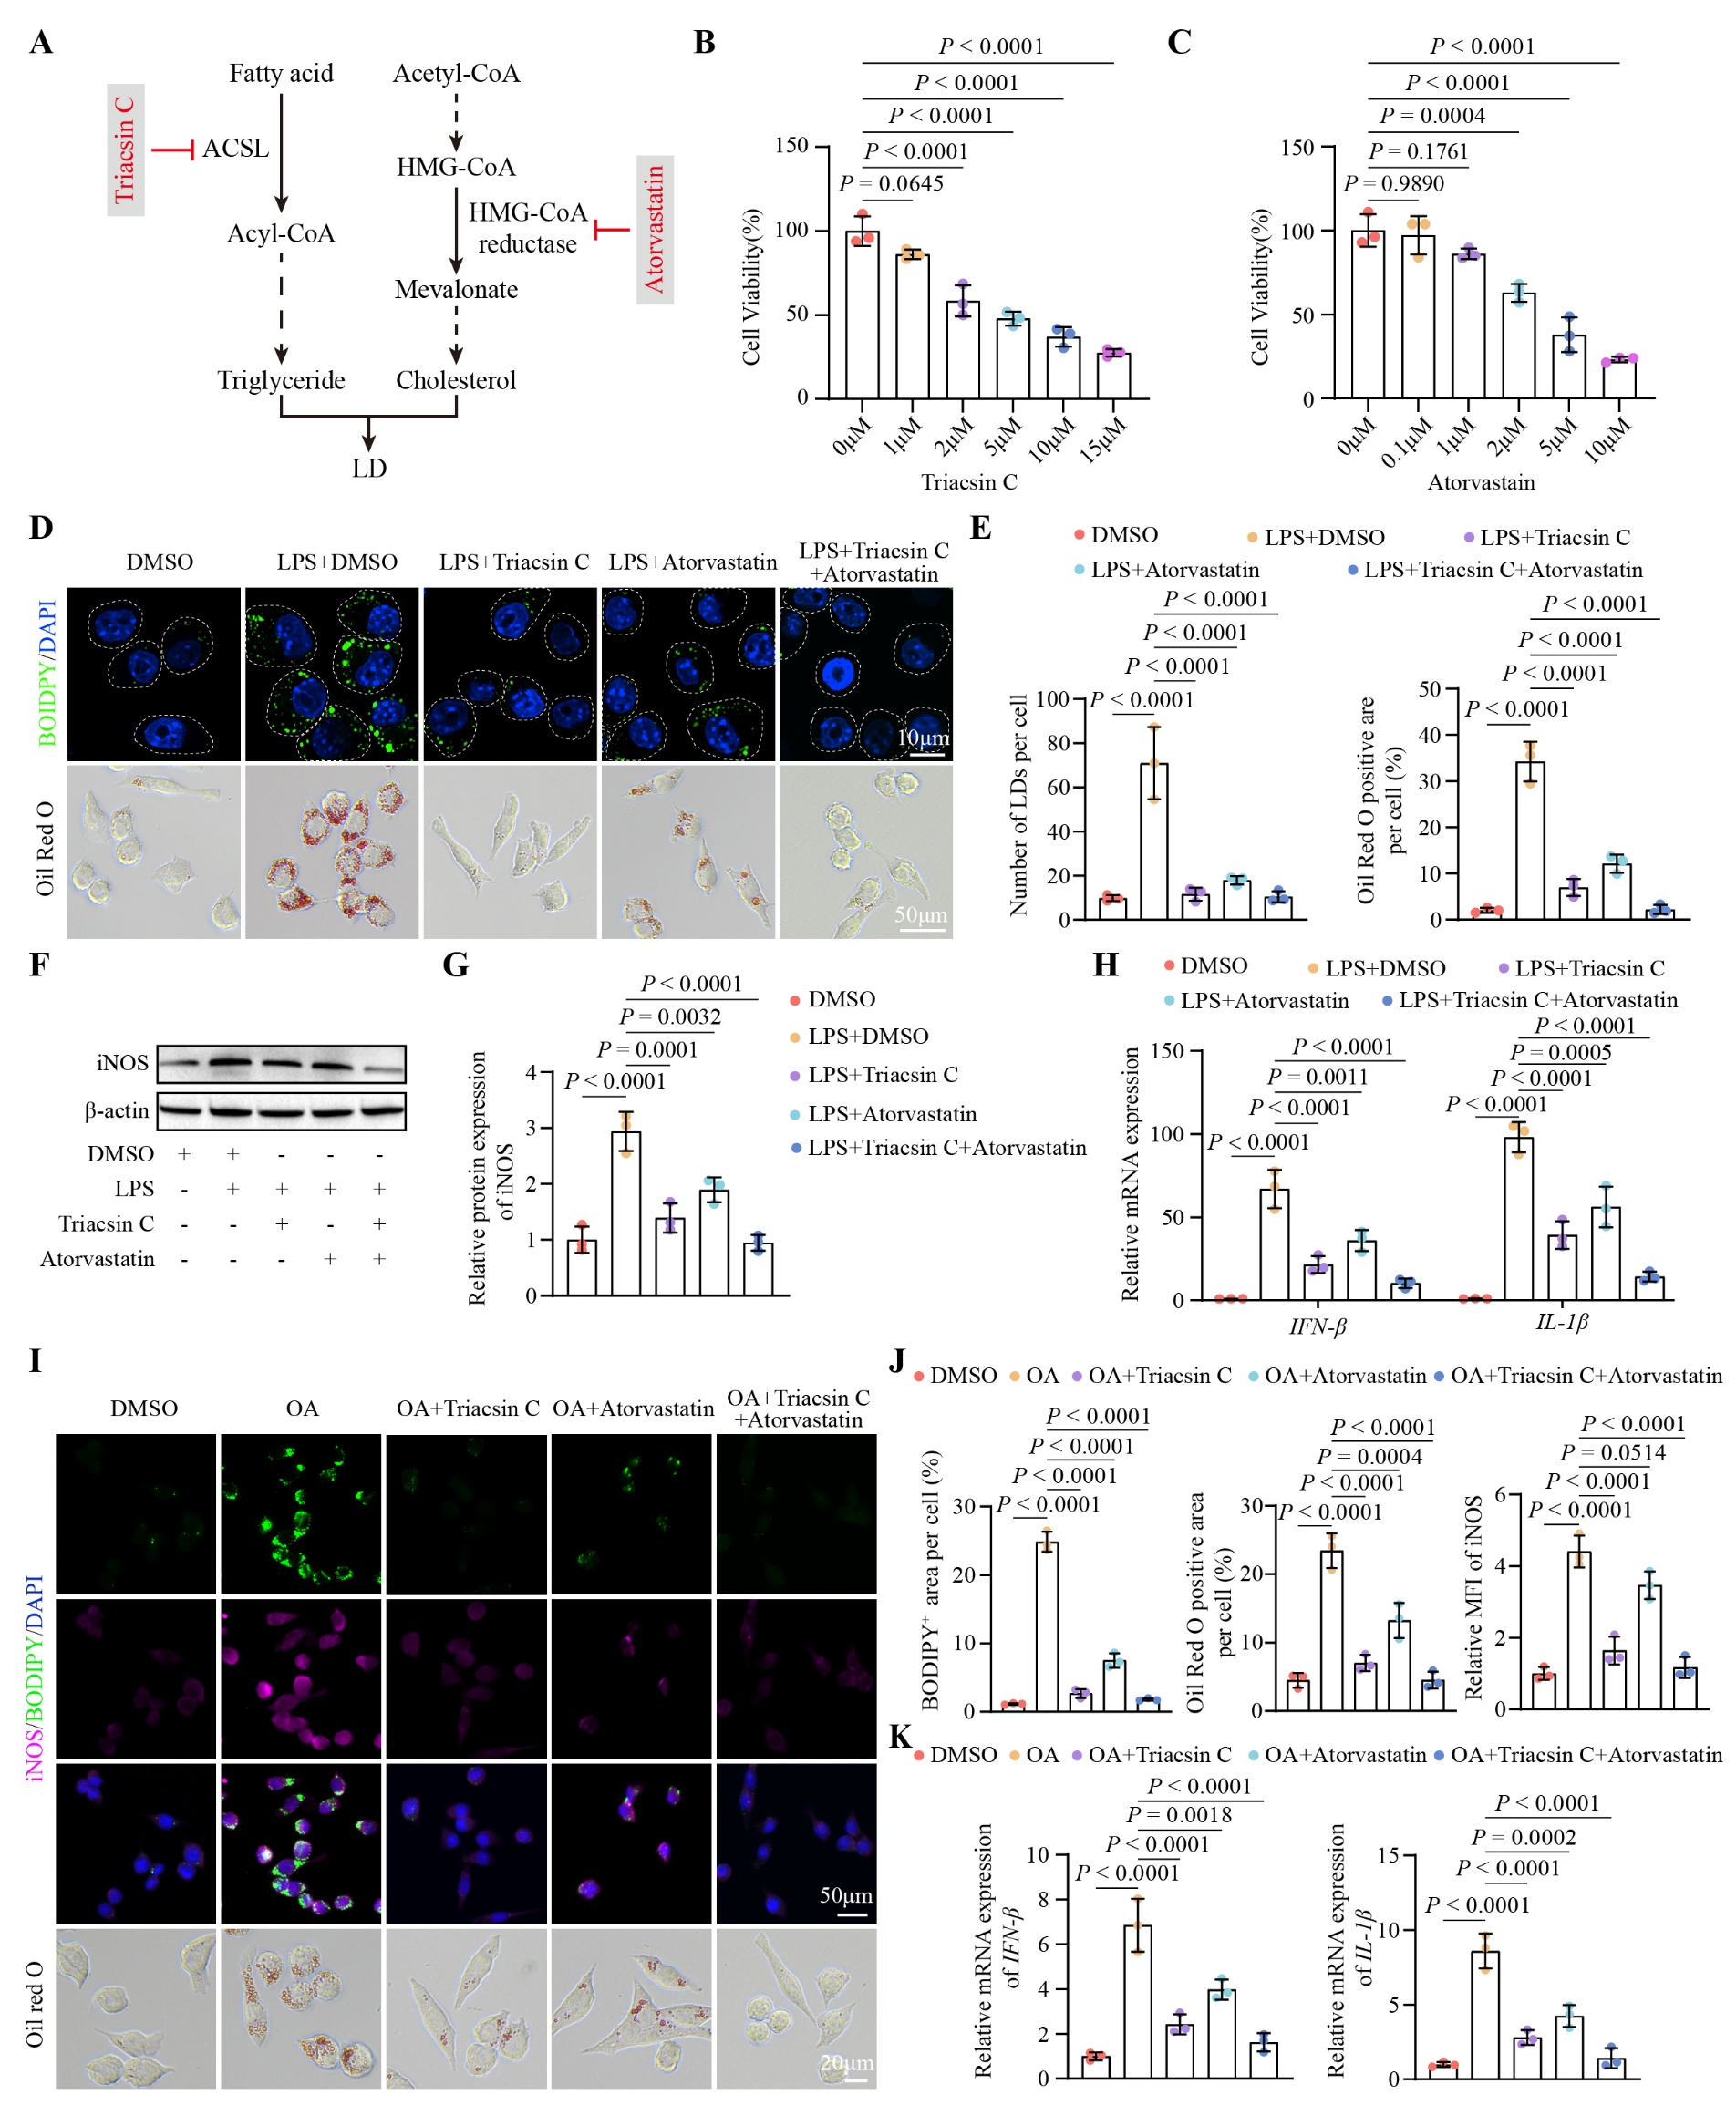
Fig. S2 Pharmacological inhibition of lipid droplet accumulation attenuates microglial inflammation.
(A) Schematic illustration of the mechanisms by which Triacsin C and Atorvastatin inhibit lipid droplet accumulation.
(B, C) Cell viability of BV2 cells treated with various concentrations of Triacsin C (B) or Atorvastatin (C) measured by CCK-8 assay to determine optimal dosing (n = 3 biological replicates per group).
(D, E) Representative two-dimensional single-plane images of BODIPY and Oil Red O staining (D) and quantification (E) of lipid droplet accumulation in fixed BV2 cells treated with Triacsin C, Atorvastatin or their combination following LPS stimulation (24 h) (n = 3 biological replicates per group).
(F, G) Western blot analysis (F) and quantification (G) of iNOS protein levels in BV2 cells treated with Triacsin C, Atorvastatin or their combination following LPS stimulation (24 h) (n = 3 biological replicates per group).
(H) RT-qPCR analysis of IFN-β and IL-1β mRNA levels in BV2 cells treated with Triacsin C, Atorvastatin or their combination following LPS stimulation (24 h) (n = 3 biological replicates per group).
(I, J) Representative two-dimensional single-plane images of iNOS and BODIPY co-staining and Oil Red O staining (I) with corresponding quantification (J) of lipid droplet accumulation in fixed BV2 cells treated with Triacsin C, Atorvastatin or their combination following oleic acid (OA) stimulation (24 h) (n = 3 biological replicates per group).
(K) RT-qPCR analysis of IFN-β and IL-1β mRNA levels in BV2 cells treated with Triacsin C, Atorvastatin or their combination following OA stimulation (24 h) (n = 3 biological replicates per group).
Data are presented as mean ± SD, and were analyzed by one-way ANOVA (B, C, E, G, H, J, K). Statistical significance defined as P < 0.05 and exact P values are indicated in the figures.
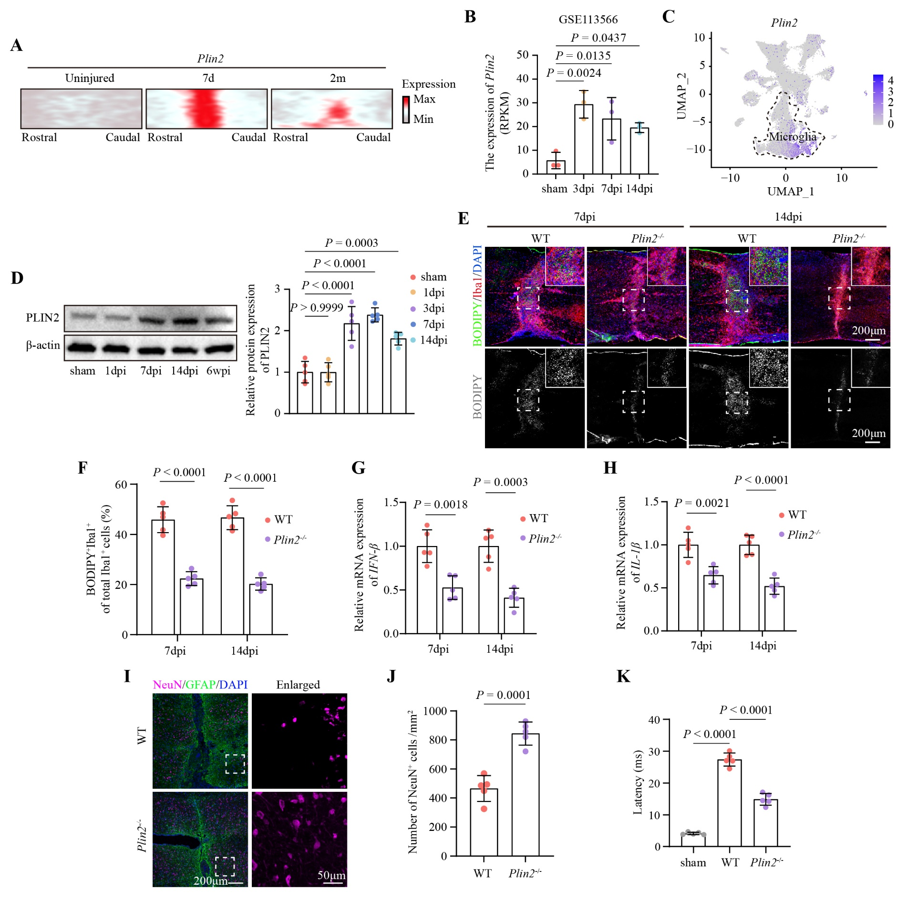
Fig. S3 Temporal expression of PLIN2 and its role in microglial lipid accumulation, inflammation and neuronal survival after SCI.
(A) Plin2 expression in the lesion core revealed by spatial transcriptomics at 7 days and 2 months after SCI.
(B) Bulk RNA-seq (GSE113566) analysis of Plin2 expression at 3, 7 and 14 dpi.
(C) UMAP plot of Plin2 expression across different spinal cord cell types.
(D) Western blot analysis and quantification of PLIN2 protein levels in spinal cord tissues at 1, 7, and 14 dpi, and 6 wpi (n = 5 mice per group).
(E, F) Representative fluorescence images (E) and quantification (F) of BODIPY and Iba1 co-staining in the lesion cores of WT and Plin2^{-/-} mice at 7 and 14 dpi (n = 5 mice per group).
(G, H) RT-qPCR analysis of IFN-β (G) and IL-1β (H) mRNA levels in spinal cord tissues of WT and Plin2^{-/-} mice at 7 and 14 dpi (n = 5 mice per group).
(I, J) Representative fluorescence images (I) and quantification (J) of NeuN and GFAP co-staining of WT and Plin2^{-/-} mice at 6wpi (n = 5 mice per group).
(K) Quantification of latency from EMG recordings in WT and Plin2^{-/-} mice after SCI (n = 5 mice per group).
Data are presented as mean ± SD, and were analyzed by one-way ANOVA (B, D, K) or two-sided unpaired Student’s t-test (F, G, H, J). Statistical significance defined as P < 0.05 and exact P values are indicated in the figures.

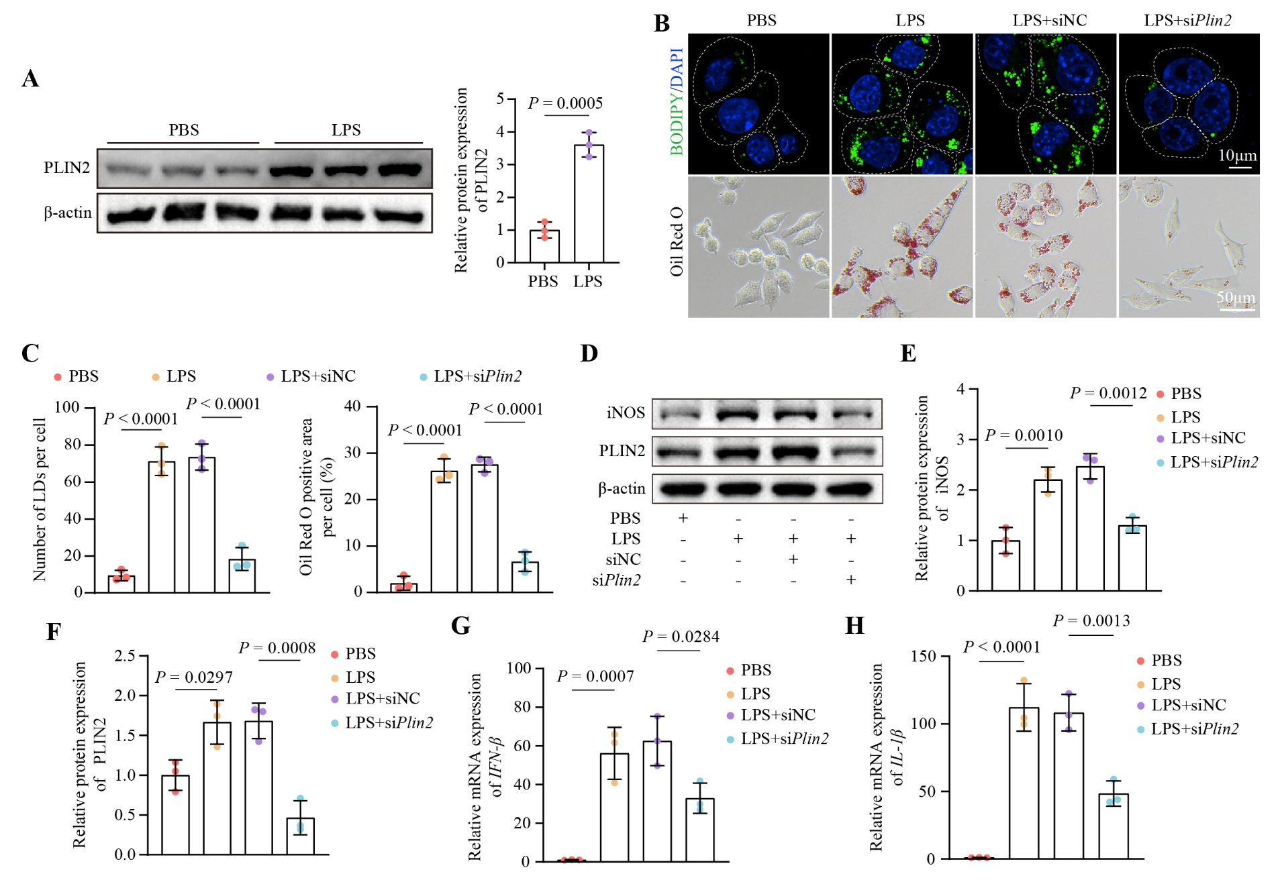
Fig. S4 PLIN2 knockdown reduces lipid droplet accumulation and inflammatory responses in LPS-activated BV2 cells.
(A) Western blot analysis and quantification of PLIN2 protein levels in BV2 cells following LPS treatment (24 h) (n = 3 biological replicates per group).
(B, C) Representative two-dimensional single-plane images of BODIPY and Oil Red O staining (B) and quantification (C) of lipid droplet accumulation in fixed BV2 cells after Plin2 knockdown under LPS stimulation (24 h) (n = 3 biological replicates per group).
(D, E, F) Western blot analysis of iNOS and PLIN2 protein levels (D) with corresponding quantification of iNOS (E) and PLIN2 (F) in BV2 cells after Plin2 knockdown under LPS stimulation (24 h) (n = 3 biological replicates per group).
(G, H) RT-qPCR analysis of IFN-β (G) and IL-1β (H) mRNA levels in BV2 cells after Plin2 knockdown under LPS stimulation (24 h) (n = 3 biological replicates per group).
Data are presented as mean ± SD, and were analyzed by two-sided unpaired Student’s t-test (A) or one-way ANOVA (C, E, F, G, H). Statistical significance defined as P < 0.05 and exact P values are indicated in the figures.

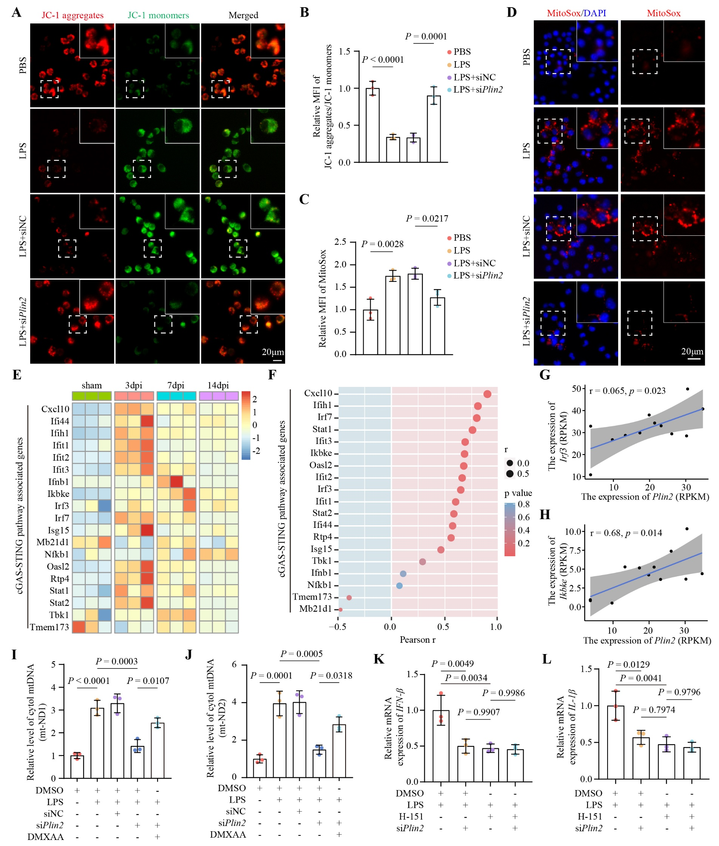
Fig. S5 PLIN2 knockdown improves mitochondrial function and suppresses STING signaling in microglia.
(A, B) Representative JC-1 staining images (A) and mean fluorescence intensity (MFI) quantification (B) of mitochondrial membrane potential in live BV2 cells after Plin2 knockdown under LPS stimulation (24 h) (n = 3 biological replicates per group).
(C, D) Mean fluorescence intensity (MFI) quantification (C) and representative fluorescence images (D) of mitochondrial ROS (MitoSox) levels in live BV2 cells after Plin2 knockdown under LPS stimulation (24 h) (n = 3 biological replicates per group).
(E) Heatmap of STING pathway genes expression in microglia from bulk RNA-seq data (GSE113566).
(F) Pearson correlation analysis between Plin2 and STING pathway genes in microglia from bulk RNA-seq data (GSE113566).
(G, H) Pearson correlation between Plin2 and Irf3 (G) or Ikbke (H) in microglia from bulk RNA-seq data (GSE113566).
(I, J) Quantification of mt-ND1(I) and mt-ND2 (J) by quantitative PCR in BV2 cells transfected with siPlin2 followed by LPS stimulation (24 h) with or without DMXAA-mediated rescue (n = 3 biological replicates per group).
(K, L) Quantification of IFN-β (K) and IL-1β (L) mRNA levels by RT-qPCR in BV2 cells transfected with siPlin2 followed by LPS stimulation (24 h) with or without H-151 treatment (n = 3 biological replicates per group).
Data are presented as mean ± SD, and were analyzed by one-way ANOVA (B, C, I, J, K, L). Statistical significance defined as P < 0.05 and exact P values are indicated in the figures.


Fig. S6 PLIN2 does not interact with mitochondrial outer membrane proteins AKAP1 or VDAC2 in BV2 cells.
(A) Co-immunoprecipitation of PLIN2 and AKAP1 in BV2 cells.
(B) Co-immunoprecipitation of PLIN2 and VDAC2 in BV2 cells.
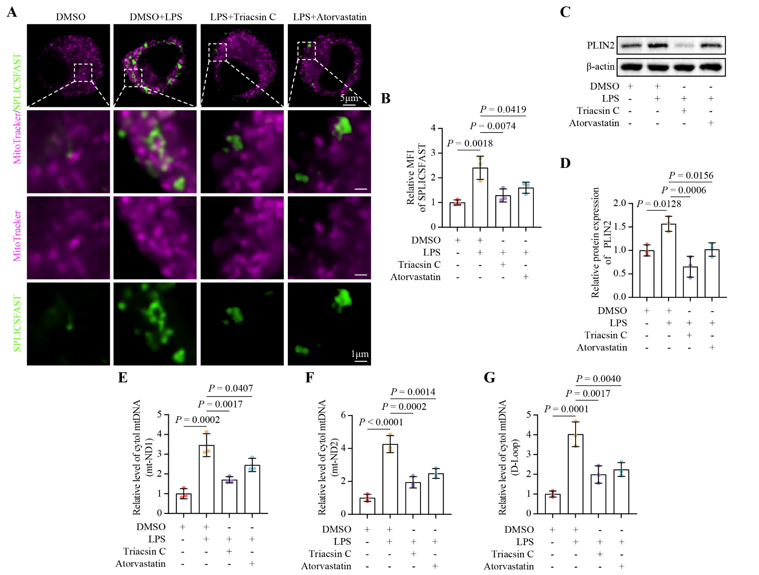
Fig. S7 Lipid droplet inhibition reduces lipid droplet-mitochondria contacts, PLIN2 expression, and cytosolic mtDNA release.
(A, B) Representative two-dimensional single-plane fluorescence images (A) and mean fluorescence intensity (MFI) quantification (B) of SPLICSFAST signal in live BV2 cells treated with Triacsin C or Atorvastatin followed by LPS stimulation (24 h). For each biological replicate, 10 cells were randomly selected and quantified for MFI, and the average value was used for statistical analysis (n = 3 biological replicates per group).
(C, D) Representative western blot images (C) and quantification (D) of PLIN2 protein in BV2 cells treated with Triacsin C or Atorvastatin followed by LPS stimulation (24 h) (n = 3 biological replicates per group).
(E, F, G) Quantification of cytosolic mtDNA levels (mt-ND1, mt-ND2, and D-Loop) by quantitative PCR in BV2 cells treated with Triacsin C or Atorvastatin followed by LPS stimulation (24 h) (n = 3 biological replicates per group).
Data are presented as mean ± SD, and were analyzed by one-way ANOVA (B, D, E, F, G). Statistical significance defined as P < 0.05 and exact P values are indicated in the figures.
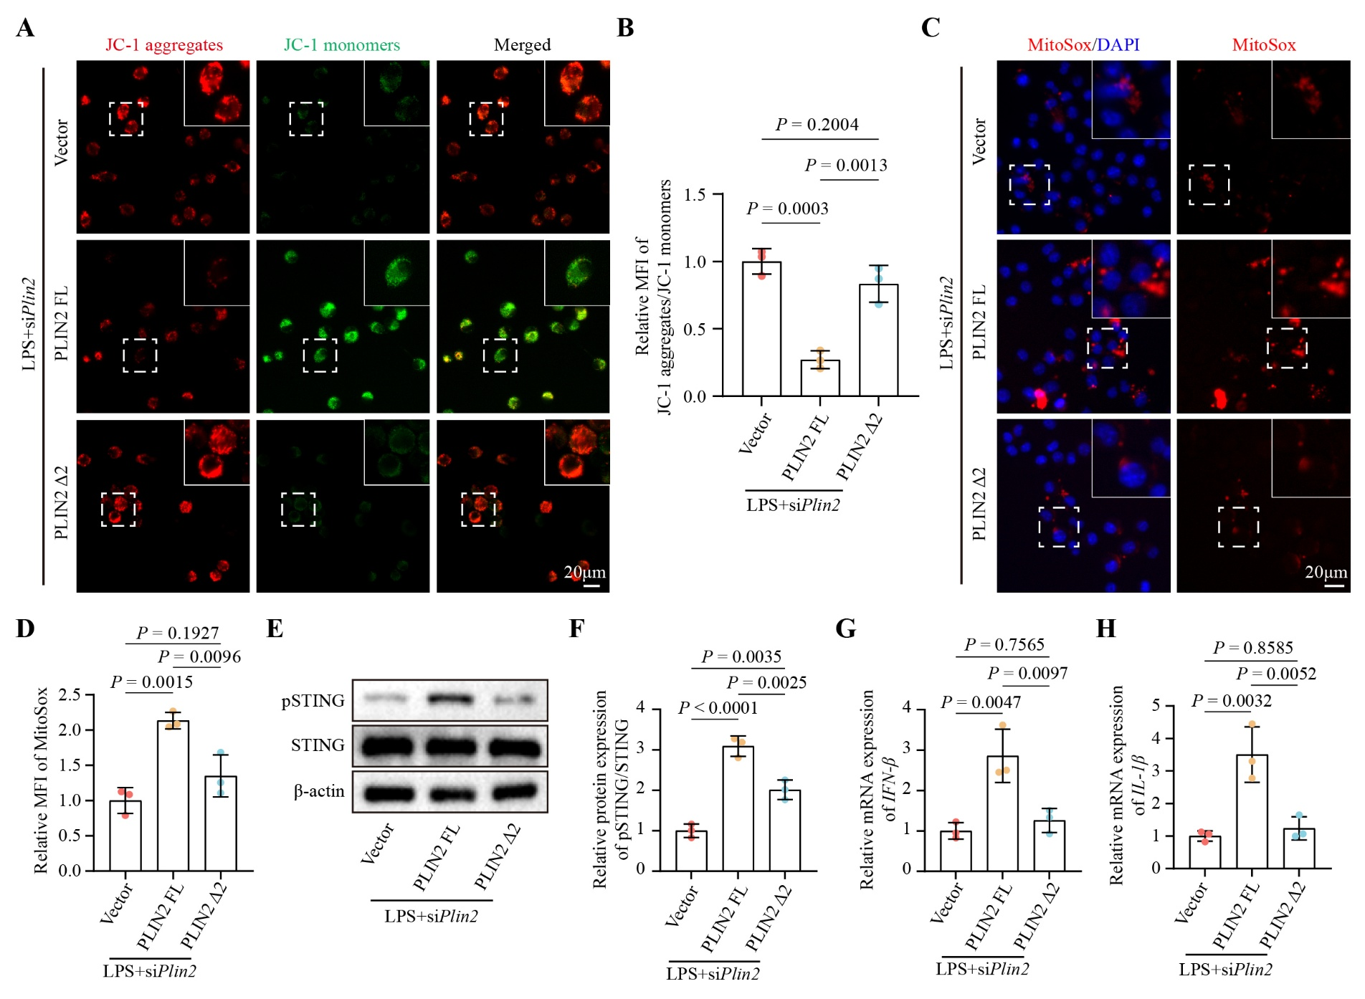
Fig. S8 PLIN2 220-392 domain regulates mitochondrial function and STING-mediated inflammatory responses.
(A, B) Representative JC-1 staining images (A) and mean fluorescence intensity (MFI) quantification (B) of mitochondrial membrane potential in live BV2 cells transfected with siPlin2, followed by re-expression of full-length PLIN2 or Δ220-392 mutant (PLIN2 Δ2), and subsequent LPS stimulation (24 h) (n = 3 biological replicates per group).
(C, D) Representative MitoSox staining (C) and mean fluorescence intensity (MFI) quantification (D) in live BV2 cells transfected with siPlin2, followed by re-expression of full-length PLIN2 or Δ220-392 mutant (PLIN2 Δ2), and subsequent LPS stimulation (24 h) (n = 3 biological replicates per group).
(E, F) Western blot analysis (E) and quantification (F) of STING pathway proteins in BV2 cells transfected with siPlin2, followed by re-expression of full-length PLIN2 or Δ220-392 mutant (PLIN2 Δ2), and subsequent LPS stimulation (24 h) (n = 3 biological replicates per group).
(G, H) RT-qPCR analysis of IFN-β (G) and IL-1β (H) mRNA levels in BV2 cells transfected with siPlin2, followed by re-expression of full-length PLIN2 or Δ220-392 mutant (PLIN2 Δ2), and subsequent LPS stimulation (24 h) (n = 3 biological replicates per group).
Data are presented as mean ± SD, and were analyzed by one-way ANOVA (B, D, F, G, H). Statistical significance defined as P < 0.05 and exact P values are indicated in the figures.

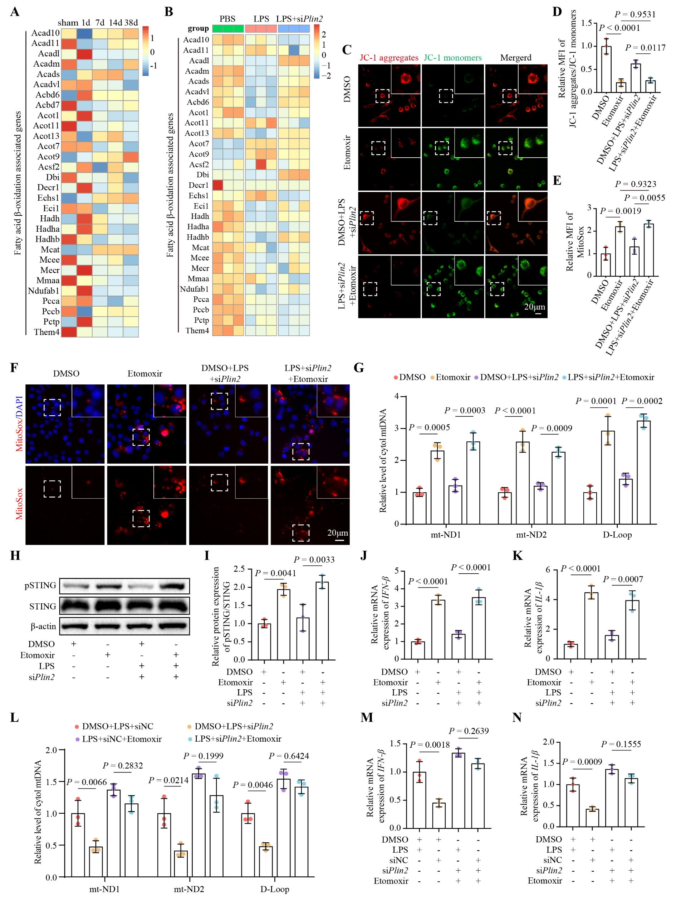
Fig. S9 Fatty acid β-oxidation regulates mitochondrial function and STING signaling in microglia.
(A) Heatmap showing expression of genes associated with fatty acid β-oxidation in microglia from scRNA-seq data (https://doi.org/10.6084/m9.figshare.17702045) at 1, 7, 14 and 38 dpi.
(B) Heatmap showing expression of genes associated with fatty acid β-oxidation in BV2 cells from bulk RNA-seq following LPS treatments with or without Plin2 knockdown.
(C, D) Representative JC-1 staining images (C) and mean fluorescence intensity (MFI) quantification (D) of mitochondrial membrane potential in live BV2 cells treated with DMSO or Etomoxir, or subjected to Plin2 knockdown followed by LPS stimulation (24 h) with or without Etomoxir (n = 3 biological replicates per group).
(E, F) Mean fluorescence intensity (MFI) quantification (E) and representative MitoSox staining images (F) in live BV2 cells treated with DMSO or Etomoxir, or subjected to Plin2 knockdown followed by LPS stimulation (24 h) with or without Etomoxir (n = 3 biological replicates per group).
(G) Quantification of cytosolic mtDNA levels (mt-ND1, mt-ND2, and D-Loop) by quantitative PCR in BV2 cells treated with DMSO or Etomoxir, or subjected to Plin2 knockdown followed by LPS stimulation (24 h) with or without Etomoxir (n = 3 biological replicates per group).
(H, I) Western blot analysis (H) and quantification (I) of STING pathway proteins in BV2 cells treated with DMSO or Etomoxir, or subjected to Plin2 knockdown followed by LPS stimulation (24 h) with or without Etomoxir (n = 3 biological replicates per group).
(J, K) RT-qPCR analysis of IFN-β (J) and IL-1β (K) mRNA levels in BV2 cells treated with DMSO or Etomoxir, or subjected to Plin2 knockdown followed by LPS stimulation (24 h) with or without Etomoxir (n = 3 biological replicates per group).
(L) Quantification of cytosolic mtDNA levels (mt-ND1, mt-ND2, and D-Loop) by quantitative PCR in BV2 cells transfected with siNC or siPlin2 followed by LPS stimulation (24 h) with or without Etomoxir (n = 3 biological replicates per group).
(M, N) RT-qPCR analysis of IFN-β (M) and IL-1β (N) mRNA levels in BV2 cells transfected with siNC or siPlin2 followed by LPS stimulation (24 h) with or without Etomoxir (n = 3 biological replicates per group).
Data are presented as mean ± SD, and were analyzed by one-way ANOVA (D, E, G, I, J, K, L, M, N). Statistical significance defined as P < 0.05 and exact P values are indicated in the figures.
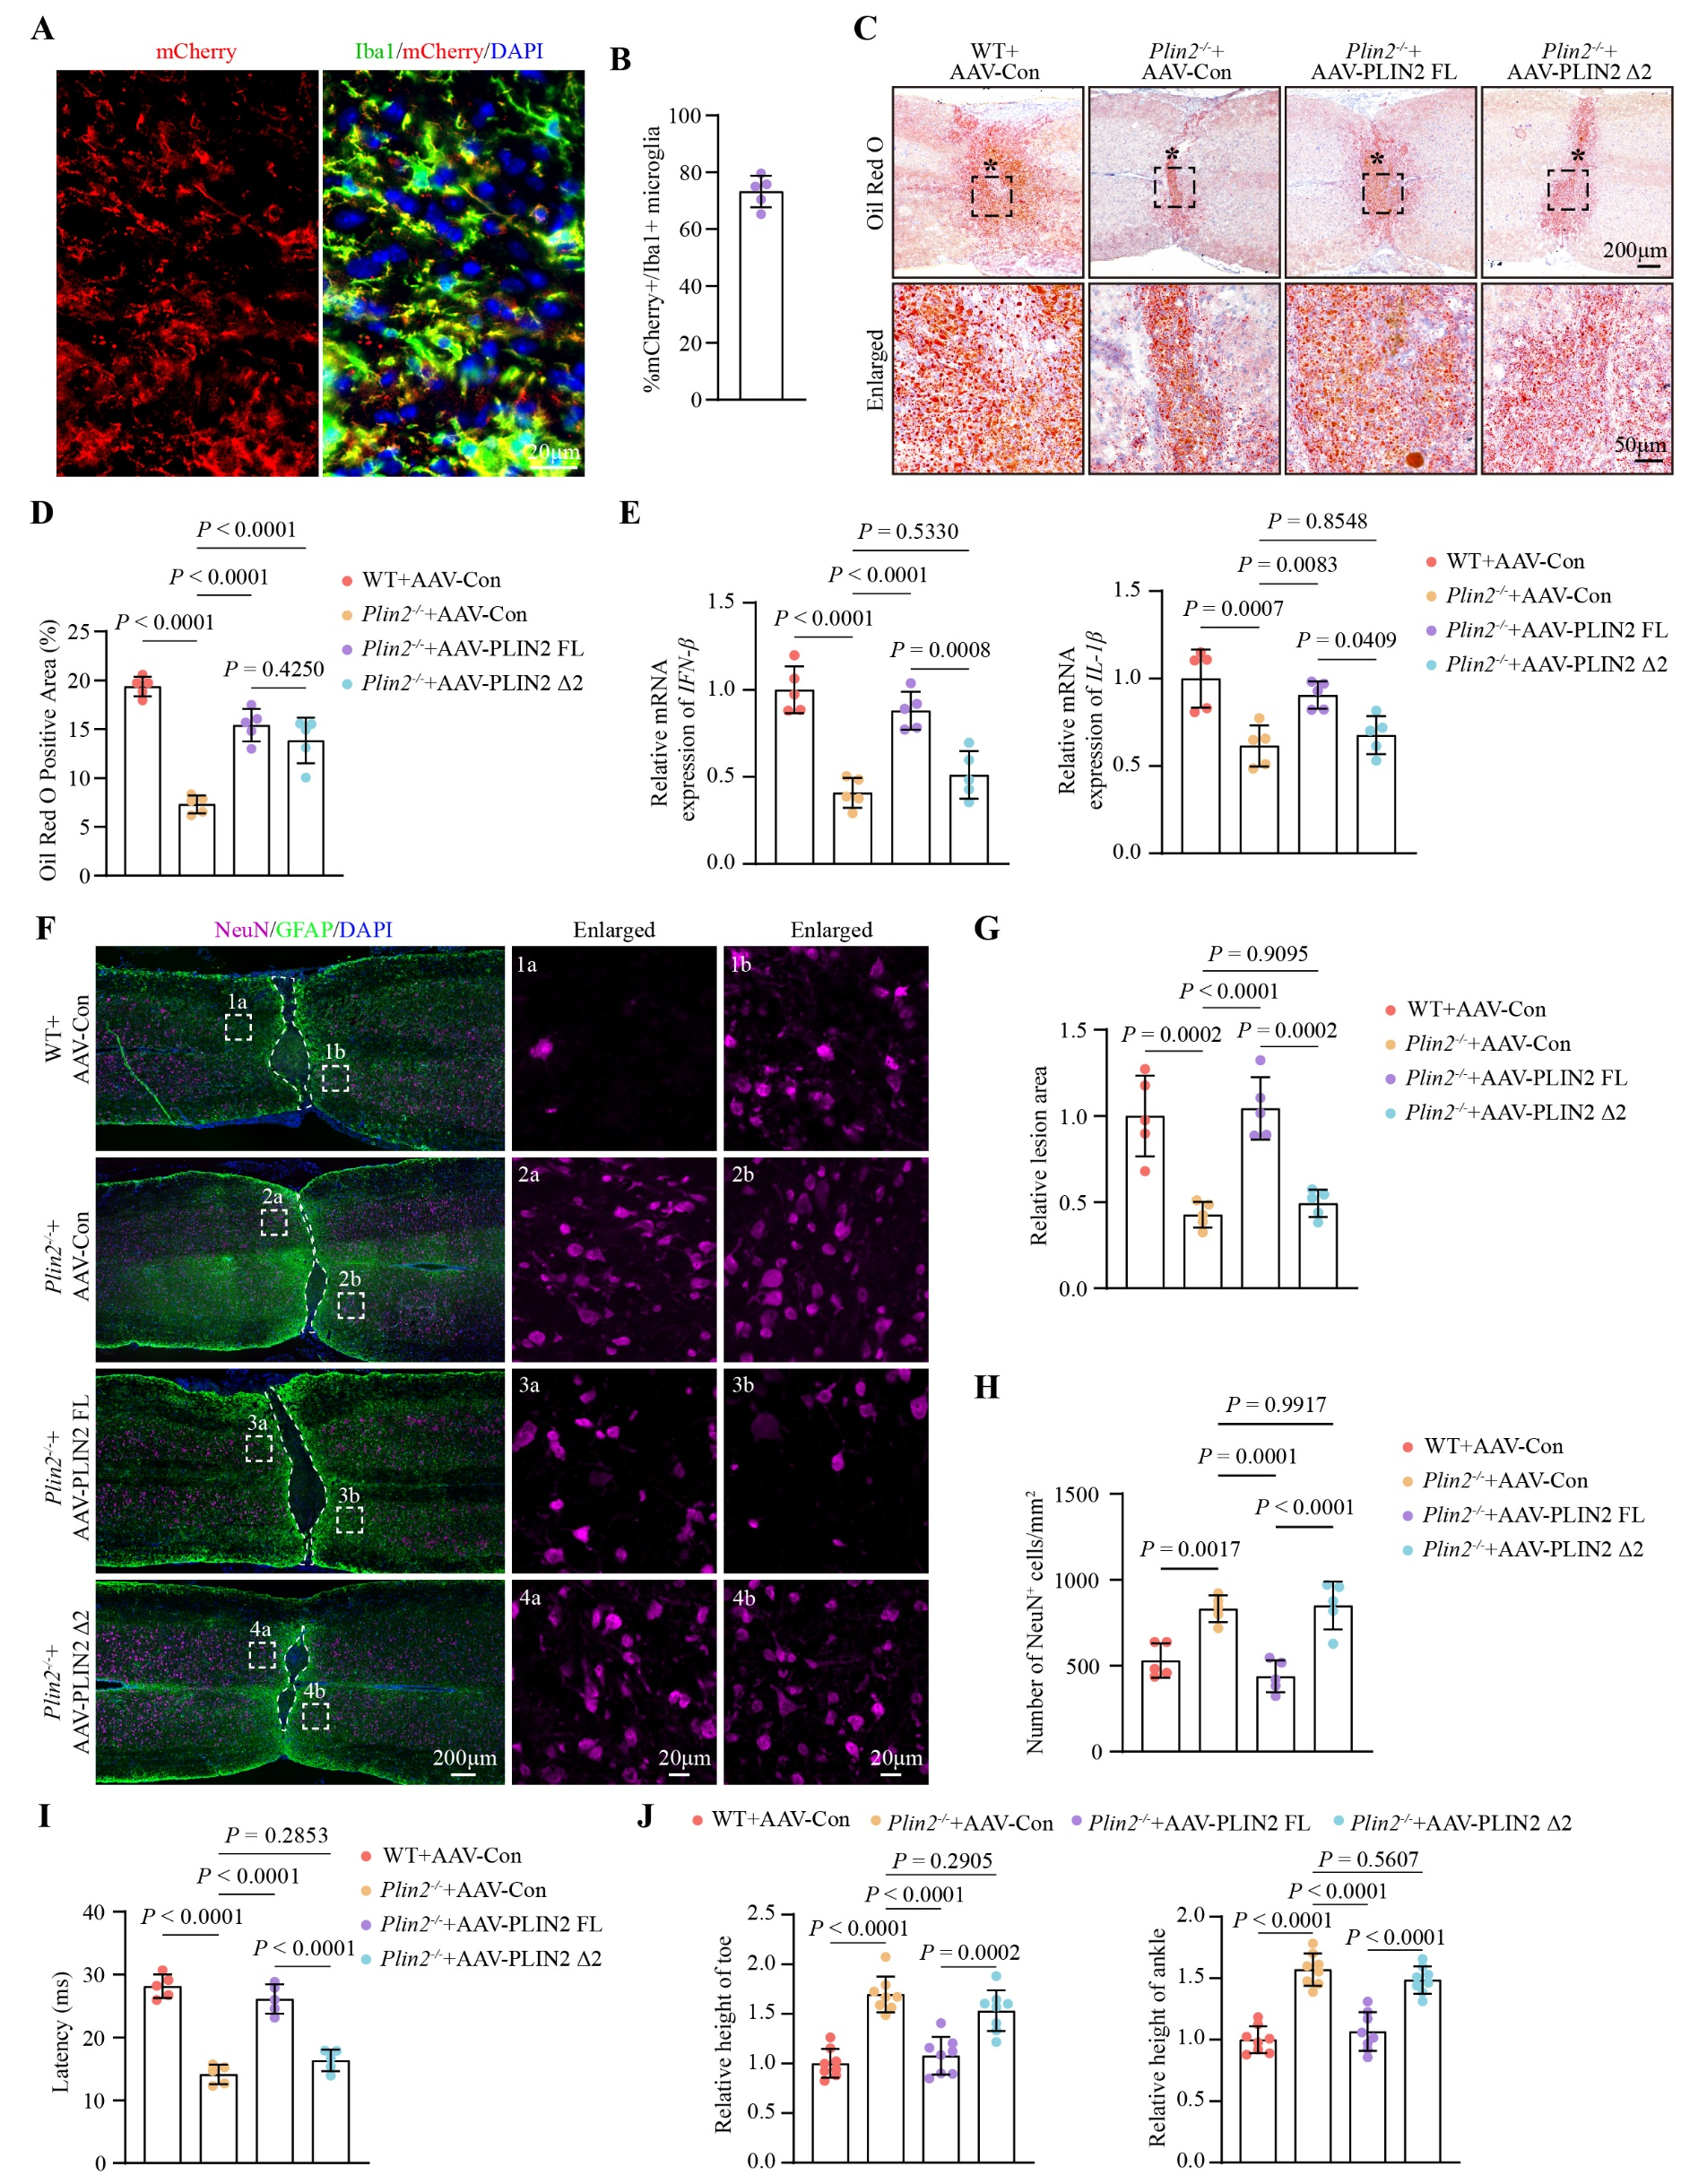
Fig. S10 PLIN2 220-392 domain modulates neuronal survival and functional recovery after SCI.
(A, B) Representative fluorescence images (A) and quantification (B) of adeno-associated virus (AAV) infection efficiency in microglia after SCI (n = 5 mice per group).
(C, D) Representative Oil Red O staining (C) and quantification (D) in Plin2^{-/-} mice re-expressing full-length PLIN2 or PLIN2 Δ2 at 14 dpi (n = 5 mice per group). In (A), asterisks (*) indicate the lesion core, and dotted-line squares indicate the regions shown in the corresponding enlarged insets. Quantification in (B) was performed based on the whole image.
(E) Quantification of IFN-β and IL-1β mRNA levels by RT-qPCR in Plin2^{-/-} mice re-expressing full-length PLIN2 or PLIN2 Δ2 at 14 dpi (n = 5 mice per group).
(F, G, H) Representative fluorescence images of NeuN and GFAP co-staining (F), quantification of lesion area (G), and quantification of NeuN⁺ cell number (H) in Plin2^{-/-} mice re-expressing full-length PLIN2 or PLIN2 Δ2 (n = 5 mice per group). Lesion area was defined by the GFAP-positive boundary (white dotted lines), and the area enclosed within this boundary was quantified as the lesion area. NeuN⁺ neurons were quantified across the entire spinal cord section field.
(I) Quantification of latency from EMG recordings in Plin2^{-/-} mice re-expressing full-length PLIN2 or PLIN2 Δ2 (n = 5 mice per group).
(J) Quantification of toe and ankle heights during walking in Plin2^{-/-} mice re-expressing full-length PLIN2 or PLIN2 Δ2 (n = 8 mice per group).
Data are presented as mean ± SD, and were analyzed by one-way ANOVA (E, G, H, I, J). Statistical significance defined as P < 0.05 and exact P values are indicated in the figures.

Supplementary Table 1. Key Resources Table
Reagent or Resource | Source | Identifier
Antibodies
Rabbit anti-Iba1 | Abcam | Cat#: ab178846
Rabbit anti-NeuN | Abcam | Cat#: ab177487
Chicken anti-GFAP | Abcam | Cat#: ab4674
Mouse anti-iNOS | Abcam | Cat#: ab210823
Rat anti-TOM20 | Abcam | Cat#: ab289670
Rabbit anti-5-HT | Immunostar | Cat#: 20080
Mouse anti-DNA | Progen | Cat#: AC-30-10
Rabbit anti-TOM20 | Proteintech | Cat#: 11802-1-AP
Rabbit anti-PLIN2 | Proteintech | Cat#: 15294-1-AP
Mouse anti-PGAM5 | Proteintech | Cat#: 68116-1-Ig
Rabbit anti-VDAC2 | Proteintech | Cat#: 55261-1-AP
Mouse anti-Flag | Proteintech | Cat#: 66008-4-Ig
Rabbit anti-Myc | Proteintech | Cat#: 16286-1-AP
Rabbit anti-AKAP1 | Cell Signaling Technology | Cat#: 5203
Rabbit anti-cGAS | Cell Signaling Technology | Cat#: 31659
Rabbit anti-pSTING | Cell Signaling Technology | Cat#: 72971
Rabbit anti-STING | Cell Signaling Technology | Cat#: 13647
Rabbit anti-β-Actin | Cell Signaling Technology | Cat#: 4967
Goat anti-Mouse IgG conjugated to Alexa Fluor™ 405 | Invitrogen | Cat#: A-31553
Goat anti-Mouse IgG conjugated to Alexa Fluor™ 488 | Invitrogen | Cat#: A-11001
Goat anti-Rabbit IgG conjugated to Alexa Fluor™ 488 | Invitrogen | Cat#: A-11008
Goat anti-Chicken IgY conjugated to Alexa Fluor™ 488 | Invitrogen | Cat#: A-11039
Goat anti-Mouse IgG conjugated to Alexa Fluor™ 555 | Invitrogen | Cat#: A-21422
Goat anti-Rabbit IgG conjugated to Alexa Fluor™ 555 | Invitrogen | Cat#: A-21428
Goat anti-Rat IgG conjugated to Alexa Fluor™ 594 | Invitrogen | Cat#: A-11007
Goat anti-Rabbit IgG conjugated to Alexa Fluor™ 647 | Invitrogen | Cat#: A-21245
Goat anti-Chicken IgY conjugated to Alexa Fluor™ 647 | Invitrogen | Cat#: A-21449
Anti-mouse IgG, HRP-linked Antibody | Cell Signaling Technology | Cat#: 7076
Anti-rabbit IgG, HRP-linked Antibody | Cell Signaling Technology | Cat#: 7074
Chemicals, peptides, and recombinant proteins
Triacsin C | Abcam | Cat#: ab141888
Lipopolysaccharide (LPS) | Sigma-Aldrich | Cat#: L4391
Oleic acid (OA) | Beyotime | Cat#: ST2053
Atorvastatin | MedChemExpress | Cat#: HY-17379
BODIPY 493/503 | MedChemExpress | Cat#: HY-W090090
BODIPY 558/568 C12 | MedChemExpress | Cat#: HY-138226
MitoSox Red | MedChemExpress | Cat#: HY-D1055
MitoTracker Deep Red | DOJINDO | Cat#: MT12
HMBR | Twinkle Factory | Cat#: 480541-250
Critical commercial assays
CCK-8 Assay Kit | MedChemExpress | Cat#: HY-K0301
Mitochondrial Membrane Potential Assay Kit with JC-1 | Solarbio | Cat#: M8650
Modified Oil Red O Staining Kit | Beyotime | Cat#: C0158S
Enhanced BCA protein assay kit | Beyotime | Cat#: P0010
Coomassie Blue Staining Kit | Beyotime | Cat#: P0017A
Total RNA Extraction Kit I | Omega | Cat#: R6834
PrimeScript RT Master Mix | TaKaRa | Cat#: RR036
Fast SYBR qPCR Mix | GenStar | Cat#: A301
FastPure Cell/Tissue DNA isolation Kit | Vazyme | Cat#: DC102
Deposited data
Bulk RNA sequencing of BV2 cells | This paper | https://doi.org/10.6084/m9.figshare.32069211
Spatial transcriptomics | Skinnider et al. | http://tabulaeparalytica.com/
Single-cell RNA sequencing of mouse spinal cords | Li et al. | https://doi.org/10.6084/m9.figshare.17702045
Bulk RNA sequencing of mouse spinal cords | Zhou et al. | GEO: GSE113566
Experimental models: Organisms/strains
Plin2^{-/-} mouse | GemPharmatech | Stain No: T034757
Oligonucleotides
CCAGCTCCAAGAAAGGACGA | Sangon Biotech | IFN-β forward
TGGATGGCAAAGGCAGTGTA | Sangon Biotech | IFN-β reverse
TTGACGGACCCCAAAAGATG | Sangon Biotech | IL-1β forward
CAGCTTCTCCACAGCCACAA | Sangon Biotech | IL-1β reverse
AATCGTGCGTGACATCAAAGAG | Sangon Biotech | Actin forward
GCCATCTCCTGCTCGAAGTC | Sangon Biotech | Actin reverse
CAAACACTTATTACAACCCAAGAACA | Sangon Biotech | ND-1 forward
TCATATTATGGCTATGGGTCAGG | Sangon Biotech | ND-1 reverse
CCATCAACTCAATCTCACTTCTATG | Sangon Biotech | ND-2 forward
GAATCCTGTTAGTGGTGGAAGG | Sangon Biotech | ND-2 reverse
AATCTACCATCCTCCGTGAAACC | Sangon Biotech | D-Loop forward
TCAGTTTAGCTACCCCCAAGTTTAA | Sangon Biotech | D-Loop reverse
GTAACCCGTTGAACCCCATT | Sangon Biotech | 18S forward
CCATCCAATCGGTAGTAGCG | Sangon Biotech | 18S reverse
Software and algorithms
GraphPad Prism 9.5 | GraphPad Software | https://www.graphpad.com/
FlowJo V10.9 | BD | https://www.flowjo.com/
ImageJ | ImageJ | https://imagej.net/ij/
Imaris | Imaris | https://imaris.oxinst.com/
R 4.5.1 | R project | https://www.r-project.org/
DeepLabCut | DeepLabCut | https://github.com/DeepLabCut
Python | Python | https://www.python.org/

