Long Noncoding RNA MNX1-AS1 mediated regulation of one-carbon metabolism by preventing CACYBP degradation to promote lung cancer progression
Juze Yang^{1,5}, Xinyi Qian^{1,5}, Jiayi Ren^{1,5}, Tengfei Sun^{1,5}, Yun Ma¹, Jia Li¹, Honghe Zhang², Bingjian Lu³, Enguo Chen^{1✉}, Yan Lu^{3,4✉}, Pengyuan Liu^{1,4✉}

Supplementary data
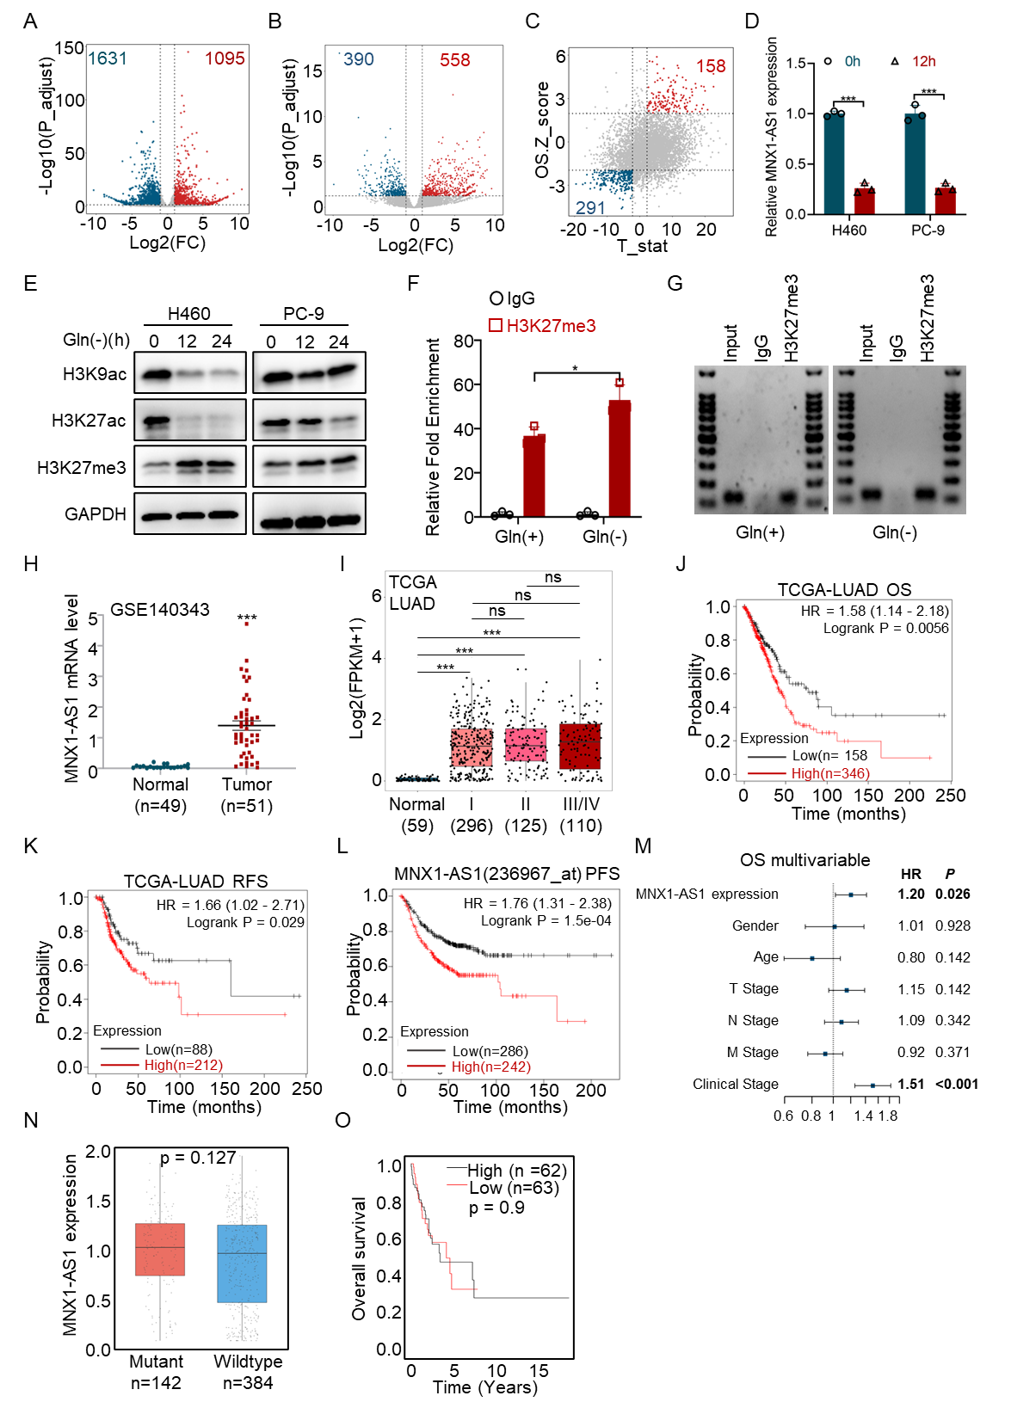
Figure S1.
(A) Scatter plots of RNA-seq data illustrating lncRNAs changes in control and
glutamine starvation cells. Transcripts >2-fold up- or down-regulated relative to the control cells were highlighted in red and navy, respectively.
(B) Volcano plot of lncRNAs differentially expressed in 6 tumor tissues paired with adjacent normal tissues.
(C) Dot plot of lncRNAs differentially expressed and associated with survival time in TCGA LUAD patients.
(D) qPCR analysis of MNX1-AS1 expression following glutamine starvation.
(E) Western blotting illustrating the levels of indicated proteins in control and glutamine-starved lung cancer cells.
(F, G) qPCR and agarose electrophoresis illustrating the relative enrichment of H3K27me3 in MNX1-AS1 promoters with or without glutamine exist.
(H) Bioinformatics analysis the expression of MNX1-AS1 in GSE140343.
(I) MNX1-AS1 expression in adjacent normal lung tissues and tumor tissues grouped into stages I to IV.
(J-L) Kaplan-Meier curves showing OS (H), RFS (I) and PFS (J) of patients with different levels of MNX1-AS1.
(M) Multivariable Cox analysis of clinical prognostic parameters for OS.
(N) Comparison of MNX1-AS1 expression between KRAS-wild-type and KRAS-mutant lung cancer tissues.
(O) Kaplan-Meier analysis showing that MNX1-AS1 expression was not associated with overall survival in patients with KRAS-mutant lung adenocarcinoma. * P<0.05; ** P<0.01; ***P<0.001.

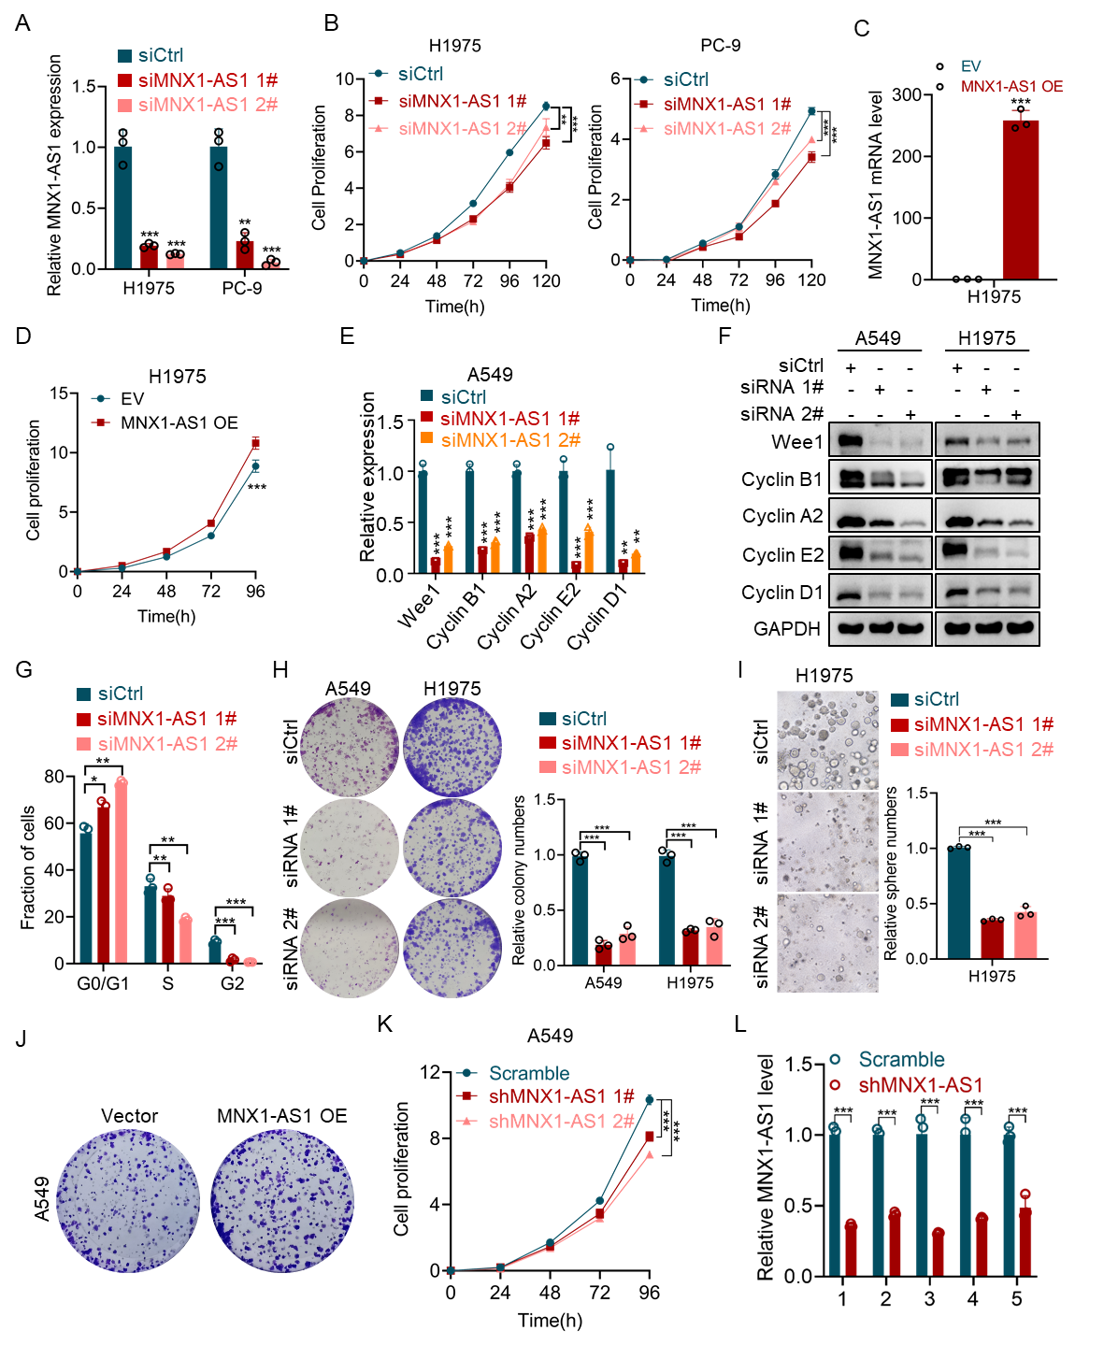
Figure S2.
(A) qPCR analysis of MNX1-AS1 knockdown efficiency following siRNA transfection in H1975 and PC-9 cells.
(B) CCK-8 proliferation assays were performed after MNX1-AS1 was silenced in H1975 and PC-9 cells.
(C) qPCR determined the MNX1-AS1 overexpression efficiency in H1975 cells.
(D) CCK-8 assays were performed after MNX1-AS1 overexpressed in H1975 cells.
(E) Relative cell cycle gene mRNA level after MNX1-AS1 silencing detected by qPCR.
(F) WB illustrating the cell cycle gene protein levels after MNX1-AS1 silencing.
(G) The cell cycle distributions of MNX1-AS1-depleted A549 cells or control cells.
(H) Colony formation assays were conducted to evaluate long-term growth of MNX1-AS1 depleted cells.
(I) Knockdown expression of MNX1-AS1 inhibits sphere formation in number and size.
(J) Colony formation assays were conducted in MNX1-AS1 overexpressed cells.
(K) CCK-8 assays were performed to examine the effect of stably knockdown MNX1-AS1 on cell growth.
(L) Endpoint qPCR analysis confirmed efficient knockdown of MNX1-AS1 in tumor tissues from shMNX1-AS1-treated nude mice compared with scramble controls (n=5). * P<0.05; ** P<0.01; ***P<0.001.

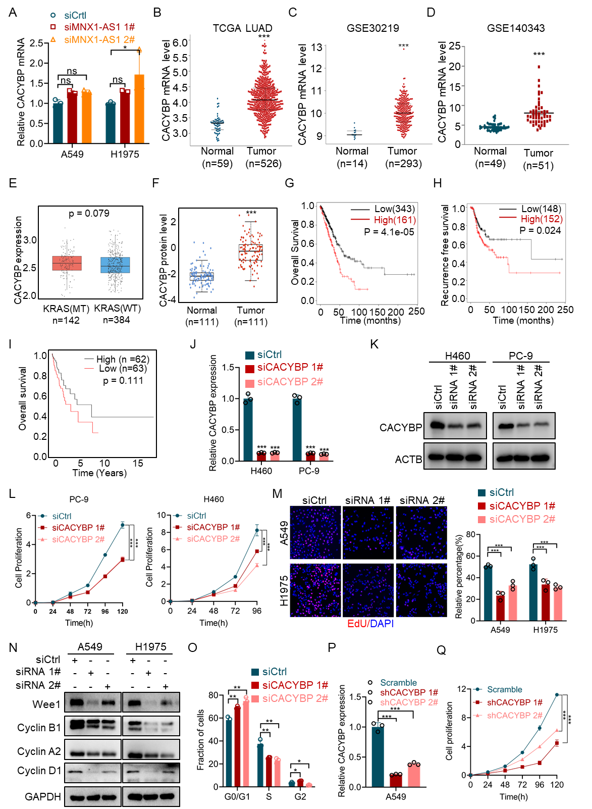
Figure S3.
- CACYBP mRNA level was assessed by qPCR after MNX1-AS1 depletion.
(B-D) CACYBP mRNA expression in TCGA LUAD (B), GSE30219 (C) and GSE140343 (D).
(E) Comparison of CACYBP expression between KRAS-wild-type and KRAS-mutant lung cancer tissues.
(F) Bioinformatics analyses the CACYBP protein levels in the CPTAC cohort database.
(G, H) Kaplan-Meier curves showing OS (G) and RFS (H) of patients with different levels of CACYBP.
(I) CACYBP expression was not associated with overall survival in KRAS-mutant lung adenocarcinoma patients.
(J) qPCR analysis of CACYBP mRNA levels in H460 and PC-9 cells following CACYBP knockdown.
(K) Western blot analysis of CACYBP protein levels in CACYBP knockdown cells.
(L) CCK-8 proliferation assays were performed after CACYBP was silenced in PC-9 and H460 cells.
(M) EdU assays were used to evaluated the DNA replications rate when CACYBP was depleted.
(N) Cell cycle related proteins were analyzed by western blot.
(O) The cell cycle distributions of CACYBP-depleted A549 cells or control cells.
(P) qPCR was performed to determine the CACYBP level in stably knockdown cells.
(Q) CCK-8 assays were performed to examine the effect of stably knockdown CACYBP on cell growth. * P<0.05; ** P<0.01; ***P<0.001.

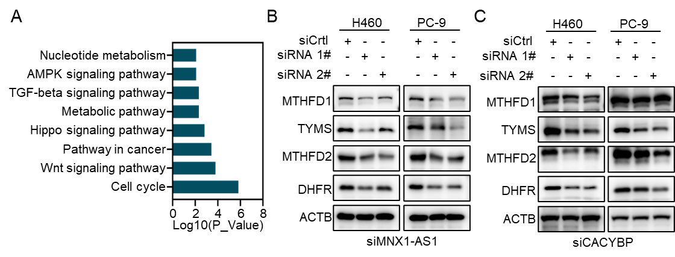
Figure S4.
(A) KEGG pathway analysis was performed to identify pathways enriched for differentially expressed genes upon MNX1-AS1 knockdown.
(B) Western blotting illustrating the levels of indicated proteins in MNX1-AS1 depleted cells.
(C) Western blotting illustrating the levels of indicated proteins in CACYBP depleted and control cells.

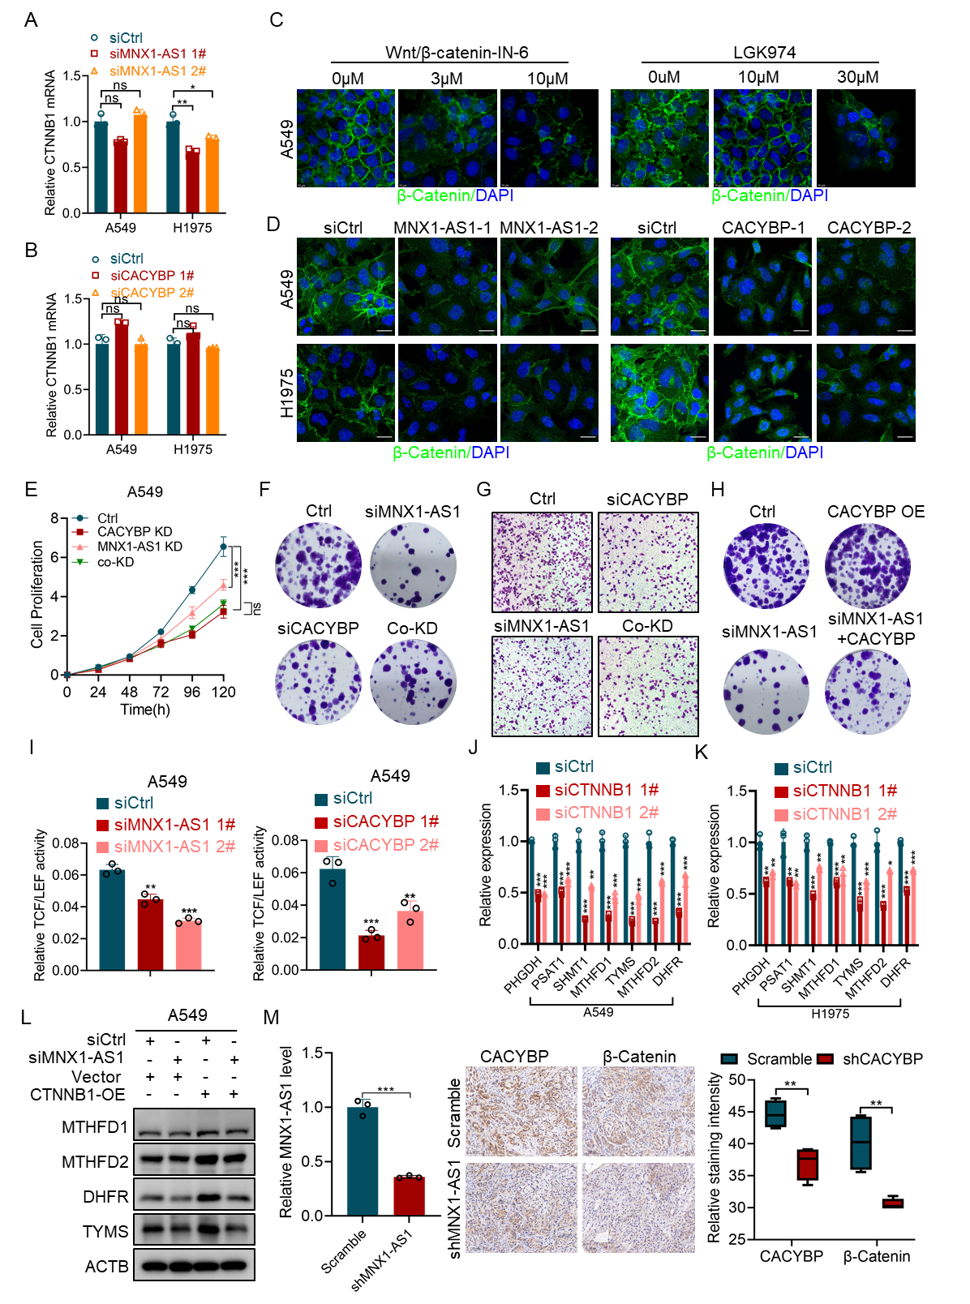
Figure S5.
(A, B) CTNNB1 mRNA level was determined by qPCR in CACYBP (A) and MNX1-AS1 (B) knockdown cells.
(C, D) Immunofluorescence analysis showing the effect of WNT inhibitors (C) and MNX1-AS1/CACYBP complex knockdown (D) on β-Catenin expression.
(E, F) CCK-8 and colony formation assays evaluating the effects of single and co-knockdown of MNX1-AS1 and CACYBP on cell proliferation.
(G) Trans-well assays assessing the effects of single and co-knockdown of MNX1-AS1 and CACYBP on cell migration.
(H) Rescue effect of CACYBP overexpression on MNX1-AS1 knockdown-mediated suppression of colony formation in A549 cells.
(I) Luciferase reporter assays were conducted to measure the influence of MNX1-AS1/CACYBP complex knockdown on β-Catenin transcription activity.
(J, K) qPCR illustrating the levels of indicated one-carbon metabolism genes in CTNNB1 silenced and control lung cancer cells.
(L) Western blotting analysis showing the rescue effect of CTNNB1 overexpression on one-carbon metabolism protein levels in MNX1-AS1-depleted cells.
(M) qPCR analysis of MNX1-AS1 levels, together with IHC and quantitative assessment of CACYBP expression and β-catenin expression in xenograft tumor tissues. Quantification of CACYBP and β-catenin staining intensity is shown as box plots. * P<0.05; ** P<0.01; ***P<0.001.
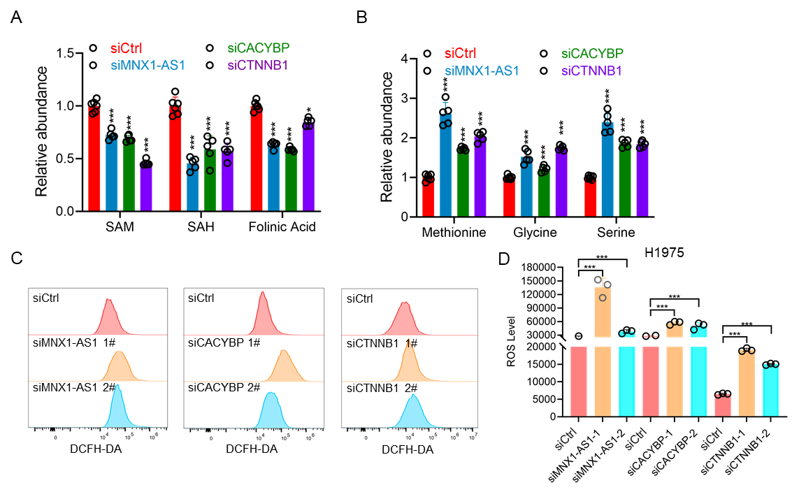
Figure S6.
(A) SAM, Folinic acid and SAH level in MNX1-AS1, CACYBP and CTNNB1 knockdown cells.
(B) Methionine, glycine and serine level in MNX1-AS1, CACYBP and CTNNB1 knockdown cells.
(C, D) ROS levels were measured in MNX1-AS1, CACYBP and CTNNB1 knockdown H1975 cells, respectively.

Table S1. Sequences of siRNAs used in this study.

Oligo name | Sequence
MNX1-AS1 siRNA 1# | GGUCGAACCUUAUCUGCUAUG
MNX1-AS1 siRNA 2# | UUAUGCAUGUGUUUGGUGGCUACCU
CACYBP siRNA 1# | CAUCAAGUUCCCACUGAGAAU
CACYBP siRNA 2# | GAUUACCUGACCCAGGUUGAA
CTNNB1 siRNA 1# | UCUAACCUCACUUGCAAUAAU
CTNNB1 siRNA 2# | AUCUGUCUGCUCUAGUAATAA

Table S2. qPCR primer sequence
Gene name | Sequence
MNX1-AS1 qPCR F | GCAGGTCGAACCTTATCTGCT
MNX1-AS1 qPCR R | GCTGCAGCATTCTGGGAAAAG
CACYBP qPCR F | GCTCCCATTACAACGGGCTA
CACYBP qPCR R | TGCACCTGCACATTCTCAGT
CTNNB1 qPCR F | CACAAGCAGAGTGCTGAAGGTG
CTNNB1 qPCR R | GATTCCTGAGAGTCCAAAGACAG
CCNA2 qPCR F | CCATACCTCAAGTATTTGCCATC
CCNA2 qPCR R | TCCAGTCTTTCGTATTAATGATTCAG
CCND1 qPCR F | CCTGTCCTACTACCGCCTCA
CCND1 qPCR R | CAGTCCGGGTCACACTTGA
CCNB1 qPCR F | CATGGTGCACTTTCCTCCTT
CCNB1 qPCR R | AGGTAATGTTGTAGAGTTGGTGTCC
WEE1 qPCR F | ATTTCTCTGCGTGGGCAGAAG
WEE1 qPCR R | CAAAAGGAGATCCTTCAACTCTGC
CCNE2 qPCR F | CTTACGTCACTGATGGTGCTTGC
CCNE2 qPCR R | CTTGGAGAAAGAGATTTAGCCAGG
MTHFD2 qPCR F | CTGCGACTTCTCTAATGTCTGC
MTHFD2 qPCR R | CTCGCCAACCAGGATCACA
PHGDH qPCR F | GTCATTGTCGGCCTCCTGAA
PHGDH qPCR R | TGTGGGAGGTGGTGACATTG
PSAT1 qPCR F | CCAGTGGAGCCCCAAAATAGA
PSAT1 qPCR R | CTCCCACAGACCTATGCCCT
PSPH qPCR F | TGTCAGAAATGACACGGCGA
PSPH qPCR R | GTAGGCGACTTACCAGCTCC
SHMT1 qPCR F | GCTGGGCTACAAAATAGTCA
SHMT1 qPCR R | AGGCAATAGAACAGGCTTC
SHMT2 qPCR F | CTACAACCAGCTGGCACTGA
Table S2. Continued
Gene name | Sequence
SHMT2 qPCR R | CACTGATGTGGGCCATGTCT
MTHFD1 qPCR F | CGGCTACTCCCAGGTCATTC
MTHFD1 qPCR R | GAGCCTTGTCTGTCTGGGTC
DHFR qPCR F | GCCACCGCTCAGGAATGA
DHFR qPCR R | GCTCCTTGTGGAGGTTCCTT
TYMS qPCR F | CCGAGACTTTTTGGACAGCC
TYMS qPCR R | TGGTCAACTCCCTGTCCTGA

Table S3. Antibody list
Name | Manufacturer | Cat.no.
WEE1 | Cell Signaling Technology | 13084
Cyclin A2 | Cell Signaling Technology | 4656
Cyclin D1 | Cell Signaling Technology | 2978
Cyclin B1 | Cell Signaling Technology | 12231
Acetyl-Histone H3 (Lys27) | Cell Signaling Technology | 8173
Tri-Methyl-Histone H3 (Lys27) | Cell Signaling Technology | 9733
Acetyl-Histone H3 (Lys9) | Cell Signaling Technology | 9649
Tri-Methyl-Histone H3 (Lys9) | Cell Signaling Technology | 13969
Cleaved PARP (Asp214) | Cell Signaling Technology | 5625
c-Jun | Cell Signaling Technology | 9165
Phospho-c-Jun (Ser73) | Cell Signaling Technology | 3270
JNK Antibody | Cell Signaling Technology | 9252
P-JNK (Thr183/Tyr185) | Cell Signaling Technology | 9251
β-Catenin | Cell Signaling Technology | 8480
Non-phospho (Active) β-Catenin | Cell Signaling Technology | 8814
Cyclin E2 | Abclonal | A9305
GAPDH | Proteintech | 60004-1-Ig
ACTB | Proteintech | 66009-1-Ig
CACYBP | Proteintech | 11745-1-AP
PHGDH | Proteintech | 14719-1-AP
DHFR | Proteintech | 15194-1-AP
TYMS | Proteintech | 66725-1-Ig
MTHFD1 | Proteintech | 10794-1-AP
MTHFD2 | Santa Cruz | sc-390708

Table S4. Chip-qPCR primer sequence
Gene name | Sequence
DHFR F | GAATCACCCTACTTACATATGCT
DHFR R | ACCTATCTTTTCCCCTCTGTG
MTHFD1 F | GTCTGGTGGCGTAGGTGTGT
MTHFD1 R | CTGGACTCGACAGCAGATGT
MTHFD2 F | TGTGTGTTCCCTTACTGGGT
MTHFD2 R | AGTTACTGCTTCAACCACGT
TYMS F | ATTAAAAACTTGGGGCCGAGT
TYMS R | GGGTTTCGCCATGTTAGCC

