Supplementary Information for

HMGB1 Directly Activates BAP1 Transcription to Sustain Tumor Growth in Mesothelioma

Flavia Novelli¹, Lydia Giannakou¹, Zhanwei Wang^{1,2}, Jin-Hee Kim¹, Qian Wang³, Miao Feng³, Zeying Li³, Cristina Favaron¹, Filippo Maldini¹, Joelle S. Suarez¹, Mika Tanji¹, Alicia A. Zolondick¹, Angela Bononi¹, Linda MacPherson¹, Euisung Hong¹, Xin Chen⁴, Youping Deng², Tak W. Mak^{5,6,7}, Harvey I. Pass⁸, Jose N. Onuchic^{9,10}, Michele Carbone^{1*}, Haining Yang^{1*}.

*Correspondence to: Michele Carbone, mcarbone@cc.hawaii.edu; Haining Yang, haining@hawaii.edu

This PDF file includes:

Supplementary Figures 1 to 5

Supplementary Methods

References

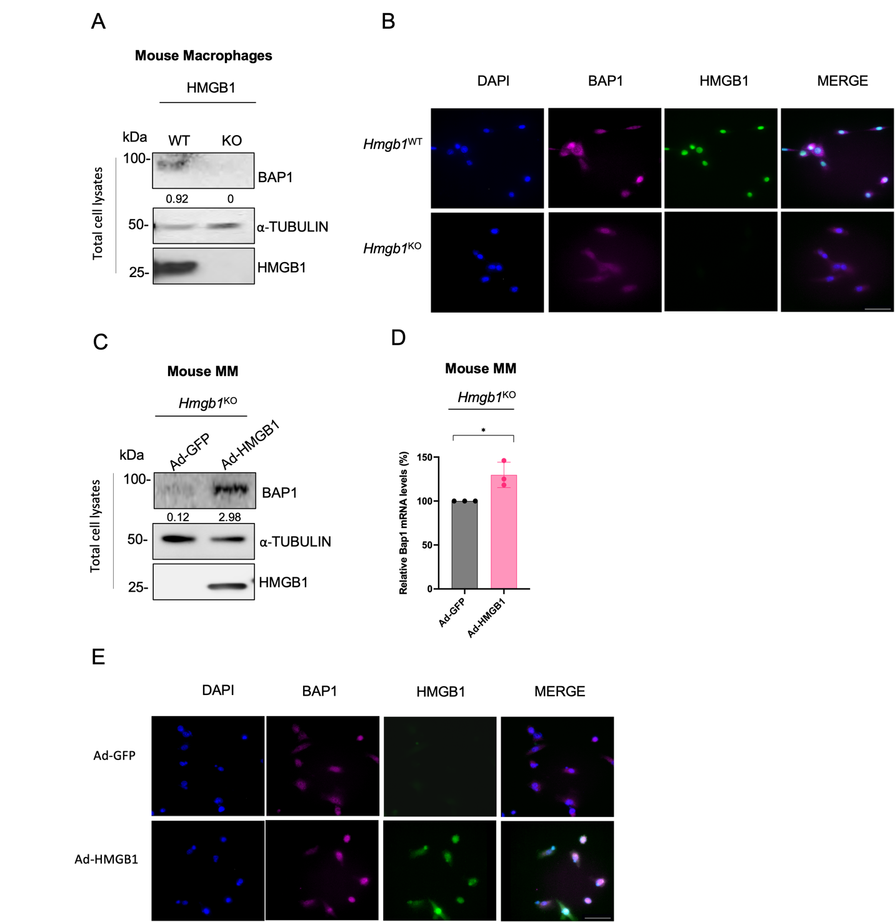

Supplementary Fig.1. HMGB1 regulates BAP1 expression in mouse cells. A, Total cell lysate from primary mouse macrophages derived from Hmgb1^{WT} and Hmgb1^{KO} mice showing BAP1 and HMGB1 protein levels. Decimals: BAP1/α-TUBULIN, HMGB1/α-TUBULIN. B, Immunofluorescence: BAP1 and HMGB1 localization in mouse Hmgb1^{WT} and Hmgb1^{KO} mesothelioma cells. Cells were immunostained for BAP1 (magenta) and HMGB1(green). Nuclei were visualized by DAPI staining (blue). Scale bar: 100μm. C, Mouse Hmgb1^{KO} mesothelioma cells were transduced with a human HMGB1 adenovirus (Ad-HMGB1) or Ad-GFP used as a control for 24h. Then cell lysates were collected and analyzed by western blot. Reintroduction of HMGB1 caused an increase in BAP1 protein expression. Decimals: BAP1/α-TUBULIN, HMGB1/α-TUBULIN. D, qRT-PCR: Bap1 mRNA levels in mouse Hmgb1^{KO} mesothelioma cells that were transduced with Ad-HMGB1 or Ad-GFP (used as control) for 24h. Reintroduction of HMGB1 caused an increase in Bap1 mRNA levels. Data are shown as mean ± SD of n=3 biological replicates. P values are calculated by unpaired two-tailed Student’s t tests (* P < 0.05). E, Immunofluorescence showing HMGB1 nuclear localization in mouse Hmgb1^{KO} mesothelioma cells transduced with a human HMGB1 adenovirus (Ad-HMGB1) or Ad-GFP and collected after 24h. Cells were immunostained for BAP1 (magenta) and HMGB1(green). Nuclei were visualized by DAPI staining (blue). Scale bar: 100μm.

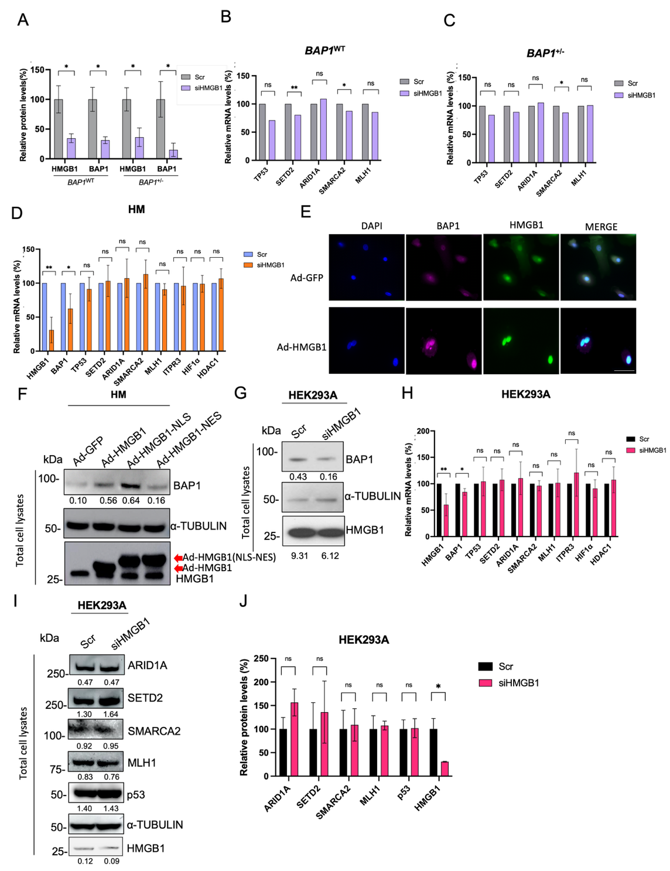
Supplementary Fig.2. HMGB1 specifically modulates BAP1 expression. A, Bar graph: HMGB1/ α-TUBULIN, BAP1/ α-TUBULIN, HMGB1/GAPDH, BAP1/ GAPDH densitometry of bands in primary BAP1^{WT} and BAP1^{+/-} fibroblasts shown as mean ± SD of the n = 5 biological replicates, one displayed in (Fig. 2A). Densitometric quantification was always normalized to a single loading control (either tubulin or GAPDH), never interchangeably. B and C, qRT-PCR: TP53, SETD2, ARID1A, SMARCA2, MLH1 mRNA levels in primary BAP1^{WT} (B) and BAP1^{+/-} (C) fibroblasts. Data are shown as mean of n=2 biological replicates. P values are calculated by unpaired two-tailed Student’s t tests (* P < 0.05), (** P < 0.01). D, qRT-PCR: HMGB1, BAP1, TP53, SETD2, ARID1A, SMARCA2, MLH1, ITPR3, HIF1α and HDAC1 mRNA levels in primary human mesothelial cells silenced for HMGB1. Data are shown as mean ± SD of the n = 3 biological replicates. P values are calculated by unpaired two-tailed Student’s t tests (* P < 0.05), (** P < 0.01). E, Immunofluorescence: BAP1 and HMGB1 localization in human mesothelial cells (HM) transduced with a human HMGB1 adenovirus (Ad-HMGB1) or Ad-GFP used as control. Nuclei were visualized by DAPI staining (blue). Scale bar: 100μm. F, Western blot: BAP1 protein expression in HM cells transduced with human HMGB1 adenovirus (Ad-HMGB1), with two HMGB1 adenoviruses that localize in the nucleus (Ad-HMGB1-NLS) and in the cytoplasm (Ad-HMGB1-NES). Ad-GFP was used as negative control.
Decimals: BAP1/α-TUBULIN. G, Total cell lysates from HEK293A cells silenced for HMGB1 gene were collected and analyzed by western blot. A nonspecific siRNA (Scr) was used as a negative control. Reduction of BAP1 protein levels was observed in HMGB1-silenced HEK293A cells compared to control cells. H, qRT-PCR: HMGB1, BAP1, TP53, SETD2, ARID1A, SMARCA2, MLH1, ITPR3, HIF1α, HDAC1 mRNA levels in HEK293A cells silenced for HMGB1. A not specific siRNA (Scr) was used as a negative control. Data are shown as mean ± SD of the n = 3 biological replicates. P values are calculated by unpaired two-tailed Student’s t tests (* P < 0.05), (** P < 0.01). I, Western blot: HMGB1, p53, SETD2, ARID1A, SMARCA2, MLH1, protein levels in HEK293A cells silenced for HMGB1. Decimals: HMGB1/α-TUBULIN, SMARCA2/α-TUBULIN, MLH1/α-TUBULIN, p53/α-TUBULIN, SETD2/α-TUBULIN, ARID1A/α-TUBULIN. J, Bar graph: ARID1A/ α-TUBULIN, SETD2/GAPDH, SMARCA2/α-TUBULIN, MLH1/ α-TUBULIN, p53/ α-TUBULIN, HMGB1/ α-TUBULIN densitometry of bands in HEK293A shown as mean ± SD of the n = 3 biological replicates, one displayed in (Supplementary Fig. 2I).

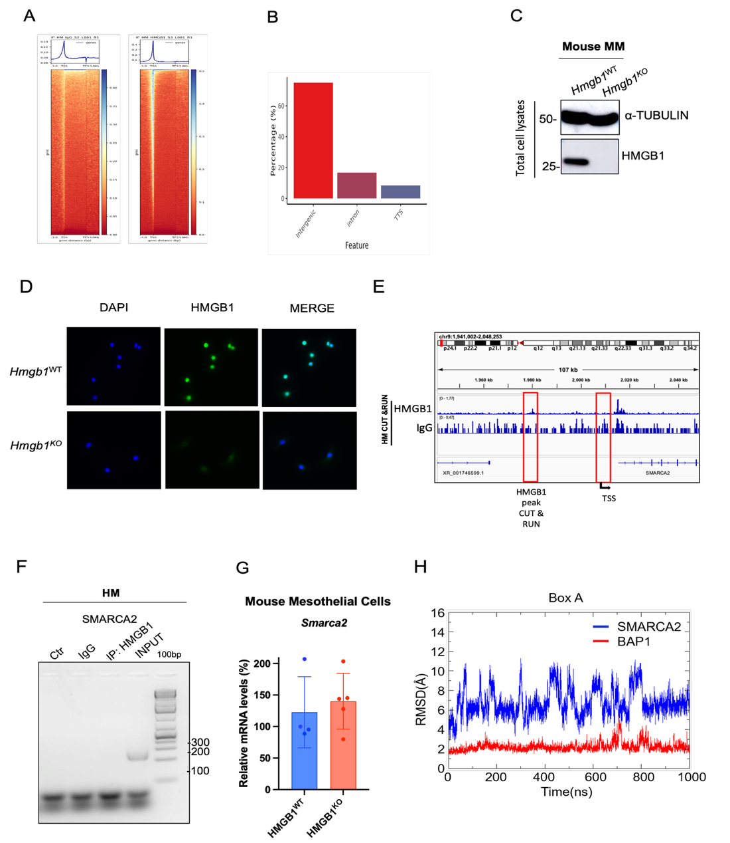

Supplementary Fig.3. HMGB1 regulates BAP1 transcription specifically. A, Heatmaps of IgG and HMGB1 samples of the CUT & RUN in HM cells generated by DeepTools to visualize the signal intensity across a range of genomic regions, aligned at transcription start sites (TSS) over a span of 6 kilobases (3kb upstream and downstream). The central bright vertical band indicates a high concentration of reads at the TSS. The color gradient correlates with increasing signal intensity, representing the level of chromatin accessibility across different genes in the sample. B, Bar plot (top) of the distribution of IgG CUT & RUN peaks in HM cells. C, Western blot: HMGB1 and α-Tubulin protein expression in mouse Hmgb1^{WT} and Hmgb1^{KO} mesothelioma cells. A specific anti-HMGB1 antibody (ab18256) was used. D, Immunofluorescence: HMGB1 expression in mouse Hmgb1^{WT} and Hmgb1^{KO} cells. A specific anti-HMGB1 antibody (ab18256) was used. E-F, A CUT & RUN ChIP assay was performed in primary HM cells. Protein–chromatin complexes were precipitated using HMGB1 antibody. DNA sequences were amplified by qPCR. IgG antibody was used as a negative control. HMGB1 does not bind to the promoter of the SMARCA2 gene. G, Smarca2 mRNA expression in mouse Hmgb1^{WT} and Hmgb1^{KO} mesothelioma cells. H, RMSD of the Cα atoms of the HMGB1 Box A helix at the binding interface of SMARCA2 (blue) and BAP1(red) promoters.

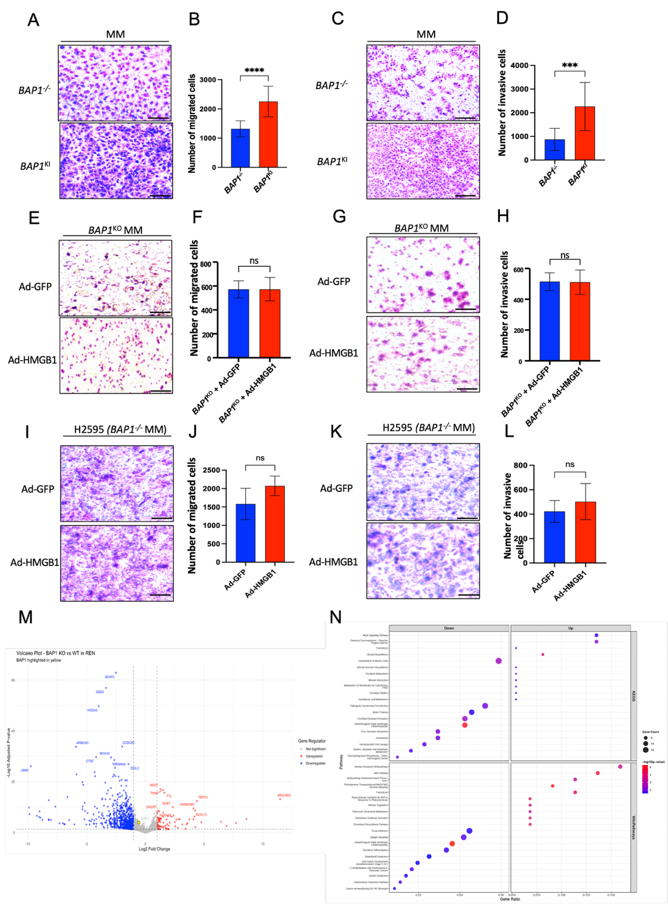

Supplementary Fig.4. BAP1 regulates the migration and invasion of MM cells. A, Transwell migration assay in BAP1^{-/-} and BAP1^{KI} MM cells. Representative images are shown. B, The average number of BAP1^{-/-} and BAP1^{KI} migrating MM cells per field of view of n=2 biological replicates is plotted. Significant increase in the number of migrating cells was observed in BAP1^{KI} MM cells compared to BAP1^{-/-} cells. P values are calculated by unpaired two-tailed Student’s t tests (**** P < 0.0001). C, Transwell invasion assay in BAP1^{-/-} and BAP1^{KI} MM cells. Representative images are shown. D, The average number of BAP1^{-/-} and BAP1^{KI} invasive MM cells per field of view of n=2 biological replicates is plotted. Significant increase in the number of invasive cells was observed in BAP1^{KI} MM cells compared to BAP1^{-/-} cells. P values are calculated by unpaired two-tailed Student’s t tests (*** P < 0.001). E, Transwell migration assay in BAP1^{KO} MM cells that were transduced with HMGB1 adenovirus (Ad-HMGB1) or Ad-GFP used as control for 24h. Representative images are shown. F, The average number of BAP1^{KO} MM cells transduced with Ad-HMGB1 or Ad-GFP (as control) migrating per field of view of n=4 biological replicates is plotted. No difference in transwell migration was observed in BAP1^{KO} cells after the reintroduction of HMGB1 (Ad-HMGB1) compared to control cells. G, Transwell invasion assay in BAP1^{KO} MM cells that were transduced with HMGB1 adenovirus (Ad-HMGB1) or Ad-GFP used as control for 24h. Representative images are shown. H, The average number of BAP1^{KO} MM cells transduced with Ad-HMGB1 or Ad-GFP (as control) invading per field of view of n=3 biological replicates is plotted. No difference in transwell invasion was observed in BAP1^{KO} cells after the reintroduction of HMGB1 (Ad-HMGB1) compared to control cells. I and J, Transwell migration assay in a different BAP1^{-/-} MM (H2595) cells transduced with Ad-HMGB1 or Ad-GFP (as control). Representative images are shown and the average number of transduced BAP1^{-/-} MM cells migrating per field of view of n=2 biological replicates is plotted. No difference in transwell migration was observed in BAP1^{-/-} cells after the reintroduction of HMGB1 (Ad-HMGB1) compared to control cells. K and L, Transwell invasion assay in a different BAP1^{-/-} MM (H2595) cell transduced with Ad-HMGB1 or Ad-GFP (as control). Representative images are shown and the average number of transduced BAP1^{-/-} MM cells invading per field of view of n=2 biological replicates is plotted. No difference in transwell invasion was observed in BAP1^{-/-} cells after the reintroduction of HMGB1 (Ad-HMGB1) compared to control cells. M, Volcano plot showing differentially expressed genes identified by RNA-sequencing analysis between BAP1^{WT} and BAP1^{KO} MM (REN) cells. Significantly upregulated genes are shown in red, significantly downregulated genes in blue, and non-significant genes in gray. Differential expression was determined using DESeq2 with an adjusted P value < 0.01 and |log2 fold change| > 1. N, KEGG pathway enrichment analysis of differentially expressed genes. The top enriched pathways are shown. Dot size represents the number of genes mapped to each pathway, and dot color indicates the adjusted P value (-log10).

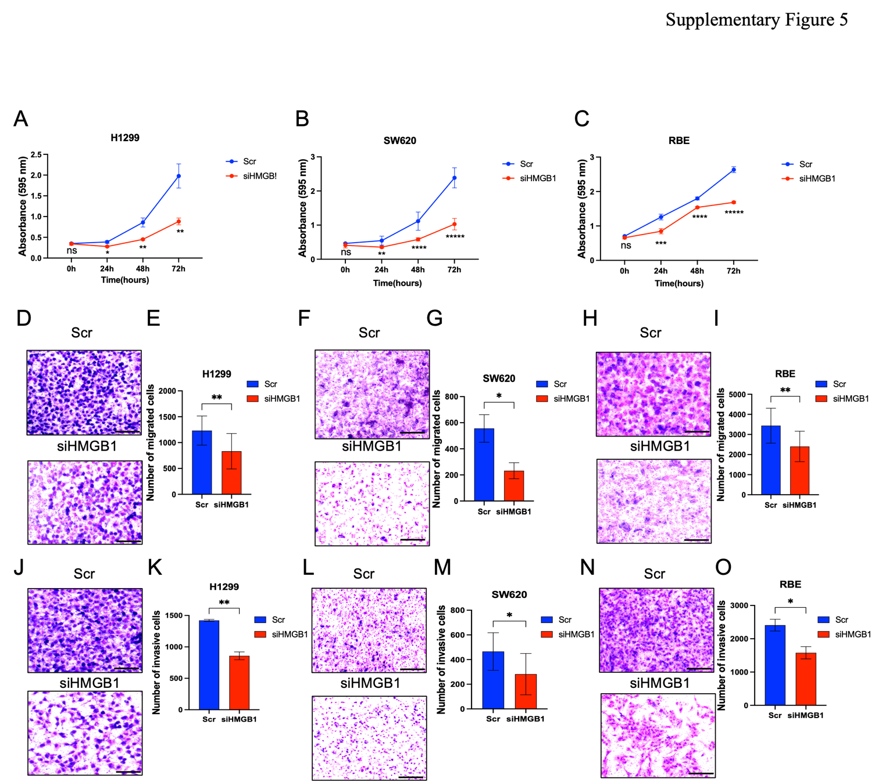

Supplementary Fig.5. HMGB1 regulates proliferation, migration and invasion of NSCLC, colorectal cancer and cholangiocarcinoma cells. A-C, Cell growth measurements at the indicated time points in H1299 (A), SW620 (B) and RBE (C) cells silenced for HMGB1. Silencing of HMGB1 significantly decreases cell growth. P values are calculated by unpaired two-tailed Student’s t tests (* P < 0.05, ** P < 0.01, *** P < 0.001, **** P <0.0001, ***** P < 0.0001). D-I, Transwell migration assay in H1299 (D), SW620 (F) and RBE (H) cells silenced for HMGB1. Representative images are shown. The average number of migrating H1299 (E), SW620 (G) and RBE (I) cells per field of view of n=2 biological replicates is plotted. Significant decrease in the number of migrating cells was observed in HMGB1-silenced cells compared to control cells. P values are calculated by unpaired two-tailed Student’s t tests (* P < 0.05, ** P < 0.01). J-O, Transwell invasion assay in H1299 (J), SW620 (L) and RBE (N) cells silenced for HMGB1. Representative images are shown. The average number of invading H1299 (K), SW620 (M) and RBE (O) cells per field of view of n=2 biological replicates is plotted. Significant decrease in the number of invading cells was observed in HMGB1-silenced cells compared to control cells. P values are calculated by unpaired two-tailed Student’s t tests (* P < 0.05, ** P < 0.01).

Supplementary Methods

Cell cultures

Human dermal skin fibroblasts from explants of skin biopsies were collected from BAP1^{WT} and BAP1^{+/-} carriers, as previously described¹. Fibroblasts were collected from 6 donors of BAP1^{WT} and 6 donors of BAP1^{+/-} matched for sex and age and they were analyzed blinded. Fibroblasts were cultured in Dulbecco modified Eagle’s medium (DMEM) with glucose (4.5 g/L), 2 mM L-glutamine, without sodium pyruvate (Corning Cellgro, Cat# 10-017-CV), supplemented with 10% fetal bovine serum (FBS) (Seradigm, Cat# 1500-500), and 1% penicillin–streptomycin (PS) (Life Technologies, Cat# 15140-163). Primary cell cultures of human mesothelial cells (HM) were derived from pleural fluids accumulated in individuals with congestive heart failure, characterized by immunohistochemistry, and cultured in DMEM with 20% FBS and 1% penicillin–streptomycin (PS)¹. Human embryonic kidney 293 cells (HEK293, ATCC CRL-1573, RRID: CVCL-0045) were cultured in DMEM supplemented with 10% FBS and 1% PS. Mesothelioma cells were grown in DMEM supplemented with 10% FBS and 1% PS ².Cells were routinely tested for Mycoplasma contamination. Short-tandem repeat analyses were performed upon arrival of all cell lines in our laboratory for authentication; positive reauthentication of their identity was performed routinely. Mouse mesothelial cells and mouse mesothelioma cells from Hmgb1^{WT} and Hmgb1^{KO} mice were collected, as previously described ³. Stable human BAP1^{KO} MM cell lines (REN, CVCL_M202) were generated with a CRISPR/Cas9 KO BAP1 plasmid (Santa Cruz, sc-400232-NIC). Stable MM BAP1^{KI} (H2595)² were generated with Myc-BAP1 plasmid (custom made by Blue Heron Biotech).H1299 and RBE cancer cell lines were cultured in Dulbecco modified Eagle’s medium (DMEM) with glucose (4.5 g/L), 2 mM L-glutamine, without sodium pyruvate (Corning Cellgro, Cat# 10-017-CV), supplemented with 10% fetal bovine serum (FBS) (Seradigm, Cat# 1500-500), and 1% penicillin–streptomycin (PS) (Life Technologies, Cat# 15140-163). SW620 cells were cultured in Roswell Park Memorial Institute (RPMI) medium supplemented with 10% fetal bovine serum (FBS) (Seradigm, Cat# 1500-500), and 1% penicillin–streptomycin (PS) (Life Technologies, Cat# 15140-163).

Gene Silencing with siRNA

siRNA oligonucleotides were obtained from Qiagen (cat. no. GS3146). GeneSolution siRNAs targeting four different HMGB1 mRNAs were as follows: Hs_HMGB1_1, cat. no. SI03650374; Hs_HMGB1_2, cat. no. SI02627842; Hs_HMGB1_3, cat. no. SI02627835; Hs_HMGB1_5, cat. no. SI02627828. A nonspecific control siRNA was used as a negative control (cat. no. 1027280). Fibroblast cell cultures and HM were seeded and grown to 50% confluence for 24 hours before gene silencing. Transfection was performed with HiPerfect (Qiagen), using a pool of the four different siRNAs (listed above) at 10nM final concentrations, in 1% FBS medium, for 24 hours.

Adenoviruses

Adenoviruses expressing human HMGB1 (Ad-HMGB1) was purchased from Vector Biolabs, catalogue number ADV-211271, and used per manufacturer’s instructions; Adenoviruses expressing BAP1 and GFP were purchased from SignaGen Laboratories (Ad-BAP1, cat. no. SL175127; Ad-GFP, cat. no. SL100708). Transduction with the indicated adenoviruses was performed in 1% FBS. Cells were seeded and grown to 50% of confluency before the transduction with adenovirus to achieve the optimal results.

Antibodies

The following primary antibodies were used: α-tubulin (4G1) (Santa Cruz Biotechnology Cat# sc- 58666), BAP1 (D7W7O) (Cell Signaling Technology Cat# 13271), BAP1 (C4) (Santa Cruz Biotechnology Cat# sc-28383), GAPDH (Cell Signaling Technology Cat# 5174S), HMGB1 (Abcam Cat# ab79823), HMGB1 (Cell Signaling Technology Cat# 3935), HMGB1 (Abcam Cat# ab18256), IP3R3 (BD Biosciences Cat# 610312), p53 (Santa Cruz Biotechnology Cat# sc126), SMARCA2 (Cell Signaling Technology Cat# 11966S), MLH1 (Cell Signaling Technology Cat# 94645S), ARID1A (Cell Signaling Technology Cat# 12354S), SETD2 (Cell Signaling Technology Cat# 80290S).
Secondary antibodies used were Goat anti-Mouse IgG (H+L) Secondary Antibody, HRP (Thermo Scientific Cat# 32430), Goat anti-Rabbit IgG (H+L) Secondary Antibody, HRP (Thermo Scientific Cat# 32460).

Immunoblotting

Total cell lysates from fibroblast cell cultures, HM, human and mouse MM were prepared in M-PER reagent (Thermo Scientific, #78501) supplemented with proteases and phosphatases inhibitors (2 mM Na3VO4, 2 mM NaF, 50 mM okadaic acid, 1 mM PMSF, and protease inhibitor cocktail), and 1 mM DTT. Protein extracts were quantified using the Bradford assay (BioRad Laboratories); 10 μg of protein per sample was loaded and separated on NuPAGE Novex 4-12% Bis-Tris Gel (Life Technologies), and electron-transferred to PVDF (polyvinylidene difluoride). Membranes were blocked with 5% non-fat dry milk Blotting- Grade Blocker (BIORAD), in Tris-buffered saline (TBS), 0.1% Tween20 (Sigma Aldrich), incubated with primary antibodies over-night at 4° C, then washed and hybridized for 1 hour at room temperature (RT) using the appropriate secondary antibody. The following primary antibodies were used: α-tubulin (4G1) (Santa Cruz Biotechnology Cat# sc- 58666), BAP1 (D7W7O) (Cell Signaling Technology Cat# 13271), GAPDH (Cat# D16H11) (Cell Signaling Technology Cat# 5174S), HMGB1 (Abcam Cat# ab79823), IP3R3 (BD Biosciences Cat# 610312), p53 (Santa Cruz Biotechnology Cat# sc126), SMARCA2 (Cell Signaling Technology Cat# 11966S), MLH1 (Cell Signaling Technology Cat# 94645S), ARID1A (Cell Signaling Technology Cat# 12354S), SETD2 (Cell Signaling Technology Cat# 80290S).

Quantitative PCR

Total RNA was extracted by the RNeasy Plus Mini Kit (Qiagen, Cat# 74134) and quantified by spectrophotometric analysis. qRT-PCR was performed on a StepOnePlus system (Applied Biosystem), using the following commercially available TaqMan Probes (Thermo Fisher Scientific): Hs01590761_g1 HMGB1(Thermo Fisher Scientific_4331182), Hs01109276_g1 BAP1(Thermo Fisher Scientific_4331182), Hs01034249_m1 TP53(Thermo Fisher Scientific_4331182), Hs01014784_m1 SETD2 (Thermo Fisher Scientific_4331182), Hs00195664_m1 ARID1A (Thermo Fisher Scientific_4331182), Hs01030858_m1 SMARCA2 (Thermo Fisher Scientific_4331182), Hs00979919_m1 MLH1 (Thermo Fisher Scientific_4331182), Hs01573555_m1 ITPR3 (Thermo Fisher Scientific_4331182), Hs00153153_m1 HIF1A (Thermo Fisher Scientific_4331182), Hs_00606262_g1 HDAC1 (Thermo Fisher Scientific_4331182), Mm00550845_m1 BAP1(Thermo Fisher Scientific_4331182), Mm00849805_gH mouse HMGB1(Thermo Fisher Scientific_4331182), Mm00508992_m1 Smarca2 (Thermo Fisher Scientific_4331182). Samples were analyzed in triplicate, and mRNA levels were normalized using the geometric mean of two reference genes (18S and β-actin).

Immunofluorescence

BAP1^{WT} fibroblasts, HM, human MM and mouse Hmgb1^{WT} and Hmgb1^{KO} mesothelioma cells were grown on 4-well sterile glass slides (Millicell EZ SLIDE). After 24 hours, cells were fixed using 4% paraformaldehyde in PBS for 10 minutes and washed three times with PBS. Then, cells were permeabilized for 10 minutes with 0.1% Triton X-100 in PBS and blocked in PBS containing 2% BSA and 0.05% Triton X-100 for 1 h. Cells were incubated overnight at 4°C with the indicated antibodies: BAP1 (C4) (Santa Cruz Biotechnology Cat# sc-28383), HMGB1 (Cell Signaling Technology Cat# 3935). After three washes in PBS, cells were incubated for 1 hour at RT with the following secondary antibodies: Alexa Fluor 488 anti-rabbit (Thermo Fisher Scientific Cat# A-11008), 1:1000 or Alexa Fluor 568 anti-mouse (Thermo Fisher Scientific Cat# A-11004), 1:1000. Finally, cells were mounted using Duolink In situ Mounting Medium conjugated with DAPI (Sigma Aldrich, Cat# DUO82040) reagent and imaged at Leica Thunder Live Cell 3D microscope equipped with a 63x objective.

Immunohistochemistry

Mouse formalin-fixed/paraffin-embedded Hmgb1^{WT} and Hmgb1^{KO} mesothelioma tissues were obtained and stained as previously described ³. IHC was conducted using the following antibodies: BAP1 (Bethyl, Cat# A302-242A), HMGB1 (Abcam, Cat# ab3935S). Mice were handled in accordance with the University of Hawaii institutional Animal Care and Use Committee (Protocol 06-032) guidelines.

Growth curves

Cell proliferation was measured using the Crystal Violet assay. MM, H1299, SW620 and RBE cells were seeded in 6- well plates. Then, cells were fixed at the indicated time points using 4% paraformaldehyde in PBS for 10 minutes and washed three times with PBS. Crystal Violet dye (0.1% solution) was added for 15 minutes at RT followed by 3 washes with PBS. Then the Crystal Violet staining was removed by adding a solution of Acetic Acid (10%) for 30 minutes. Finally, absorbance was measured at 595nm.

Luciferase Assay

For transfection, HEK293A (HEK293, ATCC CRL-1573) cells were seeded at1 × 10⁶ cells into 10 cm Petri dishes. Cells were transfected with a Flag-tagged HMGB1 plasmid (Addgene_31609) and a Fla-HA-tagged pcdna (used as negative control) with either a BAP1-luciferase reporter construct, or a CMV-renilla luciferase reporter construct used as control. Luciferase activity was measured using the luciferase reporter assay kits (Promega, E1500 and E2810) 24h after transfection. To generate the luciferase reporter construct, we amplified a 560-bp genomic fragment encompassing the BAP1 promoter (60bp) together with approximately 250 bp upstream and 250 bp downstream of the transcription start site.

Migration and invasion assays

The in vitro cell migration and invasion assays were performed using Costar Transwell permeable
polycarbonate supports (8 μm pores) in 24-well plates (Corning Inc.). For the migration assays, 1 ×10⁵ MM cells in serum-free DMEM were used per well. For the invasion assays, 1 × 10⁵ MM cells in serum-free DMEM were seeded in each well, after the upper compartment was coated with Matrigel. The lower compartment contained serum-free DMEM (negative control) or DMEM plus 10% FBS (positive control). The cells were allowed to migrate to the lower compartment for 24 hours. After the course of the experiment, the migrated cells were fixed on the lower part of the transwell membrane and stained with the Hema 3 Staining Kit (Fisherbrand). The transwells were imaged with the Infinity Capture Digital Microscope camera (Lumenera), and the number of migrated cells was analyzed using ImageJ software.

RNAseq analyses

Total RNA was isolated from BAP1^{WT} and BAP1^{KO} mesothelioma cells using the RNeasy Mini Kit (Qiagen) according to the manufacturer's instructions. RNA concentration and purity were assessed using a NanoDrop spectrophotometer (Thermo Fisher Scientific), and RNA integrity was evaluated using an Agilent Bioanalyzer 2100. Only samples with an RNA integrity number (RIN) ≥ 8 were used for library preparation.RNA-seq libraries were prepared from high-quality total RNA using a poly(A) mRNA enrichment strategy and the Watchmaker Genomics RNA Library Preparation Kit according to the manufacturer's protocol. Libraries were sequenced on an Illumina NextSeq 2000 platform using a P2 100-cycle flow cell to generate single-end 100 bp reads (1 × 100 bp). Raw sequencing reads were subjected to quality control and adapter trimming before alignment to the human reference genome (GRCh38/hg38). Gene-level read counts were generated following alignment, and differential gene expression analysis was performed using DESeq2 in R. Genes with an adjusted P value < 0.05 and an absolute log2 fold change > 1 were considered significantly differentially expressed. Volcano plots were generated in R using shrinkage-adjusted log2 fold changes and −log10-transformed adjusted P values. Functional enrichment analysis was performed separately for significantly upregulated and downregulated genes by over-representation analysis. Gene symbols were converted to Entrez gene IDs with the org.Hs.eg.db annotation package, and all mapped genes from the DESeq2 result table were used as the background universe. KEGG enrichment was performed with clusterProfiler using the human KEGG organism code “hsa,” while WikiPathways enrichment was performed with human WikiPathways gene sets from msigdbr. P values were adjusted using the Benjamini-Hochberg method, and pathways with an adjusted P value < 0.05 were considered significantly enriched. RNA-sequencing data from BAP1^{WT} and BAP1^{KO} REN cells in the NCBI Gene Expression Omnibus (GEO) under accession number GSE344968.

Bioinformatics analyses

The correlation of BAP1 mRNA expression with HMGB1 mRNA expression was performed using The Cancer Genome Atlas (TCGA) Meso Datasets (https://www.portal.gdc.cancer.gov ) and GEO DataSets (https://www.ncbi.nlm.nih.gov/gds). BAP1 and HMGB1 gene expression analysis was performed using The Cancer Genome Atlas (TCGA) Meso Datasets and GTEx Database (https://gtexportal.org/home/) for Normal lung, colon, liver. Graphs were generated using R software.

References

1. Bononi, A., Giorgi, C., Patergnani, S., Larson, D., Verbruggen, K., Tanji, M., Pellegrini, L., Signorato, V., Olivetto, F., Pastorino, S., et al. (2017). BAP1 regulates IP3R3-mediated Ca2+ flux to mitochondria suppressing cell transformation. Nature 546, 549-553. 10.1038/nature22798.
2. Pass, H.I., Stevens, E.J., Oie, H., Tsokos, M.G., Abati, A.D., Fetsch, P.A., Mew, D.J., Pogrebniak, H.W., and Matthews, W.J. (1995). Characteristics of nine newly derived mesothelioma cell lines. Ann Thorac Surg 59, 835-844.
3. Suarez, J.S. (2024). HMGB1 released by mesothelial cells drives the development of asbestos-induced mesothelioma. PNAS.

