Placental Exosomes Mediated Bta-miR-499-Lin28B /let-7 Axis Regulates
Inflammatory Bias during Early Pregnancy
Gan Zhao¹, Chao Yang¹, Jing Yang¹, Pei Liu¹, Kangfeng Jiang¹, Aftab Shaukat¹, Haichong Wu¹, Ganzhen Deng^{1*}
¹ Department of Clinical Veterinary Medicine, College of Veterinary Medicine, Huazhong Agricultural University, Wuhan 430070, People’s Republic of China.

*Corresponding author:
Ganzhen Deng, Professor, Ph.D
College of Veterinary Medicine, Huazhong Agricultural University, Wuhan, 430070, People’s Republic of China.
E-mail: ganzhendeng@sohu.com. Tel: +86 02787282091, Fax: +86 02787282091.

Supplementary Information
Supplementary Figures

Supplementary Fig. 1

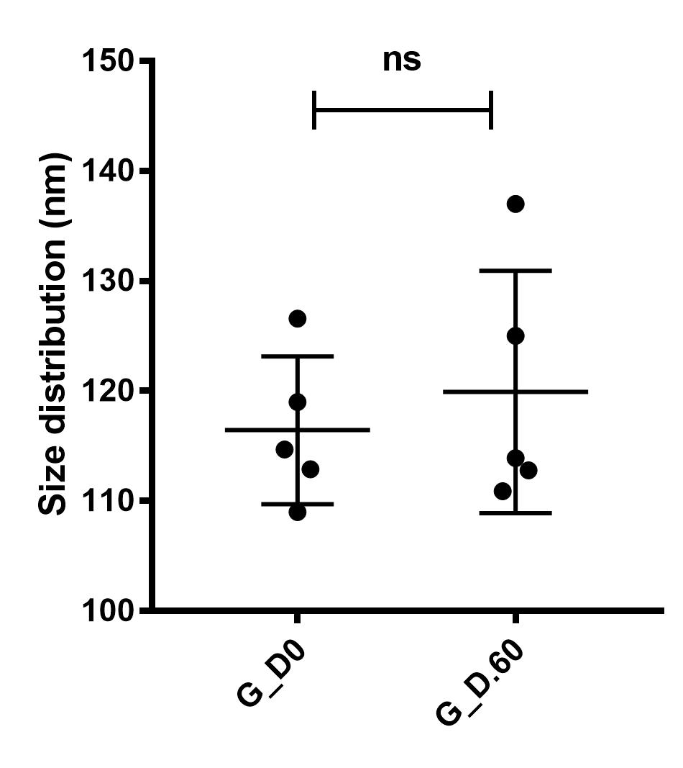

Supplementary Fig 1 Representative size distribution (nm) of exosomes was analyzed using Nanoparticle Tracking Analysis. G_D.0 and G_D.60 represent exosomes from cows at gestational day 0and 60, respectively. Data are presented as the mean±S.E.M (n=5). Two tailed, student t-test,*P<0.05; **P<0.01, ns represents P>0.05.

Supplementary Fig. 2

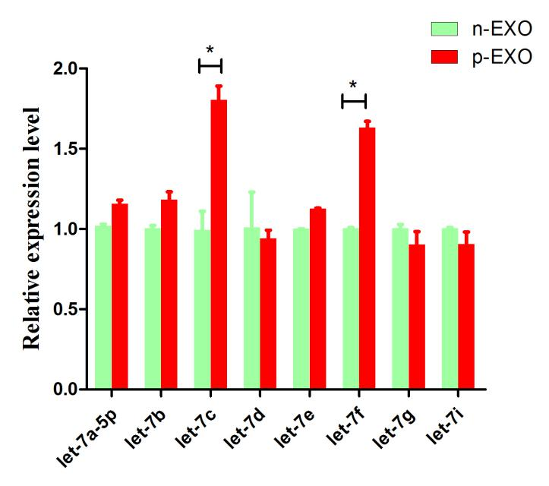
a

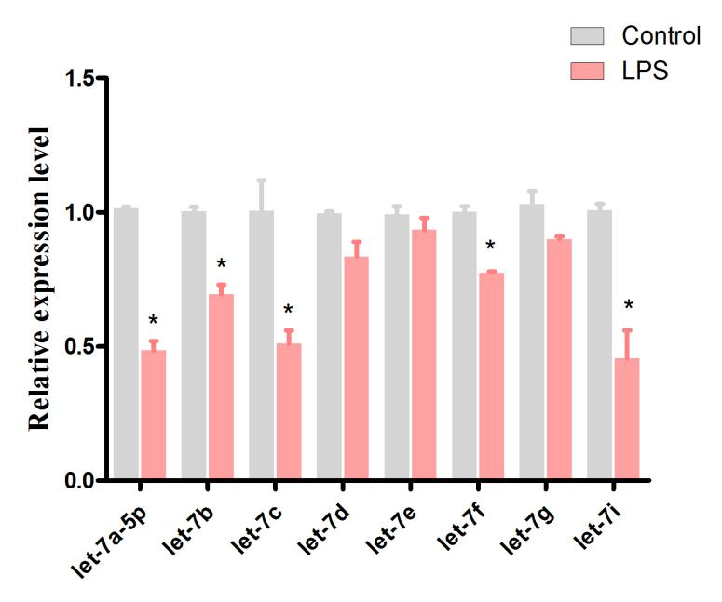
b

Supplementary Fig 2 bta-let-7 miRNA families expression level. (a) BEND cells were treated with non-pregnant (n-EXO) and early pregnant exosomes (p-EXO), and the bta-let-7 miRNA levels were evaluated by qPCR. (b) BEND cells induced by LPS and the bta-let-7 miRNA levels were evaluated by qPCR. U6 was used as control. Each experiment was performed in triplicate and data are presented as mean ± S.E.M. Student’s t test was used to analyze the data. (*p<0.05; **p<0.01)

miRNA ID | Accession Number | Primer sequence (5'-3')
bta-let-7a-5p | MIMAT0003844 | TCGGCAGGTGAGGTAGTAGGTTGTATA
bta-let-7b | MIMAT0004331 | TCGGCAGGTGAGGTAGTAGGTTGTGTG
bta-let-7c | MIMAT0004332 | GGCGGTGAGGTAGTAGGTTGTATG
bta-let-7d | MIMAT0003810 | TCGGCAGGAGAGGTAGTAGGTTGCATA
bta-let-7e | MIMAT0004333 | TCGGCAGGTGAGGTAGGAGGTTGTATAGT
bta-let-7f | MIMAT0003519 | TCGGCAGGTGAGGTAGTAGATTGTATA
bta-let-7g | MIMAT0003838 | TCGGCAGGTGAGGTAGTAGTTTGTACA
bta-let-7i | MIMAT0003851 | TCGGCAGGTGAGGTAGTAGTTTGTGCT
bta-miR-206 | MIMAT0009260 | GGCGGTGGAATGTAAGGAAGTGTG
bta-miR-133a | MIMAT0009225 | GGCGGTTTGGTCCCCTTCAACCA
bta-miR-499 | MIMAT0003536 | GGCGGTTAAGACTTGCAGTGAT
bta-miR-133b | MIMAT0009226 | GGCGGTTTGGTCCCCTTCAACCAG
bta-miR-184 | MIMAT0009246 | TCGGCAGGTGGACGGAGAACTGATAA
bta-miR-182 | MIMAT0009244 | GGCGGTTTGGCAATGGTAGAACTCA
bta-miR-429 | MIMAT0009315 | GGCGGTAATACTGTCTGGTAATGCCGT
bta-miR-200c | MIMAT0003823 | TCGGCAGGTAATACTGCCGGGTAATGA
bta-miR-96 | MIMAT0009388 | GGCGGTTTGGCACTAGCACATTTT
bta-miR-146b | MIMAT0009235 | GGCGGTGAGAACTGAATTCCATAGGC
bta-miR-499 | MIMAT0003536
mmu-miR-499-5p | MIMAT0003482
miR-499 | RT-primer | CTCAACTGGTGTCGTGGAGTCGGCAATTCAGTTGAGAAACATCA
miR-499 | F： | GCCGAGTTAAGACTTGCAG
miR-499 | R： | CTCAACTGGTGTCGTGGA
U6 | F： | CTCGCTTCGGCAGCACATATACT
U6 | R： | ACGCTTCACGAATTTGCGTGTC
Supplementary table 1 MiRNA primers design.

Supplementary table 2 Oligonucleotide primers used for qPCR.
Species | Name | Accession Number | Primer sequence (5'-3') | Product size
Mouse | Lin28B | NM_001031772.2 | F:TGGCACTGGCCACTGTAAAT | 199 bp
Mouse | Lin28B | NM_001031772.2 | R:CTCAAGGCCTTTGGGGGATT | 199 bp
Mouse | TNF-α | NM_013693.3 | F:CTTCTCATTCCTGCTTGTG | 198 bp
Mouse | TNF-α | NM_013693.3 | R:ACTTGGTGGTTTGCTACG | 198 bp
Mouse | IL-6 | NM_031168.1 | F:GGCGGATCGGATGTTGTGAT | 199 bp
Mouse | IL-6 | NM_031168.1 | R:GGACCCCAGACAATCGGTTG | 199 bp
Mouse | GAPDH | NM_001289726.1 | F:CAATGTGTCCGTCGTGGATCT | 124 bp
Mouse | GAPDH | NM_001289726.1 | R:GTCCTCAGTGTAGCCCAAGATG | 124 bp
Bovine | TNF-α | NM_173966.3 | F:CTCCTTCCTCCTGGTTGCAG | 92 bp
Bovine | TNF-α | NM_173966.3 | R:CACCTGGGGACTGCTCTTC | 92 bp
Bovine | IL-6 | NM_173923.2 | F:CTACCTCCAGAACGAGTATG | 136 bp
Bovine | IL-6 | NM_173923.2 | R:CAGCAGGTCAGTGTTTGTGG | 136 bp
Bovine | GAPDH | NM_001034034.2 | F:GGTCACCAGGGCTGCTTT | 128 bp
Bovine | GAPDH | NM_001034034.2 | R:CTGTGCCGTTGAACTTGC | 128 bp

Supplementary table 3 SiRNA sequence design.
SiRNA | Sequence (5'-3')
LIN28B-siRNA1 | GGGAGUCCCUGUUUAGGAATT
LIN28B-siRNA1 | UUCCUAAACAGGGACUCCCTT
LIN28B-siRNA2 | GCCUUGAUCAUCAUGCUAATT
LIN28B-siRNA2 | UUAGCAUGAUGAUCAAGGCTT
LIN28B-siRNA3 | GCACAGCUGUACAUCAUUUTT
LIN28B-siRNA3 | AAAUGAUGUACAGCUGUGCTT
NRAS-siRNA1 | GCACUGACAAUCCAGCUAATT
NRAS-siRNA1 | UUAGCUGGAUUGUCAGUGCTT
NRAS-siRNA2 | CCAUGAGAGACCAAUACAUTT
NRAS-siRNA2 | AUGUAUUGGUCUCUCAUGGTT
NRAS-siRNA3 | GCCAACAAGGACAGUUGAUTT
NRAS-siRNA3 | AUCAACUGUCCUUGUUGGCTT
si-NC | UUCUCCGAACGUGUCACGUTT
si-NC | ACGUGACACGUUCGGAGAATT

