Supplemental documents:

JAZF1 ameliorates age- and diet-associated hepatic steatosis through SREBP-1c–dependent mechanism

Running title: JAZF1 regulates lipid metabolism

Qin Wei^{1#}, Baoyong Zhou^{3#}, Gangyi Yang², Wenjing Hu¹, Lily Zhang¹, Rui Liu¹, Minyan Li²,Kuan Wang¹, Harvest F. Gu^{4,5}, Youfei Guan⁶, Zhiming Zhu⁷, Hongting Zheng⁸, Jun Peng⁶, Ling Li^{1*},

Fig. S1 Hepatic JAZF1 is down-regulated in human NAFLD and obesity-related mice
27KD
43KD
43KD
27KD
JAZF1 mRNA (A) and protein (B) expression levels in the liver of SD or HFD-fed C57BL/6J, Adipoq KO and db/db mice (n = 5 for each group). JAZF1 mRNA(C) and protein (D) expression in the liver of NAFLD patients and healthy subjects (n =10 for each group). Data are expressed as mean ± SD. *P < 0.05, **P < 0.01 compared with SD-fed C57BL/6J mice or healthy subjects. #P < 0.05,## P < 0.01 compared with SD-fed ADI KO mice. ▲P <0.01 compared with HFD-fed C57BL/6J mice.

Fig. S2 HFD-induced inflammation and fibrosis are attenuated in JAZF1-Tg mice

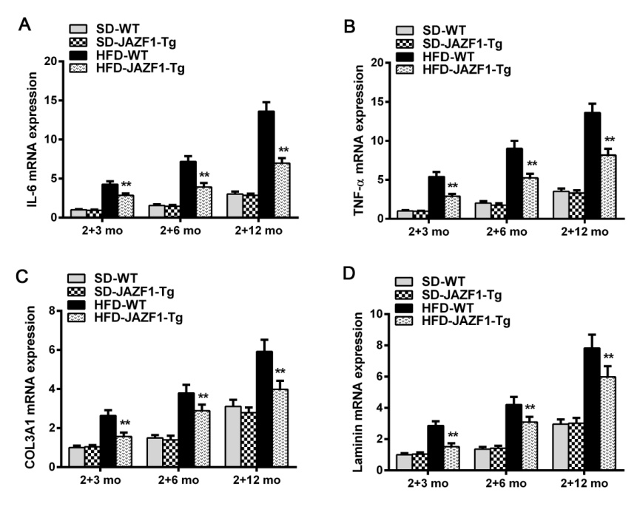
Data are presented as the means ± SD and demonstrate mRNA expression levels of the genes encoding for IL-6 (A), TNFα (B), COL3A1(C) and Laminin (D) in the liver of WT and JAZF1-Tg mice fed with SD or HFD as indicated (n=3); ** P <0.01 vs. HFD-WT mice.

Fig. S3 Schematic diagram for the mechanism of JAZF1 in the inhibition of hepatosteatosis
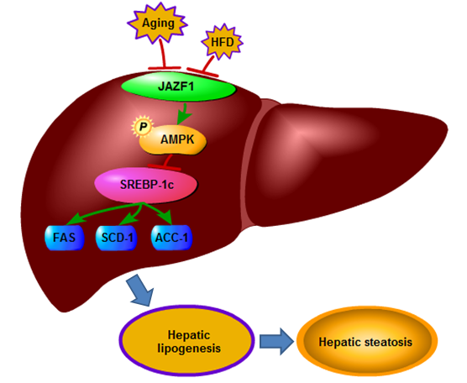

Table S1 Metabolic parameters in SD-fed animals
Parameters | WT |  |  |  | JAZF1-Tg
Parameters | 2+3 mo | 2+6 mo | 2+12 mo | 2+3 mo | 2+6 mo | 2+12 mo
Body weight (g) | 29.9 ± 0.5 | 31.8 ± 0.5## | 31.9 ± 0.6## | 29.0 ± 0.3 | 31.5 ± 0.1## | 31.5 ± 0.2##
Liver weight (g) | 1.2 ± 0.06 | 1.3 ± 0.08# | 1.4 ± 0.05## | 1.2 ± 0.04 | 1.3 ± 0.09## | 1.3 ± 0.05##
Abdominal fat (g) | 0.6 ± 0.05 | 0.8 ± 0.2# | 0.8 ± 0.08## | 0.5 ± 0.05 | 0.7 ± 0.1# | 0.7 ± 0.08#
FBG (mmol/L) | 5.8 ± 0.7 | 6.8 ± 0.9 | 9.1 ± 0.8## | 5.7 ± 0.8 | 6.2 ± 1.5 | 8.7 ± 0.8##
Cholesterol (mmol/L) | 2.8 ± 0.4 | 3.4 ± 0.2# | 3.7 ± 0.5# | 2.7 ± 0.4 | 3.2 ± 0.5 | 3.1 ± 0.5*
Triglyceride (mmol/L) | 0.5 ± 0.06 | 0.7 ± 0.1## | 0.8 ± 0.2## | 0.5 ± 0.08 | 0.5 ± 0.1* | 0.7 ± 0.1*#
FFA (mmol/L) | 0.5 ± 0.07 | 0.9 ± 0.1## | 0.7 ± 0.2# | 0.4 ± 0.1 | 0.9 ± 0.1## | 0.6 ± 0.2#
HDL-C (mmol/L) | 1.1 ± 0.2 | 1.3 ± 0.4 | 1.2 ± 0.2 | 1.1 ± 0.3 | 1.1 ± 0.2 | 1.1 ± 0.3
LDL-C (mmol/L) | 0.2 ± 0.03 | 0.3 ± 0.1 | 0.3 ± 0.06 | 0.2 ± 0.05 | 0.1 ± 0.05** | 0.2 ± 0.03#
ALT (U/L) | 31.6 ± 5.0 | 67.4 ± 5.3## | 86.7 ± 15.1## | 30.2 ± 4.1 | 45.4± 4.9**## | 52.8 ± 11.9**##
AST (U/L) | 57.7 ± 9.3 | 69.6 ± 4.8# | 105.0 ± 11.9## | 46.6 ± 7.0 | 66.7 ± 6.2## | 83.4 ± 11.7**##

SD, standard diet; FBG, fasting blood glucose; FFA, free fatty acid; HDL-C, high-density lipoprotein cholesterol; LDL-C, low-density lipoprotein cholesterol; ALT, Alanine transaminase; AST, aspartate transaminase. Data are presented as means ± SD. *P < 0.05, **P < 0.01 vs. age-matched WT mice; #P < 0.05,##P < 0.01 vs. 2+3 month-fed mice. (n = 5 for each group)

Table S2 Metabolic parameters in HFD-fed animals
Metabolic parameters | WT |  |  |  | JAZF1-Tg
Metabolic parameters | 2+3 mo | 2+6 mo | 2+12 mo | 2+3 mo | 2+6 mo | 2+12 mo
Body weight (g) | 33.1 ± 0.4 | 39.7 ± 0.6## | 52.4 ± 0.9## | 30.7 ± 0.2** | 33.1 ± 0.3**## | 39.0 ± 1.2**##
Liver weight (g) | 1.4 ± 0.03 | 1.5 ± 0.07## | 2.0 ± 0.1## | 1.3 ± 0.05** | 1.4 ± 0.1**# | 1.5 ± 0.07**##
Abdominal fat (g) | 1.3 ± 0.1 | 2.0 ± 0.3## | 3.8 ± 0.5## | 0.8 ± 0.08** | 1.1 ± 0.2**# | 1.9 ± 0.3**##
FBG (mmol/L) | 8.7 ± 0.8 | 10.8 ± 1.8# | 17.5 ± 1.7## | 7.0 ± 0.8** | 7.4 ± 0.7** | 11.6 ± 1.9**##
Cholesterol (mmol/L) | 4.4 ± 0.7 | 5.3 ± 0.7 | 5.5 ± 0.8# | 3.6 ± 0.5* | 4.2 ± 0.1**# | 3.9 ± 0.3**
Triglyceride (mmol/L) | 0.8 ± 0.2 | 1.1 ± 0.2## | 1.4 ± 0.2## | 0.7 ± 0.2 | 0.9 ± 0.1** | 0.9 ± 0.1**#
FFA (mmol/L) | 0.8 ± 0.1 | 1.3 ± 0.1## | 1.4 ± 0.3## | 0.7 ± 0.08 | 1.1 ± 0.1*## | 1.1 ± 0.3*#
HDL-C (mmol/L) | 1.5 ± 0.3 | 2.2 ± 0.5# | 1.9 ± 0.2# | 2.0 ± 0.2** | 1.4 ± 0.4**# | 1.5 ± 0.2*##
LDL-C (mol/L) | 0.3 ± 0.06 | 0.4 ± 0.1 | 0.5 ± 0.1# | 0.2 ± 0.05* | 0.2 ± 0.04** | 0.3 ± 0.08*#
ALT (U/L) | 52.4 ± 9.1 | 165.1 ± 10.3## | 242.3 ± 62.7## | 38.8 ± 7.4** | 58.9 ± 7.4**## | 122.1 ± 19.8**##
AST (U/L) | 79.2 ± 9.1 | 172.5 ± 14.2## | 273.6 ± 74.5## | 53.4 ± 7.5**## | 81.5 ± 9.1**## | 114.8 ± 15.6**##

HFD, high fat diet; FBG, fasting blood glucose; FFA, free fatty acid; HDL-C, high-density lipoprotein cholesterol; LDL-C, low-density lipoprotein cholesterol; ALT, Alanine transaminase; AST, aspartate transaminase. Data are presented as means ± SD. n = 5 for each group. * P < 0.05, **P < 0.01 vs. age-matched WT mice, #P < 0.05, ##P < 0.01, vs. 2+3 month-fed mice.

Table S3 Clinical and metabolic features of subjects with JAZF1 expression analysis
Control (N=10) NAFLD (N=10)
Age (years) 52.0 ± 14.6 54.1 ± 11.7
BMI (kg/m²) 20.8 ± 2.8 24.7 ± 3.6*
ALT (U/L) 33.3 ± 21.6 46.2 ± 23.0*
AST (U/L) 28.7 ± 12.4 34.9 ± 13.3*
ALP (U/L) 114.6 ± 41.3 100.3 ± 50.6
Grade of steatosis
Grade 0 10 (100%)
Grade 1 6 (60%)
Grade 2 4 (40%)

Data are expressed as mean ± SD. *P < 0.05, **P < 0.01. BMI, body mass index; ALT, Alanine transaminase; AST, aspartate transaminase; ALP, Alkaline phosphatase.

Table S4 Primers used for SREBP-1c promoter recombinant plasmids
Promoter regions | Primers
-574/+42 F | 5' -CCGCTCGAGGGATCCAGAACTGGATCATCAGCCCC-3'
R | 5' -CCCAAGCTTCCTAGGGCGTGCAGACGCTACCCCG-3'
-381/+42 F | 5' -CCGCTCGAGAAATGGTCCAGGCAAGTTCTGGGTG-3'
R | 5' -CCCAAGCTTCCTAGGGCGTGCAGACGCTACCCCG-3'
-212/+42 F | 5' -CCGCTCGAGGCGCTGGCGCAGACGCGGTTAAAGG-3'
R | 5' -CCCAAGCTTCCTAGGGCGTGCAGACGCTACCCCG-3'
-118/+42 F | 5' -CCGCTCGAGTGGGCGGGGCCCTAATGGGGCGCGG-3'
R | 5' -CCCAAGCTTCCTAGGGCGTGCAGACGCTACCCCG-3'
-50/+42 F | 5' -CCGCTCGAGCACGGAGGCGATCGGCGGGCTTTA-3'
R | 5' -CCCAAGCTTCCTAGGGCGTGCAGACGCTACCCCG-3'

Table S5 Primers used for site-directed mutation
Plasmid | Primers
mut LXRE1 F | 5'-GGGTTGGGACGACAGCCCGGGATCCACCAATCAGCGCGCGCTGGCG-3'
R | 5' -CGCCAGCGCGCGCTGATTGGTGGATCCCGGGCTGTCGTCCCAAC-3'
mut LXRE2 F | 5'-GCGGTTAAAGGCGGACCCGGGATCCACCAATCGGCCCCATTCAGAGC-3'
R | 5' -GCTCTGAATGGGGCCGATTGGTGGATCCCGGGTCCGCCTTTAACC-3'

Table S6 Specific primers used for RT-PCR analyses
Gene Species Primer Sequence
JAZF1 Mus musculus F 5'-CCACTCCACCTCGACATA-3'
R 5'-CCACCTCTTCCTCATCATAC-3'
SREBP-1c Mus musculus F 5'-CAAGGCCATCGACTACATCCG-3'
R 5'-CACCACTTCGGGTTTCATGC-3'
SCD-1 Mus musculus F 5'-TGATGTTCCAGAGGAGGTA-3'
R 5'-CCAGAGTGTATCGCAAGAA-3'
PPAR-α Mus musculus F 5'-TGCCTTAGAACTGGATGAC-3'
R 5'-ATCTGGATGGTTGCTCTG-3'
ACC-1 Mus musculus F 5'-AGCAGTTACACCACATACAT-3'
R 5'-GTCATCACCATCTTCATTACC-3'
FAS Mus musculus F 5'-CTCATCCACTCAGGTTCAG-3'
R 5'-AGGTATGCTCGCTTCTCT-3'
CPT-1 Mus musculus F 5'- AGCCAGACGAAGAACATC-3'
R 5'-CCTTGACCATAGCCATCC-3'
IL-6 Mus musculus F 5'- TAGTCCTTCCTACCCCAATTTCC-3'
R 5'- TTGGTCCTTAGCCACTCCTTC-3'
TNF-α Mus musculus F 5'- GATCGGTCCCCAAAGGGATG-3'
R 5'- TGAGGGTCTGGGCCATAGAA-3'
COL3A1 Mus musculus F 5'- CCCACAGCCTTCTACACCT-3'
R 5'- CCCATTCCTCCCACTCC-3'
Laminin Mus musculus F 5'- TCCGTACTACCTCTAAGAAT-3'
R 5'- GATAGCCACCCACATAA-3'
β-actin Mus musculus F 5'-AAGACCTCTATGCCAACAC-3'
R 5'-CTGCTTGCTGATCCACAT-3'
JAZF1 Homo sapiens F 5'-CGAGTATGACGAGGAGGA-3'
R 5'-GTTCTGTGACCATTCTTAGC-3'
SREBP-1a Homo sapiens F 5'-TCAGCGAGGCGGCTTTGGAGCAG-3'
R 5'-CATGTCTTCGATGTCGGTCAG-3'
SREBP-1c Homo sapiens F 5'-GGAGCCATGGATTGCACTTT-3'
R 5'-TCAAATAGGCCAGGGAAGTCA-3'
FAS Homo sapiens F 5'-GTCCACCAGCAACATCAG-3'
R 5'-TTCTCCAGCAAGCCATCT-3'
SCD-1 Homo sapiens F 5'-CGATATGCTGTGGTGCTTA-3'
R 5'-AAGGAGTGGTGGTAGTTGT-3'
ACC-1 Homo sapiens F 5'-AACCACATCTTCCTCAACTT-3'
R 5'-ACTTCCATACCGCATTACC-3'
β-actin Homo sapiens F 5'-AGACCTCTATGCCAACACAGT-3'
R 5'-TCGTACTCCTGCTTGCTGAT-3'

