Supplemental Information
Supplemental Materials and Methods

Materials: Cariporide (HOE-642) and TMZ were purchased from Sigma Chemicals (St. Louis, MO). Dulbecco’s Modified Eagle Medium (DMEM/HEPES, Cat #12430-054) and Penicillin/streptomycin (Cat #15240062) were from Gibco (Carlsbad, CA). Fetal bovine serum (FBS) and G418 sulfate were obtained from Invitrogen (Carlsbad, CA). Anti-mouse PD-1 (Cat #BE0146) and isotype IgG2a were from BioXCell (West Lebanon, NH). Rabbit antibody against Ki67 (Cat #9129S), rabbit antibody against cleaved caspase-3 (Cat #9661S) and rabbit antibody against β-actin (Cat #4970S) were from Cell Signaling (Beverly, MA). Rabbit antibody against NHE1 (Cat #ab67314) and rat antibody against CD8 (Cat #ab22378) were from Abcam Ltd (Cambridge, MA). Mouse antibody against NHE1 (Cat #sc-136239) was from Santa Cruz Biotechology (Dallas, TX). APC-CD11b, BV510-CD45, PE-Cy5 CD8a, APC/Cy7-CD4, PE-FoxP3, PE-PD-1, APC-CD25 and PE-Cy7-CTLA-4 were obtained from Biolegend. APC-IFNγ and eFluor 450-CD16/32 were purchased from eBioscience and PE-Ym1 (clone EPR15263) was from Abcam. The BrdU Cell Proliferation Assay kit (Cat #2752) was from Millipore (Billerica, MA). Proximity ligation assay (PLA) probe with anti-Rabbit PLUS and anti-Mouse MINUS kit (Cat #DUO920002/DUO92004-100RXN) was from Sigma (St. Louis, MO). BCA Protein Assay Kit (Cat #23227) was from Thermo Scientific (Rockford, IL).
Immunostaining image analysis: Confocal images of immunofluorescence-stained brain sections (25 μm) were acquired with a Leica DMIRE2 inverted confocal laser scanning microscope, using a 40x objective, identical pinhole, intensity, and exposure parameters were applied for all the images to be compared. Images were computer processed in Image J (National Institutes of Health), Adobe photoshop CC and Adobe illustrator softwares. Background intensity in each original image was subtracted using Image J software as described previously ¹.
Cell counting: In a blinded manner, positively stained cells (Ki67, CD-8, or Caspase-3) were counted in the tumor or in the tumor border of coronal brain sections (n=4) using ImageJ Cell Counter plugin. The positive puncta signals localized to the cytoplasma were counted for the Ki67, CD-8 and Caspase-3 positive immunosignals. For negative controls, brain sections were stained with isotype control antibodies followed by respective secondary antibodies. In each section, 3-4 randomly selected fields were analyzed and averaged per brain section. The number of cells that were positively stained with anti-Ki67, anti-CD-8, or anti-caspase-3 in each area was normalized and expressed as a percentage of immunolabeled cells relative to the total number of cells assessed by TO-PRO-3 in each area.
Fluorescence intensity quantification: To quantify NHE1 protein expression, representative images from 3-4 regions per brain section (n=5) were taken under identical camera and microscope settings. For every image, the mean intensity values were measured using Image J software.

NHE1 full-length blot of SB28 glioma cells for Figure 1C
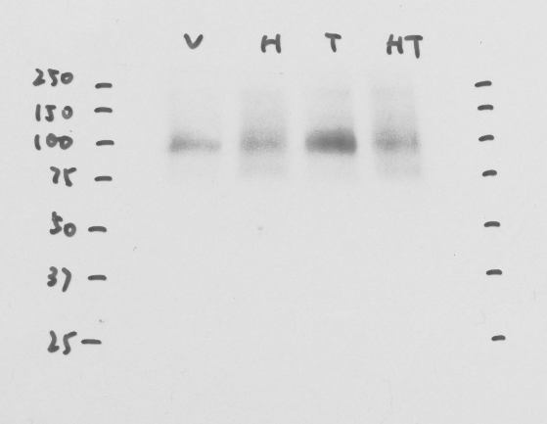

β-actin full-length blot of SB28 glioma cells for Figure 1C
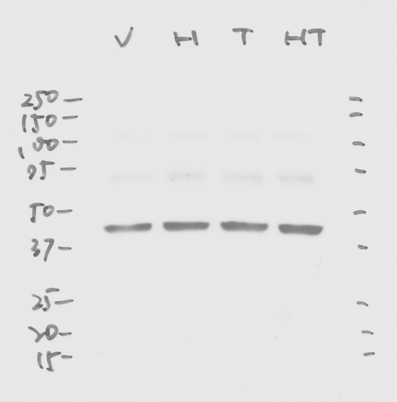

Fig. S1. Western blot supplementary materials for Figure 1C.
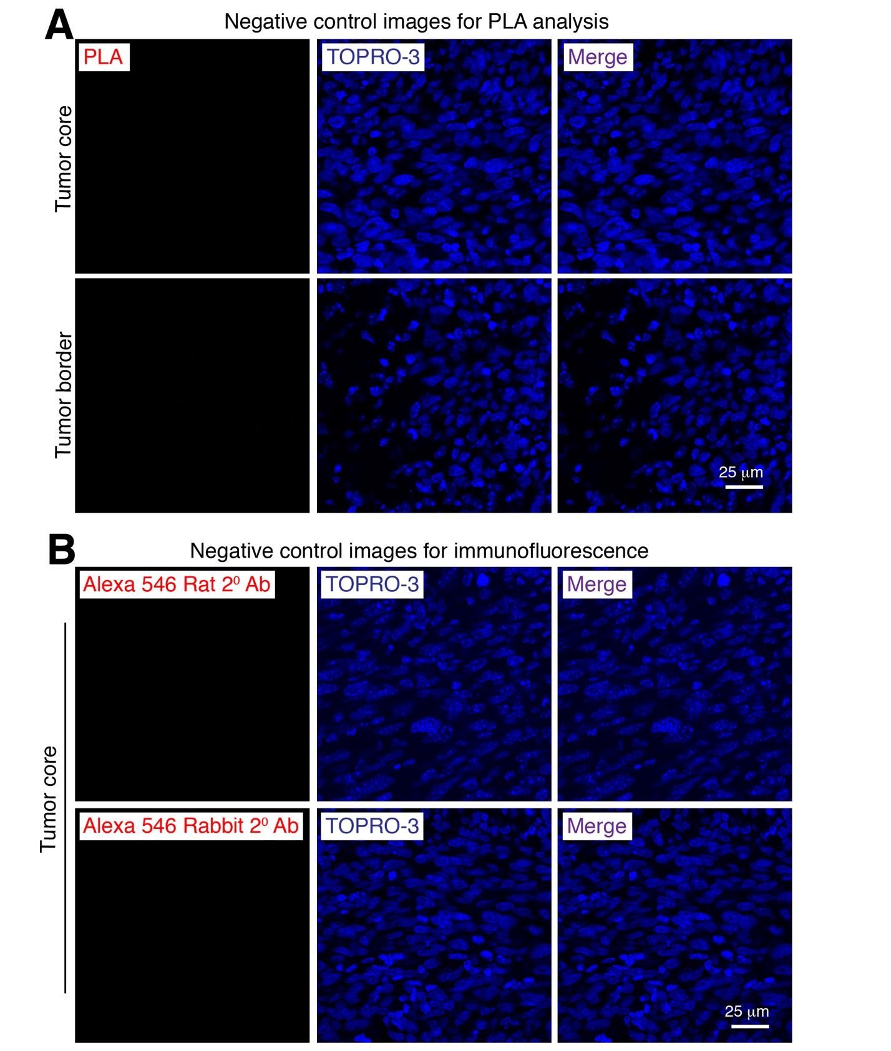
Fig. S2. Representative negative control images
A. Brain sections were incubated with primary anti-MMP9 antibody alone at 4ºC overnight followed by incubation with anti-rabbit PLA MINUS and anti-mouse PLA PLUS secondary probes. All other steps were similar to the double-antibody labeling in PLA as described in Methods section.
B. Representative images of isotype negative controls for NHE1, Ki67, cleaved caspase-3, and CD8 staining. Brain sections were incubated with isotype anti-rabbit IgG control (NHE1, Ki67, and cleaved caspase-3) or isotype anti-rat IgG2b control (CD8) at 4ºC overnight followed by incubation with secondary antibody (Alexa 546 rabbit secondary or Alexa 546 rat secondary antibody).

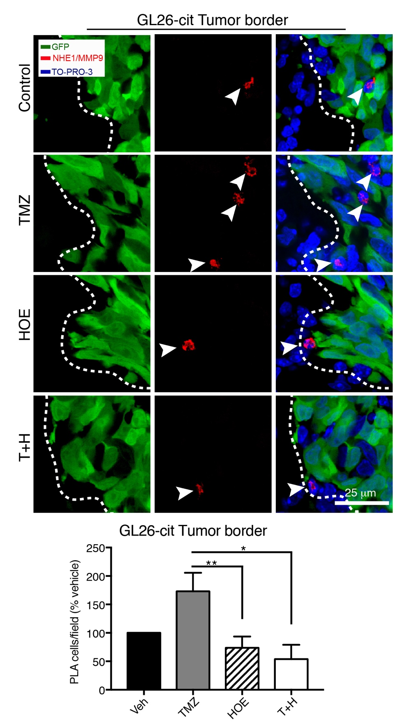
Fig. S3. Proximity ligation assay for NHE1-MMP9 interactions in brain tumor tissues
Representative confocal images of GFP and PLA immunofluorescence signal (arrow head) near the tumor border (dashed lines) in mice transplanted with GL26-Cit cells. Summary data of PLA⁺ positive cells were expressed as % of vehicle control. Data are means ± SEM (n=6-7). * p < 0.05; ** p < 0.01.

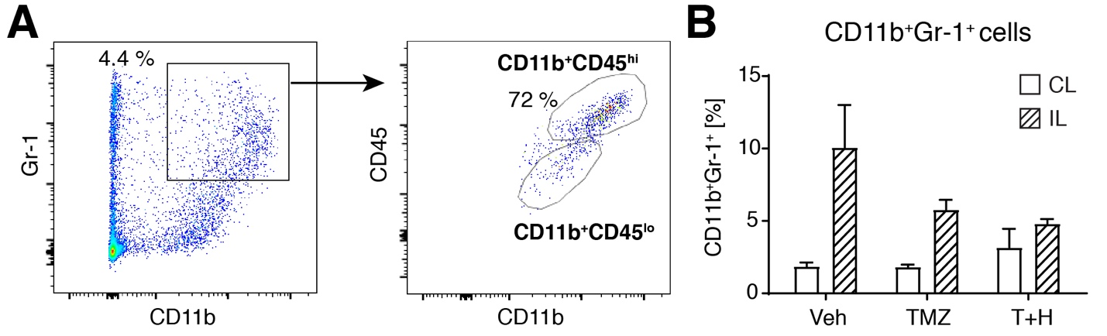
Fig. S4. Myeloid-derived suppressor cells within CD11b⁺CD45^{hi} population.
A. Representative flow cytometric profile illustrating gating of CD11b⁺/Gr-1⁺ and CD11b⁺/CD45^{hi} population. B. Percentage of myeloid derived suppressor cells (CD11b⁺/Gr-1⁺) in non-tumor bearing contralateral (CL) hemispheres and ipsilateral SB28 tumor tissues (IL) from mice treated with Veh (PBS-DMSO), TMZ and T+H (as described in Fig. 6). All data are mean ± SEM, n=2.
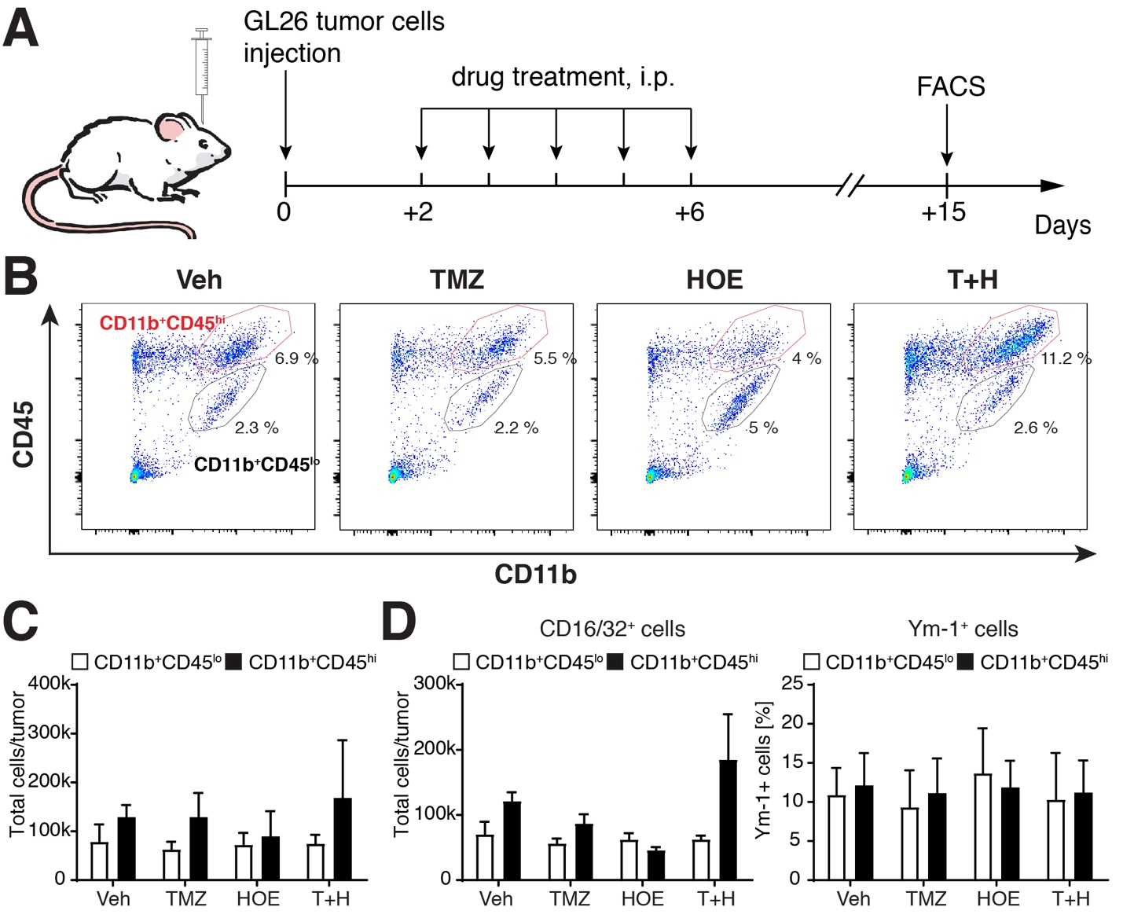

Fig. S5. Effects of NHE1 blockade in combination with TMZ treatment on anti-tumor pro-inflammatory TAMs of GL26 tumors
A. Mice received either Veh (PBS-DMSO), HOE642, TMZ or T+H combination treatments for 5 consecutive days. Mice were sacrificed at 15 d.p.i. and flow cytometric analysis of tumor tissues was performed. B. Representative flow cytometric profile showing gating strategy of microglia (CD11b⁺/CD45^{lo-med}) and infiltrating myeloid cells (CD11b⁺/CD45^{hi}). C. Total number of microglia and infiltrating myeloid cells. D. Inflammatory profile of CD11b⁺/CD45^{lo} and CD11b⁺/CD45^{hi} cells. All data are mean ± SEM, n=3.

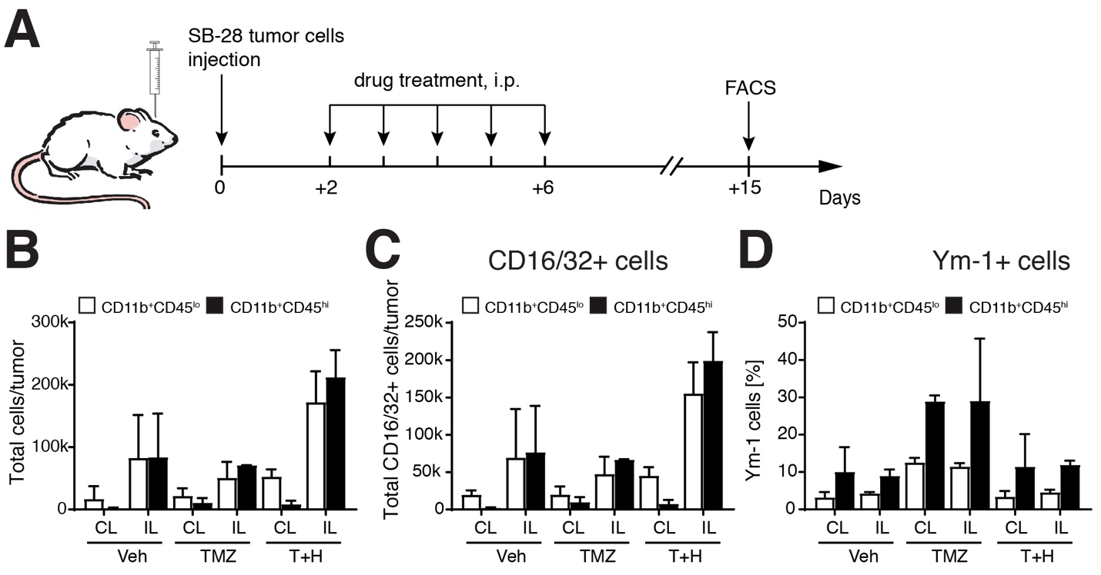
Fig. S6. Effects of treatments on immune cells from non-tumor brain tissues
A. Mice received either Veh (PBS-DMSO), HOE642, TMZ or T+H combination treatments for 5 consecutive days as described before. Mice were sacrificed at 15 d.p.i. and flow cytometric analysis was performed. B. Total number of microglia (CD11b⁺/CD45^{lo}) and infiltrating myeloid cells (CD11b⁺/CD45^{hi}) in non-tumor contralateral (CL) hemisphere tissues and ipsilateral (IL) tumor tissues. C, D. Inflammatory profiles of microglia and infiltrating myeloid cells. All data are mean ± SEM, n=2.

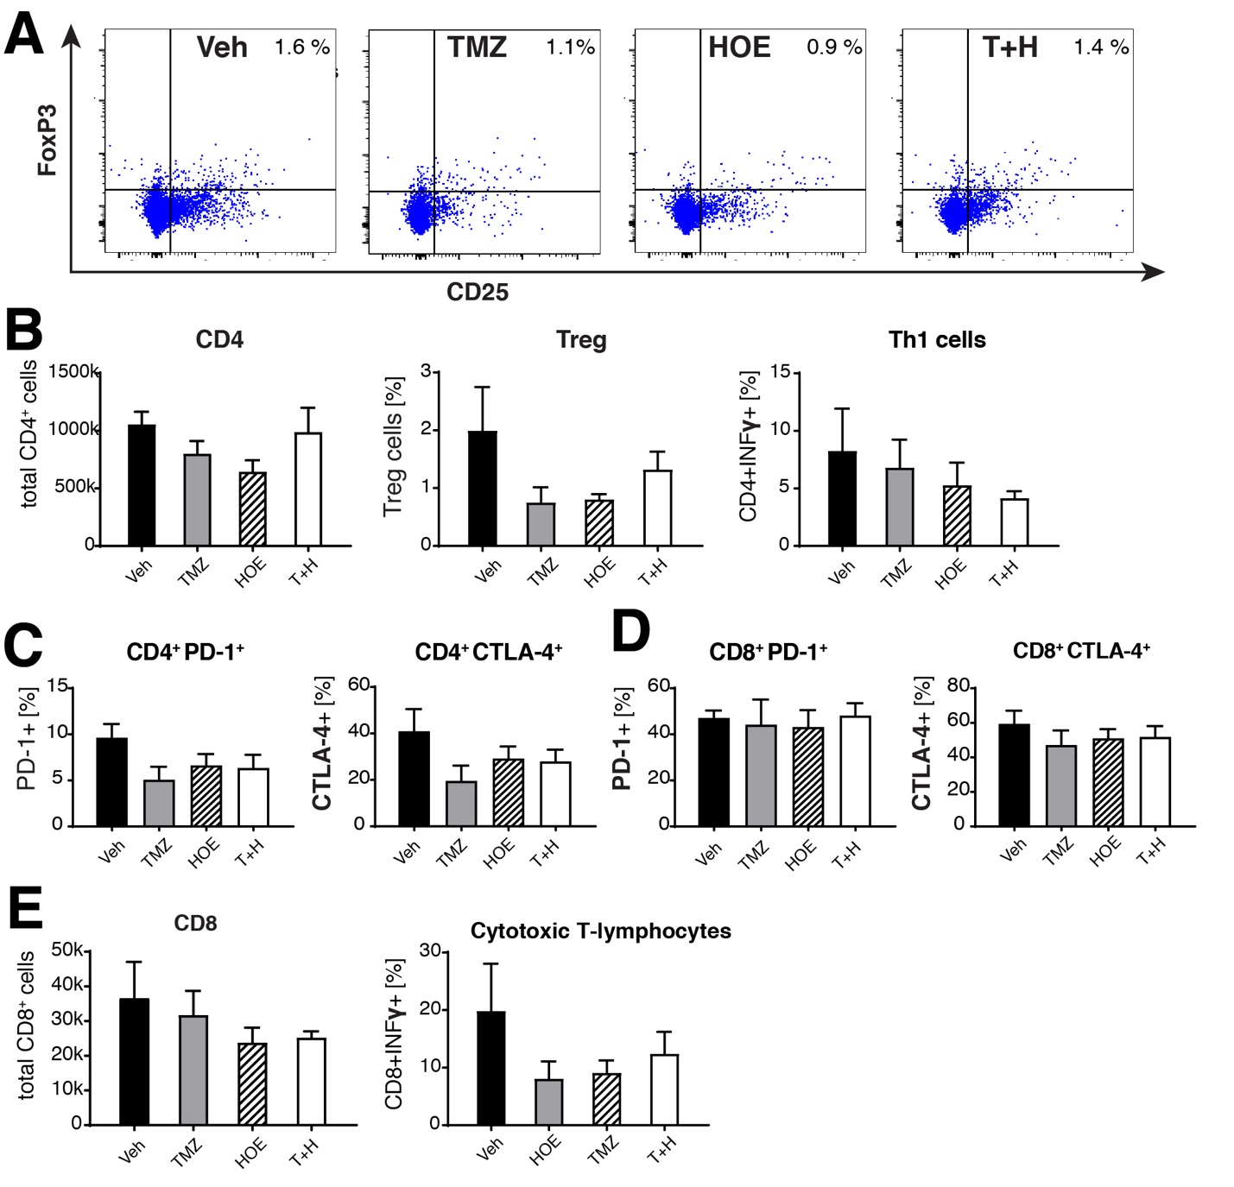
Fig. S7. Flow cytometric profiles of T cells in GL26 glioma
A. Representative flow cytometric profile of CD4⁺CD25⁺FoxP3⁺ (Treg). B. Total CD4⁺ T cell counts and percentage of CD4⁺IFNγ⁺ and Treg cells within CD4⁺ population. C. Percentage of PD-1 and CTLA4 expression in CD4⁺ T cell population. D. Percentage of PD-1 and CTLA4 expression in CD8⁺ T cell population. E. Total CD8⁺ T cell counts and percentage of IFNγ⁺ cells in CD8⁺ population. Data are mean ± SEM, n=5-7.

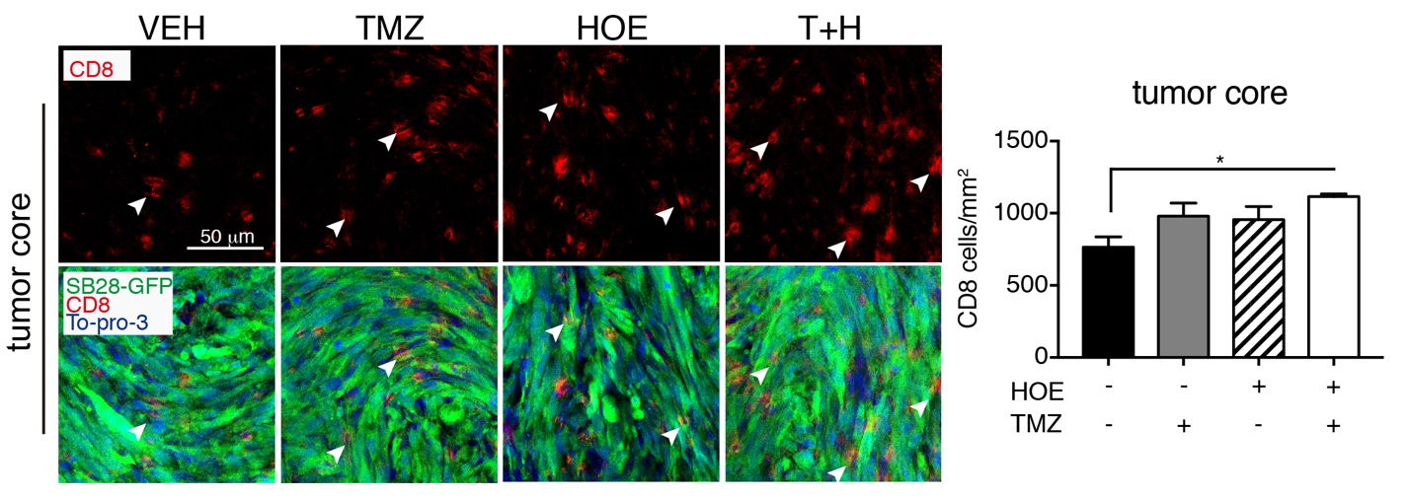
Fig. S8. Infiltration of CD8⁺ T cell in SB28-GFP tumor core
Representative immunostaining of fixed brain sections (25 µm thickness) for CD8 protein expression in SB28 tumor core. Data are mean ± SEM (n=5). *p < 0.05.

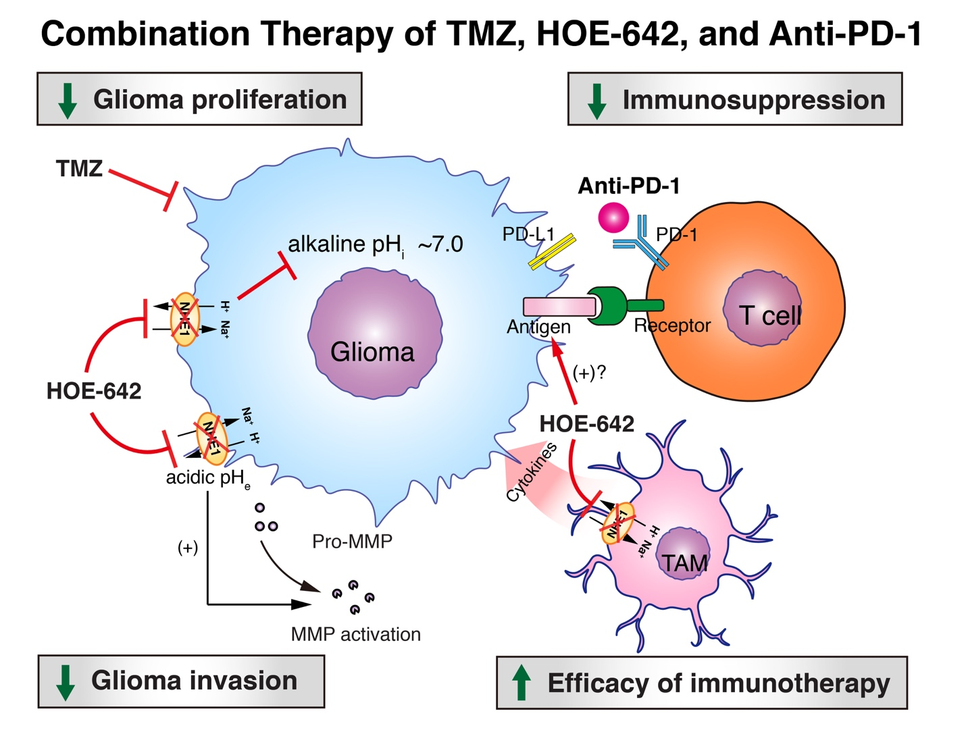
Fig. S9. Blockade of Na/H exchanger stimulates glioma immunogenicity and increases TMZ and anti-PD-1 therapy efficacy.
Na/H exchanger (NHE1) plays a role in glioma progression via multiple mechanisms. First, NHE1-mediated H⁺ efflux maintains glioma alkaline pH_{i} and cell proliferation. NHE1 activation promotes glioma tumor invasion via maintaining acidic pH_{e}, which stimulates metalloprotease (MMP) family proteins. In response to temozolomide (TMZ) treatment, glioma cells increased NHE1 protein expression and developed resistance to TMZ-mediated apoptosis. Administration of NHE1 inhibitor HOE-642 together with TMZ significantly decreased glioma proliferation, and increased glioma apoptosis and animal overall survival. In addition, blockade of NHE1 stimulated pro-inflammatory polarization of tumor-associated microglia and macrophages (TAMs) and increased infiltration of T cells into tumor tissues. Importantly, combination therapy of TMZ, NHE1 inhibitor, and anti-PD-1 antibody significantly extended median survival of the glioma-bearing mice. Therefore, blocking NHE1 protein is a novel strategy to improve combinatorial TMZ chemotherapy and immunotherapy for glioma.
References
1 Begum, G. et al. Inhibition of WNK3 Kinase Signaling Reduces Brain Damage and Accelerates Neurological Recovery After Stroke. Stroke 46, 1956-1965, doi:10.1161/STROKEAHA.115.008939 (2015).

