Supplementary Information

Reprogramming mechanisms influence the maturation of hematopoietic progenitors from human pluripotent stem cells

Hye-Ryeon Heo, Haengseok Song, Hye-Ryun Kim, Jeong Eun Lee, Young Gie Chung, Woo Jin Kim, Se-Ran Yang, Kye-Seong Kim, Taehoon Chun, Dong Ryul Lee, Seok-Ho Hong

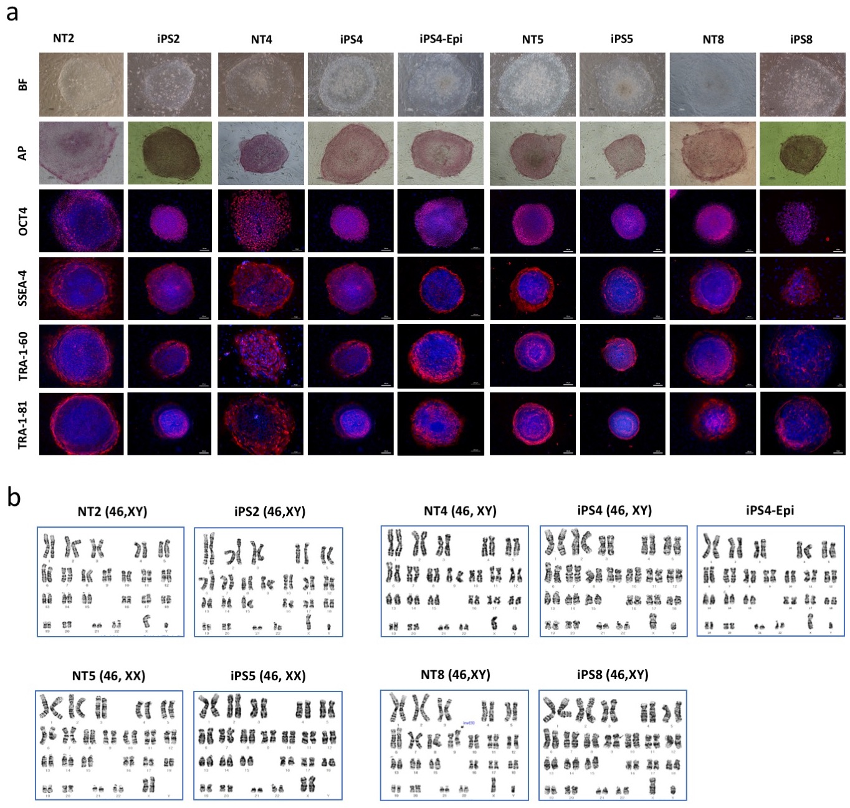

Supplementary Figure 1. Generation and characterization of isogenic human NT-ESCs and iPSCs. a Evaluation of pluripotency of human NT-ESCs and iPSCs by alkaline phosphatase staining and immunocytochemistry for pluripotency markers. Antibodies against OCT4, SSEA-4, TRA-1-60 and TRA-1-81 were used for immunocytochemistry, and endogenous alkaline phosphatase activity were assessed by AP staining kit. Scale bars are 100 µm except OCT-4, SSEA-4, TRA-1-60 and TRA-1-81 of NT2, NT4, NT8 and iPS4-Epi (50 µm). b Karyotyping results by G-banding.

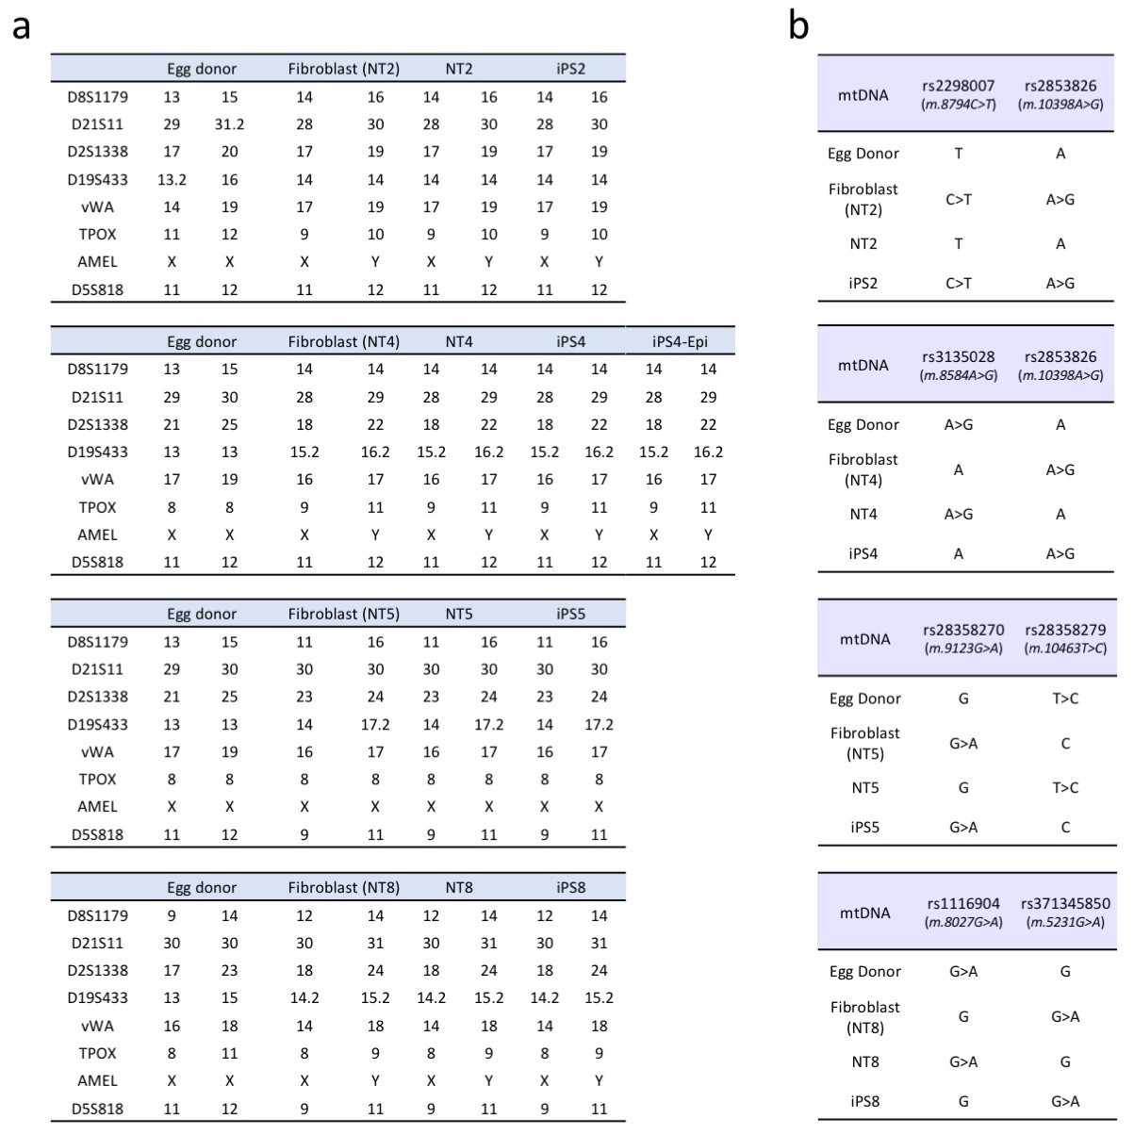

Supplementary Figure 2. Genetic analysis of isogenic human NT-ESCs and iPSCs. a Nuclear DNA genotyping was obtained using an AmpFlSTR® identifier kit and an ABI 3130 genetic analyzer. There was no contribution of oocyte nuclear DNA to the NT-ESCs or iPSCs. b Mitochondrial DNA genotyping. The regions containing the single nucleotide polymorphism sites were amplified, sequenced, and analyzed using the SeqScape® Software. The NT-ESCs and iPSCs contained the oocyte mtDNA.

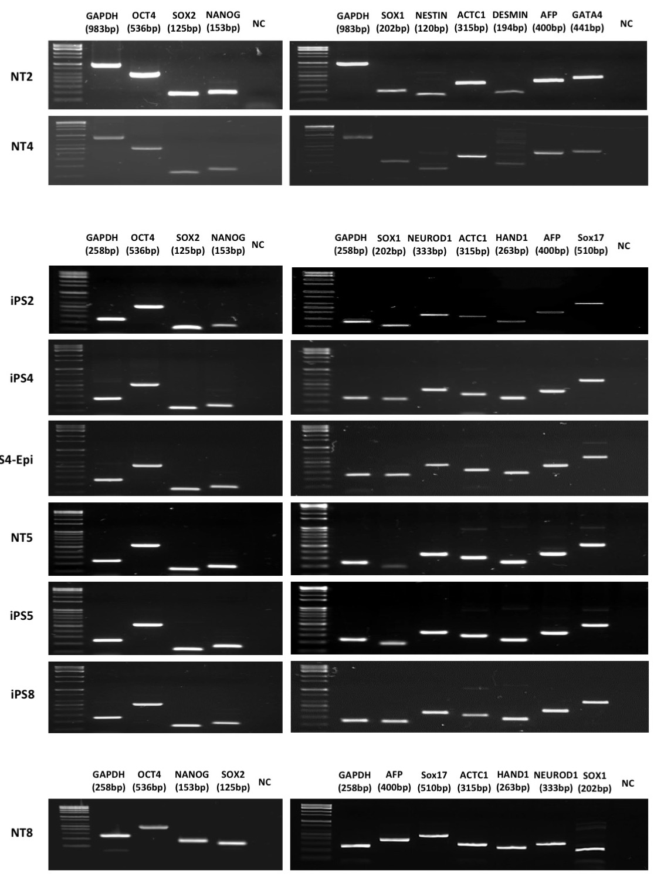

Supplementary Figure 3. Pluripotency analysis of isogenic human NT-ESCs and iPSCs. Expression of pluripotency and three-germ layer markers in NT-ESCs and iPSCs by RT-PCR. OCT4, NANOG, and SOX2 genes were used for pluripotency markers. For three germ layer differentiation, the expression levels of SOX1 and NESTIN/NEUROD1 for ectoderm, ACTC1 and DESMIN/HAND1 for mesoderm, and AFP and GATA4/SOX17 for endoderm were tested in EBs. GAPDH was used as an internal control.
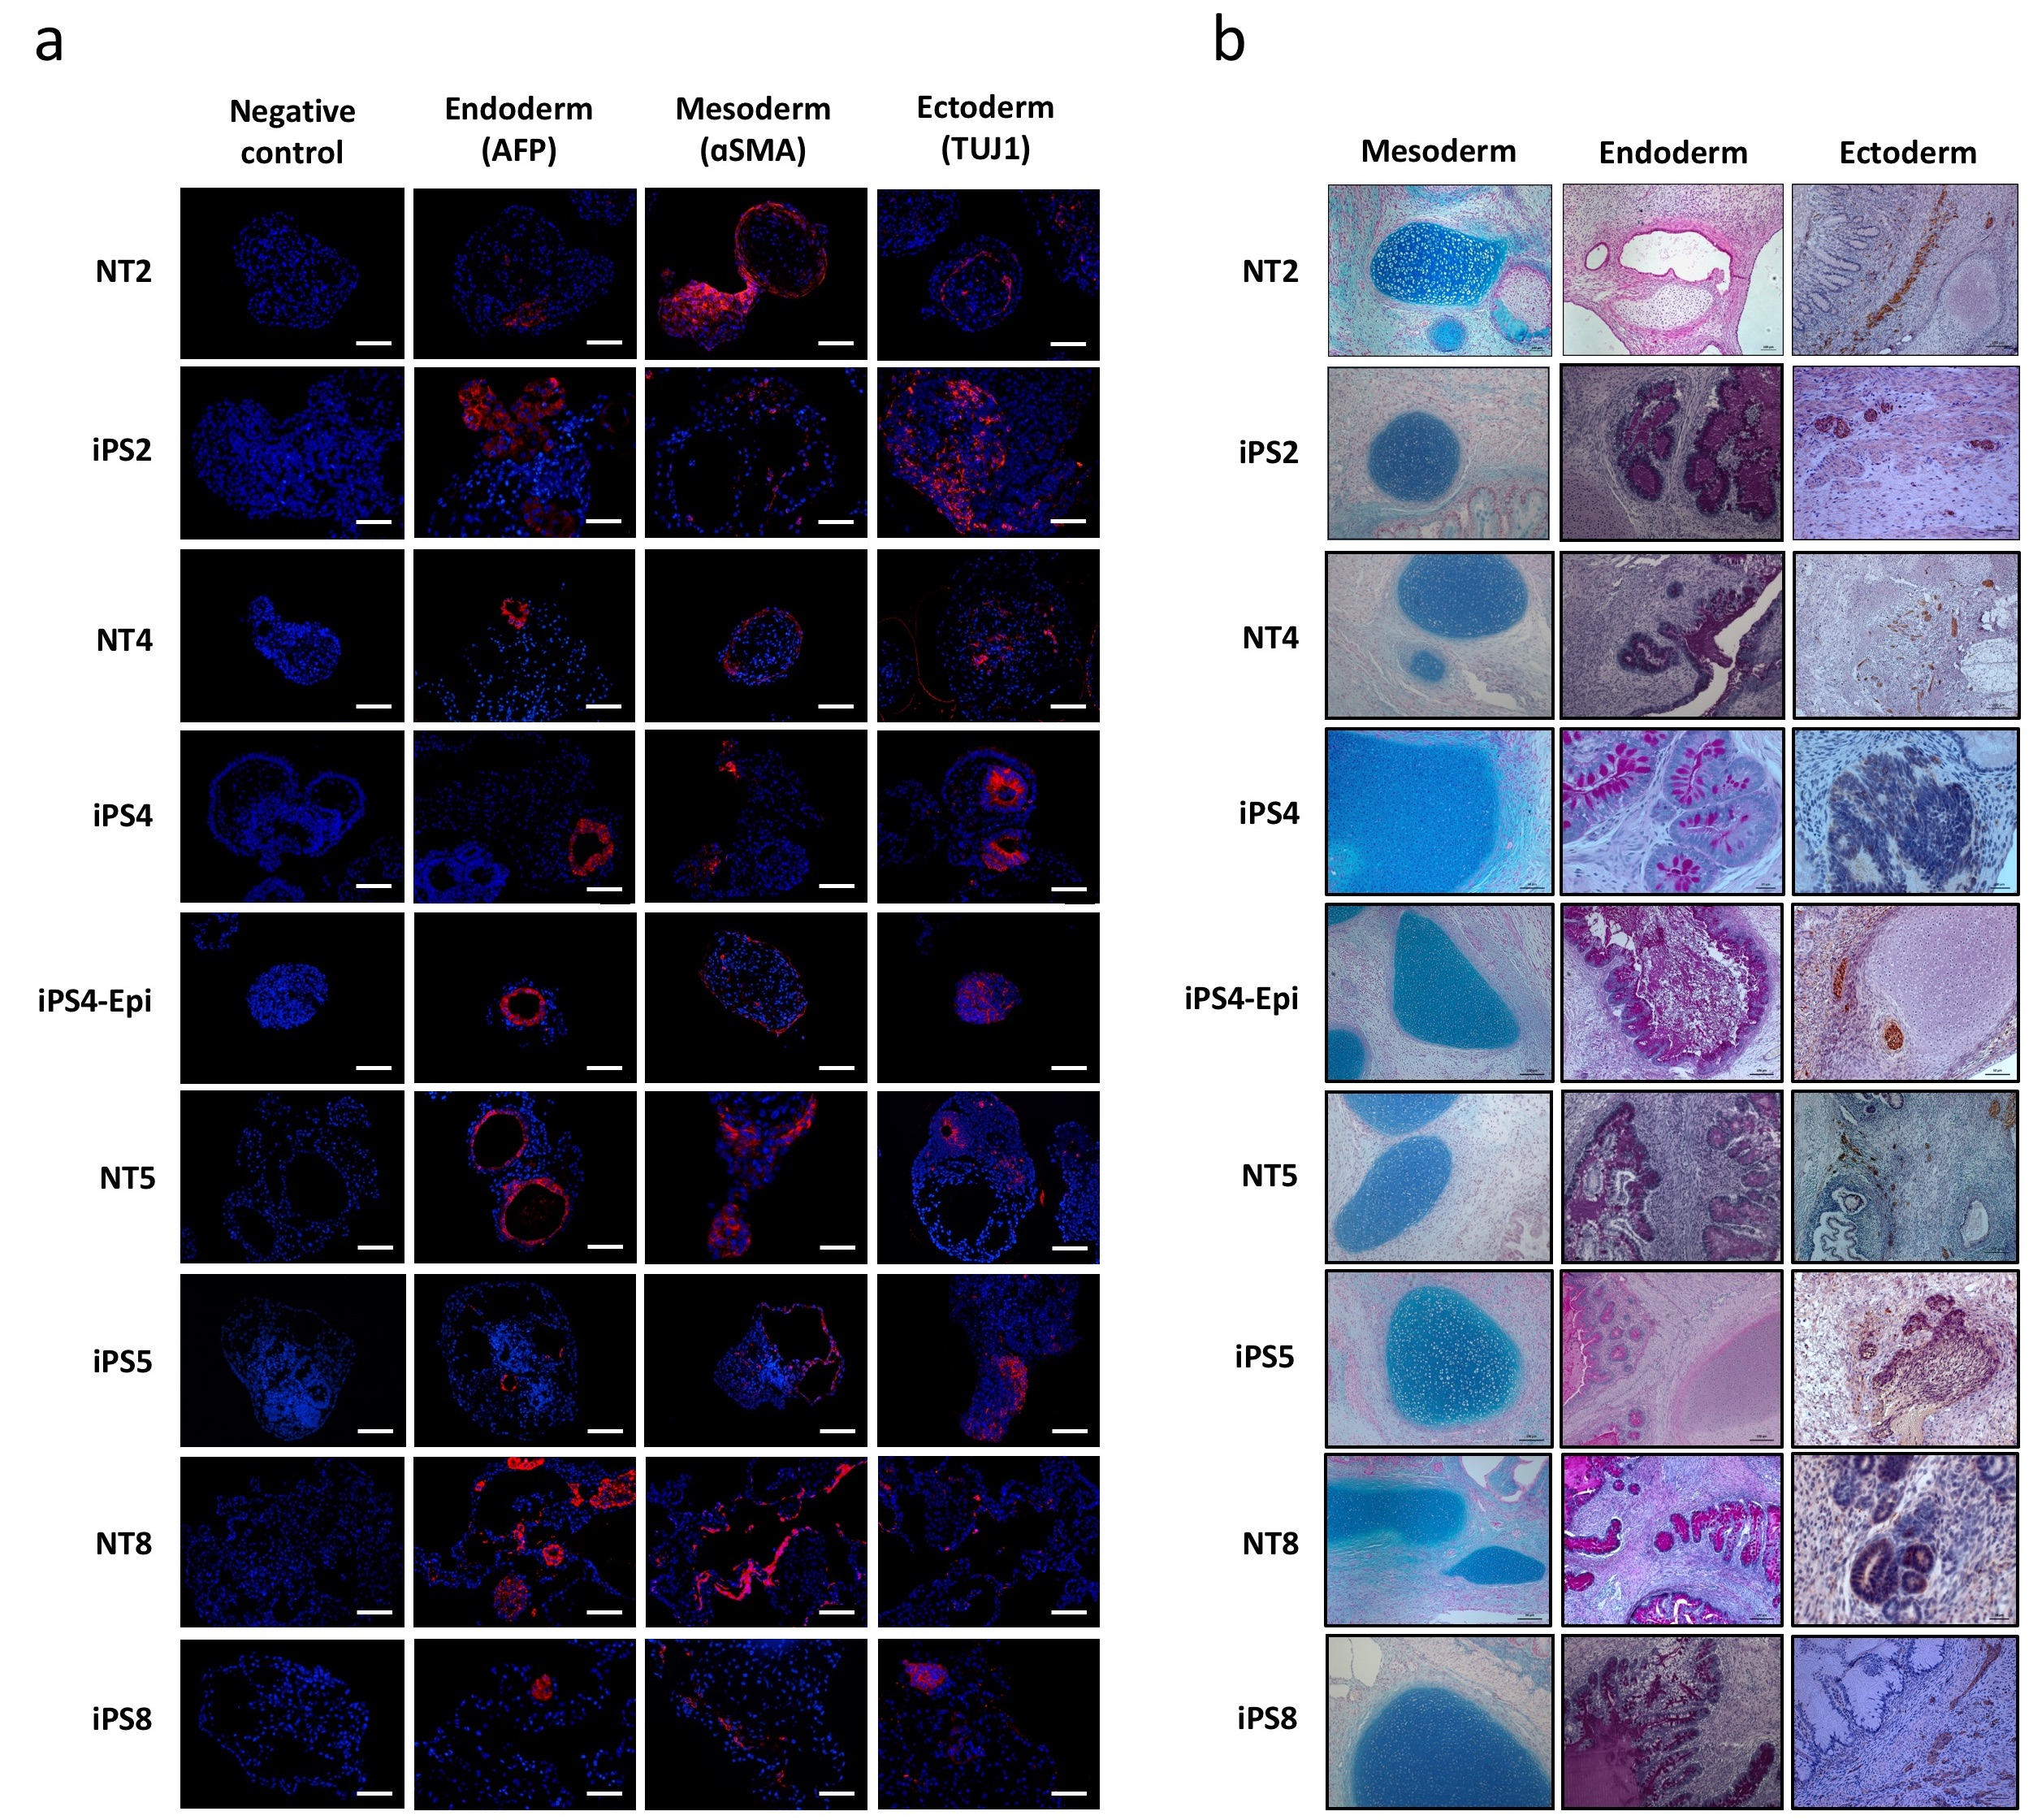

Supplementary Figure 4. Teratoma formation assay of isogenic human NT-ESCs and iPSCs. a Differentiation marker expression in EBs derived from human NT-ESCs and iPSCs by immunohistochemistry. Antibodies against AFP for endoderm, ɑSMA for mesoderm, and TUJ1 for ectoderm were used. DAPI was used for counter staining. Scale bars are 100 µm. b Differentiation marker expression in teratomas derived from human NT-ESCs and iPSCs. Teratoma assay confirms differentiation capacity of NT-ESCs and iPSCs into the three germ layers in vivo; mesoderm-derived cartilage (Alcian blue staining), endoderm-derived secretory epithelium (Periodic Acid Schiff staining), and ectoderm-derived neural epithelium with rosette (immunohistochemistry using TUJ1 antibody). Original magnification, x100.

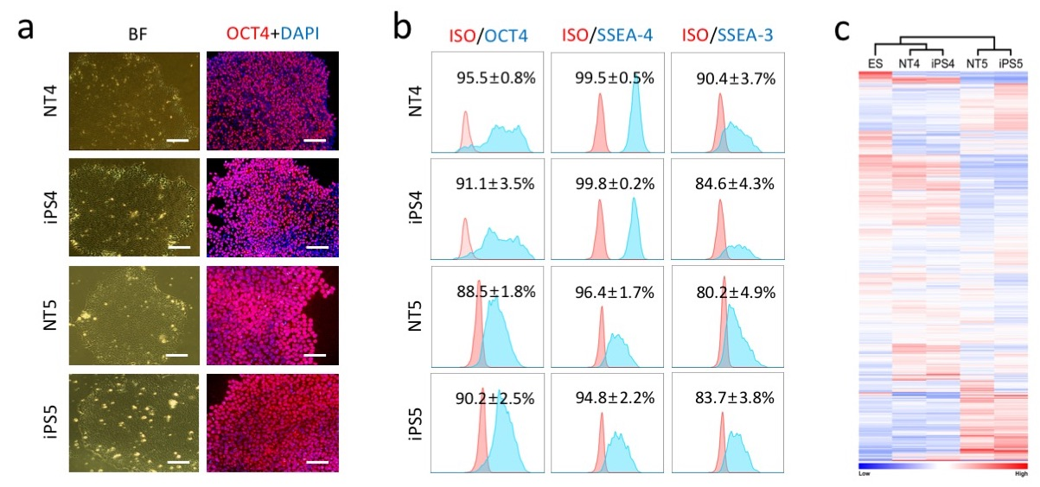

Supplementary Figure 5. Similar phenotypes and transcriptional landscape between Isogenic iPSCs and NT-ESCs. a Immunocytochemistry staining for OCT4 (red) in feeder-free cultures. The nuclei were counterstained with 4,6-diamidino-2-phenylindole (DAPI, blue). Scale bar, 100 μm. BF, Bright field. b Representative histograms showing the expression of pluripotency markers (OCT4, SSEA-3/4) in feeder-free cultures. Frequencies shown in histograms indicate the mean±SD from three independent experiments. ISO, Isotype control. c Unsupervised hierarchical clustering of global gene expression profiles in genetically matched iPSCs and NT-ESCs. ES, human embryonic stem cells.

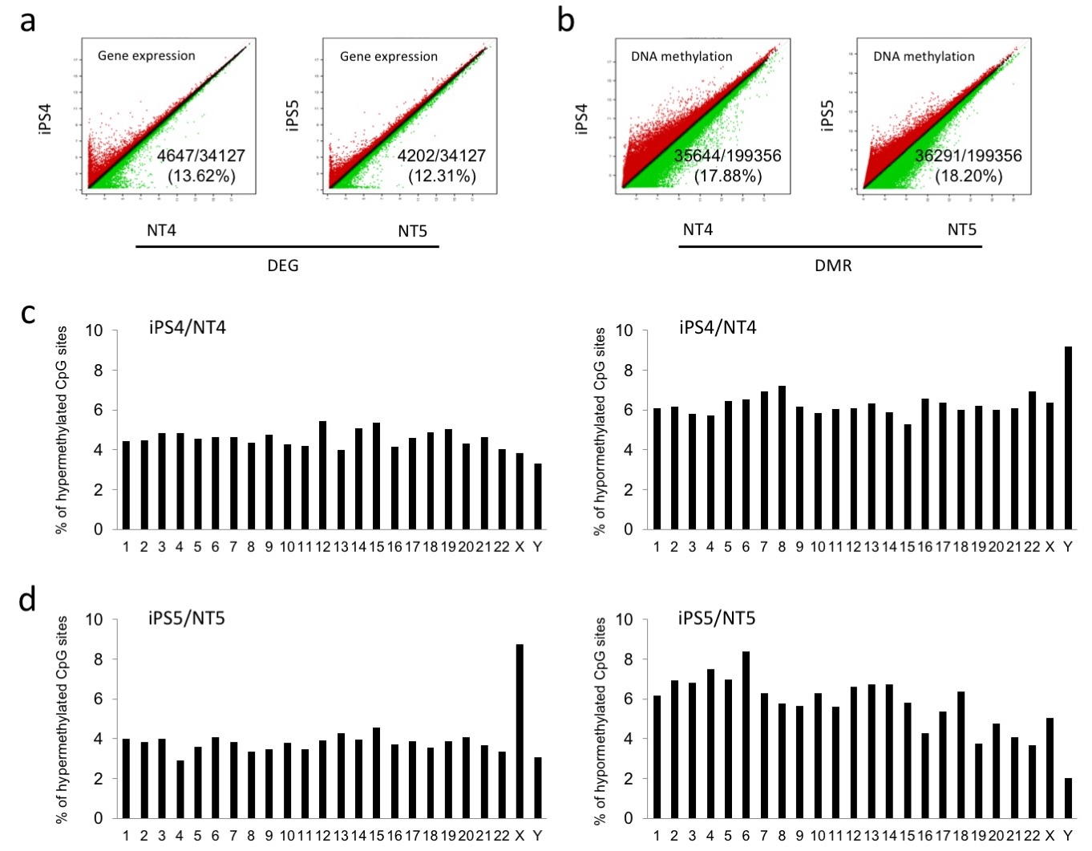

Supplementary Figure 6. Transcriptomic and methylomic analyses of isogenic NT-ESCs and iPSCs. a Scatter plots of gene expression of isogenic NT-ESCs and iPSCs in undifferentiated state by microarray analysis. Red and green dots indicate DEGs (FC>1.5, FDR<0.05). b DMRs between NT-ESCs and iPSCs were identified by comparing DNA methylation profiles (FC>1.5, FDR<0.05). Red and green dots indicate DMRs. c, d Chromosomal mapping of DMRs. Frequencies of hyper- and hypomethylated sites were shown in the graphs.

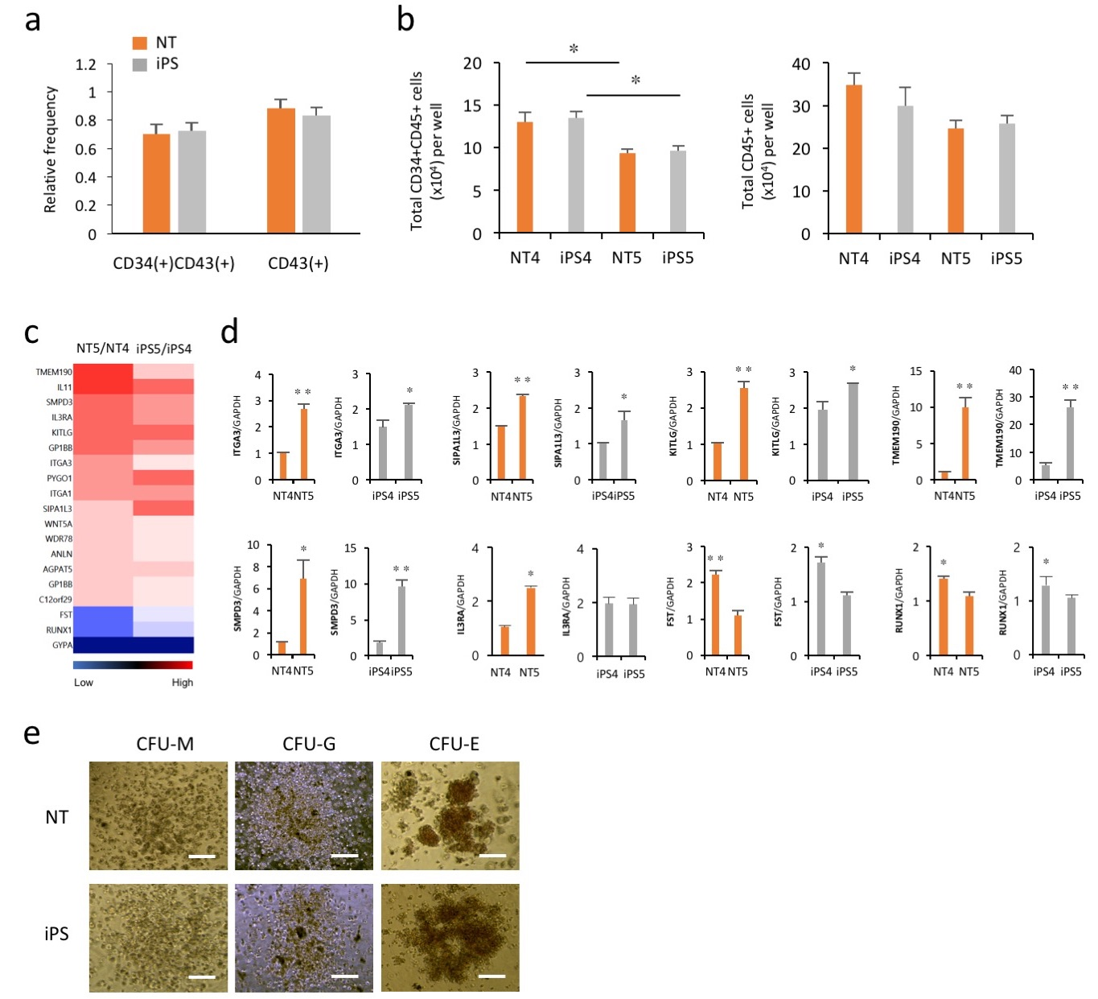

Supplementary Figure 7. Hematopoietic differentiation assay of isogenic NT-ESCs and iPSCs. a Flow cytometry analysis for committed hematopoietic progenitors (CD34+CD43+) and mature blood (CD34-CD43+) cells on day 17. b Total number of CD34+CD45+ and CD34-CD45+ cells on day 17. *p<0.05. c A heat map showing differentially expressed hematopoietic-related genes between NT4 and NT5 or iPS4 and iPS5. d Verification of the transcriptomic analysis with qPCR on selected genes. *p<0.05, **p<0.01. e Representative images of CFU subtypes derived from hematopoietic progenitors. Scale bar, 100 µm. All bars indicate the mean±SD from three independent experiments.

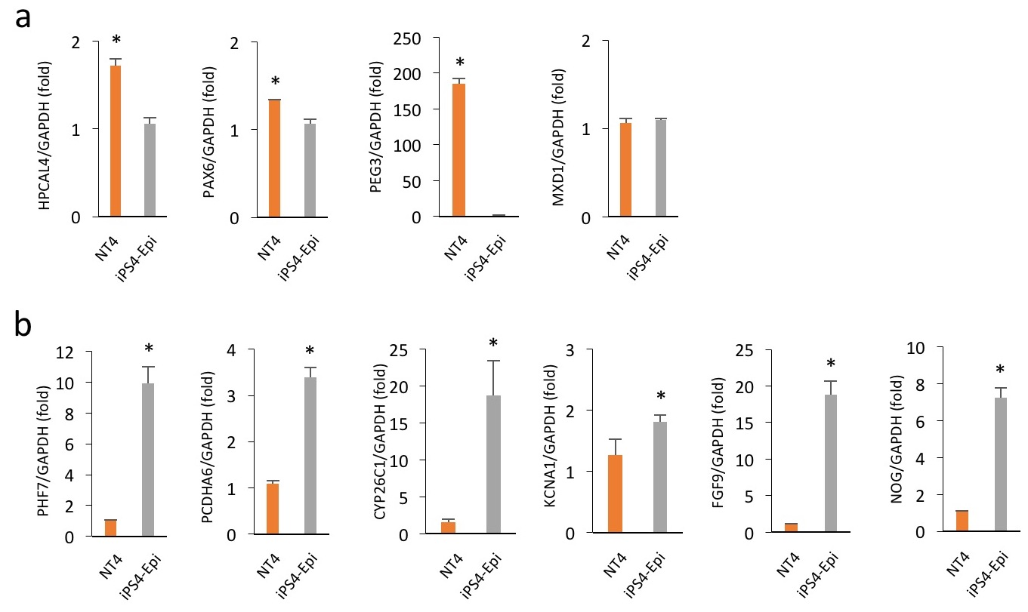

Supplementary Figure 8. Comparison of hematopoietic gene expression between NT4 and iPS4-Epi. Verification of the transcriptomic analysis with qPCR on selected up (a) and downregulated genes (b). All bars indicate the mean±SD from three independent experiments. *p<0.05.

Supplementary Table 1. Primer sequences for qPCR and RT-PCR
Gene | Sequence (5' to 3')
GATA6 | F  R |  | CAGCAAAAATACTTCCCCCA  ACTTGAGCTCGCTGTTCTCG
NKX2.1 | F  R |  | AGCACACGACTCCGTTCTC  GCCCACTTTCTTGTAGCTTTCC
NEUROG2 | F  R |  | CCCTGACCCCGCTGTCATCC  CCCTCCGCACCCGCAGCCAC
SOX1 | F  R |  | CCCGCCAGCCGCCCCGATG  CCATCTTGCGCCGCTGCCCGC
SOX1 | F  R |  | GTGTCCAATTGTTGGCATCTAGGTC  CAAGGAAATAAGGTGGTTGGAGCAC
NESTIN | F  R |  | TCCAGGAACGGAAAATCAAG  GCCTCCTCATCCCCTACTTC
NUEROD1 | F  R |  | GTTTCTCAGGACGAGGAGCAC  TGGACAGCTTCTGCGTCTTA
ACTC1 | F  R |  | CATCCTGACCCTGAAGTATCCCATC  CCCTCATAGATGGGGACATTGTGAG
DESMIN | F  R |  | TCGGCTCTAAGGGCTCCTC  CGTGGTCAGAAACTCCTGGTT
HAND1 | F  R |  | AAGAGAACCAGACGCAGGAA  GGCAGGATGAACAAACACCT
AFP | F  R |  | GAAATGACTCCAGTAAACCCTGGTG  AGACTCGTTTTGTCTTCTCTTCCCC
GATA4 | F  R |  | CTCTACCACAAGATGAACGGC  CATCGCACTGACTGAGAACG
SOX17 | F  R |  | CGCACGGAATTTGAACAGTA  AAAACACACCCAGGACAACA
OCT4 | F  R |  | CTGAAGCAGAAGAGGATCAC  GACCACATCCTTCTCGAGCC
GAPDH | F  R |  | TGCACCACCAACTGCTTAGC  GGCATGGACTGTGGTCATGAG

