SUPPLEMENTARY

Supplementary Figures

Figure S1. Time-dependent up-regulation of HLA-DR in HUVECs by IFN-γ. HUVECs were treated with IFN-γ for up to 4 days and subjected to flow cytometry to assess HLA-DR expression.

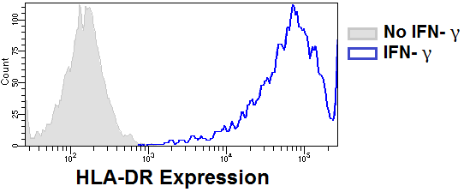
Figure S2. HLA-DR expression levels in EA.hy926 cells. Cell culture of the EA.hy926 cell line was treated for 4 days with IFN-γ (N = 5). The expression of HLA-DR was assessed by flow cytometry.
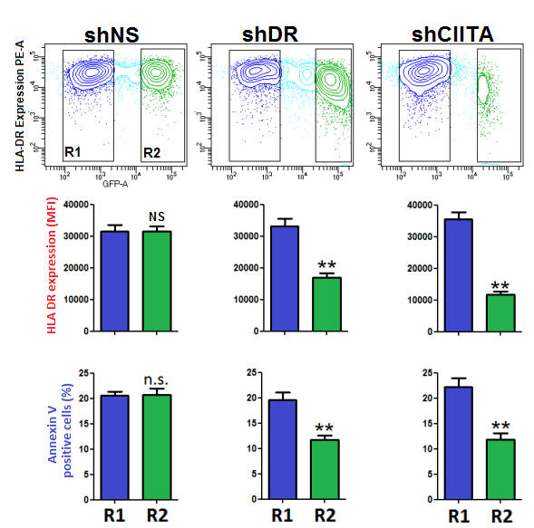
Figure S3. HLA-DR knockdown reduced the L243-mediated ECs death. HUVECs were transduced with GFP–containing lentiviral vectors encoding for sequencing targeting shDR or shCIITA or for a short hairpin RNA shNS (control), as described in Materials and Methods. After treatment with IFN-γ for 3 days cells were incubated for 3 h with L243 (N = 3). Cells were gated into R1 and R2 according to GFP-MFI levels by flow cytometry. HLA-DR antibody binding and cytotoxicity was determined in these two cell populations. Data are from a representative dot plot (upper panel) and statistical results mean ± SEM (lower panels). **P < 0.01. GFP, green fluorescent protein

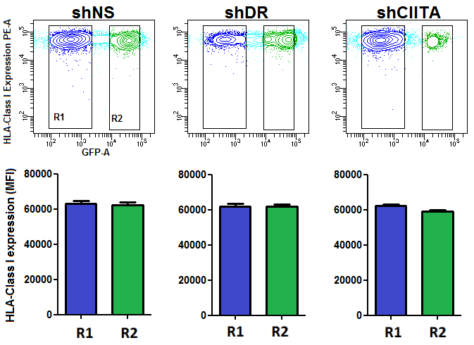

Figure S4. Targeting HLA-DR expression by shNS, shDR or shCIITA did not interfere with HLA I expression. HUVECs were transduced with lentiviral vectors encoding for GFP and the indicated short sequencing shDR or shCIITA or a non-specific short hairpin RNA shNS (control), as described in Materials and Methods. After treatment with IFN-γ cells were incubated for 3 h with HLA I mAb W6/32 (N = 3). Cells were gated R1 and R2 according to GFP-MFI levels by flow cytometry. HLA-DR antibody binding was determined in these two cell populations. Data are from a representative dot plot (upper panel) and statistical results mean ± SEM (lower panels).

Figure S5. Quantification of F actin stress fiber intensity. After pretreatment with IFN-γ for 4 days, HUVECs were treated with isotype control antibody (IsoCtrl), mAb L243 or thrombin in the absence or presence of Cyto-D (100 nM) for 3 h, as indicated. Cells were then incubated with Texas Red Phalloidin for staining of F-actin stress fiber formation and DAPI for staining of nuclei (N = 3). Intensity of Phalloidin was measured in ImageJ program as described in MATERIALS AND METHODS. Data shown are as bar graphs from 3 independent experiments mean ± SEM. *P < 0.05, **P < 0.01, ***P < 0.001.

Figure S6. Effect of Rho GTPase inhibitor CT04 on L243-mediated cytotoxicity. HUVECs were treated with IFN-γ for 4 days, which was followed by 3 h treatment with Rho GTPase inhibitor I CT04 (1 μg/ml) and L243 (N = 3). Cytotoxicity was assessed with PI in a flow cytometer. Data are presented as mean ± SEM. **P < 0.01

Supplementary Table

 | Luminex MFI
Serum | HLA-DR51 | HLA-DR52
Neg # 1 | 178 | 384
Neg # 2 | 256 | 152
HLA-DR52 # 1 | 205 | 17787
HLA-DR52 # 2 | 149 | 17534

Table S1. HLA-DR antibody identification in allosera by Luminex assay. Human allosera were analyzed by single antigen Luminex assay (One Lambda, Canoga Park, CA, USA).

