Inhibition of eIF2α dephosphorylation accelerates Pterostilbene-induced cell death in human hepatocellular carcinoma cells in an ER stress and autophagy-dependent manner

Supplemental Figure-1

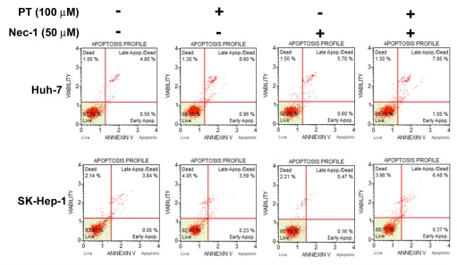

Supplementary Figure 1. Huh-7 and SK-Hep-1 cells were treated with PT (100 μM) in the presence or absence of the necrosis inhibitor Nec-1 (50 μM), quantitative analysis of Annexin V/PI-stained cells using a flow cytometer.

Supplemental Figure-2

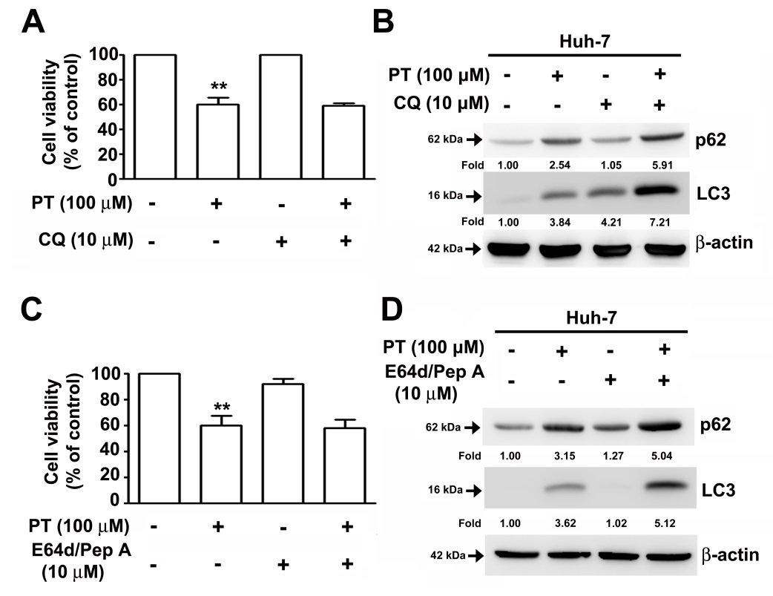

Supplemental Figure-2 Effect of CQ or combined of E-64d/pepstatin A in PT treated Huh-7 cells. Huh-7 cells were pretreated with CQ or combined of E-64d/pepstatin A for 2 h, then added the PT (100 μM) for 22 h. a, c. Cell viability was measured using an MTT assay. b, d. The p62 and LC3 protein expression levels were assessed using a western blot analysis. β-actin served as an internal control. Data are presented as the mean±SE of at least three independent experiments. **p < 0.01 compared with controls.

Supplemental Figure-3

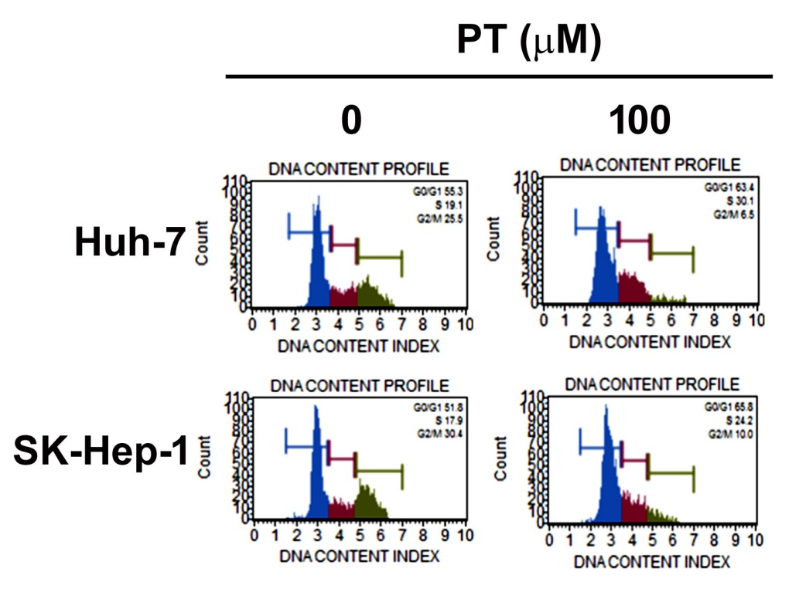

Supplemental Figure-3 Effect of PT on cell cycle regulation in Huh-7 and SK-Hep-1 cells. Huh-7 and SK-Hep-1 cells were treated without or with PT (100 μM) and cell cycle progression was measured by flow cytometry.

