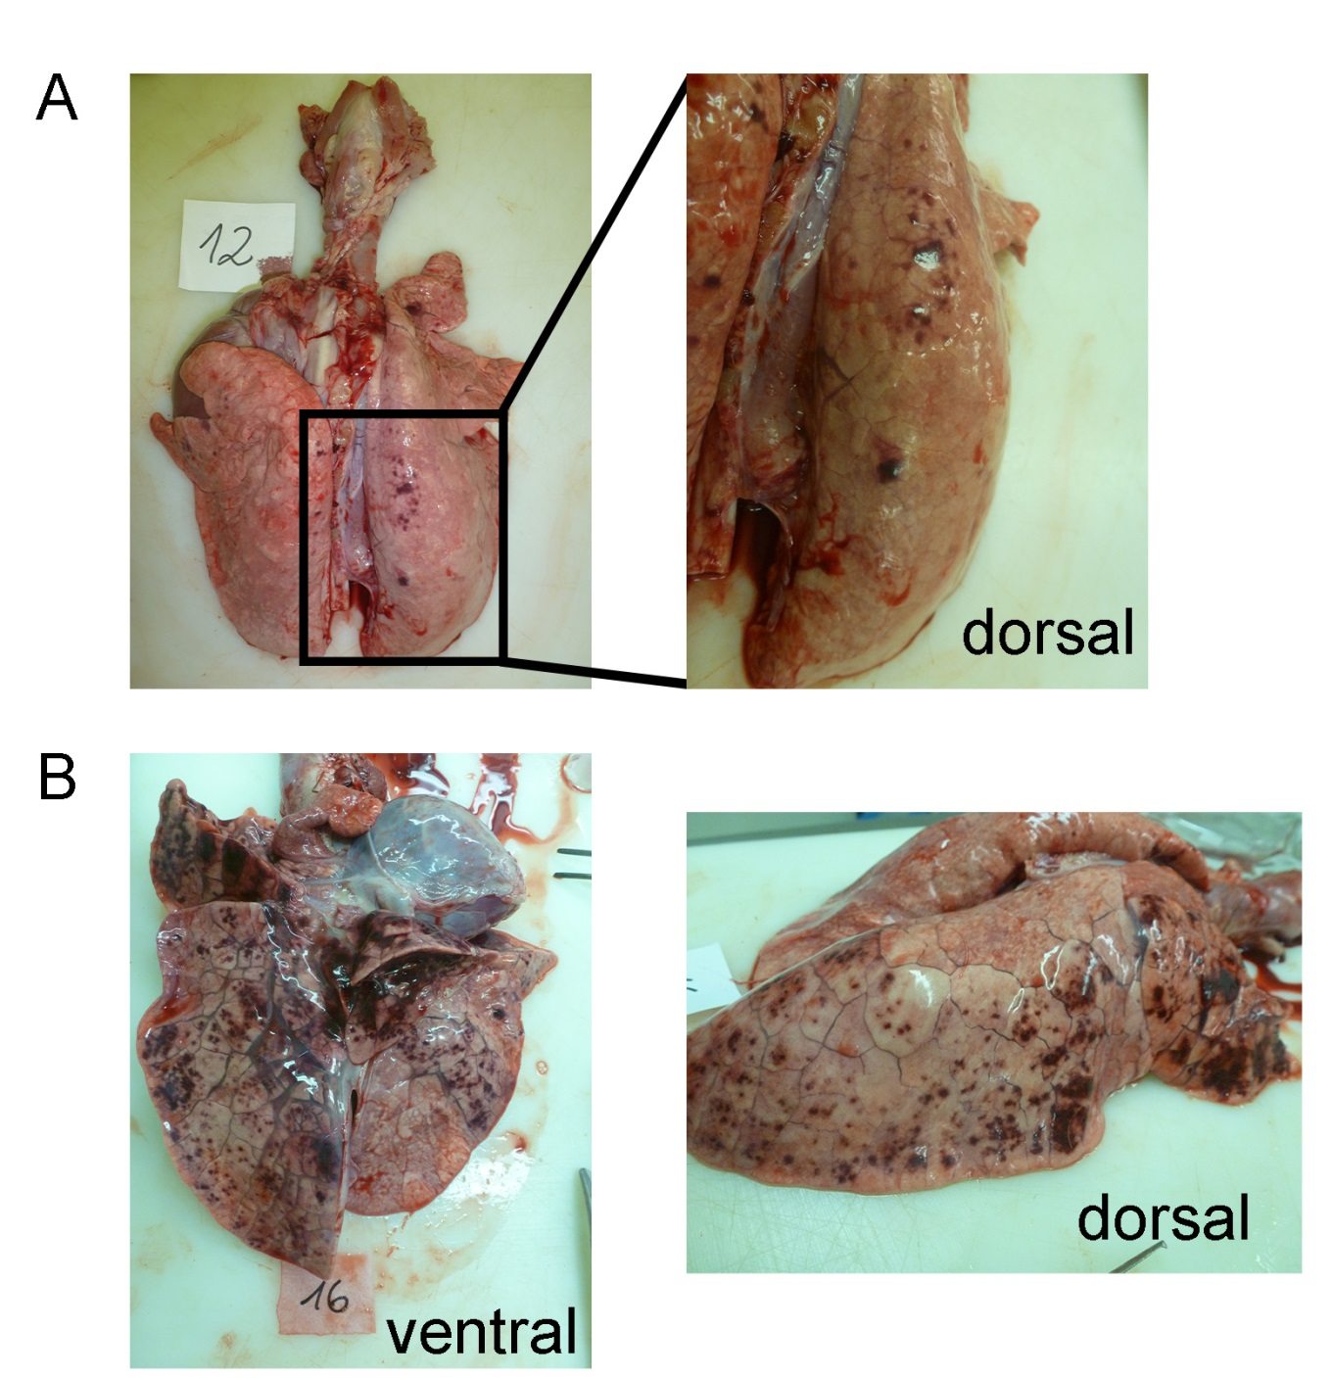

Supplemental figure 13: Macroscopic findings in lungs of A.pp infected pigs 8-10 hours after experimental infection. (A) Lung of infected pig with low lung lesion score (3.45). (B) Lung of infected pig with high lung lesion score (18.23). Macroscopic lung alterations were characterized by consolidated red foci reflecting multifocal haemorrhagic lesions accompanied by an interlobular oedema.

