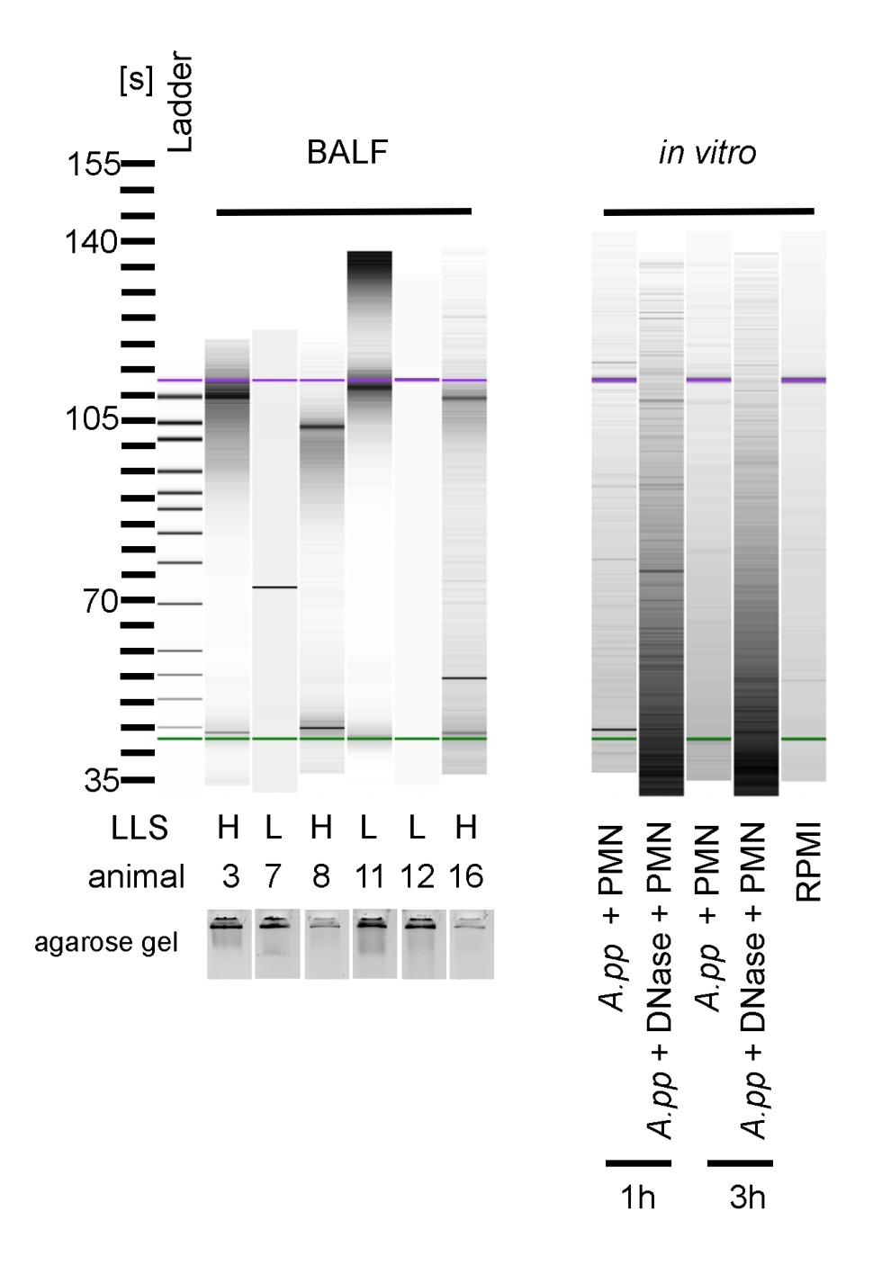

Supplemental figure 5 Bioanalyzer based and gel agarose electrophoresis based analysis of BALF samples and in vitro samples. Left panel shows BALF samples of infected animals with high (H) and low (L) lung lesion score (LLS). Animal numbers refer to values presented in supplemental table 1. BALF samples were in addition loaded on an 1.3% agarose gel to identify high molecule DNA fragments.

Right panel shows analysis of collected in vitro samples (supernatants from Figure 2A). RPMI was used as negative control. Internal standard is presented as violet (10.380 bp) and green (35 bp) line.

