Supplementary Information

Intermittent compressive force promotes osteogenic differentiation in human periodontal ligament cells by regulating transforming growth factor-β pathway

Jeeranan Manokawinchoke¹, Prasit Pavasant¹, Chenphop Sawangmake², Nuttapol Limjeerajarus³, Chalida N. Limjeerajarus^{1,4}, Hiroshi Egusa^{5,*}, Thanaphum Osathanon^{1,6,*}

¹Center of Excellence for Regenerative Dentistry and Department of Anatomy, Faculty of Dentistry, Chulalongkorn University, Bangkok, 10330 Thailand
²Department of Pharmacology, Faculty of Veterinary Science, Chulalongkorn University, Bangkok, 10330 Thailand
³Research Center for Advanced Energy Technology, Faculty of Engineering, Thai-Nichi Institute of Technology, Bangkok 10250 Thailand
⁴Department of Physiology, Faculty of Dentistry, Chulalongkorn University, Bangkok, 10330 Thailand
⁵Division of Molecular and Regenerative Prosthodontics, Tohoku University Graduate School of Dentistry, Sendai 980-8575, JAPAN
⁶Genomics and Precision Dentistry Research Unit, Faculty of Dentistry, Chulalongkorn University, Bangkok, 10330 Thailand

Co-corresponding author
Thanaphum Osathanon, DDS, PhD
Department of Anatomy, Faculty of Dentistry,
Chulalongkorn University, Bangkok, 10330 Thailand
Tel: +66-2-218-8885
Fax: +66-2-218-8870
Email: thanaphum.o@chula.ac.th
Hiroshi Egusa, DDS, PhD
Division of Molecular and Regenerative Prosthodontics,
Tohoku University Graduate School of Dentistry,
Sendai 980-8575, JAPAN
Email: egu@dent.tohoku.ac.jp

Supplementary Table 1 Oligonucleotide sequences

Gene | Primer sequences (F=forward, R=Reverse) |  | Accession number
GAPDH | F | 5’-TCA TGG GTG TGA ACC ATG AGA A-3’ | NM_002046.3
GAPDH | R | 5’-GGC ATG GAC TGT GGT CAT GAG-3’ | NM_002046.3
RUNX2 | F | 5’-ATG ATG ACA CTG CCA CCT CTG A-3’ | NM_001024630.3
RUNX2 | R | 5’-GGC TGG ATA GTG CAT TCG TG-3’ | NM_001024630.3
OSX | F | 5’-GCC AGA AGC TGT GAA ACC TC-3’ | NM_152860.1
OSX | R | 5’-GCT GCA AGC TCT CCA TAA CC-3’ | NM_152860.1
ALP | F | 5’-CGA GAT ACA AGC ACT CCC ACT TC-3’ | NM_000478.3
ALP | R | 5’-CTG TTC AGC TCG TAC TGC ATG TC-3’ | NM_000478.3
COL1A1 | F | 5’-GTG CTA AAG GTG CCA ATG GT-3’ | NM_000088.3
COL1A1 | R | 5’-ACC AGG TTC ACC GCT GTT AC-3’ | NM_000088.3
DMP1 | F | 5’-CAG GAG CAC AGG AAA AGG AG-3’ | NM_004407.3
DMP1 | R | 5’-CTG GTG GTA TCT TGG GCA CT-3’ | NM_004407.3
DSPP | F | 5’-ATA TTG AGG GCT GGA ATG GGG A-3’ | NM_014208.3
DSPP | R | 5’-TTT GTG GCT CCA GCA TTG TCA-3’ | NM_014208.3
OCN | F | 5’-CTT TGT GTC CAA GCA GGA GG-3’ | NM_199173.4
OCN | R | 5’-CTG AAA GCC GAT GTG GTC AG-3’ | NM_199173.4
BMP2 | F | 5’-GCG TGA AAA GAG AGA CTG C-3’ | NM_001200.2
BMP2 | R | 5’-CCA TTG AAA GAG CGT CCA C-3’ | NM_001200.2
BMP4 | F | 5’-AAA GTC GCC GAG ATT CAG GG-3’ | NM_001202.4
BMP4 | R | 5’-GAC GGC ACT CTT GCT AGG C-3’ | NM_001202.4
BMP7 | F | 5’-TCG GCA CCC ATG TTC ATG C-3’ | NM_001719.2
BMP7 | R | 5’-GAG GAA ATG GCT ATC TTG CAG G | NM_001719.2
TGFB1 | F | 5’-GGA TAC CAA CTA TTG CTT CAG CTC C-3’ | NM_000660.4
TGFB1 | R | 5’-AGG CTC CAA ATG TAG GGG CAG GGC C-3’ | NM_000660.4
TGFB2 | F | 5’-ATT GCC CTC CTA CAG ACT TGA G-3’ | NM_001135599.2
TGFB2 | R | 5’-CAG CAC AGA AGT TGG CAT TGT A-3’ | NM_001135599.2
TGFB3 | F | 5’-GGT TTT CCG CTT CAA TGT GT-3’ | NM_003239.2
TGFB3 | R | 5’-GCT CGA TCC TCT GCT CAT TC-3’ | NM_003239.2

Supplementary Table 2 Top 20 significantly upregulated and downregulated genes in the CCF-treated hPDLs.
Gene symbol | Gene name | Log2FC |  | FDR
Upregulated genes
AMIGO2 | Adhesion molecule with Ig like domain 2 | 3.65 |  | 2.57E-74
FZD8 | Frizzled class receptor 8 | 4.33 |  | 2.79E-69
KRT16 | Keratin 16 | 5.43 |  | 3.84E-45
CSRP2 | Cysteine and glycine rich protein 2 | 2.34 |  | 3.87E-37
DACT1 | Disheveled binding antagonist of beta catenin 1 | 2.41 |  | 5.95E-34
NREP | Neuronal regeneration related protein | 2.83 |  | 3.08E-32
LMCD1 | LIM and cysteine rich domains 1 | 3.16 |  | 1.00E-29
KCNG1 | Potassium voltage-gated channel modifier subfamily G member 1 | 2.43 |  | 4.48E-25
FSTL3 | Follistatin-like 3 (secreted glycoprotein) | 2.00 |  | 8.67E-25
TSPAN2 | Tetraspanin 2 | 4.15 |  | 8.92E-22
CCDC99 | Coiled-coil domain containing 99 | 2.50 |  | 1.18E-21
EGR2 | Early growth response 2 | 4.07 |  | 1.18E-21
LTBP1 | Latent transforming growth factor beta binding protein 1 | 2.11 |  | 1.19E-21
PMEPA1 | Prostate transmembrane protein, androgen induced 1 | 2.26 |  | 2.01E-21
SKIL | SKI-like oncogene | 1.99 |  | 6.31E-21
TPM1 | Tropomyosin 1 (alpha) | 2.44 |  | 2.52E-20
LRRC15 | Leucine rich repeat containing 15 | 2.78 |  | 5.63E-20
SLC2A1 | Solute carrier family 2 (facilitated glucose transporter), member 1 | 2.09 |  | 4.01E-19
LIMS1 | LIM and senescent cell antigen-like domains 1 | 1.66 |  | 1.36E-18
BHLHE40 | Basic helix-loop-helix family, member e40 | 2.31 |  | 1.67E-18
Downregulated genes
SECTM1 | Secreted and transmembrane 1 | -1.69 | 8.02E-15
RYR2 | Ryanodine receptor 2 | -2.59 | 9.29E-15
ADH1B | Alcohol dehydrogenase 1B (class I), beta polypeptide | -4.90 | 2.39E-13
CNKSR3 | CNKSR family member 3 | -1.48 | 2.49E-13
NEDD4L | Neural precursor cell expressed, developmentally down-regulated 4-like, E3 ubiquitin protein ligase | -1.35 | 2.99E-13
SLC9A9 | Solute carrier family 9 (sodium/hydrogen exchanger), member 9 | -1.38 | 8.50E-13
RSPO2 | R-spondin 2 | -2.59 | 1.16E-12
EPHA4 | EPH receptor A4 | -1.58 | 7.90E-11
PPAP2B | Phosphatidic acid phosphatase type 2B | -1.75 | 1.11E-10
ENPP2 | Ectonucleotide pyrophosphatase/phosphodiesterase 2 | -2.24 | 1.29E-10
EYA1 | Eyes absent homolog 1 (Drosophila) | -1.12 | 1.70E-09
MASP1 | Mannan-binding lectin serine peptidase 1 (C4/C2 activating component of Ra-reactive factor) | -1.34 | 2.99E-09
RAB27B | RAB27B, member RAS oncogene family | -1.11 | 1.59E-08
C10orf54 | Chromosome 10 open reading frame 54 | -1.21 | 7.19E-08
PDGFD | Platelet derived growth factor D | -1.29 | 1.12E-07
PTGFR | Prostaglandin F receptor (FP) | -1.15 | 1.17E-07
CLDN11 | Claudin 11 | -2.65 | 2.28E-07
PTPLAD2 | Protein tyrosine phosphatase-like A domain containing 2 | -1.11 | 3.18E-07
OSR1 | Odd-skipped related 1 (Drosophila) | -1.54 | 3.19E-07
FAM43A | Family with sequence similarity 43, member A | -1.58 | 4.55E-07

Supplementary Table 3 Top 20 significantly upregulated and downregulated genes in the ICF-treated hPDLs.

Gene symbol | Gene name | Log2FC |  | FDR
Upregulated genes
AMIGO2 | Adhesion molecule with Ig-like domain 2 | 5.03 |  | 6.30E-85
TSPAN2 | Tetraspanin 2 | 6.98 |  | 2.00E-61
KCNG1 | Potassium voltage-gated channel, subfamily G, member 1 | 3.90 |  | 3.09E-59
C18orf1 | Chromosome 18 open reading frame 1 | 7.67 |  | 3.69E-58
FZD8 | Frizzled family receptor 8 | 5.46 |  | 6.26E-58
MURC | Muscle-related coiled-coil protein | 5.06 |  | 2.14E-56
KCNN4 | Potassium intermediate/small conductance calcium-activated channel, subfamily N, member 4 | 3.67 |  | 5.57E-50
KRT16 | Keratin 16 | 6.24 |  | 8.37E-49
FABP3 | Fatty acid binding protein 3, muscle and heart (mammary-derived growth inhibitor) | 4.64 |  | 9.10E-49
KANK4 | KN motif and ankyrin repeat domains 4 | 8.63 |  | 7.81E-45
FSTL3 | Follistatin-like 3 (secreted glycoprotein) | 3.82 |  | 4.40E-42
PMEPA1 | Prostate transmembrane protein, androgen induced 1 | 3.82 |  | 1.14E-39
ZNF365 | Zinc finger protein 365 | 4.95 |  | 1.40E-39
TIMP3 | TIMP metallopeptidase inhibitor 3 | 3.56 |  | 1.71E-38
TRIB1 | Tribbles homolog 1 (Drosophila) | 3.90 |  | 4.55E-37
COMP | Cartilage oligomeric matrix protein | 6.42 |  | 6.32E-37
NFATC2 | Nuclear factor of activated T-cells, cytoplasmic, calcineurin-dependent 2 | 4.02 |  | 7.12E-37
PRG4 | Proteoglycan 4 | 8.25 |  | 5.80E-36
EGR2 | Early growth response 2 | 5.83 |  | 5.48E-33
LDLR | Low density lipoprotein receptor | 3.42 |  | 1.59E-32
Downregulated genes
MASP1 | Mannan-binding lectin serine peptidase 1 (C4/C2 activating component of Ra-reactive factor) | -3.36 | 2.26E-43
RAB27B | RAB27B, member RAS oncogene family | -3.53 | 7.04E-40
SEPP1 | Selenoprotein P, plasma, 1 | -4.40 | 1.74E-38
PTX3 | Pentraxin 3, long | -3.31 | 9.99E-37
PTPLAD2 | Protein tyrosine phosphatase-like A domain containing 2 | -3.08 | 2.80E-36
RYR2 | Ryanodine receptor 2 (cardiac) | -5.20 | 1.73E-34
RSPO2 | R-spondin 2 | -5.23 | 1.63E-33
SLC2A12 | Solute carrier family 2 (facilitated glucose transporter), member 12 | -4.45 | 1.41E-32
NEDD4L | Neural precursor cell expressed, developmentally down-regulated 4-like, E3 ubiquitin protein ligase | -2.73 | 2.68E-32
VWA5A | von Willebrand factor A domain containing 5A | -3.90 | 2.97E-32
SECTM1 | Secreted and transmembrane 1 | -4.97 | 1.15E-31
PPAP2B | Phosphatidic acid phosphatase type 2B | -3.14 | 1.65E-31
RCAN2 | Regulator of calcineurin 2 | -3.08 | 3.20E-31
CASP1 | Caspase 1, apoptosis-related cysteine peptidase | -4.98 | 9.03E-31
CNKSR3 | CNKSR family member 3 | -2.82 | 9.38E-28
PDGFD | Platelet derived growth factor D | -2.78 | 4.42E-24
PDGFRA | Platelet-derived growth factor receptor, alpha polypeptide | -2.40 | 2.13E-23
DAPK1 | Death-associated protein kinase 1 | -4.45 | 4.44E-22
THRB | Thyroid hormone receptor, beta | -3.09 | 1.97E-21
COLEC12 | Collectin sub-family member 12 | -3.16 | 2.59E-21

Supplementary Table 4 Top 10 enriched KEGG pathway of the upregulated and downregulated genes in the CCF-treated hPDLs.

Pathway | Entrez Gene ID | FDR
Upregulated pathway
Terpenoid backbone biosynthesis | HMGCS1; IDI1; MVD; HMGCR | 0.0040
Arginine and proline metabolism | GLS; ALDH1B1; ODC1; P4HA3; ADC | 0.0162
ECM-receptor interaction | ITGA11; COL4A1; THBS2; ITGB3; COMP; ITGB6 | 0.0162
Arrthythmogenic right ventricular cardiomyopathy (ARVC) | DSP; CACNG4; ITGB3; ITGA11; CTNNA2; ITGB6 | 0.0162
TGF-β signaling pathway | CDKN2B; INHBE; THBS2; LTBP1; COMP; INHBA | 0.0162
Hypertrophic cardiomyopathy (HCM) | TPM1; CACNG4; ACTC1; ITGB3; ITGA11; ITGB6 | 0.0162
Metabolic pathways | AZIN2; DHCR7; TYMP; ALDH1B1; AMACR; GCH1; GLS; P4HA3; HMGCR; HMGCS1; IMPA2; MVD; ACLY; NNMT; ODC1; PLA2G3; PLCB4; LPCAT2; PRPS1; CYP4F11; MSMO1; XYLT1; UAP1; BPGM; SQLE; UCK2; DGKI; LIPG; PRDX6 | 0.0162
Dilated cardiomyopathy | ITGA11; CACNG4; ITGB3; ITGB6; ACTC1; TPM1 | 0.0195
Steroid biosynthesis | DHCR7; MSMO1; SQLE | 0.0205
African trypanosomiasis | F2RL1; IL12A; PLCB4 | 0.1051
Downregulated pathway
Calcium signaling pathway | PTGFR; PDE1A; ADRA1D; PLCD4; HTR2B; ATP2B2; RYR2; PDGFRA; SLC8A1; HRH1; EDNRA | 2.28e-05
Axon guidance | PLXNC1; EPHA4; EFNA5; SEMA3E; SEMA3A; SEMA6A; NTNG1; SRGAP3 | 0.0005
Cytokine-cytokine receptor | CCR1; CXCR7; TGFB3; TNFSF13B; TNFS15; ACVR2B; TGFB2; PDGFRA; KIT; TNFRSF19 | 0.0011
Dilated cardiomyopathy | RYR2; LAMA2; ITGB8; TGFB2; SLC8A1; TGFB3 | 0.0011
Hypertrophic cardiomyopathy | RYR2; LAMA2; ITGB8; TGFB2; SLC8A1; TGFB3 | 0.0011
TGF-β signaling pathway | ID2; BMP4; ACVR2B; TGFB2; TGFB3 | 0.0075
Neuroactive ligand-receptor interaction | THRB; PTGFR; ADRA1D; LPAR6; HTR2B; GRIA4; EDNRA; HRH1 | 0.0208
Arrthythmogenic right ventricular cardiomyopathy (ARVC) | RYR2; LAMA2; ITGB8; SLC8A1 | 0.0273
Tytosine metabolism | MAOA; ADH1B; ALDH3A1 | 0.0330
ABC Transporters | ABCA6; ABCA9; ABCA8 | 0.0364

Supplementary Table 5 Top 10 enriched KEGG pathway of the upregulated and downregulated genes in the ICF-treated hPDLs.

Pathway | Entrez Gene ID | FDR
Upregulated pathway
Pathways in cancer | CDKN2B; NKX3-1; FZD8; SLC2A1; WNT2; XIAP; CYCS; FGF21; PDGFB; FZD6; CTNNA2; WNT5A;PDGF1; JUN; ITGA3; MYC; IGF1; COL4A1; PIK3CD; MET; FGF11; GLI1; TGFB1; NRAS; WNT9A; WNT10B; FZD4; COL4A4; WNT11; WNT7B; TCF7; VEGFA; FGF1; PPARD; PTGS2; LEF1; HIF1A; WNT5B; E2F1; RUNX1; LAMC2; CSF1R | 2.26e-06
Focal adhesion | FLNC; PDGFC; VAV3; COL4A4; XIAP; ACTN1; VEGFA; PDGFB; PDGFA; JUN; VASP; ITGA3; ITGA7; COL2A1; MYLK; COL5A1; IGF1; ACTN4; COL4A1; ITGA11; TNN; PIK3CD; MET; ITGB6; COMP; LAMC2; MYLK2 | 6.87E-05
Basal cell carcinoma | WNT9A; LEF1; WNT10B; FZD4; WNT5B; FZD8; WNT2; TCF7; WNT11; WNT7B; FZD6; GLI1; WNT5A | 6.87e-05
Regulation of actin cytoskeleton | PDGFC; VAV3; NRAS; EZR; MYH9; CHRM4; MRAS; ACTN1; FGF21; NCKAP1; PDGFB; FGF1; PDGFA; ITGA3; ARPC5; ITGA7; LIMK1; MYLK; SLC9A1;ACTN4; ITGA11; PIK3CD; ITGB6; TIAM1; MSN; LIMK2; MYLK2; FGF11 | 6.87e-05
Melanogenesis | CREB3L2; WNT9A; NRAS; WNT10B; FZD4; FZD8; WNT2; TCF7; WNT7B; WNT11; FZD6; WNT5A; CALM2; LEF1; WNT5B; ADCY2; ADCY7; TYRP1 | 6.87e-05
Arrhythmogenic right ventricular cardiomyopathy (ARVC) | SGCA; LEF1; CACNG4; ITGA3; ITGA7; DSG2; SGCD; ACTN4; TCF7; ITGA11; ACTN1; ITGB6; CDH2; DSP; CTNNA2 | 7.19E-05
TGF-β signaling pathway | TGFB1; CDKN2B; LTBP1; ID1; ACVR1; BMPR2; INHBB; ACVR1C; MYC; SMAD7; INHBE; COMP; INHBA; NODAL | 0.0013
Cytokine-cytokine receptor interaction | TGFB1; CXCR5; LIF; PDGFC; IL11; ACVR1; BMPR2; CCL2; RELT; CLCF1; TNFRSF21; CSF2; VEGFA; CXCR3; PDGFB; IL21R; TNFSF9; PDGFA; IL12A; INHBB; INHBE; TNFRSF12A; MET; TNFSF4; TNFRSF10D; TNFSF18; INHBA; CSF1R | 0.0019
Wnt signaling pathway | WNT9A; WNT10B; FZD4; PORCN; FZD8; WNT2; NFATC2; TCF7; WNT7B; WNT11; DAAM1; FZD6; WNT5A; JUN; PPARD; LEF1; MYC; WNT5B; PRICKLE2 | 0.0034
Dilated cardiomyopathy | TGFB1; SGCA; ACTC2; CACNG4; ITGA3; ADCY2; ITGA7; SGCD; IGF1; ITGA11; TPM1; ITGB6; ADCY7 | 0.0076
Downregulated pathway
Calcium signaling pathway | P2RX4; PTGFR; ITPKB; TNNC2; CYSLTR1; P2RX7; RYR2; ADORA2B; ADRB2; PDGFRA; EGFR; GNA14; HRH2; SLC8A1; EDNRA; ADRA1B; CAMK2D; PDE1A; ADRA1D; P2RX6;PLCD4; HTR2B; PTK2B; OXTR; ERBB3; PHKG1; HEH1 | 0.0013
Tryptophan metabolism | IDO1; CYP1A1; EHHADH; HAAO; INMT; AOX1; MAOA; CCBL2; ALDH7A1; GCDH; ALDH3A2; | 0.0022
Drug metabolism-cytochrome P450 | ADH1A; GSTM5; GSTM2; FMO1; FMO5; FMO4; GSTM4; ALDH3A1; AOX1; MAOA; MGST2; ADH1B; FMO3; ADH1C | 0.0040
Pathways in cancer | FGF13; FGF10; JUP; FGF5; PDGFRA; ITGA2B; WNT2B; DAPK2; GLI3; MITF; TGFB3; DAPK1; AXIN2; BCL2; WNT16; ARNT2; CASP8; KIT; PTCH2; LAMA4; BIRC3; PPARG; PTCH1; MMP1; RASSF5; LAMA2; EGFR; SMAD3; PGF; TCF7L1; TRAF1; FGFR2; AR; FGF7; HGF; STAT5A; BMP4; PLD1 | 0.0040
Fatty acid metabolism | ACSL5; ADH1A; ACADS; ACADSB; EHHADH; ALDH7A1; GCDH; ADH1B; ALDH3A2; ADH1C | 0.0053
Valine, leucine and isoleucine degradation | ACADS; ACADSB; ALDH6A1; EHHADH; BCKDHB; MCCC1; AOX1; ALDH7A1; ABAT; ALDH3A2 | 0.0053
Propanoate metabolism | ACACB; ACSS3; ALDH6A1; EHHADH; ALDH7A1; ABAT; ACSS1; ALDH3A2 | 0.0114
Axon guidance | PLXNC1; EPHA5; NFATC1; SEMA6A; PLXNB1; SRGAP3; GNAI1; FYN; SEMA3D; EFNA5; NTN4; EPHB6; NTN1; SEMA3A; NTNG1; FES; SEMA6C; UNC5D | 0.0140
Arrhythmogenic right ventricular cardiomyopathy (ARVC) | TCF7L1; ITGB8; JUP; ITGA4; RYR2; ACTN2; LAMA2; ITGAB4; CACNA2D4; CACNB4; ITGA2B; SLC8A1 | 0.0267
ABC transporters | ABCA5; ABCG2; ABCA10; ABCA13; ABCA6; ABCA7; ABCA9; ABCA8 | 0.0640

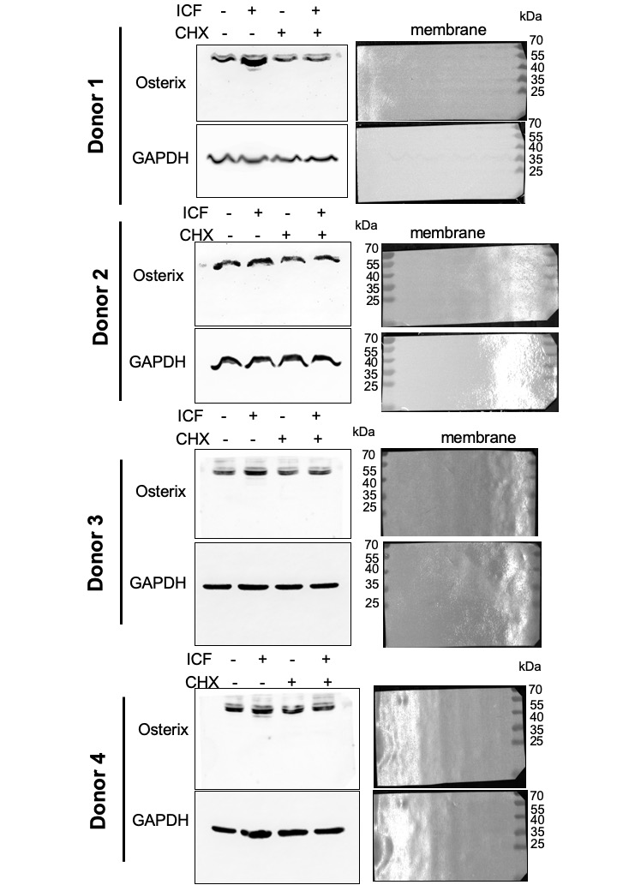

Supplementary Figure 1 Cells were pretreated with cycloheximide (CHX) for 30 min prior to ICF stimulation for 24 h in serum free culture medium. OSX and GAPDH protein expression was demonstrated using western blot. Cells from four different donors were utilized.

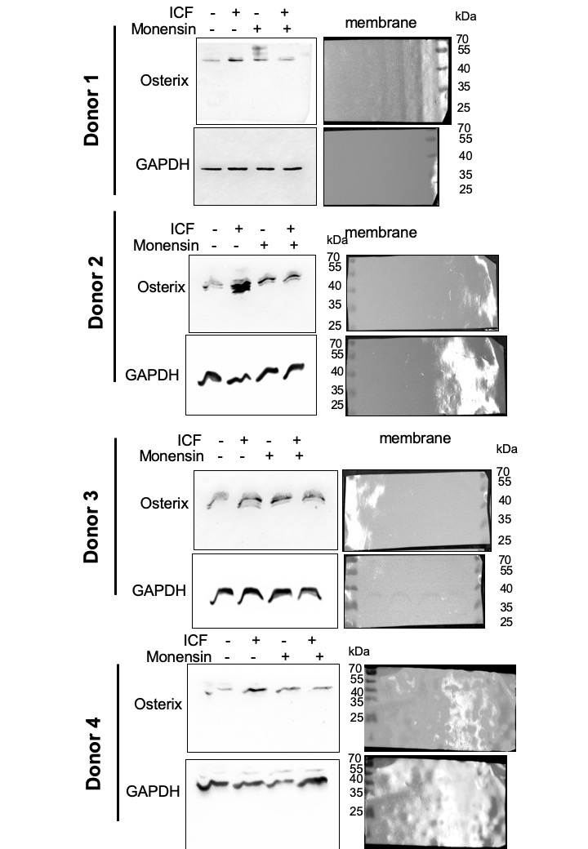

Supplementary Figure 2 Cells were pretreated with monensin for 30 min prior to ICF stimulation for 24 h in serum free culture medium. OSX and GAPDH protein expression was demonstrated using western blot. Cells from four different donors were utilized.

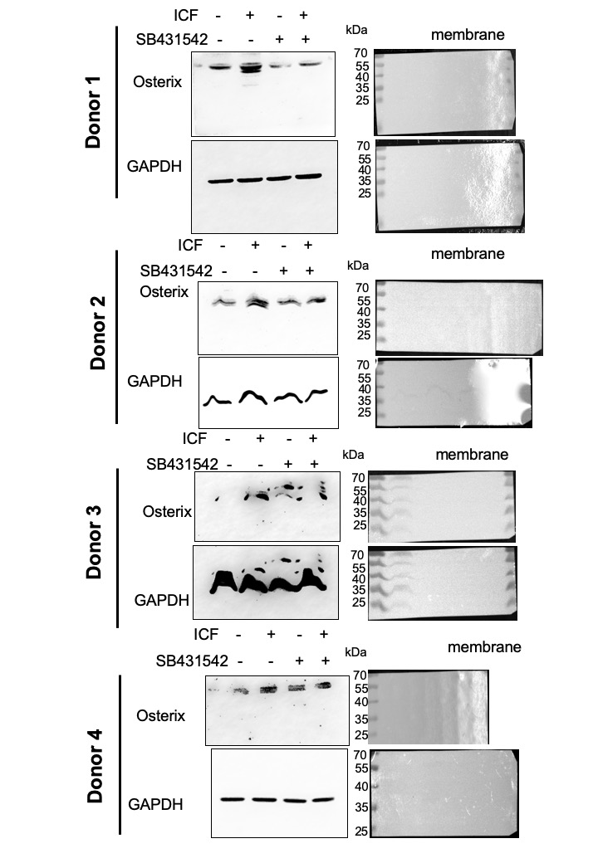

Supplementary Figure 3 Cells were pretreated with SB431542 for 30 min prior to ICF stimulation for 24 h in serum free culture medium. OSX and GAPDH protein expression was demonstrated using western blot. Cells from four different donors were utilized.

