SUPPLEMENTAL MATERIAL
SARS-CoV-2 infection is associated with a pro-thrombotic platelet phenotype
Dario Bongiovanni M.D.*^{1,2,3}, Melissa Klug M.Sc *^{1,2,4}, Olga Lazareva M.Sc⁴, Simon Weidlich M.D.⁵, Marina Biasi B.Sc ¹, Simona Ursu Ph.D ⁶, Sarah Warth Ph.D⁶, Christian Buske M.D.^{6,7}, Marina Lukas M.D.⁵, Christoph D. Spinner M.D.⁵, Moritz von Scheidt M.D.^{2,8}, Gianluigi Condorelli Ph.D³, Jan Baumbach Ph.D⁴, Karl-Ludwig Laugwitz M.D.^{1,2}, Markus List Ph.D.^{4,†} and Isabell Bernlochner M.D.^{1,2,†}
* These authors contributed equally
†These authors jointly supervised this work

¹ Technical University of Munich, School of Medicine, University hospital rechts der Isar, Department of Internal Medicine I, Munich, Germany
² German Center for Cardiovascular Research (DZHK), Partner Site Munich Heart Alliance, Germany;
³ Department of Cardiovascular Medicine, Humanitas Clinical and Research Center IRCCS and Humanitas University, Rozzano, Milan, Italy
⁴ Chair of Experimental Bioinformatics, TUM School of Life Sciences Weihenstephan, Technical University of Munich, Munich, Germany;
⁵ Technical University of Munich, School of Medicine, University hospital rechts der Isar, Department of Internal Medicine II, Munich, Germany
⁶ Core Facility Cytometry, Ulm University Medical Faculty, Germany
⁷ CCC Ulm, Institute of Experimental Cancer Research, University Hospital Ulm, Germany
⁸ Deutsches Herzzentrum München, Cardiology, Technische Universität München, Munich, Germany;

Running title: platelet activation during SARS-CoV-2 infection

- Supplemental Results
Flowsom and clustering analysis
FlowSOM allows to investigate subsets of platelets with similar phenotype that are not detectable at the UMAPs analysis (Figure 1). As platelets are less heterogenous than other cells from peripheral blood and specific markers for subgroups are lacking, clustering analysis is challenging and did not provide strong results. Supplemental Figure III shows the different expression patterns involved in the TRAP-stimulation process in the control group compared to COVID-19 patients. Non-stimulated platelets of healthy donors express activation markers P-Selectin and LAMP-3 mostly in clusters 1 and 2, whereas COVID-19 patients show the highest expression of these markers in cluster 4 (Supplemental Figure IIIA). Interestingly, cluster 1 is characterized by a significantly higher median expression of CD62P and CD41 as well as a significantly lower median expression of CD61 and CD107a compared to COVID-19 patients. Cluster 4, containing most of the activated cells in patients, is characterized by a significantly higher median expression of GPIIb/IIIa complex, CD47 and CD9 (P values and medians are shown in Supplemental Table III and IV).
After TRAP-stimulation the clusters in which the platelets are most activated also differ between control and patients. COVID-infected platelets show most activation, mirrored in the higher P-Selectin and LAMP-3 expression, in cluster 2, whereas the control group shows most activated platelets in clusters 4 and 5 (Supplemental Figure IIIB).
- Supplemental Figures
Supplemental Figure I: Gating protocol
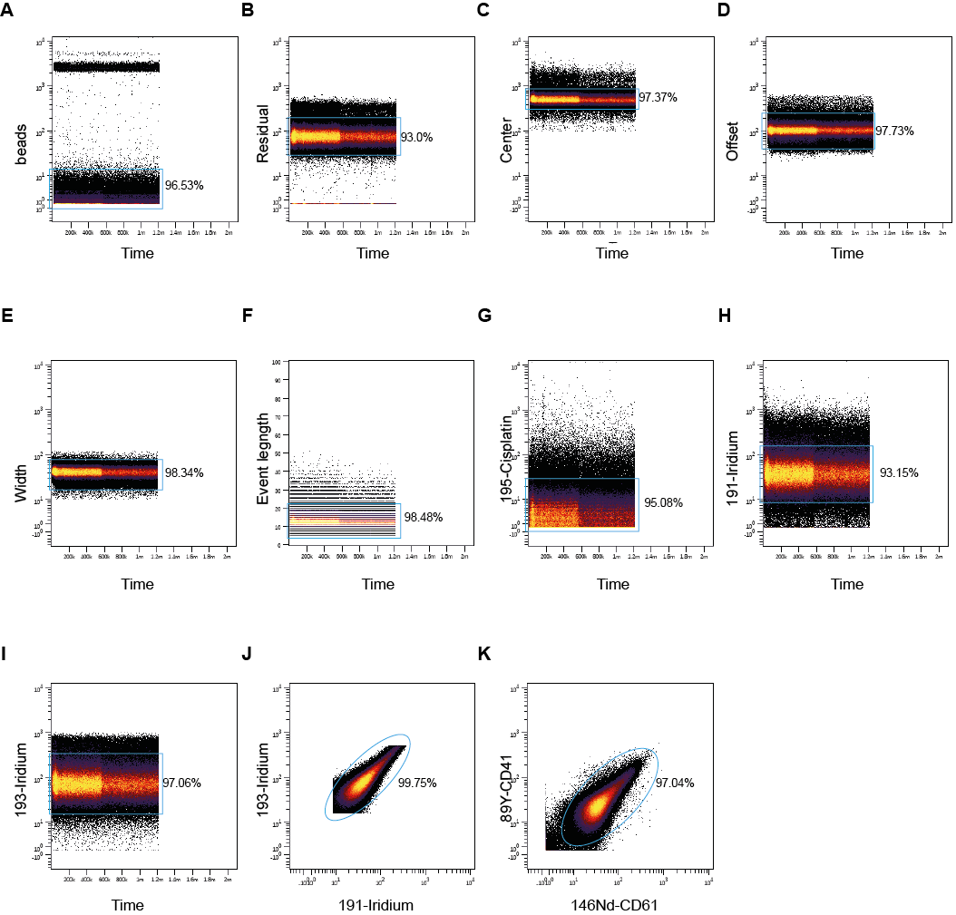Supplemental Figure I Legend: Gating protocol. A) Exclusion of beads, B-E) clean-up according to the Gaussian discrimination, F) selecting event length for low range intensity, G) live-dead cell discrimination by only excluding cisplatin stained cells, H-J) RNA containing cells stained with 191/193-Iridium, K) gating only CD41 and CD61 positive cells to exclude debris and contamination.
Supplemental Figure II: Marker expression in non-stimulated and TRAP-stimulated platelets
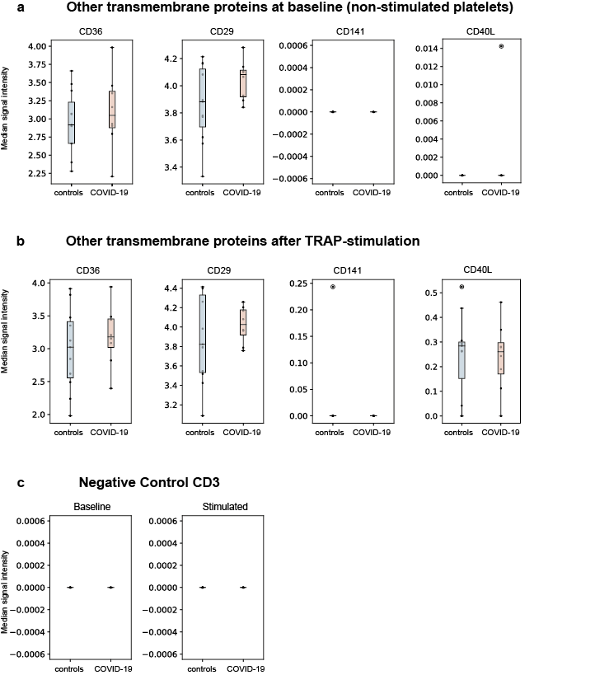
Supplemental Figure II Legend: Marker expression in non-stimulated and TRAP-stimulated platelets. Median signal intensity of transmembrane proteins measured in (a) non-stimulated platelets and (b) TRAP-stimulated platelets. (c) Negative control marker CD3 measured at baseline and after stimulation state. The horizontal line within the box plot represents the median, the top and bottom of each box indicate the interquartile range (Q1-Q3), whisker bars indicate the largest observation that is less than or equal to the upper inner fence (UIF =Q3+1.5*IQR) or the smallest observation that is greater than or equal to the lower inner fence (LIF=Q1-1.5*IQR). The circles indicate outliers, if present; *: p<0.01.
Supplemental Figure III: FlowSOM analysis in non-stimulated and TRAP-stimulated platelets
Supplemental Figure III legend: Clustering analysis of platelets in healthy controls and COVID-19 patients. Platelets from platelet-rich plasma were stained with the described CYTOF panel (see methods). Single live CD41/CD61 cells for each file were exported, concatenated and then analyzed using FlowSOM. Cells were clustered into nodes, which were divided over 12 metaclusters. This automatic meta-clustering of the FlowSOM nodes is indicated by the background color of the nodes (red, orange, yellow, lime, green, mint, cyan, azure, violet, purple, pink and magenta) and the numbers from 1-12. Separate FlowSOM trees show the P-Selectin (first row) and LAMP-3 (second row) expression across the clusters for healthy controls and COVID-19 patients in (A) non stimulated platelets and (B) after stimulation with 10 µM TRAP.
- Supplemental Tables
Supplemental Table I Baseline demographic and clinical characteristics of the trial population
Characteristic | Patients  (n=8) | Healthy donors  (n=11) | p value
Age (years), mean (+/-SD) | 51.4 (11.7) | 44.7 (13.0) | 0.27
18-39 years, no. (%) | 1 (12.5) | 4 (36)
40-60 years, no. (%) | 5 (62.5) | 6 (55)
60-70 years, no. (%) | 2 (25) | 1 (9)
Male sex, no. (%) | 5 (62.5) | 5 (45) | 0.49
SARS-CoV-2 RT-PCR upper respiratory tract, no. (%) | 8 (100)
Oxygen saturation at admission, % mean (+/-SD) | 93.5 ± 2.9
Length of hospital stay (days), mean (+/-SD) | 9.5 (6.3)
CT scan: typical lesions* no. (%) | 7 (88)
Thrombocytes (G/l), mean (+/-SD) | 225.5 (57.7)
Hemoglobin (g/dl), mean (+/-SD) | 13.1 (1.7)
Leukocytes (G/l), mean (+/-SD) | 4.9 (1.6)
CRP (mg/dl), mean (+/-SD) | 3.9 (7.1)
D-Dimer (µg/l), mean (+/-SD) | 728 (2294.2)
IL6 (pg/ml), mean (+/-SD) | 18.9 (21.2)
GFR (ml/min), mean (+/-SD) | 95.5 (17.6)
Notes: In case of non-detectable level, the lowest detectable level of each parameter has been used for statistics: CRP < 0.1 is equal to 0.1, Il-6 <1.5 is equal to 1.5, D-Dimer <200 is equal to 200. SD: standard deviation. N=8 SARS-CoV-2 positive patients. *bilateral ground-glass opacities
Supplemental Table II: CyTOF Antibodies and Reagents
Antibody | Source | Identifier
CD107a/LAMP1 (H4A3)-151Eu | Fluidigm Sciences | Cat#: 3151002B
CD141 (M80)166Er | Fluidigm Sciences | Cat#: 3166017B
CD154/CD40L (24-31)-168Er | Fluidigm Sciences | Cat#: 3168006B
CD29 (TS2/16)156Gd | Fluidigm Sciences | Cat#: 3156007B
CD3 (UCHT1)-170Er | Fluidigm Sciences | Cat#: 3170001B
CD31/PECAM-1 (WM59)-145Nd | Fluidigm Sciences | Cat#: 3145004B
CD36 (5-271)152Sm | Fluidigm Sciences | Cat#: 3152007B
CD40 (5C3)-142Nd | Fluidigm Sciences | Cat#: 3142010B
CD41 (HIP8)-89Y | Fluidigm Sciences | Cat#: 3089004B
CD42a (GR-P)- 141Pr | Thermofisher | Cat#: MA1-91023
CD42b (HIP1)-144Nd | Fluidigm Sciences | Cat#: 3144020B
CD47 (CC2C6)209B | Fluidigm Sciences | Cat#: 3209004B
CD61 (VI-PL2)-146Nd | Fluidigm Sciences | Cat#: 3146011B
CD62P (KO-2-7)-161Dy | Thermofisher | Cat#: MA1-81809
CD63 (H5C6)-150Nd | Fluidigm Sciences | Cat#: 3150021B
CD69 (FN50)162Dy | Fluidigm Sciences | Cat#: 3162001B
CD9 (SN4 C33A2)-171Yb | Fluidigm Sciences | Cat#: 3171009B
GPVI (HY101)-175Lu | Thermofisher | Cat#: 14-9813-81
GPIIb/GPIIIa complex (CRC64)-155Gd | Biozol | Cat#: MBS465049
PAR1 (ATAP2) -147Sm | Thermofisher | Cat#: 35-2200
PEAR (492621)-174Yb | Novusbio | Cat#: MAB4527
Maxpar® X8 Multimetal Labeling Kit | Fluidigm | Cat#: 201300
Cell-ID™ Intercalator-Ir | Fluidigm | Cat#: 201192A
Cell-ID™ Cisplatin | Fluidigm | Cat#: 201064
Maxpar® Cell Staining Buffer | Fluidigm | Cat#: 201068
Maxpar® Fix and PermBuffer | Fluidigm | Cat#: 201067
AB Stabilizer, PBS base | Boca Scientific | Cat#: 131050

Supplemental Table III: P values compared using linear mixed effect model for the described clusters in non-stimulated platelets
Marker | Cluster | P value | P value corrected | Median Control | Median COVID-19
CD61 | 1 | <1x10⁻²⁵⁰ | <1x10⁻²⁵⁰ | 4.789x10¹⁴ | 5.1643x10¹⁴
CD62P | 1 | <1x10⁻²⁵⁰ | <1x10⁻²⁵⁰ | 3.2686x10¹⁶ | 4.573x10¹⁴
CD29 | 1 | 9.0205x10⁻²¹⁵ | 1.9271x10⁻²¹³ | 6.2913x10¹⁵ | 6.144x10¹⁵
CD41 | 1 | 4.1299x10⁻¹⁰ | 3.7328x10⁻¹⁰ | 4.407x10¹⁵ | 4.5827x10¹⁴
CD107a | 1 | 3.7819x10⁻⁷ | 3.2917x10⁻⁷ | 3.3153x10¹⁵ | 7.4297x10¹⁵
CD141 | 1 | 1.2438x10⁹ | 5.7312x10⁸ | 2.5689x10¹⁴ | 1.7287x10¹⁶
CD45 | 1 | 1.3897x10¹⁰ | 5.9379x10⁸ | 2.5438x10¹⁶ | 2.1306x10¹⁶
PEAR | 1 | 1.1527x10¹¹ | 4.3691x10¹⁰ | 3.5706x10¹⁶ | 2.8945x10¹⁶
CD42b | 1 | 4.9259x10¹⁶ | 5.8463x10¹² | 5.6423x10¹⁵ | 5.8607x10¹⁵
CD3 | 1 | 8.7116x10¹⁵ | 2.027x10¹⁵ | 2.8502x10¹⁶ | 1.1436x10¹⁶
CD63 | 1 | 2.7188x10¹⁶ | 4.9915x10¹⁵ | 2.1707x10¹⁶ | 2.6622x10¹⁵
CD47 | 1 | 5.5995x10¹⁵ | 6.5467x10¹⁵ | 4.8086x10¹⁴ | 4.9879x10¹⁵
PAR1 | 1 | 6.5115x10¹⁵ | 7.3461x10¹⁵ | 3.6313x10¹⁴ | 3.4258x10¹³
CD69 | 1 | 7.8502x10¹⁵ | 8.3975x10¹⁵ | 4.0856x10¹⁵ | 4.1516x10¹⁵
CD42a | 1 | 7.9185x10¹⁵ | 8.3975x10¹⁵ | 5.8604x10¹⁵ | 5.855x10¹⁵
CD40 | 1 | 8.2703x10¹⁵ | 8.7153x10¹⁵ | 1.2393x10¹⁶ | 1.2974x10¹⁵
CD154 | 1 | 3.5171x10¹⁶ | 8.8873x10¹⁵ | 2.9581x10¹⁵ | 2.4996x10¹⁵
GPIIb/GPIIIa complex | 1 | 7.3096x10¹⁵ | 1.1847x10¹⁶ | 7.0382x10¹⁵ | 7.235x10¹⁵
GPVI | 1 | 6.1383x10¹⁰ | 2.2192x10¹⁶ | 5.6377x10¹⁴ | 5.3819x10¹⁴
CD36 | 1 | 2.5488x10¹⁶ | 3.291x10¹⁶ | 5.4386x10¹⁵ | 5.4801x10¹⁴
CD31 | 1 | 3.9753x10¹⁵ | 4.7663x10¹⁶ | 4.7019x10¹⁵ | 4.7062x10¹⁵
CD9 | 1 | 3.3561x10¹⁶ | 6.0204x10¹⁶ | 6.6857x10¹⁶ | 6.8132x10¹⁵
PEAR | 2 | <1x10⁻²⁵⁰ | <1x10⁻²⁵⁰ | 2.7487x10¹⁶ | 2.2745x10¹⁶
CD31 | 2 | 2.6082x10⁻⁵ | 0.0002 | 3.6938x10¹⁶ | 3.8553x10¹⁶
CD45 | 2 | 23646.6 | 1.4624x10⁶ | 1.6076x10¹⁶ | 1.4287x10¹⁴
CD42b | 2 | 66550 | 3.9099x10⁶ | 4.7507x10¹⁵ | 5.0019x10¹⁵
CD107a | 2 | 6.8117x10¹⁵ | 2.0522x10¹⁴ | 2.2649x10¹⁶ | 3.7987x10¹⁴
GPIIb/GPIIIa complex | 2 | 2.5182x10¹⁶ | 4.7343x10¹⁴ | 6.0753x10¹⁵ | 6.4499x10¹⁵
CD141 | 2 | 6.7644x10¹⁵ | 1.1039x10¹⁵ | 0 | 0
CD47 | 2 | 5.2213x10¹⁵ | 1.2916x10¹⁵ | 3.9796x10¹⁴ | 4.2452x10¹⁴
CD69 | 2 | 6.6305x10¹⁶ | 1.5582x10¹⁵ | 3.1443x10¹⁴ | 3.4x10¹⁵
CD63 | 2 | 7.466x10¹⁵ | 2.2208x10¹⁵ | 1.3572x10¹⁴ | 1.6128x10¹⁵
PAR1 | 2 | 1.5633x10¹⁶ | 3.1945x10¹⁵ | 2.844x10¹⁴ | 2.6462x10¹⁶
CD62P | 2 | 1.862x10¹⁶ | 3.6227x10¹⁵ | 2.3127x10¹⁴ | 3.2974x10¹⁶
CD40 | 2 | 2.5809x10¹⁶ | 4.7757x10¹⁵ | 6.1466x10¹⁴ | 6.7899x10¹⁵
CD61 | 2 | 1.9377x10¹⁶ | 6.5051x10¹⁵ | 3.8149x10¹⁴ | 4.3428x10¹⁵
CD29 | 2 | 8.7437x10¹⁴ | 9.0919x10¹⁵ | 5.3786x10¹⁵ | 5.3715x10¹⁶
CD154 | 2 | 9.1399x10¹⁵ | 9.3386x10¹⁵ | 2.3948x10¹³ | 1.646x10¹⁵
CD3 | 2 | 1.4562x10¹⁶ | 2.093x10¹⁶ | 1.1879x10¹⁴ | 4.6158x10¹⁵
CD41 | 2 | 9.4588x10¹⁵ | 2.117x10¹⁶ | 3.3999x10¹⁴ | 3.8161x10¹⁶
GPVI | 2 | 1.0928x10¹⁶ | 2.4226x10¹⁶ | 4.9204x10¹⁵ | 4.7187x10¹⁴
CD36 | 2 | 1.9802x10¹⁶ | 2.6899x10¹⁶ | 4.399x10¹⁶ | 4.6892x10¹⁴
CD42a | 2 | 1.2363x10¹⁵ | 2.7152x10¹⁶ | 4.983x10¹⁵ | 5.0986x10¹⁵
CD9 | 2 | 1.6483x10¹⁵ | 3.2551x10¹⁶ | 5.8293x10¹⁵ | 6.036x10¹⁴
GPIIb/GPIIIa complex | 4 | <1x10⁻²⁵⁰ | <1x10⁻²⁵⁰ | 4.5805x10¹⁴ | 5.0348x10¹⁵
CD47 | 4 | <1x10⁻²⁵⁰ | <1x10⁻²⁵⁰ | 2.366x10¹⁴ | 2.707x10¹⁶
CD9 | 4 | 3.2894x10⁻¹⁸¹ | 6.4418x10⁻¹⁷⁹ | 4.3633x10¹⁴ | 4.668x10¹⁵
CD61 | 4 | 6.5894x10⁵ | 3.6869x10⁷ | 2.3594x10¹⁴ | 2.8277x10¹⁶
PEAR | 4 | 2.0109x10⁷ | 9.8449x10⁷ | 1.5474x10¹⁶ | 1.2398x10¹⁴
CD45 | 4 | 2.5591x10⁷ | 1.3986x10⁸ | 5.6262x10¹⁴ | 5.0433x10¹⁵
CD42b | 4 | 9.4779x10⁸ | 4.2025x10⁹ | 3.2911x10¹⁴ | 3.6601x10¹⁵
CD29 | 4 | 7.3992x10¹⁵ | 8.0875x10¹⁴ | 3.9467x10¹⁴ | 3.9979x10¹⁶
CD62P | 4 | 6.3814x10¹⁵ | 1.5302x10¹⁵ | 5.9289x10¹⁴ | 1.249x10¹⁵
CD31 | 4 | 1.7487x10¹⁶ | 2.4461x10¹⁵ | 2.2297x10¹⁶ | 2.4554x10¹⁵
CD40 | 4 | 1.3482x10¹⁶ | 2.8803x10¹⁵ | 0 | 0
GPVI | 4 | 2.3007x10¹⁶ | 4.3957x10¹⁵ | 3.4869x10¹⁴ | 3.2768x10¹⁵
PAR1 | 4 | 3.8031x10¹⁶ | 4.6068x10¹⁵ | 1.4133x10¹⁶ | 1.2348x10¹⁵
CD69 | 4 | 5.7294x10¹⁵ | 6.6654x10¹⁵ | 1.953x10¹⁶ | 2.0041x10¹⁶
CD41 | 4 | 3.2817x10¹⁵ | 8.4035x10¹⁵ | 1.8969x10¹⁶ | 2.3588x10¹⁴
CD42a | 4 | 3.041x10¹⁶ | 9.9256x10¹⁵ | 3.5568x10¹⁶ | 3.6519x10¹⁶
CD36 | 4 | 1.0721x10¹⁶ | 1.6908x10¹⁶ | 2.9472x10¹⁴ | 3.2089x10¹⁶
CD63 | 4 | 1.0902x10¹⁶ | 1.6967x10¹⁶ | 3.6263x10¹⁴ | 4.7517x10¹⁵
CD107a | 4 | 1.8926x10¹⁵ | 3.6456x10¹⁶ | 0 | 0

Supplemental Table IV: P values compared using linear mixed effect model for the described clusters in stimulated platelets
Marker | Cluster | P value | P value corrected | Median Control | Median COVID-19
CD36 | 2 | 8.8872x10¹⁵ | 9.1779x10¹³ | 3.2686x10¹⁴ | 3.3664x10¹⁶
CD29 | 2 | 1.0197x10¹⁶ | 2.5609x10¹⁴ | 4.1338x10¹⁴ | 3.8753x10¹⁴
GPVI | 2 | 1.0088x10¹⁶ | 2.5609x10¹⁴ | 3.4052x10¹⁶ | 3.1317x10¹⁴
CD47 | 2 | 4.8015x10¹⁵ | 6.0636x10¹⁴ | 2.6911x10¹⁶ | 2.9689x10¹⁶
CD62P | 2 | 6.5394x10¹⁵ | 7.4496x10¹⁴ | 4.1018x10¹⁵ | 4.3811x10¹⁶
CD69 | 2 | 2.584x10¹⁴ | 3.8848x10¹⁵ | 1.9053x10¹⁶ | 2.0767x10¹⁶
CD42b | 2 | 2.6123x10¹⁶ | 3.8956x10¹⁵ | 3.3737x10¹⁶ | 3.4955x10¹⁴
CD107a | 2 | 4.2718x10¹⁶ | 5.601x10¹⁵ | 2.6415x10¹⁶ | 2.5124x10¹⁶
CD3 | 2 | 4.8504x10¹⁶ | 6.0906x10¹⁵ | 0 | 0
PAR1 | 2 | 5.1036x10¹³ | 6.3365x10¹⁵ | 4.5664x10¹⁵ | 4.2549x10¹⁶
CD31 | 2 | 5.7245x10¹⁵ | 6.7674x10¹⁵ | 2.5203x10¹⁵ | 2.4991x10¹⁶
CD141 | 2 | 5.8479x10¹⁵ | 6.7674x10¹⁵ | 0 | 0
CD9 | 2 | 6.7705x10¹⁵ | 7.6732x10¹⁵ | 4.5782x10¹⁶ | 4.6065x10¹⁴
CD42a | 2 | 6.9407x10¹³ | 7.826x10¹⁵ | 3.5087x10¹⁵ | 3.5515x10¹⁶
CD40 | 2 | 7.2491x10¹⁵ | 8.0103x10¹⁵ | 0 | 0
GPIIb/GPIIIa complex | 2 | 7.6033x10¹⁵ | 8.2775x10¹⁵ | 5.0073x10¹⁵ | 5.0389x10¹⁴
CD154 | 2 | 8.6336x10¹⁴ | 8.9686x10¹⁵ | 1.9048x10¹⁵ | 2.0018x10¹⁶
CD41 | 2 | 9.7838x10¹⁵ | 9.9185x10¹⁵ | 2.3461x10¹⁶ | 2.4627x10¹⁴
PEAR | 2 | 7.1384x10¹⁵ | 1.4473x10¹⁶ | 1.5801x10¹⁵ | 1.3833x10¹⁴
CD61 | 2 | 1.3435x10¹⁶ | 3.2991x10¹⁶ | 2.6533x10¹⁶ | 3.1428x10¹⁴
CD63 | 2 | 2.1906x10¹⁶ | 3.4899x10¹⁶ | 1.8883x10¹³ | 1.7499x10¹⁶
CD41 | 4 | 8.4064x10⁻⁷ | 0.0001 | 4.4365x10¹⁵ | 4.5144x10¹⁴
CD47 | 4 | 78.551 | 7890.9 | 4.8513x10¹⁵ | 4.8159x10¹⁵
PEAR | 4 | 1.3555x10⁶ | 1.1095x10⁷ | 3.5899x10¹⁴ | 2.6513x10¹⁶
CD141 | 4 | 2.3663x10⁸ | 1.5847x10⁸ | 4.5298x10¹⁴ | 1.7541x10¹⁶
PAR1 | 4 | 1.2052x10⁹ | 7.1986x10⁸ | 3.4496x10¹⁵ | 3.0544x10¹⁶
CD29 | 4 | 5.0706x10⁸ | 2.8015x10⁹ | 6.1473x10¹⁶ | 5.8864x10¹⁶
CD42a | 4 | 3.0415x10¹⁵ | 9.2078x10¹⁴ | 5.571x10¹⁴ | 5.3545x10¹⁵
CD3 | 4 | 4.0944x10¹⁰ | 1.7401x10¹⁵ | 2.8731x10¹⁴ | 1.8212x10¹⁴
CD69 | 4 | 2.6611x10¹⁶ | 3.8956x10¹⁵ | 4.1835x10¹⁵ | 4.0367x10¹⁵
CD31 | 4 | 1.733x10¹⁶ | 4.1164x10¹⁵ | 4.4233x10¹⁵ | 4.2745x10¹⁵
GPIIb/GPIIIa complex | 4 | 4.7583x10¹⁴ | 6.0435x10¹⁵ | 7.0584x10¹³ | 7.0418x10¹⁵
CD107a | 4 | 5.2382x10¹⁵ | 6.3785x10¹⁵ | 1.6701x10¹⁴ | 1.9428x10¹⁵
CD40 | 4 | 2.6649x10¹⁵ | 9.8157x10¹⁵ | 1.1691x10¹⁴ | 1.0274x10¹⁵
CD9 | 4 | 9.8464x10¹⁵ | 9.9363x10¹⁵ | 6.6826x10¹⁵ | 6.6441x10¹⁵
CD62P | 4 | 5.3384x10¹⁵ | 1.4747x10¹⁶ | 6.7002x10¹³ | 6.3378x10¹⁶
CD154 | 4 | 8.7294x10¹⁵ | 1.7073x10¹⁶ | 1.062x10¹⁴ | 7.3675x10¹⁵
CD63 | 4 | 5.4837x10¹⁴ | 1.9237x10¹⁶ | 4.6271x10¹⁴ | 3.8839x10¹⁵
CD36 | 4 | 1.0764x10¹⁶ | 2.016x10¹⁶ | 5.1902x10¹⁴ | 5.1622x10¹⁶
CD42b | 4 | 1.3156x10¹⁵ | 2.3684x10¹⁶ | 5.4886x10¹⁵ | 5.3726x10¹⁴
CD61 | 4 | 1.5982x10¹⁵ | 2.738x10¹⁶ | 4.687x10¹⁵ | 4.9245x10¹⁵

Supplemental Table V: Antibodies
Target antigen | Vendor or Source | Catalog # | Working concentration | Persistent ID / URL
CD62P | Thermofisher | MA1-81809 | 0.5 mg/ml | https://www.thermofisher.com/antibody/product/P-Selectin-Antibody-clone-Psel-KO-2-7-Monoclonal/MA1-81809
PEAR | Novusbio | MAB4527 | 0.5 mg/ml | https://www.novusbio.com/products/pear1-antibody-492621_mab4527
PAR1 | Thermofisher | 35-2200 | 0.5 mg/ml | https://www.thermofisher.com/antibody/product/PAR1-Antibody-clone-ATAP2-Monoclonal/35-2200
CD42a | Thermofisher | MA1-91023 | 0.5 mg/ml | https://www.thermofisher.com/antibody/product/CD42a-Antibody-clone-GR-P-Monoclonal/MA1-91023
GPIIb/GPIIIa complex | Biozol | MBS465049 | 0.5 mg/ml | https://www.mybiosource.com/monoclonal-dog-human-rabbit-antibody/cd41-cd61/465049
GPVI | Thermofisher | 14-9813-81 | 0.5 mg/ml | https://www.thermofisher.com/antibody/product/GP6-Antibody-clone-HY101-Monoclonal/14-9813-81
CD107a/LAMP1 | Fluidigm Sciences | 3151002B | 0.5 mg/ml | https://www.fluidigm.com/reagents/proteomics/3151002b-antihuman-cd107a-lamp1--h4a3--151eu-⁻¹⁰0tests
CD141 | Fluidigm Sciences | 3166017B | 0.5 mg/ml | https://www.fluidigm.com/reagents/proteomics/3166017b-antihuman-cd141--m80--166er-⁻¹⁰0tests
CD154/CD40L | Fluidigm Sciences | 3168006B | 0.5 mg/ml | https://www.fluidigm.com/reagents/proteomics/3168006b-antihuman-cd154-cd40l--24-31--168er-⁻¹⁰0tests
CD29 | Fluidigm Sciences | 3156007B | 0.5 mg/ml | https://www.fluidigm.com/reagents/proteomics/3156007b-antihuman-cd29--ts2-16--156gd-⁻¹⁰0tests
CD3 | Fluidigm Sciences | 3170001B | 0.5 mg/ml | https://www.fluidigm.com/reagents/proteomics/3170001b-antihuman-cd3--ucht1--170er-⁻¹⁰0tests
CD31/PECAM | Fluidigm Sciences | 3145004B | 0.5 mg/ml | https://www.fluidigm.com/reagents/proteomics/3145004b-antihuman-cd31-pecam-1--wm59--145nd-⁻¹⁰0tests
CD36 | Fluidigm Sciences | 3152007B | 0.5 mg/ml | https://www.fluidigm.com/reagents/proteomics/3152007b-antihuman-cd36--5-271--152sm-⁻¹⁰0tests
CD40 | Fluidigm Sciences | 3142010B | 0.5 mg/ml | https://www.fluidigm.com/reagents/proteomics/3142010b-antihuman-cd40--5c3--142nd-⁻¹⁰0tests
CD41 | Fluidigm Sciences | 3089004B | 0.5 mg/ml | https://www.fluidigm.com/reagents/proteomics/3089004b-antihuman-cd41--hip8--89y-⁻¹⁰0tests
CD42b | Fluidigm Sciences | 3144020B | 0.5 mg/ml | https://www.fluidigm.com/reagents/proteomics/3144020b-antihuman-cd42b--hip1--144nd-⁻¹⁰0tests
CD47 | Fluidigm Sciences | 3209004B | 0.5 mg/ml | https://www.fluidigm.com/reagents/proteomics/3209004b-antihuman-cd47--cc2c6--209bi-⁻¹⁰0tests
CD61 | Fluidigm Sciences | 3146011B | 0.5 mg/ml | https://www.fluidigm.com/reagents/proteomics/3146011b-antihuman-cd61--vi-pl2--146nd-⁻¹⁰0tests
CD63 | Fluidigm Sciences | 3150021B | 0.5 mg/ml | https://www.fluidigm.com/reagents/proteomics/3150021b-antihuman-cd63--h5c6--150nd-⁻¹⁰0tests
CD69 | Fluidigm Sciences | 3162001B | 0.5 mg/ml | https://www.fluidigm.com/reagents/proteomics/3162001b-antihuman-cd69--fn50--162dy-⁻¹⁰0tests
CD9 | Fluidigm Sciences | 3171009B | 0.5 mg/ml | https://www.fluidigm.com/reagents/proteomics/3171009b-antihuman-cd9--sn4-c3-3a2--171yb-⁻¹⁰0tests

