Table S1 Research on the accuracy of DNA sequencing
Treatment | #68 | #68+2control | #68+3control | #68+4control | #68+5control
Editing efficiency | 50% | 16.7% | 12.5% | 10% | 8.3%
Sequencing peak | 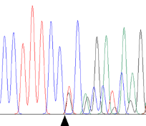 | 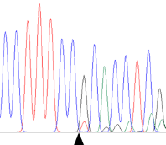 | 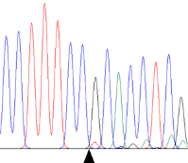 | 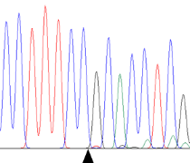 | 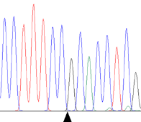
Note: #68 is a progeny produced by crossing #34 and a negative individual, and the heterozygosity rate of FGF5 gene in which was 50%. The black triangle indicates where the mutation occurred.

