SUMOylation disassembles the tetrameric pyruvate kinase M2 to block myeloid differentiation of leukemia cells
Li Xia^{1#}, Yue Jiang², Xue-Hong Zhang², Xin-Ran Wang¹, Ran Wei¹, Kang Qin¹, and Ying Lu^{1,2#}

Supplemental Figure 1 Comparative steady-state metabolomics analyses of subject-matched 32D^{BCR-ABL}, NB4 and U937 cells performed via LC–MS. Data are shown as the mean from n=3 experiments. Three independent experiments were performed and data were collected.
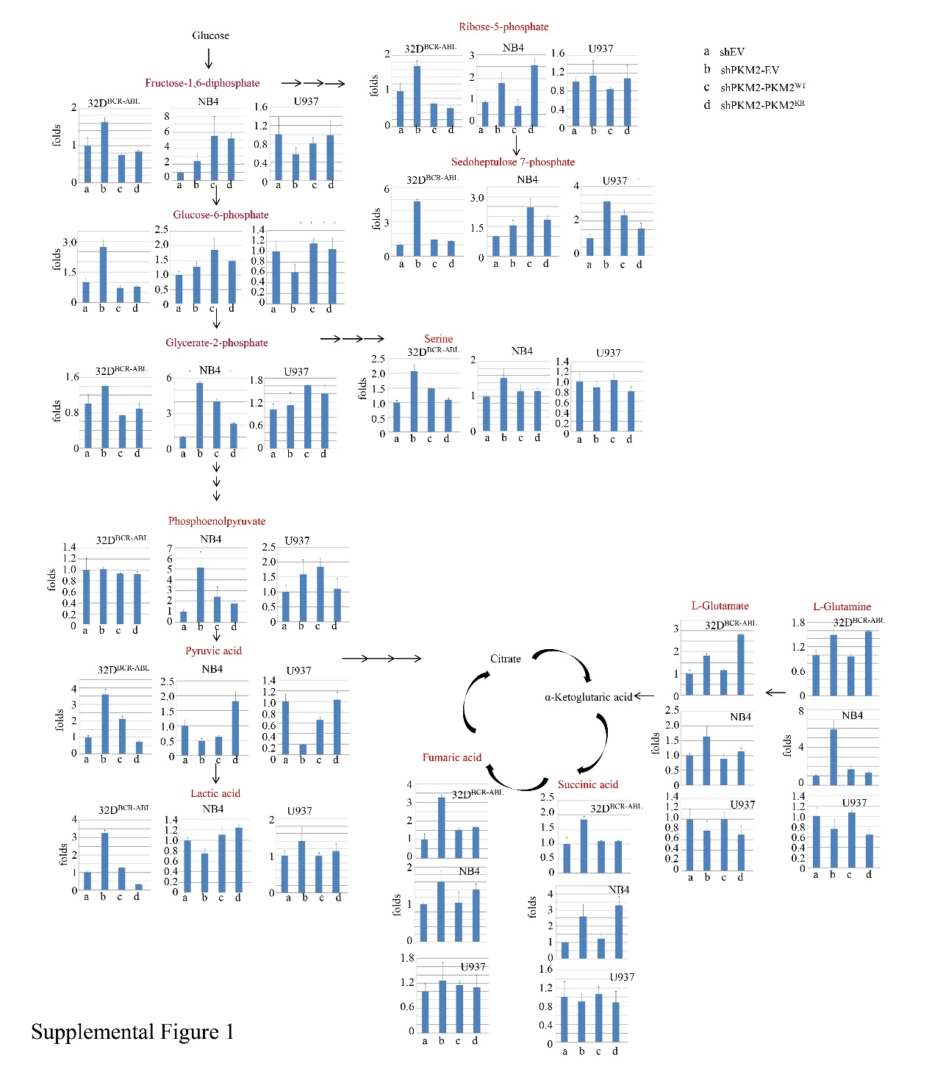

References
1. Xia, L., et al. A Novel Role for Pyruvate Kinase M2 as a Corepressor for P53 during the DNA Damage Response in Human Tumor Cells. J Biol Chem 291, 26138-26150 (2016).
2. Goyama, S., et al. Transcription factor RUNX1 promotes survival of acute myeloid leukemia cells. J Clin Invest 123, 3876-3888 (2013).

