Supplementary materials for

Caspase-6-cleaved Tau fails to induce Tau hyperphosphorylation and aggregation, neurodegeneration, glial inflammation, and cognitive deficits.

Anastasia Noël ^{1,2}, Bénédicte Foveau ^{1,2}, Andréa C. LeBlanc ^{1,2,3}

¹ Bloomfield Center for Research in Aging, Lady Davis Institute for Medical Research, Jewish General Hospital, 3755 Chemin Côte Ste Catherine, Montreal, QC, Canada H3T 1E2
² Department of Neurology and Neurosurgery, McGill University, 3755 University Street, Montreal, Québec, QC, Canada H3A 2B4
³ Department of Anatomy and Cell Biology, McGill University, 3755 University Street, Montreal, Québec, QC, Canada H3A 2B4

Running title: Caspase-6-cleaved Tau is not toxic.

Corresponding author: Andréa LeBlanc, PhD, Bloomfield Center for Research in Aging, Lady Davis Institute for Medical Research, Jewish General Hospital, 3755 Chemin Côte Ste Catherine, Montreal, QC, Canada H3T 1E2. Tel.: +1 (514) 340 8222 ext 25303; e-mail: andrea.leblanc@mcgill.ca

Supplementary Table 1. Fisher's exact test p values for the comparison of the NOR impaired CTC KI/Cre and CTO KI/Cre mice with their respective control genotypes at 3, 9, 18 and 25 months of age.

 | p value | CTC KI/Cre | CTO KI/Cre | CTC KI/WT | CTO KI/WT | WT/Cre | WT/WT
3M | CTC KI/Cre |  | 1.0000 | 1.0000 |  | 0.3326 | 0.2241
3M | CTO KI/Cre | 1.0000 |  |  | 0.0897 | 0.3150 | 0.0996
9M | CTC KI/Cre |  | 1.0000 | 0.1917 |  | 1.0000 | 1.0000
9M | CTO KI/Cre | 1.0000 |  |  | 1.0000 | 1.0000 | 1.0000
18M | CTC KI/Cre |  | 1.0000 | 0.3333 |  | 0.4815 | 1.0000
18M | CTO KI/Cre | 1.0000 |  |  | 1.0000 | 1.0000 | 1.0000
25M | CTC KI/Cre |  | 1.0000 | 1.0000 |  | 1.0000 | 1.0000
25M | CTO KI/Cre | 1.0000 |  |  | 1.0000 | 1.0000 | 0.6581

Supplementary Table 2. Fisher's exact test p values for the comparison of the Barnes maze impaired CTC KI/Cre and CTO KI/Cre mice with their respective control genotypes at 3, 9, 18 and 25 months of age.

 | p value | CTC KI/Cre | CTO KI/Cre | CTC KI/WT | CTO KI/WT | WT/Cre | WT/WT
3M | CTC KI/Cre |  | 0.4828 | n.d. |  | 0.2258 | 0.0421*
3M | CTO KI/Cre | 0.4828 |  | 1.0000 |  | 1.0000 | 0.3898
9M | CTC KI/Cre |  | 1.0000 | 0.6059 |  | 0.5996 | 0.5996
9M | CTO KI/Cre | 1.0000 |  |  | 1.0000 | 1.0000 | 0.5996
18M | CTC KI/Cre |  | 0.3845 | 1.0000 |  | 1.0000 | 0.5645
18M | CTO KI/Cre | 0.3845 |  |  | 0.0671 | 0.3845 | 0.0671
25M | CTC KI/Cre |  | 1.0000 | 0.5333 |  | 0.1029 | 1.0000
25M | CTO KI/Cre | 1.0000 |  |  | 0.1748 | 0.0473* | 1.0000
n.d.: not determined

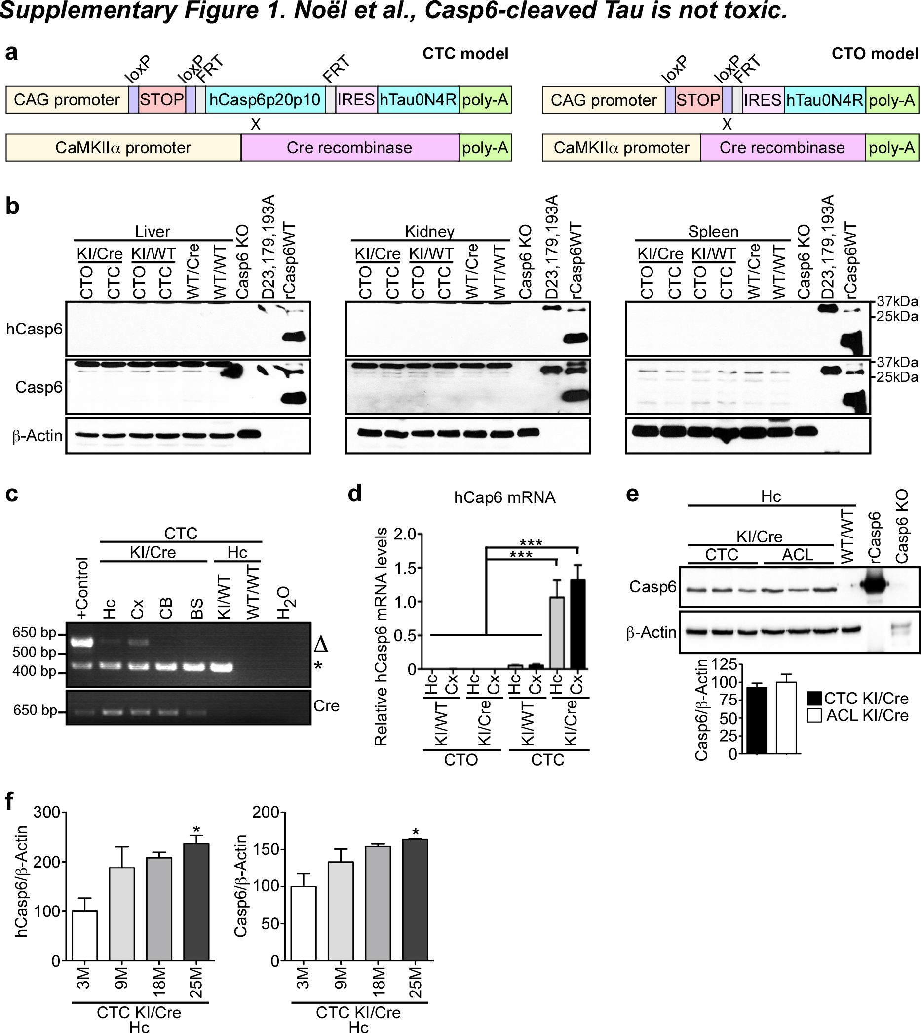

Supplementary Figure 1. CTC KI/Cre mice express hCasp6 under the CaMKIIa-Cre action. (a) Schematic diagram showing the constructs in transgenic mice crossed to generate the Conditional hTau-hCasp6 expressing (CTC) and Conditional hTau Only expressing (CTO) models. CAG promoter: ubiquitous cytomegalovirus immediate early enhancer fused to the chicken β-Actin (CAG) promoter, IRES: internal ribosomal entry site sequence, hCap6p20p10: hCasp6 cDNA lacking its pro-domain, FRT: Flippase recognition target sites. (b) Western blot analyses with anti-hCasp6, anti-total Casp6 and anti-β-Actin antibodies of 15 μg total proteins from 25-month-old CTO KI/Cre, CTC KI/Cre, CTO KI/WT, CTC KI/WT, WT/Cre and WT/WT liver, kidney and spleen. Casp6 KO protein extract was used as negative control. Recombinant unprocessed full-length Casp6 D23, 179, 193A (D23,179,193A) and Casp6WT were used as positive controls. (c) Red safe-stained agarose gel showing excision of the STOP sequence in the CTC KI/Cre mouse hippocampus and cortex by multiplex PCR amplification of the non-excised (*) and Cre-excised (Δ) knocked-in Hprt allele. Positive control for Hprt allele: mix of hCasp6-hTau transgene comprising the STOP cassette, with hCasp6-hTau transgene devoid of the STOP cassette. Genomic DNA from a T29-1 CaMKIIα-Cre mouse was used as positive control for the Cre gel. PCR without DNA (H₂O) or with wild-type genomic DNA (WT/WT) were used as negative controls. Hc: hippocampus. (d) RT-qPCR analyzes of hCasp6 mRNA in the hippocampus (Hc) and cortex (Cx) of KI/WT and KI/Cre mice (n=3/structure/genotype, 2 months of age). One-way ANOVA followed by Bonferroni's post-hoc, ***p<0.001. (e) Western blot analyses with anti-total Casp6 and anti-β-Actin antibodies of 15 μg total proteins from 3-month-old CTC KI/Cre, ACL KI/Cre and WT/WT hippocampus (n=3/genotype). Unpaired Student’s two-tailed t-test (p=0.59). Casp6C163A (rCasp6) was used as positive control. (f) Quantifications of western blots shown in Figure 1c. Results are expressed as hCasp6 or Casp6 over β-Actin, relative to 3-month-old CTC KI/Cre hippocampus (n=3/age). One-way ANOVA followed by Bonferroni's post-hoc, *p<0.05 vs 3-month-old CTC KI/Cre.

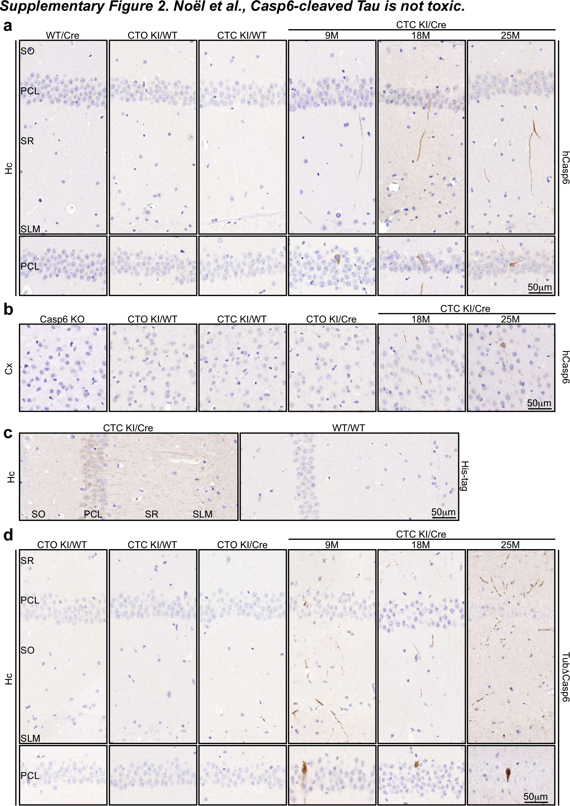

Supplementary Figure 2. Specific expression of active hCasp6 in the hippocampus and cortex of CTC KI/Cre mice throughout aging. Representative micrographs of (a,c,d) hippocampal or (b) cortical sections from WT/Cre, CTO KI/WT, CTC KI/WT, CTC KI/Cre and Casp6 KO mice stained with (a-b) anti-hCasp6, (c) anti-his-tag, or (d) anti-TubΔCasp6 antibody. n=3-5/genotype/age/structure. SO: stratum oriens, PCL: pyramidal cell layer, SR: stratum radiatum, SLM: stratum lacunosum molecular.

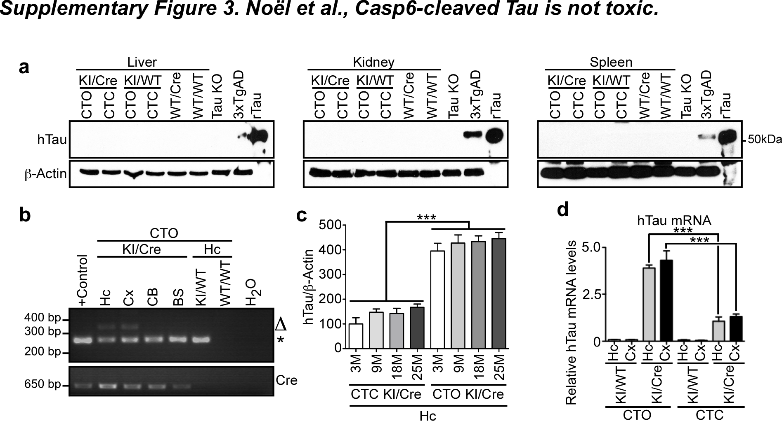

Supplementary Figure 3. CTC and CTO KI/Cre mice express hTau under the CaMKIIa-Cre action. (a) Western blot of 15 μg total proteins from 25-month-old CTO KI/Cre, CTC KI/Cre, CTO KI/WT, CTC KI/WT, WT/Cre and WT/WT liver, kidney and spleen with anti-hTau and anti-β-Actin antibodies. Lysates from Tau KO hippocampus was used as negative control. Protein extract from 3xTgAD and recombinant hTau were used as positive controls. (b) Red safe-stained agarose gel showing excision of the STOP sequence in the CTO KI/Cre mouse hippocampus and cortex by multiplex PCR amplification of the non-excised (*) and Cre-excised (Δ) knocked-in Hprt alleles. Positive control for non-excised knocked-in Hprt allele: hCasp6-hTau transgene comprising the STOP cassette. Genomic DNA from a T29-1 CaMKIIα-Cre mouse was used as positive control for the Cre gel. PCR without DNA (H₂O) or with wild-type genomic DNA (WT/WT) were used as negative controls. Hc: hippocampus, Cx: cortex, CB: cerebellum, BS: brainstem. (c) Densitometric analyses of western blots shown in Figure 1c. Results are expressed as ratios of hTau over β-Actin, relative to 3-month-old CTC KI/Cre. (d) RT-qPCR analyzes of hTau mRNA in the hippocampus (Hc) and cortex (Cx) of 2-month-old KI/WT and KI/Cre mice. (c&d) n=3/genotype. One-way ANOVA followed by Bonferroni's post-hoc test, ***p<0.001.

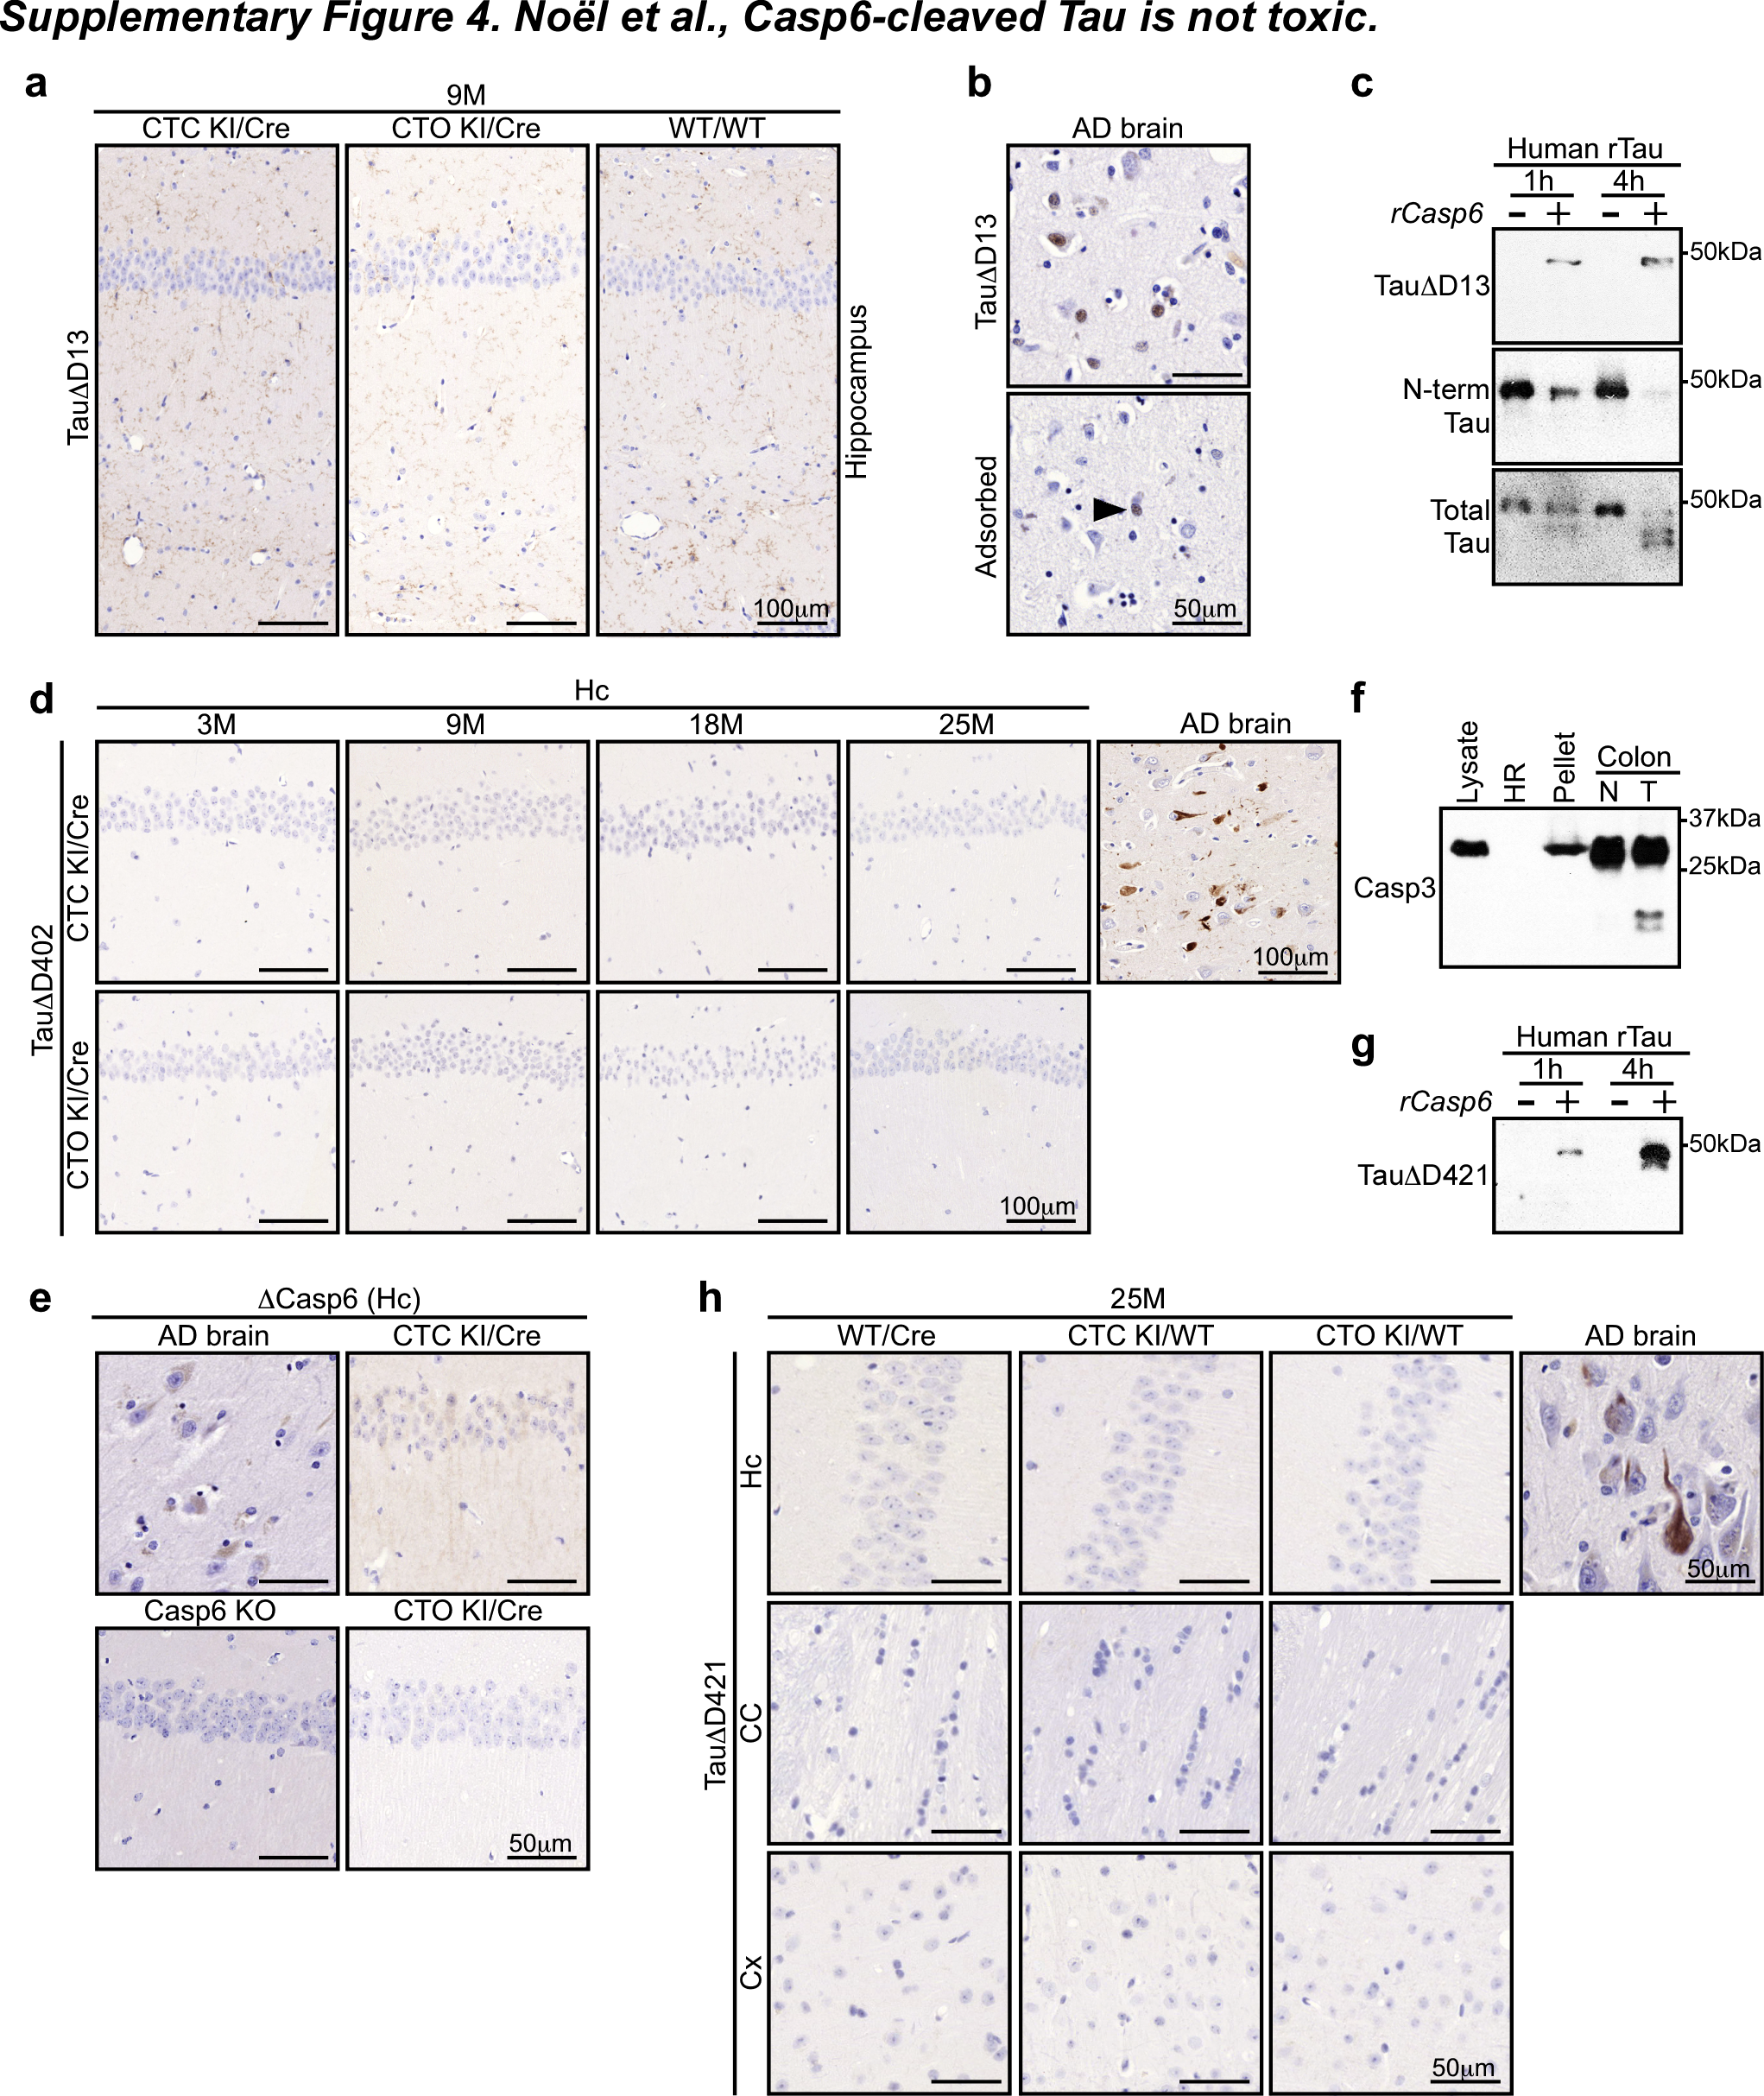
Supplementary Figure 4. Casp6 directly cleaves Tau at D421 and TauΔD421 is present in the CTC KI/Cre brains. (a-b) Representative micrographs of brain sections from (a) WT/WT, CTC and CTO KI/Cre, or (b) human AD stained with anti-TauΔD13 antibody. (c) Western blot analyses of human recombinant Tau0N4R (rTau) incubated with recombinant human active Casp6p20p10 (rCasp6) (+) or vehicle (-) for 1h or 4h with anti-TauΔD13, anti-hTau (N-term Tau) and anti-total Tau antibodies. (d) Representative micrographs of brain sections from 3- to 25-month-old CTC and CTO KI/Cre, or human AD stained with anti-TauΔD402. (e) Representative micrographs of brain sections from human AD, Casp6 KO, CTC and CTO KI/Cre stained with anti-processed Casp6 (ΔCasp6) antibody. (f) Western blot analyses of Casp3 in murine brain lysate, heat resistant (HR) and heat unstable proteins (pellet). Murine normal colon (N) or AOM-DSS induced colon tumor (T) lysates were used as controls for full length and processed Casp3. (g) Western blot analyses of human recombinant Tau0N4R (rTau) incubated with recombinant human active Casp6p20p10 (rCasp6) (+) or vehicle (-) for 1h or 4h with anti-TauΔD421 antibody. (h) Representative micrographs of brain sections from 25-month-old WT/Cre, CTC KI/WT and CTO KI/WT, or human AD stained with anti-TauΔD421 antibody.

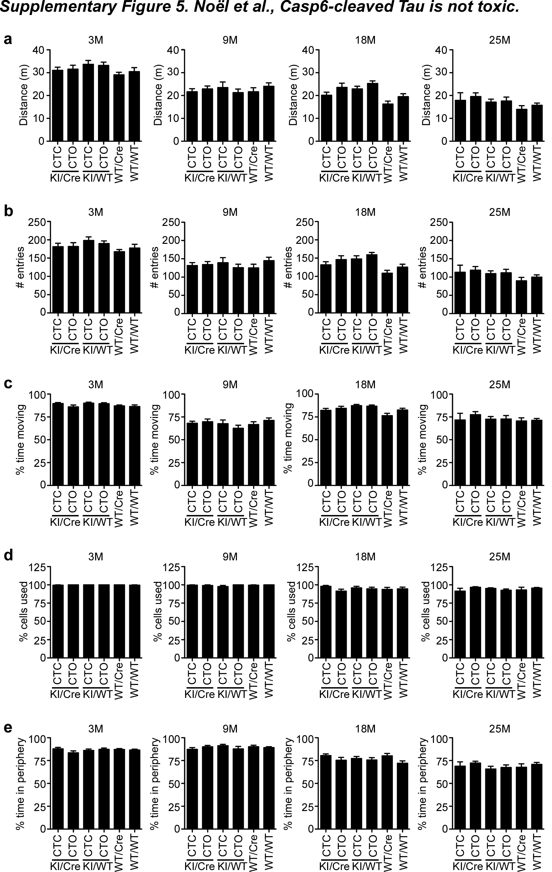
Supplementary Figure 5. CTC and CTO KI/Cre mice perform normally during the openfield test. (a) Total distance travelled, (b) total number of entries, (c) percentage of time moving, (d) percentage of cells used, and (e) percentage of time spent in the periphery of CTC KI/Cre (3M: n= 15, 9M: n=16, 18M: n=13, 25M: n=9), CTO KI/Cre (3M: n=14, 9M: n=15, 18M: n=14, 25M: n=17), CTC KI/WT (3M: n=15, 9M: n=13, 18M: n=15, 25M: n=14), CTO KI/WT (3M: n=16, 9M: n=15, 18M: n=17, 25M: n=16), WT/Cre (3M: n=16, 9M: n=15, 18M: n=14, 25M: n=10), and WT/WT (3M: n=15, 9M: n=16, 18M: n=17, 25M: n=18) at 3, 9, 18 and 25 months of age. Data represent the mean ± SEM.

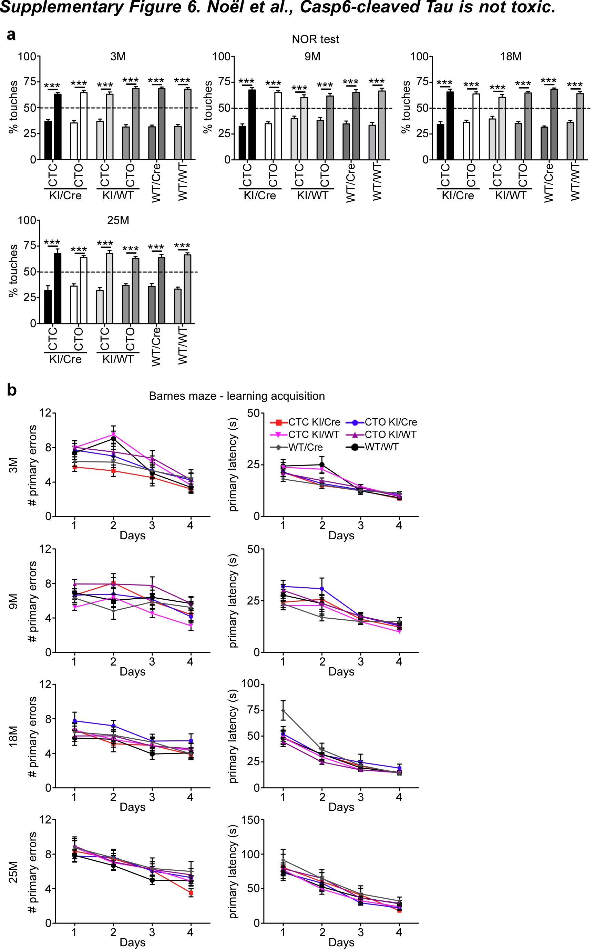

Supplementary Figure 6. CTC and CTO KI/Cre mice perform normally during the cognitive tests. (a) Percentage of touches to the familiar (left bars) and novel objects (right bars) during the novel object recognition test (NOR) and (b) number of primary errors and primary latency (s) to the target during the Barnes maze learning acquisition of 3 to 25-month-old CTC KI/Cre (3M: n= 15, 9M: n=16, 18M: n=13, 25M: n=9 for NOR and n=7 for Barnes maze), CTO KI/Cre (3M: n=14 for NOR and n=15 for Barnes maze, 9M: n=15, 18M: n=14, 25M: n=17), CTC KI/WT (3M: n=15, 9M: n=13, 18M: n=15, 25M: n=14), CTO KI/WT (3M: n=16, 9M: n=15, 18M: n=17, 25M: n=16), WT/Cre (3M: n=16, 9M: n=15, 18M: n=14, 25M: n=10), and WT/WT (3M: n=15 for NOR and n=14 for Barnes maze, 9M: n=16, 18M: n=17, 25M: n=18 for NOR and n=17 for Barnes maze). Statistical evaluations were done with (a) one-way ANOVA followed by a Bonferroni's post-hoc analysis, or (b) repeated-measures ANOVAs, with genotype and days as factors. Data represent the mean ± SEM. ***p<0.001.

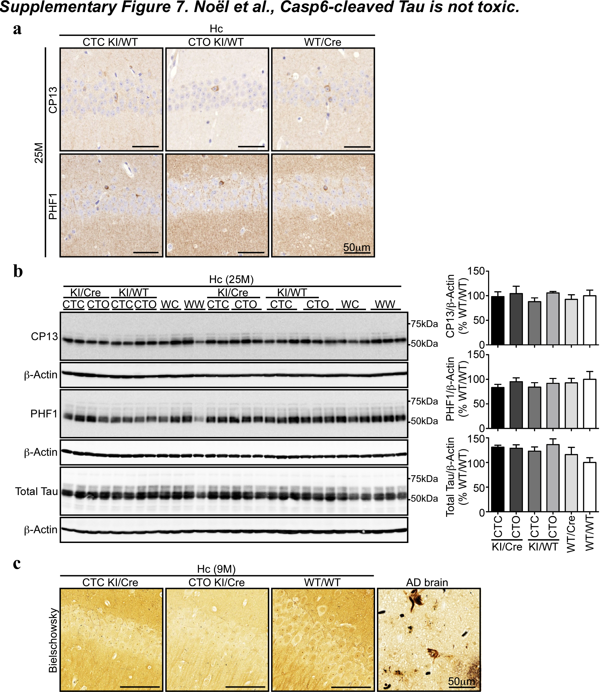

Supplementary Figure 7. The levels of phosphorylated Tau are not increased in the hippocampus of old CTC KI/Cre. (a) Representative micrographs of hippocampal sections from 25-month-old CTC KI/WT, CTO KI/WT and WT/Cre stained with CP13 or PHF1. (b) Western blot of 10 μg total hippocampal proteins from 25-month-old CTO and CTC KI/Cre, CTO and CTC KI/WT, WT/Cre and WT/WT with CP13, PHF1, anti-total Tau and anti-β-Actin antibodies. The histograms represent densitometric analyses of ratios of CP13, PHF1 or total Tau over β-Actin, relative to WT/WT (n=4-5/genotype). One-way ANOVA followed by Bonferroni's post-hoc test was performed. *p<0.05. (c) Representative micrographs of Bielschowsky silver staining of 9-month-old CTC and CTO KI/Cre, or WT/WT hippocampus tissue sections. Human AD brain was used as positive control. Hc: hippocampus.

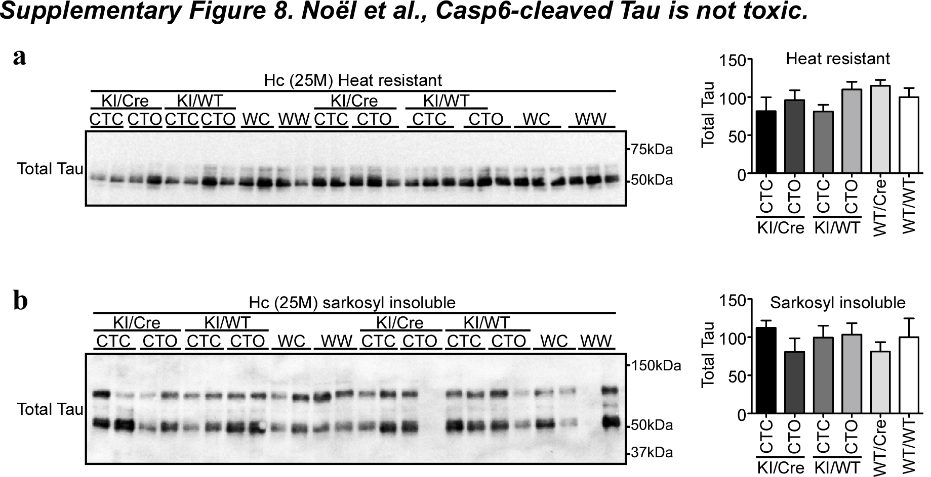

Supplementary Figure 8. Sarkosyl insoluble Tau is not significantly increased in the hippocampus of old CTC KI/Cre. Western blot analysis of total Tau in (a) the heat resistant protein hippocampal fraction or (b) the sarkosyl insoluble protein hippocampal fraction from 25-month-old CTC and CTO KI/Cre, CTC and CTO KI/WT, WT/Cre and WT/WT (n=4-5/genotype). Data represent the mean ± SEM. One-way ANOVA followed by Bonferroni's post-hoc test. Hc: hippocampus, WC: WT/Cre, WW: WT/WT.

