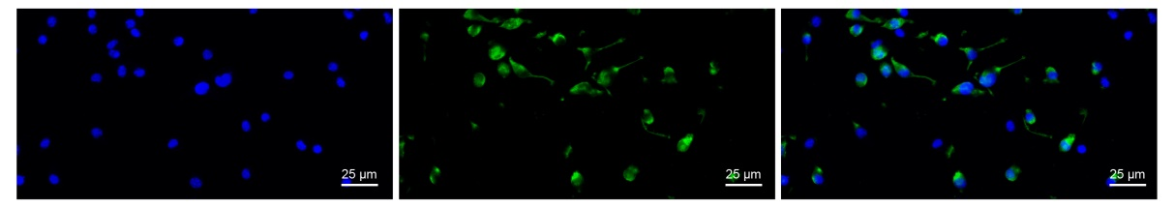
Fig. S1. NSE immunofluorescence staining image of hippocampal neurons. Left, DAPI-stained nuclei. Middle, NSE immunofluorescence staining image. Right, Merged image.

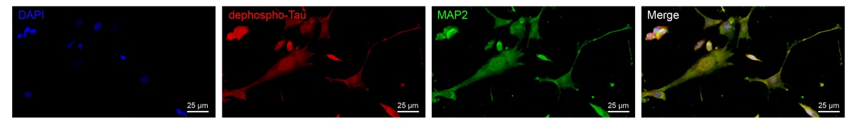
Fig. S2. Immunofluorescence images of hippocampal neurons for dephospho-Tau and MAP2.

Supplementary table 1 Primer sequences for RT-qPCR
Gene | Sequence
EZH2 | Forward: 5’-CTGCTCTGAATGGCAACTCC-3’
EZH2 | Reverse: 5’-TTATTCATAGAGCCACCTGG-3’
KLF2 | Forward: 5’-GAGCCTATCTTGCCGTCCTTT-3’
KLF2 | Reverse: 5’-CACGTTGTTTAGGTCCTCATCC-3’
GAPDH | Forward: 5’-GGTGAAGGTCGGTGTGAACG-3’
GAPDH | Reverse: 5’-CTCGCTCCTGGAAGATGGTG-3’
Note: EZH2, enhancer of zeste homolog 2; KLF2, Krüppel-like factor 2; GAPDH, glyceraldehyde-3-phosphate dehydrogenase; RT-qPCR, reverse transcription-quantitative polymerase chain reaction

