Supplementary Figure S1

Supplementary Figure S1. The effect of abiraterone on AR negative cell lines and AR positive cell line transfected with KAT2A-silencing plasmids or vectors. a Proliferation ability of AR negative PC cell lines PC-3 and DU145 and AR positive C4-2-AbiR with sh-KAT2A or vectors under abiraterone circumstance tested by soft agar assay. b Relative cell viability of PC-3, DU145 and C4-2-AbiR with sh-KAT2A or vectors under abiraterone circumstance tested by CCK-8.

Supplementary Figure S2

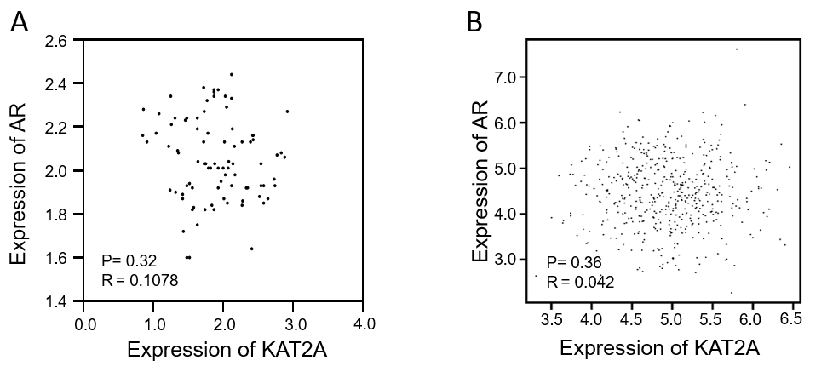

Supplementary Figure S2. The correlation between expression of KAT2A and AR. a The correlation between KAT2A and AR expression based on IHC H-score of 87 samples. b The correlation between KAT2A and AR expression based on TCGA database.

Supplementary Figure S3
Supplementary Figure S3. Resistance to abiraterone can be modified by upregulation of KAT2A in parental PC cell line. a Relative mRNA expression levels of KAT2A, AR and PSA in LNCaP-P stably transfected with OE-KAT2A or vectors were detected by qRT-PCR. b The protein levels of KAT2A, AR and PSA in LNCaP-P stably transfected with OE-KAT2A or vectors were detected by western blotting. c Aggregates of AR in cytoplasm or nucleus in LNCaP-P stably transfected with oe-KAT2A or vectors were extracted and detected. d Location of AR in C4-2-P stably transfected with oe-KAT2A or vectors was detected by IF. e Location of AR in LNCaP-P stably transfected with oe-KAT2A or vectors was detected by IF. *p < 0.05, **p < 0.01

Supplementary Figure S4
Supplementary Figure S4. a, b Acetylation level of AR in C4-2-P and LNCaP-P stably transfected with oe-KAT2A detected by pan-acetylation antibody after immunoprecipitation by AR antibody from cell lysates. c Proliferation of PC-3 cell line stably transfected with AR of wild type, K630Q or K630A with or without abiraterone. d Pattern of pGL3-basic containing promoter of KAT2A and mutant. e The negative control of IF in testing co-localisation of KAT2A and AR in C4-2-AbiR. f Proliferation of PC-3 cell line stably transfected with K630Q/K630A and KAT2A-SH/ KAT2A-OE/ vector with abiraterone tested by colony formation assay. g Relative cell viability of PC-3 cell line stably transfected with K630Q/K630A and KAT2A-SH/ KAT2A-OE/ vector with abiraterone tested by CCK-8.

Supplementary Table 1: qRT-PCR primer sequences in this study
Gene names | Primer sequence
GAPDH-F | 5′-GGTCGGAGTCAACGGATTTG-3′
GAPDH-R | 5′-GGAAGATGGTGATGGGATTTC-3′
KAT2A-F | 5′-CTCTGCCTTAACTACTGGAAGC-3′
KAT2A-R | 5′-GCCATCTGGTGTAATTGACCTTG-3′
AR-F | 5′-ACTTTGAGGCTGTCAGAGCG-3′
AR-R | 5′-AGGCTGTGATGATGCGGTAG-3′
PSA-F | 5′-GATGCTGTGAAGGTCATGGA-3′
PSA-R | 5′-TGGAGGTCCACACACTGAAG-3′

Supplementary Table 2: KAT2A-sh sequences in this study
Name | Sequence
KAT2A-sh1 | 5′-CCGGGCGCATGCCTAAGGAGTATATCTCGAGATATACTCCTTAGGCATGCGCTTTTTG-3′
KAT2A-sh2 | 5′-CCGGGGCTACCTACAAGGTCAATTACTCGAGTAATTGACCTTGTAGGTAGCCTTTTTG-3′

Supplementary Table 3: Drugs and reagents
Drug / Reagent | Source | Identifier / formulation
PI/RNase Staining Buffer | BD Biosciences | Catalog No: 550825
Abiraterone acetate | MedChemExpress | Catalog No: HY-75054
R1881 | Sigma | Catalog No: R0908
Deacetylase Inhibitor Cocktail | MedChemExpress | Catalog No: HY-K0030

Supplementary Table 4： Primary and secondary antibodies used in this study
Antibody | Source | Identifier | Host
KAT2A antibody | CST | Catalog No: 3305T | Rabbit
KAT2A antibody | Proteintech | Catalog No: 66575-1-Ig | Mouse
AR antibody | CST | Catalog No: 5153T | Rabbit
Acetylated-Lysine antibody | CST | Catalog No: 9441S | Mouse
PSA antibody | Proteintech | Catalog No: 10679-1-AP | Rabbit
Lamin B1 antibody | Proteintech | Catalog No: 12987-1-AP | Rabbit
β-actin antibody | Proteintech | Catalog No: 66009-1-Ig | Mouse
His-Tag antibody | Proteintech | Catalog No: 10001-0-AP | Rabbit
Flag-Tag antibody | Proteintech | Catalog No: 20543-1-AP | Rabbit
HRP conjugated Goat anti-mouse antibody | Proteintech | Catalog No: SA00001-1 | Goat
HRP conjugated Goat anti-rabbit antibody | Proteintech | Catalog No: SA00001-2 | Goat

