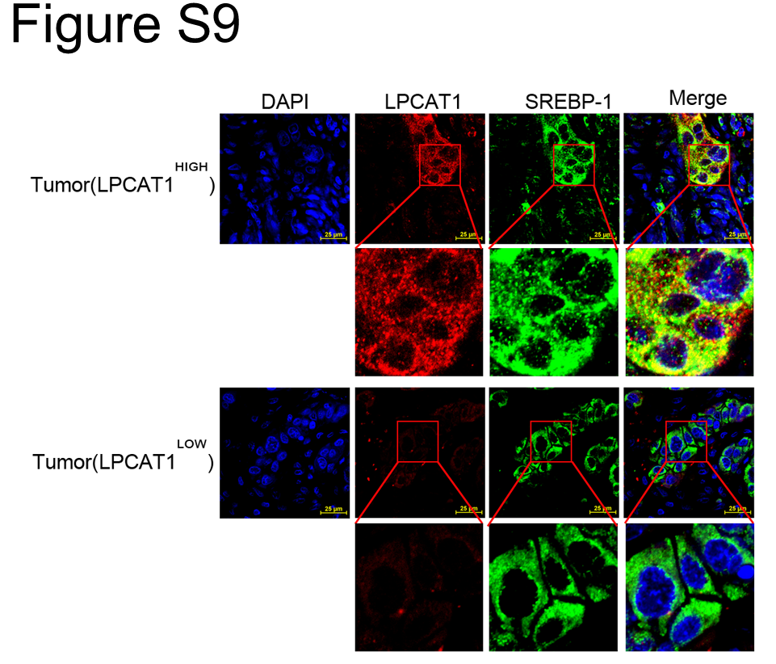
Supplementary Figure 9. LPCAT1 co-localized with SREBP-1 in ESCC patients.
The co-localization of SREBP1 with LPCAT1 in tumor tissues was detected by immunohistochemistry analysis. Data are from three independent experiments.

