SUPPLEMENTAL MATERIAL

STAT1 CONFERS SENSITIVITY TO RADIATION IN CERVICAL CANCER CELLS BY CONTROLLING PARP1 LEVELS: A NEW PERSPECTIVE FOR PARP1 INHIBITION

Raspaglio et al.

This Supplemental Material contains:

Supplementary Table 1: List of Antibodies used in Western Blot analysis

Supplementary Figure 1: STAT1-silencing increases STAT3 occupancy at the PARP1 promoter

Supplementary Figure 2: Interferon-γ sensitizes radioresistant cervical cancer cells

Supplementary Figure 3: Effects of Interferon-γ, with or without IR, on viral E6 mRNA in cervical cancer cells
Supplementary Table 1. List of Antibodies used in Western Blot analysis.
Antibody name | Clone | Supplier
Phospho STAT1 (Tyr701) | Polyclonal | Santa Cruz Biotechnology (Santa  Cruz, CA)
STAT1 | HPA000931 | Sigma-Aldrich (Darmstadt, Germany)
PA28α | AT12H3 | Santa Cruz Biotechnology
PA28β | G-10 | Santa Cruz Biotechnology
Poly(ADP)-ribose (PAR) | 10H | Santa Cruz Biotechnology
PARP1 | 46D11 | Cell Signaling Technology (Boston,  MA)
Phospho STAT3 (Tyr705) | D3A7 | Cell Signaling Technology
STAT3 | 124H6 | Cell Signaling Technology
Phospho mTOR (Ser2448) | Polyclonal | Cell Signaling Technology
mTOR | 7C10 | Cell Signaling Technology
p62 (SQSTM1) | D3 | Santa Cruz Biotechnology
LC3A/B | D3U4C | Cell Signaling Technology
Cleaved Caspase-3 | 5A1E | Cell Signaling Technology
Cyclin B1 | Y106 | Abcam (Cambridge, UK)
γH2AX (S139) | Polyclonal | Cell Signaling Technology
β-Actin | AC-15 | Sigma-Aldrich
GAPDH | 6C5 | Abcam

Supplementary Fig. 1
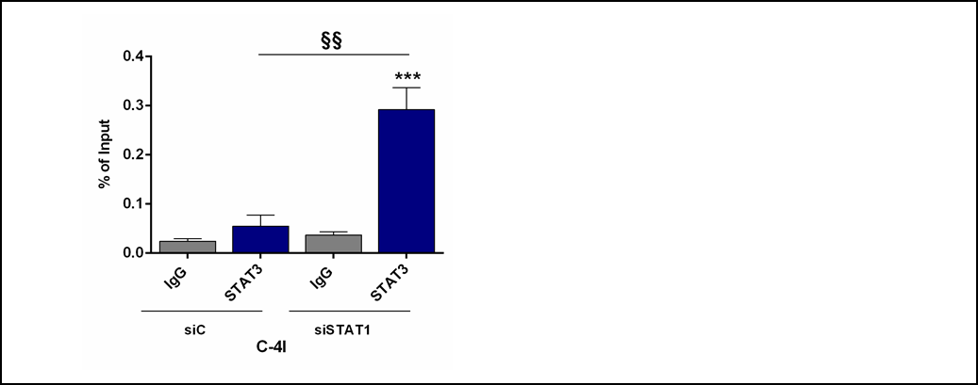
Supplementary Fig. 1 STAT1-silencing increases STAT3 occupancy at the PARP1 promoter. C4-I cells were silenced for STAT1 for 48h and specific STAT3 recruitment was assessed by ChIP-qPCR. The amount of precipitated DNA was calculated as percent of input (mean ± SD, n=3). Statistical significances have been evaluated through an unpaired t-test. ***P<0.001 siSTAT1 group with respect to IgG. §§P<0.01 siSTAT1 with respect to siC.

Supplementary Fig. 2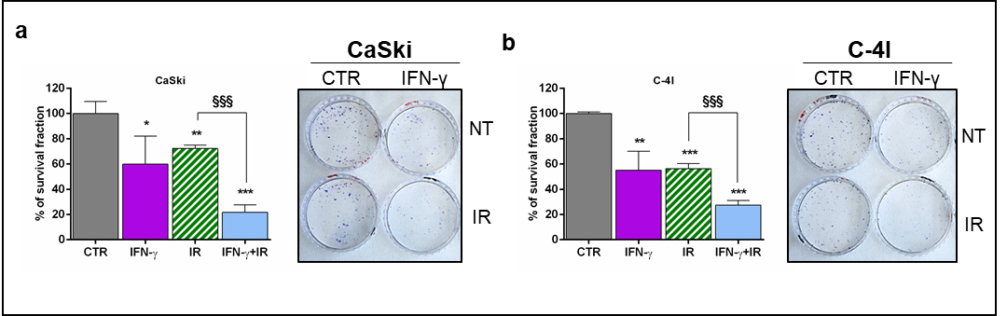
Supplementary Fig. 2 Interferon-γ sensitizes radioresistant cervical cancer cells. Clonogenic survival fractions of CaSki (a) and C-4I (b) cells treated with 10 ng/ml IFN-γ with or without IR (2 Gy). Cells were pre-treated for 2h with IFN-γ and then irradiated. Bar charts represent percentage of survival fraction normalized to CTR (mean ± SD, n=3). Representative pictures are shown on the right. Statistical significances have been evaluated through an unpaired t-test. *P<0.05, **P<0.01 and ***P<0.001 respect to CTR. §§§P<0.001 combined treatment with respect to IR. CTR: Untreated. IFN-γ: Interferon-γ.

Supplementary Fig. 3
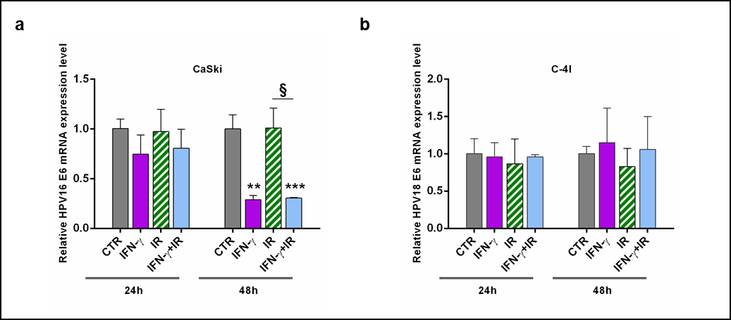
Supplementary Fig. 3 Effects of Interferon-γ, with or without IR, on viral E6 mRNA in cervical cancer cells. CaSki and C-4I cells were treated with 10 ng/ml IFN-γ (a and b) with or without IR (2 Gy). Relative viral E6 mRNA expression level was evaluated by RT-qPCR 24h and 48h after treatment. Results are presented as fold change compared to CTR cells (mean ± SD, n=2). Statistical significances have been evaluated through an unpaired t-test. **P<0.01 and ***P<0.001 respect to CTR. §P<0.05 combined treatment with respect to IR. CTR: Untreated. IFN-γ: Interferon-γ. IR: 2 Gy γ-rays.

