Figure 1
Figure 1A
Control
PrP106-126 6h
PrP106-126 12h
PrP106-126 24h

PrP106-126 36h

Figure 2
Figure 2A
Control
PrP106-126 24h
Overexpress pink1
Overexpress pink1+PrP
siRNA pink1
siRNA pink1+PrP

Figure 2C
Control
PrP106-126 24h
Overexpress pink1
Overexpress pink1+PrP
siRNA pink1
siRNA pink1+PrP

Figure 3
Figure 3C
Control
PrP106-126 24h
Overexpress parkin
Overexpress parkin+PrP
NMN
NMN+PrP
UA
UA+PrP
siRNA parkin
siRNA parkin+PrP

Figure 5
Figure 5A
Control PrP106-126 24 h
Overexpress parkin Overexpress parkin+PrP
NMN NMN+PrP
UA UA+PrP
siRNA parkin siRNA parkin+PrP

Figure 5B
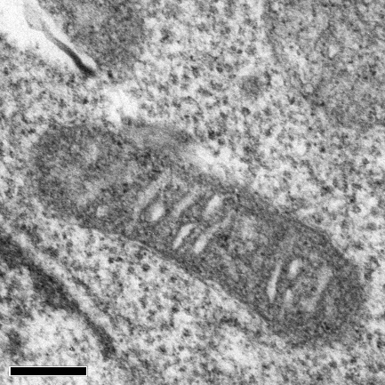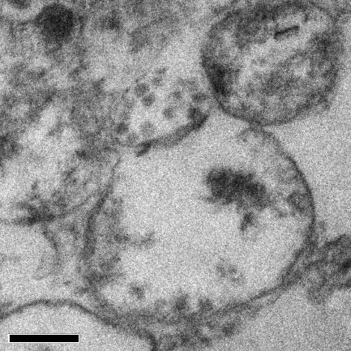
Control PrP106-126 24 h
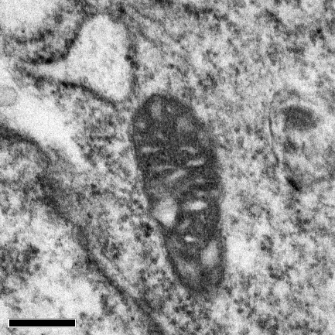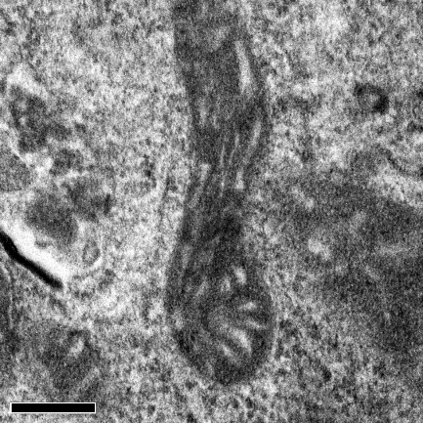
Overexpress parkin Overexpress parkin+PrP
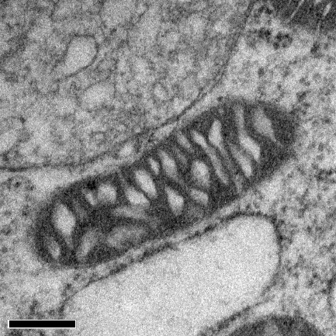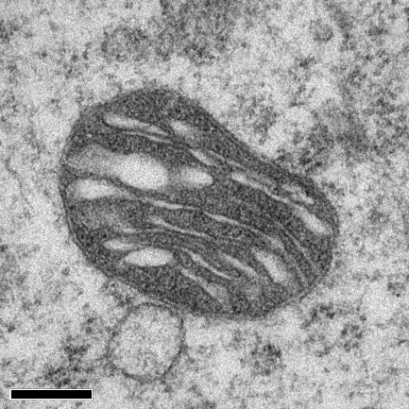
NMN NMN+PrP
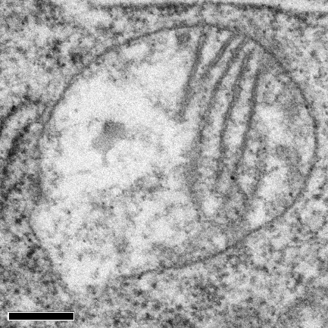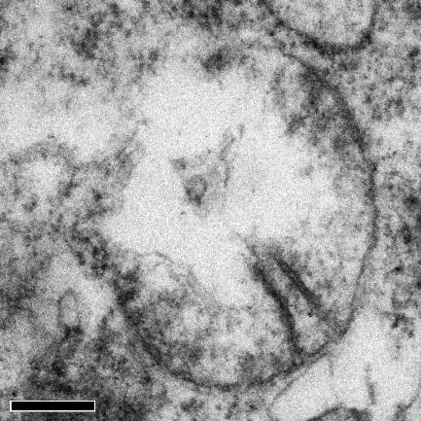
UA UA+PrP
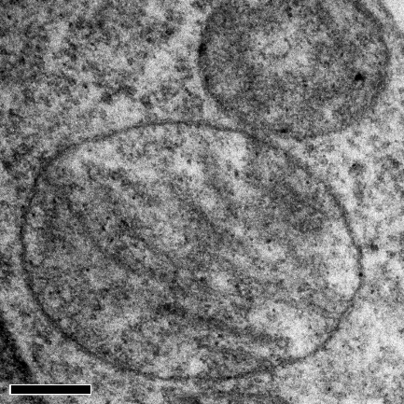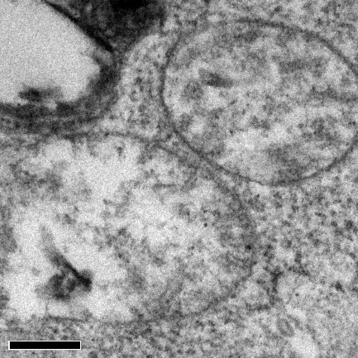
siRNA parkin siRNA parkin+PrP

Figure 6
Figure 6A
Control
PrP106-126 24 h
Overexpress parkin
Overexpress parkin+PrP
NMN
NMN+PrP
UA
UA+PrP
siRNA parkin
siRNA parkin+PrP

Figure 6C
Control
PrP106-126 24 h
Overexpress pink1
Overexpress pink1+PrP
siRNA pink1
siRNA pink1+PrP

