Figure 1
Figure 1C
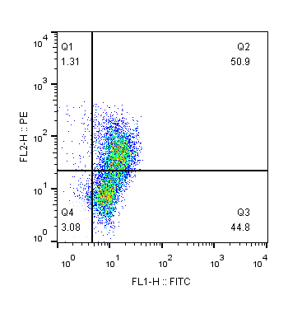
Control
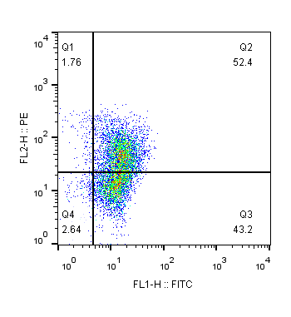
PrP106-126 6h
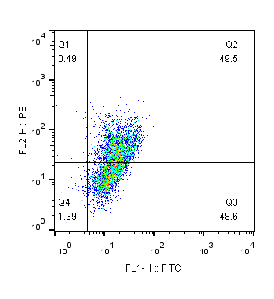
PrP106-126 12h
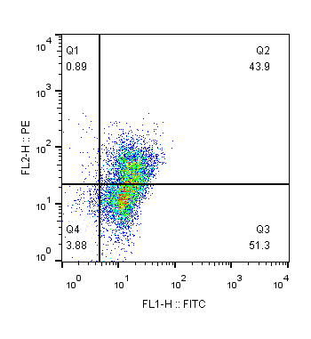
PrP106-126 24h
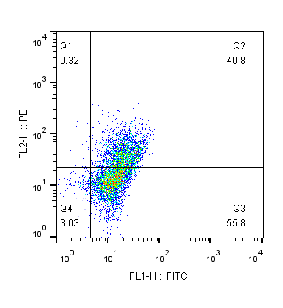
PrP106-126 36h

Figure 2
Figure 2E
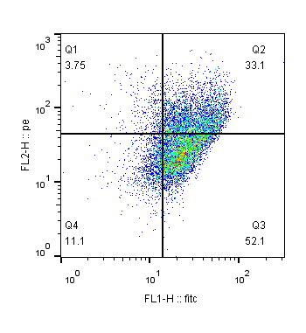
Control
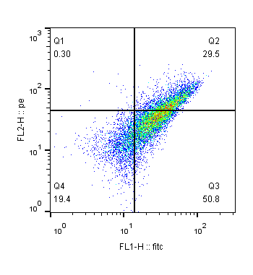
PrP106-126 24h
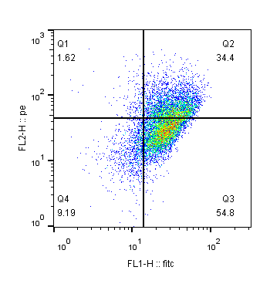
Overexpress pink1
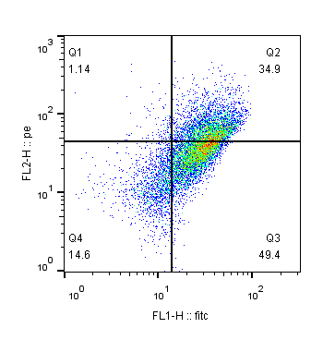
Overexpress pink1+prp
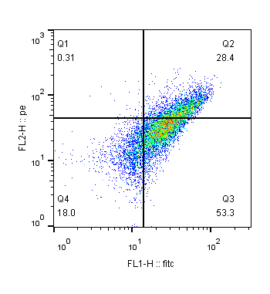
siRNA pink1
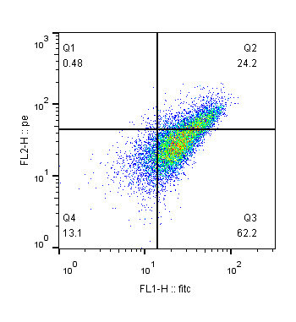
siRNA pink1+prp

Figure 3
Figure 3E
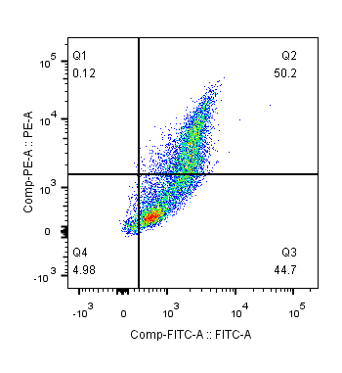
Control
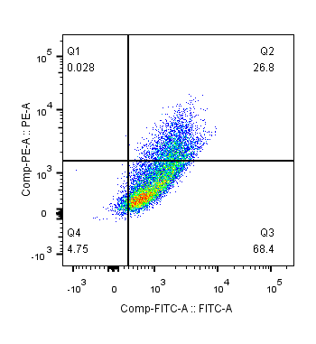
PrP106-126 24h
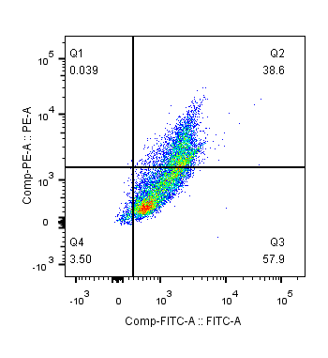
Overexpress parkin
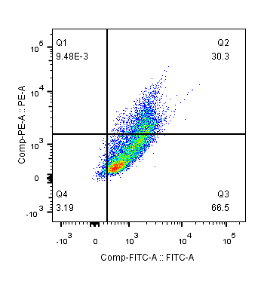
Overexpress parkin+prp
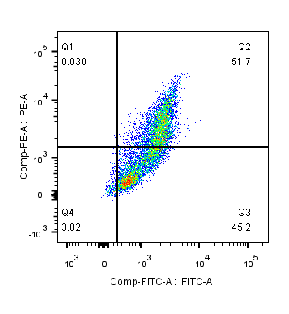
NMN
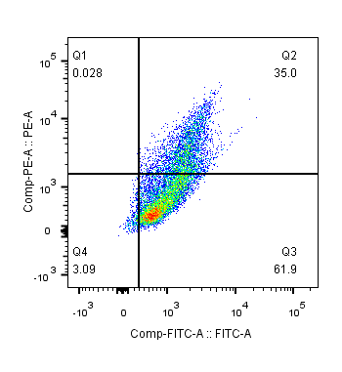
NMN+prp
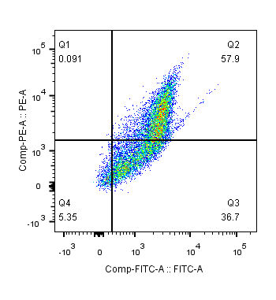
UA
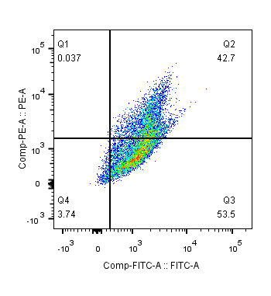
UA+prp

Figure 3F
Control
PrP106-126 24h
siRNA parkin
siRNA parkin+prp

Figure 5
Figure 5D
Control
PrP106-126 24h
Overexpress parkin
Overexpress parkin+prp106-126
NMN
NMN+prp106-126
UA
UA+PrP106-126

Figure 5E
Control
PrP106-126 24h
siRNA parkin
siRNA parkin+prp106-126

