Supplementary Figure and Figure legends
Fig S1. Analysis of expression of LXN in obese rat (A) and mice (B) tissues based on GEO profile database.

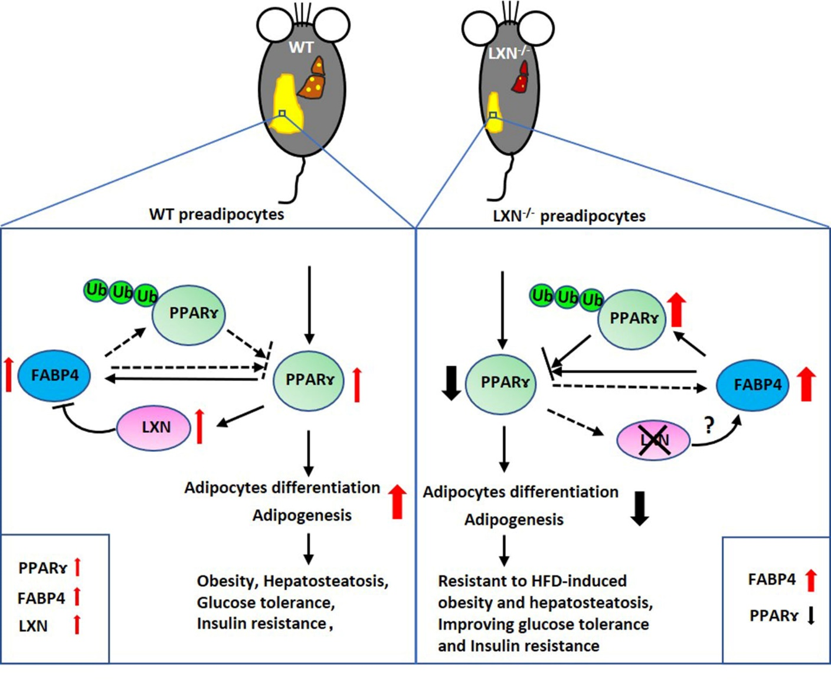
Fig S2 Schematic diagram to demonstrate the mechanism by which LXN loss prevents preadipocytes differentiation and adipogenesis. The protein level of PPARɤ is precisely regulated by LXN and FABP4 during adipocyte differentiation. WT preadipocytes cultured in differentiation medium increased the protein level of PPARɤ, which induced the expression of FABP4 and LXN. Conversely, excessive FABP4 negatively regulates PPARɤ protein level by accelerating its ubiquitination (left, dotted arrow); while LXN positively regulates PPARɤ protein level by inhibiting FABP4 overexpression. In LXN^{-/-} preadipocytes, loss of LXN upregulates FABP4 expression via a PPARɤ-independent pathway, resulting in increased PPARɤ ubiquitination (right, solid arrow) and decreased adipocyte differentiation.

