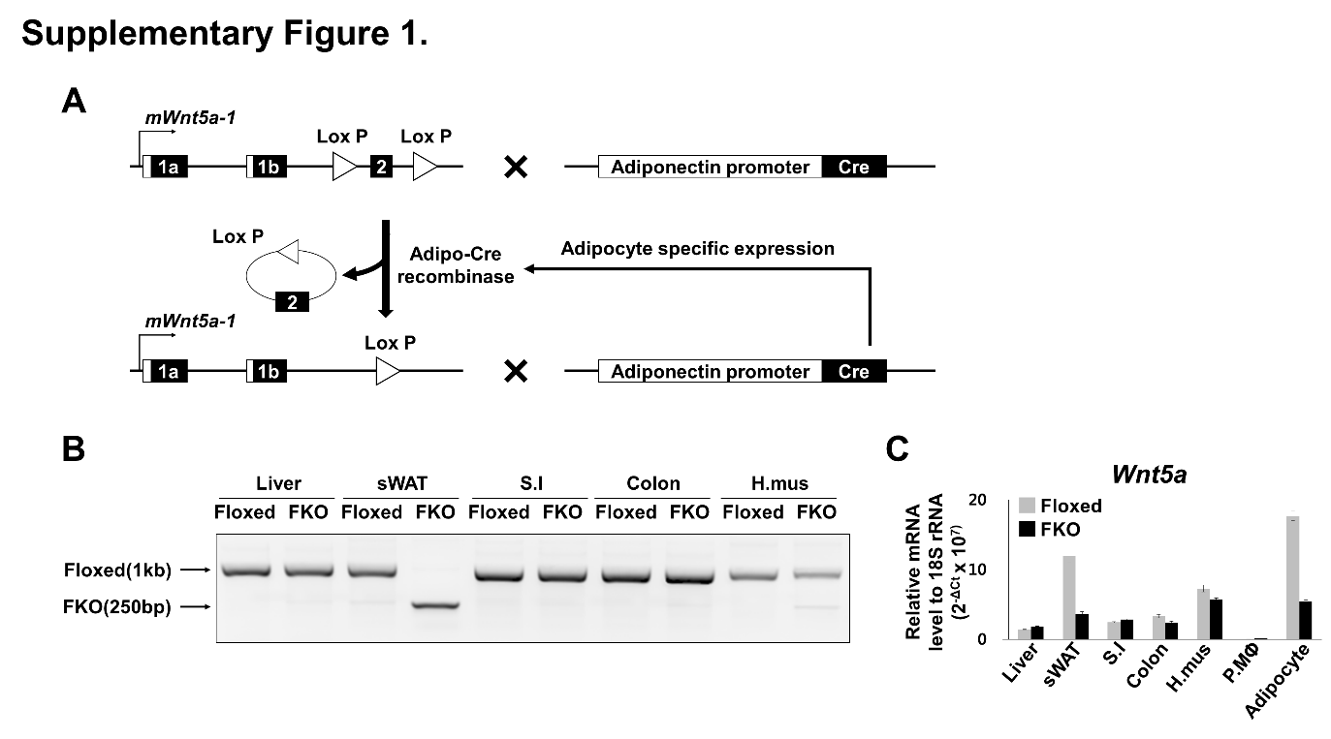
Supplementary Figure 1. Fat-specific Wnt5a KO mice (A) Schematic representation of the Cre-LoxP strategy used to generate Wnt5a-FKO. B6;129S-Wnt5a^{tm1.1Krvl}/J has Lox P sites on both sides of Wnt5a Exon 2 (Floxed) and B6;FVB-Tg(Adiponectin-cre)1Evdr/J has the Cre gene which is regulated by the adiponectin promoter. (B) PCR of genomic DNA encoding Wnt5a Exon 2 in liver, sWAT, Small intestine (SI), Colon, and hind muscle (H. mus) of 8-week-old Floxed and FKO mice. Wnt5a floxed DNA fragment (1 kb) and Wnt5a knockout DNA fragment (250 bp) were detected. (C) qRT-PCR of Wnt5a mRNA normalized with 18S rRNA in liver, sWAT, small intestine (S.I), colon, hind muscle (H.mus), peritoneal macrophage (P.MΦ) and adipocytes from WAT of 13-week-old male Floxed and FKO mice (Floxed 20 w, ND, n=1; FKO 20 w, ND, n=1). The y-axis indicates the Wnt5a mRNA level relative to the endogenous 18S rRNA.

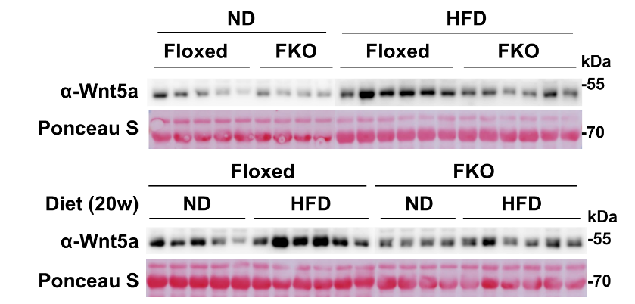
Supplementary Figure 2. Wnt5a protein levels in fat-specific Wnt5a KO mice Western blot analyses of the Wnt5a protein in sera of Floxed and FKO mice which were fed with either ND or HFD for 20 weeks since 8 weeks old.

Supplementary Table S1. Primer sequences used in qRT-PCR analyses.
Mouse Gene | Strand | Sequence
18S rRNA | Sense | ACCGCAGCTAGGAATAATGGAATA
18S rRNA | Antisense | CTTTCGCTCTGGTCCGTCTT
Wnt5a⁽¹⁾ | Sense | GGAACGAATCCACGCTAAGGGT
Wnt5a⁽¹⁾ | Antisense | AGCACGTCTTGAGGCTACAGGA
Wnt5a-1 | Sense | GTGGCGACTTCCTCTCCG
Wnt5a-1 | Antisense | CGGTCCCCAAAGCCACT
Wnt5a-2 | Sense | ACTTGTTGCTCCGGCCC
Wnt5a-2 | Antisense | CGGTCCCCAAAGCCACT
Wnt5a⁽²⁾ | Sense | GGCTCCACTTGTTGCTC
Wnt5a⁽²⁾ | Antisense | TGGCTTAATAACCTCAAACGA
Ctgf | Sense | CTGCCTACCGACTCGAAGAC
Ctgf | Antisense | CATTGGTAACTCGGGTGGAG
Cyr61 | Sense | GCTCAGTCAGAAGGCAGACC
Cyr61 | Antisense | GTTCTTGGGGACACAGAGGA
Ankrd1 | Sense | CTGTGAGGCTGAACCGCTAT
Ankrd1 | Antisense | TCTCCTTGAGGCTGTCGAAT
Pparg2 | Sense | CTGATGCACTGCCTATGAGCA
Pparg2 | Antisense | ATGCGAGTGGTCTTCCATCAC
IL-6 | Sense | ACAACCACGGCCTTCCCTACTT
IL-6 | Antisense | CACGATTTCCCAGAGAACATGTG
PAI1 | Sense | GCCTCCTCATCCTGCCTAA
PAI1 | Antisense | GCCAGGGTTGCACTAAACAT
Fam107a | Sense | GCTCATCAAACCCAAGAAGCTGC
Fam107a | Antisense | AGCTCAGGCTTGCTGTCCATAC
FABP4 | Sense | GATGAAATCACCGCAGACGACA
FABP4 | Antisense | ATTGTGGTCGACTTTCCATCCC
Leptin | Sense | GCAGTGCCTATCCAGAAAGTCC
Leptin | Antisense | GGAATGAAGTCCAAGCCAGTGAC
F4/80 | Sense | CTTTGGCTATGGGCTTCCAGTC
F4/80 | Antisense | GCAAGGAGGACAGAGTTTATCGTG
TNFa | Sense | CTGAACTTCGGGGTGATCGG
TNFa | Antisense | GGCTTGTCAGTCGAATTTTGAGA
MCP1 | Sense | CCTGCTGTTCACAGTTGC
MCP1 | Antisense | ATTGGGATCATCTTGCTG

⁽¹⁾ Primers for Wnt5a mRNA of wild type C57BL/6J mice and 3T3-L1 ⁽²⁾ Primers for Wnt5a mRNA of Floxed and FKO mice.

Supplementary Table S2. Primers used in ChIP-qPCR analyses and genotyping analyses.
PCR Region | Strand | Sequence
Wnt5a –0.3kb | Sense | GGCTAGCTGTCCATCAACCG
Wnt5a –0.3kb | Antisense | GCGCCAAATTTTGTCCTTTC
Wnt5a TSS | Sense | CTGACAATCAGGAGGCGTGA
Wnt5a TSS | Antisense | TACTCAACTGTGGCCCGAGG
Ctgf –0.1kb | Sense | CTTCTTGGTGTTGTGCTGGA
Ctgf –0.1kb | Antisense | GATTGATCCTGACCCCTTGA
Wnt5a Exon 2⁽¹⁾ | Sense | GGC TCC ACT TGT TGC
Wnt5a Exon 2⁽¹⁾ | Antisense | TGG CTT AAT AAC CTC AAA CGA
⁽¹⁾ primers for genotying Floxed and FKO mice.

