Supplementary Table 1 Primer sequences for RT-qPCR
Target | Sequences
miR-139-5p | F: 5’-CGACGCGTCCCTCTTCCCATTCCTTC-3’
miR-139-5p | R: Universal Reverse Primer (miScript II RT Kit)
U6 | F: 5’-CGCTTCGGCAGCACATA-3’
U6 | R: 5’-Universal Reverse Primer (miScript II RT Kit)-3’
KIF3A | F: 5’-TCCCGTTCCCATGCCATCTT-3’
KIF3A | R: 5’-GCTTCCTTTAGGCGCTGTCC-3’
β-actin | F: 5’-AGCGAGCATCCCCCAAAGTT-3’
β-actin | R: 5’-GGGCACGAAGGCTCATCATT-3’
cel-miR-39 | F: 5’-GGTCACCGGGTGTAAATCAGCTTG-3’  R: Universal Reverse Primer (miScript II RT Kit)
Note: miR-139-5p, microRNA-139-5p; U6, U6 snRNA; KIF3A, kinesin family member 3a; β-actin, Beta-actin; cel-miR-39, cel-microRNA-39; F, forward; R, reverse.

Supplementary Fig. 1 Identification of BMSCs and BMSCs-EVs. A, The morphological characteristics of BMSCs and their osteogenic, adipogenic, and chondrogenic differentiation observed under an optical microscope. Scale bar: 25 μm. B, The morphological characteristics of BMSCs-EVs observed under a TEM. C, Particle size of the BMSCs-EVs analyzed by NTA. D, The expression of EV surface marker proteins in the BMSCs-EVs examined by western blot analysis. The cell experiment was repeated three times independently.

Supplementary Fig. 2 BMSCs-EVs inhibit the proliferation, migration and invasion of BOY-12E cells while inducing their apoptosis. A. The uptake of EVs labeled with PKH67 (green fluorescence) by the BOY-12E cells analyzed using a fluorescence microscope. DAPI stained nucleus is blue. Scale bar: 25 μm. B, The proliferation of BOY-12E cells co-cultured with different concentrations of EVs examined by CCK-8. C, The migration and invasion of BOY-12E cells co-cultured with different concentrations of EVs with BOY-12E cells tested by Transwell assay. D, The apoptosis of BOY-12E cells co-cultured with different concentrations of EVs tested by Hoechst 33342/PI staining. E, The expression of apoptosis-related factors in BOY-12E cells co-cultured with different concentrations of EVs tested by western blot analysis. Measurement data were expressed as mean ± standard deviation. Paired t test was conducted to compare data between the cancer tissues and adjacent normal tissues. *p < 0.05, **p < 0.01, ***p < 0.001 or ****p < 0.0001, vs. PBS group. The cell experiment was repeated three times independently.

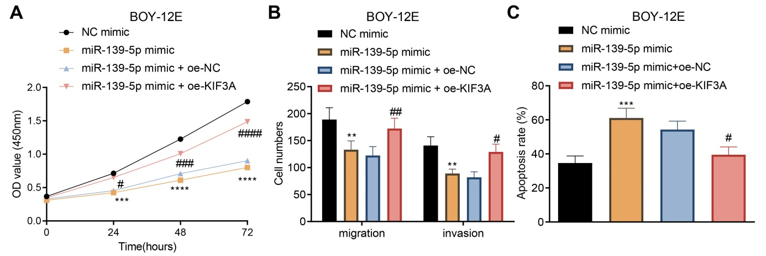
Supplementary Fig. 3 miR-139-5p targets KIF3A to inhibit the proliferation, migration and invasion of BOY-12E cells while inducing their apoptosis. A, The proliferation of BOY-12E cells transfected with miR-139-5p mimic or combined with oe-KIF3A examined by CCK-8. B, The migration and invasion of BOY-12E cells transfected with miR-139-5p mimic or combined with oe-KIF3A examined by Transwell assay. C, The apoptosis of BOY-12E cells transfected with miR-139-5p mimic or combined with oe-KIF3A examined by Hoechst 33342/PI staining. Measurement data were expressed as mean ± standard deviation. Unpaired t test was performed for two-group data comparison. One-way ANOVA was conducted for multi-group data comparison, followed by Tukey's post hoc test. *p < 0.05, **p < 0.01, ***p < 0.001 or ****p < 0.0001, vs. NC mimic group. #p < 0.05, ##p < 0.01, ###p < 0.001, or ####p < 0.0001, vs. miR-139-5p mimic + oe-NC group. The cell experiment was repeated three times independently.

Supplementary Fig. 4 miR-139-5p delivered by BMSCs-EVs down-regulates KIF3A and activates p21 to inhibit the proliferation, migration and invasion of BOY-12E cells while inducing their apoptosis. A. The expression of KIF3A and the ratio of p-p21/p21 in BOY-12E cells transfected with miR-139-5p mimic or combined with oe-KIF3A detected using western blot analysis. ****p < 0.0001, vs. NC mimic group. ##p < 0.01 or ####p < 0.0001, vs. miR-139-5p mimic + oe-NC group. B, Transfection efficiency of si-p21 in BOY-12E cells detected using western blot analysis. *p < 0.05, vs. si-NC group. C, The ratio of p-p21/p21 in BOY-12E cells treated with EVs-miR-139-5p mimic or combined with si-p21 examined by western blot analysis. D, The proliferation of BOY-12E cells treated with EVs-miR-139-5p mimic or combined with si-p21 examined by CCK-8. E, The migration and invasion of BOY-12E cells treated with EVs-miR-139-5p mimic or combined with si-p21 examined by Transwell assay. F, The apoptosis of BOY-12E cells treated with EVs-miR-139-5p mimic or combined with si-p21 examined by Hoechst 33342/PI staining. Measurement data were expressed as mean ± standard deviation. Unpaired t test was performed for two-group data comparison. One-way ANOVA was conducted for multi-group data comparison, followed by Tukey's post hoc test. In panels C-F, **p < 0.01, ***p < 0.001 or ****p < 0.0001, vs. EVs-NC mimic group. #p < 0.05 or ##p < 0.01, vs. EVs-miR-139-5p mimic + si-NC. The cell experiment was repeated three times independently.

