Figure S1, related to Fig.3. Identification of METTL3 targets via MeRIP-qPCR
a, The m6A modification site of EphA2 predicted by SRAMP website tools, and primers designed for MeRIP-qPCR assay. b, The m6A modification site of VEGFA predicted by SRAMP website tools, and primers designed for MeRIP-qPCR assay.
a.
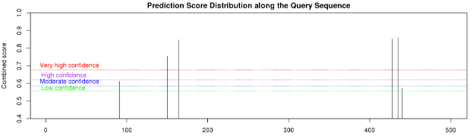
b. 