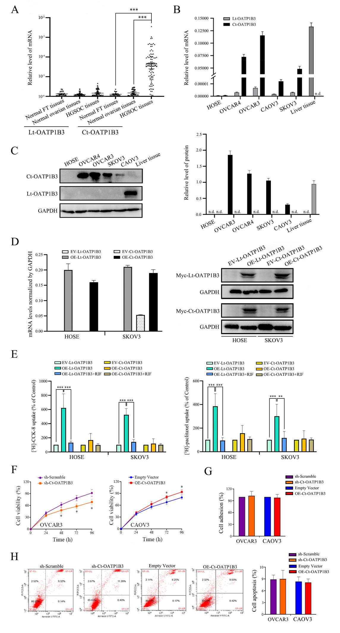
Figure S1. Expression and function of Ct-OATP1B3 in HGSOC tissues and cell lines
A Lt-OATP1B3 and Ct-OATP1B3 mRNA levels in normal fallopian tube (FT) tissues, normal ovarian tissues, as well as HGSOC tissues. B Lt-OATP1B3 and Ct-OATP1B3 mRNA levels in normal ovarian surface epithelium (HOSE) and HGSOC cell lines. C Lt-OATP1B3 and Ct-OATP1B3 protein levels in normal ovarian surface epithelium (HOSE) and HGSOC cell lines. D Establishment of stable cell lines overexpressing Myc-Lt-OATP1B3 or Myc-Ct-OATP1B3. Myc-Lt-OATP1B3 or Myc-Ct-OATP1B3 overexpression plasmid was stably transfected into HOSE and SKOV3 cells, qPCR was used to detect the expression levels of Lt-OATP1B3 or Ct-OATP1B3 mRNA, Western blot and anti-Myc antibody were used to detect the expression level of Myc-Lt-OATP1B3 or Myc-Ct-OATP1B3 protein. E Lt-OATP1B3- and Ct-OATP1B3-mediated uptake of [³H]-CCK-8 and [³H]-paclitaxel in HOSE and SKOV3 cells. F The influences of Ct-OATP1B3 on proliferation of HGSOC cells. G The influences of Ct-OATP1B3 on adhesion of HGSOC cells. H Cell apoptosis of HGSOC cells after knockdown or overexpression of Ct-OATP1B3. *P<0.05, **P<0.01, ***P<0.001.
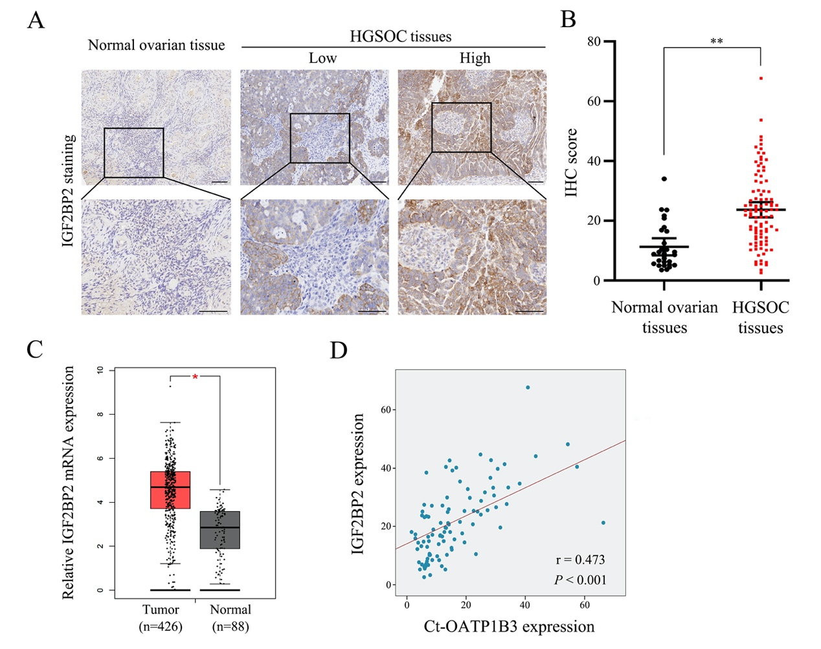
Figure S2. The expression of IGF2BP2 is correlated with Ct-OATP1B3 in HGSOC tissues
A Representative images of IGF2BP2 staining in normal ovarian epithelial sample and HGSOC tissues. Scale bar, 100μm. B Quantification of IGF2BP2 staining in 97 HGSOC and 29 normal ovarian tissues. C Higher expression of IGF2BP2 mRNA in HGSOC samples compared with normal control in GEPIA database. D Correlation between Ct-OATP1B3 and IGF2BP2 staining intensity in HGSOC patients. *P<0.05, **P<0.01, ***P<0.001.
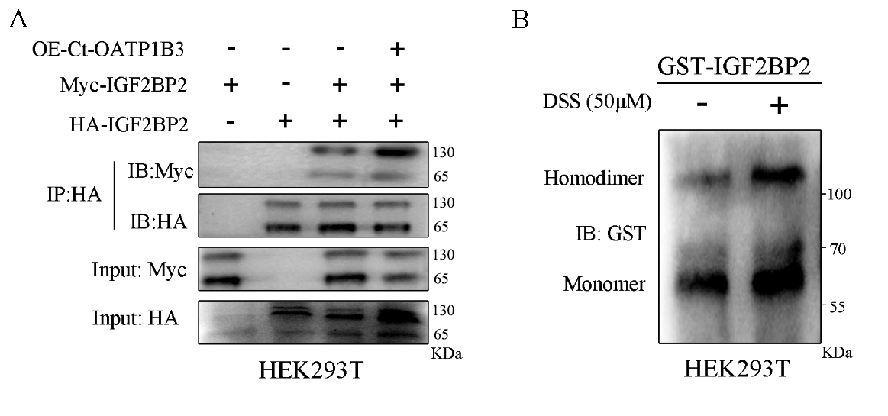Figure S3. Homodimerization of the full-length IGF2BP2 in vitro.
A HA-IGF2BP2 and Myc-IGF2BP2 were cotransfected into HEK-293T cells. The lysates of these cells were immunoprecipitated with an anti-HA antibody. The immunoprecipitates and input were examined by immunoblotting with the respective antibodies. B GST-IGF2BP2 fusion protein was incubated with the bivalent chemical cross-linker DSS. The cross-linked complexes were analyzed by Western blot using an anti-GST antibody.

