Fig1 B

A549-Hif1α 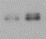 HCC827-Hif1α 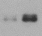 NCI-H1299-Hif1α 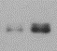
A549-LC3B 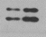 HCC827-LC3B 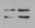 NCI-H1299-LC3B 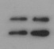
A549-p62 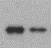 HCC827-p62 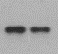 NCI-H1299-p62 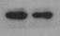
A549-β-actin 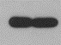 HCC827-β-actin 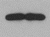 NCI-H1299-β-actin 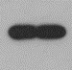

Fig2 A
A549-Hif1α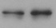 HCC827-Hif1α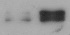 NCI-H1703-Hif1α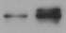 PC-9-Hif1α
NCI-H1299-Hif1α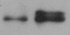
A549 eIF5A2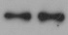 HCC827 eIF5A2 NCI-H1703 eIF5A2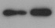 PC-9 eIF5A2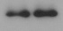 NCI-H1299 eIF5A2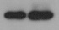
A549-β-actin 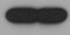 HCC827-β-actin 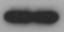 NCI-H1703-β-actin 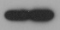 PC-9-β-actin 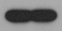 NCI-H1299-β-actin 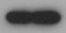

Fig3 B
eIF5A2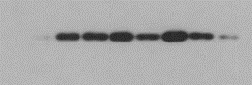
β-actin 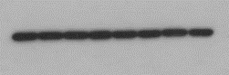

Fig3 D
eIF5A2 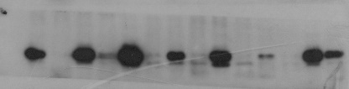
β-actin 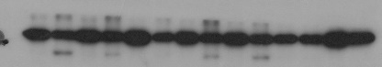

Fig4 B
A549 eIF5A2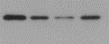 NCI-H1299 eIF5A2 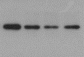
A549-β-actin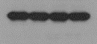 NCI-H1299-β-actin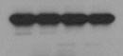
Fig4 F
A549-Beclin-1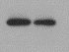 A549-Beclin-1 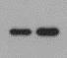
A549-p62 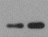 A549-p62 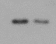
A549-β-actin 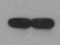 A549-β-actin 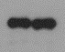
Fig5 B
A549 eIF5A2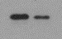 HCC827 eIF5A2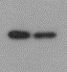 NCI-H1703 eIF5A2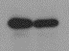 PC9 eIF5A2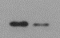 NCI-H1299 eIF5A2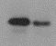
A549 ATG3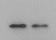 HCC827 ATG3 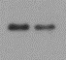 NCI-H1703 ATG3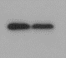 PC9 ATG3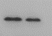 NCI-H1299 ATG3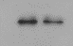
A549 Tubulin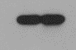 HCC827 Tubulin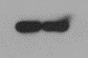 NCI-H1703 Tubulin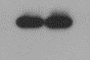
PC9 Tubulin 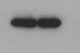 NCI-H1299 Tubulin 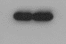

Fig5 G
A549-ATG3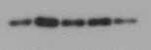 NCI-H1299-ATG3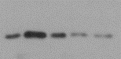
A549- Hif1α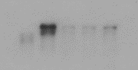 NCI-H1299-Hif1α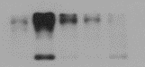
A549- Tubulin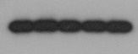 NCI-H1299-Tubulin