A novel mechanism for macrophage pyroptosis in rheumatoid arthritis induced by Pol β deficiency
Lili Gu^{1a}, Yuling Sun^{1a}, Ting Wu¹, Ge Chen¹, Xiaojun Tang², Lianfeng Zhao¹, Lingfeng He¹, Zhigang Hu¹, Lingyun Sun², Feiyan Pan¹*, Zhimin Yin¹*, Zhigang Guo¹*

¹Jiangsu Key Laboratory for Molecular and Medical Biotechnology, College of Life Sciences, Nanjing Normal University, 1 Wen Yuan Road, Nanjing, China 210023.
²Department of Rheumatology and Immunology, The Affiliated Drum Tower Hospital of Nanjing University Medical School, Nanjing, China 210008

Supplementary Information

The following file contains supplementary material for the paper “DNA polymerase β deficiency exacerbates rheumatoid arthritis by exacerbating macrophage pyroptosis via the cGAS-STING-NF-κB pathway”.
This file is composed of:
- Supplementary tables (2 tables)
- Supplementary figures and relative supplementary figure legends (10 figures)

Supplementary Table 1. Primer sequences used for qRT-PCR

Gene | Primer sequence (5ʹ → 3ʹ)
Homo-β-actin | Sense: CTCTTCCAGCCTTCCTTCCT  Antisense: CAGGGCAGTGATCTCCTTCT
Homo-Pol β | Sense: CATGGGTGTTTGCCAGCTTC  Antisense: AGGGACGGATGGTGTACTCA
Mus-Pol β | Sense: CGTGCTGGAAAGGCAAATCT  Antisense: CCTTCAGAAAGACTGCCAGC
Mus-β-actin | Sense: GAAATCGTGCGTGACATCAAAGAG  Antisense: CAATAGTGATGACCTGGCCGTC
Mus-NLRP3 | Sense: ATTACCCGCCCGAGAAAGG  Antisense: CATGAGTGTGGCTAGATCCAAG
Mus-GSDMD | Sense: CCATCGGCCTTTGAGAAAGTG  Antisense: ACACATGAATAACGGGGTTTCC
Mus-IL-1β | Sense: AGCTTCAGGCAGGCAGTATC  Antisense: AGTCACAGAGGATGGGCTCT
Mus-IL-18 | Sense: AGTGAACCCCAGACCAGACT  Antisense: TGGCAAGCAAGAAAGTGTCC
Mus-IFNα | Sense: GCAATCCTCCTAGACTCACTTCTGCA  Antisense: TATAGTTCCTCACAGCCAGCAG
Mus-IFNβ | Sense: AGCTGAAGCAGTTCCAGAAG  Antisense: AGTCTCATTCCAGCCAGTGC

No. | Gender | Age | Disease duration  ( months) | RF  (IU/mL) | CRP  (mg/L) | Anti-CCP  ( RU/ml) | ESR  (mm/h) | DAS28 | VAS score | Morning stiffness  duration (hours) | SJC | TJC
1 | F | 68 | 2 | 77.7 | 23.2 | 195.6 | 60 | 6.4 | 6 | 1.0 | 8 | 10
2 | F | 56 | 6 | 67.5 | 4.7 | 147.3 | 18 | 5.1 | 5 | 3.5 | 7 | 8
3 | M | 49 | 13 | 20.3 | 18.9 | 4.5 | 14 | 5.2 | 5 | 1.0 | 9 | 20
4 | F | 53 | 35 | 189.3 | 46.9 | 3.5 | 34 | 6.2 | 6 | 1.5 | 10 | 16
5 | F | 63 | 56 | 89.6 | 5.1 | 74.1 | 70 | 5.4 | 3 | 0.5 | 4 | 4
6 | F | 73 | 11 | 229．4 | 5.0 | 200.8 | 43 | 6.5 | 7 | 4.0 | 11 | 18
7 | F | 61 | 7 | 6.6 | 31.1 | 317.7 | 60 | 4.8 | 3 | 1.0 | 5 | 8
8 | M | 67 | 34 | 26.1 | 7.8 | 87.6 | 20 | 4.7 | 4 | 1.5 | 7 | 10

Table S2 Basic information of RA patients

Supplementary Figures
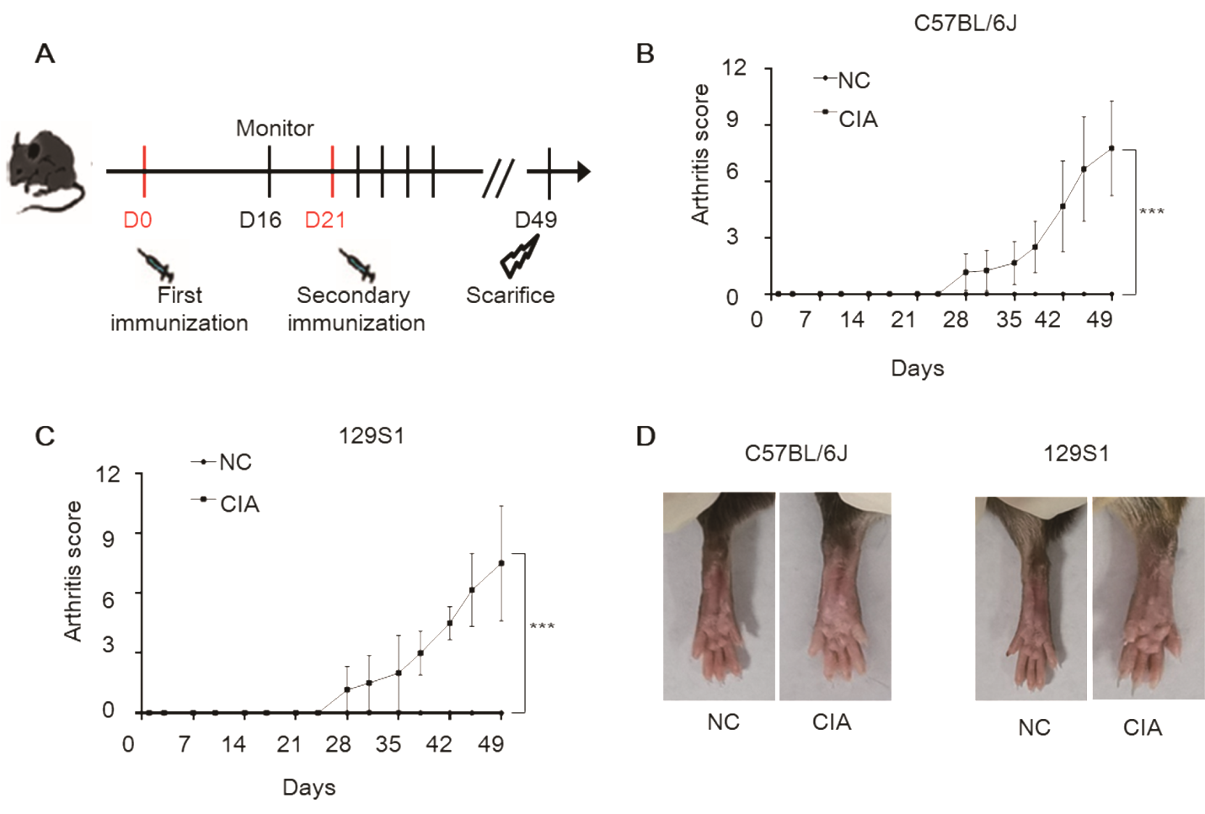

Fig. S1. Construction of a collagen-induced arthritis (CIA) mouse model. (A) Schematic illustrating the establishment of the CIA mouse model. (B, C) Clinical arthritic scores of CIA mice. Data are means ± SD from at least 6 mice. ***P<0.001, two-way ANOVA. (D) Representative macroscopic images of CIA mice from at least 6 mice.

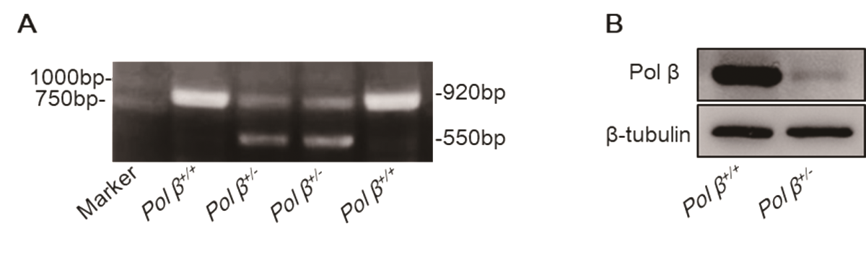
Fig. S2. Establishment of Pol β^{+/-} transgenic mice. We created Pol β^{+/-} mice by CRISPR/Cas9-mediated genome engineering, the Pol β^{+/-} mice were identified by PCR and Western blotting. (A) Representative agarose gel electrophoresis of genomic DNA isolated from wild-type and Pol β^{+/-} mice. (B) Representative blot of three independent experiments.

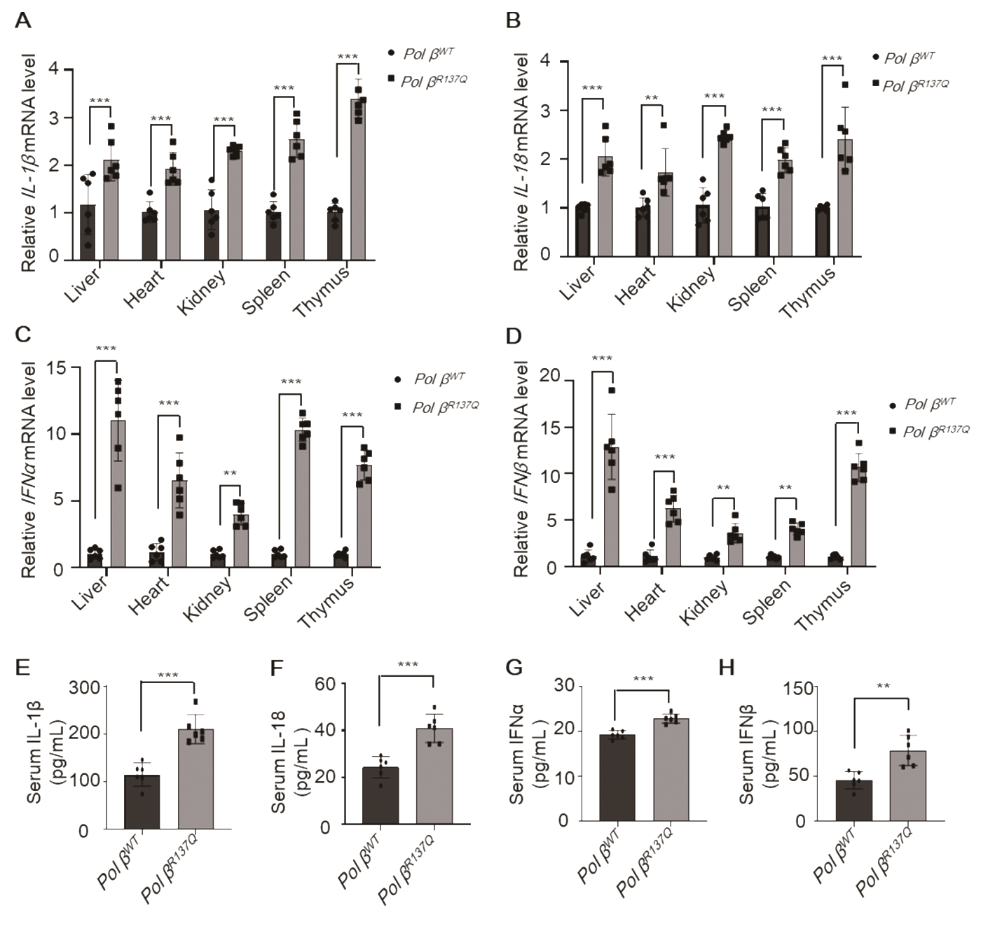
Fig. S3. Pol β deficiency upregulates the levels of inflammatory cytokines in mice. (A-D) The levels of IL-1β, IL-18, IFNα, IFNβ mRNA in the liver, heart, kidney spleen and thymus of mice were examined by qRT-PCR. (E-H) The protein levels of IL-1β, IL-18, IFNα, IFNβ in the serum of mice were analyzed by ELISA. **P<0.01, ***P<0.001. Data present mean ± SD of at least 6 mice per group. A-D, two-way ANOVA, E-H, Student’s t-test.

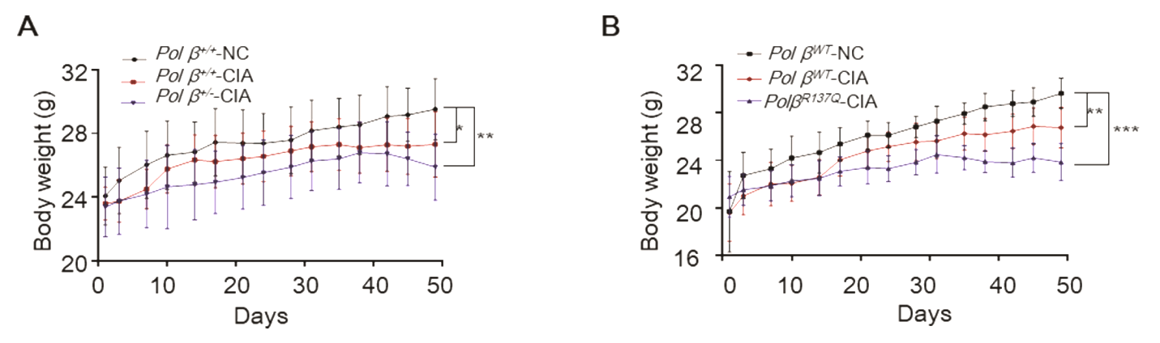
Fig. S4. Pol β deficiency decreases the body weight of CIA mice. (A, B) Body weight in C57BL/6J mice (Pol β^{+/+}-NC, Pol β^{+/+}-CIA, Pol β^{+/-}-CIA) (A) and 129S1 mice (Pol β^{WT}-NC, Pol β^{WT}-CIA, Pol β^{R137Q}-CIA) (B). *P<0.05, **P<0.01, ***P<0.001. Data present mean ± SD of at least 6 mice per group, two-way ANOVA.
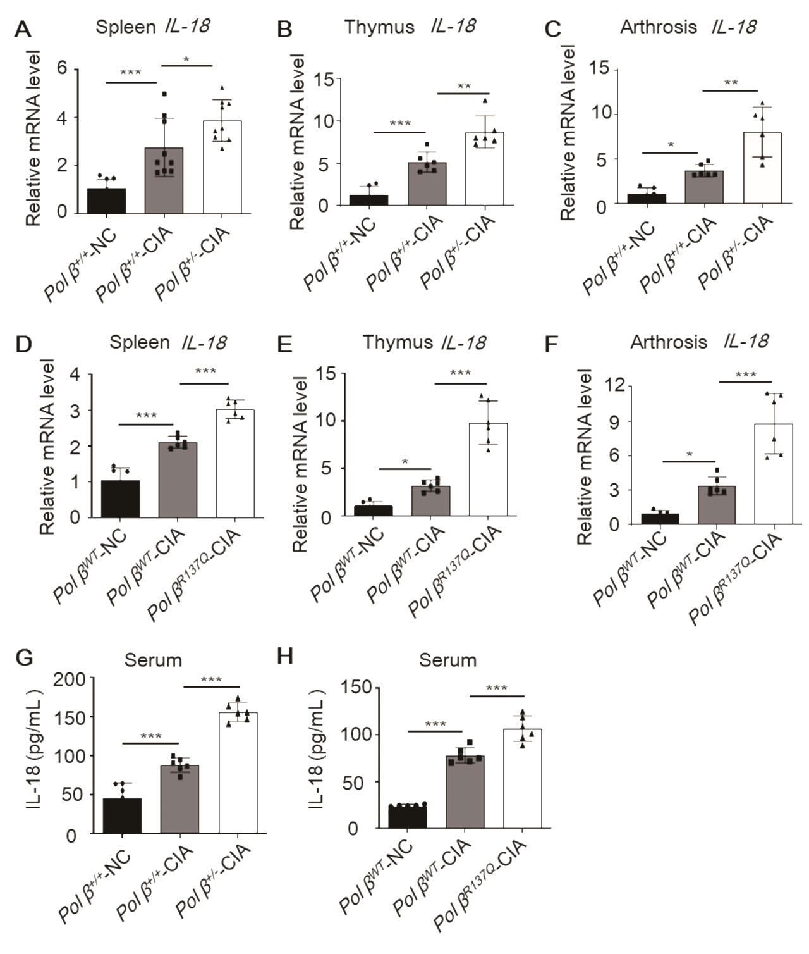
Fig. S5. Pol β deficiency increases IL-18 in CIA mice. (A–F) IL-18 mRNA levels in the spleen, thymus and arthrosis of CIA mice were detected by qRT-PCR. (G, H) The levels of IL-1β in the serum of CIA mice were analyzed by ELISA. Data are mean ± SD of at least 6 mice per group. *P<0.05, **P<0.01, ***P<0.001, one-way ANOVA. Data points indicate individual mice.

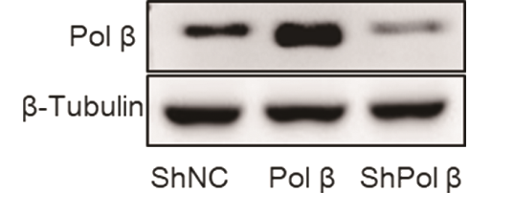
Fig. S6. Establishment of stable Pol β knockdown or overpression RAW264.7 cell line. RAW264.7 cells were transfected with ShNC, Pol β and ShPol β for 48 hours, and then the protein level of Pol β was checked by western blotting. β-tubulin was used as an internal control. Data are representative blot of three independent experiments.

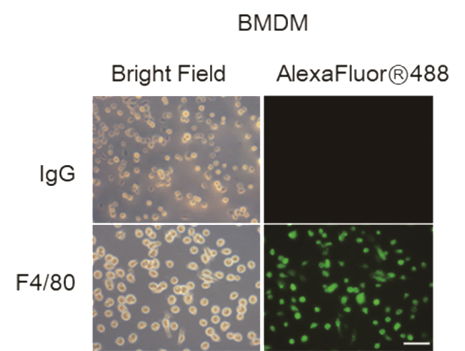
Fig. S7. Primary mouse BMDM cells were identified by using anti-F4/80 antibody. Representative images of primary mouse BMDM cells. Scale bar, 50 μm.

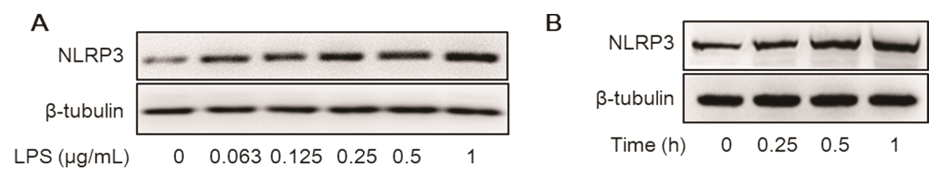
Fig. S8. Macrophages pyroptosis induced by LPS plus ATP. (A) RAW264.7 cells were treated with 0 - 1 μg/mL LPS for 5 hours, and NLRP3 expression levels were measured by Western blotting. (B) RAW264.7 cells were pretreated with 1 μg/mL LPS, and 5 mM ATP was then added and incubated for an additional 0 - 1 hour. The total incubation time was 5 hours, and the protein levels of NLRP3 were measured by Western blotting. A and B, representative blot of three independent experiments.

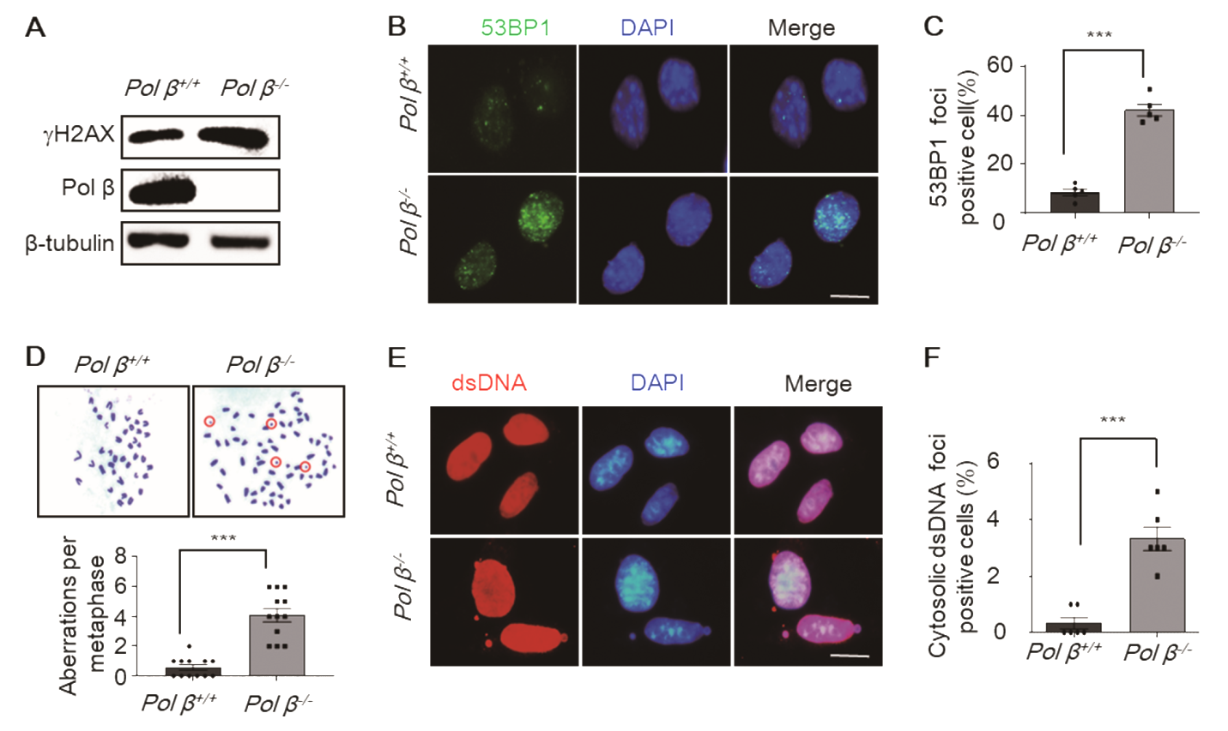

Fig. S9. Damaged DNA accumulated in Pol β-deficient cells. (A) Representative Western blot analyses of Pol β and γ-H2AX in Pol β-deficient MEF cells. (B) Representative immunofluorescence images of 53BP1 foci in cells. scale bar, 10 μm. (C) Statistical analysis of 53BP1 foci positive cell numbers in panel B. The data represent the mean ± SEM from more than 100 cells for each group; Student’s t-test, ***P<0.001. (D) The effect of Pol β deficiency on genomic instability was examined by karyotype analysis. Representative chromosome count images of metaphase cells were chosen and indicated chromosomal breakage. Lower panel: statistical analysis, data represent the mean ± SEM from more than 100 cells for each group, Student’s t-test, ***P<0.001. (E) Representative immunofluorescence images of dsDNA in Pol β^{+/+} and Pol β^{-/-} MEF cells. scale bar, 10 μm. (F) Statistical analysis of cytosolic dsDNA foci positive cells in panel E. The data represent the mean ± SEM from more than 100 cells for each group; Student’s t-test, ***P<0.001.

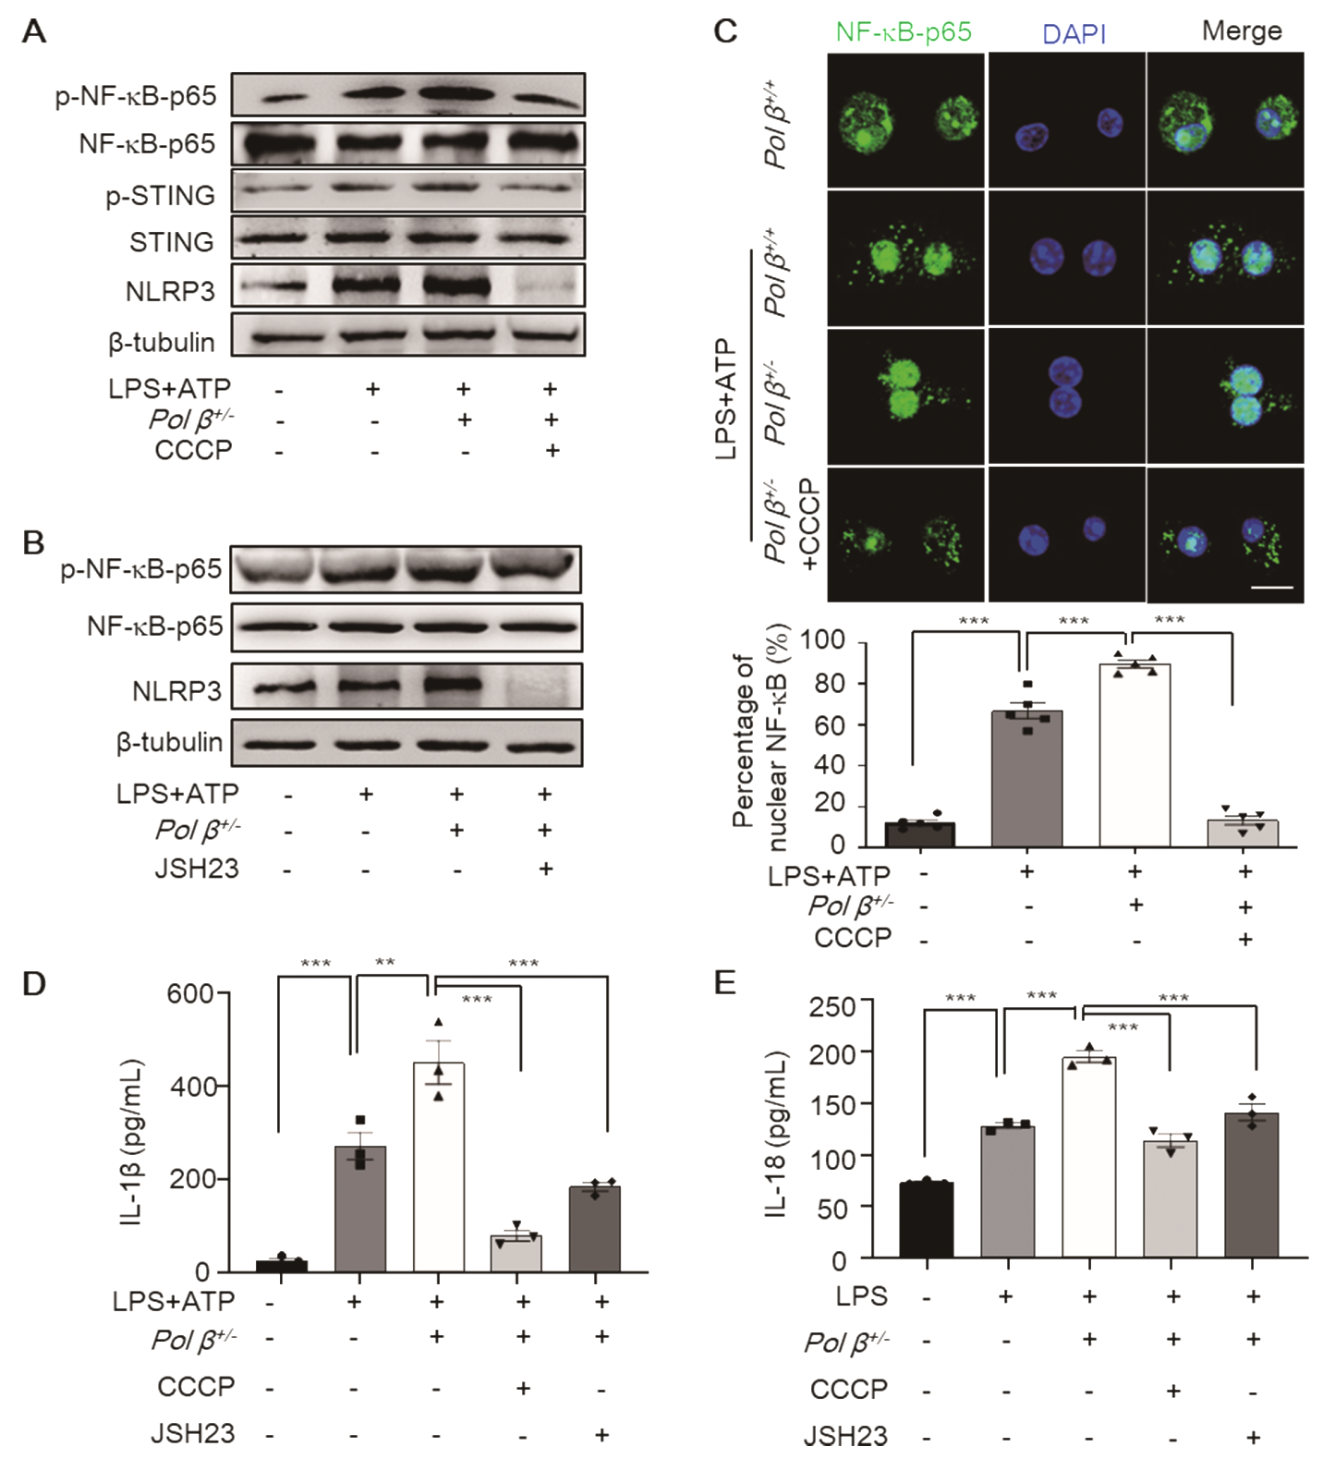

Fig. S10. Pol β deficiency exacerbates pyroptosis in BMDMs via the cGAS/STING/NF-κB pathway. Pol β-deficient BMDMs were pretreated with 10 μM CCCP or 10 μM JSH-23 for 2 hours, treated with 1 μg/mL LPS for 4 h, and then treated with 5 mM ATP for the final hour. (A, B) The levels of STING, p-STING, NF-κB-p65, p-NF-κB-p65, and NLRP3 were determined by Western blot, β-tubulin was used as an internal control. Data are representative blot of three independent experiments. (C) Representative images of NF-κB-p65 staining. Scale bar, 10 μm. Lower panel: statistical analysis, the data represent the mean ± SEM from more than 100 cells for each group; ***P<0.001, one-way ANOVA. (D, E) The levels of IL-1β and IL-18 secreted by macrophages were analyzed by ELISA. Data present the mean ± SEM of three independent experiments, **P<0.01, ***P<0.001, one-way ANOVA.

