GAPDH
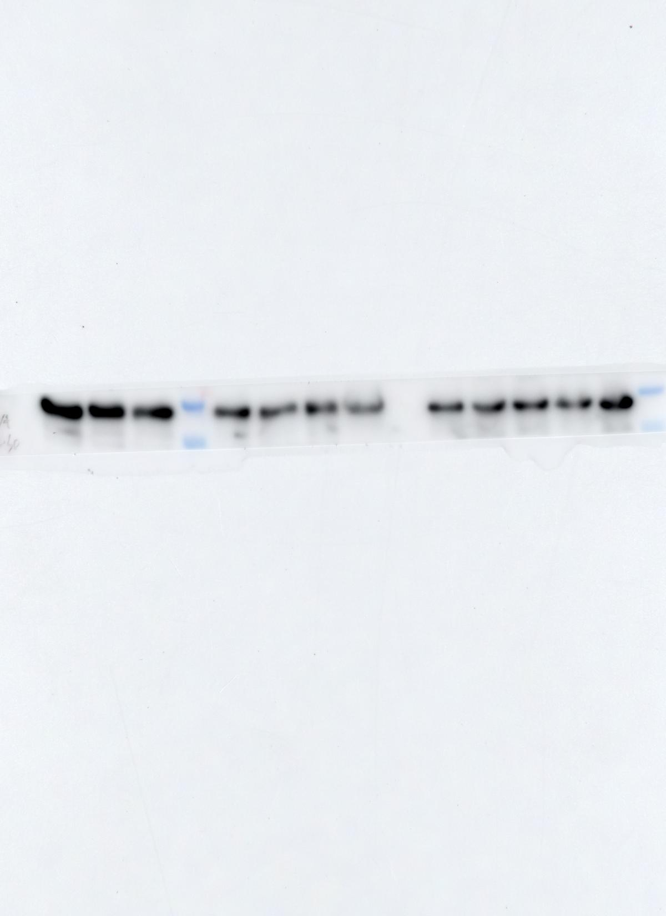
Figure 1D
Semaphorin 5A
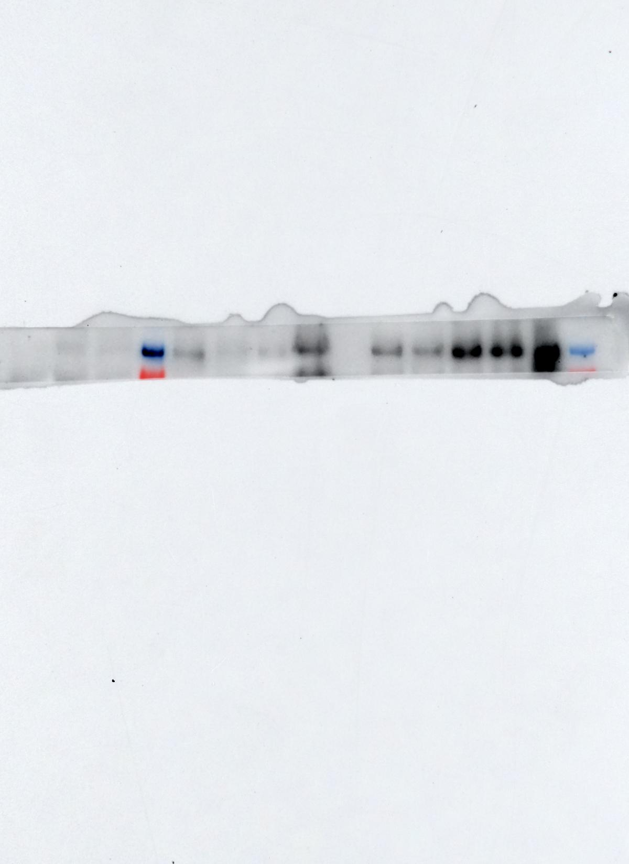
GAPDH
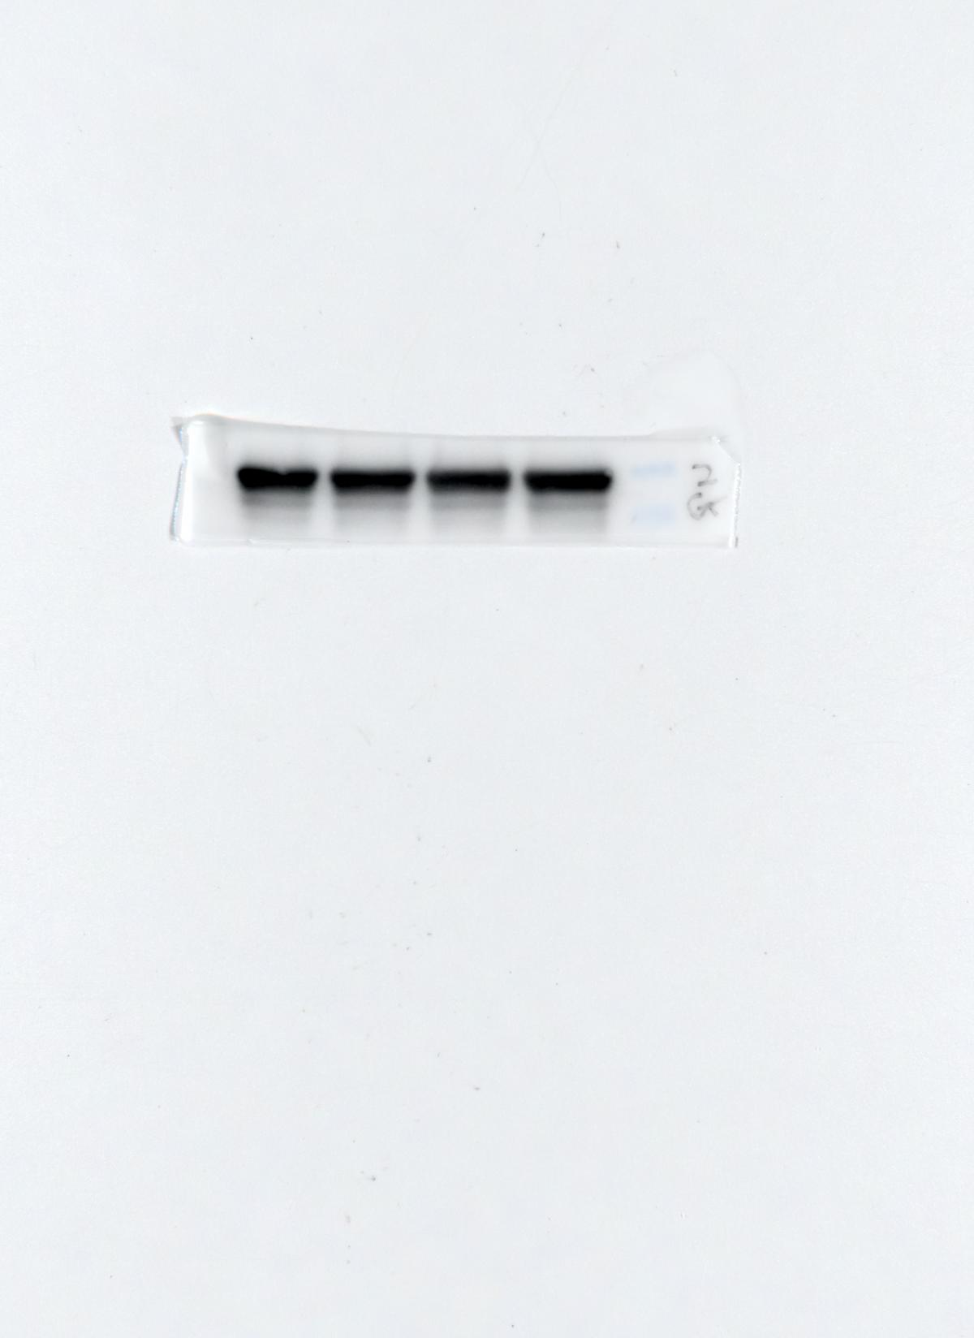
Figure 2B
Semaphorin 5A
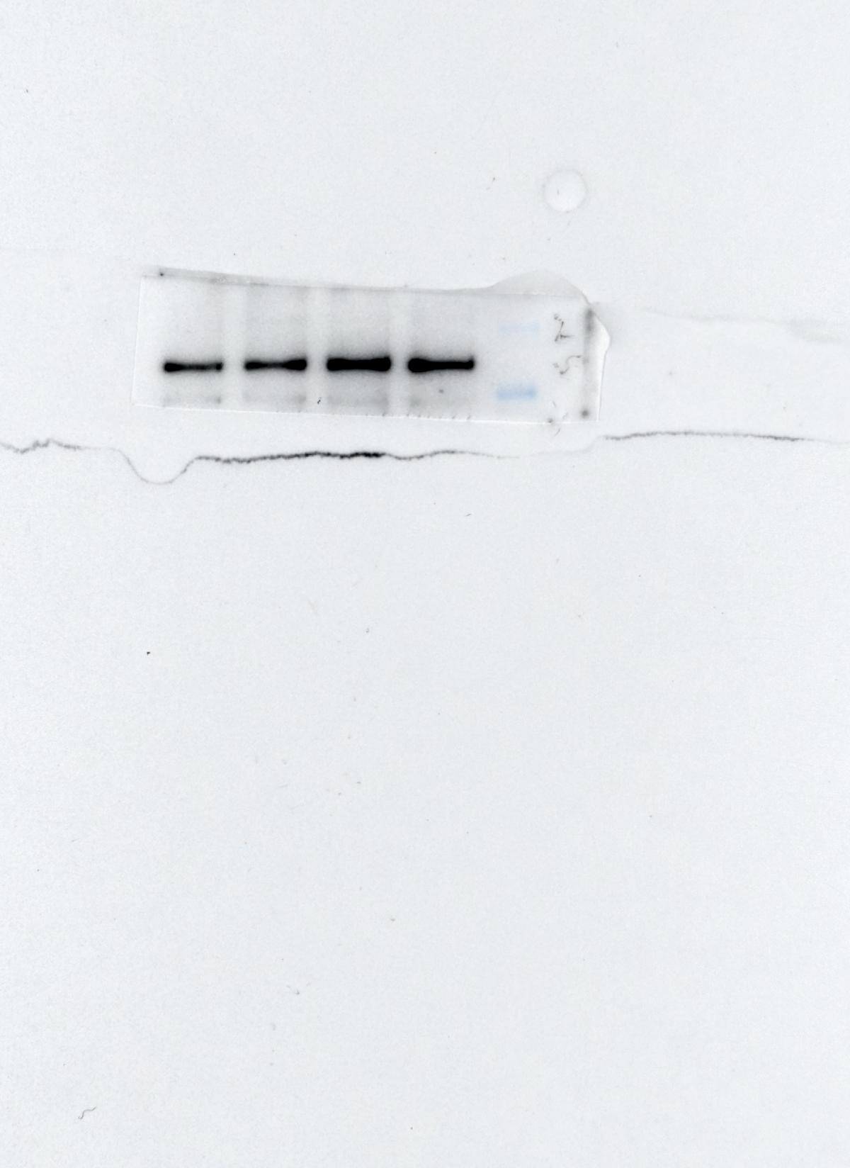
GAPDH
Figure 3C
1: Control-1
2: Semaphorin 5A-1
3: Control-2
4: Semaphorin 5A-2
5: Control-3
6: Semaphorin 5A-3
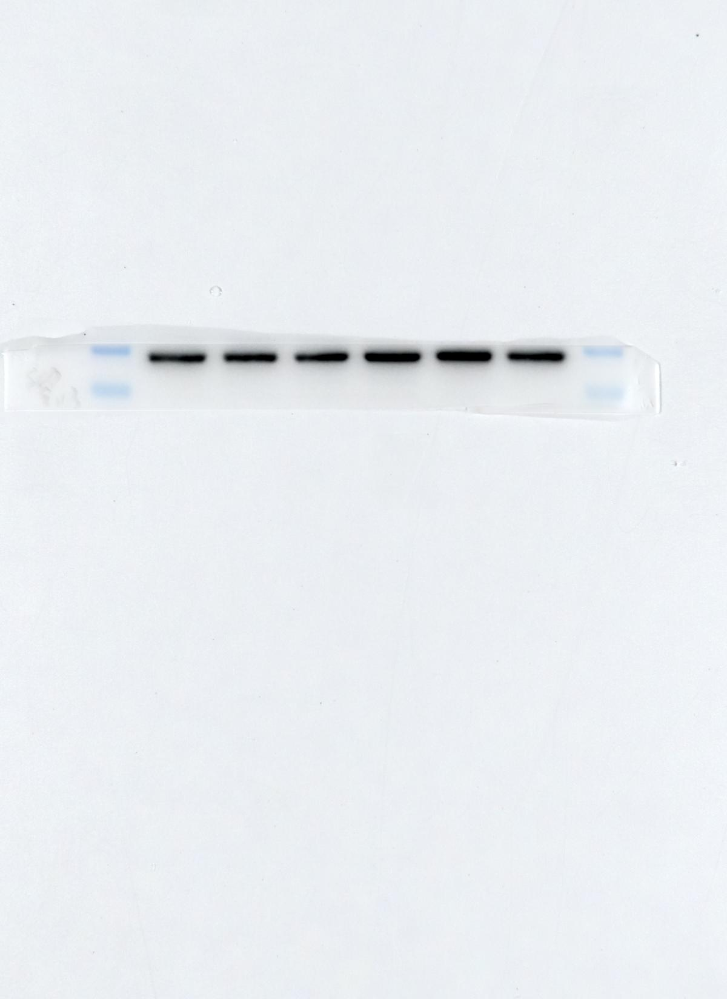
1 2 3 4 5 6
Plexin-A1
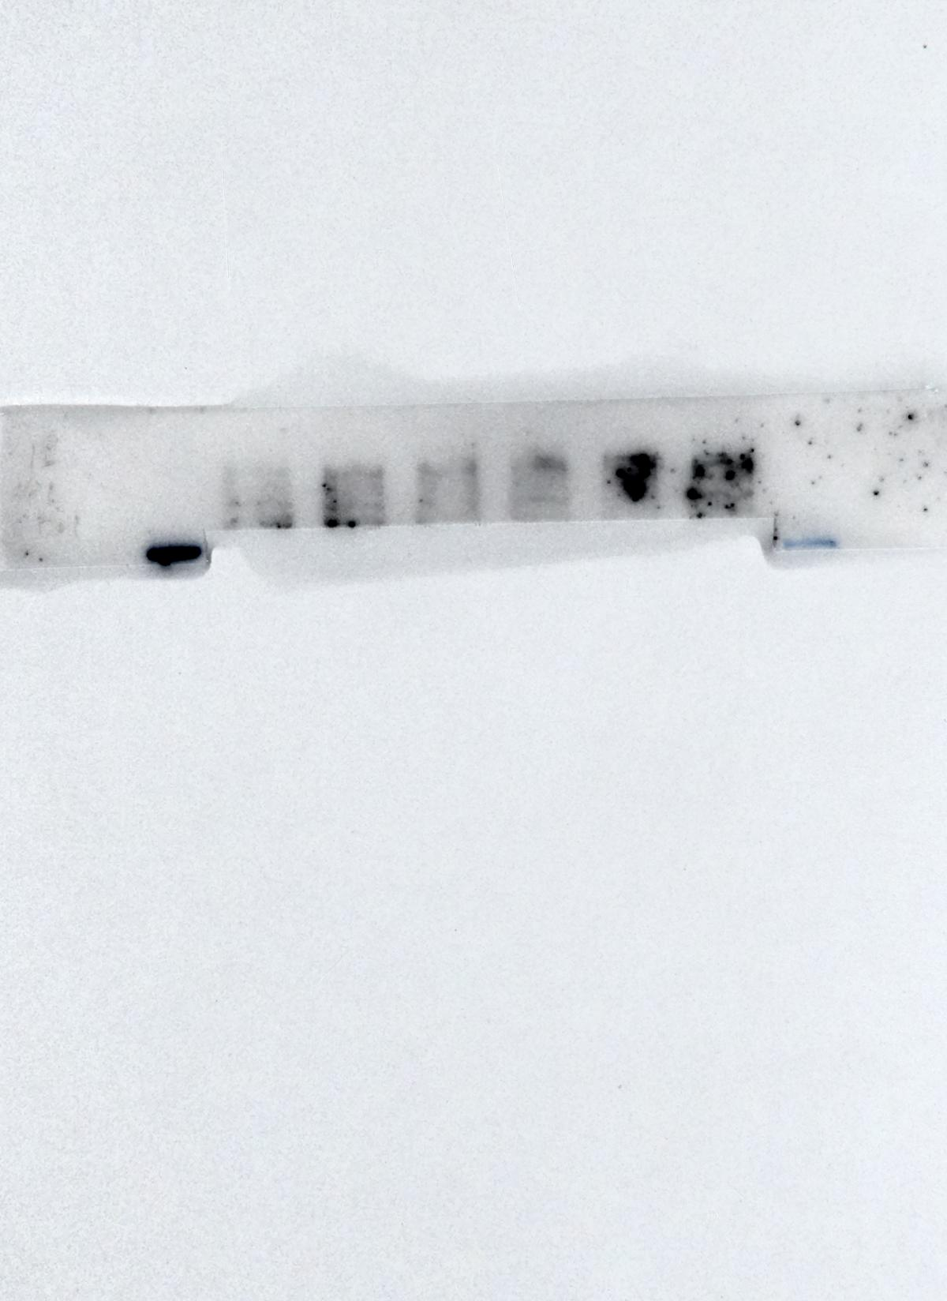
Plexin-B3
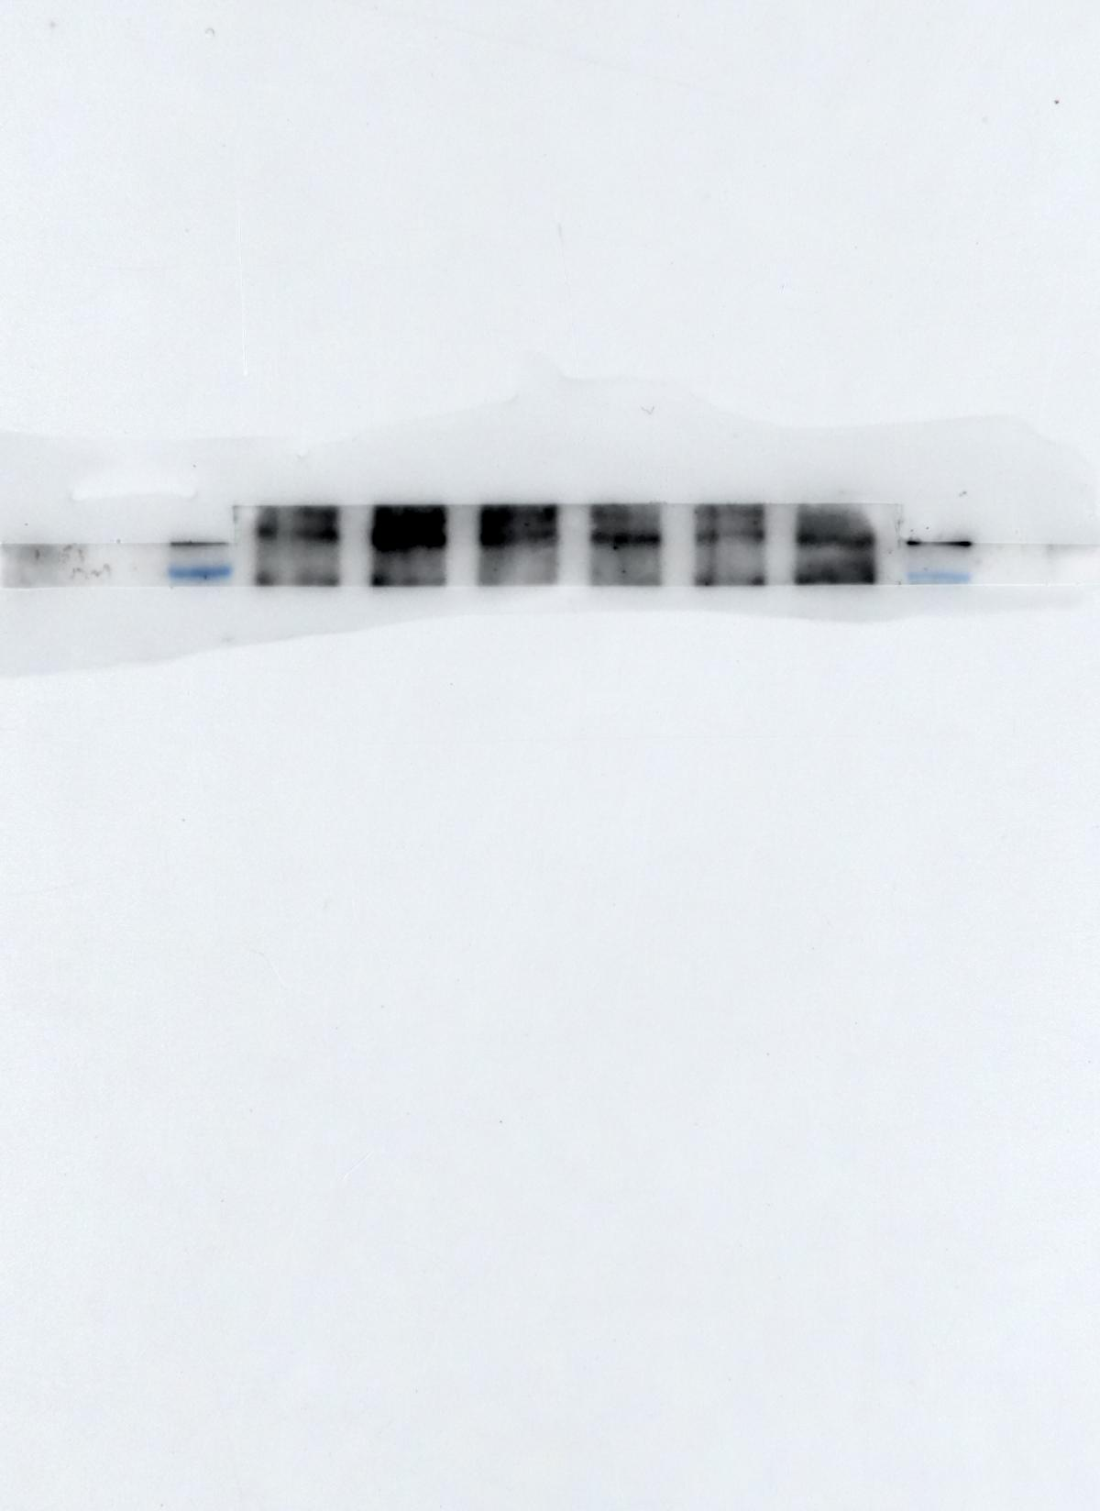
GAPDH
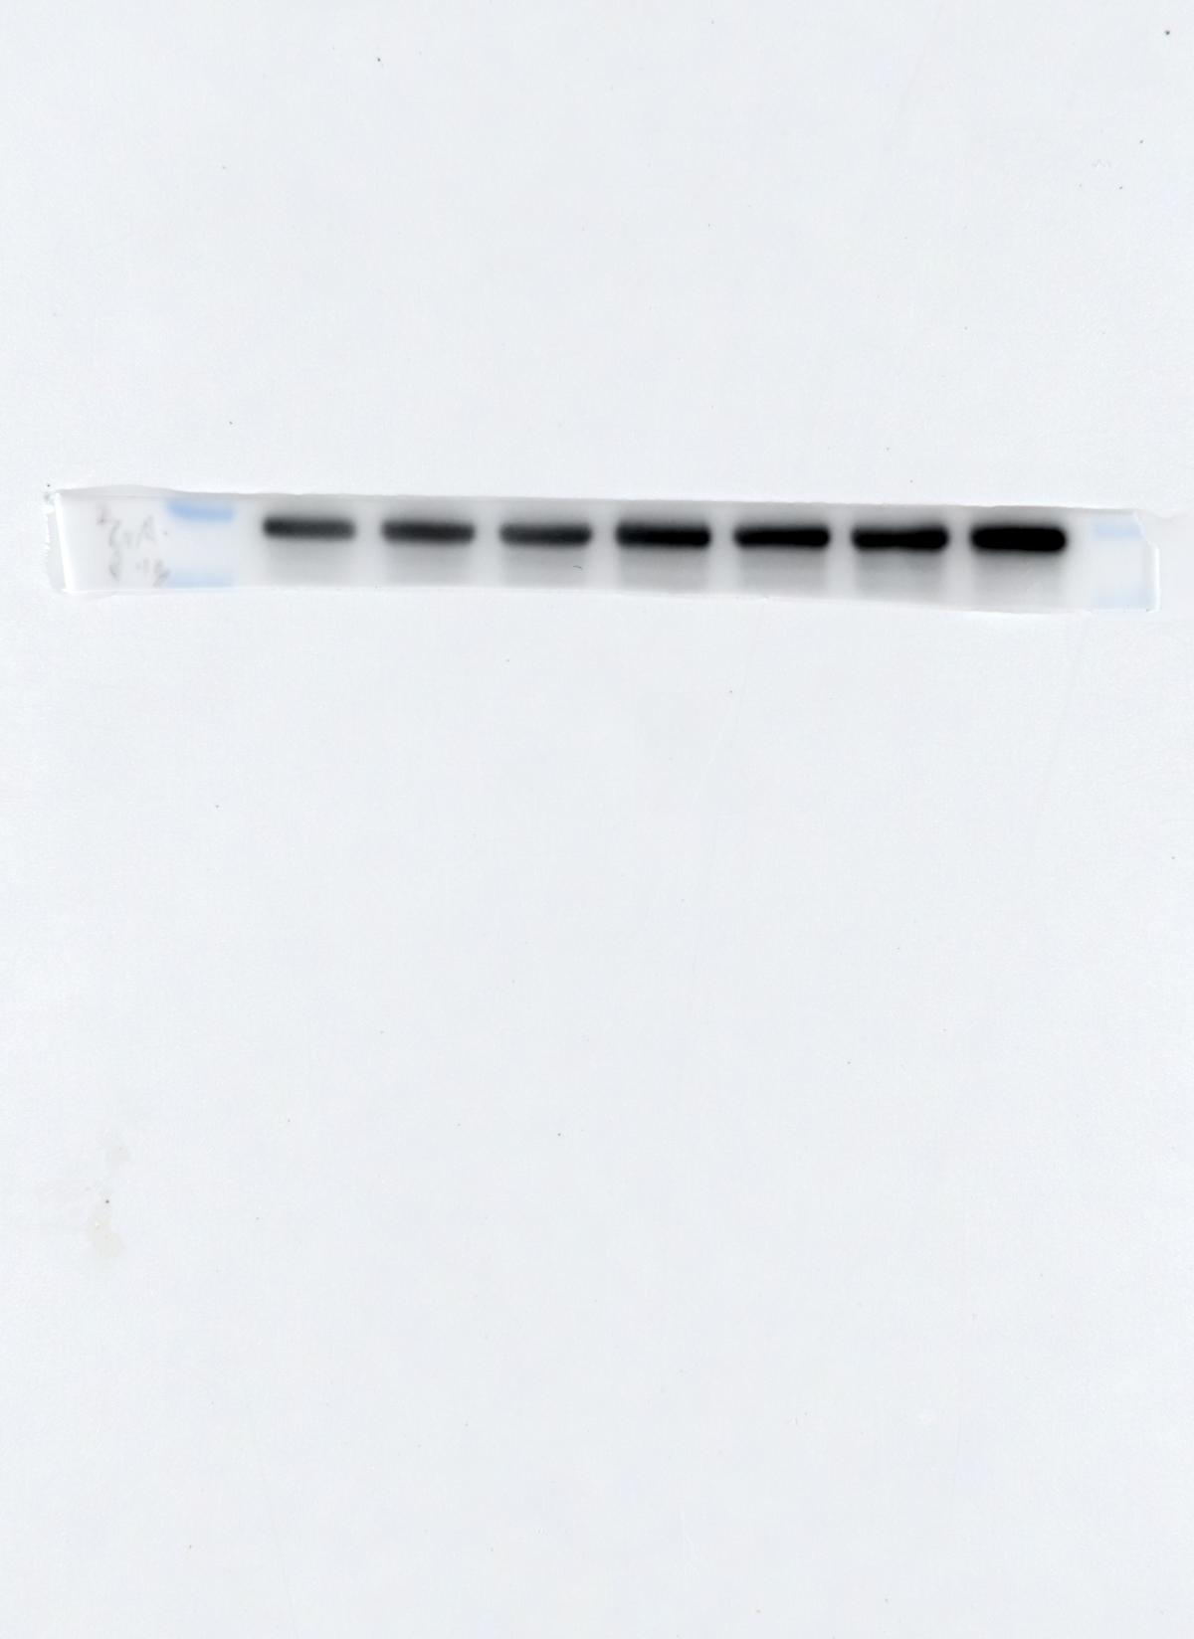
1 2 3 4 5 6 7
Figure 3D
1: si NC-1
2: si Plexin-B3-1
3: si Plexin-B3-2
4: si NC-2
5: si Plexin-A1-mix
6: si Plexin-A1-1
7: si Plexin-A1-2

Plexin-A1
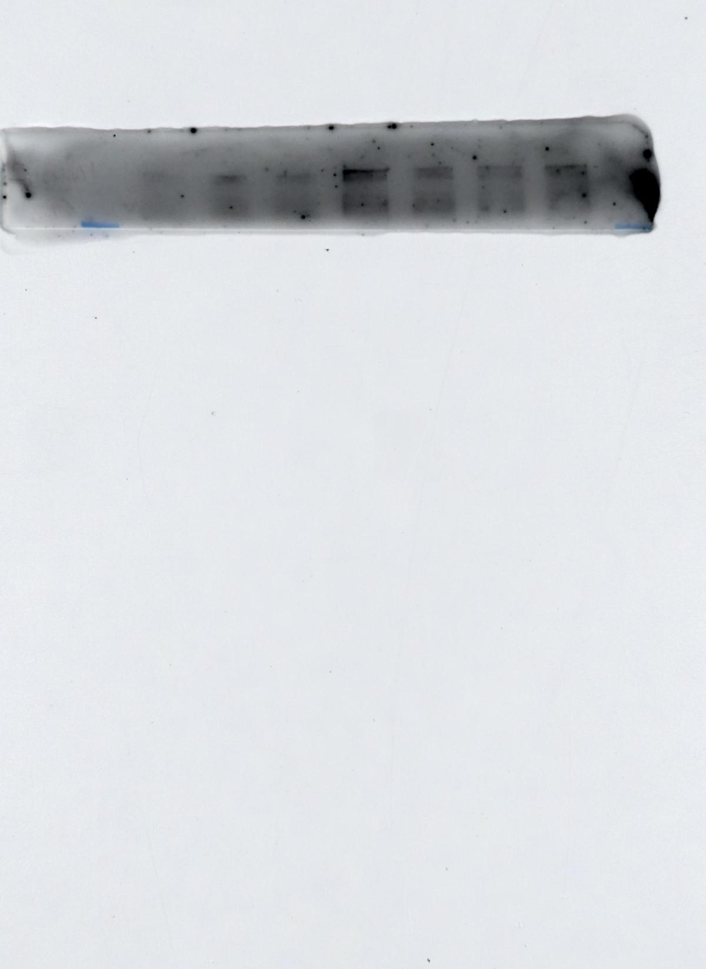
180kDa
GAPDH
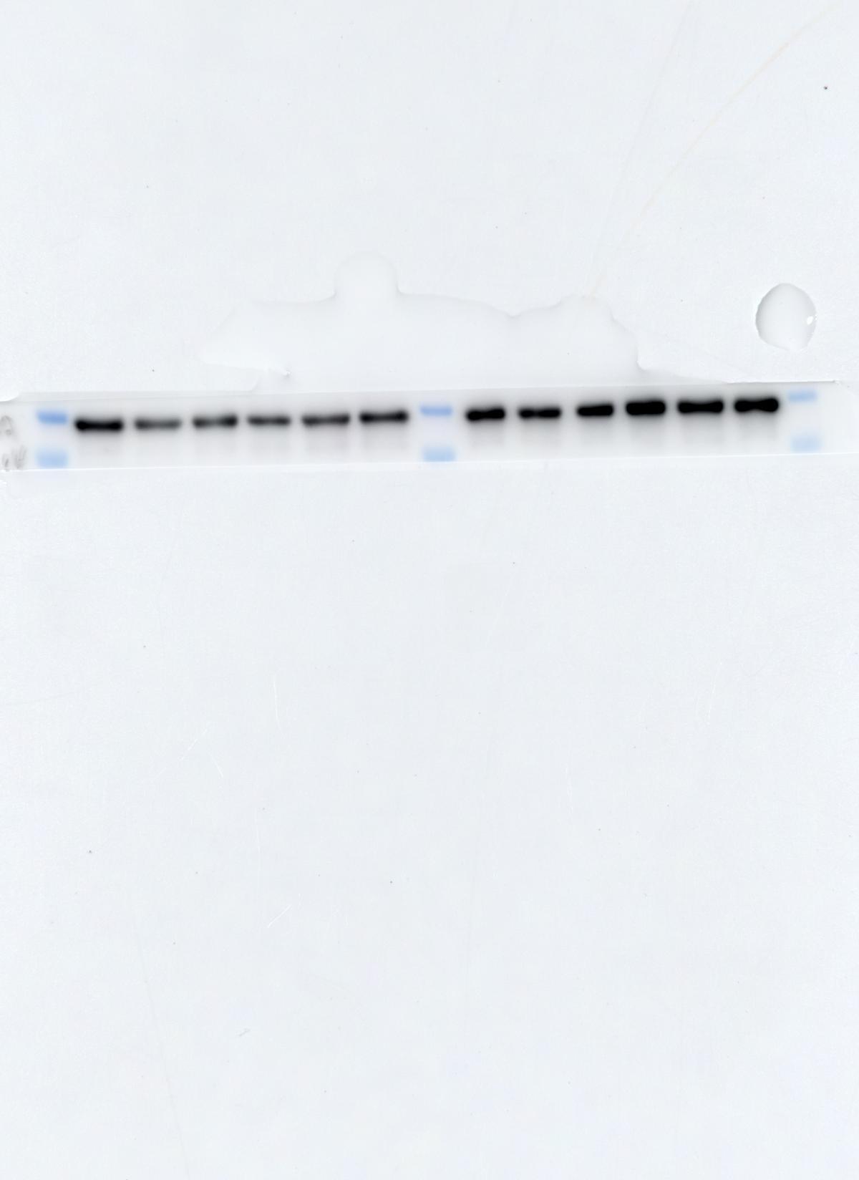
Figure 3E
1-3:OA(synovial fibroblasts)
4-6:RA(synovial fibroblasts)
7: si NC-1
8: si Plexin-A1-1
9: si Plexin-A1-2
10: si NC-2
11: si Plexin-B3-1
12: si Plexin-B3-2

40kDa
35kDa
1 2 3 4 5 6 7 8 9 10 11 12
Plexin-B3
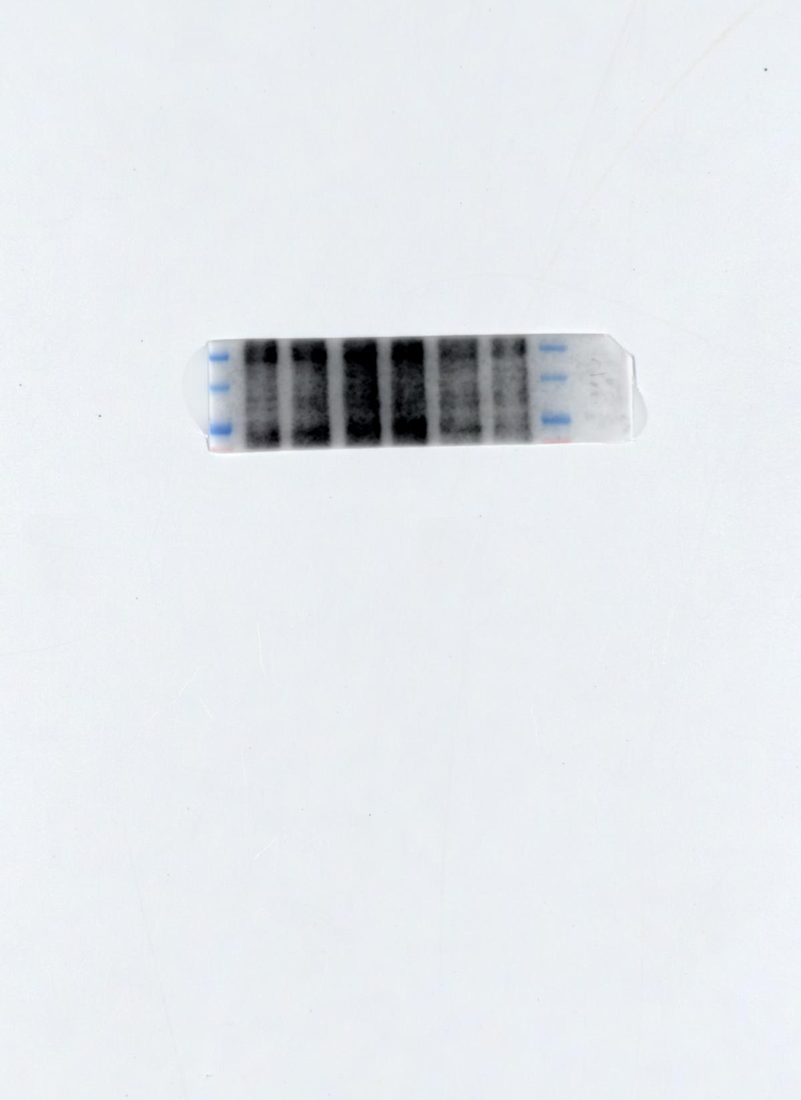
7 8 9 10 11 12
180kDa
130kDa
100kDa
GAPDH
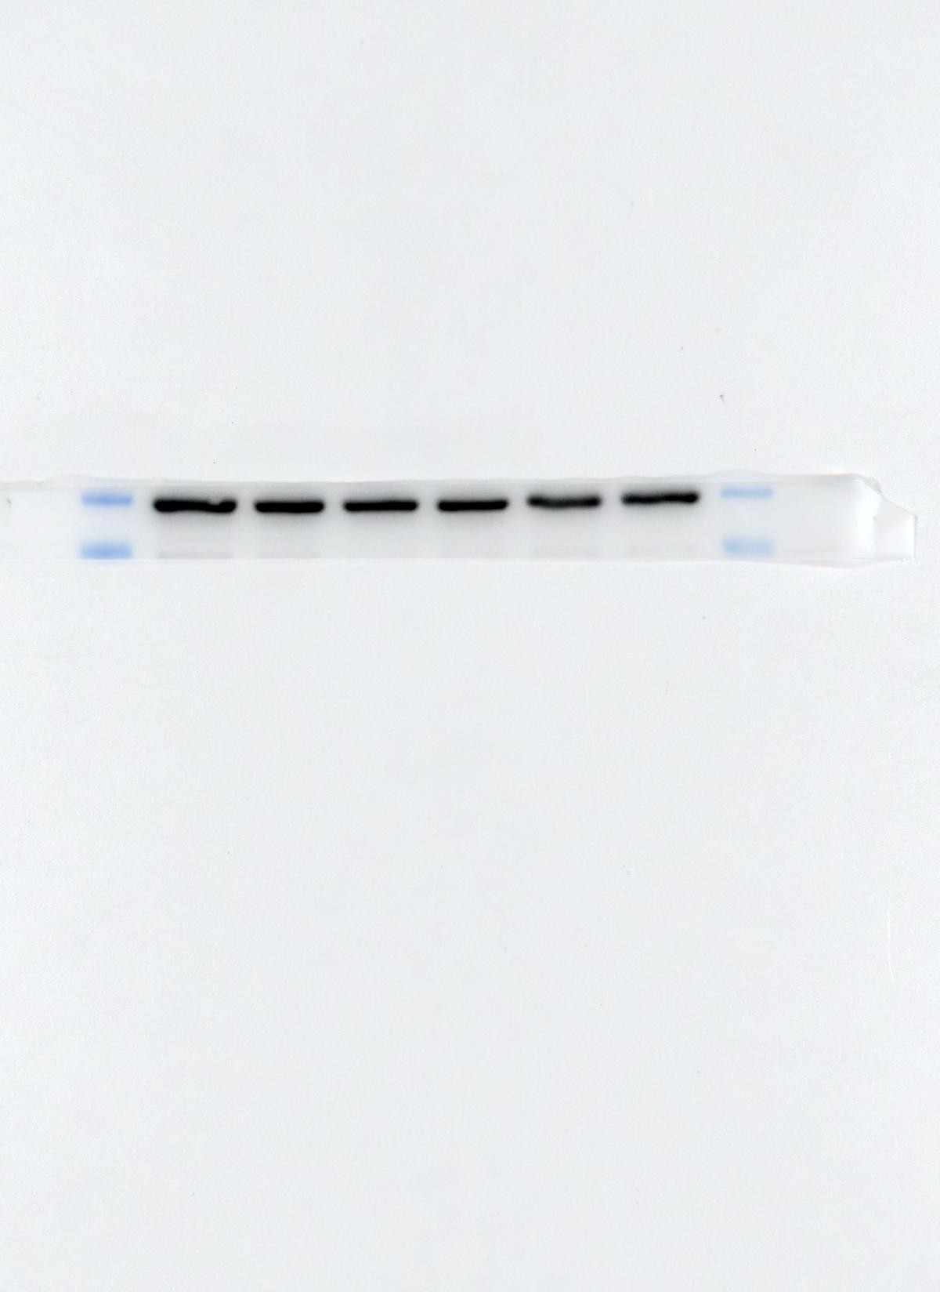
Figure4C
1: Control
2: 2h
3: 8h
4: 24h
5: 48h
6: 72h
1 2 3 4 5 6
PI3K
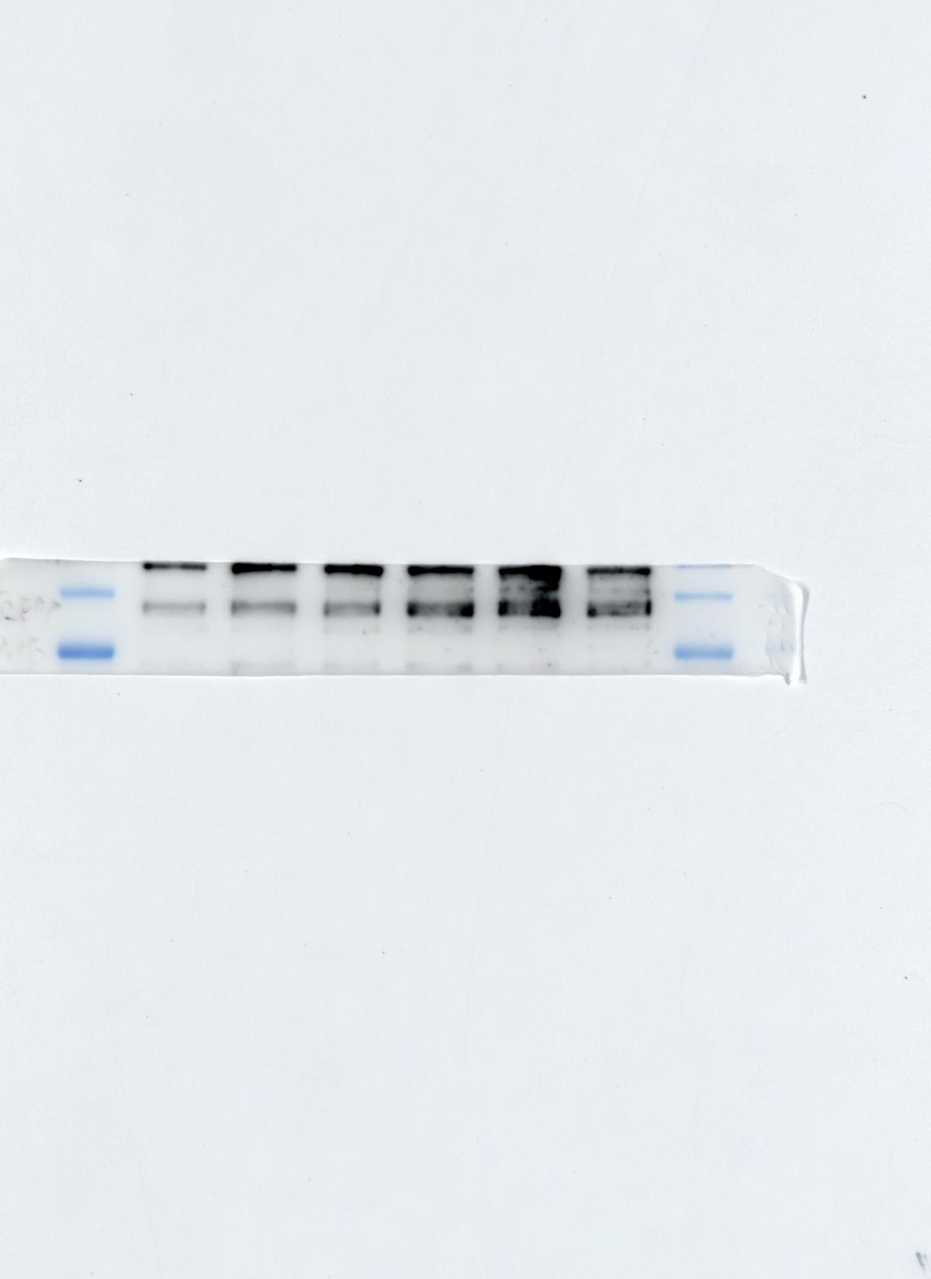
130kDa
100kDa
mTOR
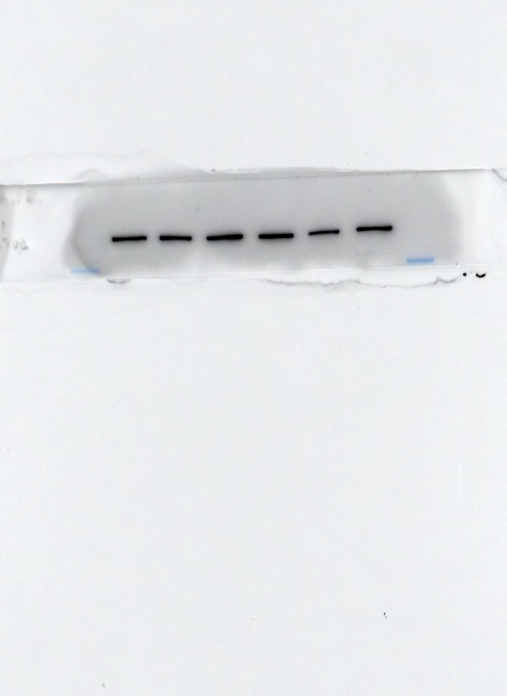
p-mTOR
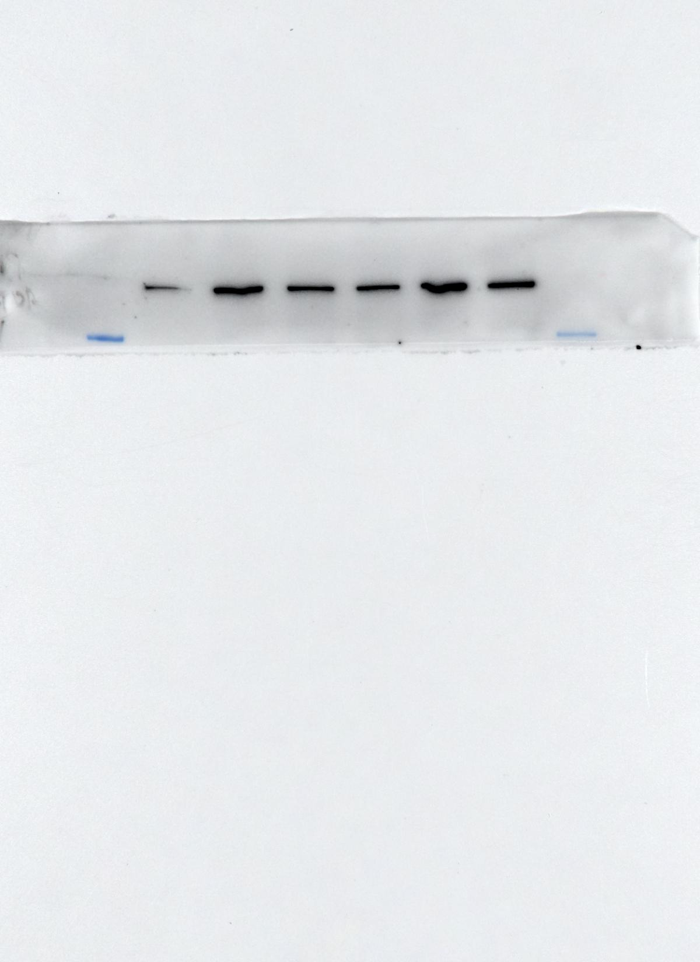
AKT
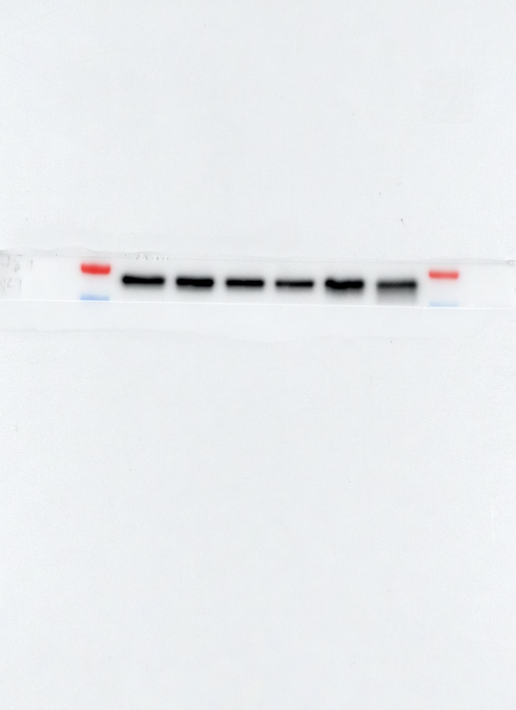
p-AKT
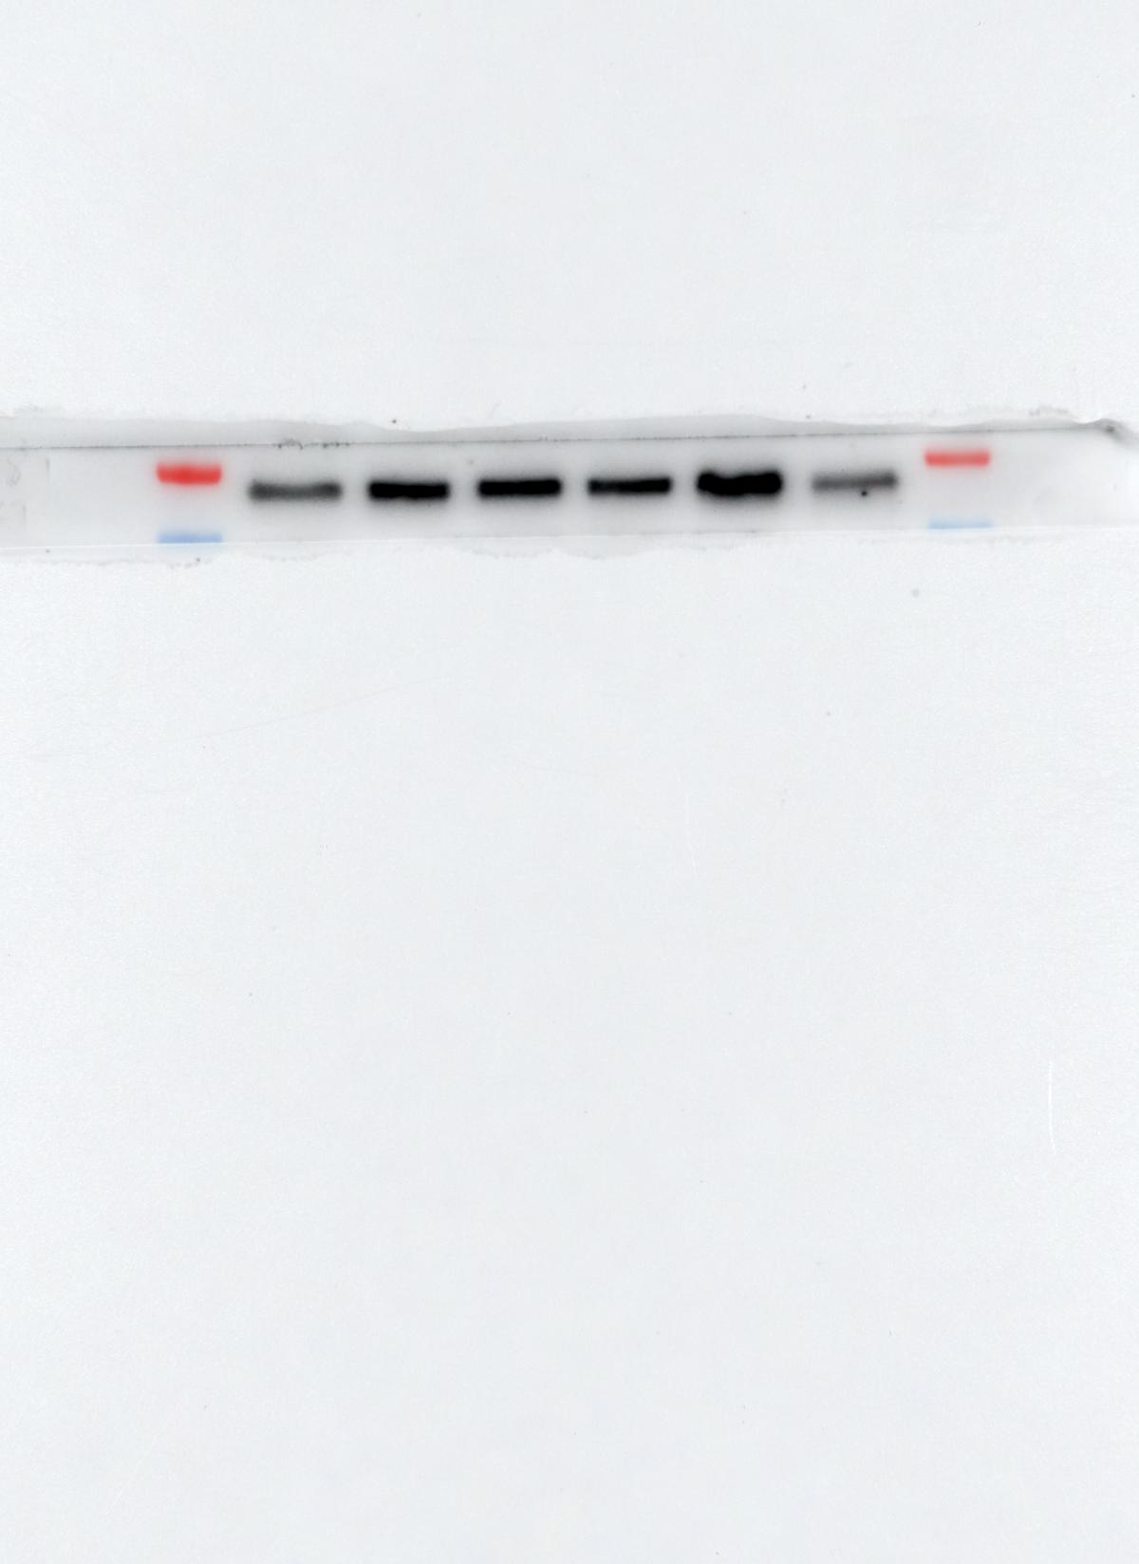
4EBP1
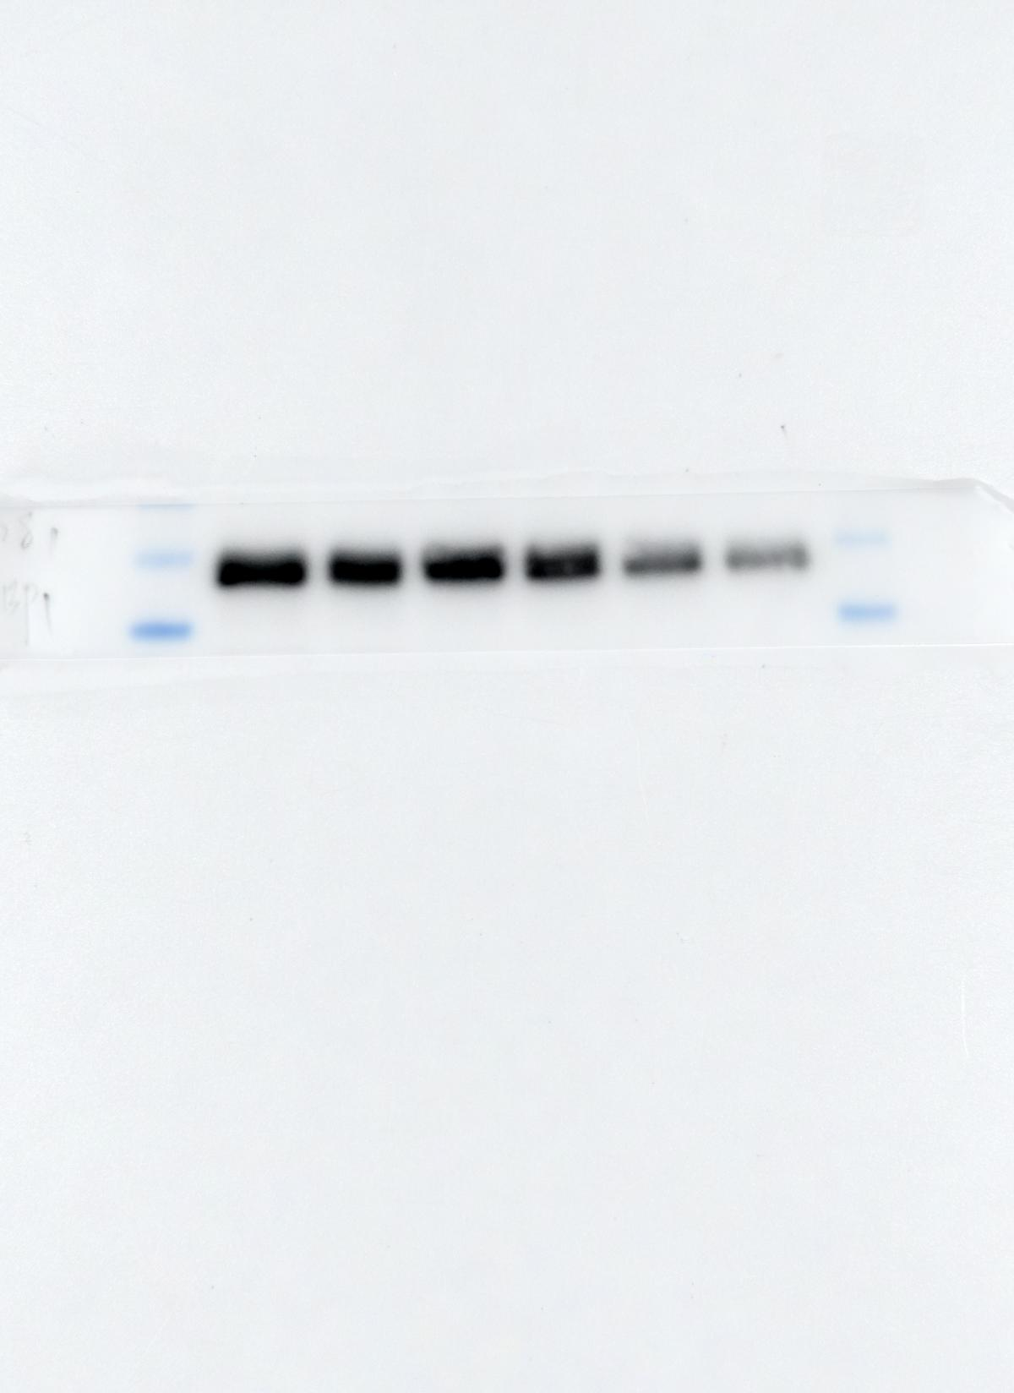
p-4EBP1
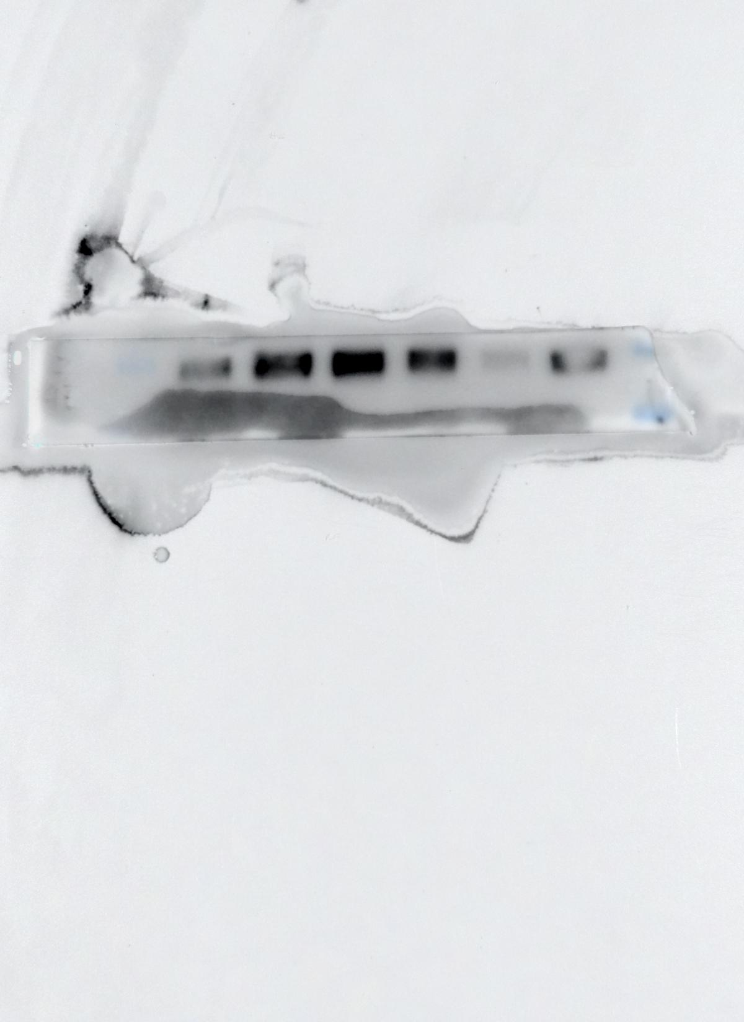
BAD
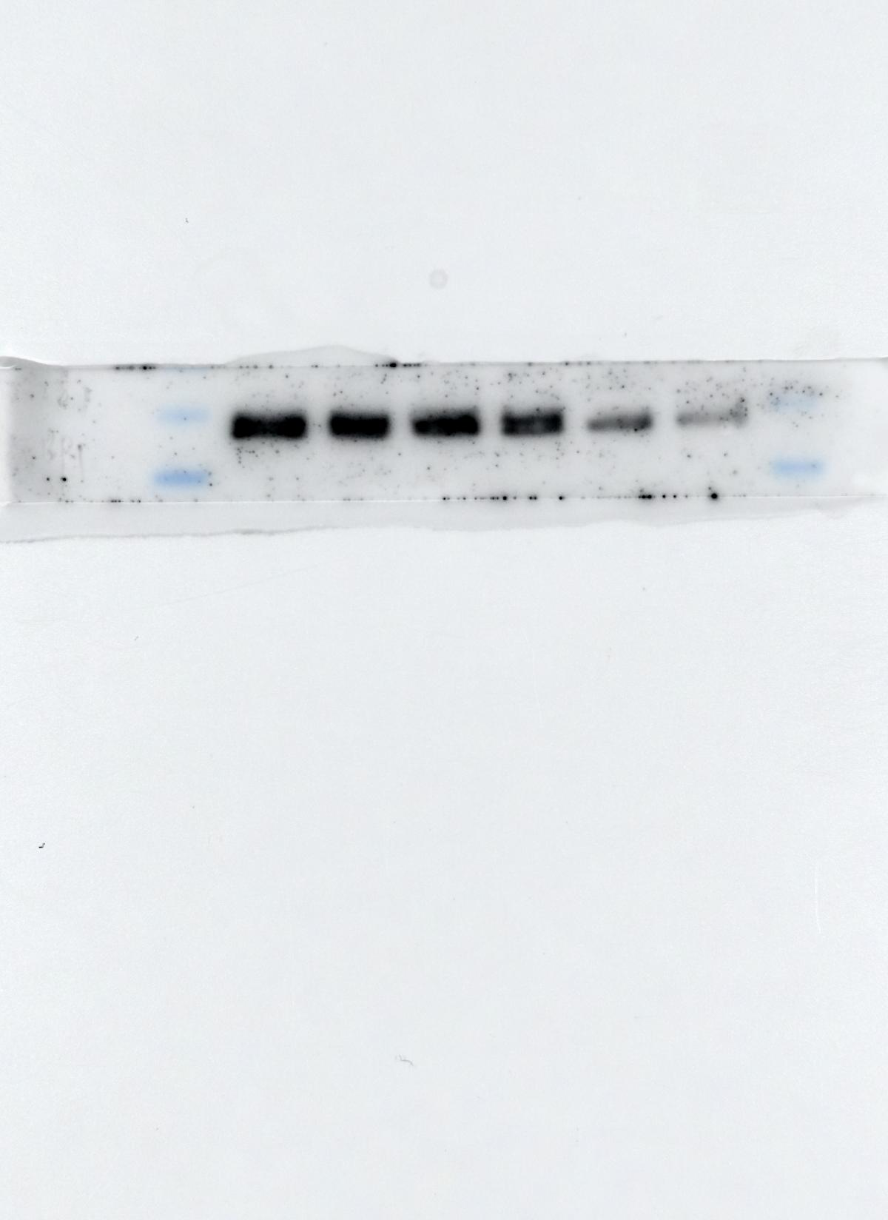
p-BAD
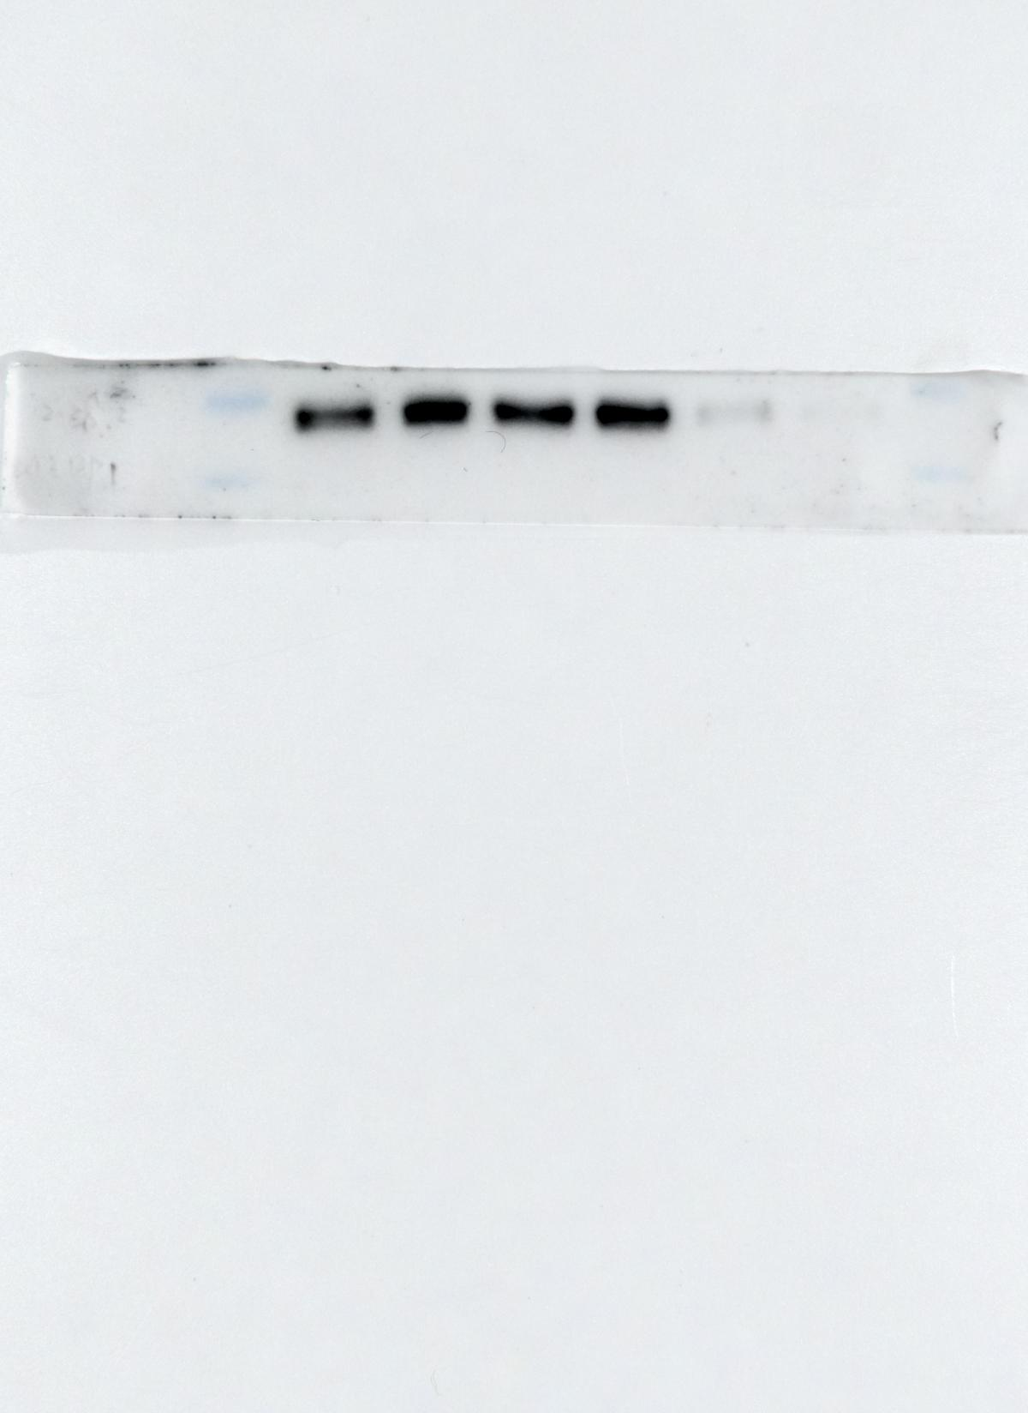
GAPDH
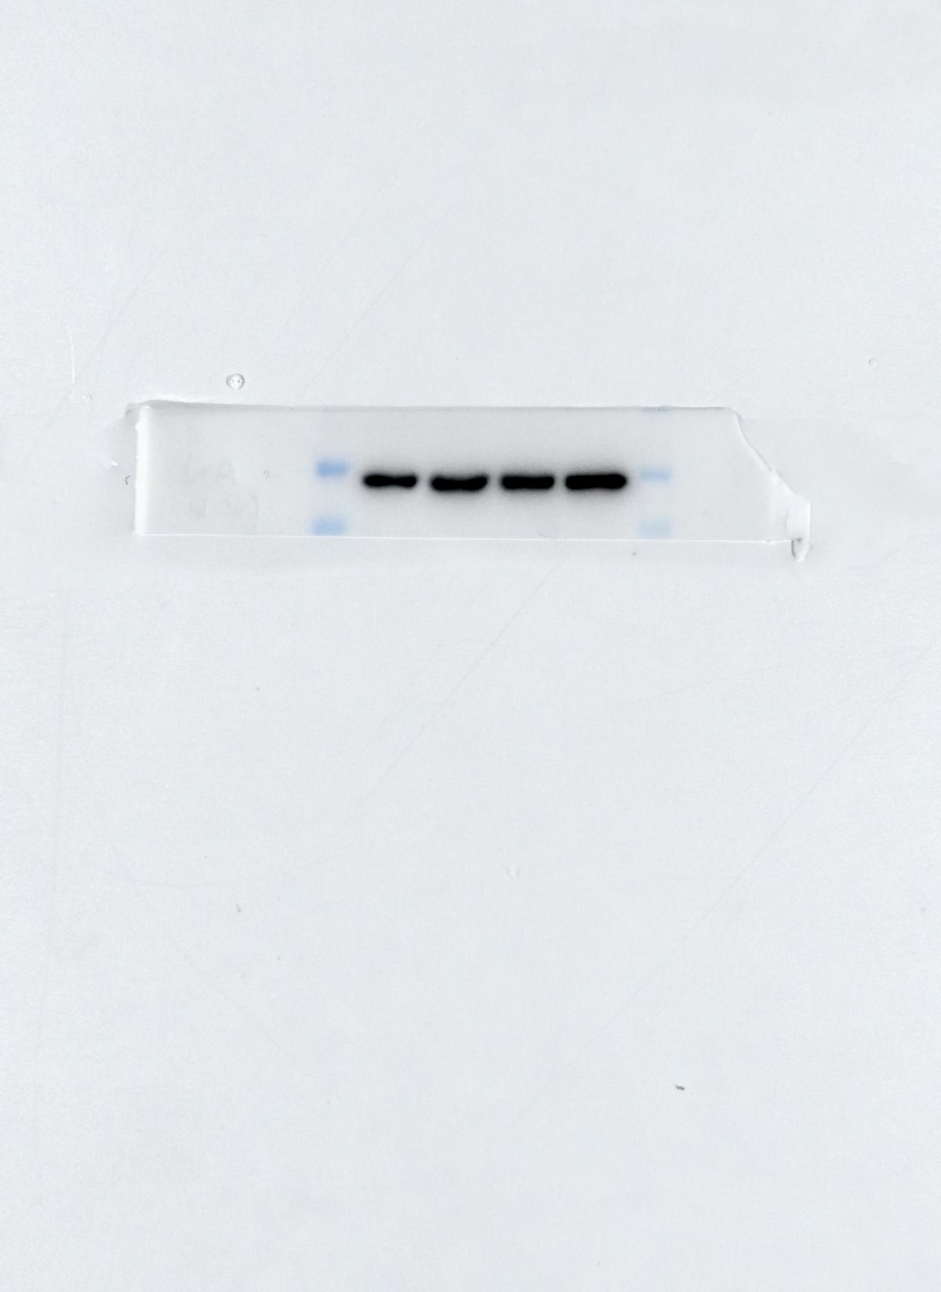
Figure 4D
PI3K inhibitor-Pictilisib
PI3K
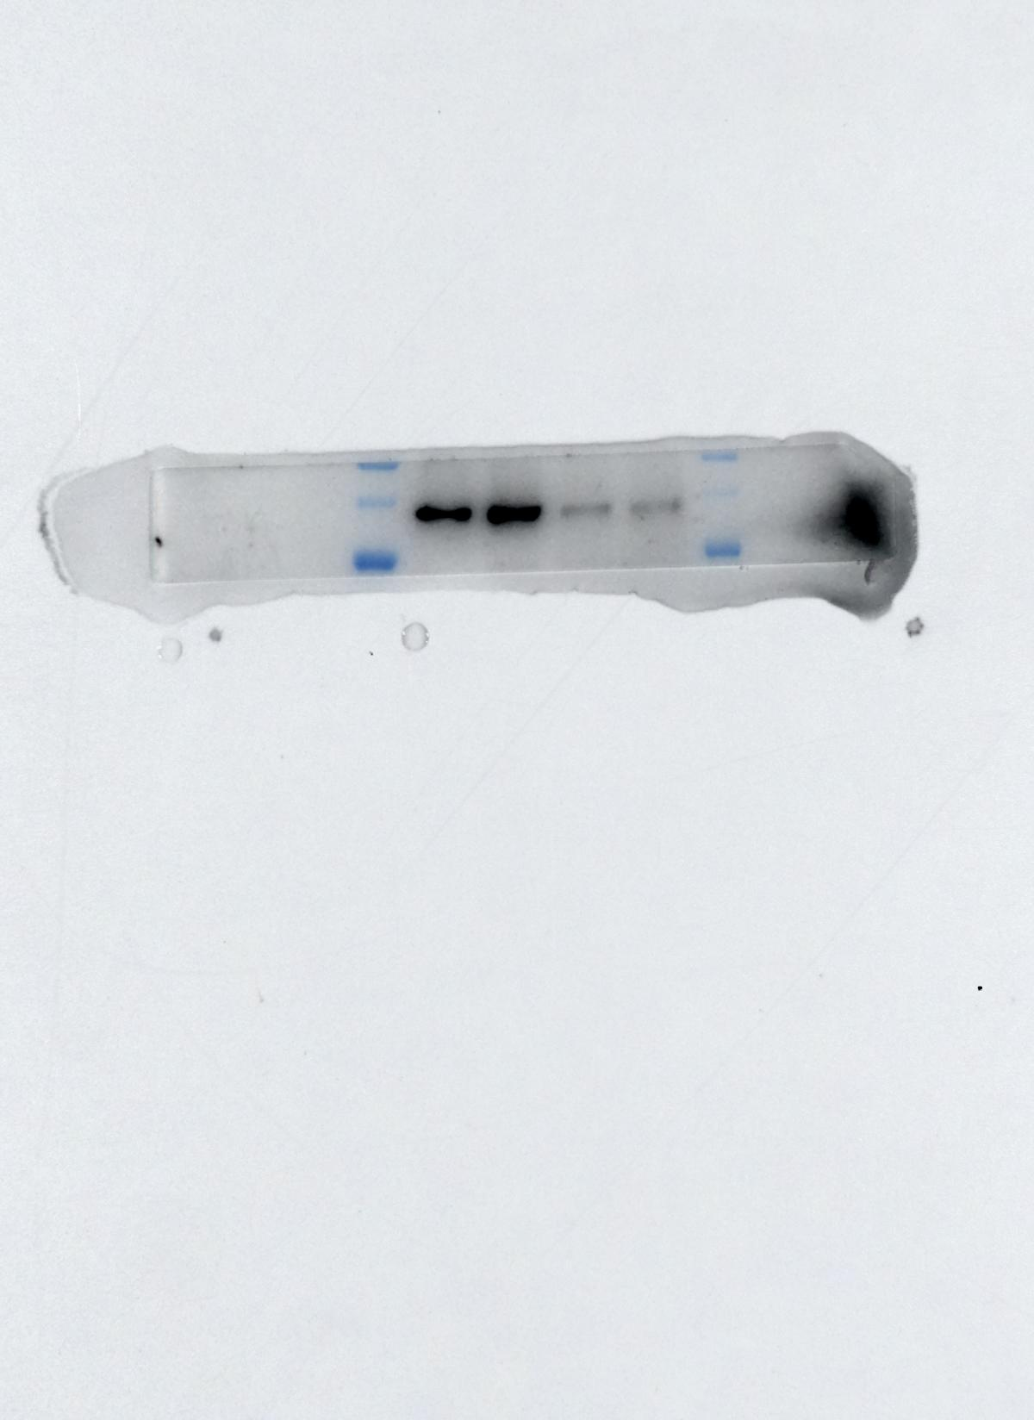
mTOR
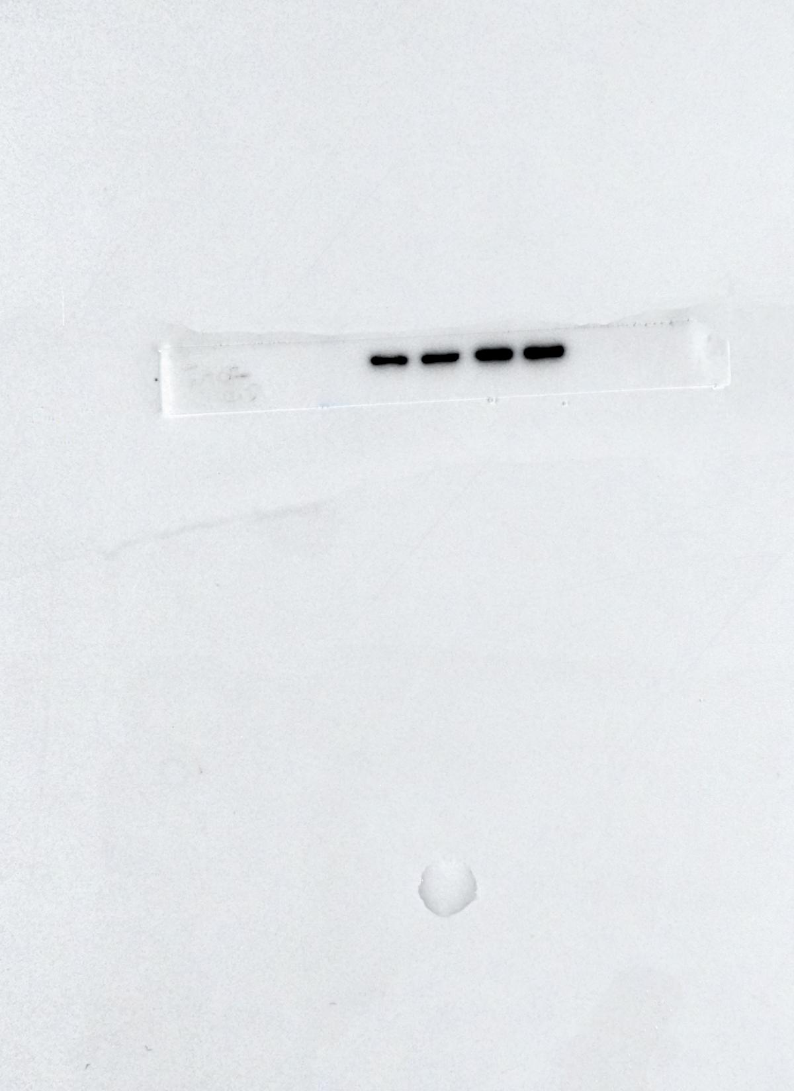
p-mTOR
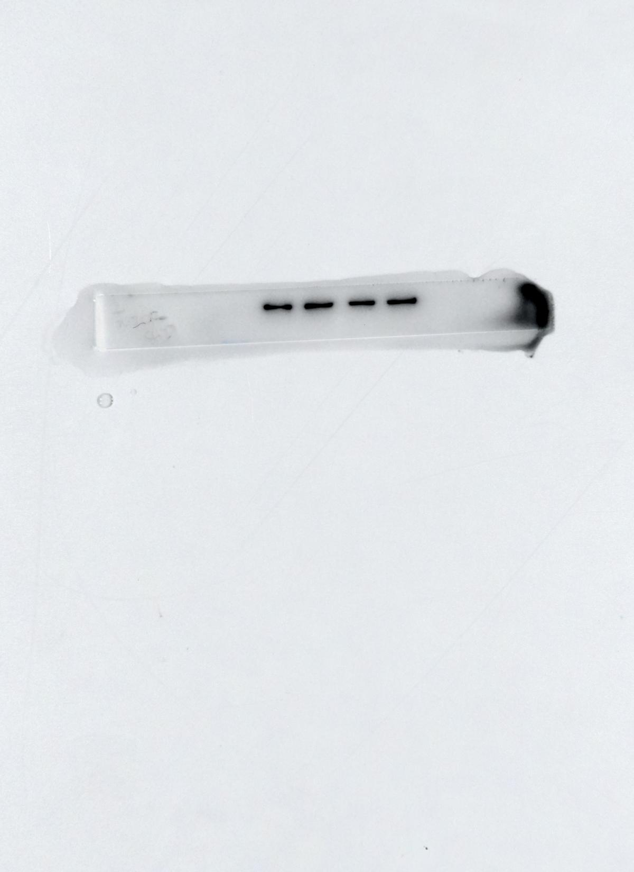
AKT
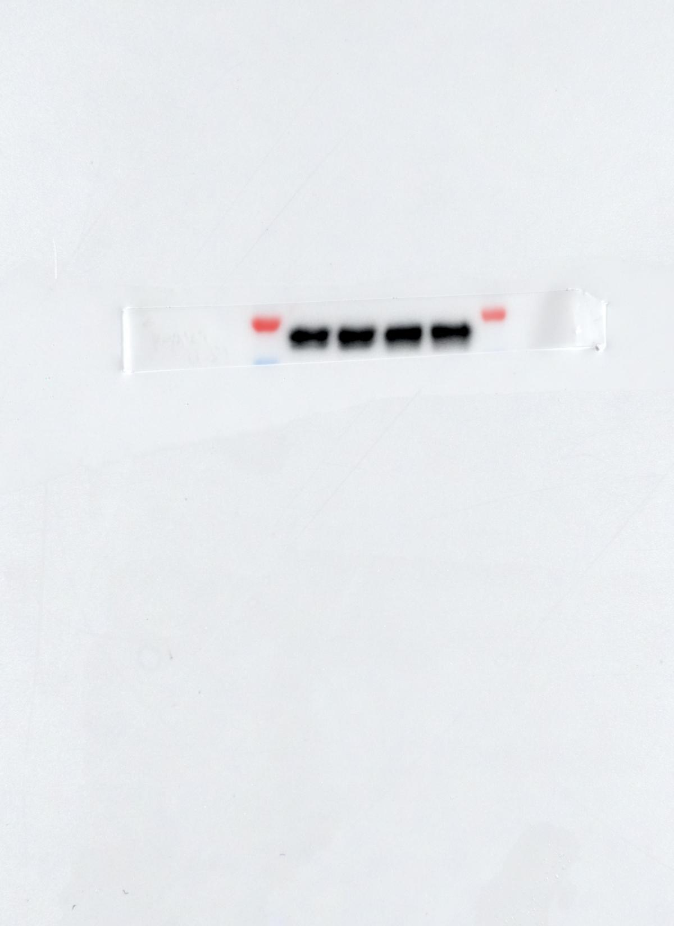
p-AKT
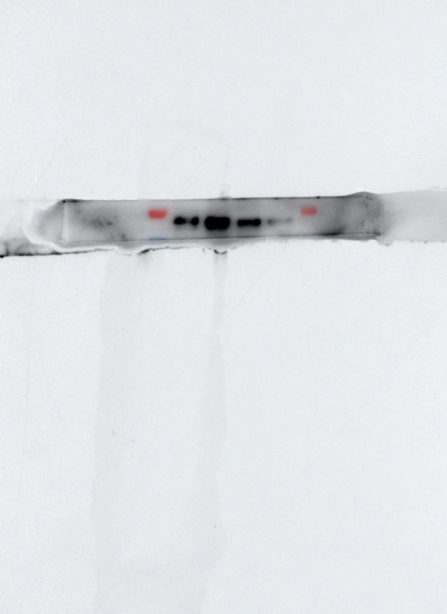
4EBP1
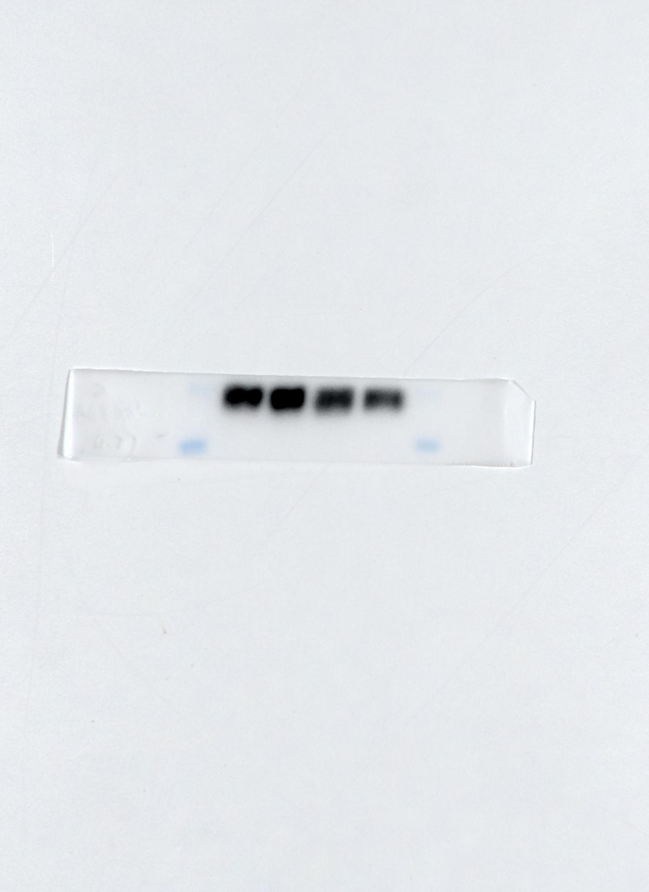
p-4EBP1
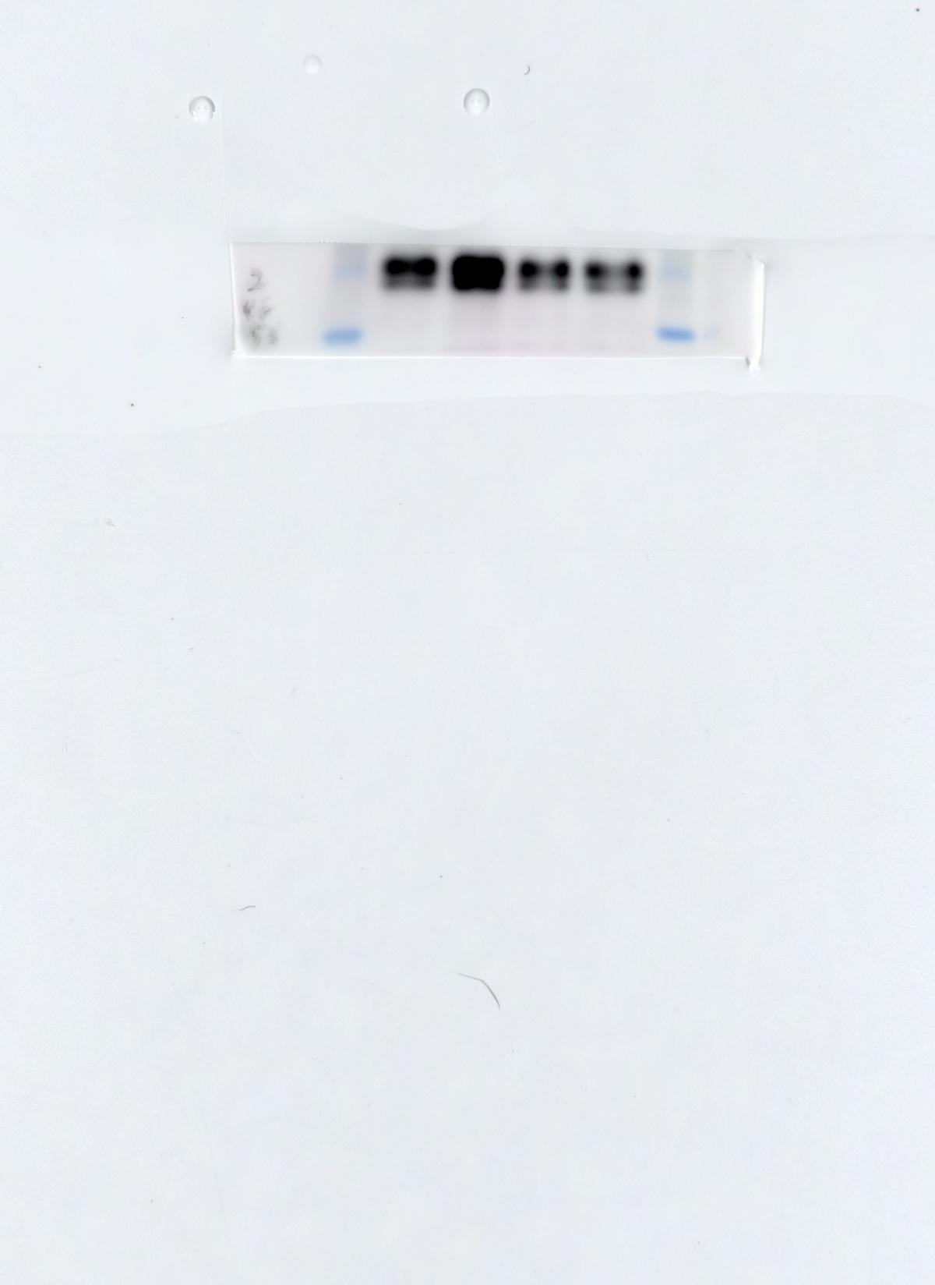
GAPDH
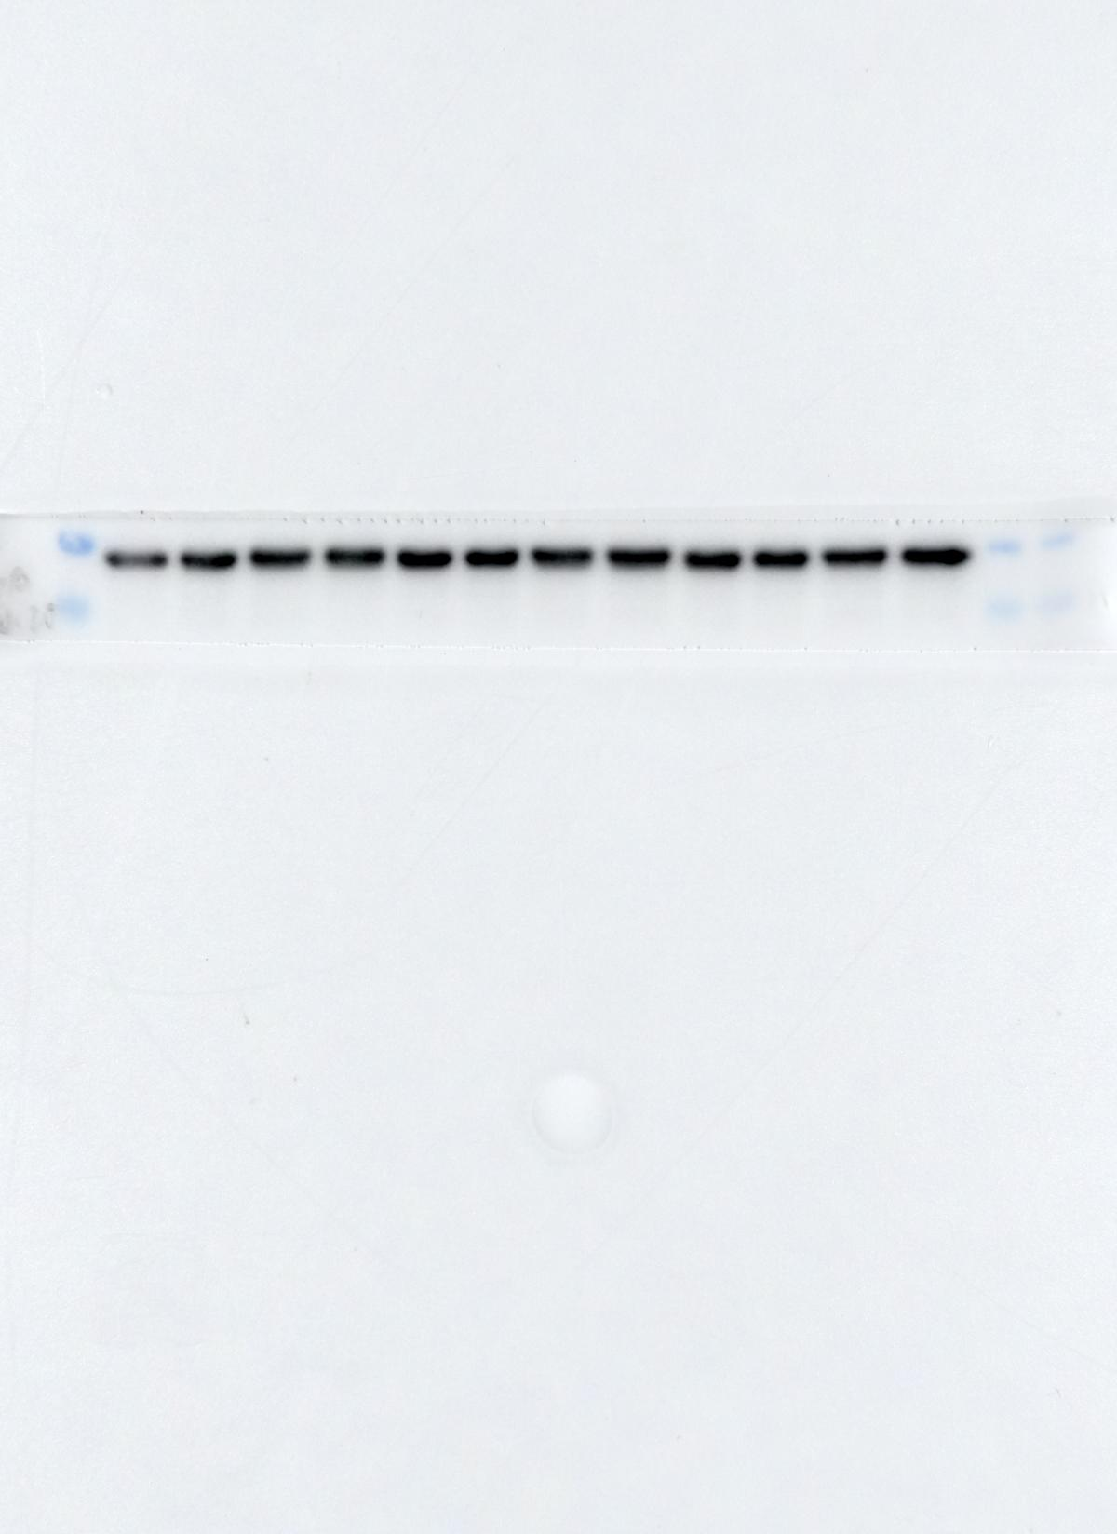
Figure 4D
mTOR inhibitor-Temsirolimus
mTOR
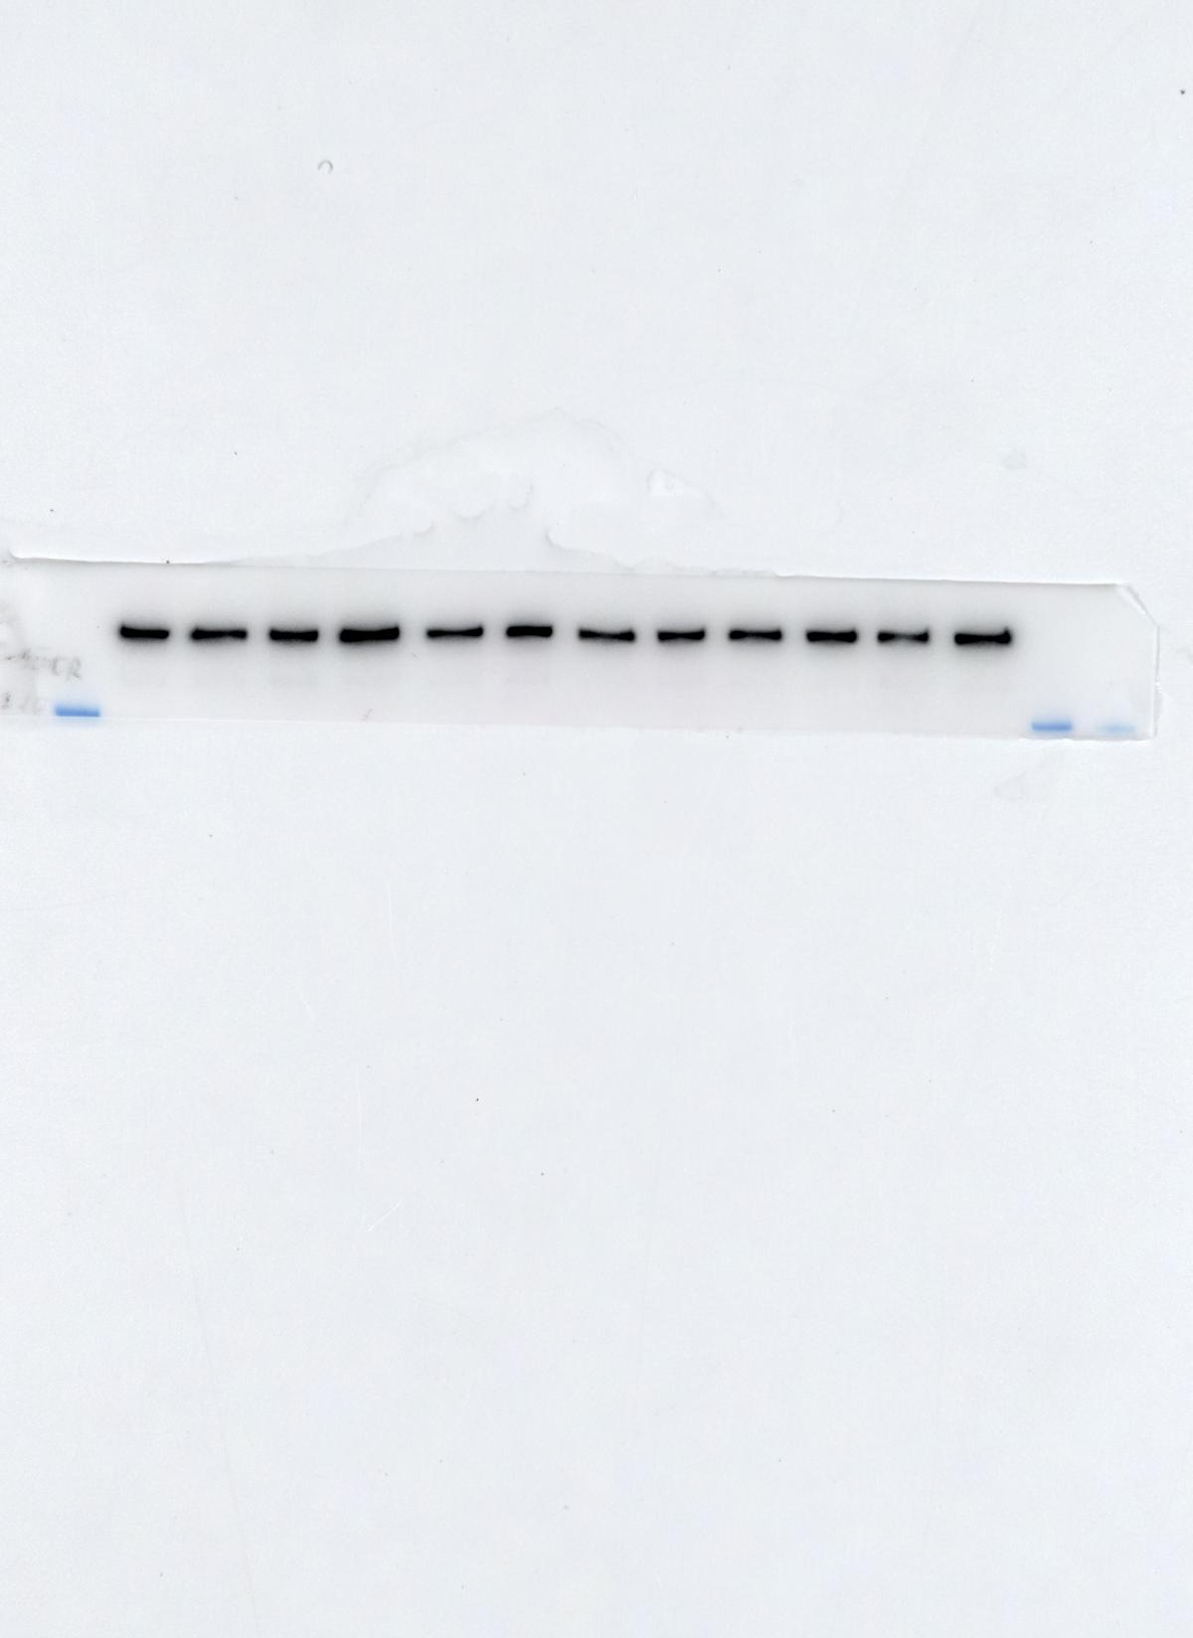
p-mTOR
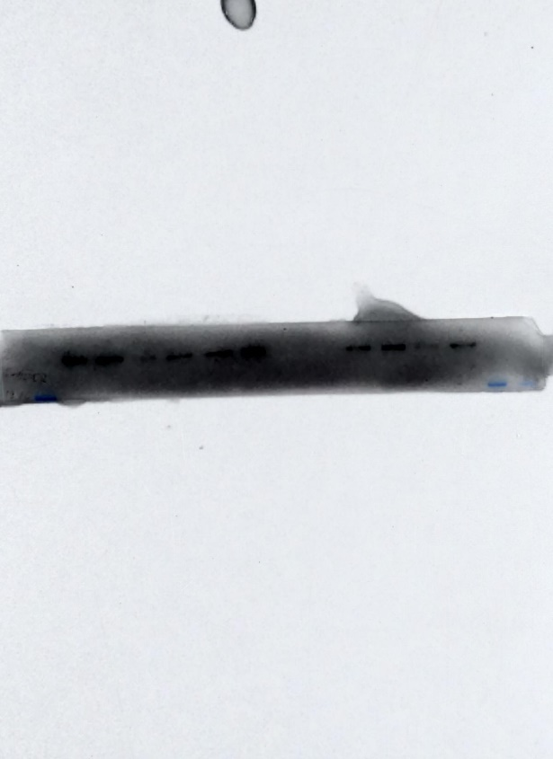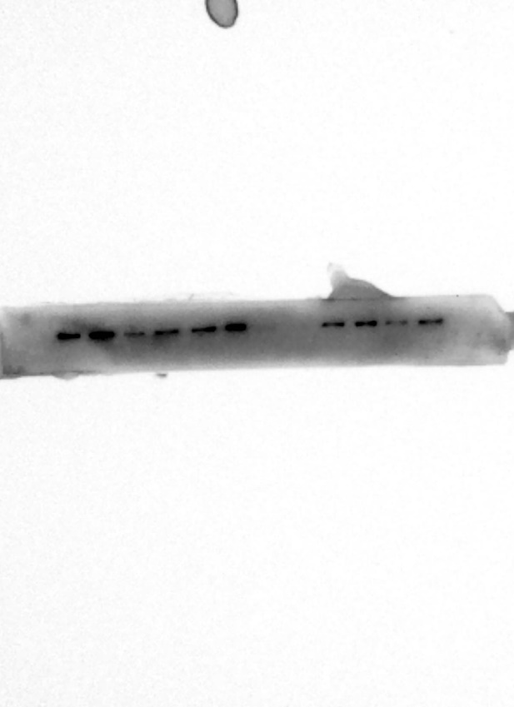
without marker
with marker

4EBP1
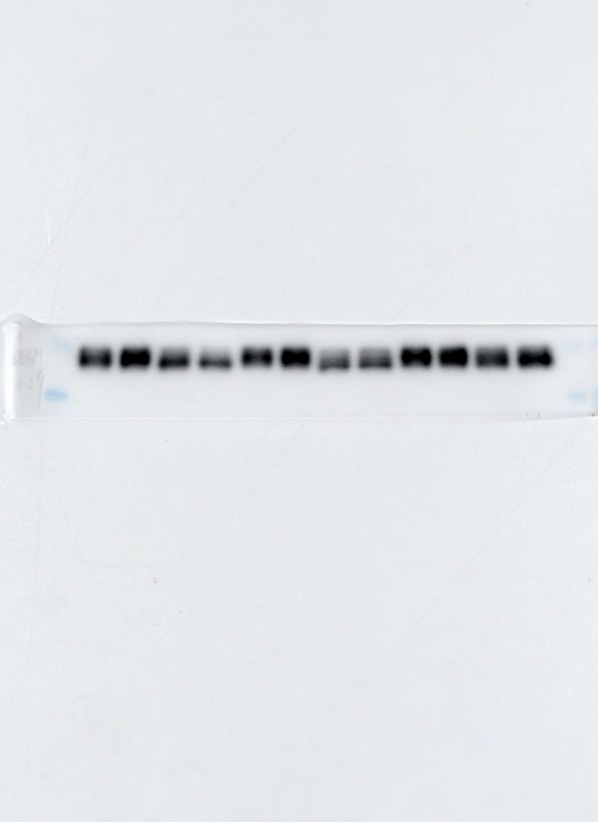
p-4EBP1
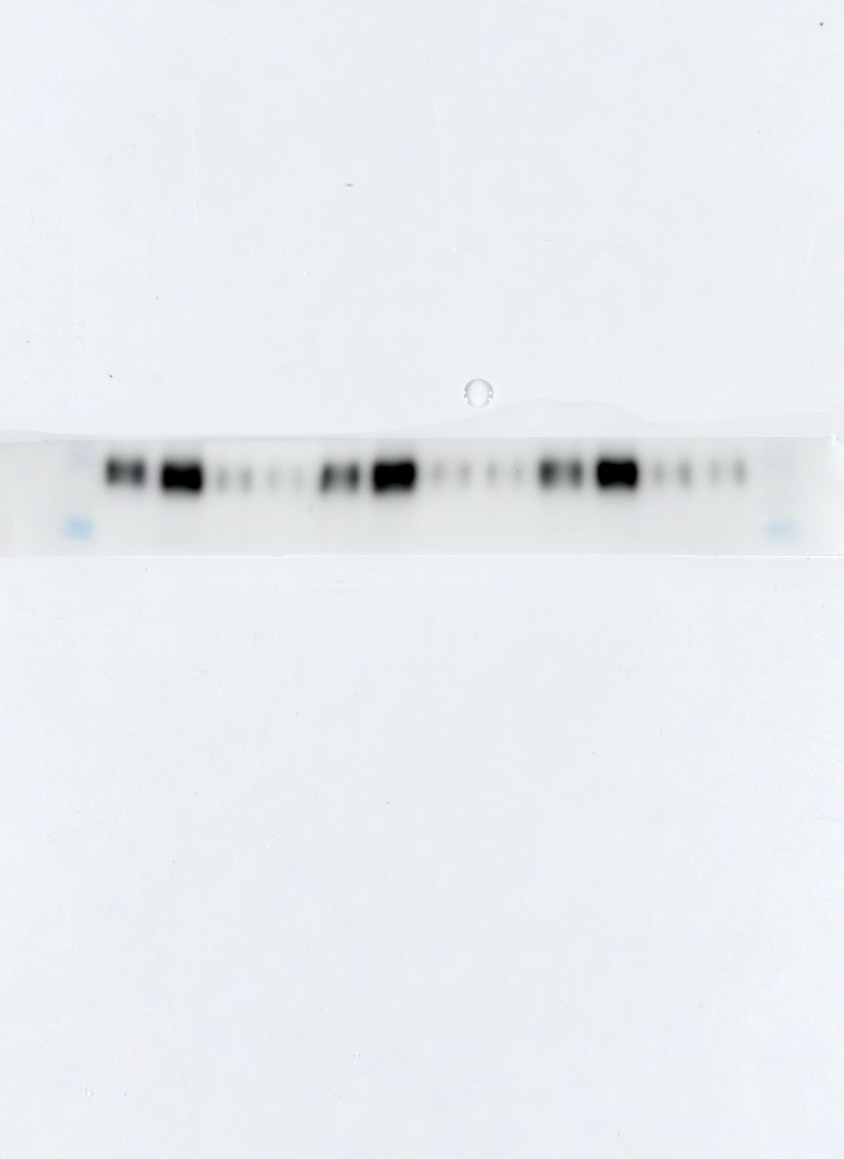
GAPDH
Figure 4F
AKT inhibitor-MK2206
mTOR
p-mTOR
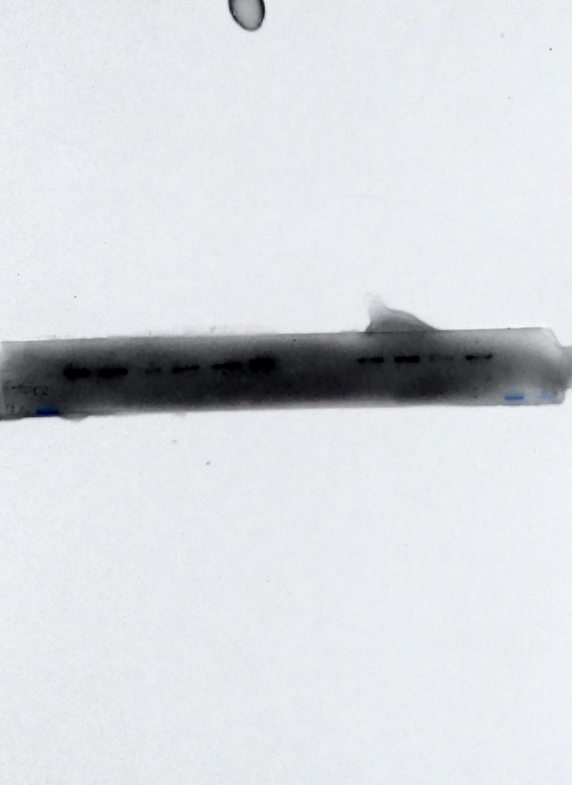
without marker
with marker
AKT
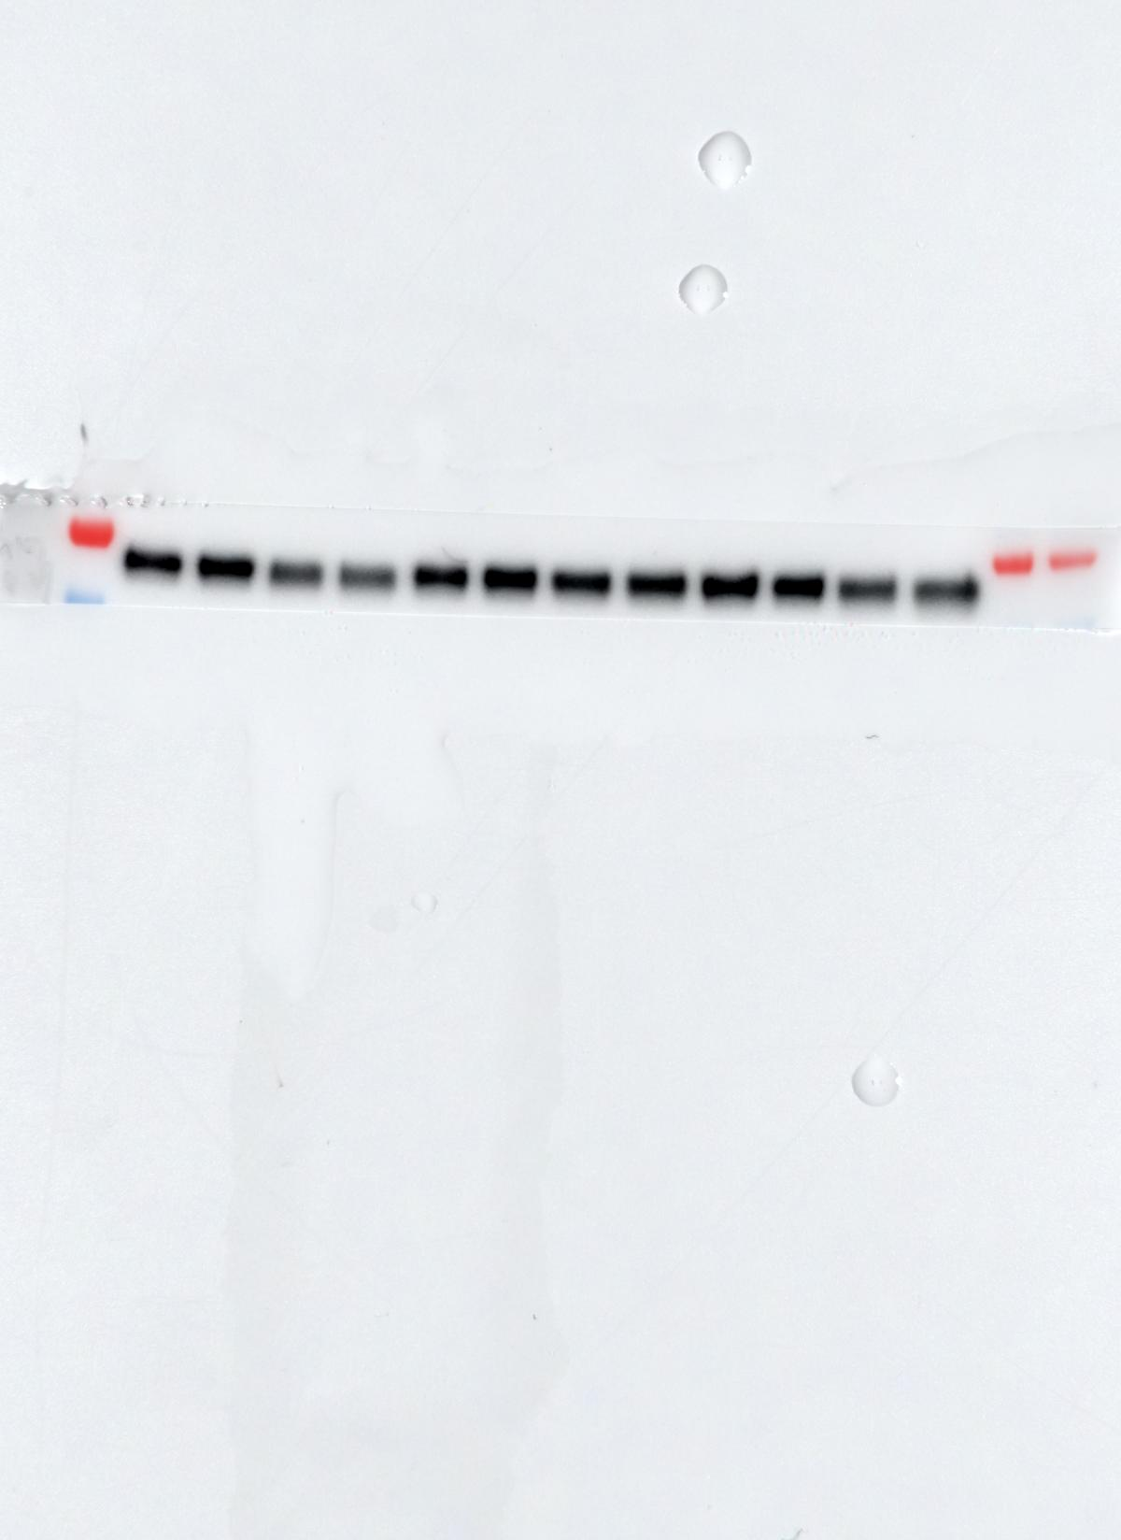
p-AKT
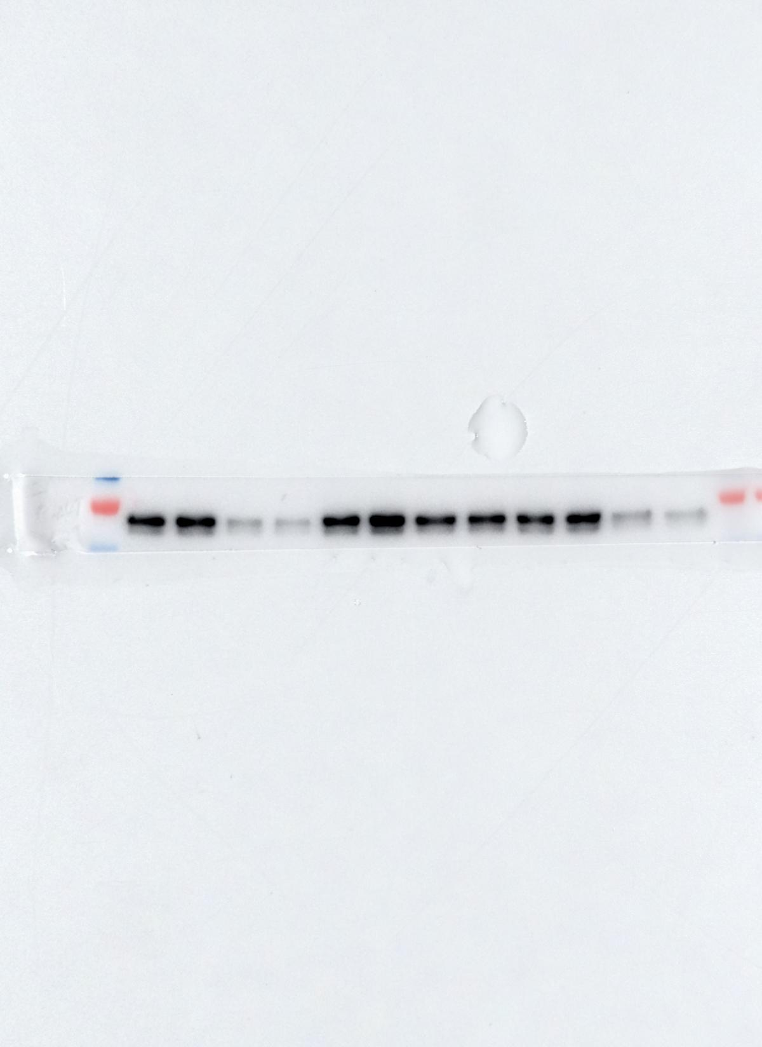
4EBP1
p-4EBP1
GAPDH
Figure 5B
1: Control-1
2: Semaphorin 5A-1
3: Control-2
4: Semaphorin 5A-2
5: Control-3
6: Semaphorin 5A-3
1 2 3 4 5 6
GPX4
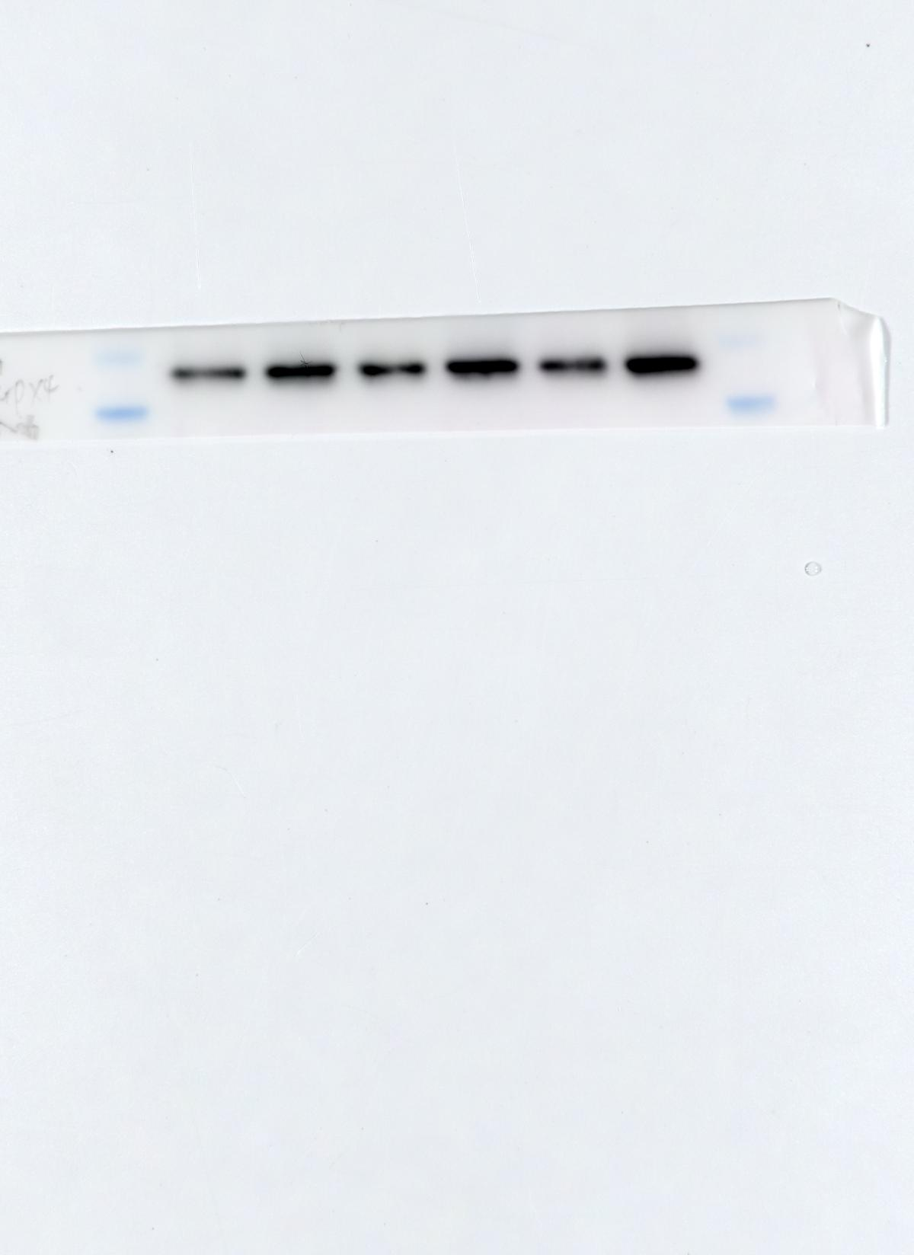
GAPDH
Figure 5I
GPX4
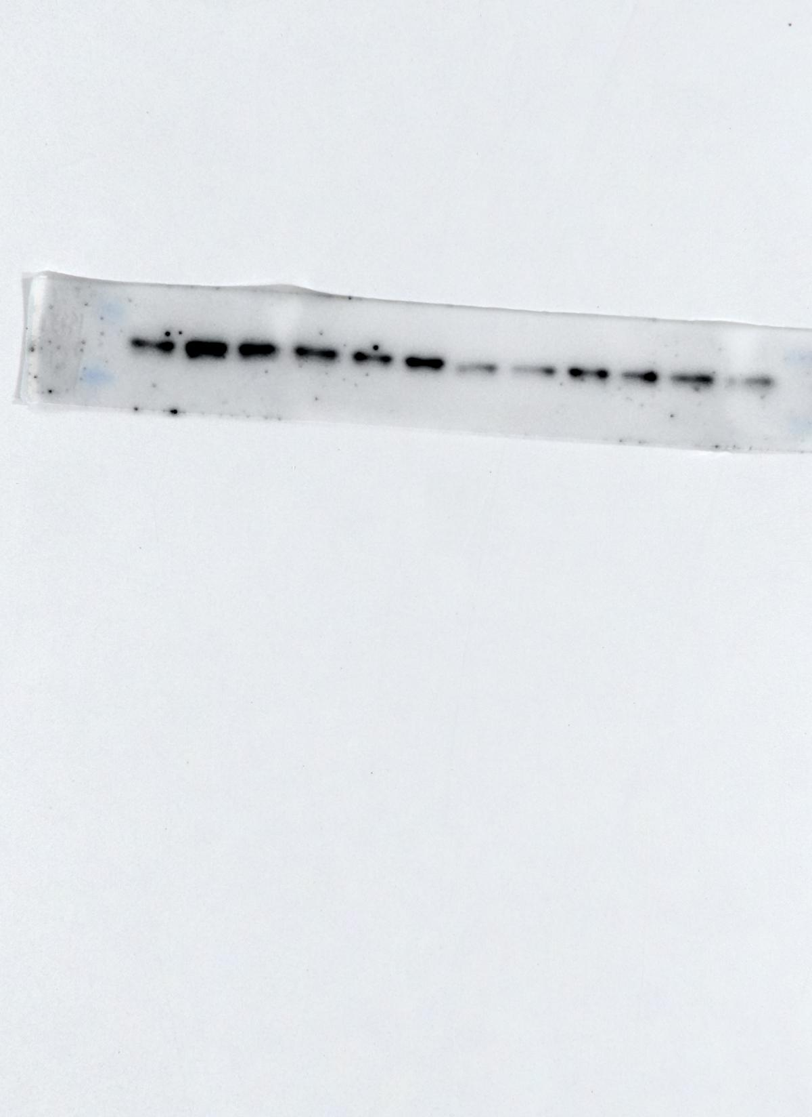
GAPDH
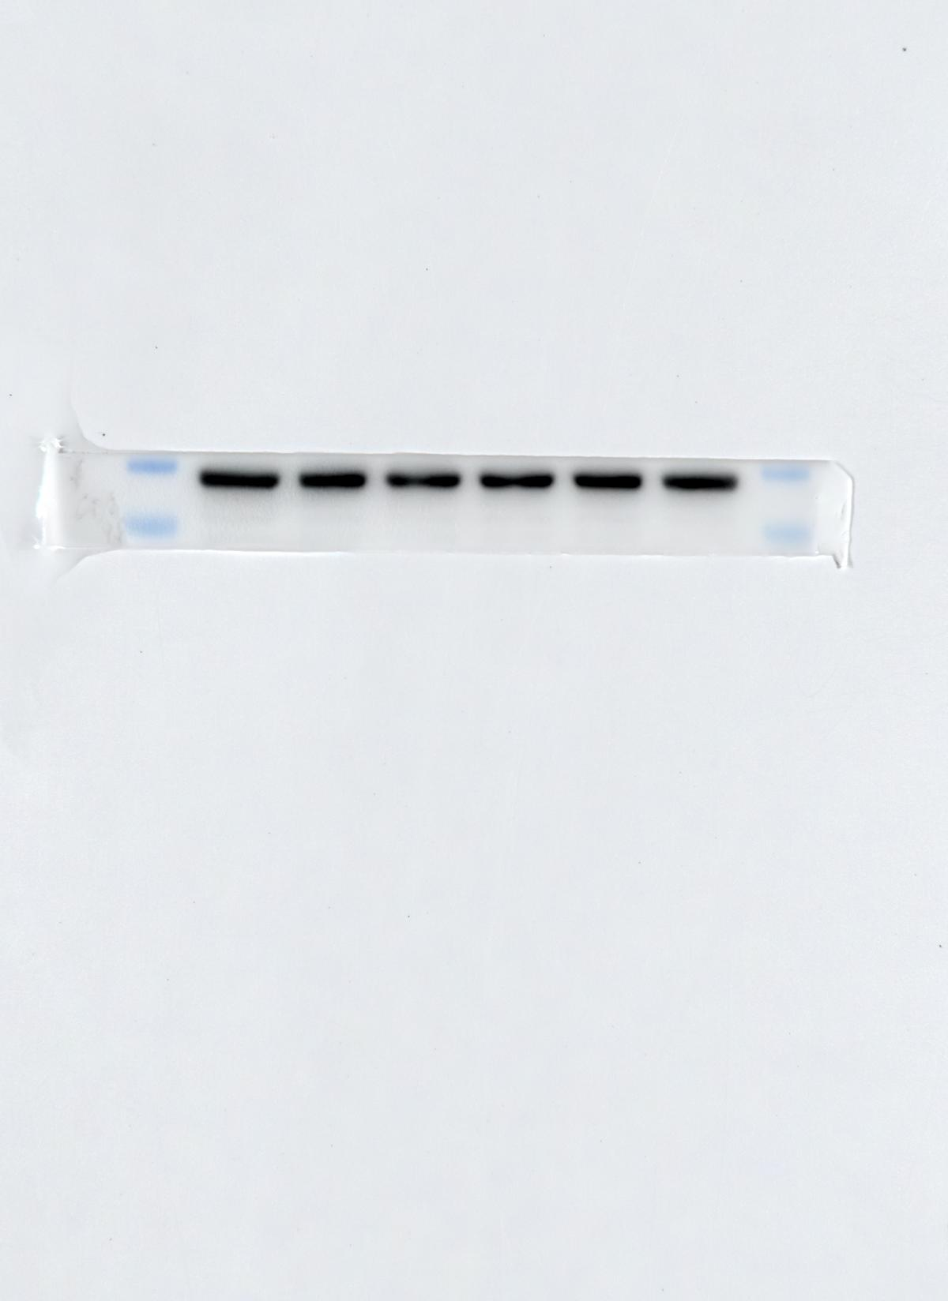
1 2 3 4 5 6
Figure 6C
1: Control-1
2: Semaphorin 5A-1
3: Control-2
4: Semaphorin 5A-2
5: Control-3
6: Semaphorin 5A-3
SCD-1
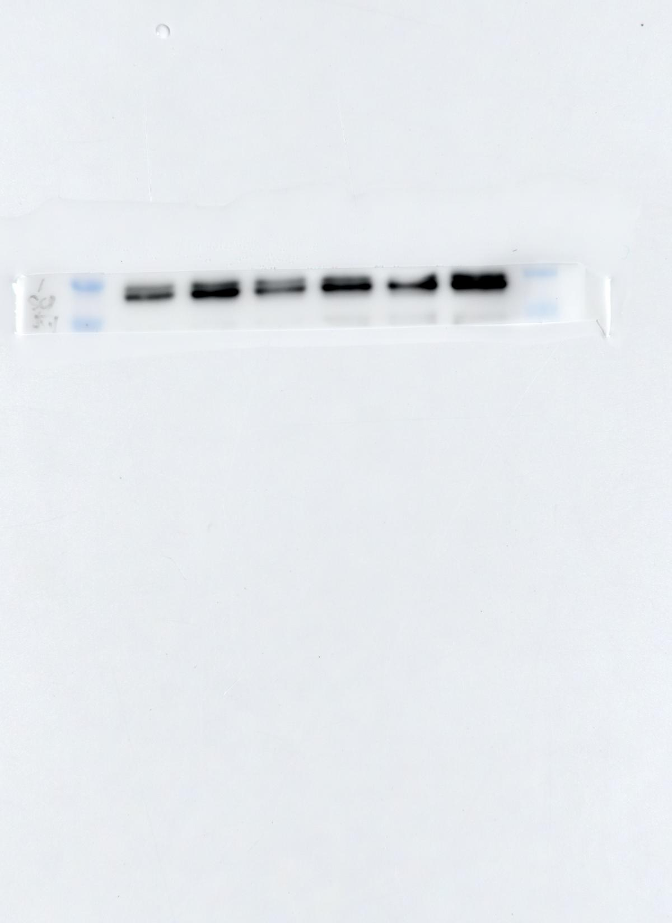
SREBP1
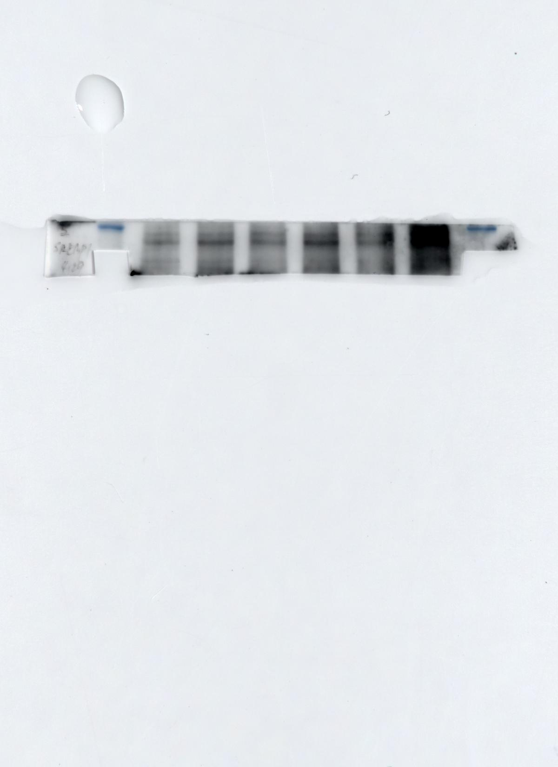
GAPDH
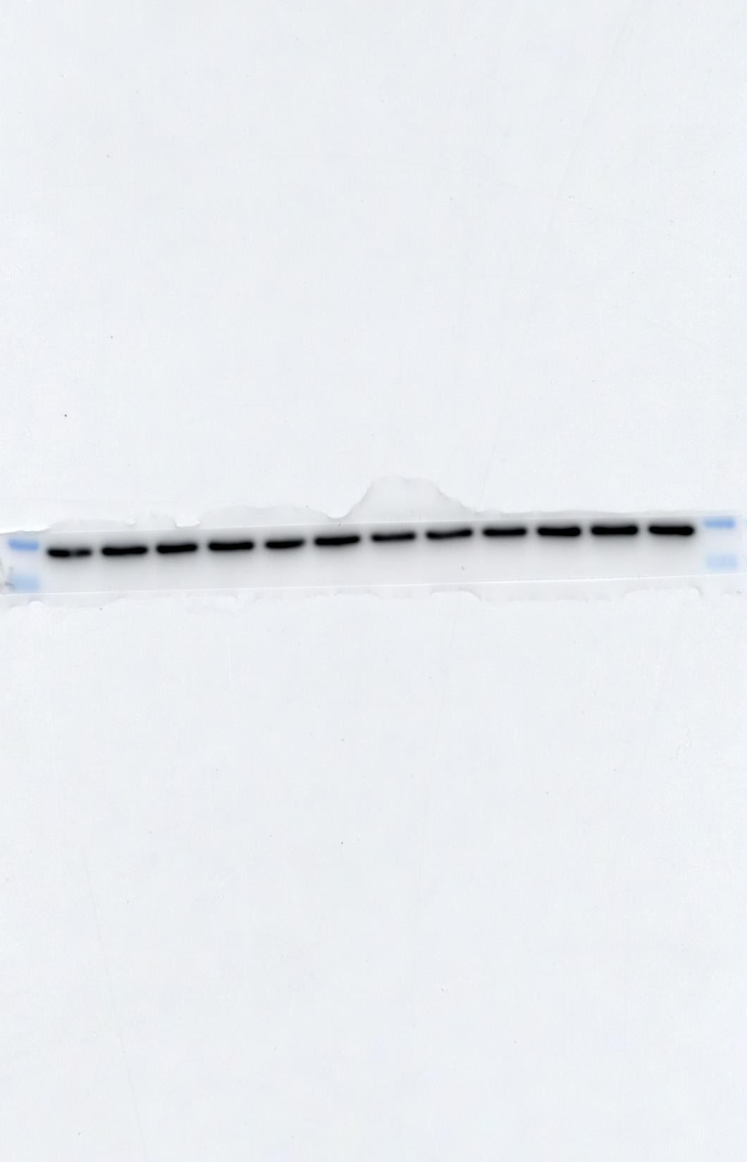
Figure 6F
SCD-1
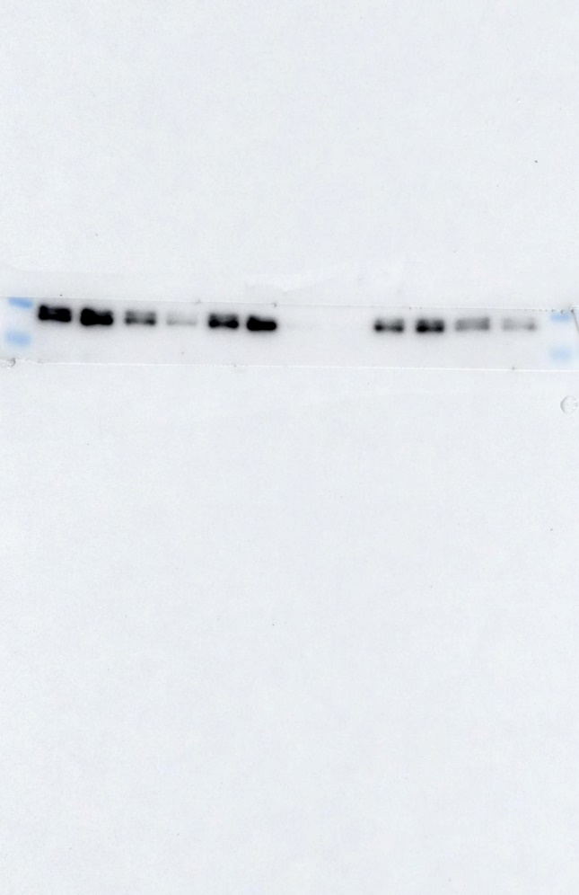
SREBP1
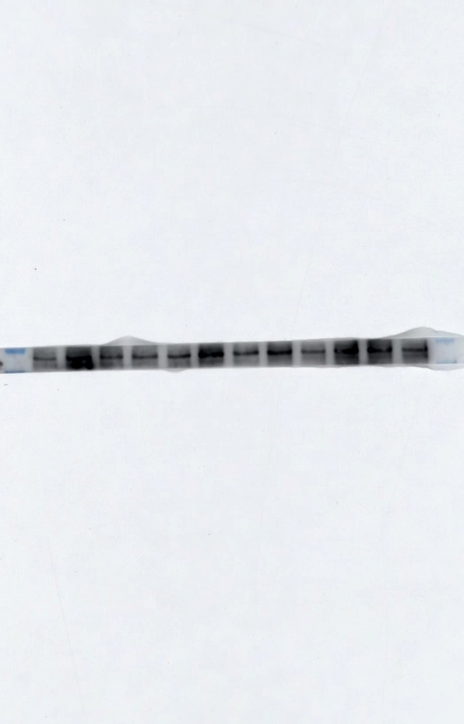
130kDa
100kDa
GAPDH
Figure 6G
1: si NC
2: si SREBP1-1
3: si SREBP1-2
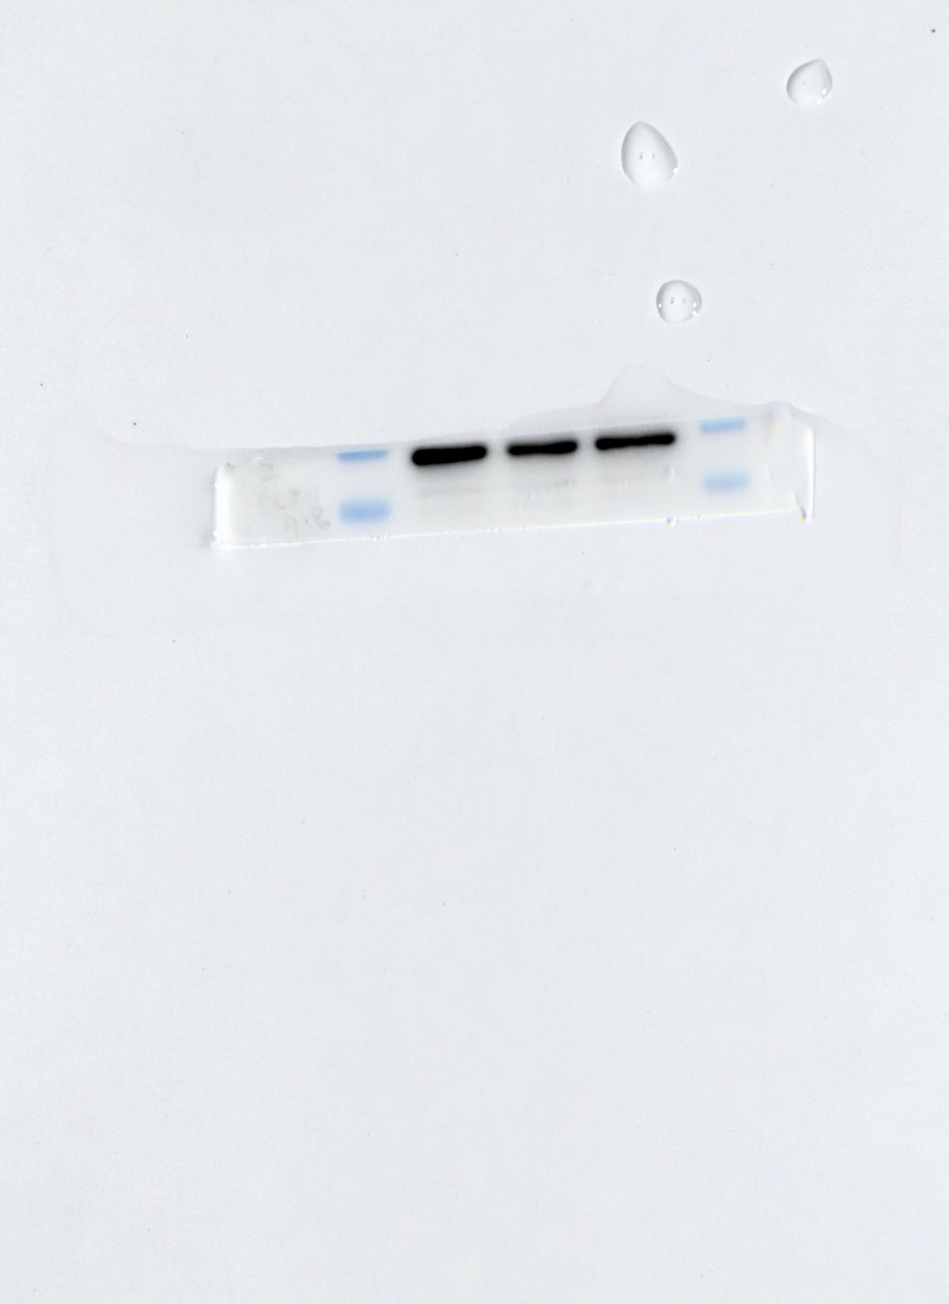
1 2 3

SREBP1
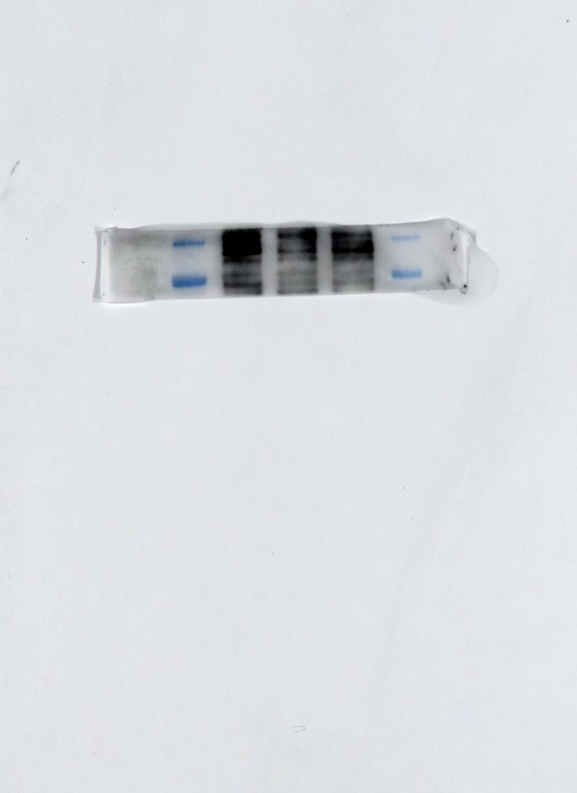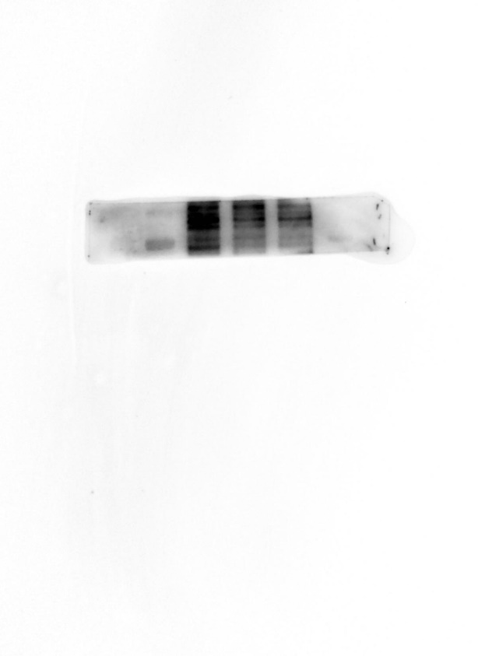
without marker
with marker
130kDa
100kDa
GAPDH
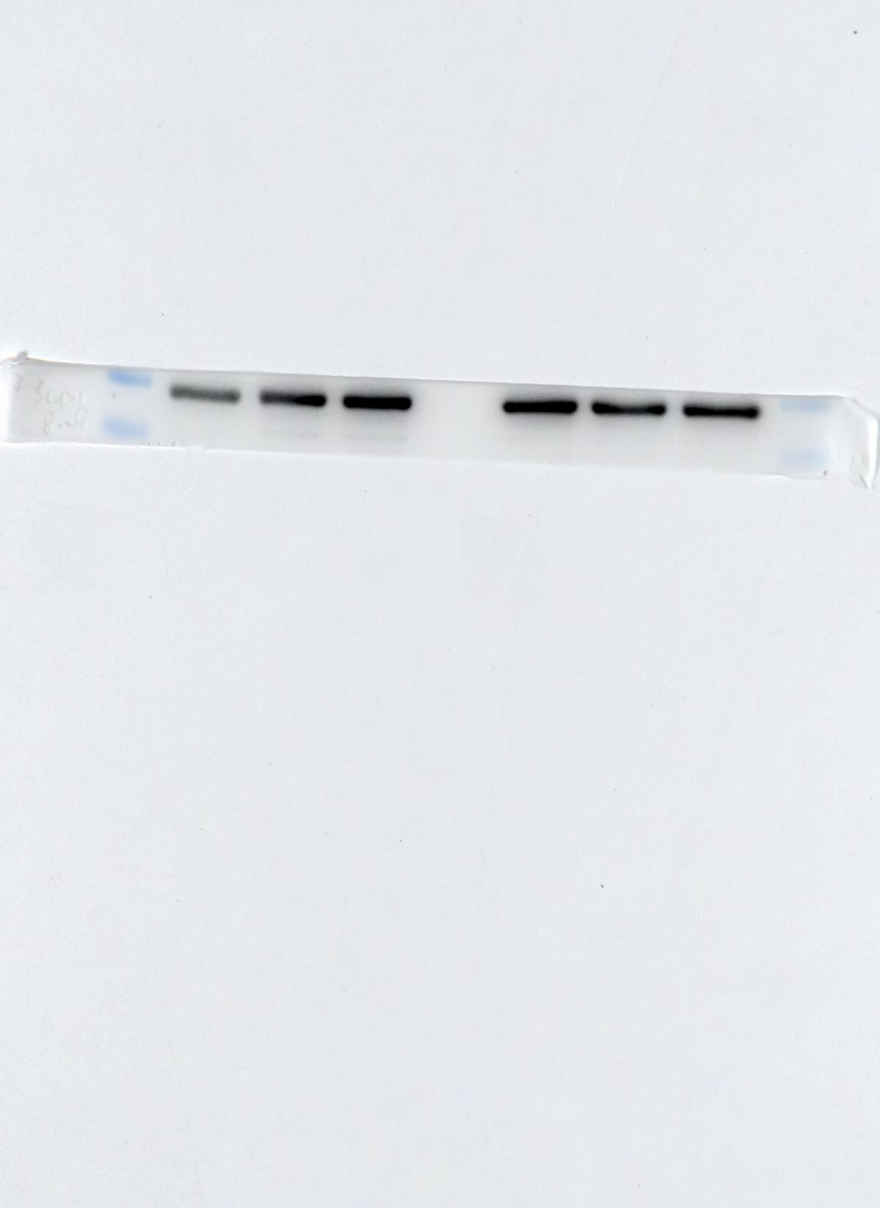
Figure 6H
1: si NC-1
2: si SCD-1-1
3: si SCD-1-2

4: si NC-2
5: si SCD-1-1
6: si SCD-1-2

1 2 3 4 5 6
SCD-1
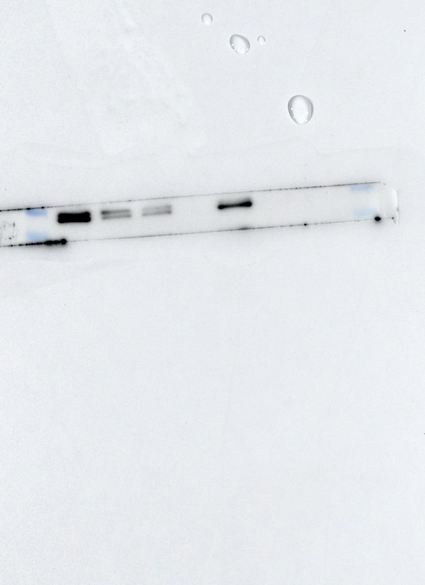
GAPDH
Supplementary Figure 1G
1: OASF1
2: OASF2
3: OASF3
4: RASF1
5: RASF2
6: RASF3
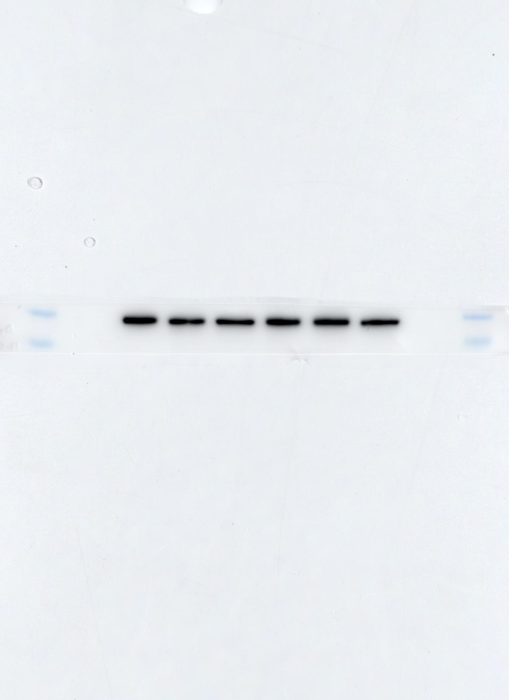
1 2 3 4 5 6

Plexin-A1
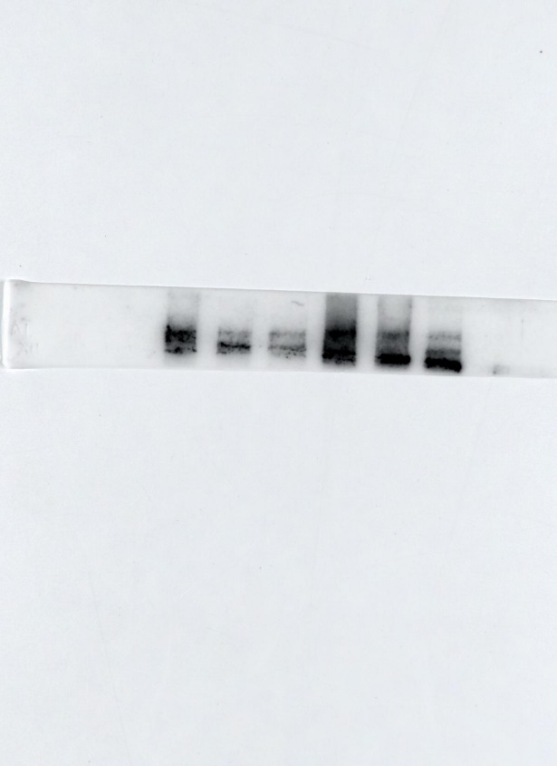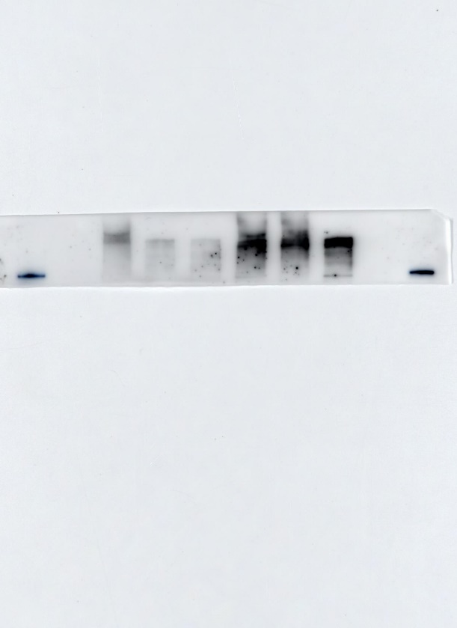
Another repeat under the same condition with marker (180kDa)
>180kDa
180kDa
Plexin-B3
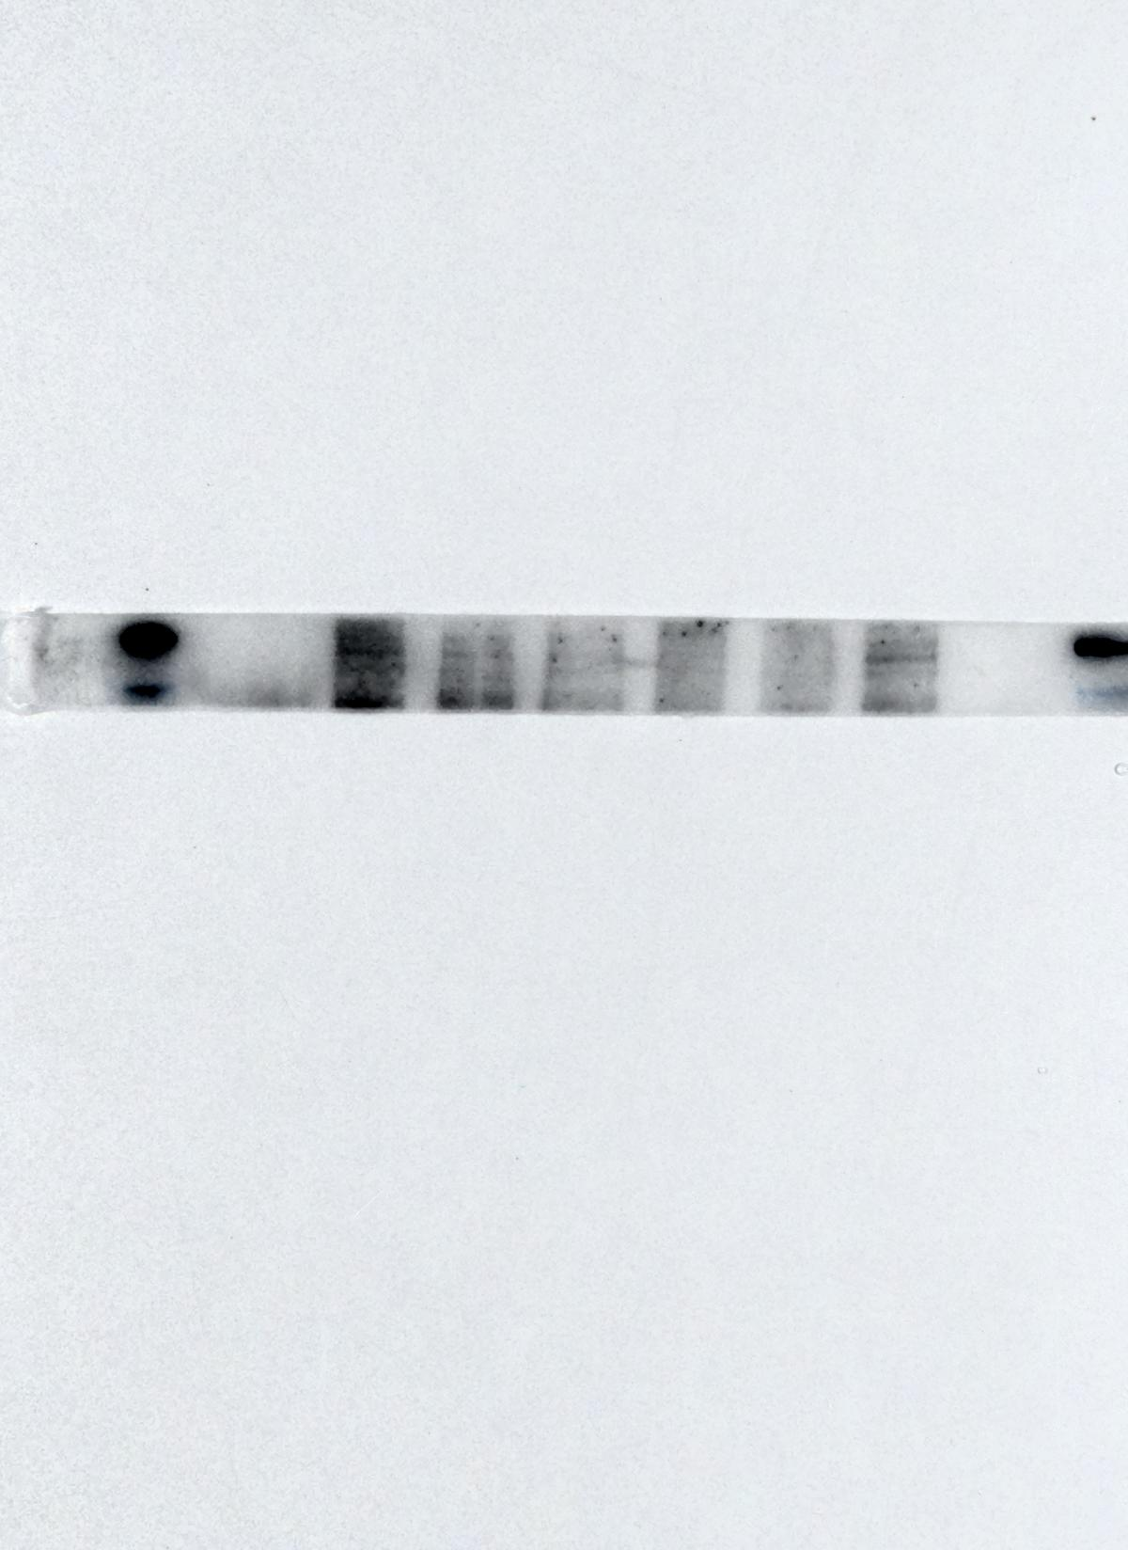
180kDa
130kDa

GAPDH
Supplementary
Figure 5A
1-3: HC
4-7: OA
8-12:RA
1 2 3 4 5 6 7 8 9 10 11 12
Semaphorin 5A
GPX4
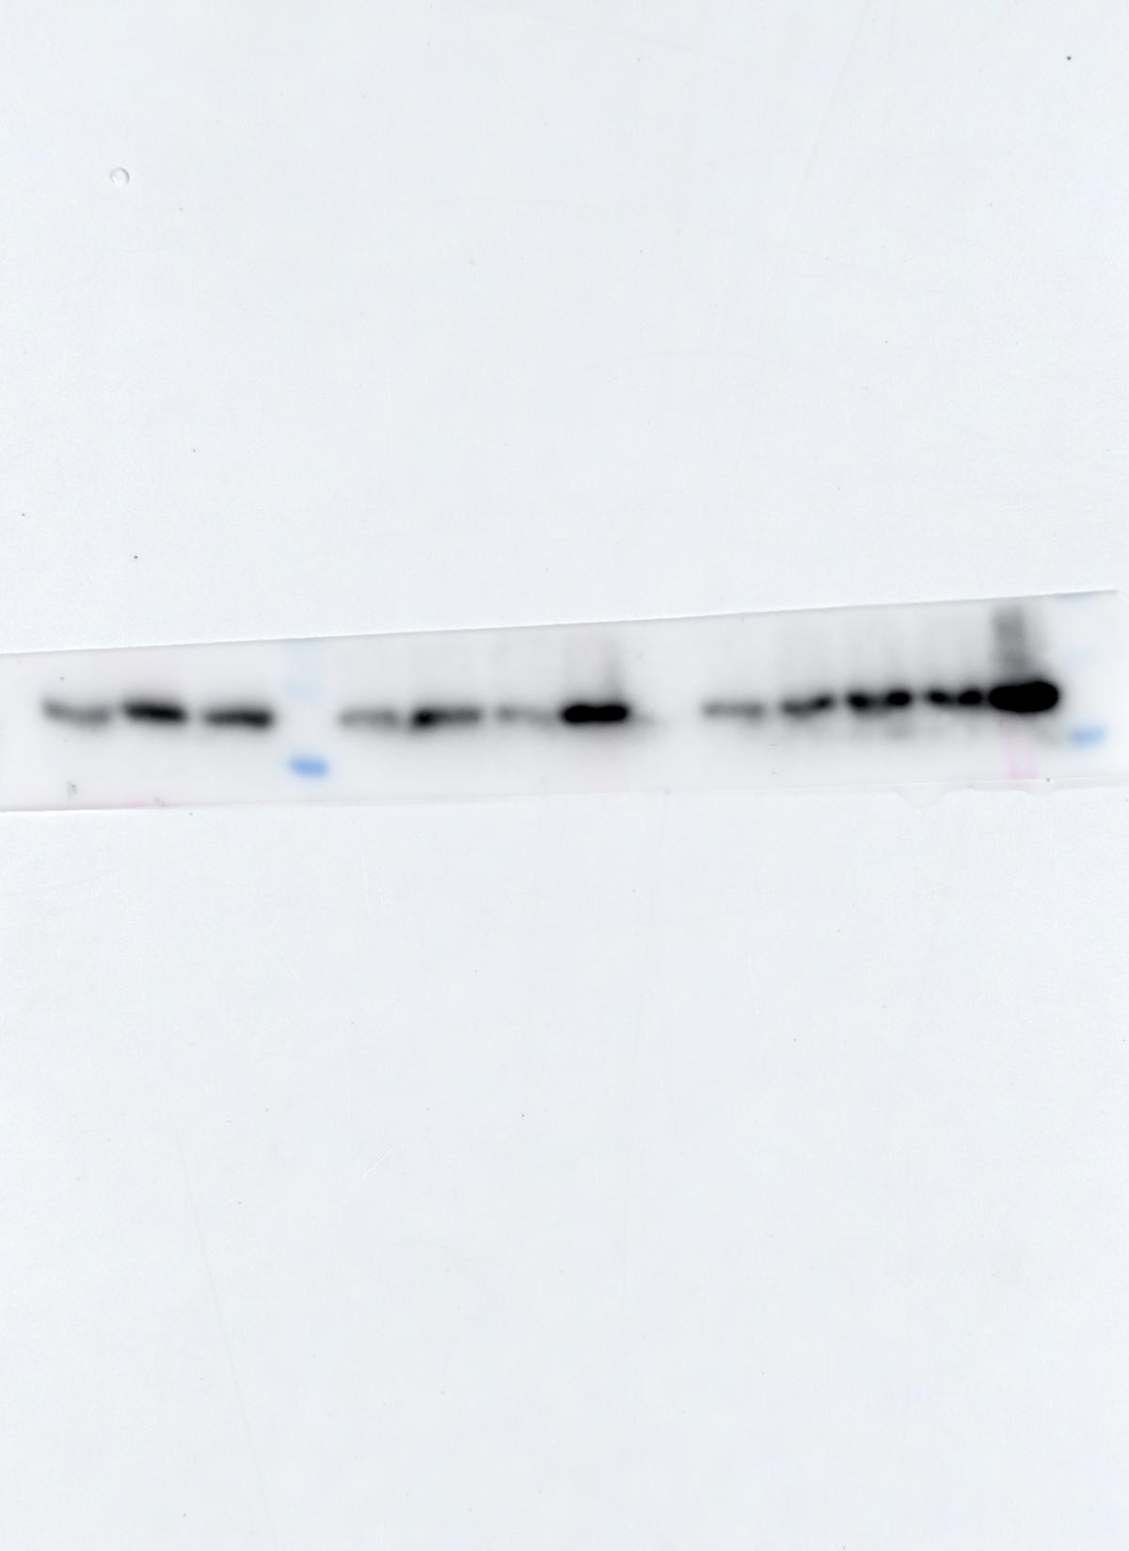
GAPDH
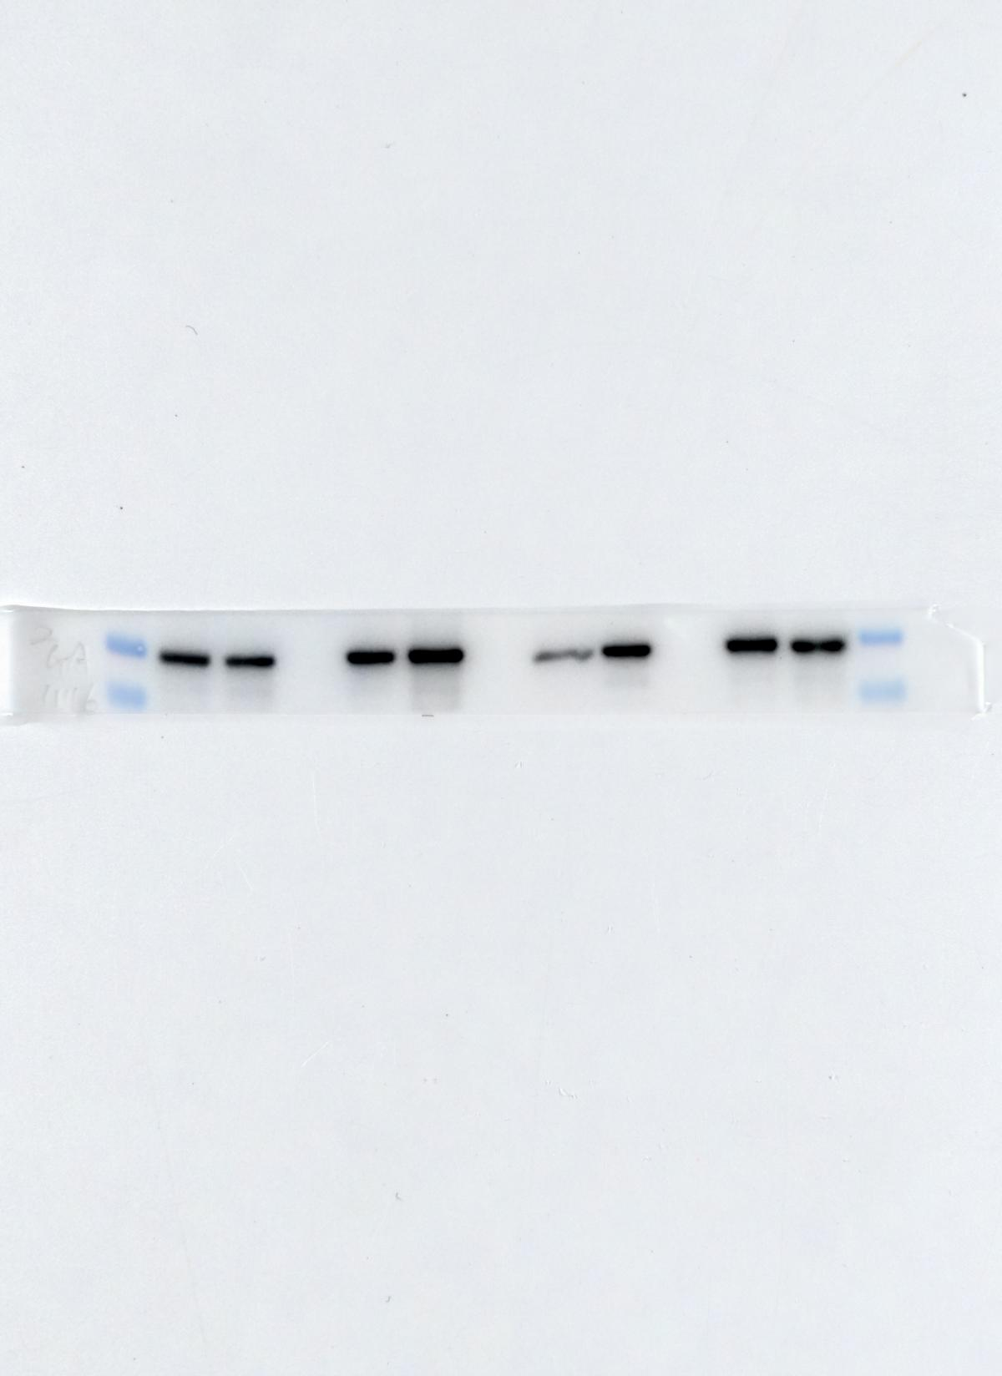
Supplementary
Figure 5A
1: OASF5
2: RASF5
3: OASF6
4: RASF6
5: OASF7
6: RASF7
7: OASF8
8: RASF8

1 2 3 4 5 6 7 8
Semaphorin 5A
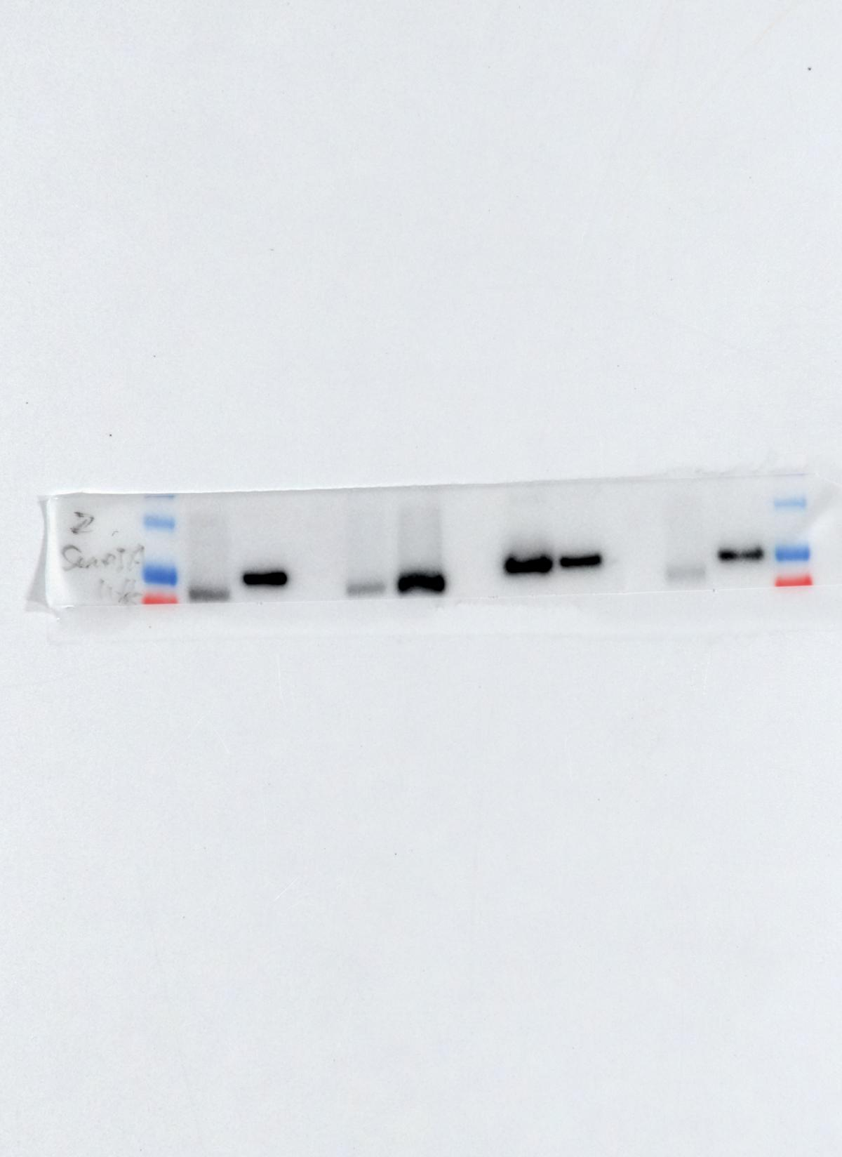
GPX4
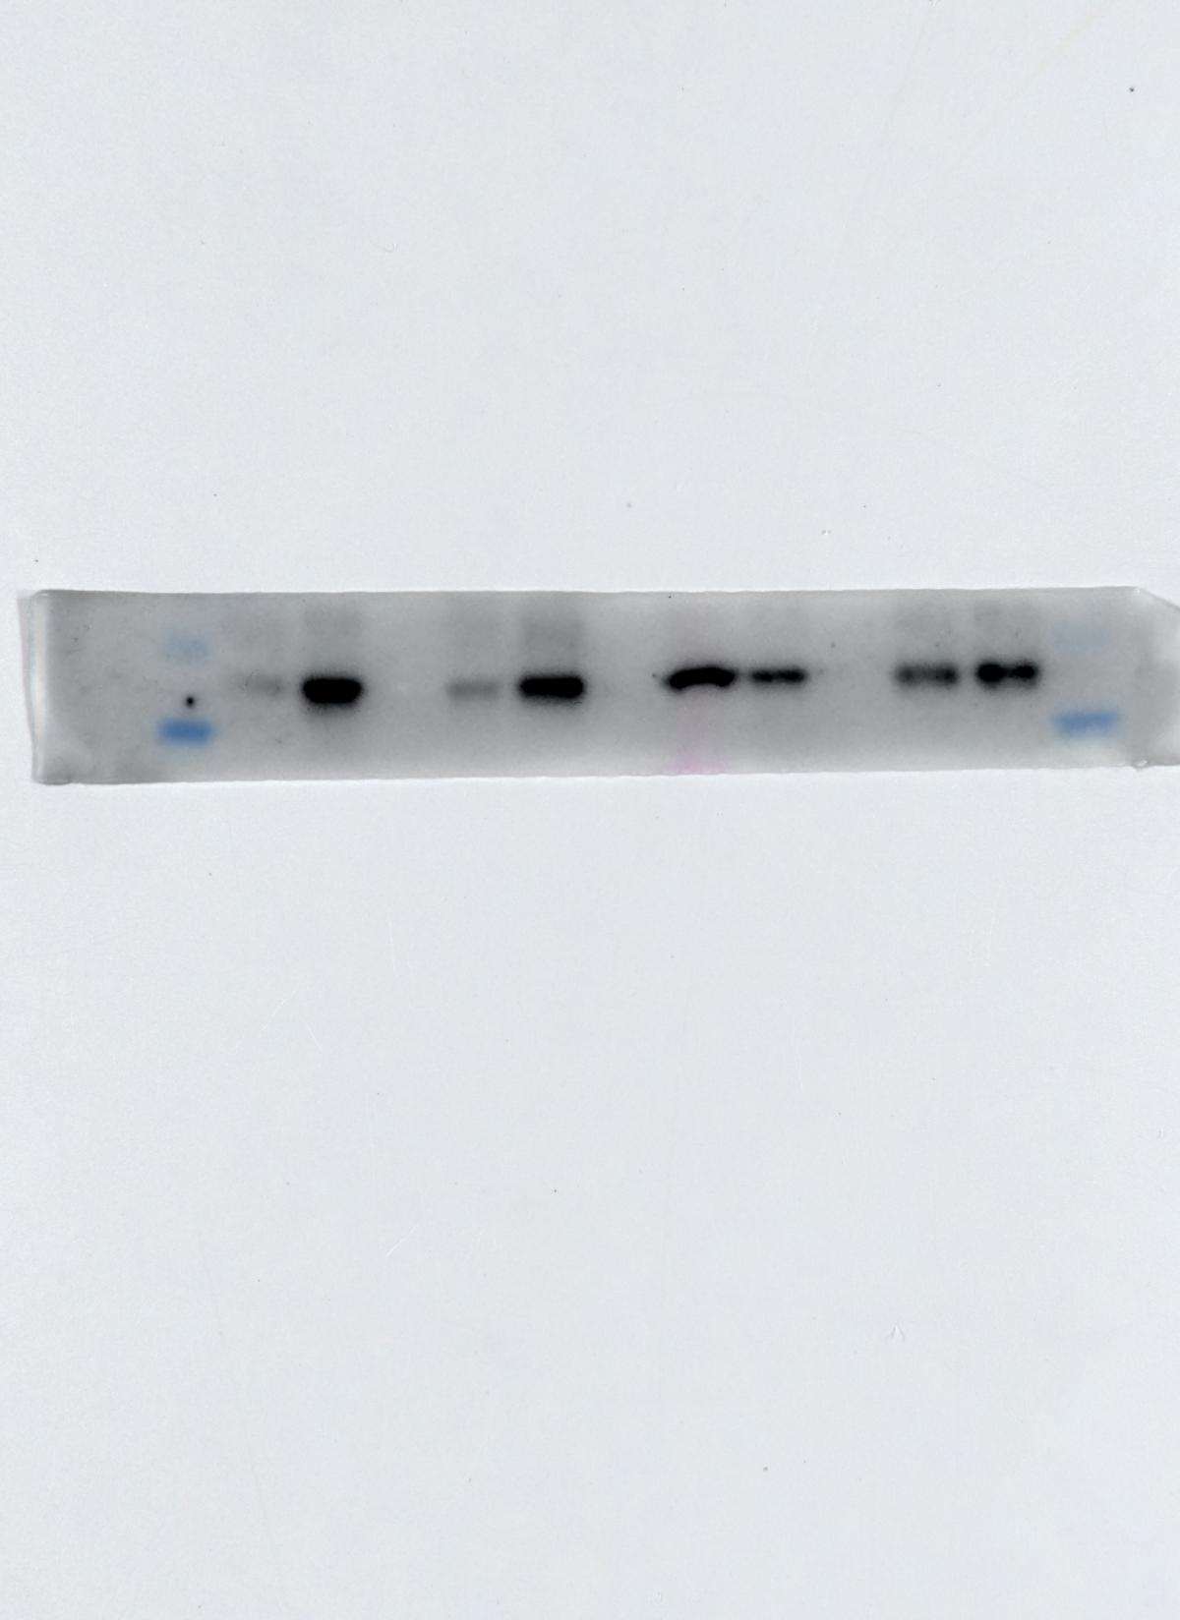
GAPDH
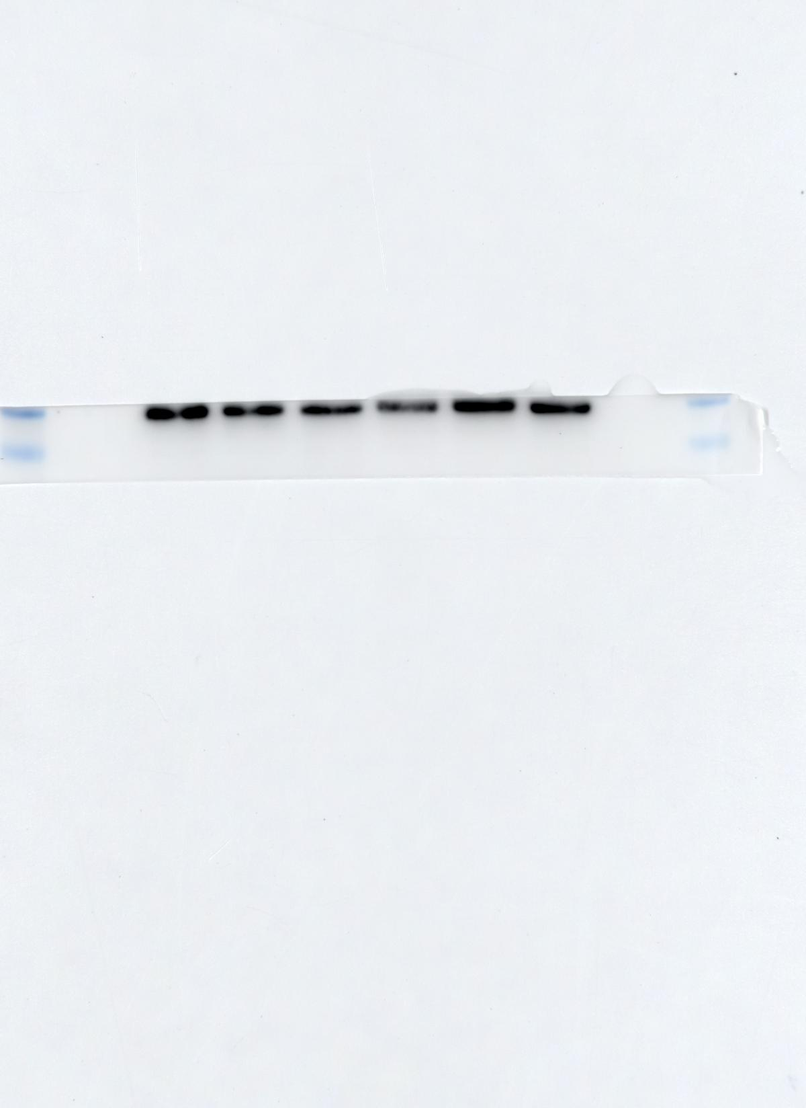
Supplementary
Figure 6C
1: OASF1
2: OASF2
3: OASF3
4: RASF1
5: RASF2
6: RASF3
SREBP1
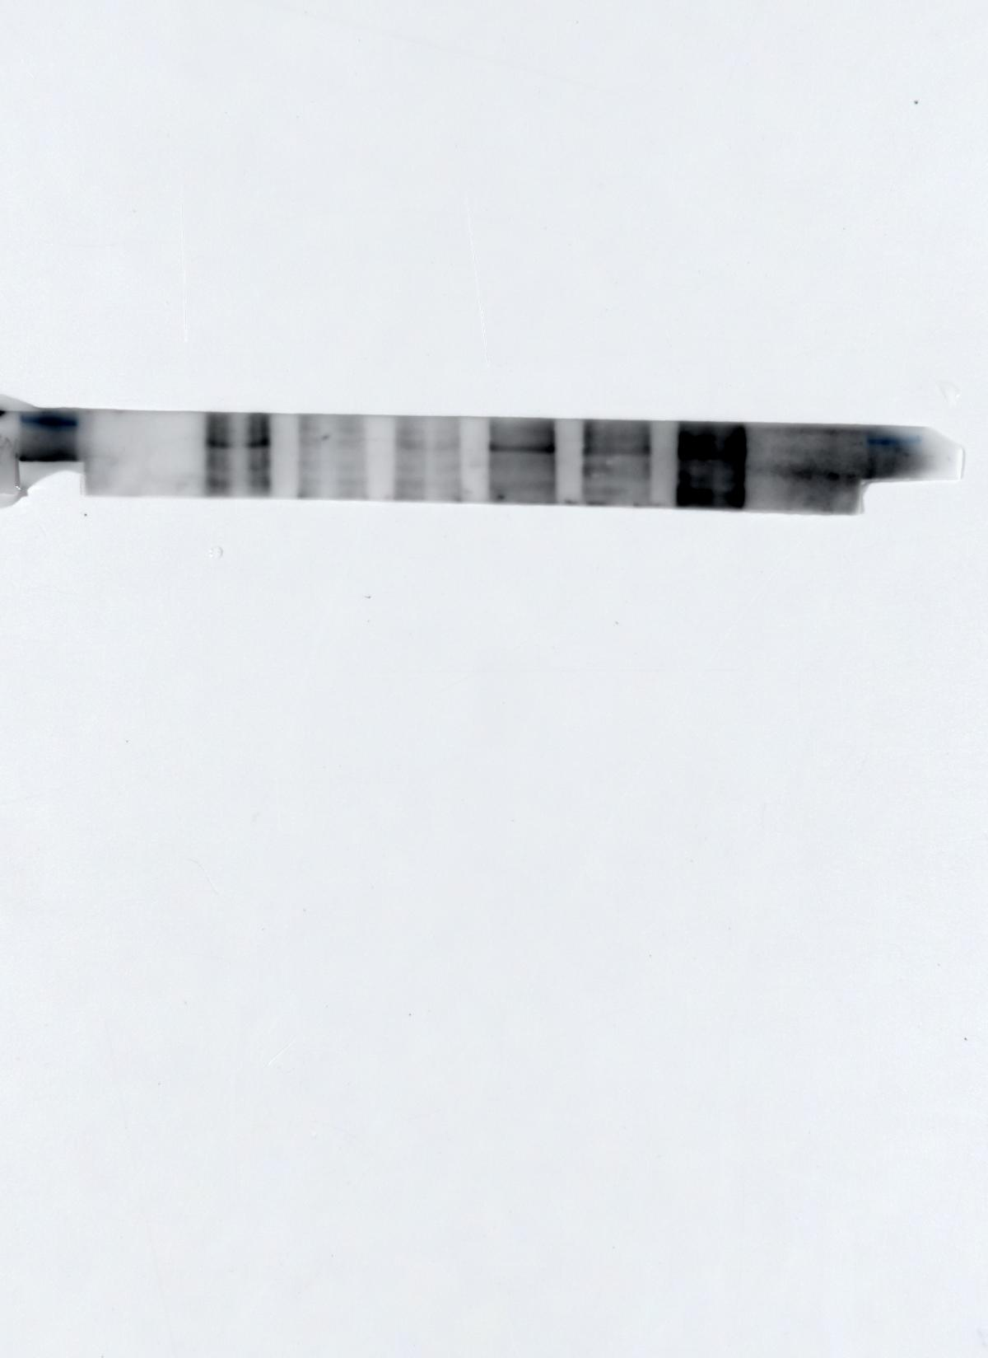
SCD-1
