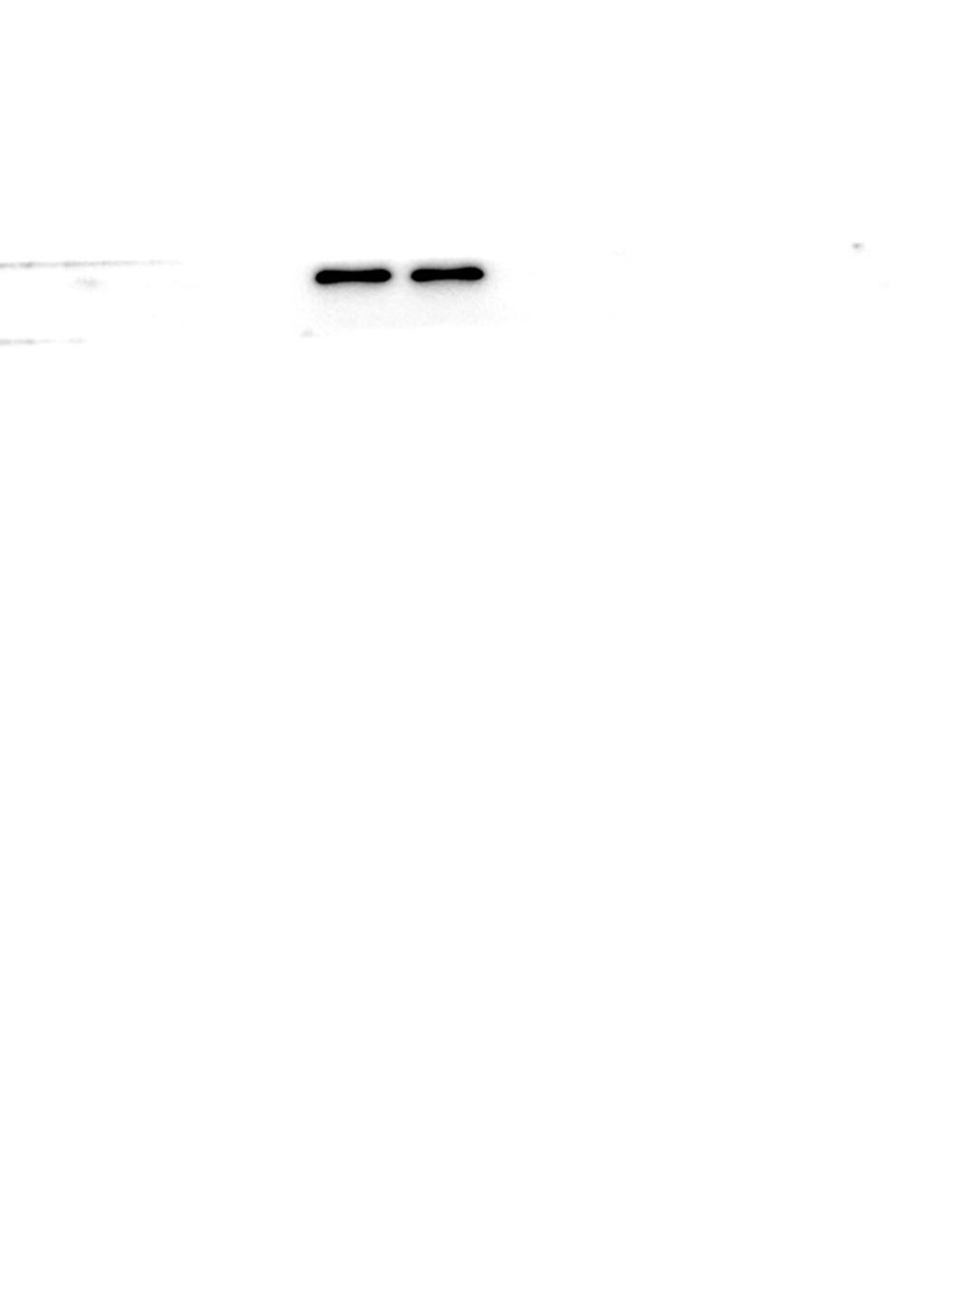
Fig.3A Western blot analysis of HOXD13

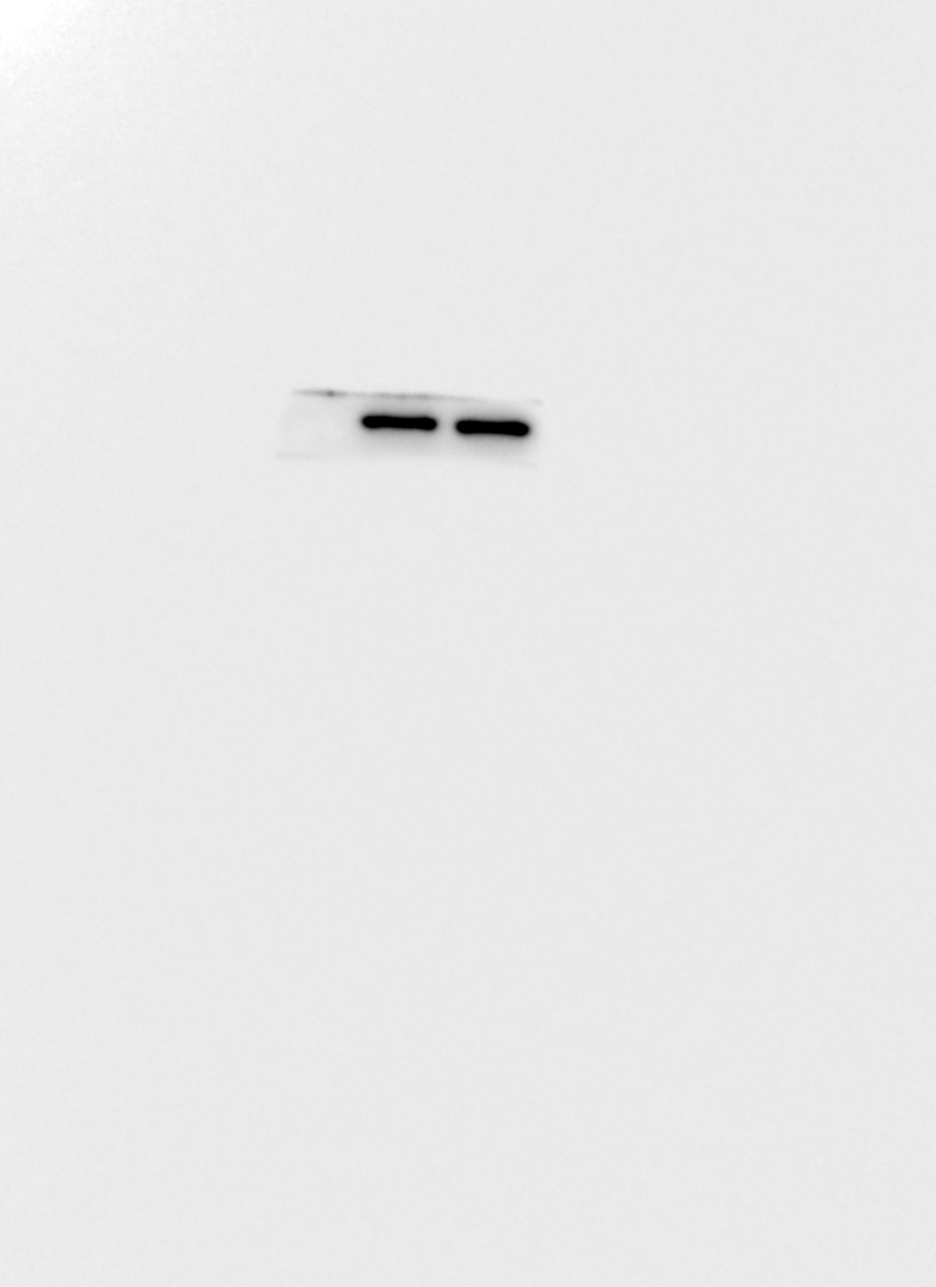
Fig.3A Western blot analysis of Actin

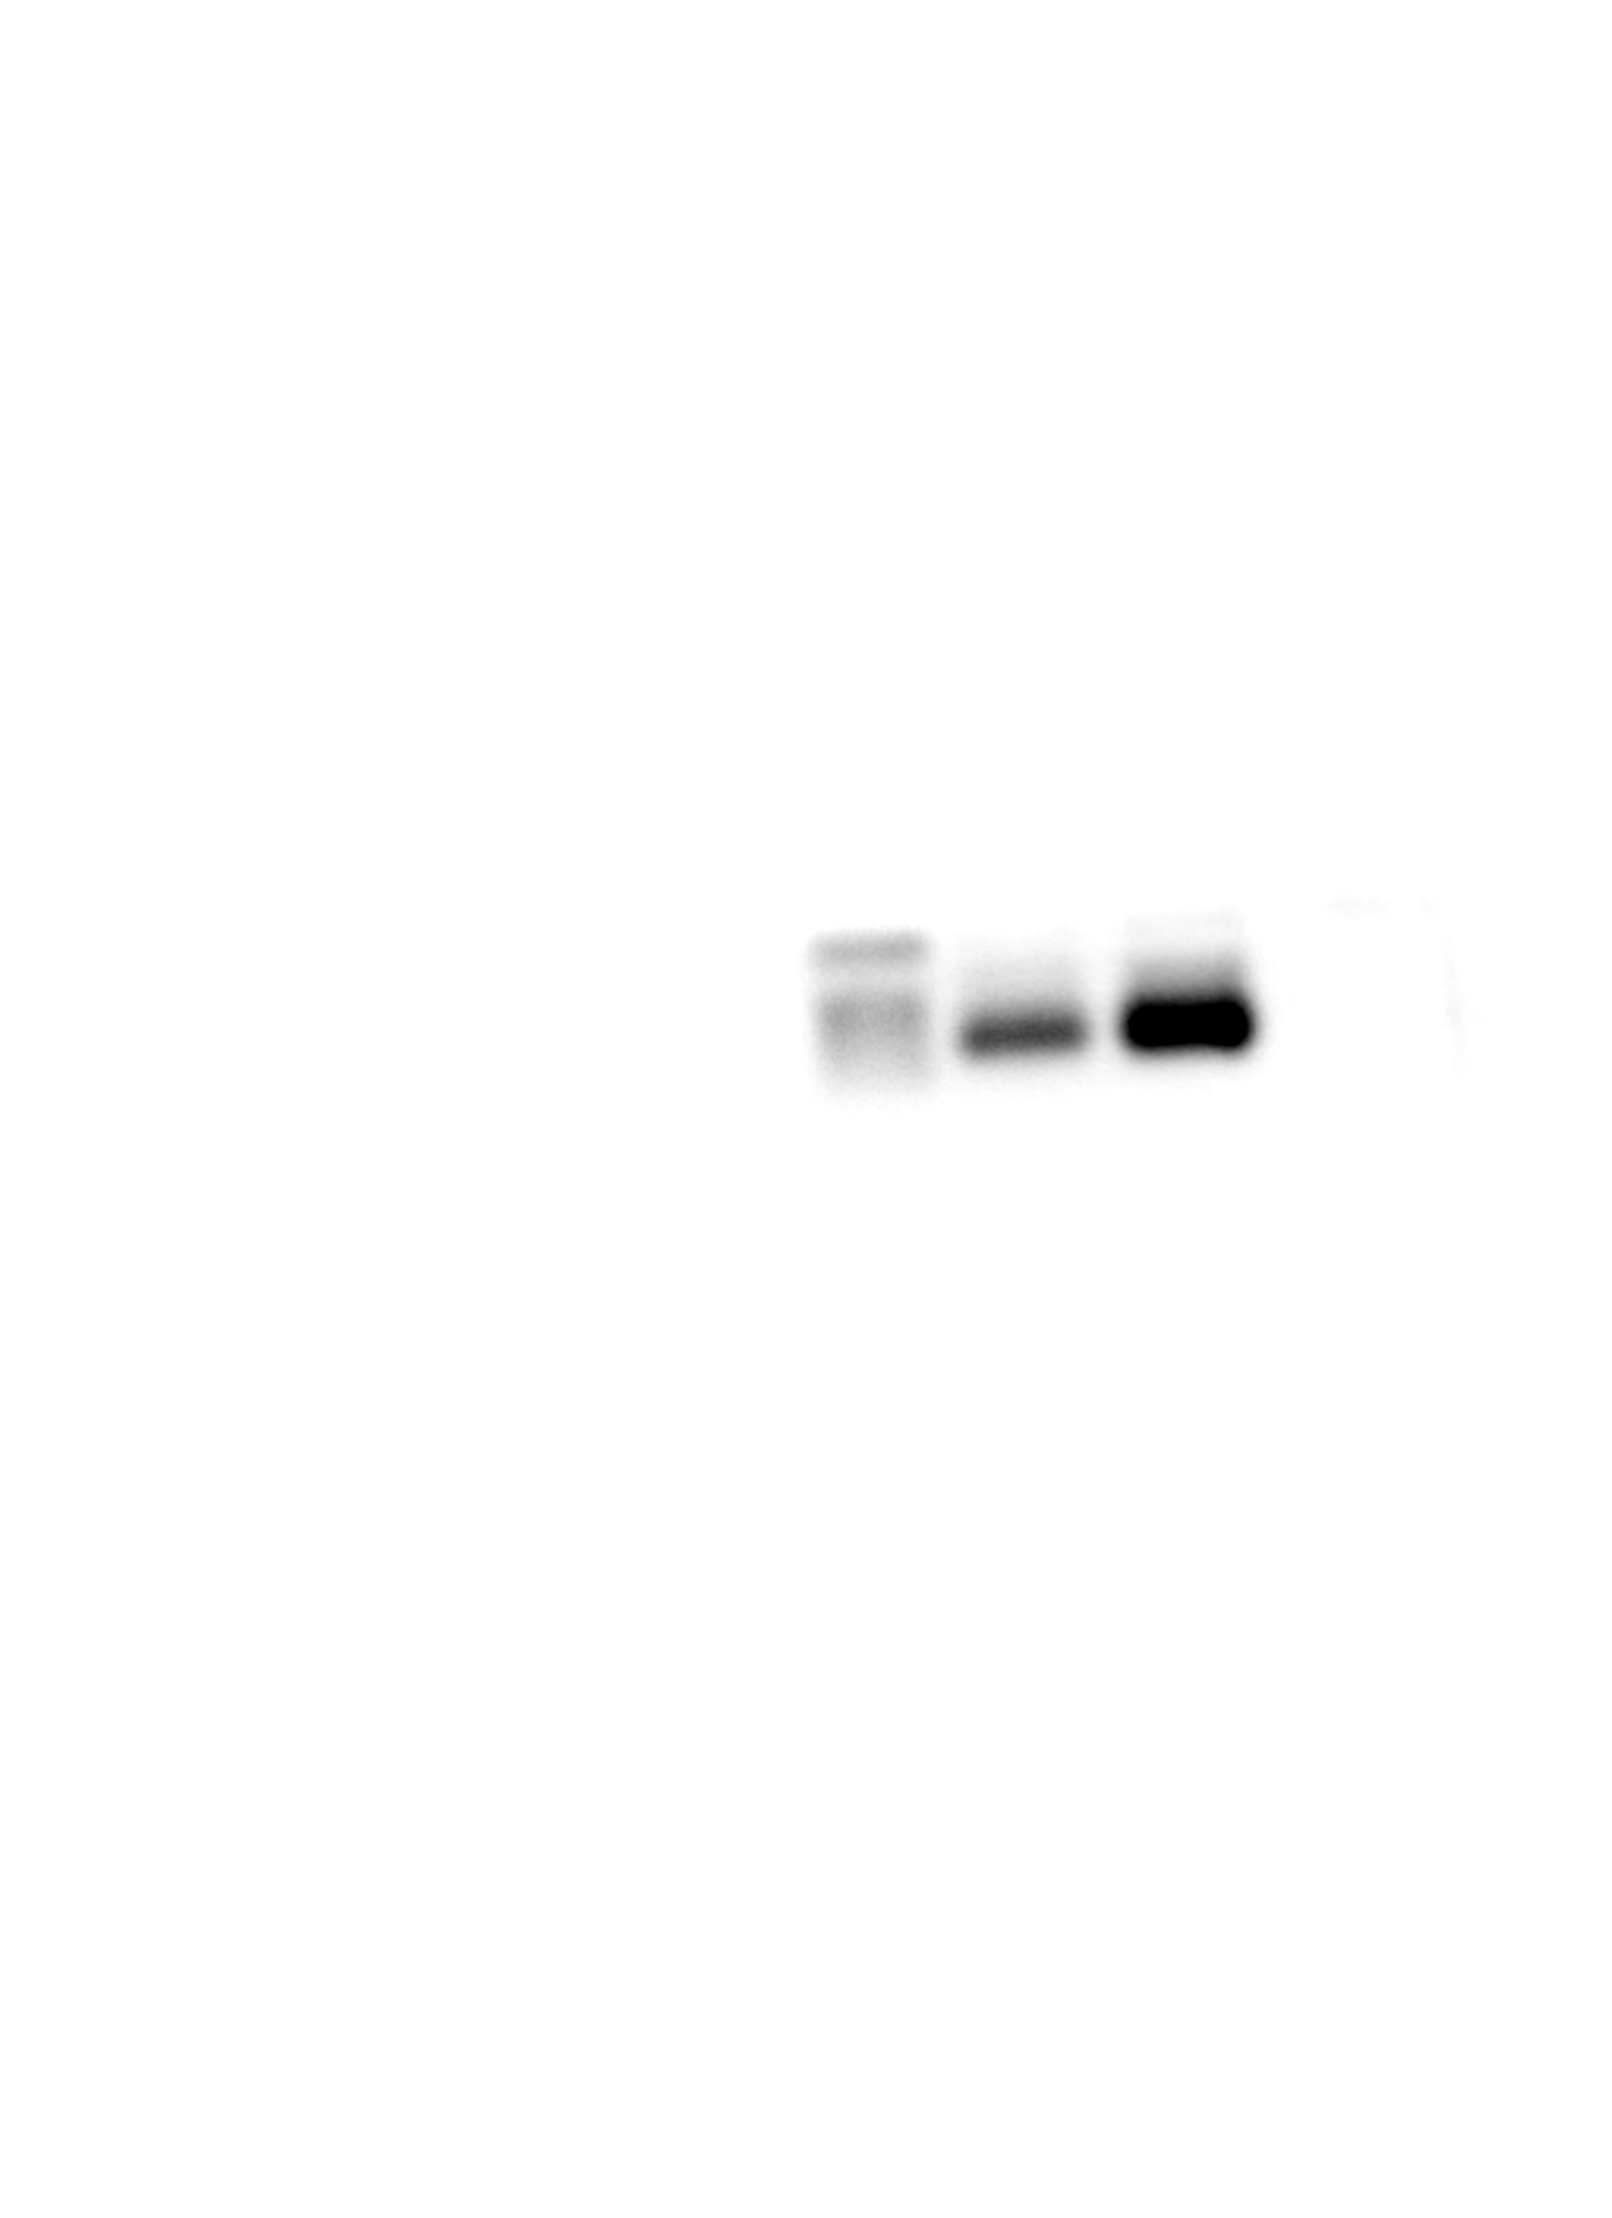
Fig.3D Western blot analysis of RANK

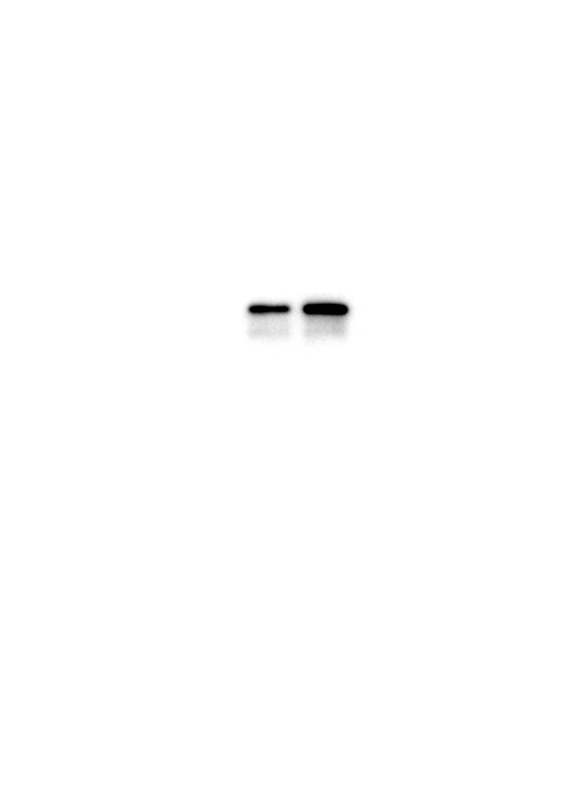
Fig.3D Western blot analysis of p65

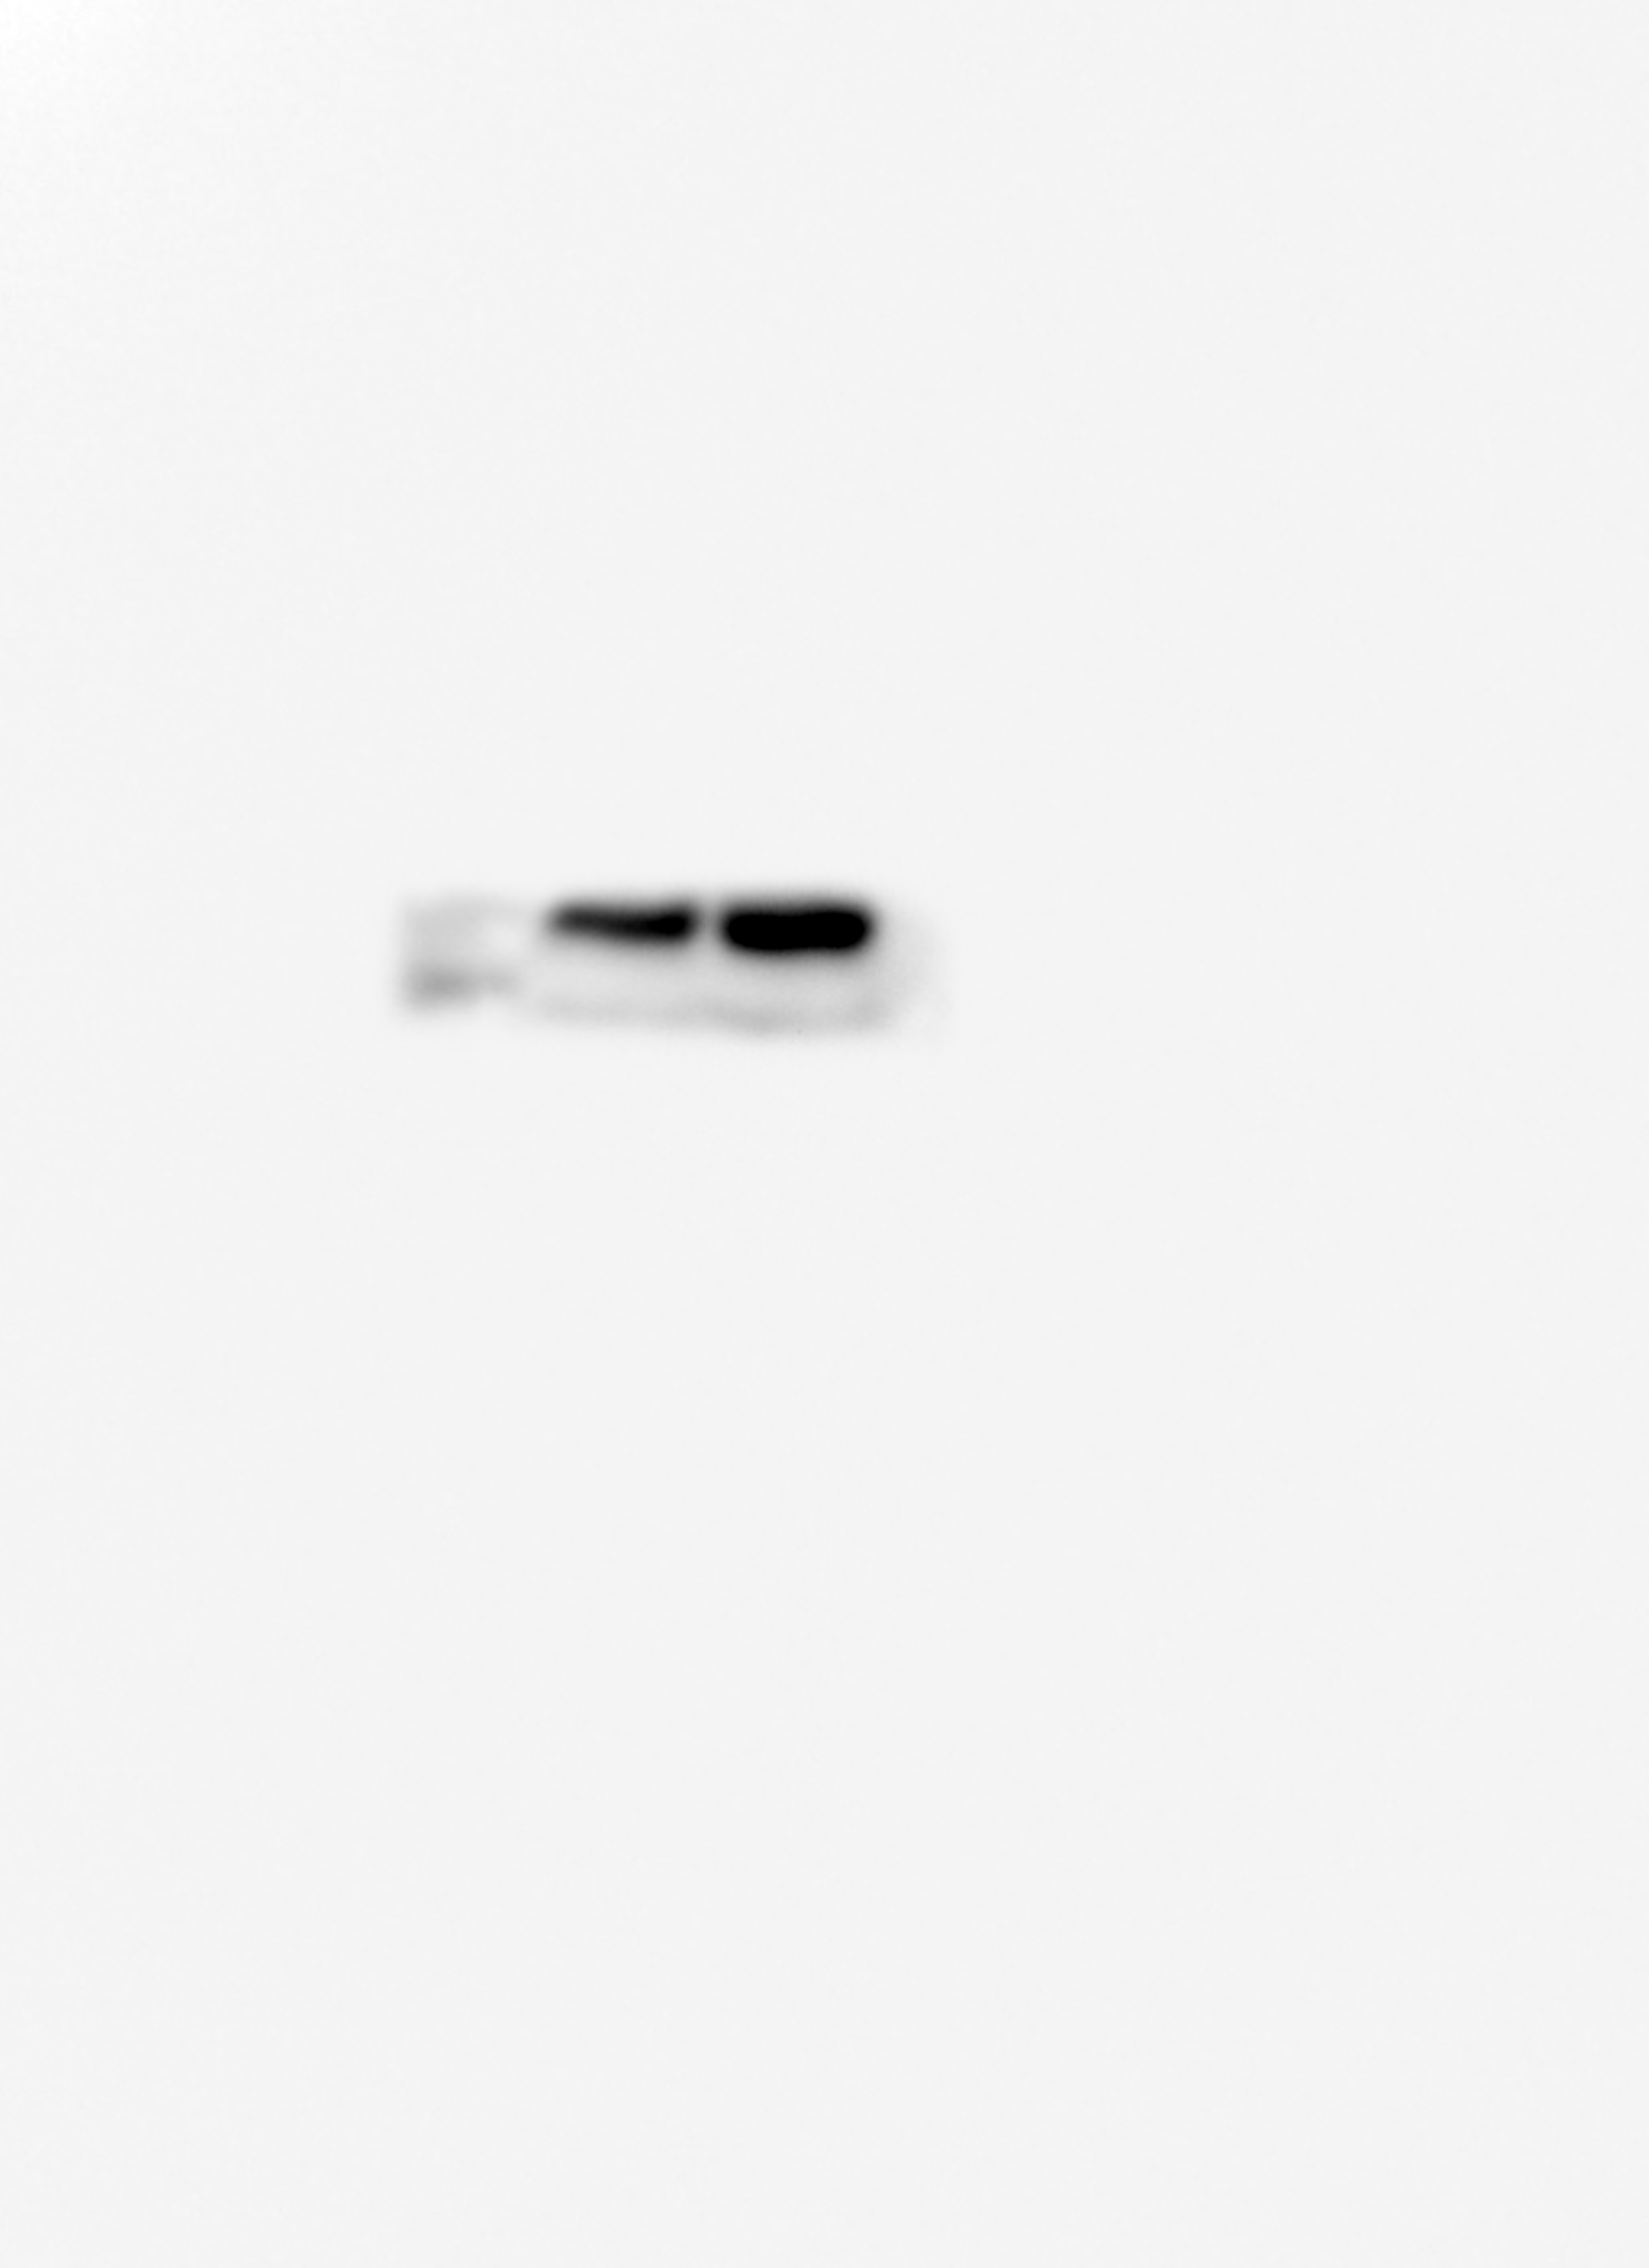
Fig.3D Western blot analysis of c-Fos

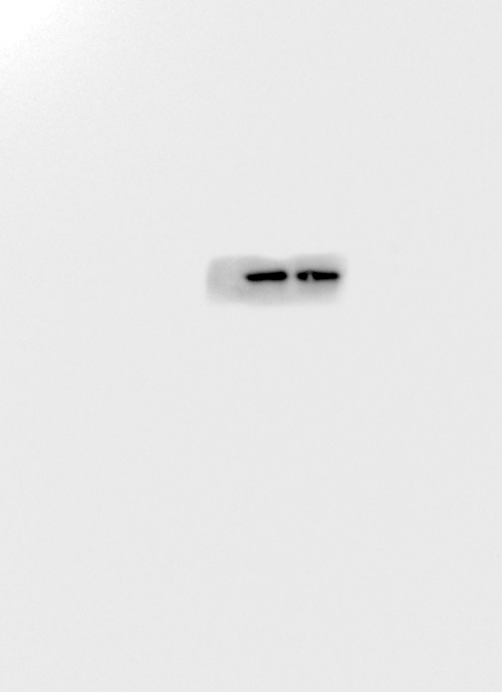
Fig.3D Western blot analysis of GAPDH

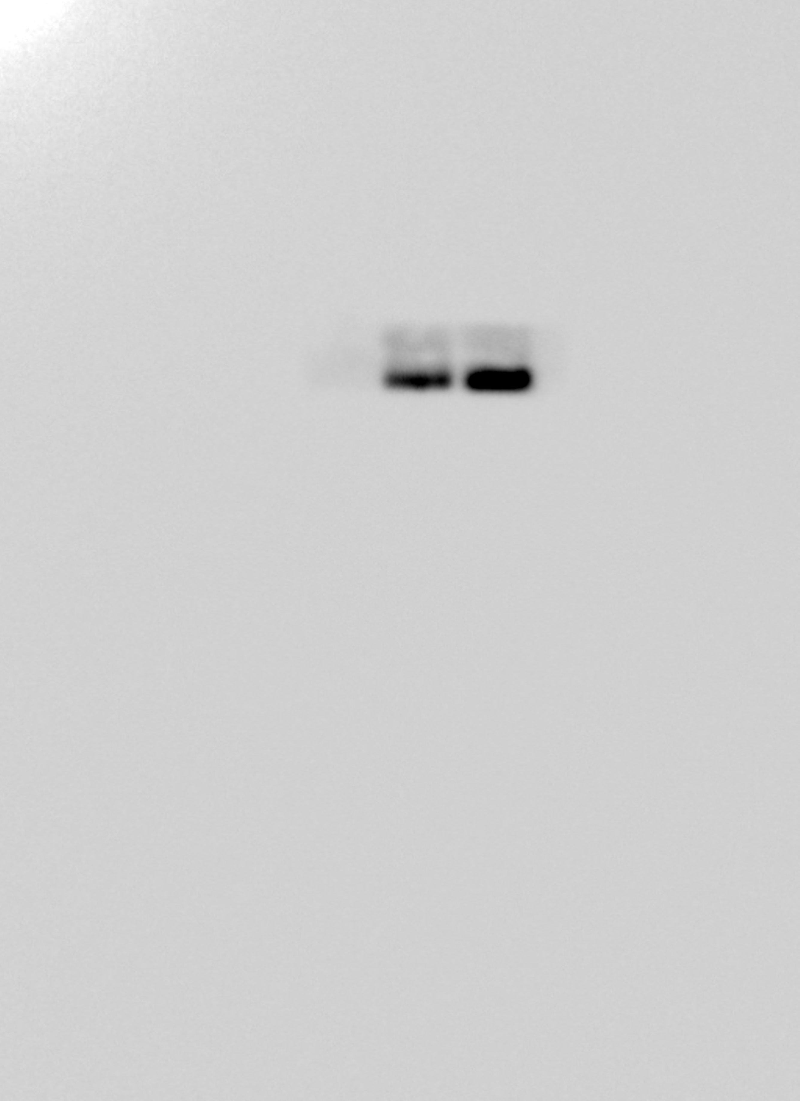
Fig.5A Western blot analysis of pSMAD5

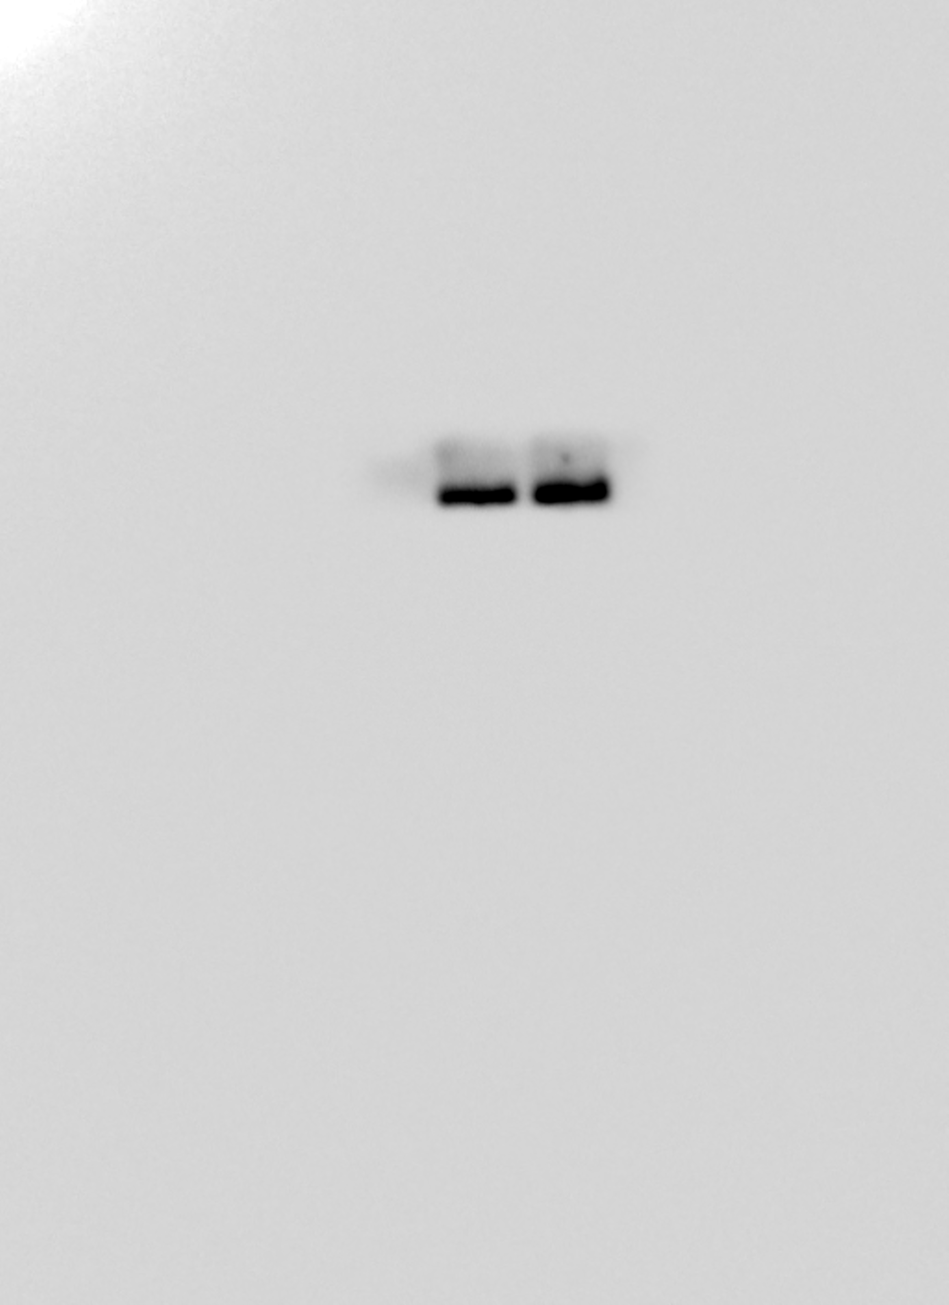
Fig.5A Western blot analysis of SMAD5

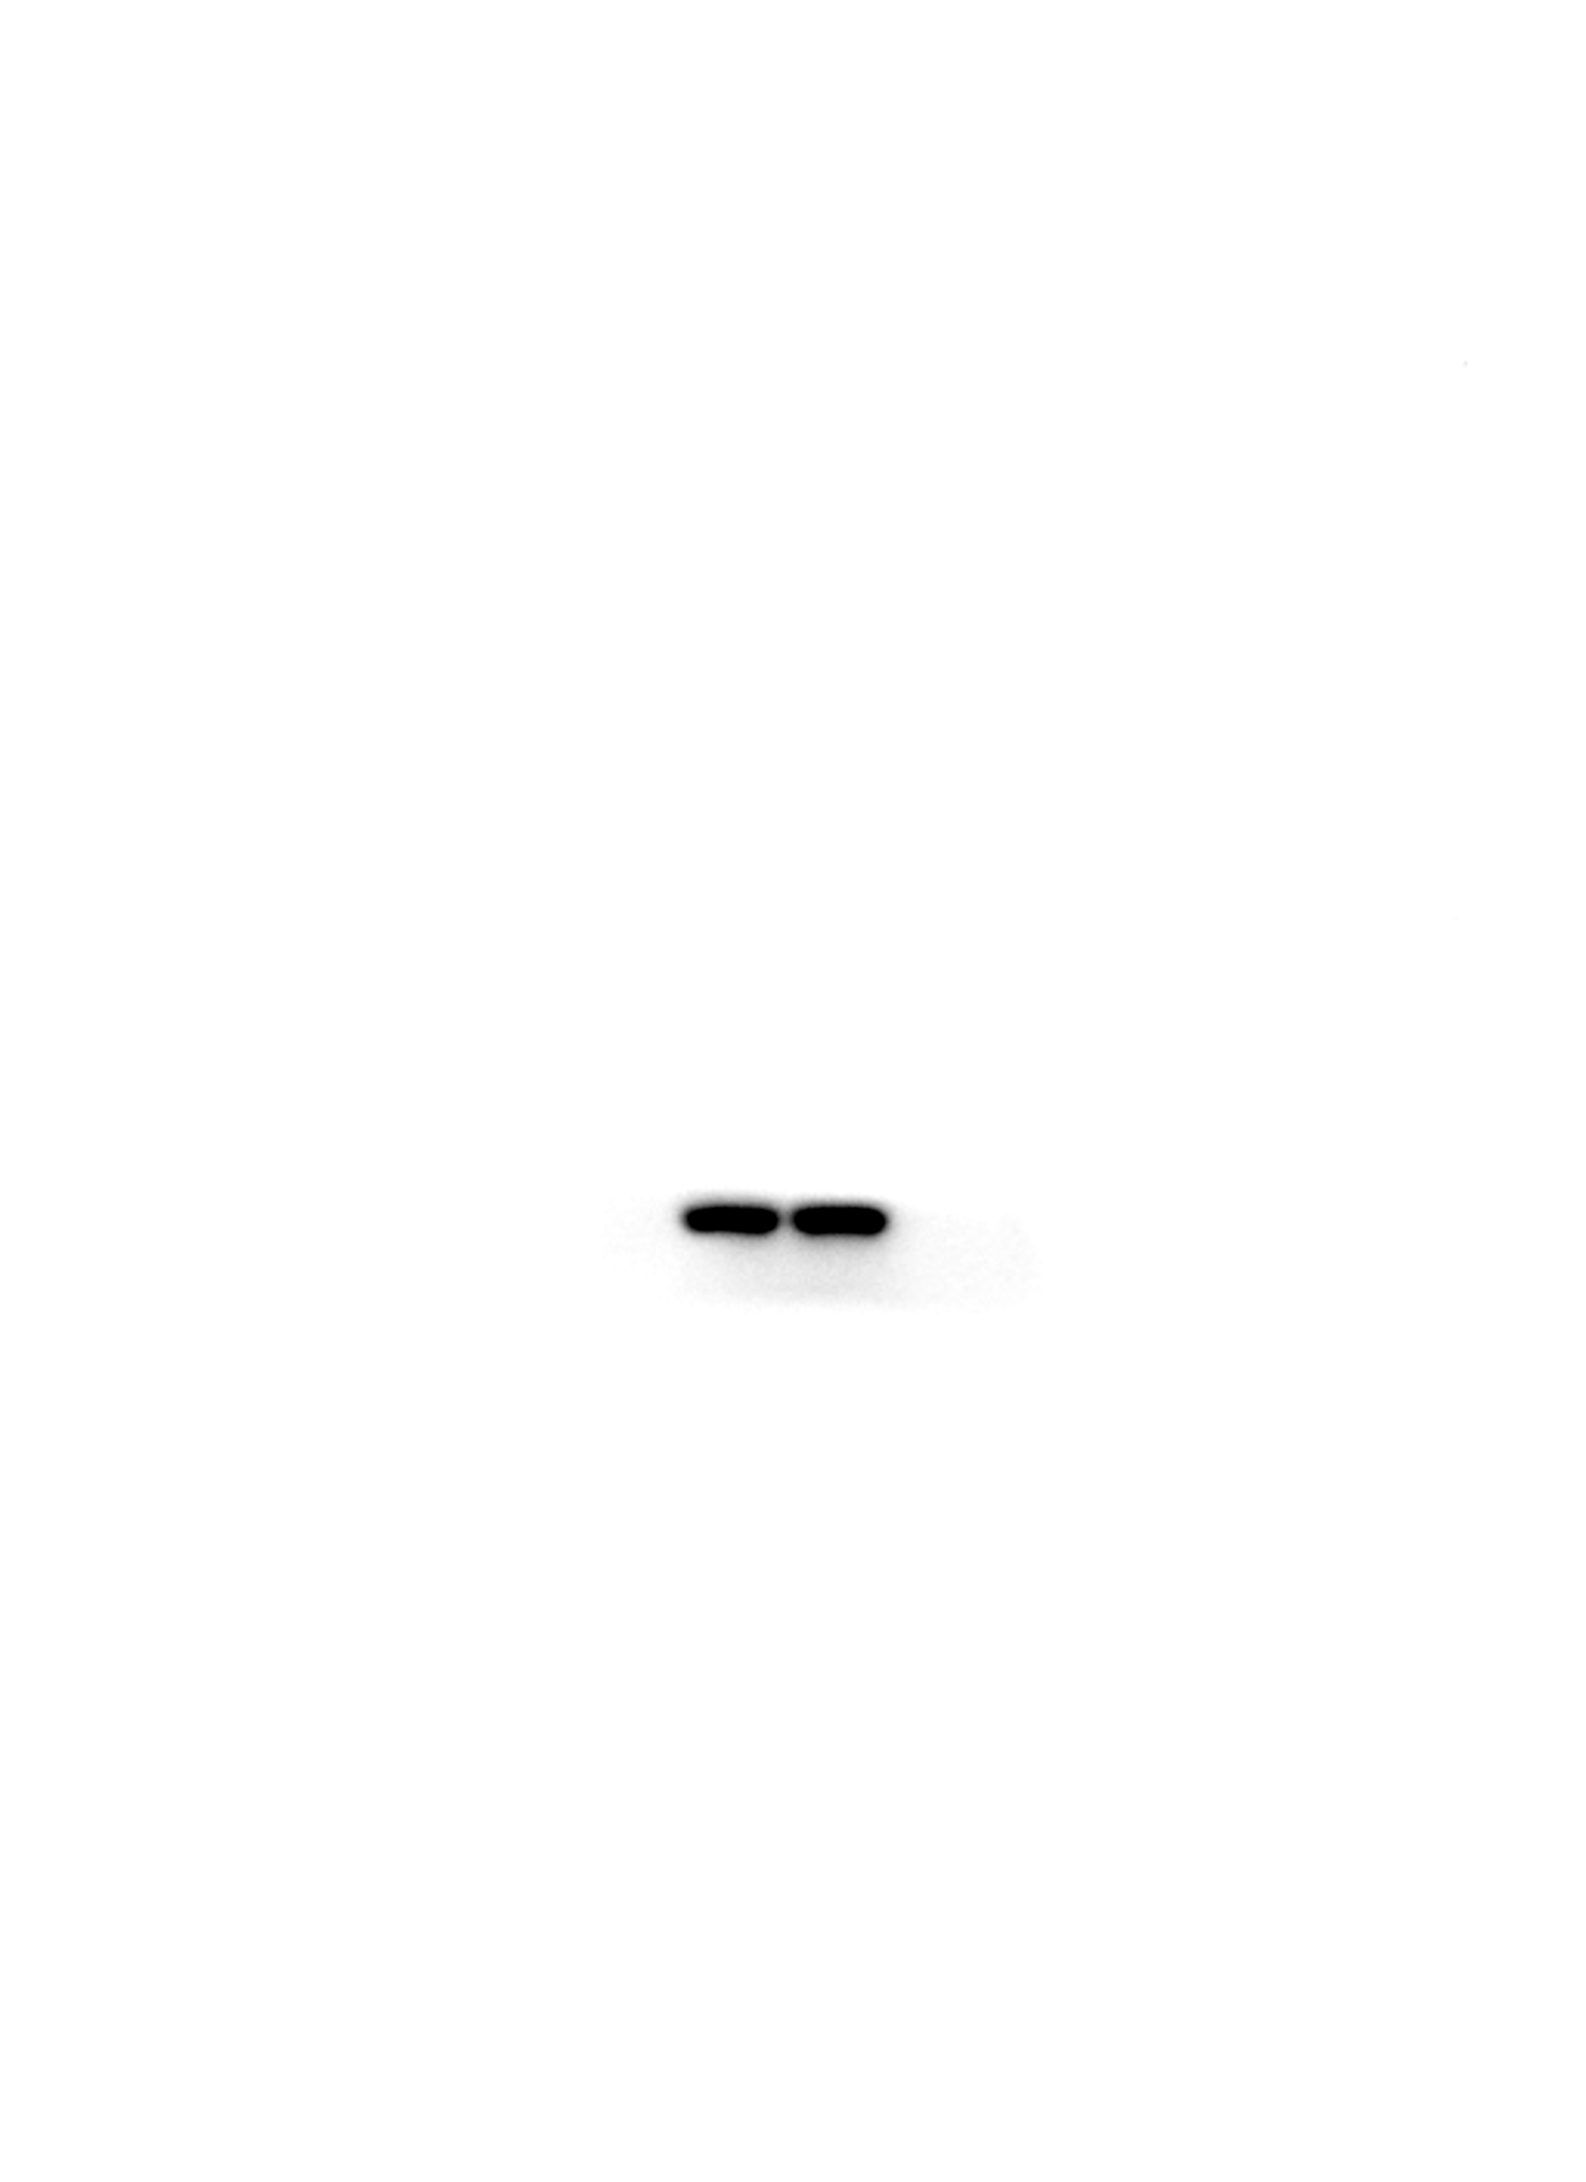
Fig.5A Western blot analysis of Actin

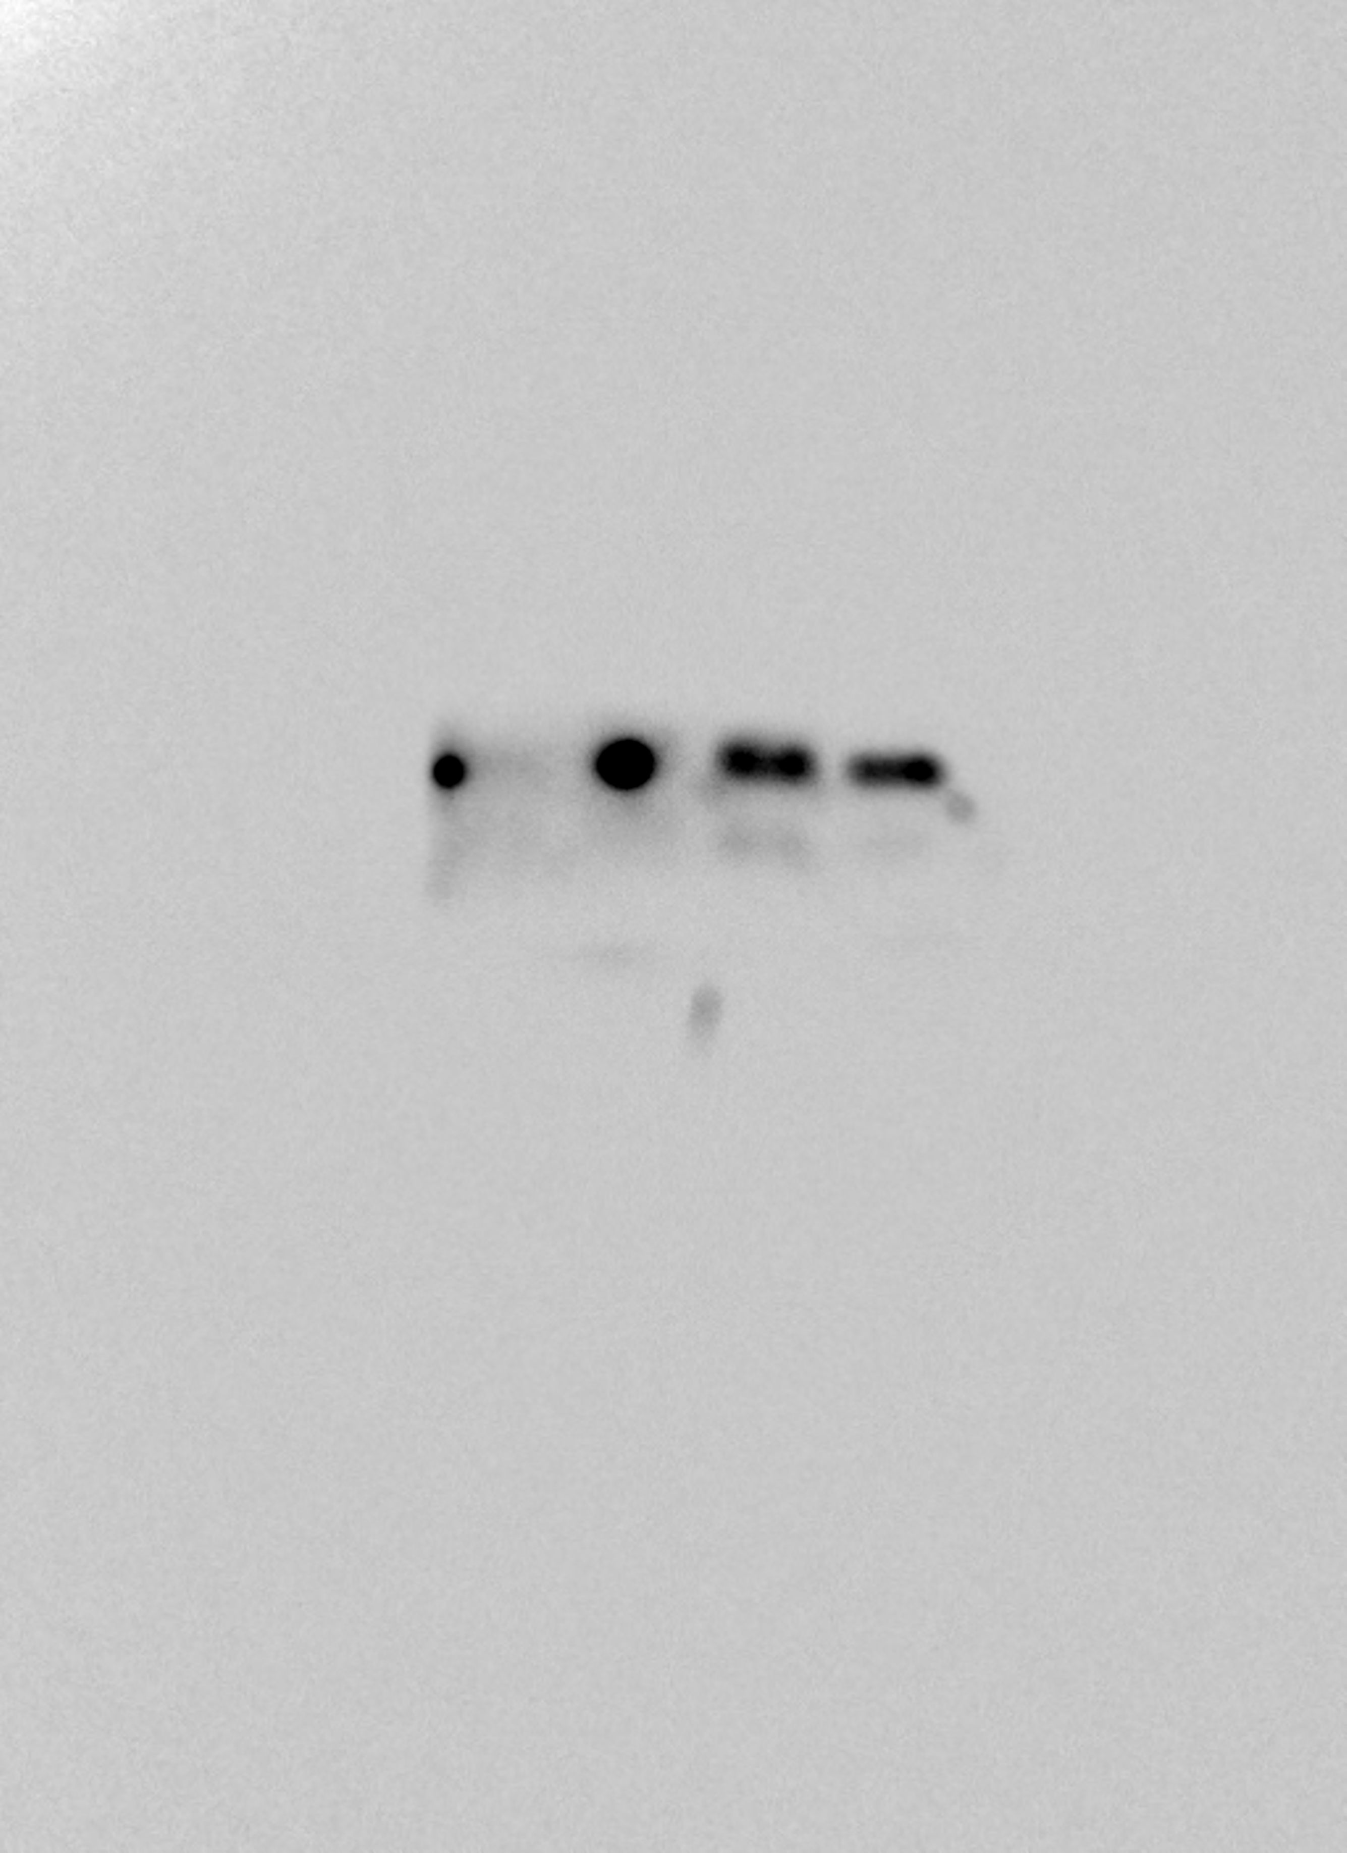
Fig.5B Western blot analysis of HOXD13 binding to pSMAD5

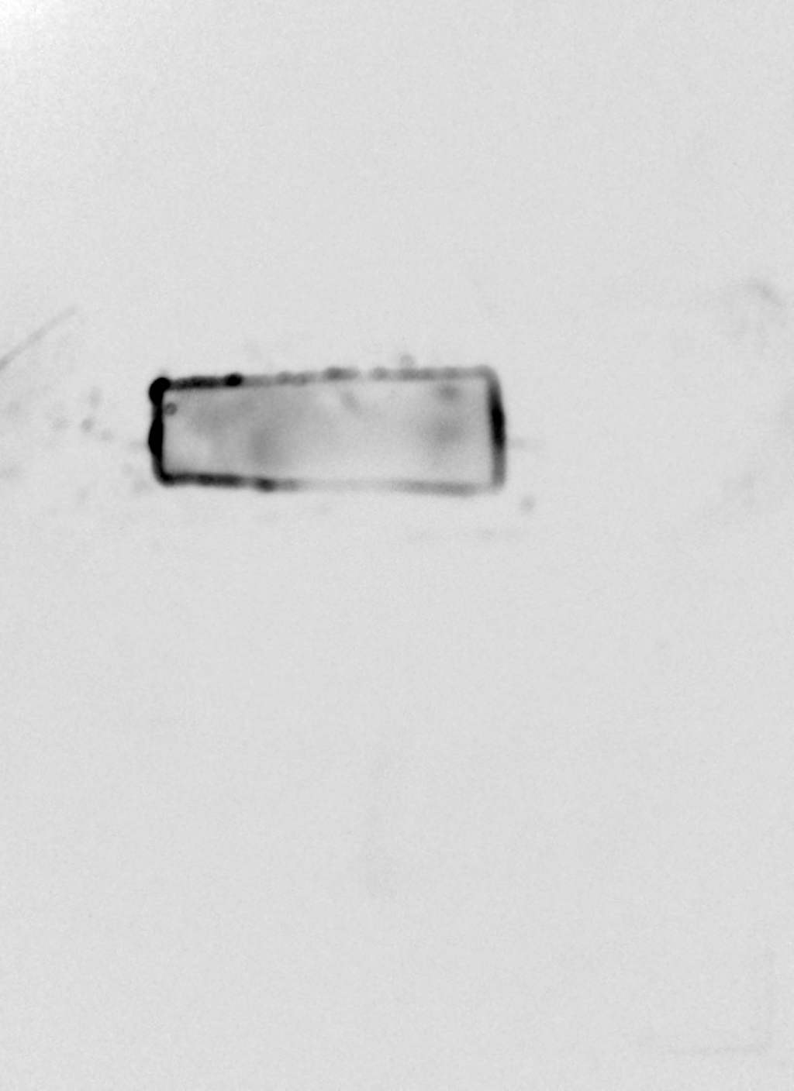
Fig.5B Western blot analysis of HOXD13 binding to IgG

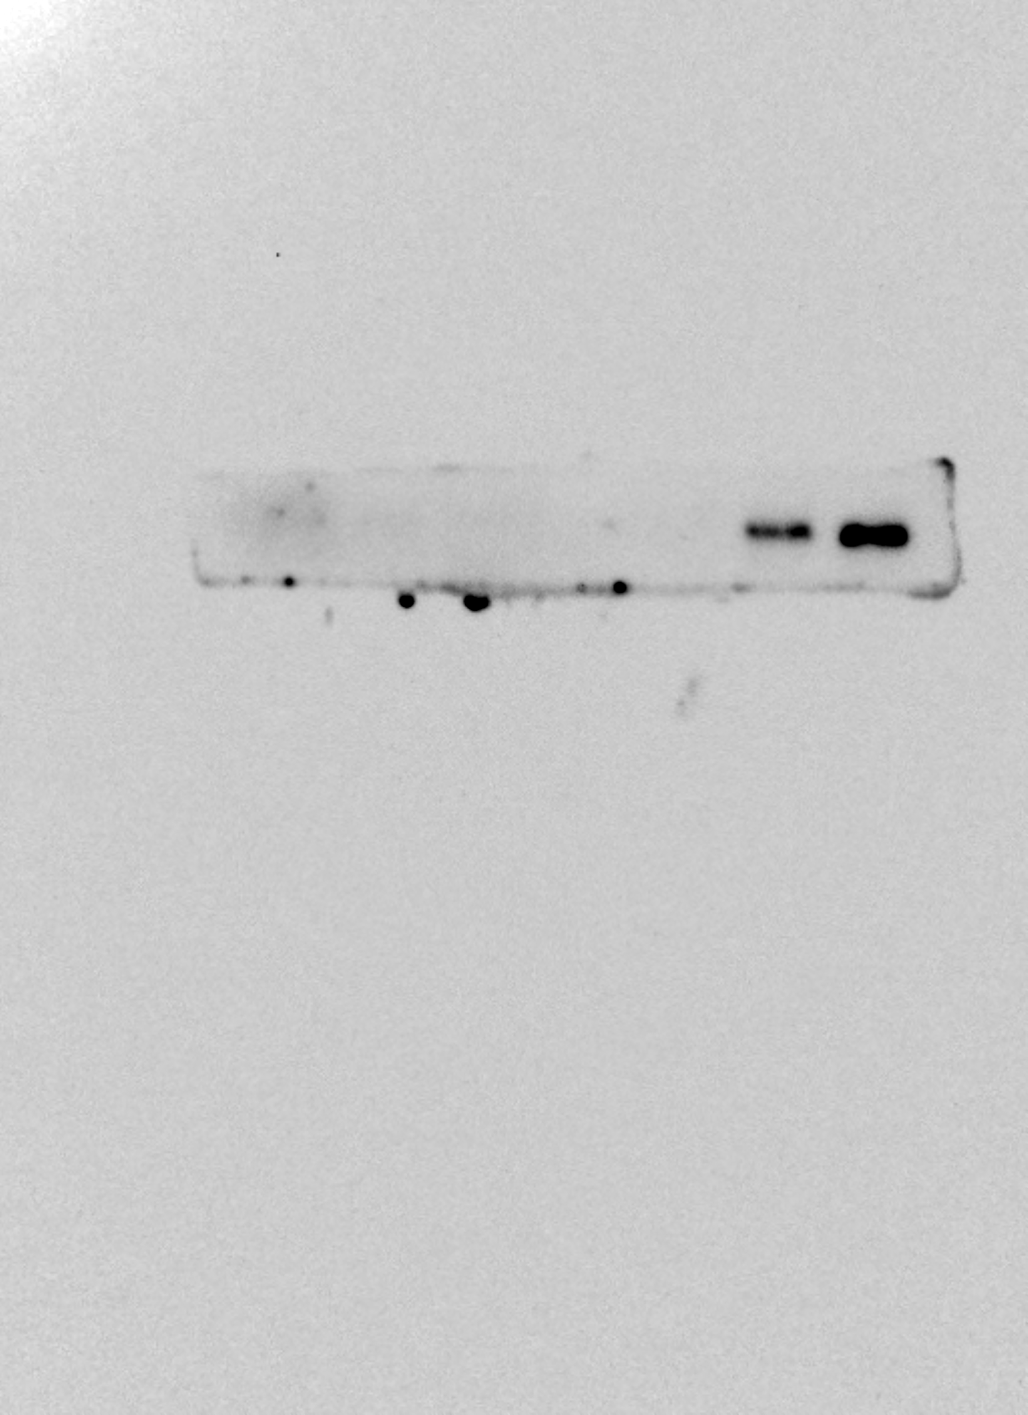
Fig.5B Western blot analysis of pSMAD5-input

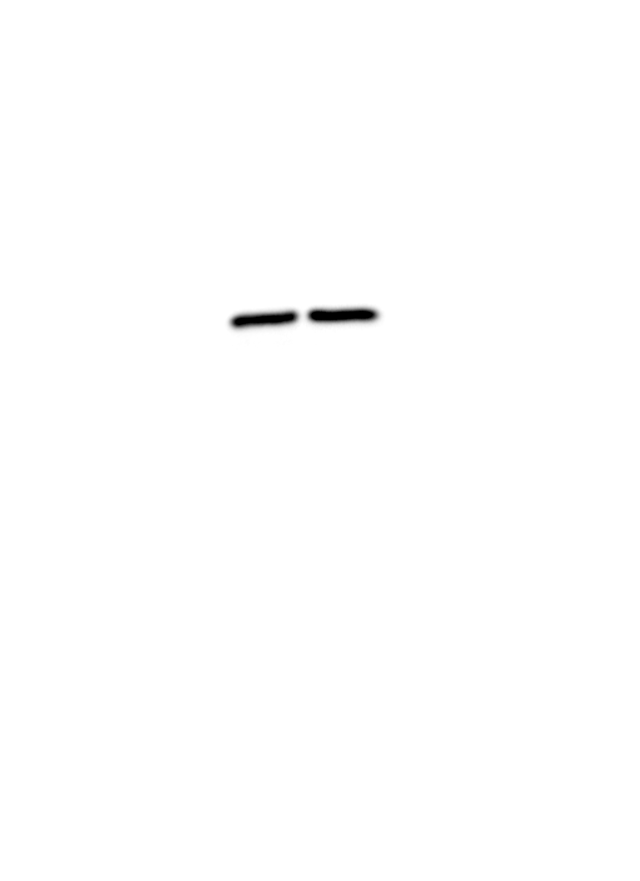
Fig.5B Western blot analysis of HOXD13-input

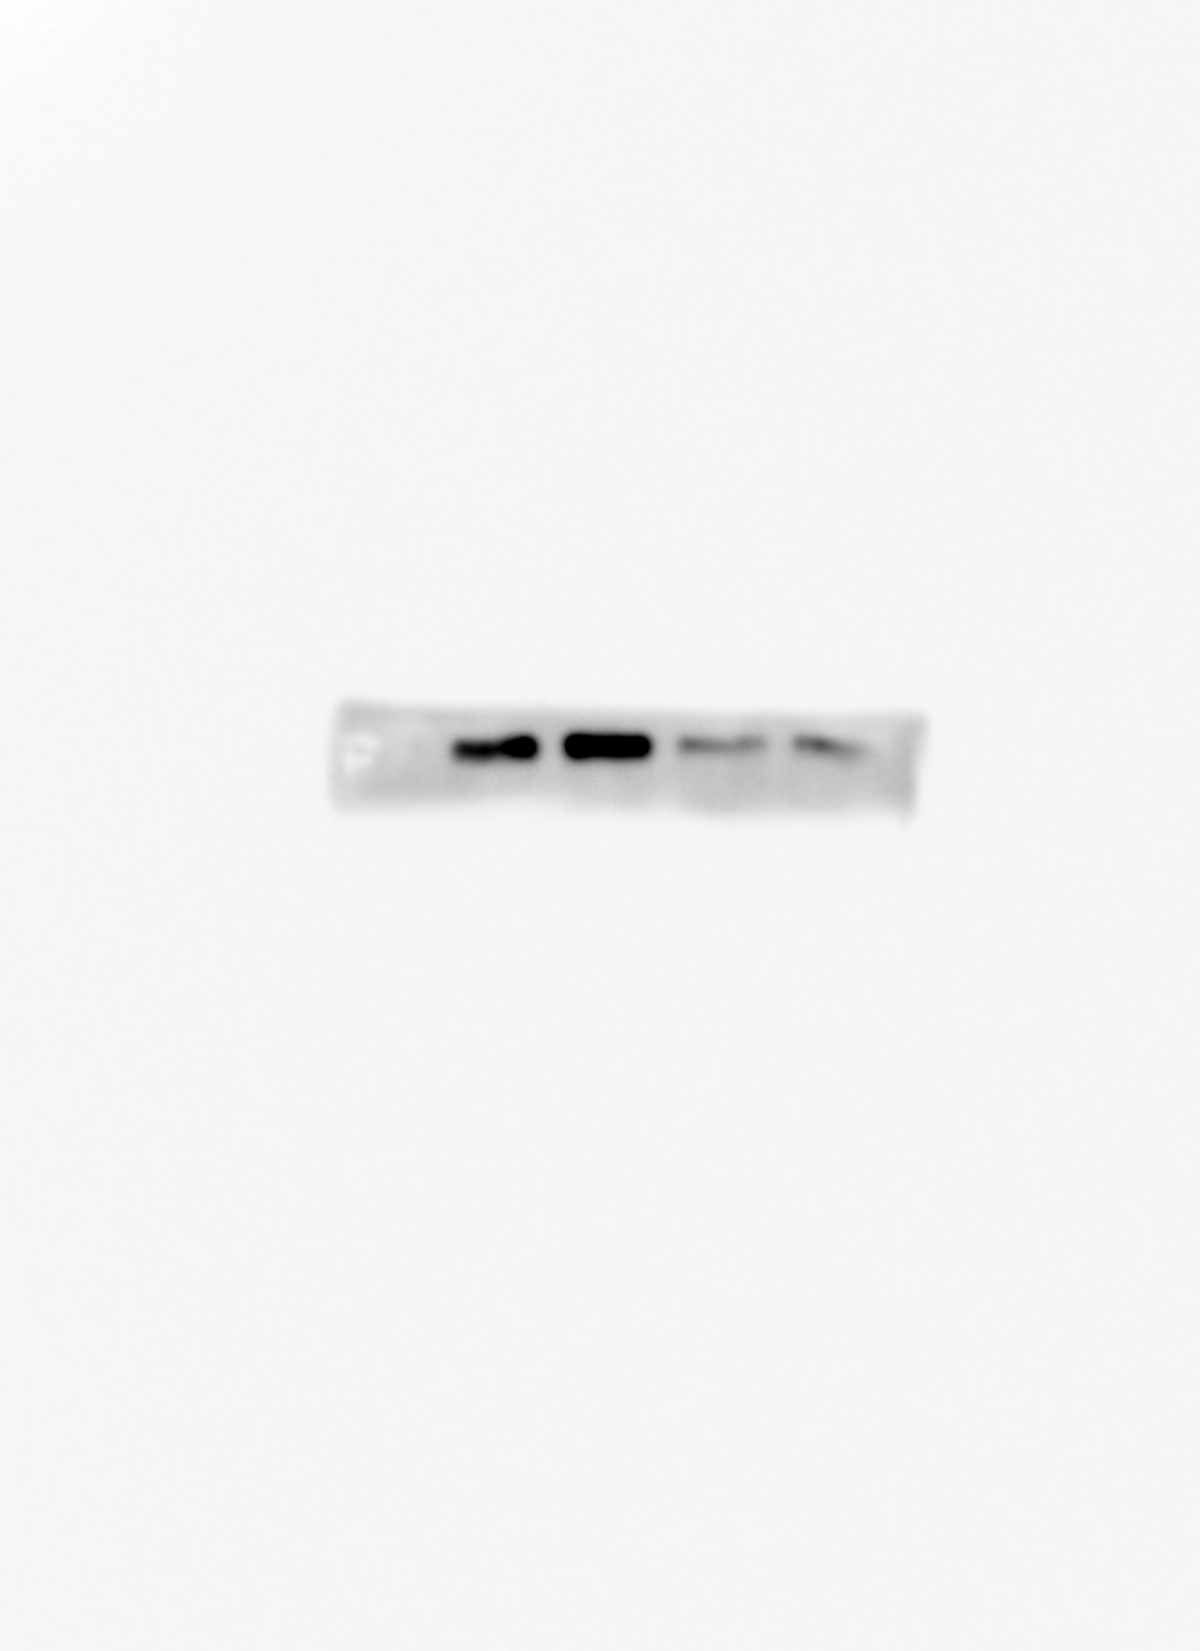
Fig.5C Western blot analysis of pSMAD5

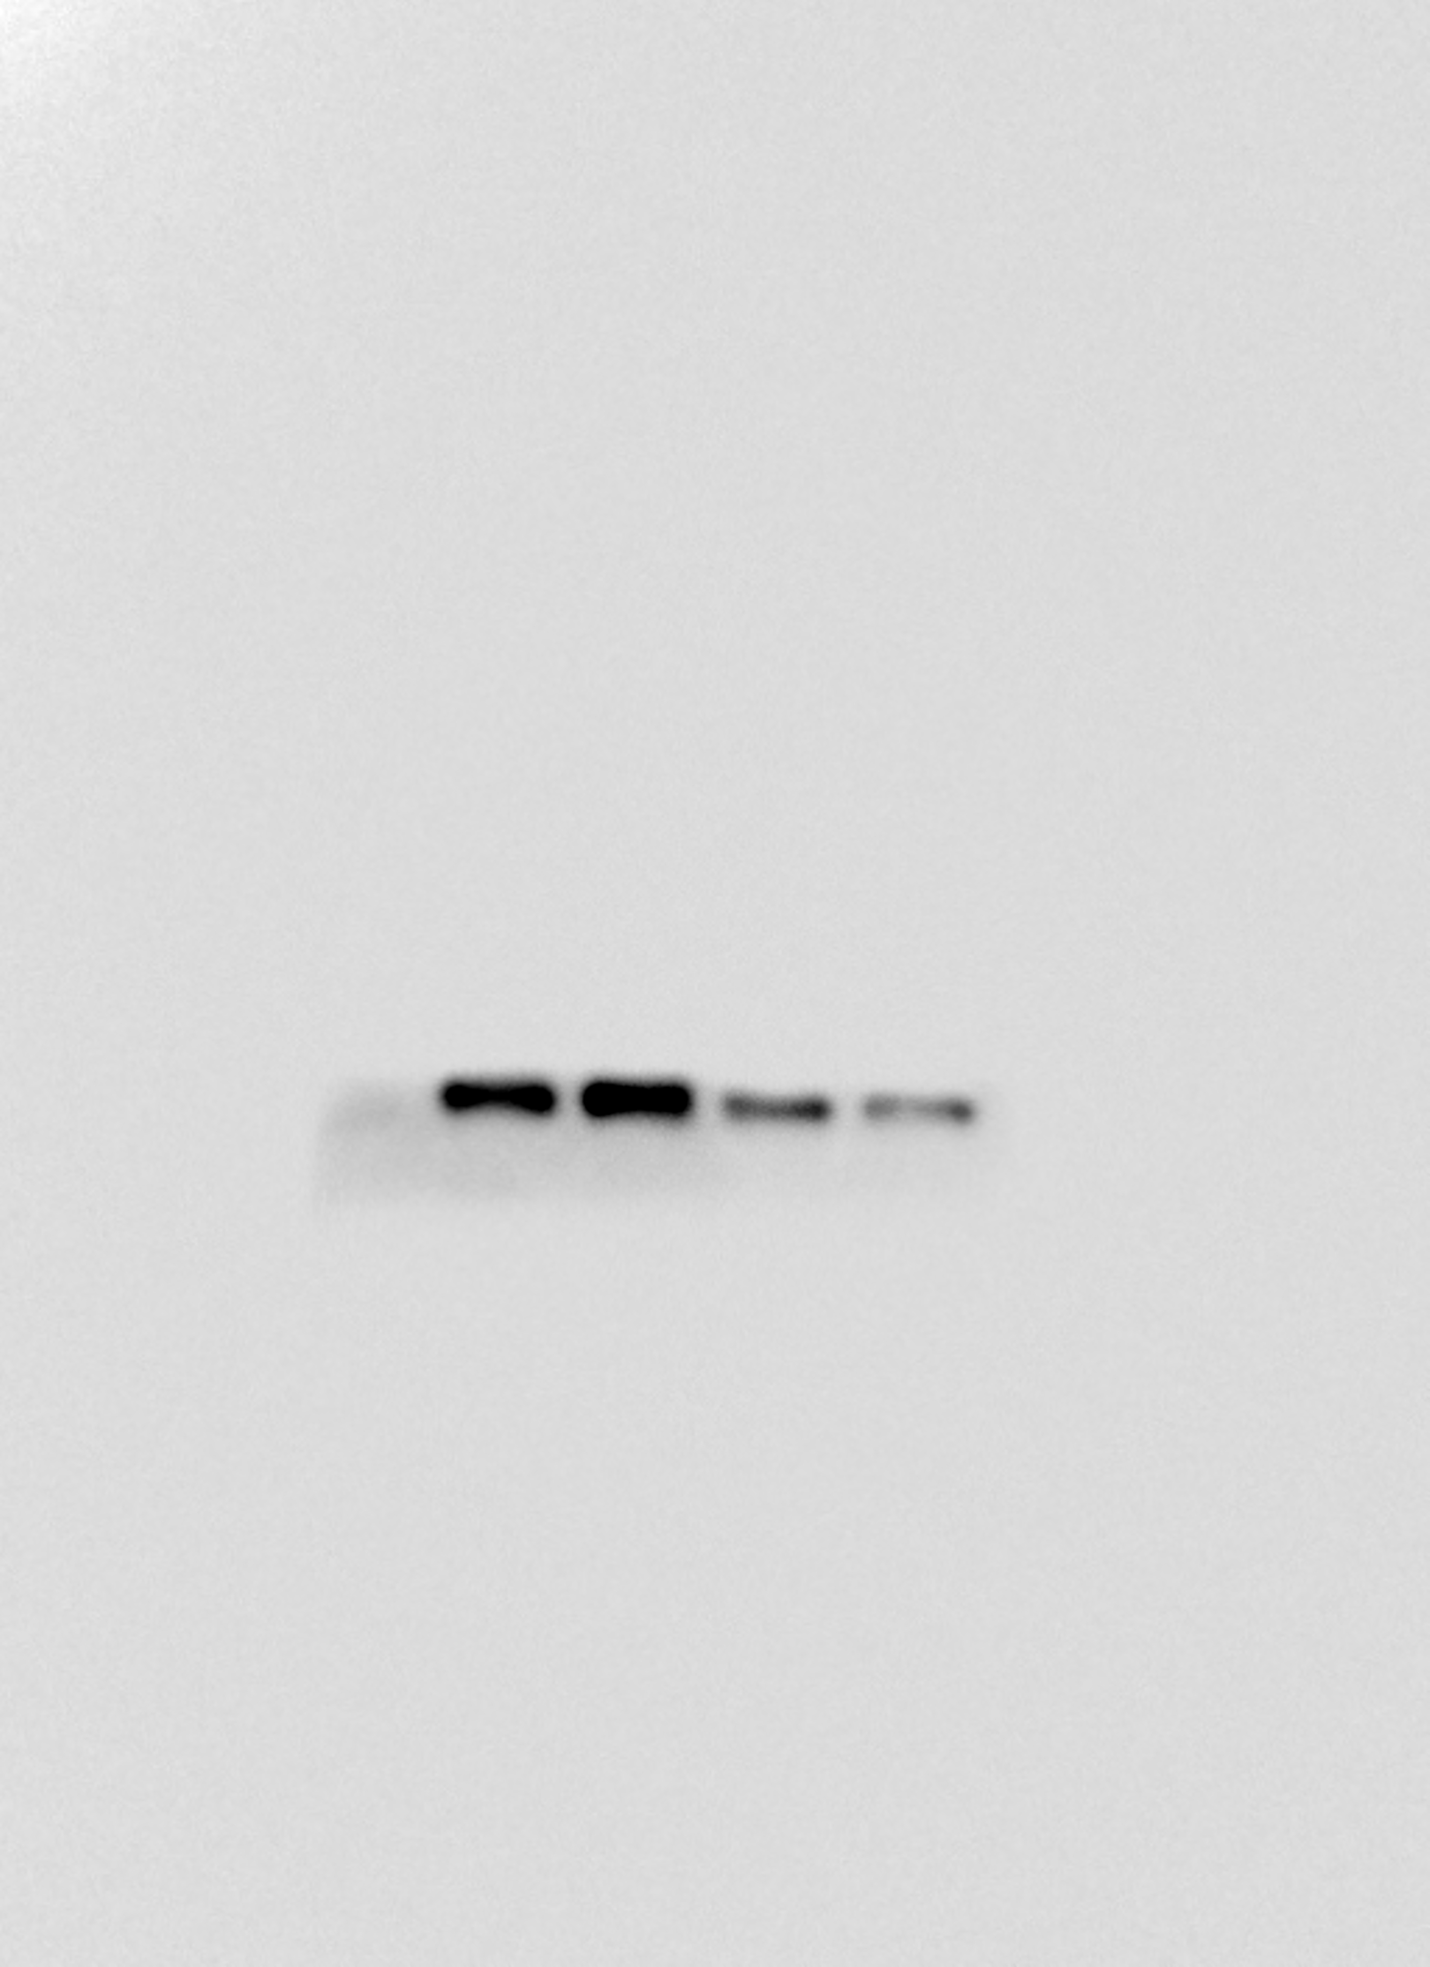
Fig.5C Western blot analysis of RANK

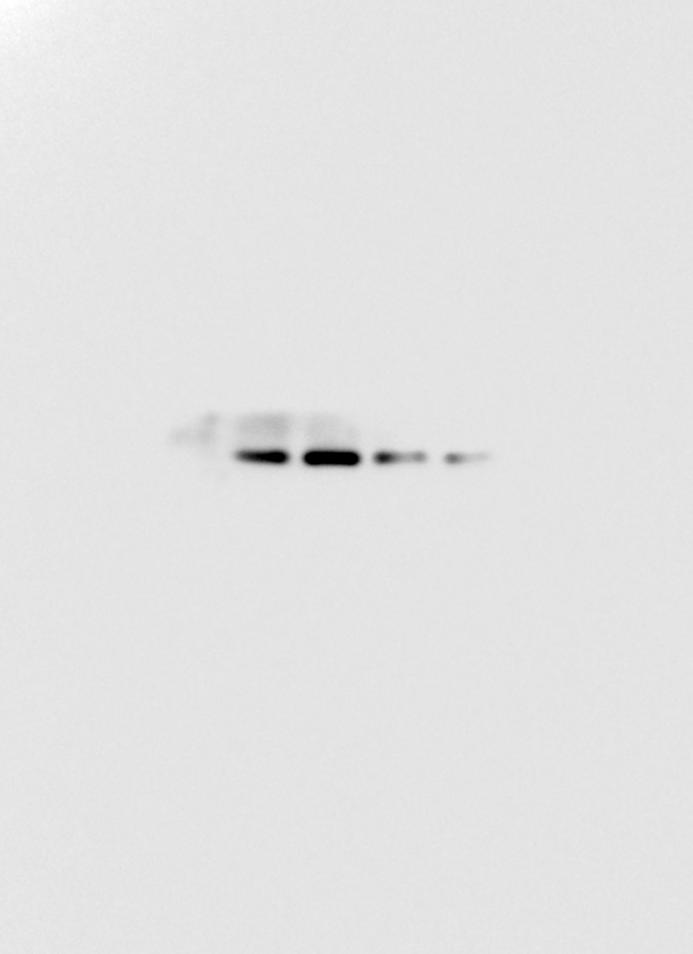
Fig.5C Western blot analysis of p65

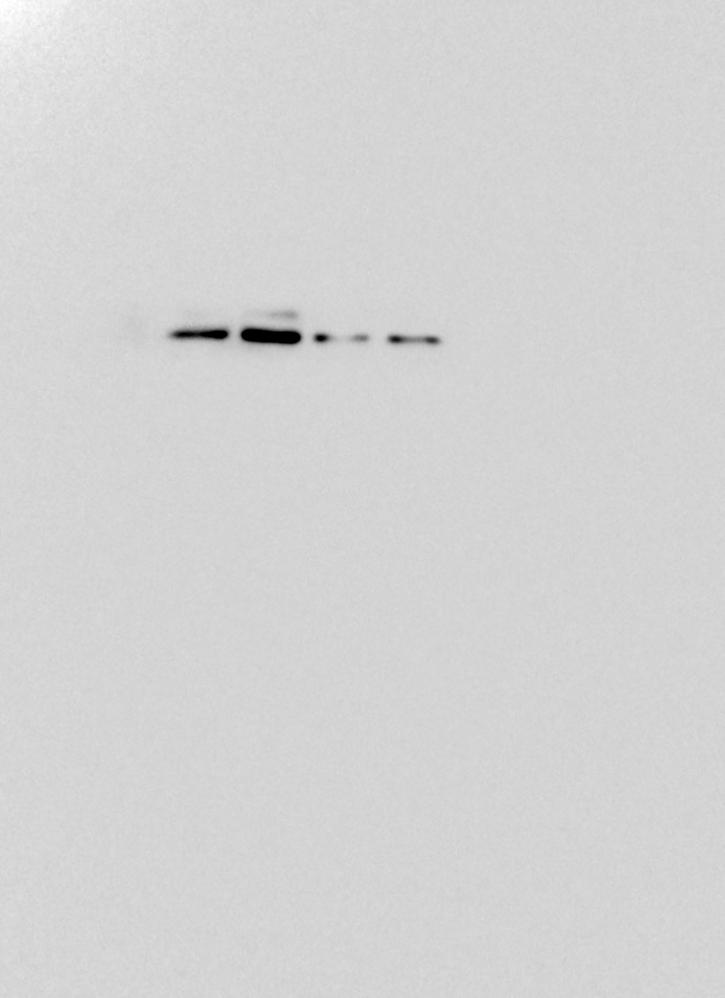
Fig.5C Western blot analysis of c-Fos

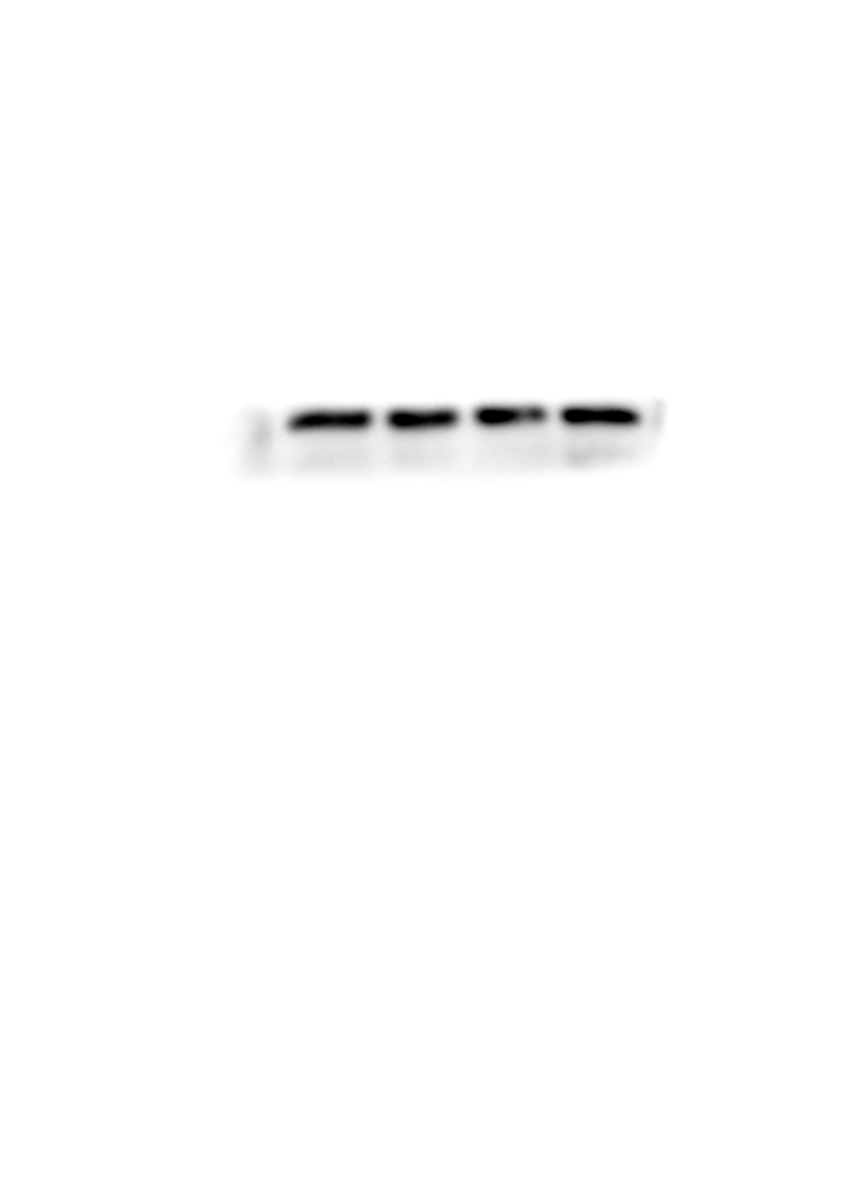
Fig.5C Western blot analysis of GAPDH

