Supplemental Figures
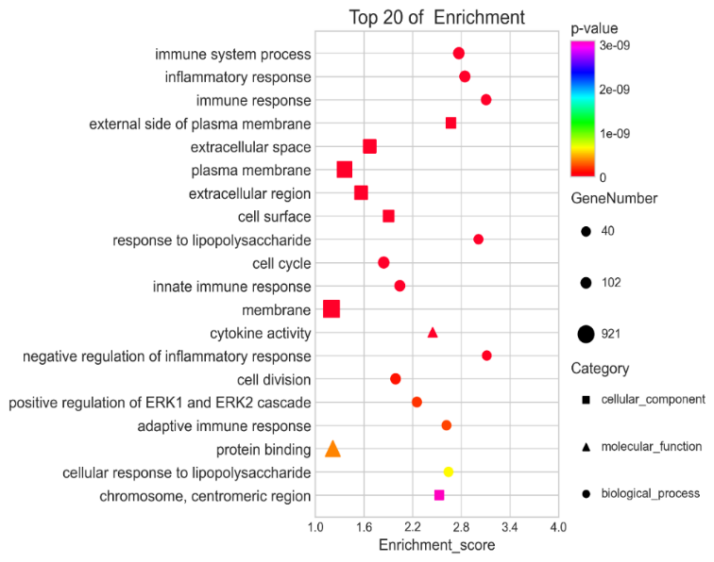
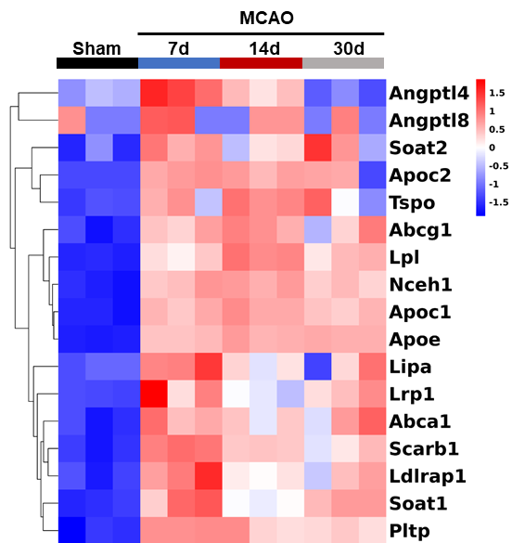
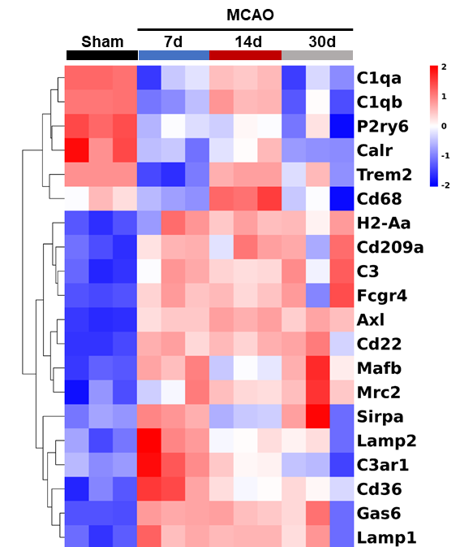
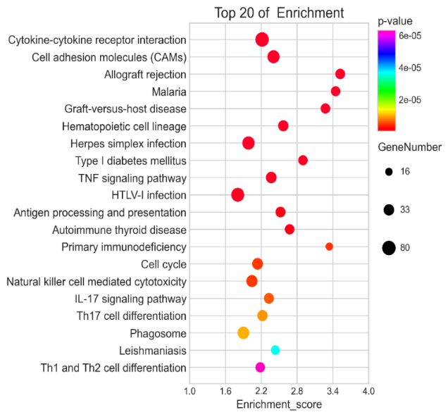
Figure 1
A
B
C
D
E

Supplemental Figure 1. Transcriptional analysis of sorted microglia
(A, B) The functional enrichment results for the interested genes were selected by STEM. GO (A) and KEGG (B) analysis of top 20 enrichment pathways are shown separately. Cluster heatmaps showing phagocytosis-associated genes (C) and lipid-associated genes (D) at different time points. (E) The number of up-regulated and down-regulated genes on the 7th day, 14th day and 30th day post-MCAO compared with sham group (fold change>2, p<0.05).

Figure 2
A
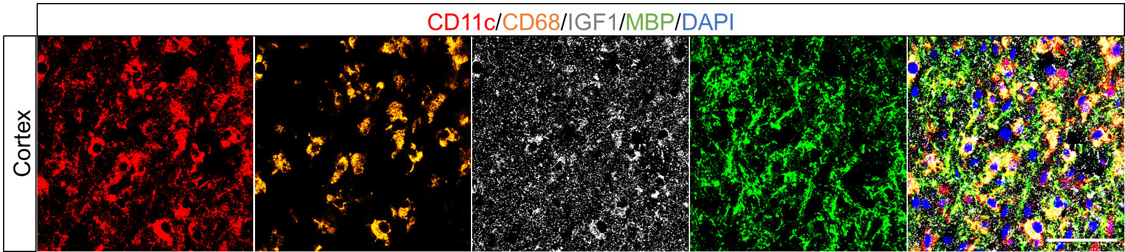
Supplemental Figure 2. Immunofluorescence co-localization of CD11c and its-associated genes.
(A) Representative images of CD11c (red), CD68 (orange), IGF-1 (gray), and MBP (green) immunostaining on the 7th Day after tMCAO in the cortex. Scale bars, 200 μm.

Figure 3
B
A

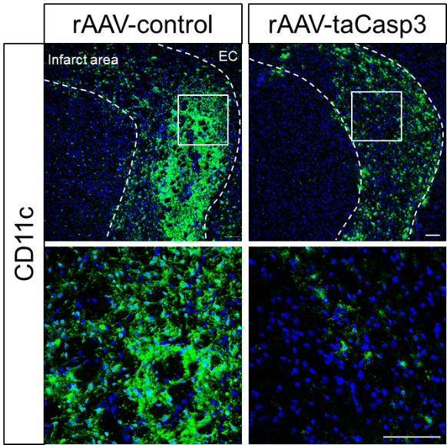

Supplemental Figure 3. CD11c expression of rAAV-control and rAAV-taCasp3 mice on the 21st day after tMCAO.
(A) Representative images of CD11c (green) on the rAAV-control and rAAV-taCasp3 group, 21st Day after tMCAO. Scale bars, 100 μm. (B) The relative mean fluorescence of CD11c in the infarct area in rAAV-control and rAAV-taCasp3 mice. n = 4. ***p < 0.001.

Figure 4
A
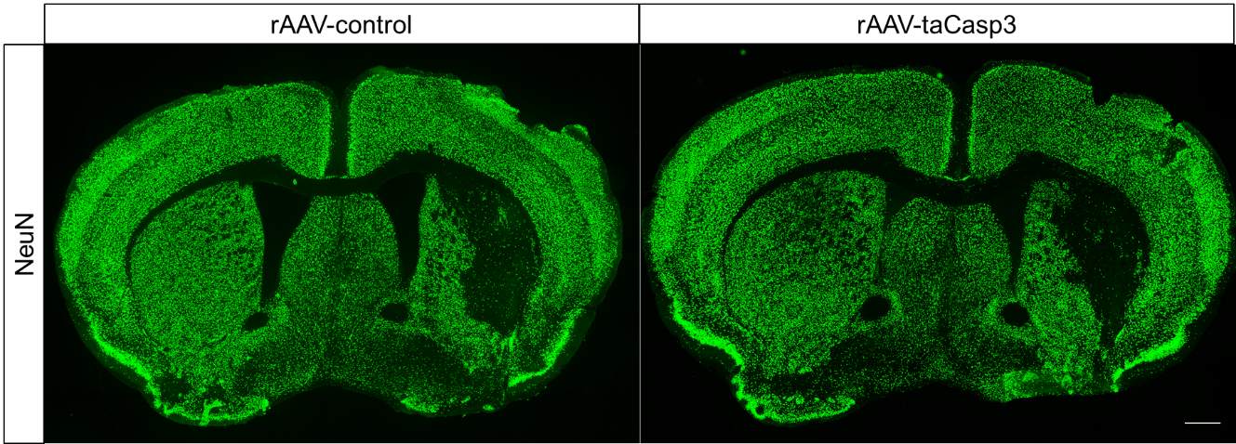

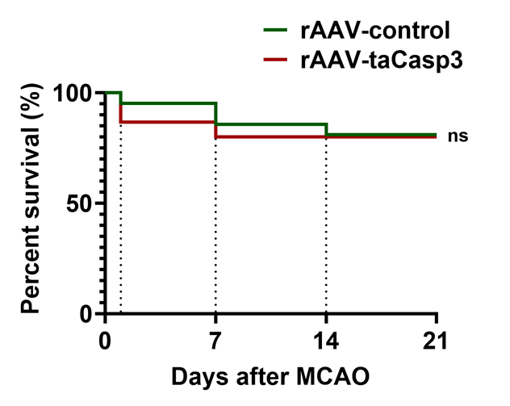
C
B

Supplemental Figure 4. Infarct area and survival curve of rAAV-control and rAAV-taCasp3 mice on the 21st day after tMCAO.
(A) Representative images of NeuN (green) in the rAAV-control group and rAAV-taCasp3 group on the 21st Day after tMCAO. Scale bars, 500 μm. (B) The percentage of infarct area in the whole brain in rAAV-control mice and rAAV-taCasp3 mice. n = 8. (C) The survival curve of the mice after MCAO in rAAV-control group and rAAV-taCasp3 group. There were 21 mice alive before tMCAO and 17 mice left on the 21st day post-tMCAO in rAAV-control group. There were 15 mice alive before MCAO and 12 mice left on the 21st day after tMCAO in rAAV-taCasp3 group. Ns indicated for no significance.

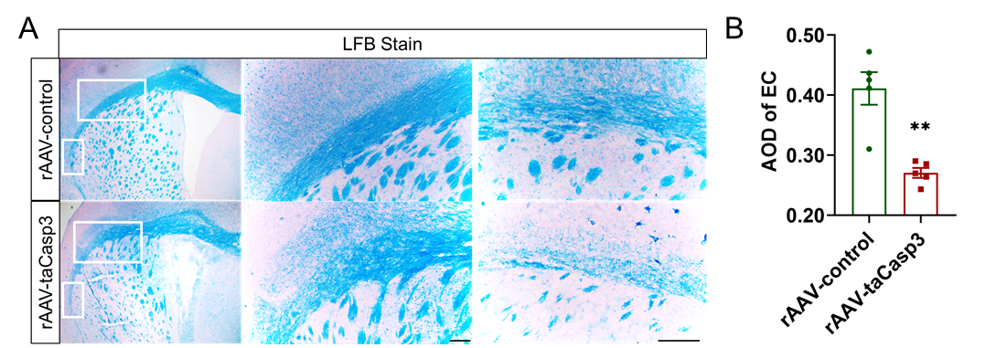
Supplemental Figure 5

Supplemental Figure 5 Myelin sheath of ipsilateral side 21 days after ischemic stroke detected by luxol fast blue (LFB).
(A) Representative LFB staining images of rAAV-control and rAAV-taCasp3 group on the 21st day after tMCAO in the external capsule (EC), showing myelin bundles in the rAAV-control group were better-structured and denser than that in the rAAV-taCasp3 group. Scale bar = 100 μm. (B) Quantitative analysis of the Average Optical Density (AOD) of myelin sheath in the EC area. n = 5, **P < 0.01. Values were mean ± SEM.

Supplemental methods：
Luxol fast blue (LFB) staining
Frozen sections were stained with Luxol fast blue staining kit (Servicebio, G1030) according to the manufacturer,s protocol. When the myelin sheath was blue and the background was almost colorless, the slices were put into 95% ethanol and Eosin (Servicebio, G1002) counterstaining. After dehydration and sealing, the slices can be examined under microscopy (Olympus IX73) and the images were collected and analyzed.

