Supplementary Material for:
PTPN14 Promotes Gastric Cancer Progression by PI3KA/AKT/mTOR Pathway

This supplementary material includes 1 table and 7figures.

Supplemental table 1. Primer sequence used for RT-QPCR.
Name | Primers Sequence
PTPN14-Forward | CGACTTCTGGCAGATGGTGT
PTPN14-Reverse | GTGGCTTTTGGTTCGTCCAC
PI3KA-Forward | TTGGAAGCAGCAACCGAAAC
PI3KA-Reverse | CTTTACTTCGCCGTCCACCA
CDK4-Forward | GGTGACAAGTGGTGGAACAG
CDK4-Reverse | GCCCATTCAGGTCAAAGATT
KIF11-Forward | TACGACACCACAGAGGAA
KIF11-Reverse | CCACACCAGCATCTACAG
TACC3-Forward | CCTCTTCAAGCGTTTTGAGAAAC
TACC3-Reverse | GCCCTCCTGGGTGATCCTT
PI3KD-Forward | CATATGTGCTGGGCATTGGC
PI3KD-Reverse | TTTCACAGTAGCCCCGGAAC
CHIP-Forward | CAAGTAGCTGGGACTACAGGC
CHIP-Reverse | AAGCATGGTGGCTCATGTGT

Supplemental figure 1. Presentation of the gastric tissue microarray. (A) The pattern diagram of gastric cancer tissues and the paired normal gastric tissues. (B) The thumbnail view of the HE staining slides and IHC staining of PTPN14.
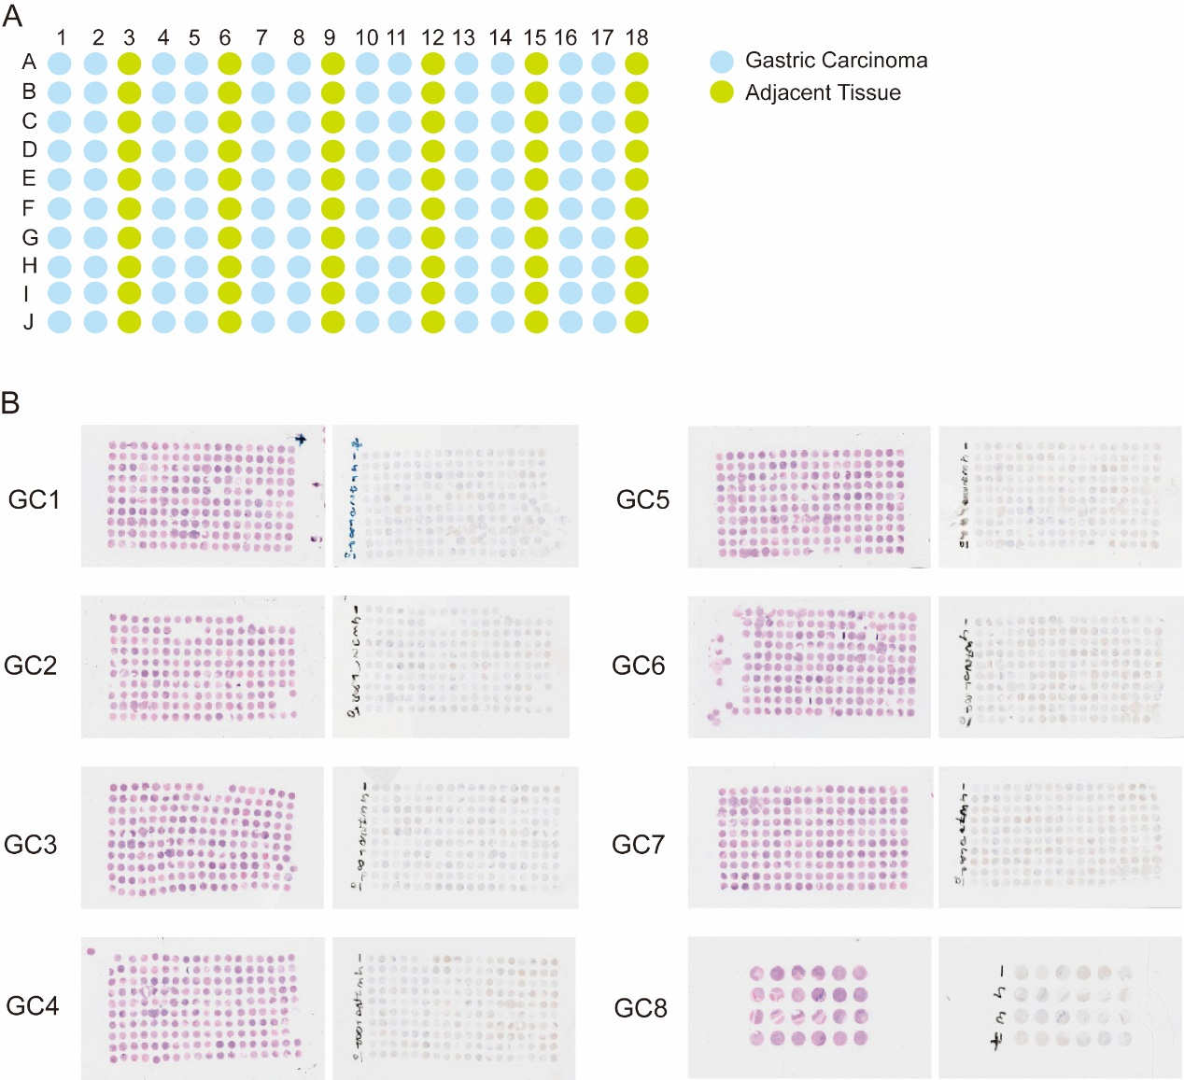
Supplemental figure 2. The ROC curve showed that the expression of PTPN14 could hardly distinguish gastric cancer tissues with LNM from gastric cancer tissues without LNM.
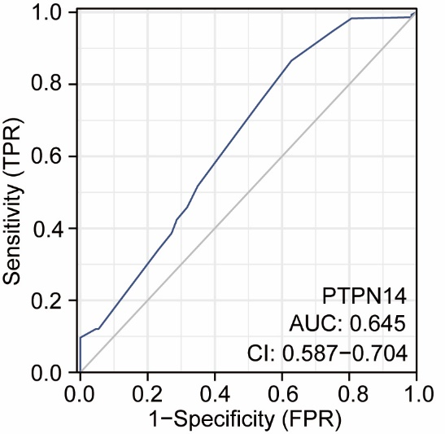
Supplemental figure 3. Bar graph representation of proportion of EDU positive cells in AGS cells (A), MKN-45 cells (B) and BGC-823 cells (C) (related to Fig. 3G-3I).
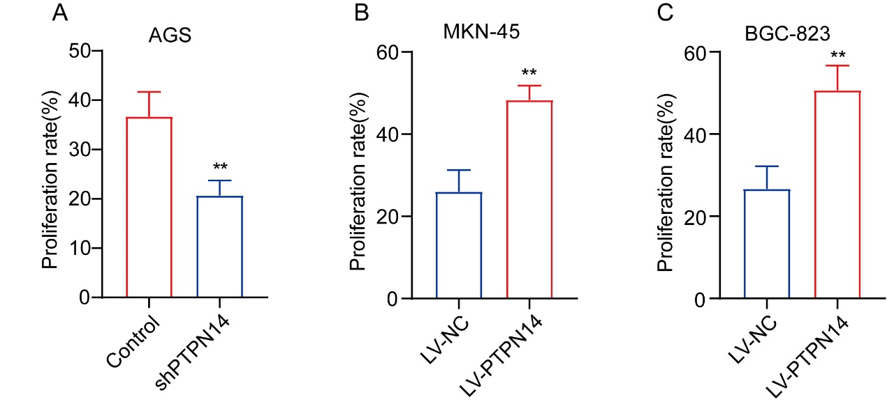
Supplemental figure 4. Bar graph representation of migration and invasion cell numbers in AGS cells (A), MKN-45 cells (B) and BGC-823 cells (C) (related to Fig. 3J-3L).
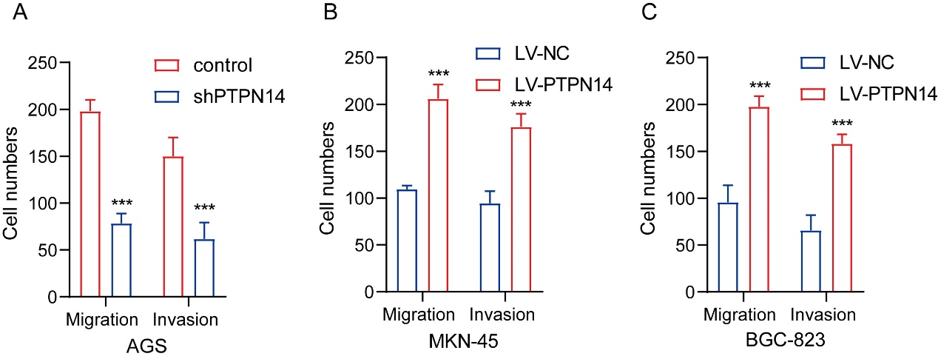
Supplemental figure 5. The transfection efficacy of GFP-PTPN14 in MKN-45 cells (A) and BGC-823 cells (B) was almost 90%.

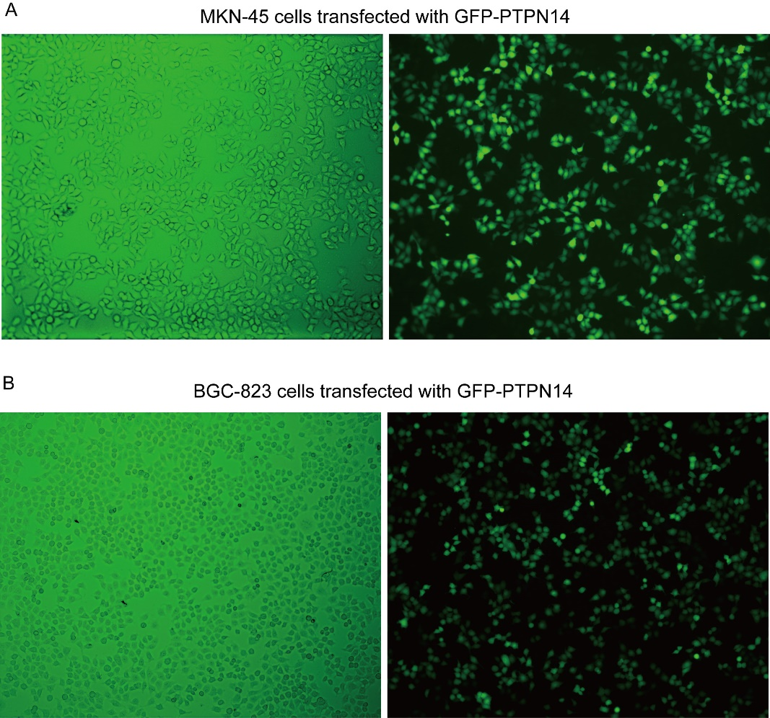
Supplemental figure 6. Bar graph representation of migration and invasion cell numbers in MKN-45 cells (A) and BGC-823 cells (B) (related to Fig. 4F-4G).
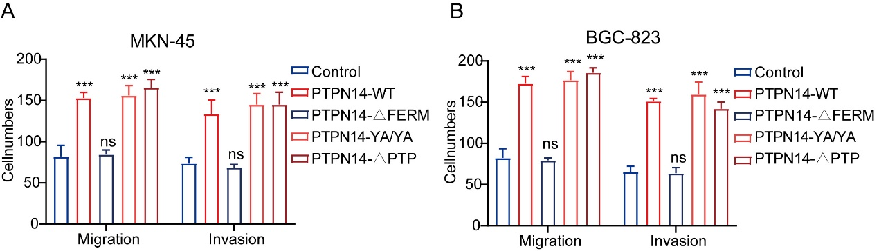
Supplemental figure 7. PTPN14 did not affect the expression of NFkB. (A) In BGC-823 cells, PTPN14 overexpression did not affect the expression level of NFkB. (B) In AGS cells, PTPN14 knockdown did not affect the expression level of NFkB.
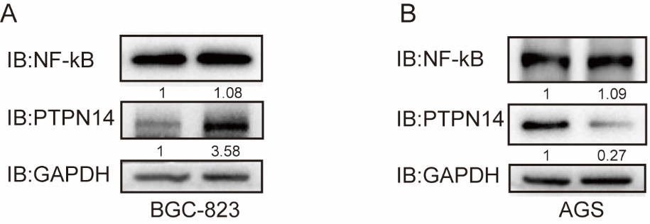
Supplemental figure 8. Bar graph representation of migration and invasion cell numbers in BGC-823 cells (A) and AGS cells (B) (related to Fig. 6H-6I).
