original western blots
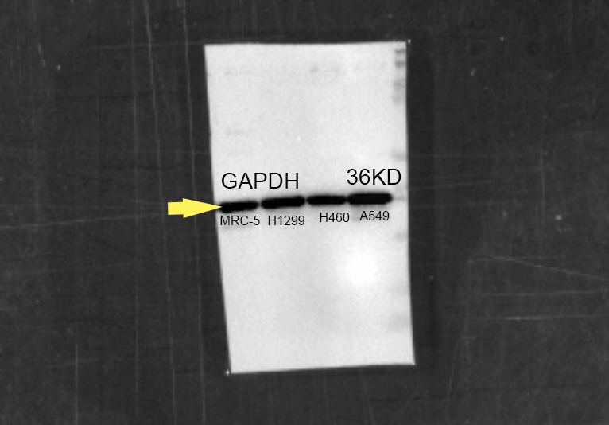
Fig4A GAPDH
Fig4A NRG2
Fig4A PLCG2
Fig4C GAPDH
Fig4C PLCG2
Fig4G GAPDH
Fig4G PLCG2
Fig4H GAPDH
Fig4H PLCG2
Fig4J GAPDH
Fig4J PLCG2
Fig4L GAPDH
Fig4L PCNA
Fig4S GAPDH
Fig4S E-Cadherin
Fig4S N-Cadherin
Fig4S Vimentin
Fig5C GAPDH
Fig5C CHREBP
Fig5C FASN

Fig5C SREBP1
Fig5D GAPDH
Fig5D AKT
Fig5D β-Catenin
Fig5D MMP9
Fig5D p-ERK
Fig5O GAPDH
Fig5O-OXPHOS
Fig6B GAPDH
Fig6B PLCG2

