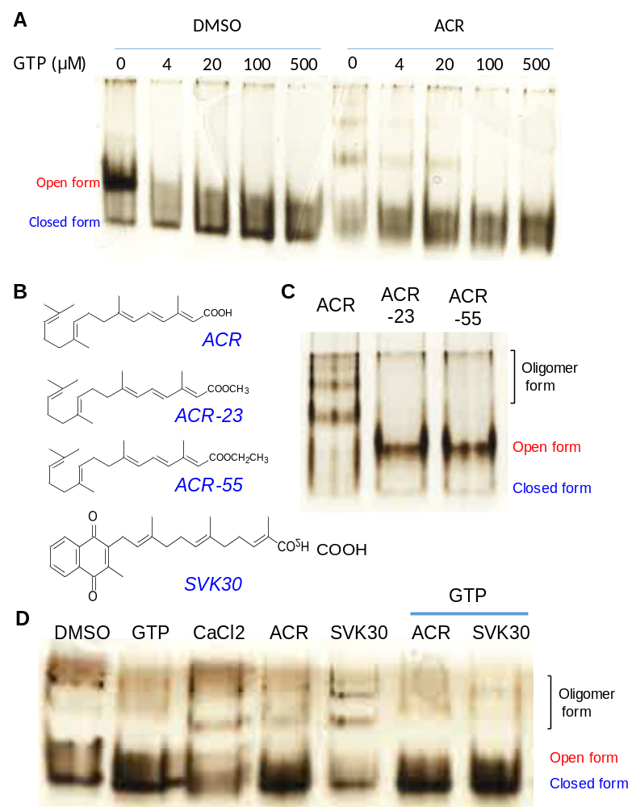
Fig. S2. Effects of ACR and vitamin K2 analog on the conformation change of TG2. (A) Recombinant human TG2 was incubated with DMSO or 100 μM ACR in the absence or presence of GTP with increasing concentrations for 2 h at room temperature and then subjected to nondenaturing electrophoresis. The protein bands were visualized with silver staining. (B) Chemical structures of ACR, ACR-23, ACR-55, and SVK30. Recombinant human TG2 was incubated (C) with 100 μM ACR, or 100 μM of the inactive derivatives of ACR (ACR-23 and ACR-55), or (D) with DMSO, 100 μM GTP, 5 mM CaCl₂, and 100 μM ACR or SVK30 in the absence or presence of 100 μM GTP for 1-2 h at room temperature and then subjected to nondenaturing electrophoresis. The protein bands were visualized with silver staining.

