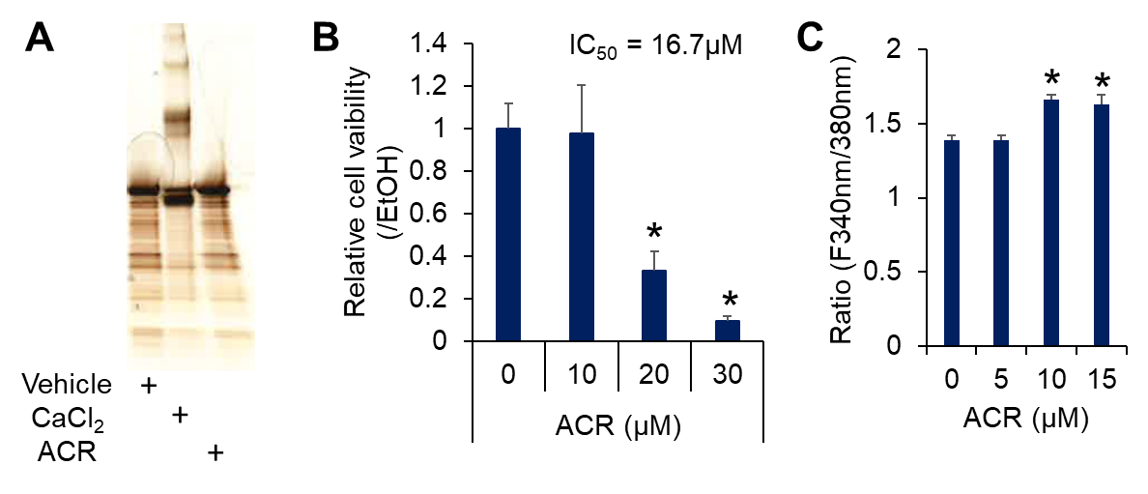
Fig. S4. Effects of CaCl₂ and ACR on the conformation structure of TG2. (A) Recombinant human TG2 was incubated with EtOH, 5 mM CaCl₂ or 100 μM ACR for 2 h at room temperature. The proteins were boiled at 98 ℃ for 10 min and subjected to SDS-PAGE. The protein bands were visualized with silver staining. (B) Dose-dependent effect of ACR on the cell viability of JHH7 cells. The cells were treated with ACR for 24 h at the indicated concentrations. The half-maximal inhibitory concentration (IC₅₀) was determined using the formula: 10^(LOG(A/B)*(50-C)/(D-C)+LOG(B)), where A represents the high concentration that encompasses 50% of inhibition, B represents the low concentration that encompasses 50% of inhition, C represents the inhibition rate at concentration B, and D represents the inhibition rate at concentration A. (C) Effect of ACR on intracellular CaCl₂ concentrations in JHH7 cells. The cells were treated with increasing concentrations of ACR for 4 h and intracellular CaCl₂ concentration was measured using Fura-2-AM fluorescence and presented as the ratio of F340/F380. The data are presented as the mean ± SD; *P < 0.05, Student’s t-test.

