Supplementary material

E3 ligase HECTD3 promotes RNA virus replication and virus-induced inflammation via K33-linked polyubiquitination of PKR

Jiaying Huang, Zhou Yu, Xuelian Li, Mingjin Yang, Qian Fang, Zheng Li, Chunmei Wang, Taoyong Chen & Xuetao Cao

Contents:
10 Supplementary Figures and Legends
2 Supplementary Tables

Supplementary Fig.1 Knockdown of Hectd3 impairs innate immune response against VSV in peritoneal macrophages. a, b Peritoneal macrophage from C57BL/6 mice were infected with VSV (MOI = 1) for indicated periods of time, the mRNA level of Hectd3 was evaluated by Q-PCR (a), the protein level of HECTD3 was evaluated by Western blotting (b). c, d Peritoneal macrophage from C57BL/6 mice were infected with VSV (MOI = 1) as indicated in the presence of actinomycin D (Act D, 10 μM) or MG132 (10 μM), the protein level of HECTD3 was evaluated by Western blotting. e-i Peritoneal macrophages from C57BL/6 mice were transfected with control (Ctrl) or Hectd3-specific siRNAs for 48h. The efficiency of knockdown (KD) was evaluated by Western blotting (e). The cells were then infected with VSV (MOI = 1) as indicated (f and g) or for 6h (h and i) and the mRNA levels of Il6 and Ifnb were evaluated by Q-PCR (f and g) and amounts of IL-6 and IFNβ in the supernatants were measured by ELISA (h and i). Results are presented as mean ± SD of triplicate samples (a and e-h; one-way ANOVA followed by Bonferroni multiple comparison). One representative data of three independent experiments are shown. *, P < 0.05; ****, P < 0.0001.

Supplementary Fig.2 HECTD3 deficiency does not affect the distribution of major immune cell populations in secondary lymph organs. a Single-cell suspensions of spleen and mesenteric lymph nodes of Hectd3^{+/+} (n = 3) or Hectd3–/– (n = 3) mice were stained with fluorescent markers and analyzed by FACS. Cells were gated for CD45⁺CD3⁺ cells, and then analyzed for CD4⁺ T cells and CD8⁺ T cells. Otherwise, cells were gated for CD45⁺ cells, and then analyzed for CD19⁺ B cells, Ly6G⁺ Neutrophils, NK1.1⁺ NK cells, CD11b⁺F4/80⁺ macrophages or CD11c⁺I-A[b]⁺ DCs. b, c The corresponding cell populations in spleen (b) and lymph nodes (c) were summarized and presented as mean ± SD (One-way ANOVA followed by Bonferroni multiple comparison). n.s., not significant (as compared to Hectd3^{+/+} group).
Supplementary Fig.3 Knockout of Hectd3 impairs innate immune response against VSV in L929 fibroblast cells.
a, b Hectd3^{+/+} or Hectd3–/– L929 fibroblast cells were infected with the indicated pathogens for 6h (MOI = 1 for VSV and SeV and MOI = 5 for HSV-1 and VACV). The amount of IL-6 (a) and IFNβ (b) in supernatants were measured by ELISA. c, d Hectd3^{+/+} or Hectd3–/– L929 fibroblast cells were infected with VSV (MOI=1) (c) or HSV-1 (MOI=5) (d) for 2h, 4h, 6h. The mRNA level of VSV nucleocapsid (nc) (c) or HSV-1 ICP0 (d) gene was examined by Q-PCR. Results are presented as mean ± SD of triplicate samples (a-d; one-way ANOVA followed by Bonferroni multiple comparison). One representative data of three independent experiments are shown. ***, P < 0.001; ****, P < 0.0001.

Supplementary Fig.4 Knockdown of HECTD3 impairs innate cytokine response to VSV and restrain virus replication in THP1 cells. a-c THP1 cells were transfected with control (Ctrl) or human HECTD3-specific siRNAs for 48h. The efficiency of knockdown (KD) was evaluated by Western blotting (a). The cells were then infected with VSV (MOI = 1) as indicated. The mRNA levels of IL6 (b) and IFNB (c) were evaluated by Q-PCR. d THP1 cells were transfected with control (Ctrl) or human HECTD3-specific siRNAs for 48h then infected with GFP-VSV (MOI=1) virus for 12h and examined by fluorescence microscope (Scale bar, 100 µm). Results are presented as mean ± SD of triplicate samples (b and c; one-way ANOVA followed by Bonferroni multiple comparison). One representative data of three independent experiments are shown. ****, P<0.0001.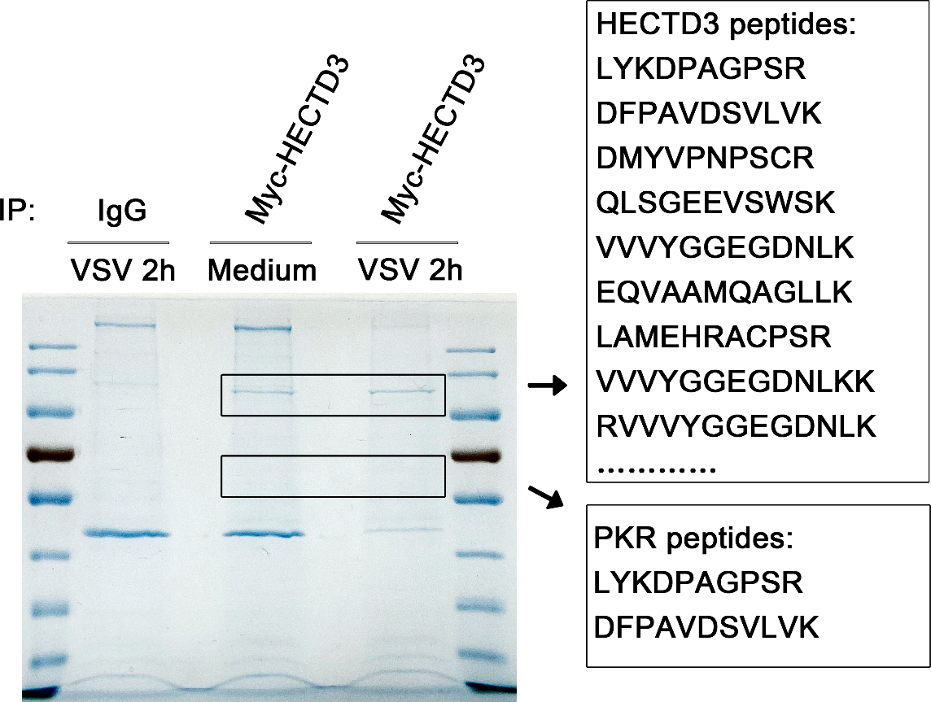
Supplementary Fig.5 MS assays of HECTD3-associated proteins. HEK293T cells were transfected with 5µg of a plasmid expressing Myc-HECTD3 for 48h then infected with VSV (MOI=1) as indicated. Whole cells lysates were immunoprecipitated (IP) with anti-Myc Sepharose Beads. The immune complexes were separated by SDS-PAGE and the gel was stained with Coomassie blue. Bands presented differently between lysates from infected and uninfected cells were subjected to MS assays. The identified unique peptides of HECTD3 and PKR are shown at the right side.

Supplementary Fig.6 HECTD3 potentiates NF-κB and IRF3 activation in macrophages upon RNA virus infection. a, b Hectd3^{+/+} or Hectd3–/– BMDM were infected with VSV (MOI=1) (a) or HSV-1 (MOI=5) (b) for 0h, 4h, 6h, 8h as indicated and the activation of signaling mediators of NF-κB and IRF3 were examined by Western blotting.
Supplementary Fig.7 HECTD3 restrains VSV induced apoptosis of macrophages. a Quantification of the percentage of ANNEXIN V⁺ Hectd3^{+/+} or Hectd3–/– BMDM (2x10⁵ cells per 24-well) infected with VSV(MOI=1) for 24h as indicated. Cells were washed by PBS, stained with ANNEXIN V-FITC for 15 min at RT，and subjected to cell apoptosis analysis by flow cytometry. Results are presented as mean ± SD of three biological replicates (one-way ANOVA followed by Bonferroni multiple comparison). One representative experiment of three is shown. ns, no significance; ****, P < 0.0001. b Hectd3^{+/+} or Hectd3–/– BMDM were infected with VSV (MOI=1) for 18h as indicated and the level of cleaved caspase3 and caspase8 were examined by Western blotting. One representative experiment of three is shown.

Supplementary Fig.8 Confirmation of the Lys residue in PKR responsible for linkage with K33O Ub chain. a-c the mutants (1-37) were constructed as indicated. HEK293T cells were transiently transfected with indicated vectors for 48h and infected with VSV (MOI = 1) for 2h. Then Polyubiquitination of PKR (mutant) in immunoprecipitations (IPs) was evaluated by immunoblot (IB) (a, mut1-12; b, mut13-24; c, mut 25-37). One representative experiment of three was shown.

Supplementary Fig.9 Knockdown of HECTD3 in Pkr^{+/+} and Pkr^{-/-} RAW264.7 cells and ISRIB inhibit the phosphorylation of EIF2α in BMDM. a Pkr^{+/+} or Pkr–/– Raw264.7 cells were transfected with control (Ctrl) or Hectd3 siRNA (#2) as indicated. The efficiency of knockout and knockdown was evaluated by Western blotting. b Hectd3^{+/+} or Hectd3–/– BMDMs were pretreated with DMSO or ISRIB (3.5nM) for 1h and infected with VSV (MOI=1) for 4h as indicated. The activation of the signaling mediators were examined by Western blotting.

Supplementary Fig.10 PKR is required for HECTD3-mediated proinflammatory cytokine expression. a-d Pkr^{+/+} or Pkr–/– Raw264.7 cells were transfected with a plasmid expressing Myc-HECTD3 and infected with VSV (MOI=1) (a, b) for 8h or transfected with poly(I:C) (c, d) for 6h as indicated. Amounts of IL-6 (a, c) and IFNβ (b, d) in supernatants were measured by ELISA. Results are presented as mean ± SD of triplicate samples (b and c; one-way ANOVA followed by Bonferroni multiple comparison). n.s., no significance; ****, P < 0.0001.

Supplementary Table 1. Sequences used in this study.
Primers for genotyping of Hectd3 knockout mice
Primer name | Primer sequence (5’→3’) | Result judgment
P1 | GACATATGAGTGCGACGAGGACCTG | P1+P2 (~550 bp, for 5’ arm)  Positive: Flox+  Negative: WT
P2 | GACGTGCTACTTCCATTTGTCACG
P3 | CTATCGCCTTCTTGACGAGTTCTTC | P3+P4 (~700 bp, for 3’ arm)  Positive: Flox+  Negative: WT
P4 | GGTATCTGCGTTGCTATCTGTCAG
P5 | GCGCTGGAGTTTCAATACCG | P5+P6 (~325 bp)  Positive: EIIA-Cre+  Negative: EIIA-Cre ⁻
P6 | TTTGACAGGAAACGCAACGG
P7 | CTTCATGGTAAGCCGTACCCAGTG | P7+P8 (~550 bp)  Positive: Hectd3^{−/−} or Hectd3^{+/−}  Negative: Hectd3^{+/+}
P8 | CACCTGAGTGACTGTAGTCTGGACG
P9 | GGAACCACTTAGGAAGCATCTAG | P8+P9 (~425 bp)  Positive: Hectd3^{+/+} or Hectd3^{+/−}  Negative: Hectd3^{−/−}
Hectd3-specific targeted sequences for CRISPR-Cas9 edition
Sequence No. | Sequence | KO efficiency
1 | GACAGTATCGAGCTCCGGCG | No
2 | GCAAGCCCAGCTTCATGCCG | No
3 | GGGTAGTGTGAAGCAGTATG | Yes
4 | CAGCCAGCAGAGGCATATAC | No
5 | GCTTCATGCCGAGGCTGTAC | Yes
Pkr-specific targeted sequences for CRISPR-Cas9 edition
Sequence No. | Sequence | KO efficiency
1 | TATAAAGAACTTAGTACTT | Yes
2 | CAAAGAAATAAATATACCT | Yes
3 | AGGATCGGCAAGCTTTAG | Yes
4 | AACATCCTCTAGCGTTGTC | No
Hectd3-homo-specific siRNA sequences
Sequence name | Sequence (5’→3’) | Knockdown efficiency
siRNA1 | GGACCUGACAUACUCACAUTT | High
 | AUGUGAGUAUGUCAGGUCCTT
siRNA2 | GGCACCUUCAGUGAGAUUATT | Highest and selected
 | UAAUCUCACUGAAGGUGCCTT
siRNA3 | CCGAGACUUUGCCAAGUAUTT | High
 | AUACUUGGCAAAGUCUCGGTT
Hectd3-mus-specific siRNA sequences
Sequence name | Sequence (5’→3’) |  | Knockdown efficiency
siRNA1 | ACACCUGAGUGACUGUAGUTT |  | High
 | ACUACAGUCACUCAGGUGUTT |  | High
siRNA2 | CCUAUACGGAGGAGUUCAATT |  | High and selected
 | UUGAACUCCUCCGUAUAGGTT |  | High and selected
siRNA3 | GCACCUUUAGUGAGAUUAATT |  | High
 | UUAAUCUCACUAAAGGUGCTT |  | High
Primers for Q-PCR assays
Gene name | Primer sequence (5’→3’)
Gene name | Sense | Anti-sense
Mouse Il6 | GAGTTGTGCAATGGCAATTCTG | GCAAGTGCATCATCGTTGTTCAT
Mouse Ifnb | CAGCTCCAAGAAAGGACGAAC | GGCAGTGTAACTCTTCTGCAT
Mouse Actb | AGTGTGACGTTGACATCCGT | GCAGCTCAGTAACAGTCCGC
Human Il6 | ACTCACCTCTTCAGAACGAATTG | CCATCTTTGGAAGGTTCAGGTTG
Human Ifnb | GTCACTGTGCCTGGACCATAG | GTTTCGGAGGTAACCTGTAAGTC
Human Actb | CATGTACGTTGCTATCCAGGC | CTCCTTAATGTCACGCACGAT
VSV NC | ACGGCGTACTTCCAGATGG | CTCGGTTCAAGATCCAGGT
HSV-1 ICP0 | GATGCAATTGCGCAACAC | GCGTCACGCCCACTATCAG

Supplementary Table 2. Antibodies used in this study.
Company | Product name | Clone No. | Catalog No.
Cell Signaling Technology (Beverly, MA) | Anti- phospho-p65(Ser536) | 93H1 | 3033
 | Anti- IKKβ | D30C6 | 8943
 | Anti-Flag tag | 9A3 | 8146
 | Anti-HA tag | C29F4 | 3724
 | Anti-IRF3 | D83B9 | 4302
 | Anti-Myc tag | 71D10 | 2278
 | Anti-p65 | L8F6 | 6956
 | Anti-phospho-IRF3 (Ser396) | 4D4G | 4947
 | Anti-phospho-TBK1 (Ser172) | D52C2 | 5483
 | Anti-TBK1 | D1B4 | 3504
 | Anti-cleaved caspase8(Asp387) | NA | 9429
 | Anti-cleaved caspase3 | 5A1E | 9664
 | Anti-Ubiquitin | P4D1 | 14049
 | Anti-K48 specific polyubiquitin | D9D5 | 8081
 | Anti-K63 specific polyubiquitin | D7A11 | 5621
 | Anti-TRAF3 | E8H3B | 36640
 | Anti-phospho-eIF2alpha (S51) | D9G6 | 3398
 | Anti-eIF2alpha | D7D3 | 5324
 | Normal rabbit IgG | NA | 2729
Medical&biological laboratories co.,LTD | Anti-IKKγ | NA | K0159
Abcam Inc. (Cambridge, MA) | Anti-HECTD3 | NA | Ab241413
 | Anti-Flag-tag | M2 | ab49763
 | Anti-HA-tag | HA.C5 | ab18181
 | Anti-Myc-tag | Myc.A7 | ab18185
 | Anti-PKR | NA | ab184257
 | Anti-phospho-PKR(T446) | NA | Ab32036
Servicebio (Wuhan, CHN) | Anti-CD45 | NA | GB11066
 | Cy3 conjugated Goat Anti-Rabbit IgG (H+L) | NA | GB21303
Novus | K33 linkage-polyubiquitin antibody | NA | NBP3-05656
BD Biosciences | BD Pharmingen™ FITC Rat Anti-Mouse CD45 | 30-F11 | 553079
 | BD Pharmingen™ APC Mouse Anti-Mouse NK-1.1 | PK136 | 550627
 | BD Pharmingen™ FITC Rat Anti-Mouse CD4 | GK1.5 | 553729
 | BD Pharmingen™ PE Rat Anti-Mouse CD8a | 53-6.7 | 553033
 | BD Pharmingen™ APC Rat Anti-Mouse CD3 Molecular Complex | 17A2 | 565643
 | BD Pharmingen™ PE Rat Anti-Mouse CD19 | 1D3 | 553786
 | BD Pharmingen™ PE Hamster Anti-Mouse CD11c | HL3 | 553802
 | BD Pharmingen™ FITC Mouse Anti-Mouse I-A[b] | AF6-120.1 | 553551
 | BD Pharmingen™ FITC Rat Anti-CD11b | M1/70 | 553301
 | BD Pharmingen™ APC Rat Anti-Mouse Ly-6G | 1A8 | 560599
 | BD Pharmingen™ PE Rat Anti-Mouse F4/80 | T45-2342 | 565410
NA, not available.

