Table S1. primer sequences utilized in this study.
qRT-PCR | Forward 5’-3’ | Reverse 5’-3’
β-actin | TGGCACCCAGCACAATGAA | CTAAGTCATAGTCCGCCTAGAAGCA
HBO1 | TCCATCTCAGGATGCCCACTGT | GTCATCTTGCCTGTGAGACAGC
CTNNB1 | CACAAGCAGAGTGCTGAAGGTG | GATTCCTGAGAGTCCAAAGACAG
CHIP-qPCR
CTNNB1 | AAATTCAAGCTGAACAGCCTGC | GCCGACCTTGTGGTCTGT

Table S2. Clinical information of the B-ALL samples used.
No. | Sex | Age | Time point | Blasts (%) | Gene mutation | HBO1 level (2^-ΔΔCT) | DFS(days)
1 | Male | 27 | relapse | 83.5% | ETV-RUNX1 | 5.27 | 27
2 | Female | 24 | relapse | 33.0% | MLL-AF4 | 5.01 | 72
3 | Male | 20 | diagnosis | 94.5% | TEL-RUNEX1 | 4.22 | 87
4 | Female | 61 | relapse | 32.0% | BCR-ABL-P190,T315I | 4.08 | 99
5 | Male | 22 | diadnosis | 96.0% | TEL-ANL1,WT1 | 4.03 | 106
6 | Female | 32 | relapse | 67.0% | WT1/ABL | 3.88 | 118
7 | Male | 30 | relapse | 18.5% | BCR-ABL-P190 | 3.60 | 123
8 | Male | 54 | diagnosis | 83.7% | BCR-ABL | 3.50 | 144
9 | Male | 31 | relapse | 90.0% | BCR-ABL-P190 | 3.01 | 161
10 | Male | 20 | relapse | 7.2% | PTPN11,F594C,FAT3 | 1.34 | 192
11 | Male | 40 | relapse | 10.5% | IKZF1,MLL-AF4,WT1 | 1.25 | 202
12 | Male | 29 | relapse | 86.0% | TP53,PHF6 | 1.24 | 254
13 | Male | 20 | diagosis | 52.5% | EBF1-PDGFRB,FAT1 | 1.17 | 269
14 | Male | 44 | relapse | 78.5% | NOTCH | 1.16 | 329
15 | Male | 19 | relapse | 9.0% | MLL-PTD/ABL | 1.14 | 360
16 | Male | 23 | relapse | 94.5% | MYC, BCR/ABL1 | 1.14 | 691
17 | Female | 69 | relapse | 65.0% | WT1/ABL | 1.11 | 800
18 | Male | 22 | remission | 1.5% | FAT3,KMT2D | 2.93 | 99
19 | Female | 55 | remission | 1.0% | BCR/ABL | 2.91 | 66
20 | Male | 24 | relapse | 90.7% | CRLF2,IKZF1 | 2.78 | 172
21 | Female | 31 | remission | 1.0% | IKZF1,HOX11 | 2.65 | 157
22 | Female | 41 | relapse | 93.5% | BCR-ABL-P190 | 2.26 | 307
23 | Female | 58 | diagnosis | 65.0% | BCR-ABL-P190,IKZF1 | 2.14 | 293
24 | Female | 46 | remission | 2.0% | BCR-ABL-P190,EVI1 | 2.12 | 46
25 | Male | 55 | diagnosis | 57.2% | P210,TP53,IKZF1 | 1.74 | 15
26 | Male | 21 | diagnosis | 42.0% | IKZF1 | 1.67 | 462
27 | Male | 18 | diagnosis | 30.0% | TP53,CDKN2A,FAT1 | 1.56 | 131
28 | Male | 22 | remission | 2.0% | WT1,NRAS | 1.55 | 245
29 | Male | 70 | diagnosis | 82.0% | WT1,TP53,NF1 | 1.53 | 10
30 | Female | 27 | diagnosis | 89.8% | E2A-PBX1 | 1.44 | 650
31 | Male | 18 | diagnosis | 49.3% | NF1,PIK3CA | 1.40 | 172
32 | Male | 38 | diagnosis | 71.5% | BCR-ABL-P190 | 1.39 | 316
33 | Male | 19 | diagnosis | 61.0% | BCR-ABL-P190,IKZF1 | 1.10 | 203
34 | Male | 24 | remission | 0.5% | IKZF1,NUP214 | 1.09 | 669
35 | Male | 58 | relapse | 85.5% | KRAS, TP53 | 1.09 | 207
36 | Male | 34 | diagnosis | 93.5% | BCR-ABL-P190,IKZF1 | 1.01 | 314
37 | Male | 64 | diagnosis | 30.0% | TP53,FAT1 | 1.00 | 200
38 | Male | 27 | remission | 3.0% | BCR-ABL-P190,CREBBP | 0.99 | 508
39 | Female | 26 | diagnosis | 96.0% | WT1 | 0.98 | 347
40 | Female | 20 | diagnosis | 75.9% | TCF3-PBX1 | 0.95 | 134
41 | Male | 21 | diagnosis | 80.7% | FLT3,ZBTB7A,DPF2 | 0.86 | 825
42 | Female | 20 | diagnosis | 91.5% | BCR-ABL-P190 | 0.85 | 249
43 | Male | 35 | remission | 1.0% | SIL-TAL1,HOX11 | 0.83 | 748
44 | Female | 72 | diagnosis | 94.7% | CRLF2 | 0.82 | 117
45 | Male | 21 | relapse | 70.0% | IKZF1 | 0.82 | 221
46 | Male | 18 | diagnosis | 87.0% | IKZF3 | 0.82 | 146
47 | Male | 19 | diagnosis | 99.5% | KRAS,NF1,WT1 | 0.64 | 166
Abbreviation: DFS, Disease-free survival.

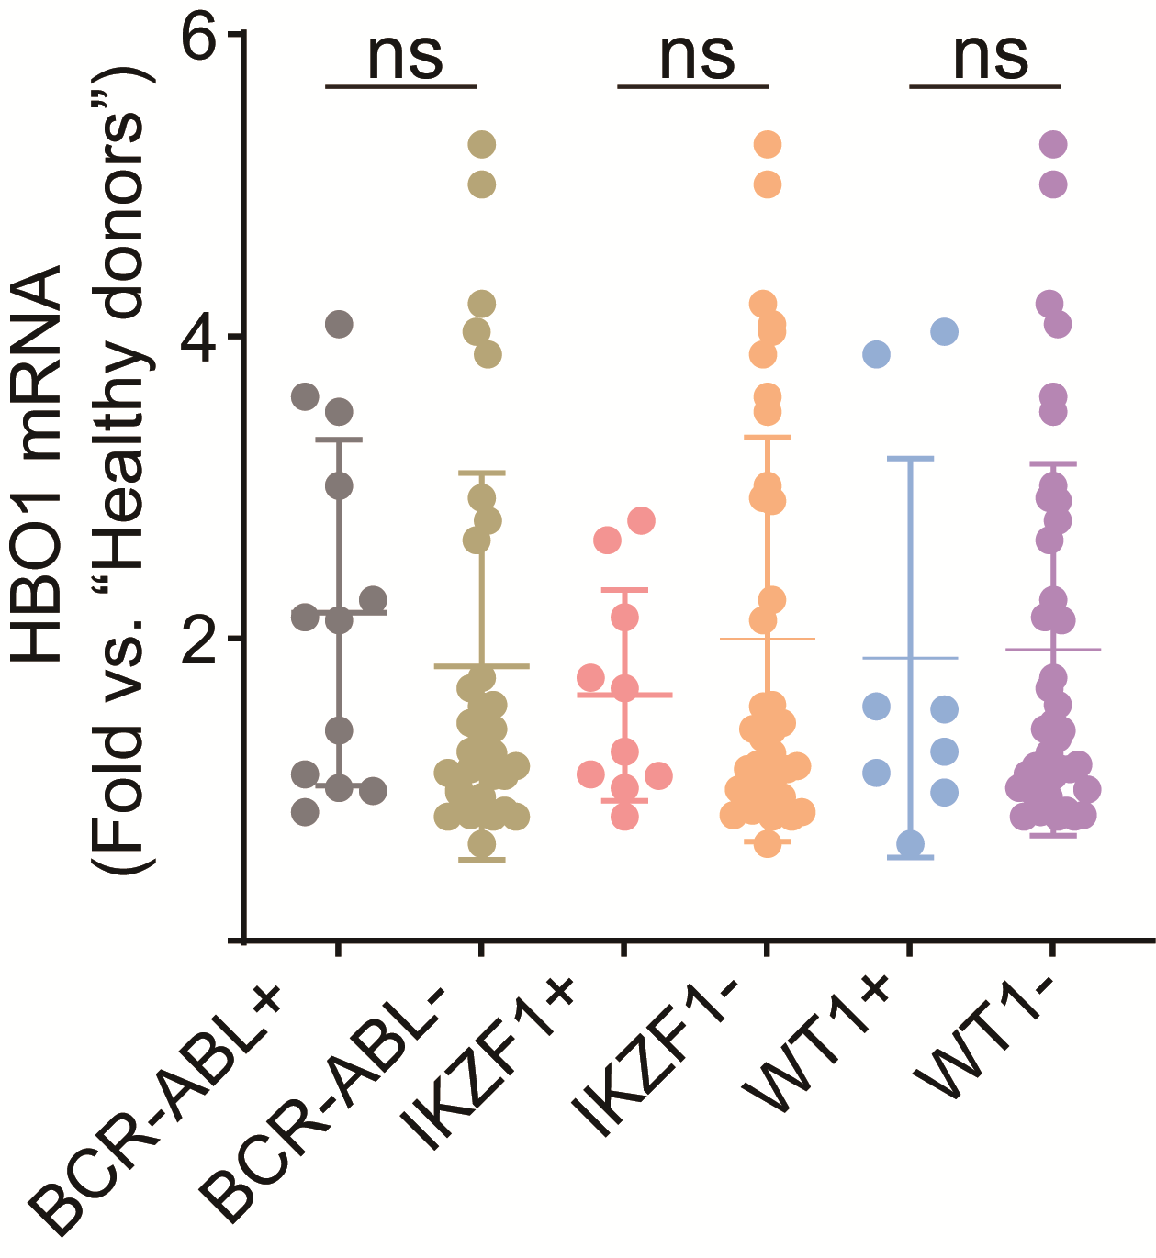
Figure S1. HBO1 mRNA expression in B-ALL patients with different gene mutations.
The expression of HBO1 mRNA in B-ALL patients with or without the listed gene mutation in our clinical sample data. Significance was tested by 2-tailed unpaired student’s t-tests. ns, no significance.

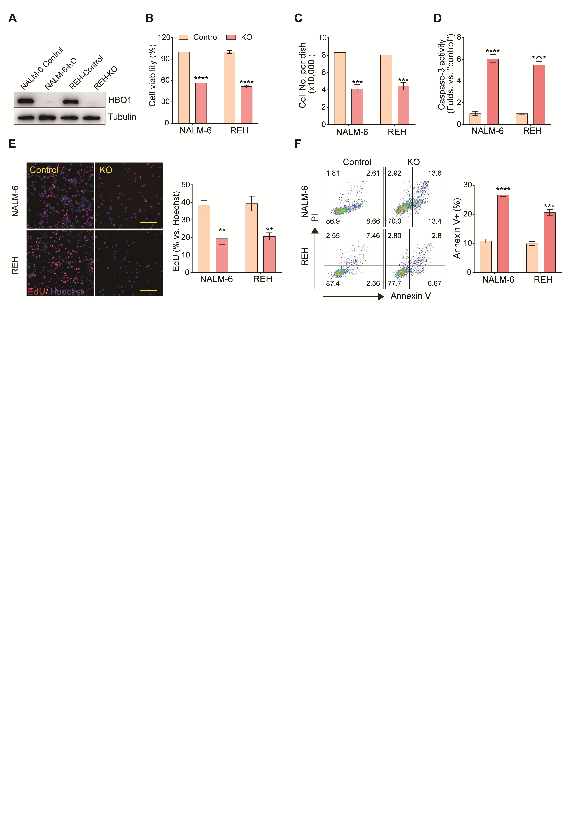

Figure S2. HBO1 knockout by CRISPR/Cas9 induces significant anti-B-ALL cell activity.
(A). Western blot assays were used to detect the expression of HBO1 protein in NALM-6 and REH cells with or without HBO1 knockout. (B-C). NALM-6 and REH cells with or without HBO1 knockout were cultured for 96 h and then cell viability (B) and number (C) was measured. (D). Statistical plots of caspase-3 activity in NALM-6 and REH cells cultured for 48 h with or without HBO1 knockout. (E). Nuclear EdU incorporation (left) and statistics (right) of NALM-6 and REH cells treated as (D). (F). FACS analysis (left) and statistics (right) of the apoptosis of NALM-6 and REH cells treated as (D). Scale bar = 100 μm (E). Error bars indicate mean ± standard deviation (SD). Significance was tested by 2-tailed unpaired student’s t-tests (B-F), ** P < 0.01, *** P < 0.001, **** P < 0.0001. n=3 per group (B-F).

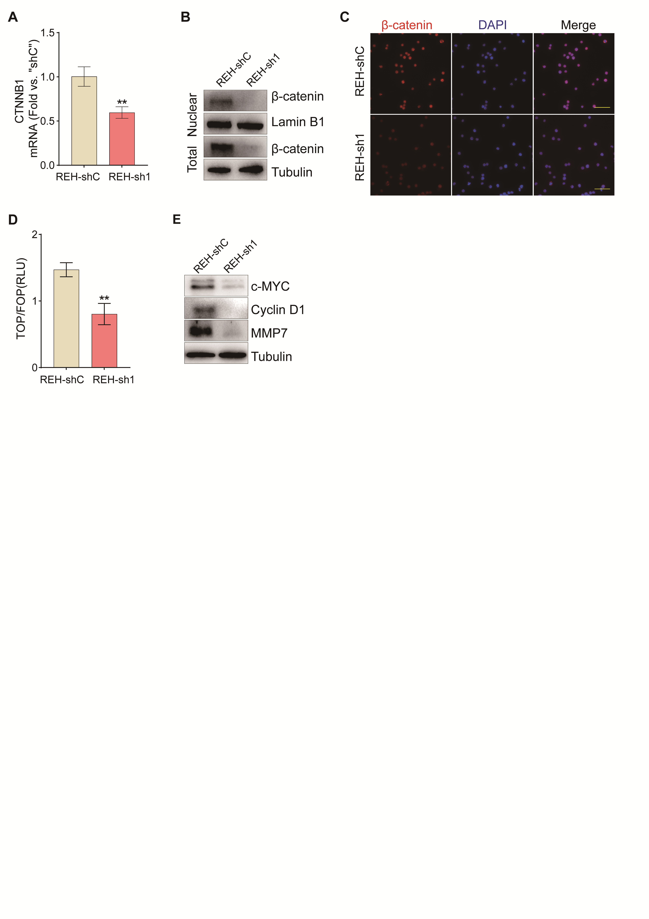

Figure S3. Knockdown HBO1 inhibits the Wnt signaling pathway.
(A-B). The expression of CTNNB1 mRNA (A) and β-catenin protein (B) in REH cells with or without HBO1 knockdown. (C). Immunofluorescence experiments were used to detect the expression of β-catenin protein in REH cells treated as (A). (D). The activity of Wnt signaling in REH cells treated as (A). (E). Listed proteins were detected in REH cells treated as (A) through western blot assays. Scale bar=100 μm (C). Error bars indicate mean ± standard deviation (SD). Significance was tested by 2-tailed unpaired student’s t-tests (A, D). ** P < 0.01. n=3 per group (A, D).

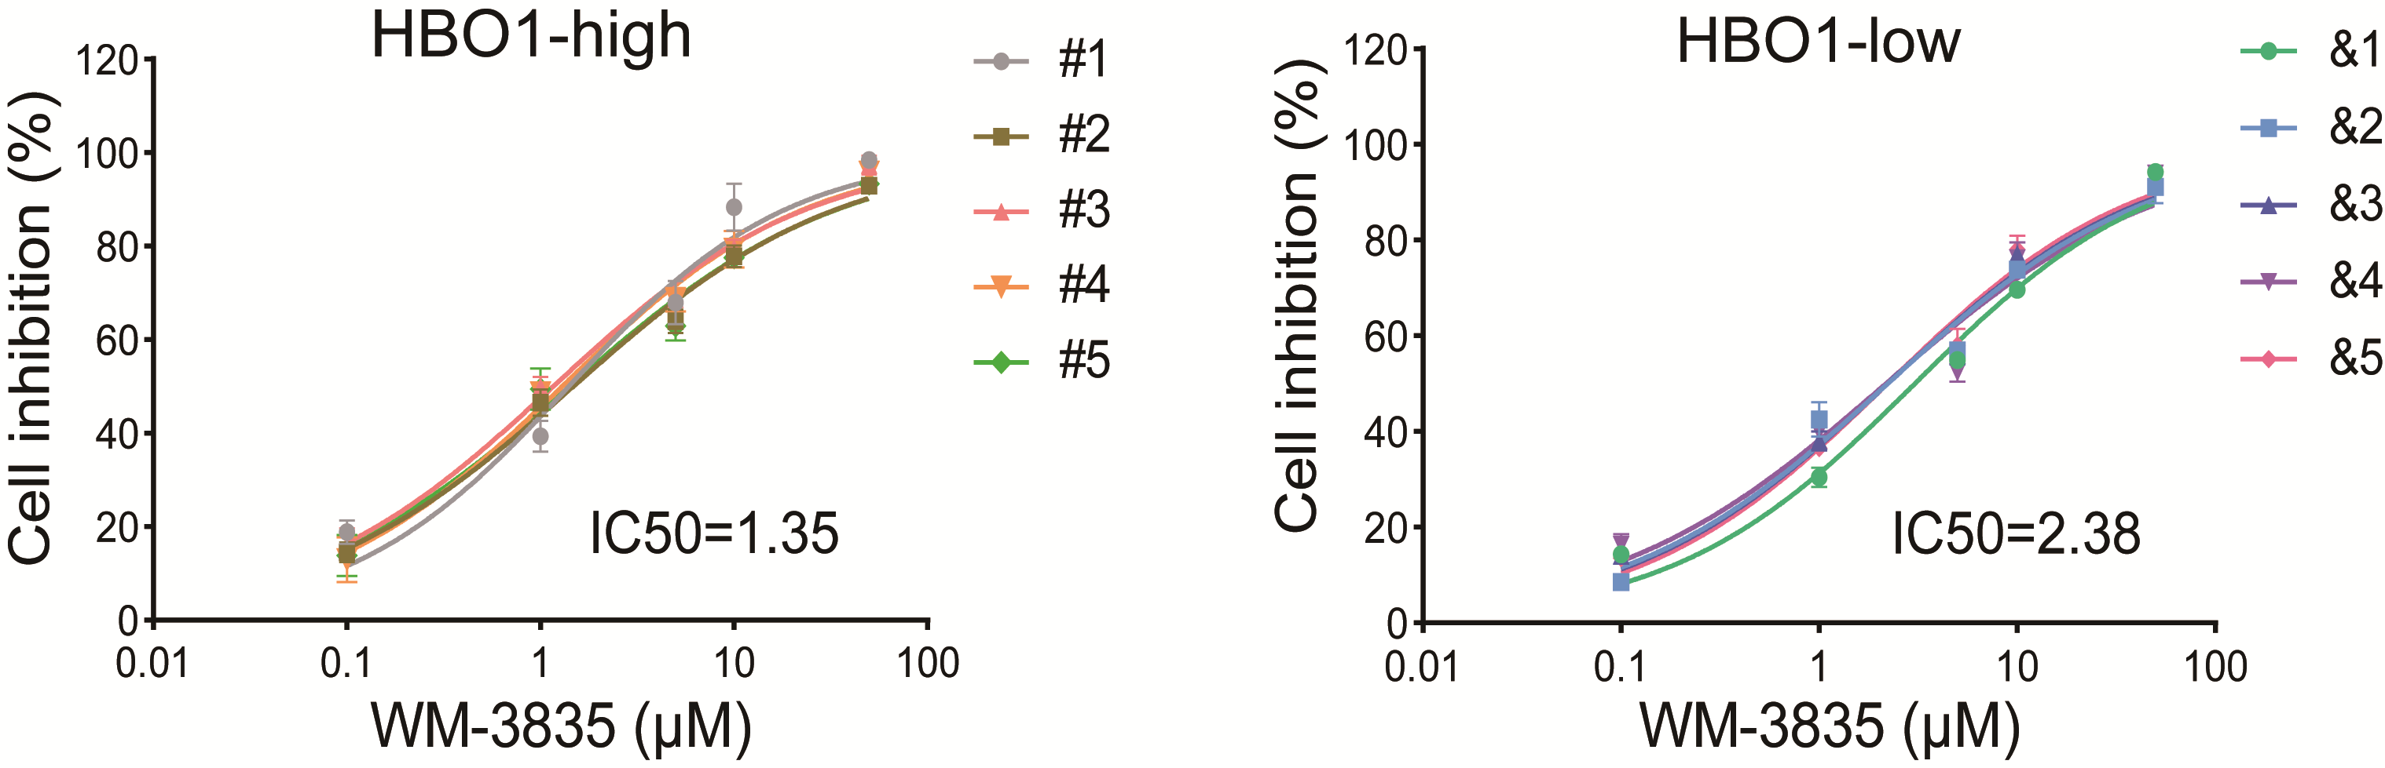
Figure S4. B-ALL primary cells with high HBO1 expression are more sensitive to WM-3835.
Dose-effect curves of the inhibitory action of WM-3835 on B-ALL primary cells from B-ALL patients with HBO1 high (left) or low (right) expression in vitro for 96 h.

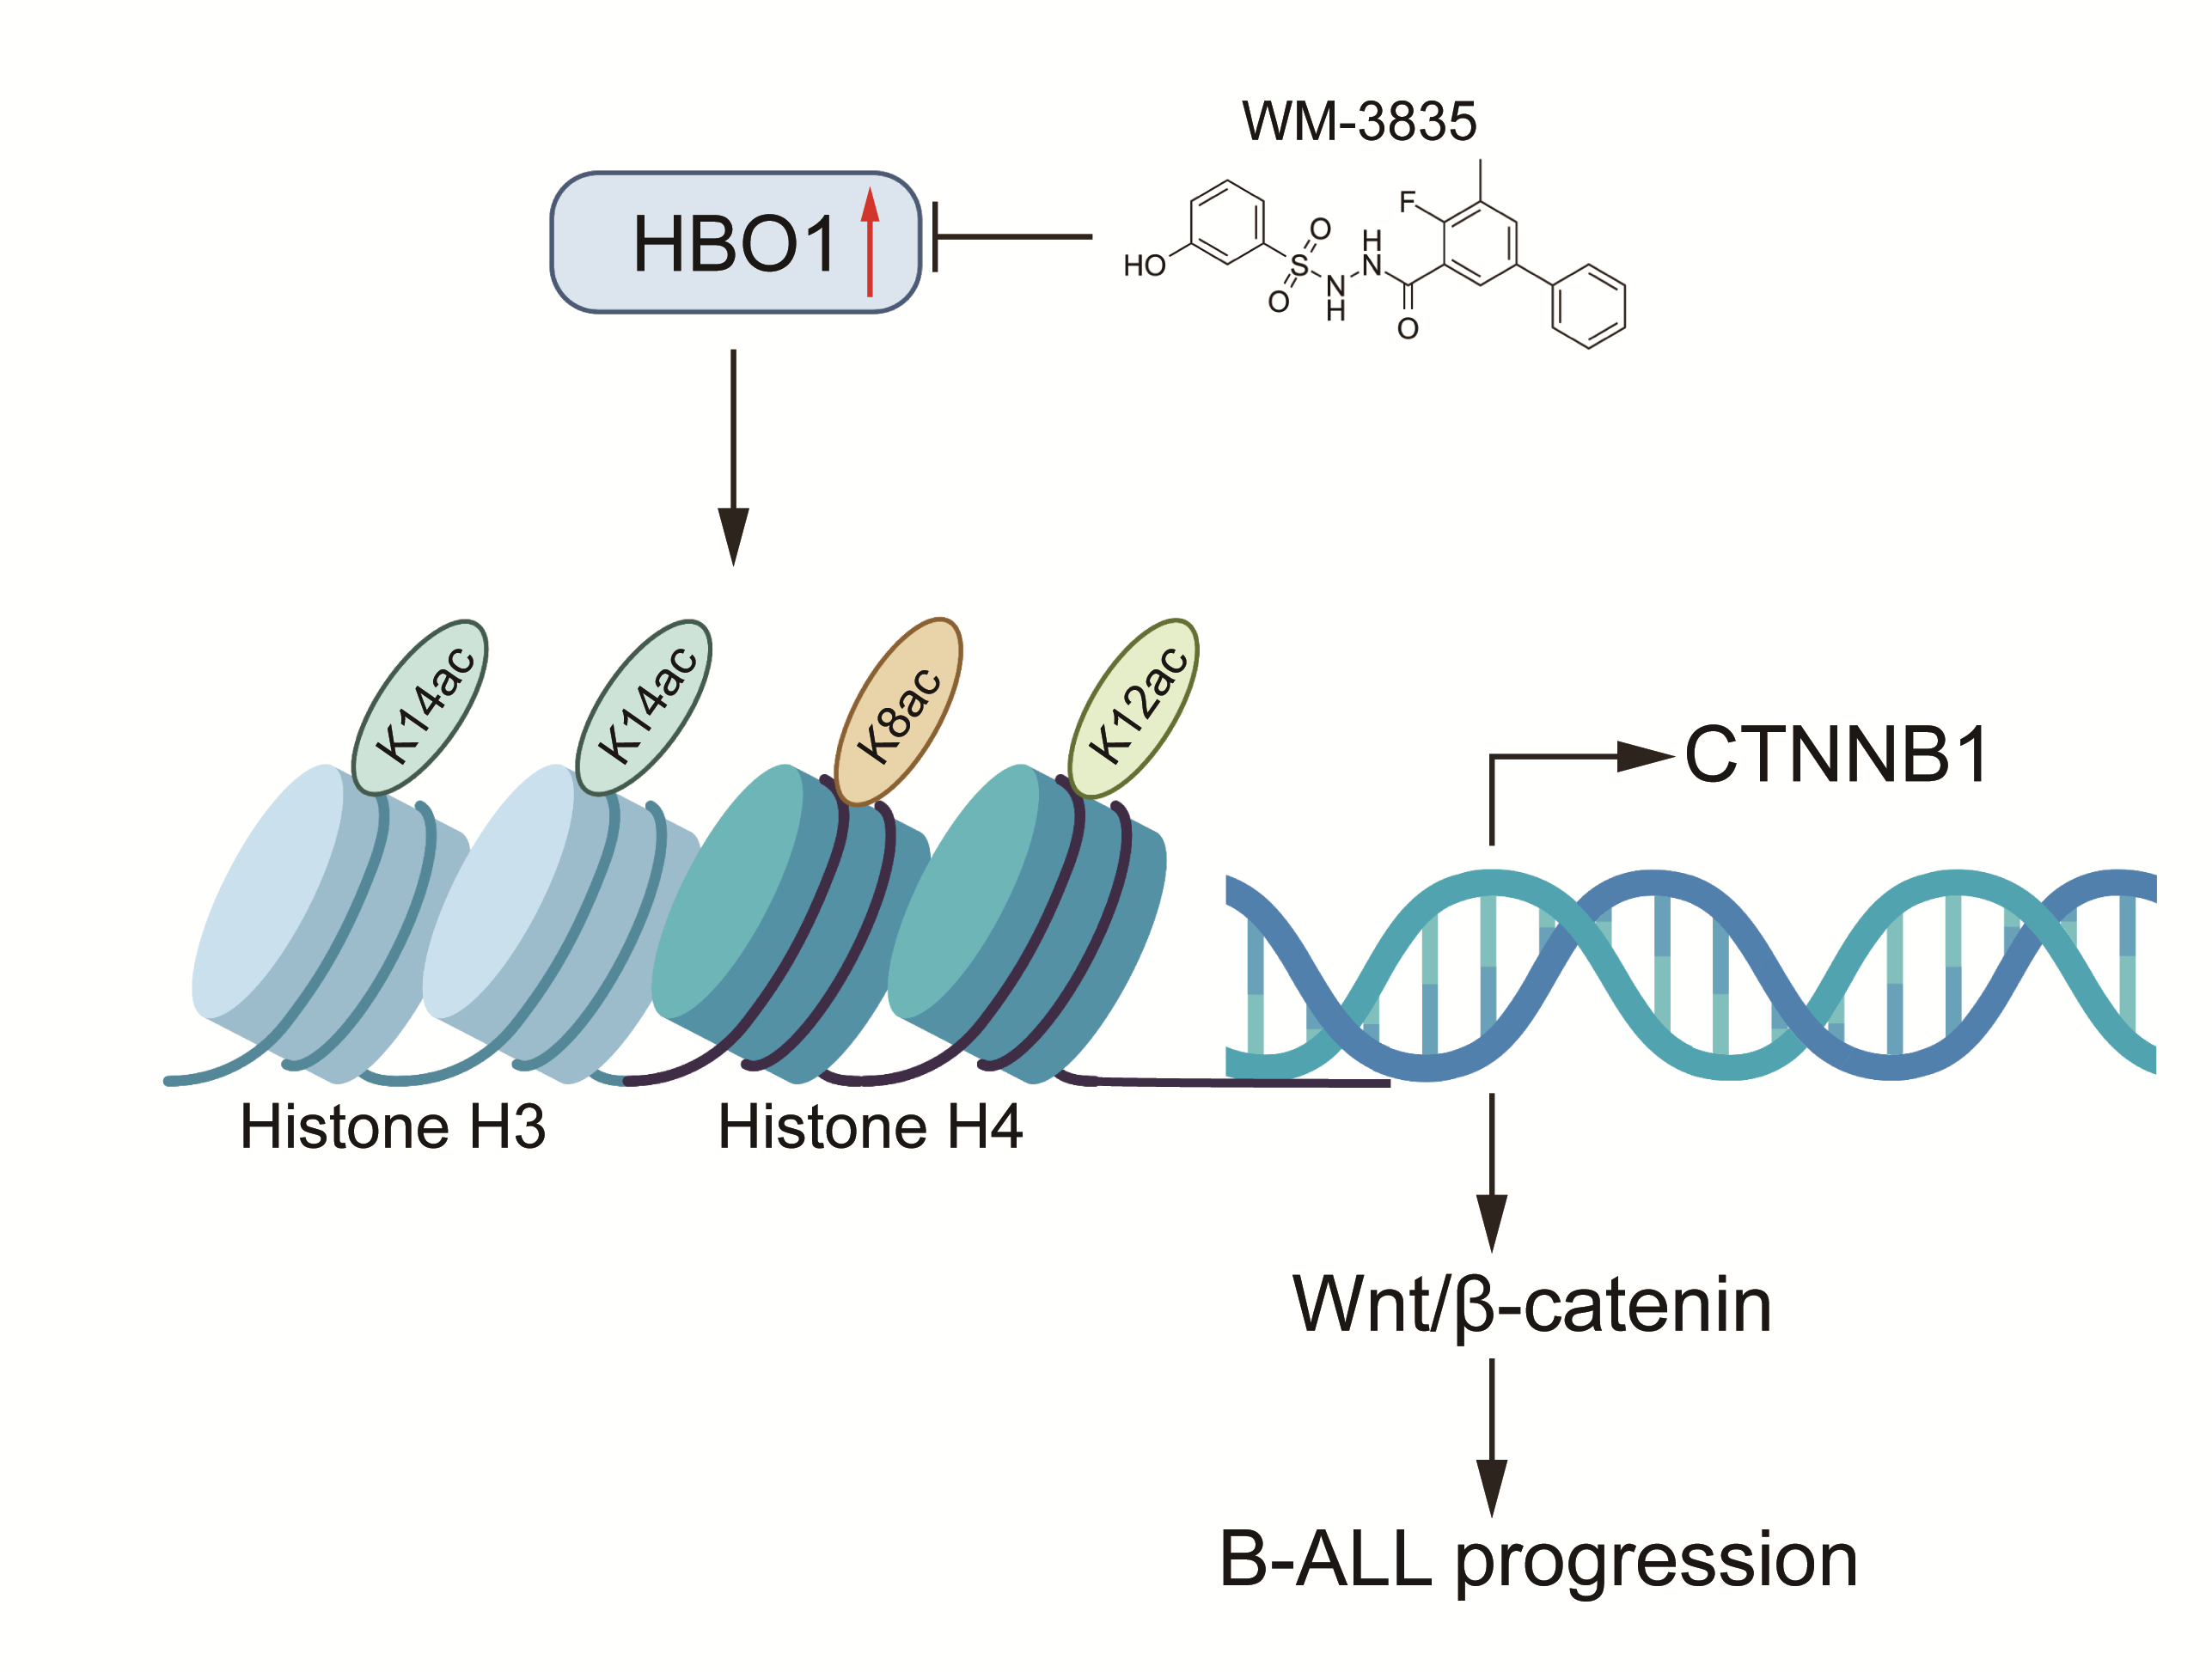
Figure S5. A working model for HBO1-regulated B-ALL progression.
HBO1 was upregulated in B-ALL cells and then boosted the acetylation of H3K14, H4K8, and H4K12, thereby facilitating the transcription of CTNNB1, ultimately leading to activation of the Wnt/β-catenin signaling pathway as well as the progression of B-ALL. However, HBO1-targeted inhibitor WM-3835 could inhibit this effect.

