Supplementary Figures
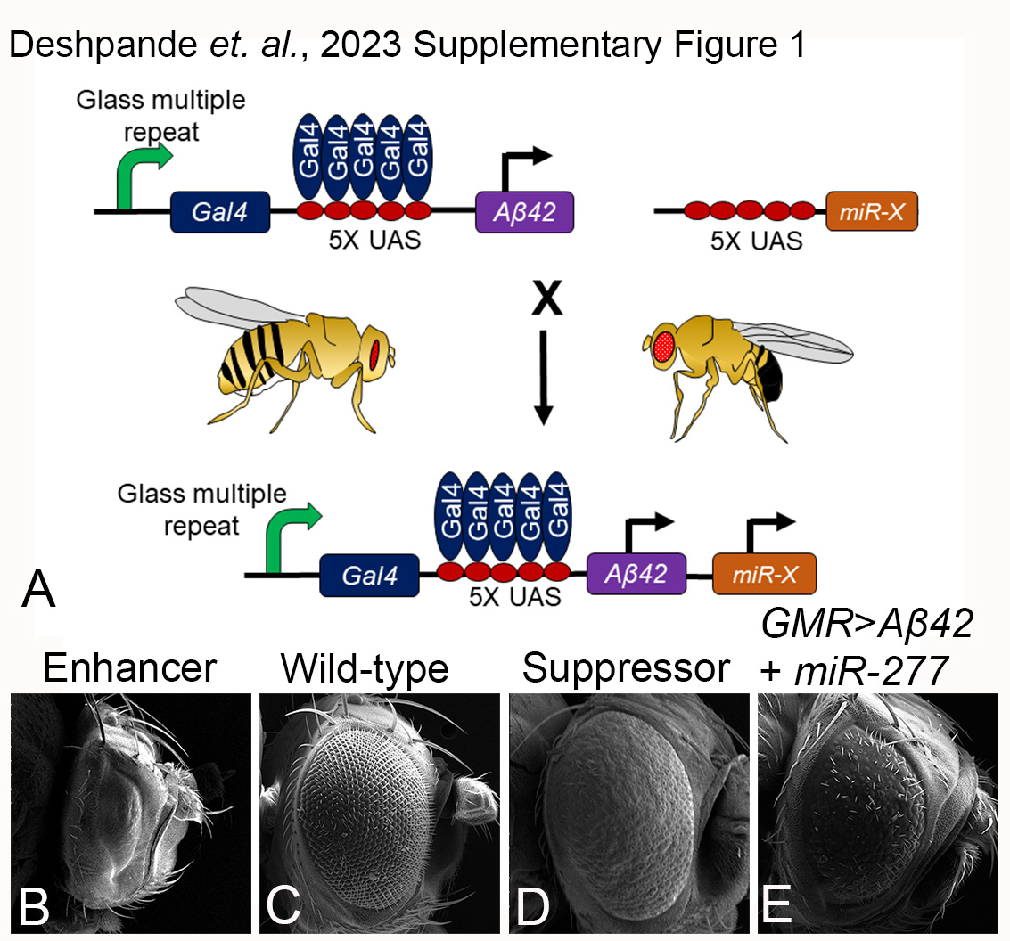
Supplementary Figure 1: Strategy for forward genetic screening to identify candidate miRNAs as genetic modifiers of Aβ42- mediated neurodegeneration. Flies expressing human Aβ42 in the developing eye under the control of the GMR-Gal4 driver exhibit small, rough eye phenotype. They were crossed individually to flies with different candidate miRNAs expressed under UAS control (normal eyes). Eye phenotypes were then observed in the progeny and screened for either an enhancer or suppressor of the Aβ42 eye phenotype. In forward genetic screening we identified miR-277 as the suppressors of Aβ42 eye phenotype (rescue eye phenotype).
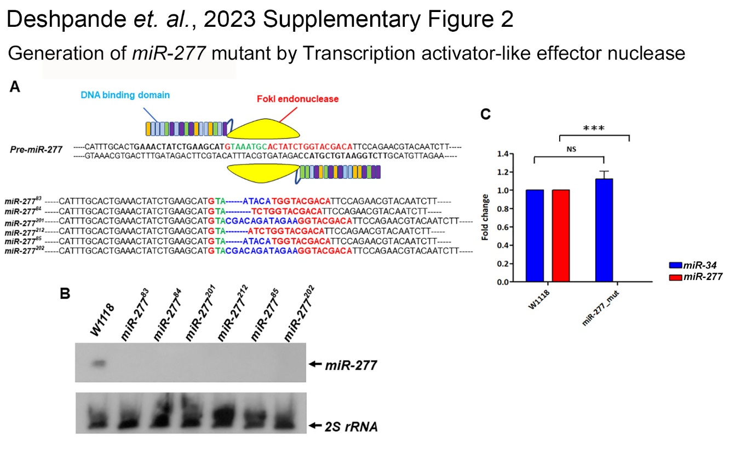 Supplementary Figure 2: Generation of miR-277 mutant line by TALEN. (A) Schematic of miR-277_TALEN pair binding to pre-miR-277 DNA. The bold was indicated miR-277_TALEN binding site (Black), mature miR-277 (Red) and seed region (green) (top). The small indels of miR-277 mutant lines were showed in the blue bold (bottom). (B) The expression of mature miR-277 RNA was validated in the wild type W1118 and six miR-277 mutant lines by northern blotting. (C) Quantitative polymerase chain reaction analysis of miR-277 and miR-34 expression in wild type W1118 and miR-277 mutant line. Data are presented as the mean ± standard deviation, n=3. *** p-value <0.001 vs. the W1118. U6 was used for internal control.
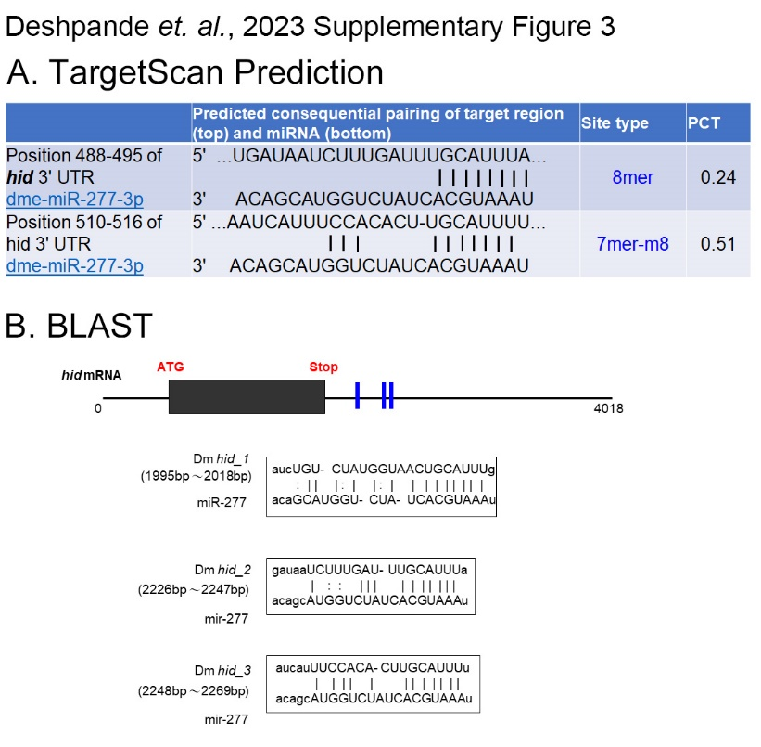 Supplementary Figure 3: miR-277 regulates hid 3’UTR. (A) TargetScanFly (http://www.targetscan.org/fly_72/) predicted hid as one of the targets of miR-277 based on the seed sequence. (B) Schematic representation of the mRNA sequence of hid from Drosophila melanogaster. According to the web BLAST of NCBI (https://blast.ncbi.nlm.nih.gov/Blast.cgi) analysis between the 3’UTR of hid mRNA and miR-277, three candidate target sites can be recognized by the seed region of miR-277. Alignment of miR-277 miRNA with the predicted target sites from the hid 3’UTR are shown below.
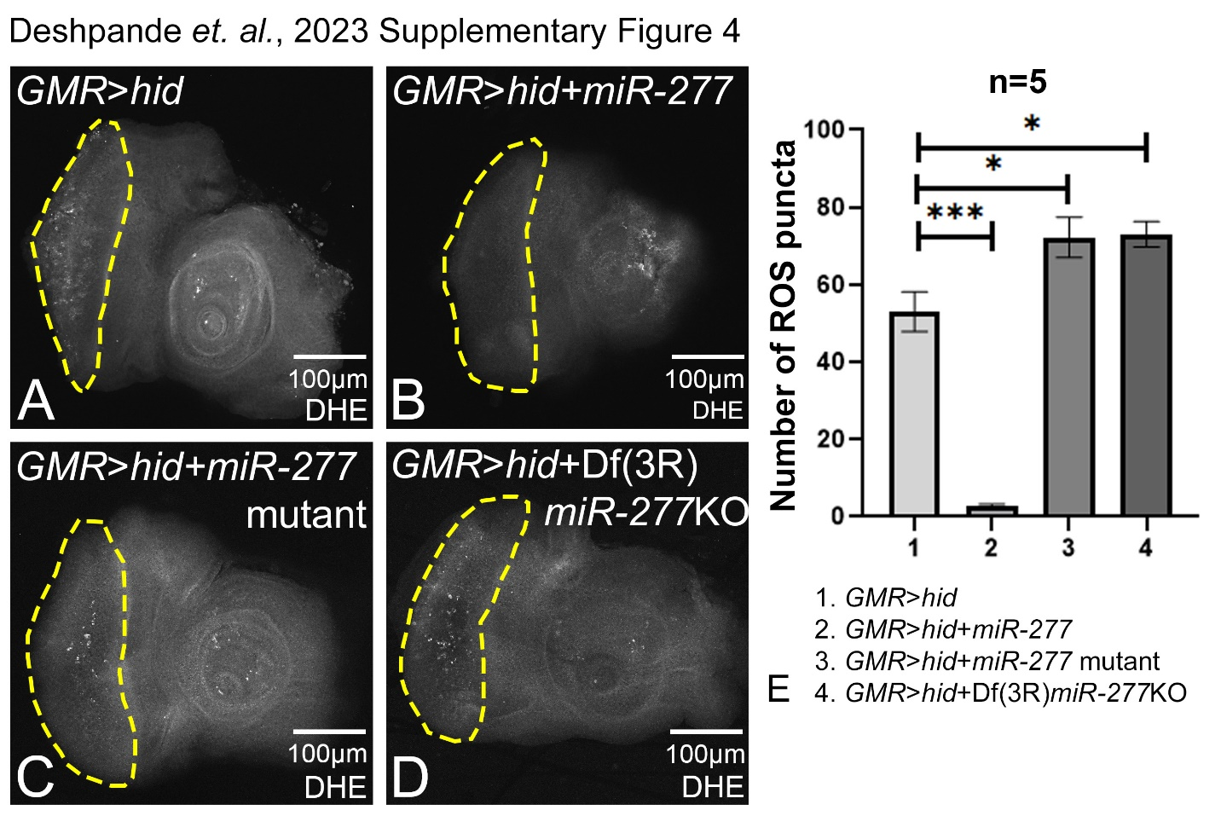 Supplementary Figure 4: Modulation of miR-277 in GMR>hid downregulates ROS production. Dihydroethidium (DHE) is employed to detect ROS produced in cells. (A) GMR>Aβ42 shows elevated levels of ROS puncta (B) Gain-of-function of miR-277 in the background of GMR>hid (GMR>hid+ miR-277) results in significant reduction in the ROS production as compared to GMR>hid. Loss-of-function of miR-277 in GMR>hid background using (C) miR-277 mutant (GMR>hid+ miR-277 mutant), and (D) Df(3R)miR-277KO (GMR>hid+ Df(3R)miR-277KO) results in the increased ROS production. (A-E) ROS puncta were counted within yellow dotted line, the region of interest, for the statistical analysis. We quantified ROS puncta in photoreceptor cells of five eye imaginal discs per genotype (n=5) (1. GMR>hid, 2. GMR>hid+ miR-277, 3. GMR>hid+ miR-277 mutant, 4. GMR>hid + Df(3R)miR-277KO). Statistical analysis was performed using student’s t-test for independent samples. GMR>hid+miR-277 exhibits significant reduction in ROS puncta as compared to GMR>hid (n=5; p=0.00052) whereas GMR> hid + miR-277 mutant (n=5; p=0.03) and GMR>hid+ Df(3R)miR-277KO (n=5; p=0.02) show significant increase in ROS puncta as compared to GMR>hid. Error bars show standard error of mean (mean ± SEM), and symbols above the error bar signify as *** p-value <0.001, ** p-value <0.01, * p-value <0.05, and not significant (ns), p-value >0.05 respectively. The orientation of all imaginal discs is identical with posterior to the left and dorsal up. Scale bar= 100 μm
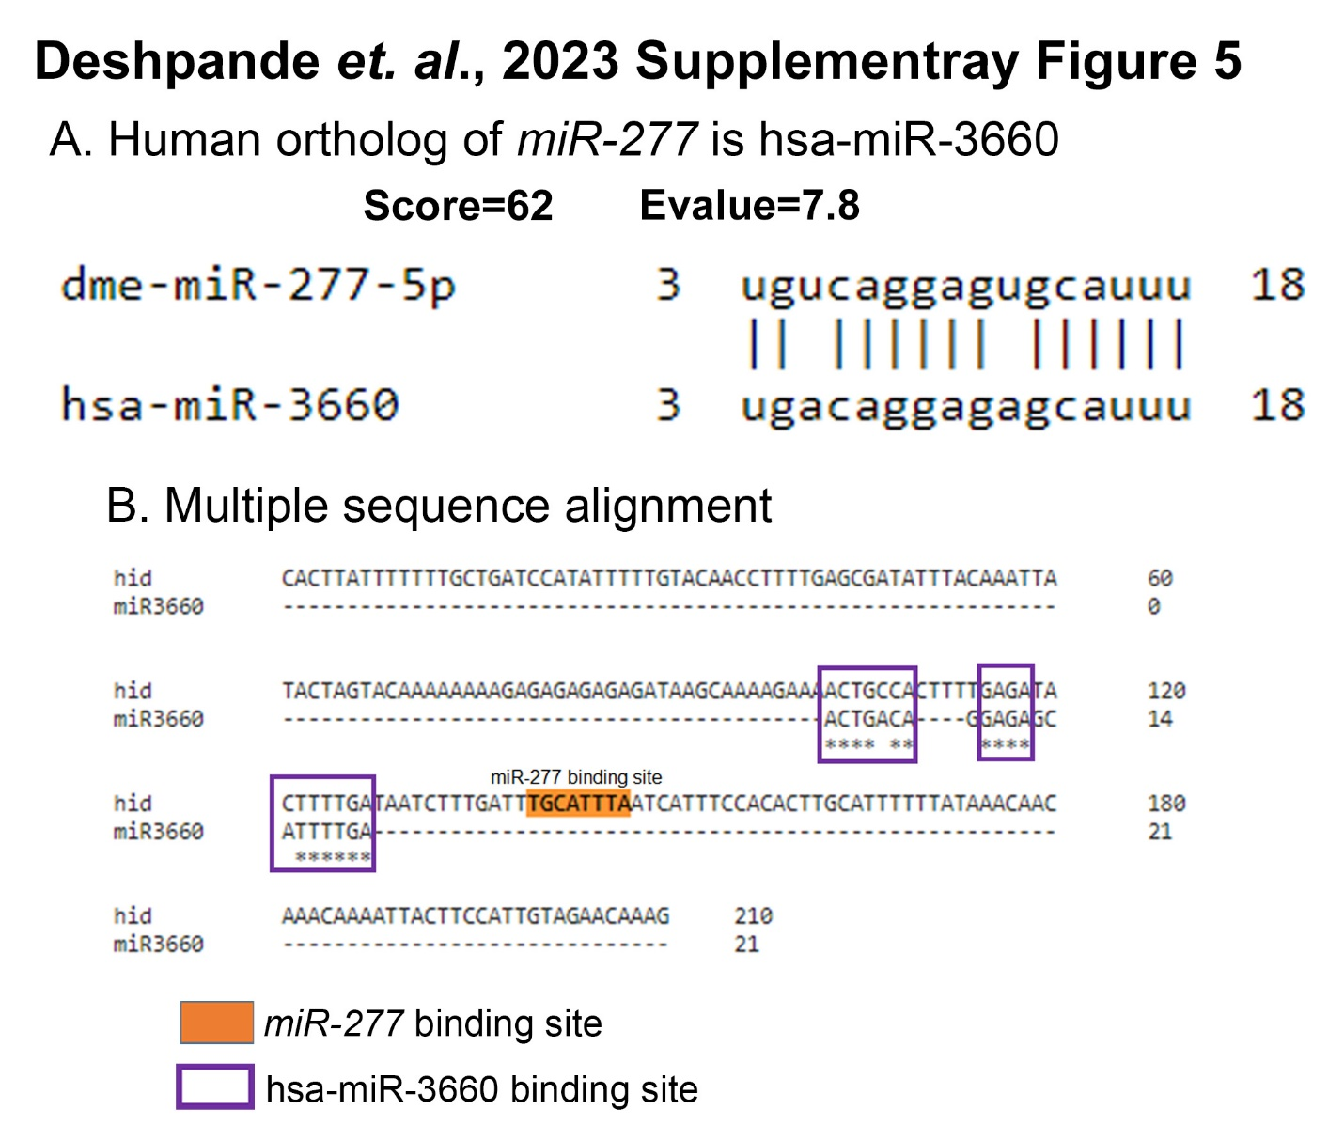
Supplementary Figure 5: A. Human ortholog of miR-277 is hsa-miR-3660: miRDB (https://mirdb.org/) predicts the orthologs of miRNAs. Dme-miR-277-5p and hsa-miR-3660 shows conserved nucleotide sequence with score=62. B. Multiple sequence alignment: Clustal omega predicts the hsa-miR-3660 binding site at 3’UTR of hid.

