Supplementary Figures

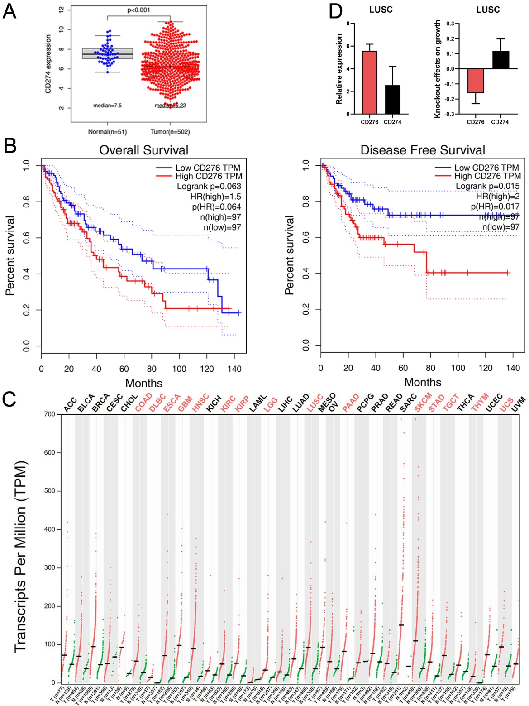
SFig.1 A. Expression of CD274 in LUSC (n=502) and normal samples (n=51) based on TCGA. B. Difference in overall and disease-free survival (P=0.063, P =0.015, respectively) between the top 20% and bottom 20% of LUSC patients (n=97) with CD276 expression analyzed by GEPIA. C. CD276 expression in 33 cancers and normal tissues analyzed by GEPIA, and cancer types with significant differences in expression marked by red. D. CD276 and CD274 expression in 28 LUSC cell lines downloaded from DepMAp(left). Effects of CD276 or CD274 knockout on the growth of 22 LUSC cell lines analyzed by DepMap (right). * P < 0.05; ** P < 0.01; *** P < 0.001. ns, not significant. Variables are presented as mean ± SD.

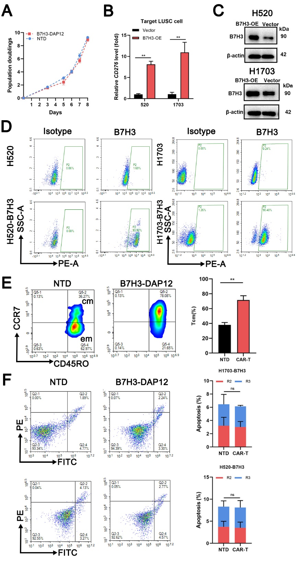
SFig.2 A. Changes of the number of CAR-T per day after lentiviral infection with NTD as a control. B-D. B7H3 expression in H520 and H1703 infected with control or B7H3-overexpression lentivirus shown by qRT-PCR, WB, and flow cytometry. E. Tcm subsets of B7H3-DAP12-CAR-T or NTD at day8 shown by flow cytometry. F. Apoptosis rates of B7H3-DAP12-CAR-T or NTD co-cultured with target cells at E:T = 2:1 for 48h shown by flow cytometry. *P < 0.05; ** P < 0.01; *** P < 0.001. ns, not significant. Variables are presented as mean ± SD.

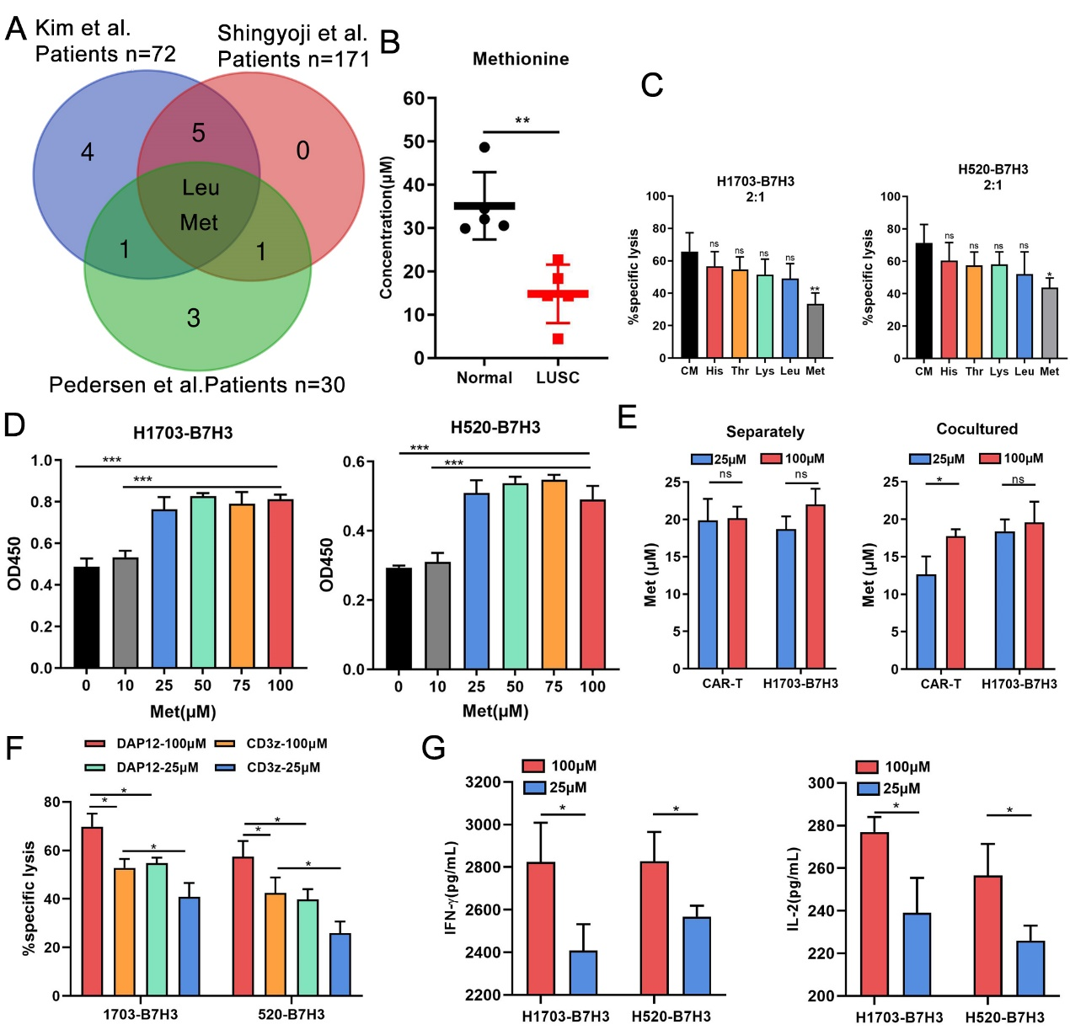
SFig.3 A. Differentially expressed amino acids in three cohorts of lung cancer patients (n=72, 171, and 30, respectively). B. Met discrepancies between patients with LUSC and healthy individuals detected by LCMS (n=5 per group). C. Cytotoxicity of B7H3-DAP12-CAR-T co-cultured with 1×10⁴ LUSC cells (E:T = 2:1) for 24h in RPMI-1640 with different concentrations of amino acids (His=24µM, Thr=42µM, Lys=54µM, Leu=95µM, or Met=25µM, respectively) shown by LDH cytotoxicity assay. D. The growth of LUSC cells cultured in 0, 10, 25, 50, 75, and 100µM for 3 days shown by CCK8. E. Met concentrations in CAR-T and target cells after 2 days separately or together (E:T = 1:1) at 25 or 100µM Met shown by ELISA. F. Cytotoxicity of DAP12-CAR-T and CD3z-CAR-T co-cultured with 1×10⁴ LUSC cells (E:T = 2:1) for 24h at 25 or 100µM Met shown by LDH cytotoxicity assay. G. IL-2 and IFN-γ secreted by B7H3-CD3z-CAR-T co-cultured with target tumor cells (2 × 10⁵) at E:T = 2:1 for 48h in 25 or 100μM Met measured by ELISA. *P < 0.05; ** P < 0.01; *** P < 0.001; ns, not significant. Variables are presented as mean ± SD.
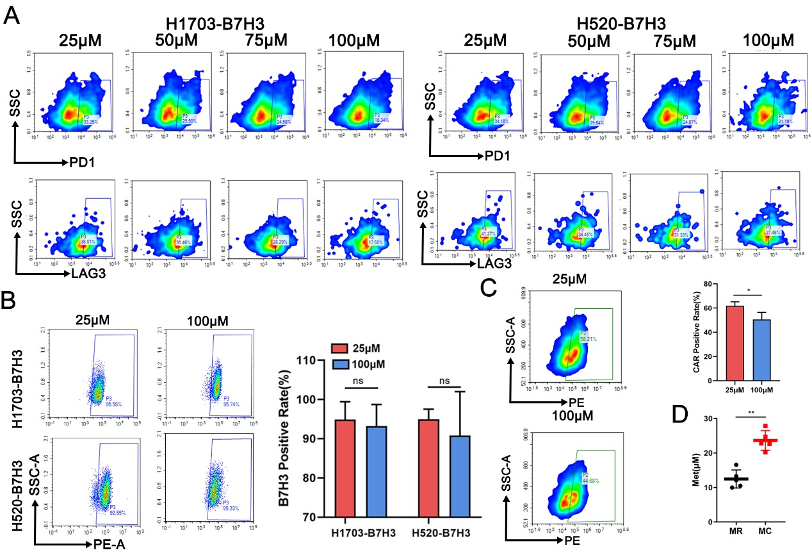
SFig.4 A. Representative images of PD1 and LAG3 on B7H3-DAP12-CAR-T co-cultured with target cells at 25, 50, 75, or 100μM for 48h measured by flow cytometry. B. B7H3 expression on H520-B7H3 and H1703-B7H3 at 25or 100μM Met shown by flow cytometry. C. CAR expression on B7H3-DAP12-CAR-T at 25or 100μM Met shown by flow cytometry. D. Met concentration in tumors of mice fed by MR or NC feeds detected by ELISA. *P < 0.05; ** P < 0.01; *** P < 0.001; ns, not significant. Variables are presented as mean ± SD.

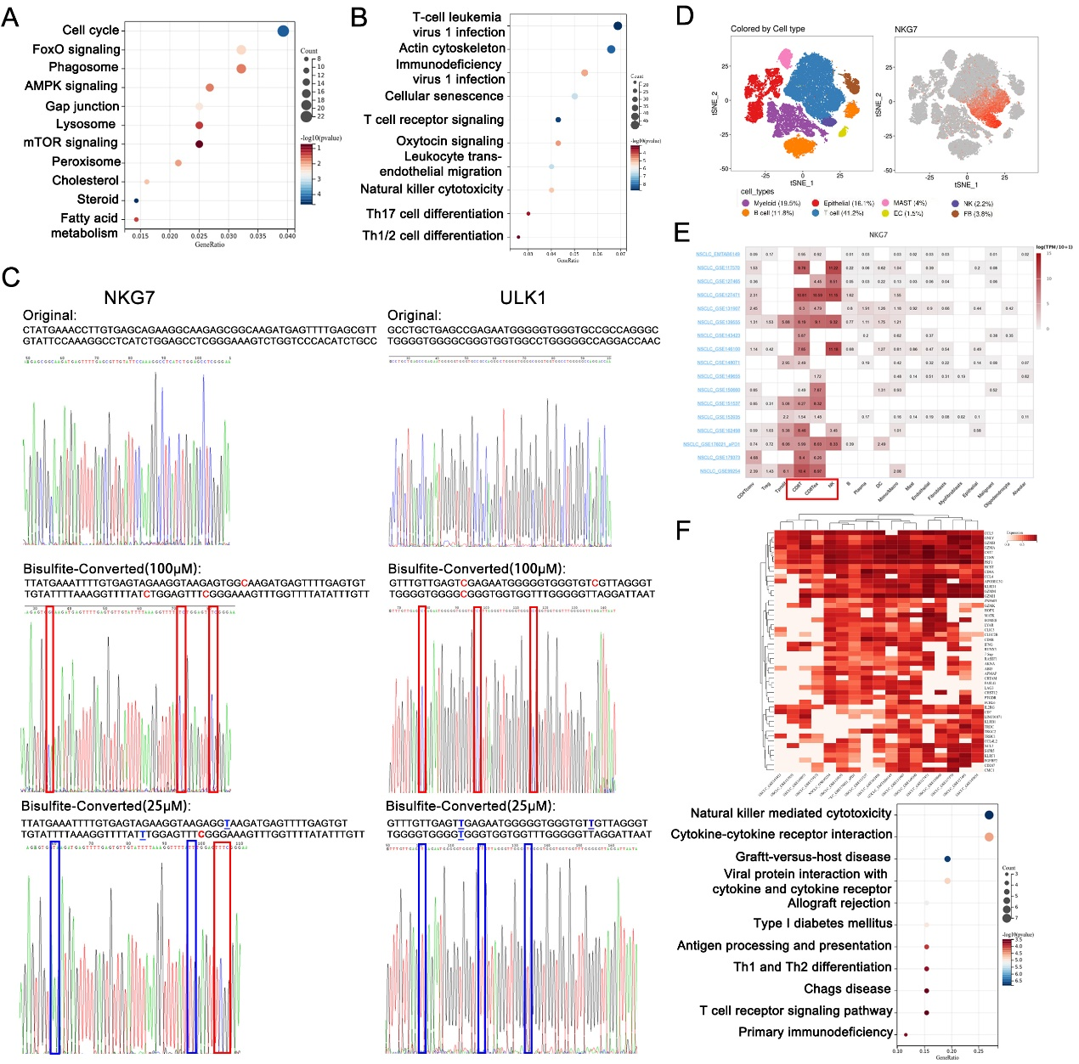
SFig.5. A-B. KEEG analysis of expression downregulated genes (n = 1538) or m5C downregulated genes (n = 1748) in CAR-T co-cultured with 1703-B7H3 (E:T = 1:1) at 25μM Met compared to those at 100μM Met. C. m5C sites in NKG7 and ULK1 mRNA in CAR-T co-cultured with H1703-B7H3 (E:T = 1:1) at 25 or 100μM Met detected by Sanger sequencing. mRNA without bisulfite conversion served as the reference. Red C: m5C; Blue T: converted T. D. Distribution of NKG7-enriched cells shown by the published single-cell sequencing. E. Distribution of NKG7 in different cell lines in multiple NSCLC samples shown by the database TISCH2. F. Heatmap of the top 50 genes correlated with NKG7 expression in TISCH2. KEEG analysis of signaling pathways containing top 50 genes correlated with NKG7 expression.

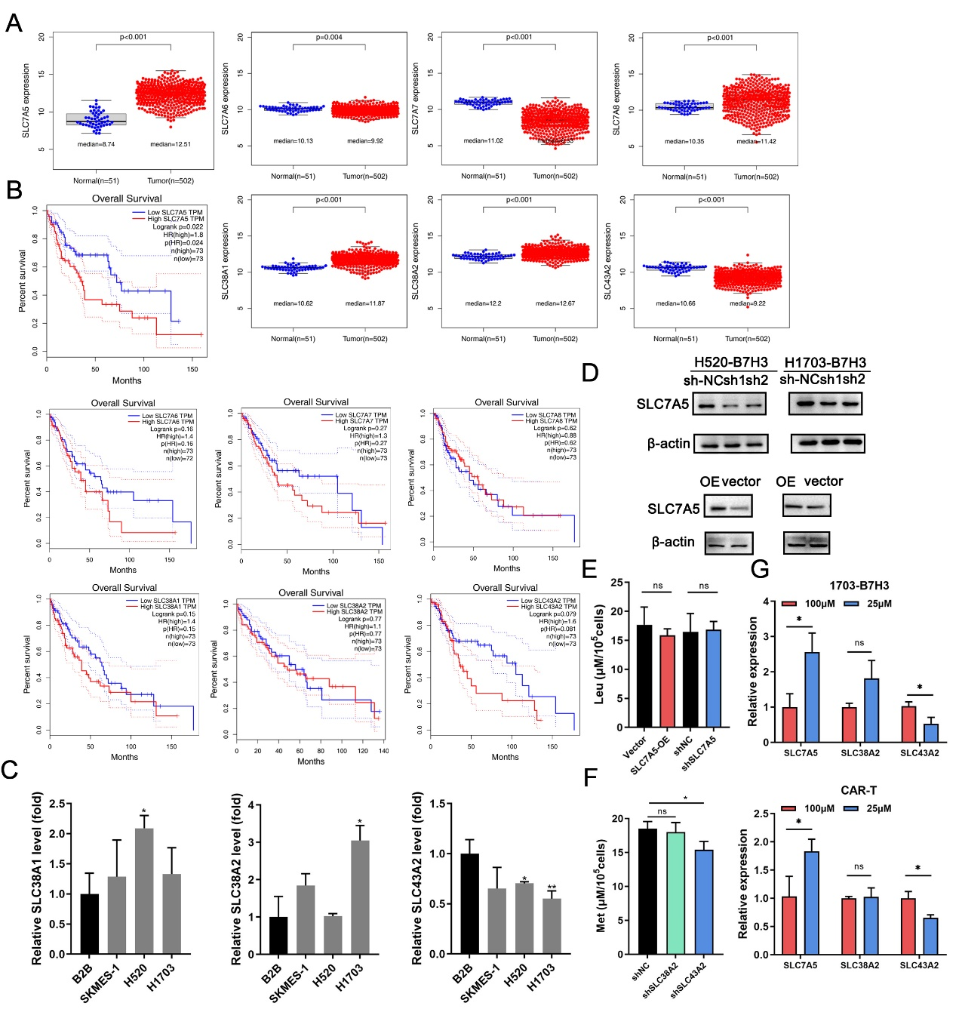
SFig.6. A. Expression of SLC7A5, SLC7A6, SLC7A7, SLC7A8, SLC38A1, SLC38A2, and SLC43A2 in LUSC (n=502) and normal adjacent tissues for (n=51) based on TCGA. B. Overall survival K-M plots of LUSC patients with the top 20% expression or with the bottom 20% expression of SLC7A5, SLC7A6, SLC7A7, SLC7A8, SLC38A1, SLC38A2, and SLC43A2 based on TCGA. C. Expression of SLC38A1, SLC38A2, and SLC43A2 in LUSC cell lines and B2B shown by qRT-PCR. D. Expression of SLC7A5 in LUSC cell lines with SLC7A5 up- or down-regulated shown by WB. E. After culturing for 2 days, Leu concentration in supernatant of 1× 10⁵ 1703-B7H3 cells with SLC7A5 up- or down-regulated detected by ELISA. F. After culturing for 2 days, Met concentration in supernatant of 1× 10⁵ 1703-B7H3 cells with SLC38A2 or SLC43A2 downregulated detected by ELISA. G. SLC7A5, SLC38A2, SLC43A2 expression in 1703-B7H3 and CAR-T after co-culturing (E:T = 2:1) for 48h in 25 or 100μM Met shown by qRT-PCR. *P < 0.05; ** P < 0.01; *** P < 0.001; ns, not significant. Variables are presented as mean ± SD.

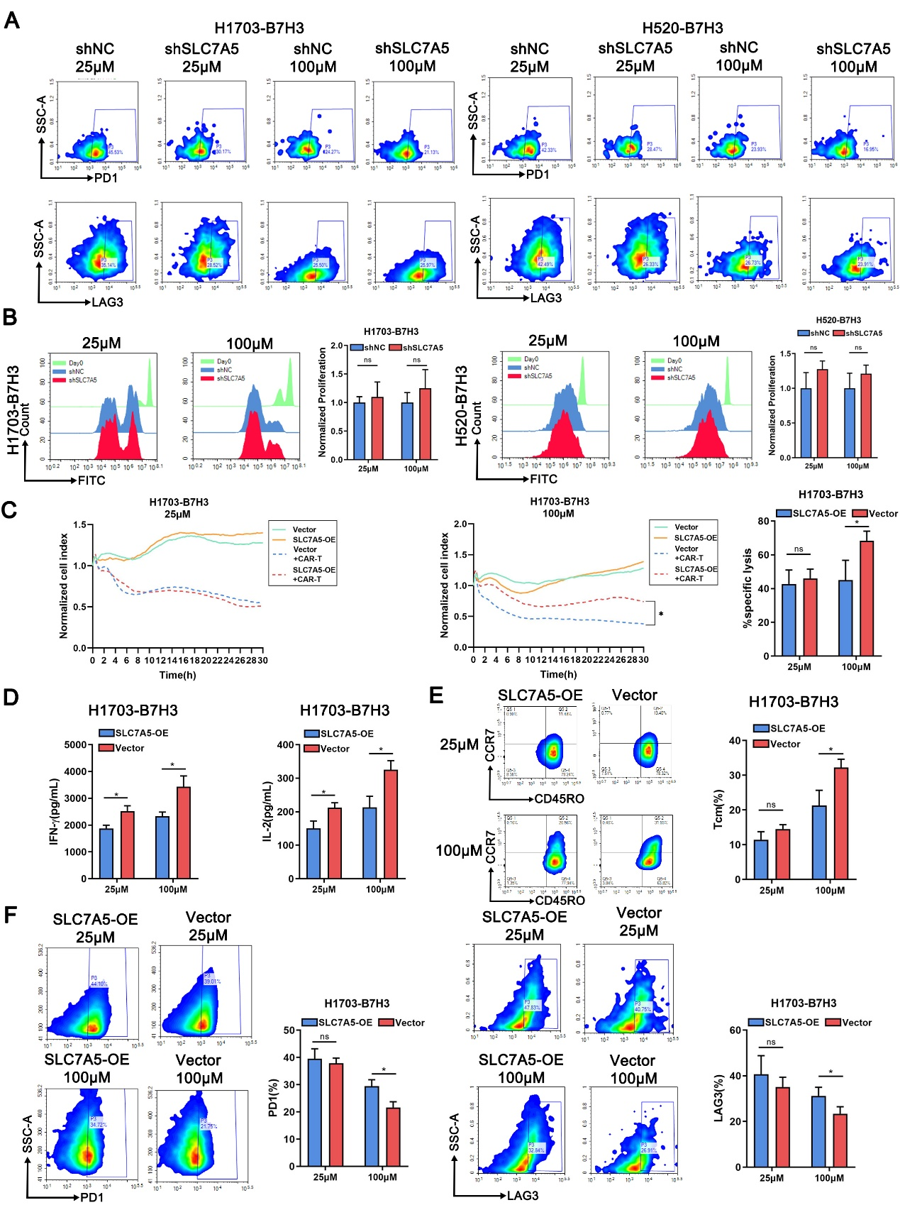
SFig.7 A. Representative images of PD1 and LAG3 expression on B7H3-DAP12-CAR-T co-cultured with normal or SLC7A5 downregulated target cells at 25 or 100μM Met for 48h measured by flow cytometry. B. Proliferation of CFSE labelled B7H3-DAP12-CAR-T co-cultured with normal or SLC7A5 downregulated target cells at E:T = 1:1 at 25 or 100μM Met for 3 days shown by flow cytometry. C. Normalized cell index of B7H3-DAP12-CAR-T co-cultured with normal or SLC7A5 upregulated target cells (E:T =0:1 and 2:1) in 25 or 100μM Met within 30h. D. IL-2 and IFN-γ secreted by B7H3-DAP12-CAR-T co-cultured with normal or SLC7A5 upregulated target cells (2 × 10⁵) at E:T = 2:1 for 48 h in 25 or 100μM Met measured by ELISA. E. Tcm subsets of B7H3-DAP12-CAR-T co-cultured with normal or SLC7A5 upregulated target cells at E:T = 2:1 for 48h at 25 or 100μM shown by flow cytometry. F. Exhaustion markers (PD1 and LAG3) on B7H3-DAP12-CAR-T co-cultured with normal or SLC7A5 upregulated target cells at 25 or 100μM for 48h measured by flow cytometry. *P < 0.05; ** P < 0.01; *** P < 0.001; ns, not significant. Variables are presented as mean ± SD.

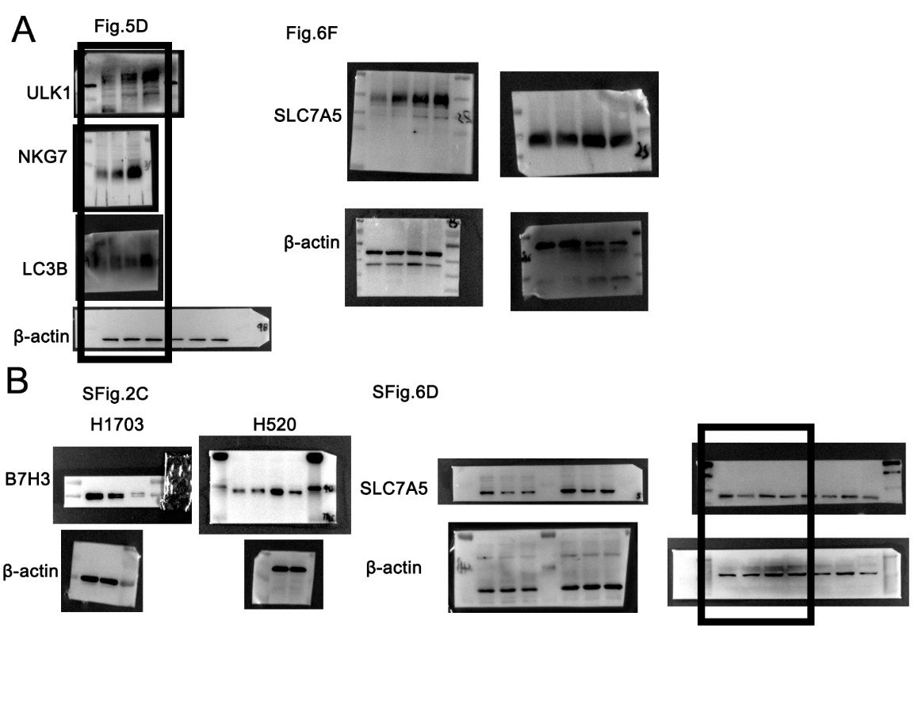
SFig.8 A-B. Unprocessed scans of western blot analysis. Some immunoblotting assays membranes are cut into pieces to incubate with different antibodies. Hence, the raw images of these membranes are of small size.

Supplementary Tables
Table S1. Primers used for qPCR, amplification, and shRNA.

Table S2. Clinical information of 48 patients with LUSC.

Table S3. Amino acids discrepancies between patients with LUSC and healthy individuals detected by liquid chromatograph mass spectrometer.

Table S4. Genes significantly downregulated at 25μM Met concentration (n = 1538).

Table S5. Genes with significantly downregulated m5C at 25μM Met concentration (n = 1748).

Table S6. Immune and cell infiltration related genes (n = 761).

