Fig. S1. A Heatmap of top 9 principal components. B PCA was used for dimensionality reduction color coded by sample. C Scatter plots showing the correlation between the percentage of mitochondrial genes and the mRNA reads, together with the relationship between sequencing depth and the number of detected genes.
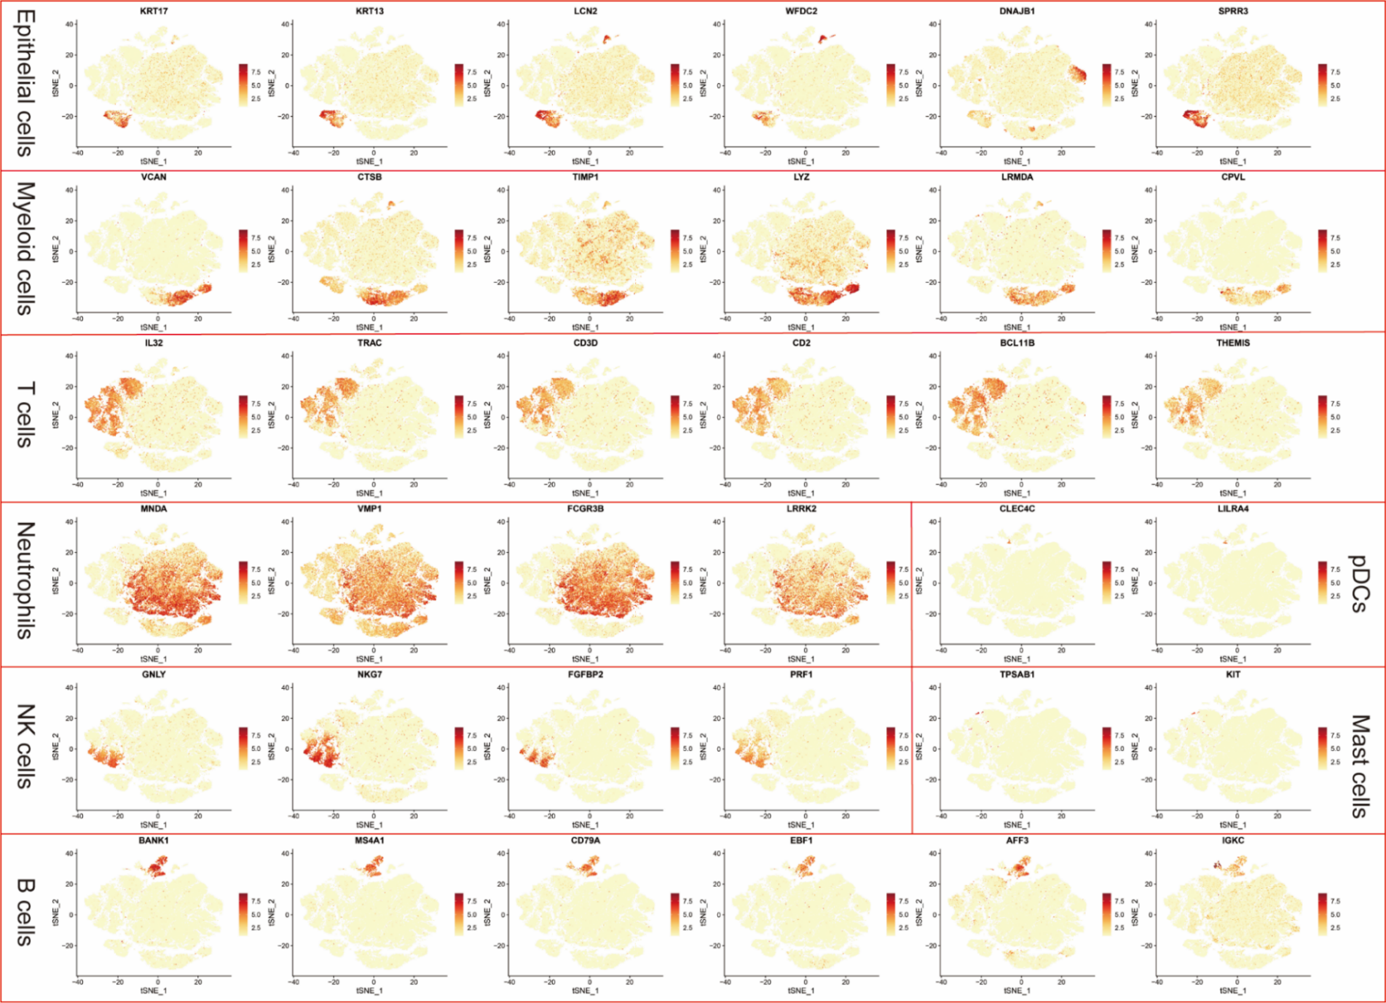

Fig. S2. The t‐SNE plots showing the expression and distribution of canonical cell markers.
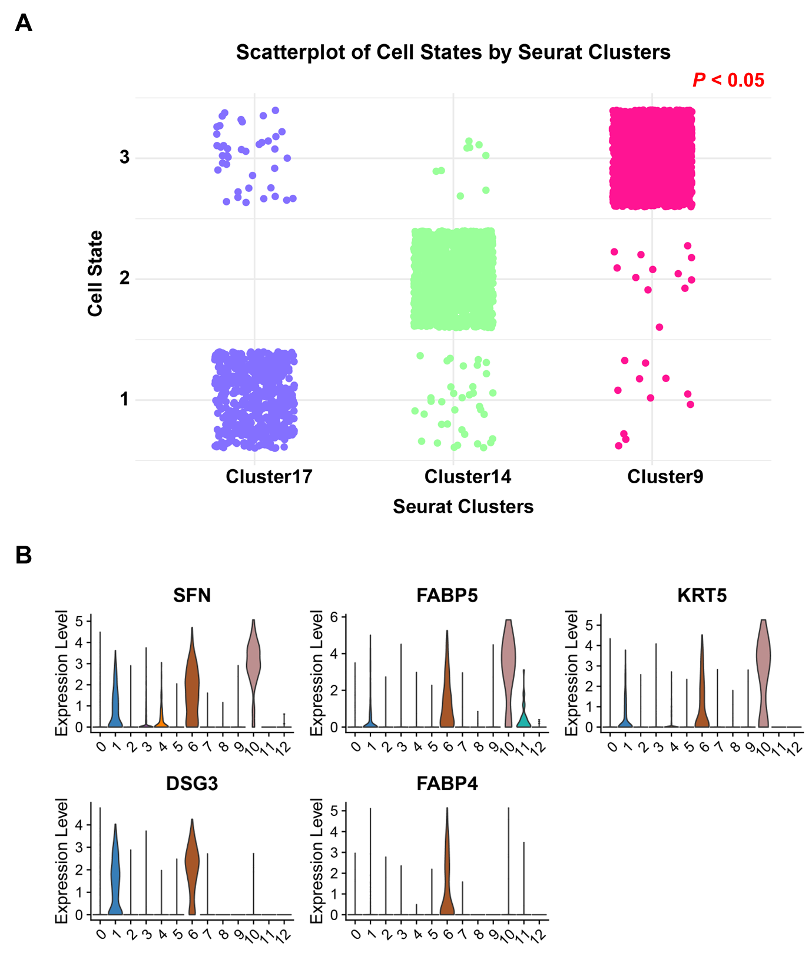
Fig. S3. A Scatterplot of cell states by seurat clusters. B Violin plots displayed the expression of malignant cell markers (DSG3, FABP4, SFN, FABP5, and KRT5) in epithelial cells.

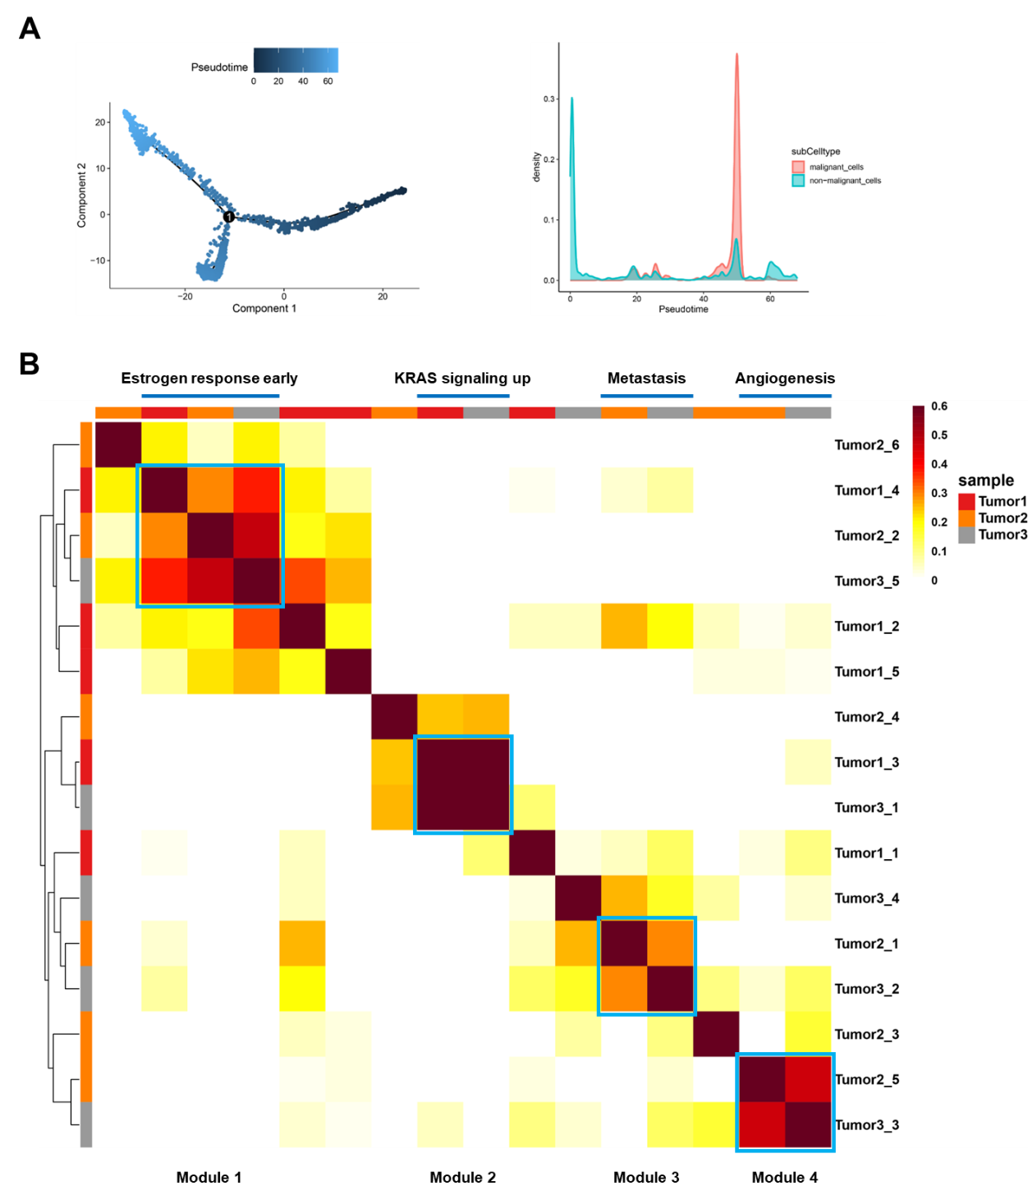
Fig. S4. A Trajectory analysis of the epithelial cells annotated by pseudotime (left) and density distribution of epithelial cells along the pseudotime trajectory (right). B Pairwise correlation clustering of intra-tumoral GEPs. 16 GEPs were derived by NMF from three tumors and formed four consensus modules (module 2 signature genes listed in Table S5), whose biological significance was predicted (top).
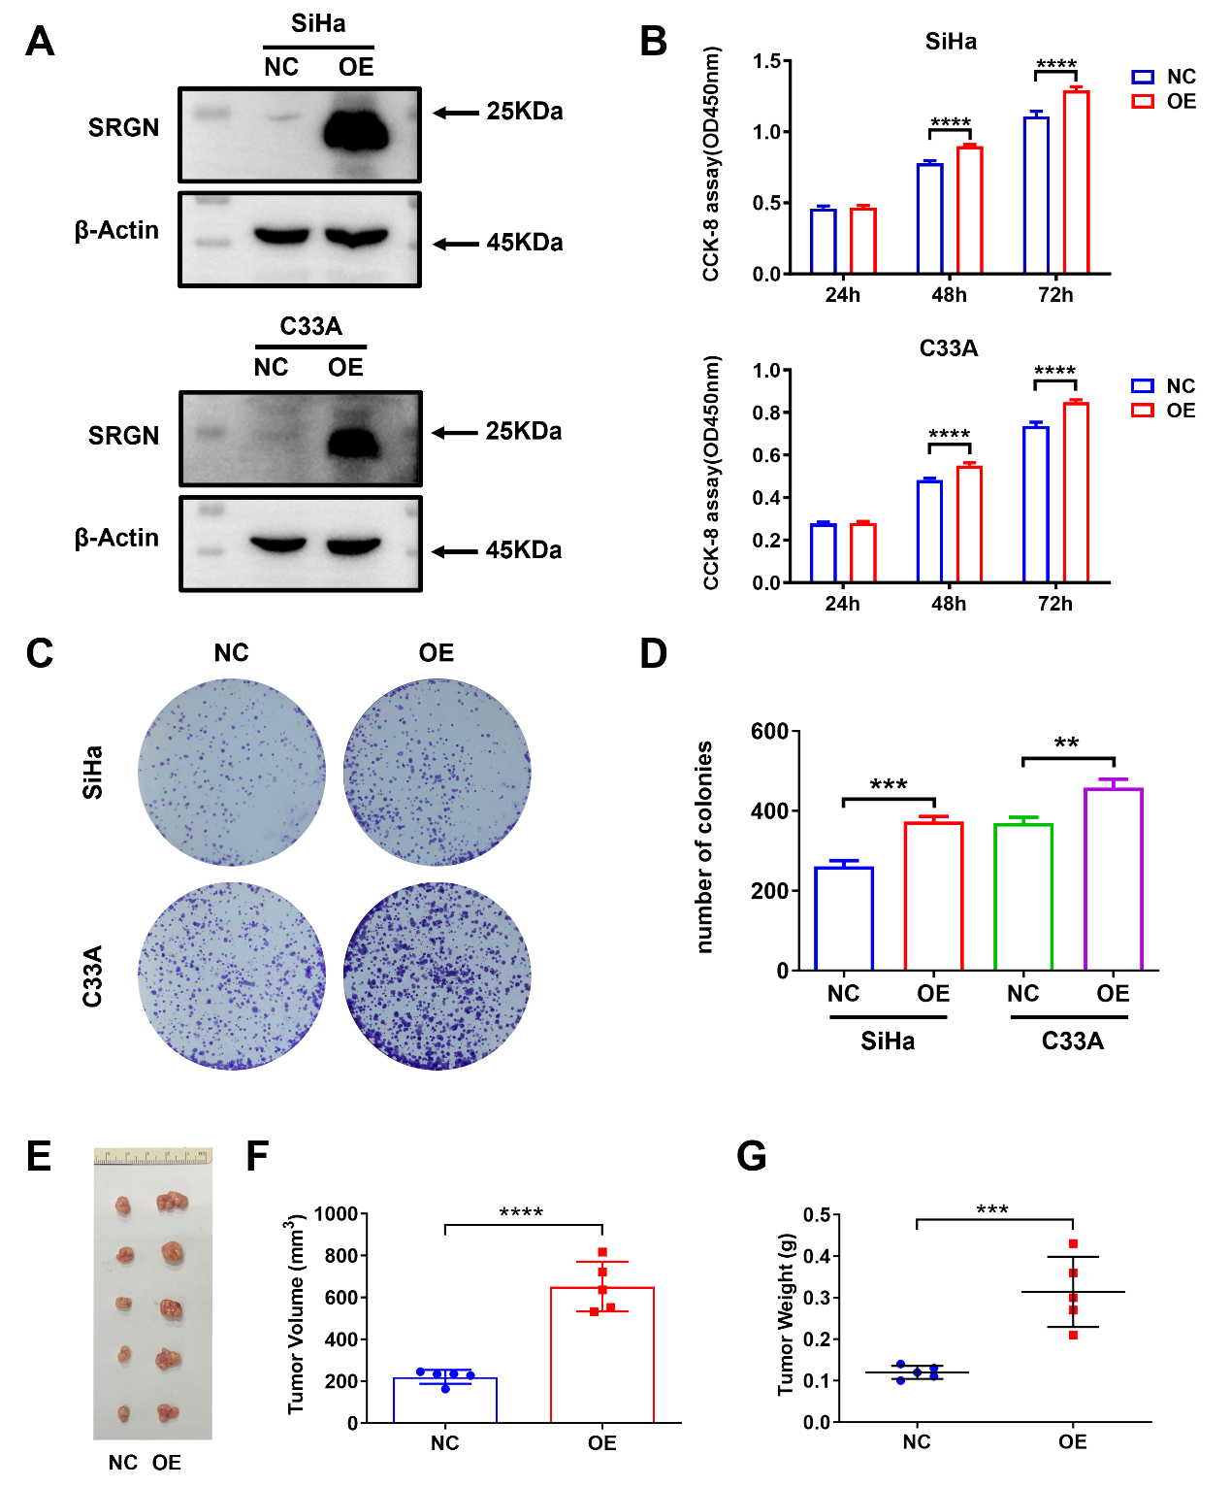
Fig. S5. A SRGN-overexpressing SiHa and C33A cells were constructed and confirmed via western blot. B-D The effect of SRGN overexpression on cell viability in SiHa and C33A cells was detected via CCK-8 assay (B) and colony formation (C-D). E Photograph of SRGN-overexpression Siha xenografts (right) relative to the control (left). F-G The final volume (F) and weight (G) of xenograft tumours in the SRGN-overexpression and control groups. OE: SRGN-overexpression, NC: normal control. **P < 0.01, ***P < 0.001, ****P < 0.0001.
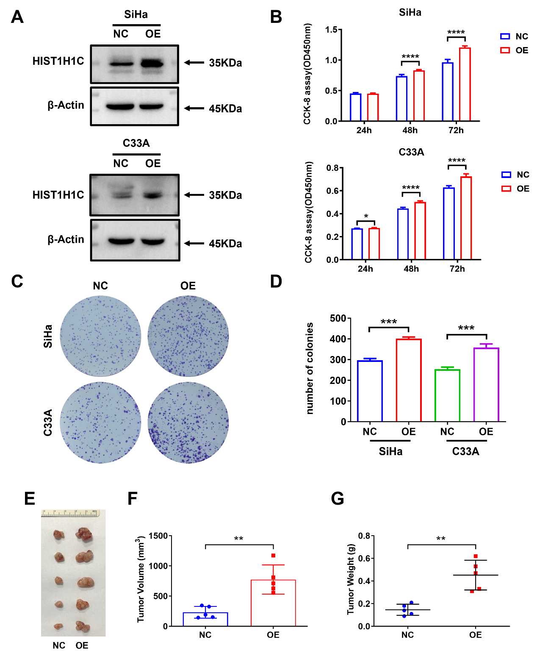
Fig. S6. A HIST1H1C-overexpressing SiHa and C33A cells were constructed and confirmed via western blot. B-D The effect of HIST1H1C overexpression on cell viability in SiHa and C33A cells was detected via CCK-8 assay (B) and colony formation (C-D). E Photograph of HIST1H1C-overexpression Siha xenografts (right) relative to the control (left). F-G The final volume (F) and weight (G) of xenograft tumours in the HIST1H1C-overexpression and control groups. OE: HIST1H1C-overexpression, NC: normal control. *P < 0.05, **P < 0.01, ***P < 0.001, ****P < 0.0001.
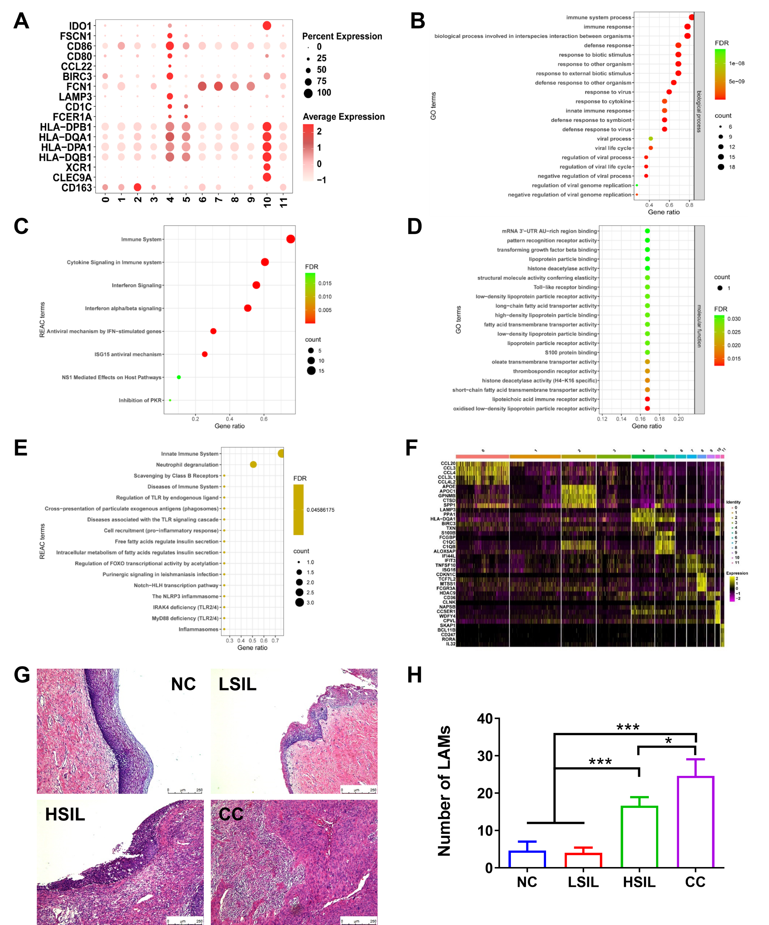
Fig. S7. A Expression of myeloid cell-specific markers across different clusters. The dot size is proportional to the fraction of marker-expressing cells in the group. B-C The GO Analysis and the REAC terms Analysis of subcluster 7 in myeloid cells. D-E The GO Analysis and the REAC terms Analysis of subcluster 9 in myeloid cells. F Heatmap showing the differentially expressed genes of myeloid cells across cluster, with top genes indicated. G The H&E staining of NC, LSIL, HSIL, and CC tissues. H The number of LAMs. *P < 0.05, ***P < 0.001.
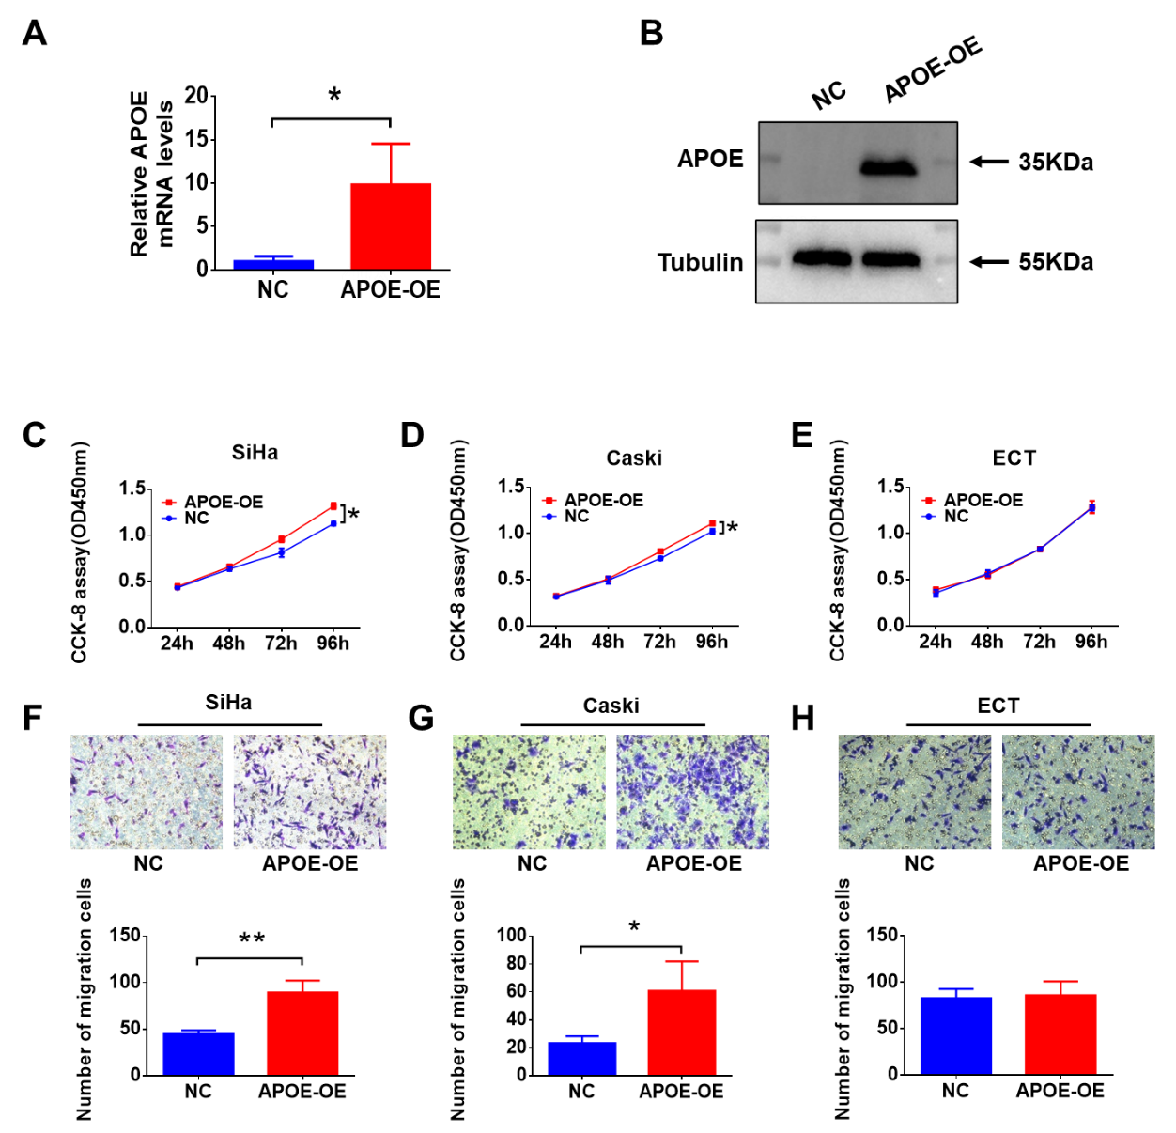
Fig. S8. A q-PCR analysis of APOE overexpression efficacy in THP-1 cells. B Western blot analysis of APOE overexpression efficacy in THP-1 cells. C-E CCK8 assay of SiHa, Caski, ECT cells with conditioned medium (CM) in different groups, respectively. F-H Transwell assay of SiHa, Caski, ECT cells cultured with the CM from APOE-OE macrophages and NC macrophages, respectively. *P < 0.05, **P < 0.01.
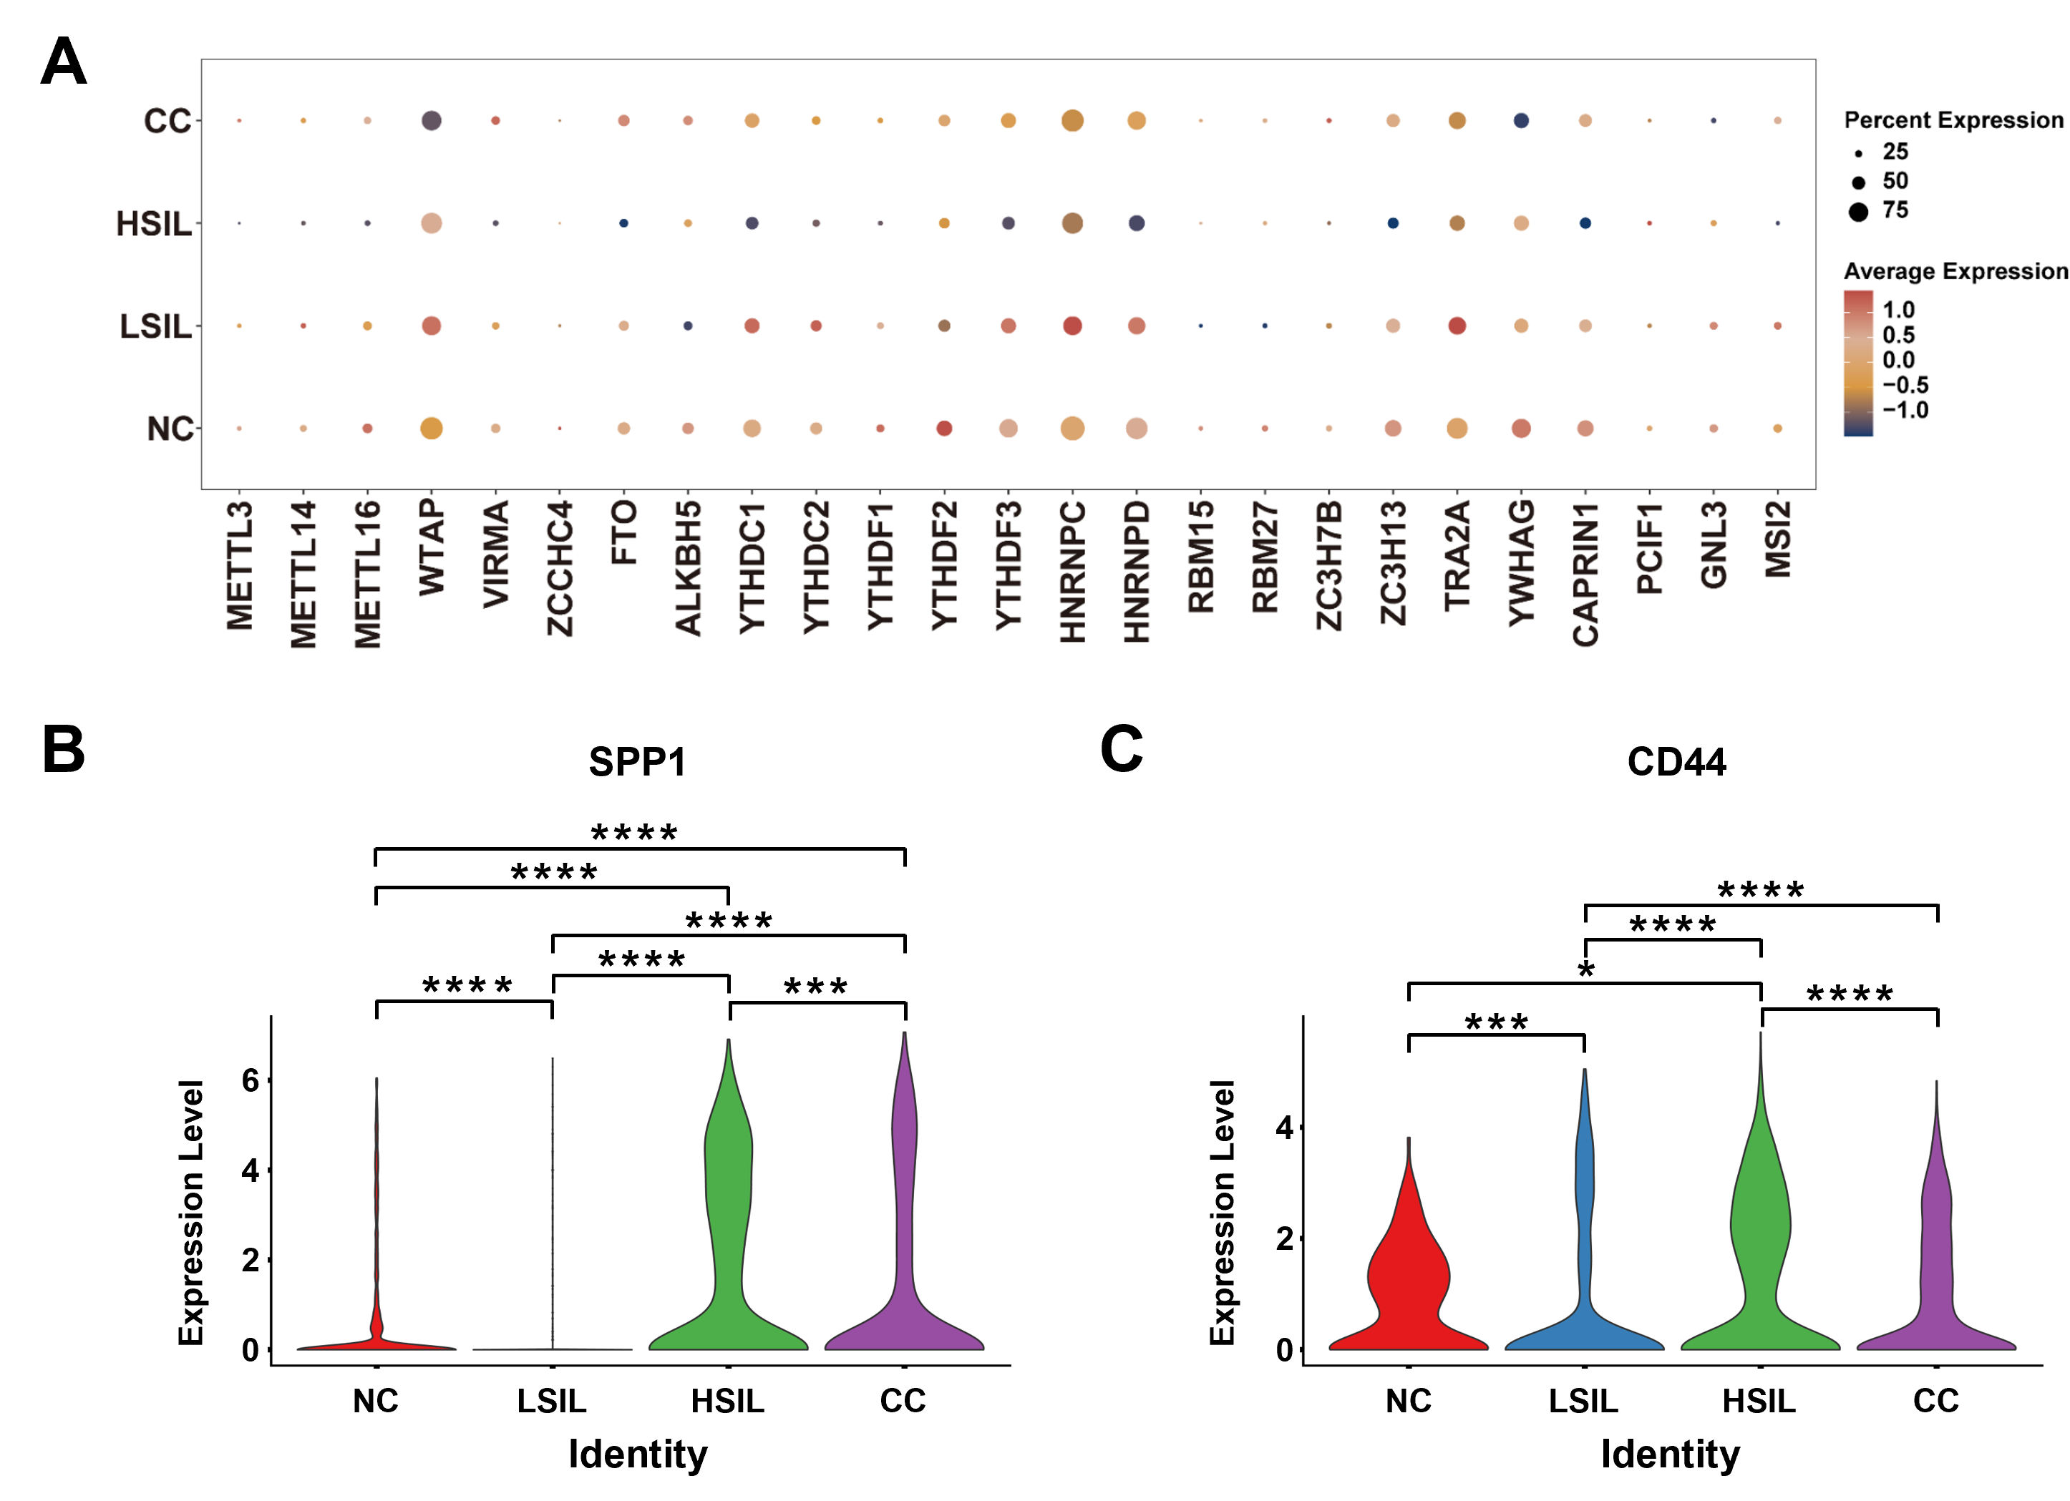
Fig. S9. A The expression of m6A methylation associated RNA transcripts of macrophage in NC, LSIL, HSIL, and CC group. B-C The level of SPP1 in macrophages and CD44 in epithelial cells in NC, LSIL, HSIL, and CC groups. *P < 0.05, ***P < 0.001, ****P < 0.0001.

