Supplementary Materials

Figure S1. Cdk14 distribution in mouse organs and organ architecture of Cdk14^{-/-} mice. (A) Micrographs from in situ hybridization experiments (downloaded from the Allen Brain Atlas) depicting the expression of Snca and Cdk14 in the mouse brain. SN and Hippocampus are highlighted at 10x magnification. (B) Immunoblots showing Cdk14 protein from different organs of Cdk14^{-/-} and WT mice. (C) Hematoxylin and eosin (H&E) staining does not reveal obvious rearrangements of brain morphology of Cdk1^{+/-} and Cdk14^{-/-} mice in comparison to WT-mice (1 mm and 50 µm scale bars). (D) Synapsin and PSD95 immunofluorescence experiments in primary cortical neurons and in the hippocampus of adult mice do not display differences in synaptic integrity between WT, Cdk1^{+/-} and Cdk14^{-/-} mice (20 µm scale bar). Mean + SEM, one-way ANOVA, Bonferroni post hoc comparisons, n=3-4. (E) H&E-stainings of lungs and spleens of Cdk1^{+/-} and Cdk14^{-/-} mice do not differ from stainings of WT mice (100 µm scale bars). (F) Immunoblots showing the levels of α-Syn, Cdk14, and GAPDH in the TSS buffer-soluble protein fraction from hemibrains of 3-month-old WT, Cdk14^{+/-} and Cdk14^{-/-} mice. Mean + SEM, one-way ANOVA, Bonferroni post hoc comparisons, n=4-5.

Figure S2. Behavioral profile and numbers of midbrain dopaminergic neurons of PFF injected Cdk14^{-/-}-mice. (A) Transmission electron micrograph (500 nm scale bar) illustrating mouse α-Syn PFFs used for intrastriatal injections and corresponding α-Syn PFF length analysis. (B) Immunofluorescence experiment depicting less pS129 α-Syn-positive neurons in primary cortical neurons from Cdk14^{-/-} mice than in cultured neurons from WT-mice after PFF-treatment at 9 DIV. Mean + SEM, one-way ANOVA, Bonferroni post hoc comparisons, n=4 (50 µm scale bar). (C) 12-month-old Cdk14^{+/-} and Cdk14^{-/-} mice do not display altered behavior in the nesting, tail suspension, elevated plus maze, Y maze, open field, hanging wire, pole (Mean + SEM, two-way ANOVA, Bonferroni post hoc comparisons) and rotarod test (Mean +/- SEM, repeated measures two-way ANOVA, Bonferroni post hoc comparisons, n:9-10). PFF treatment does not result in significant changes of behavior at 6 months post injection. (D) PFF injection does not change the striatal dopamine content in the ipsilateral (IL), PFF-injected hemisphere (measured by LC-MS/MS, mean + SEM, two-way ANOVA, Bonferroni post hoc comparisons, n:2-8), but it decreases the number of TH-positive cells in the substantia nigra pars compacta (SN) IL relative to the non-injected, contralateral hemisphere (CL) to a similar extent in WT-, Cdk14^{+/-}- and Cdk14^{-/-}- mice at -3.08 mm relative to bregma (sections counterstained with hematoxylin, 500 µm scale bar). Mean + SEM, two-way ANOVA, Bonferroni post hoc comparisons, n=3. (E) Immunoblots showing the levels of α-Syn, Cdk14, and GAPDH in the TSS buffer-soluble protein fraction from hemibrains of 3-month-old WT, Cdk14^{+/-} and Cdk14^{-/-} mice. Mean + SEM, one-way ANOVA, Bonferroni post hoc comparisons, n=4-5.

Figure S3. Human PFFs are lost in media of primary mouse neurons within 14 days post application and FMF-04-159-2-induced reduction of CDK14 is potentially mediated by the proteasome. (A) Human α-Syn is not detectable in media of WT mouse neurons after 14 days (D14) of treatment with human (h) α-Syn PFFs. Mean + SEM, two-way ANOVA, Bonferroni post hoc comparisons, n=4. (B) HEK293T cells were transfected with empty vector (V), FLAG-tagged WT or mutant α-Syn (A30P, G51D, A53T and S129A)-coding plasmid DNA, followed by immunoprecipitation (IP) of FLAG-tagged α-Syn and visualization of CDK14 and FLAG/α-Syn by immunoblots. (C) Treatment of HEK293T cells with 500 nM and 250 nM of FMF-04-159-2 for 18 hours reduced levels of phosphorylated (pS1460) LRP6 and total LRP6, as shown by immunoblots. One-way ANOVA, Bonferroni post hoc comparisons, n=4. (D) For protein degradation experiments, HEK293T cells were treated with 500 nM FMF-04-159-2, 1 µM MG-132 and 200 nM Bafilomycin A1 for 18 hours. Activity of the ubiquitin proteasome system and autophagy is visualized with immunoblots by Ubiquitin and LC3B, respectively. Two-way ANOVA, Bonferroni post hoc comparisons, n=3.

Figure S4. In vivo administration of FMF-04-159-2 does not induce pain or alter organ morphology. (A) The development of body weight (BDW, as % relative to the day of surgery (day 0)), the activity, neurological signs for pain, the facial grimace, the coat condition and the respiration (scored from 0 to 3, 3 = maximal discomfort) of FMF-04-159-2-treated PAC α-Syn^{A53T} TG mice compared to their vehicle-treated counterparts were measured over a period of 25 days after the stereotactic surgery. FMF-04-159-2 was applied at 0.35 mg/kg/day for 28 days in 4-month-old PAC α-Syn^{A53T} TG mice. Mean +/- SEM, repeated measures two-way ANOVA, Bonferroni post hoc comparisons, n=6. (B) H&E staining of the lung, spleen and liver of FMF-04-159-2-treated PAC α-Syn^{A53T} TG mice did not reveal alterations in organ cytoarchitecture compared to vehicle-treated mice (100 µm scale bars).

Fig. S1
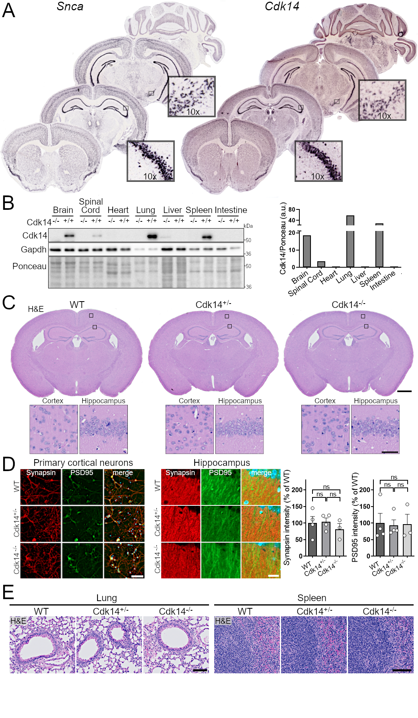
Fig. S2
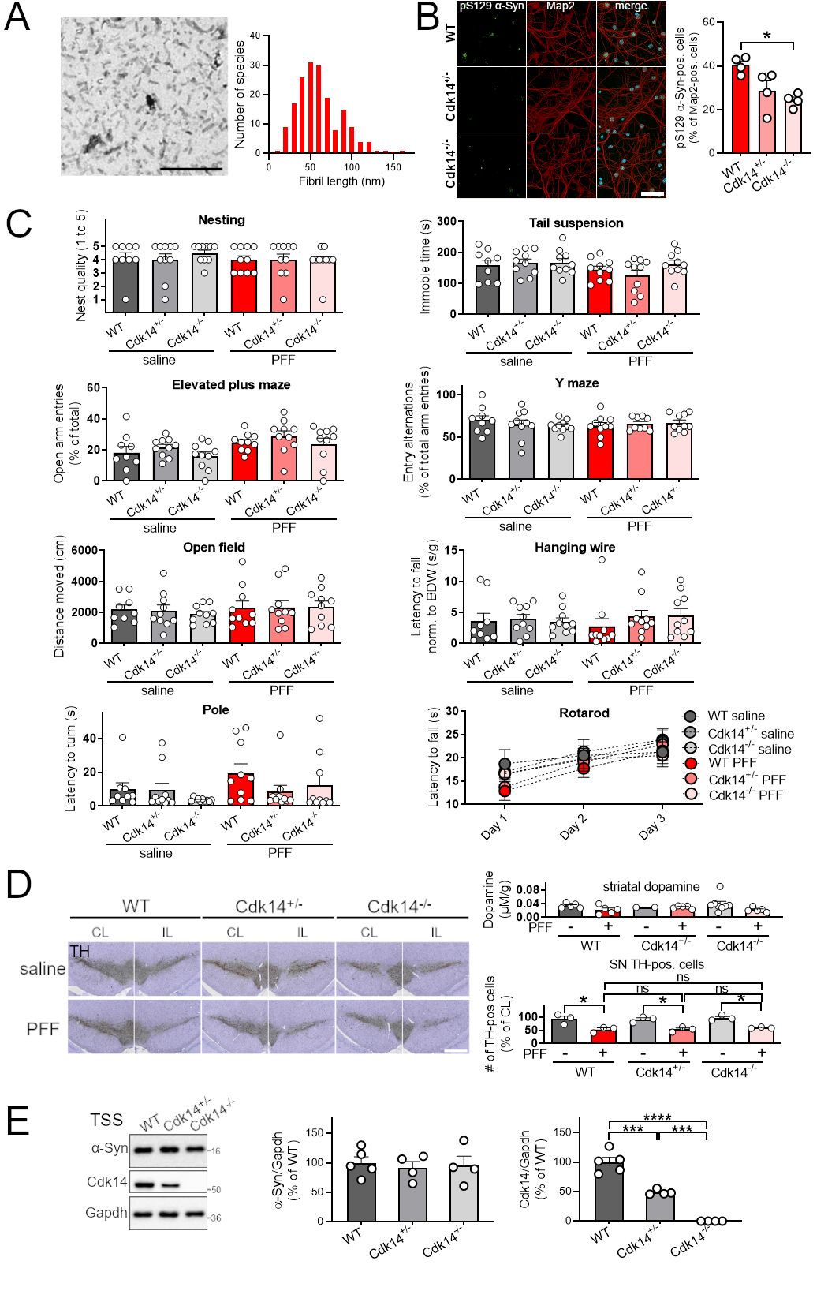
Fig. S3
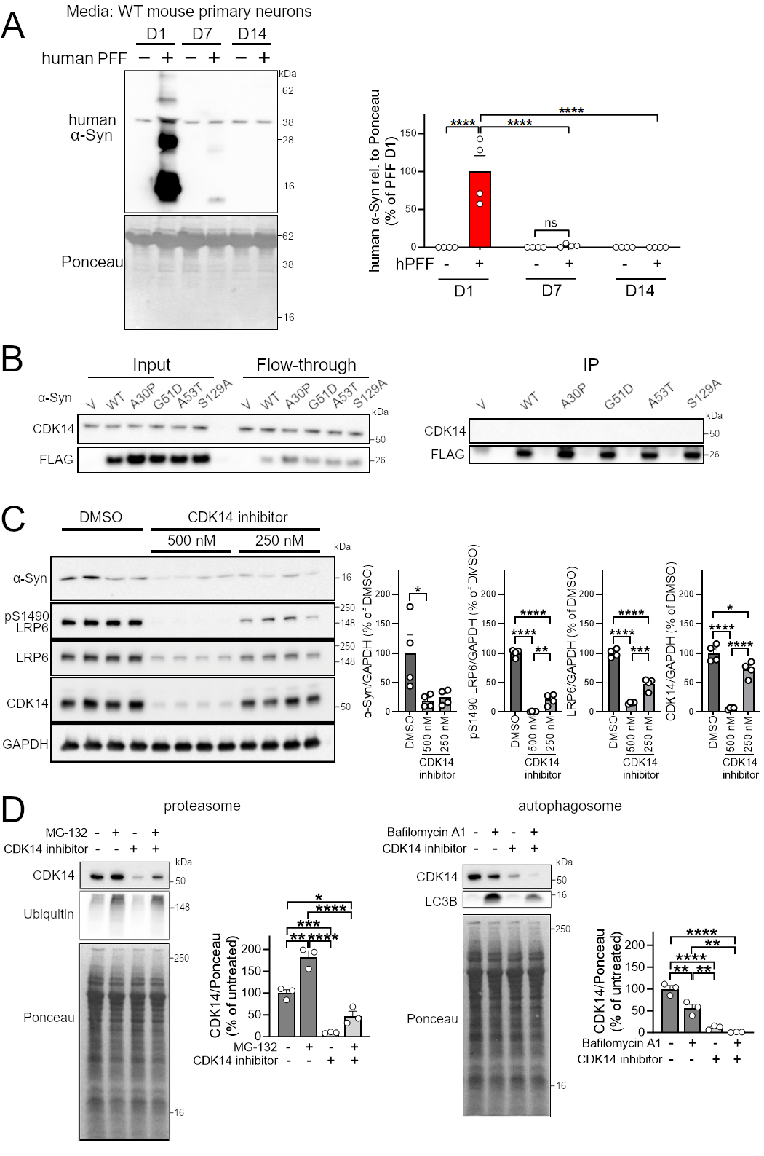
Fig. S4
