Supplementary Information

The GFPT2-O-GlcNAcylation-YBX1 axis promotes IL-18 secretion to regulate the tumor immune microenvironment in pancreatic cancer

Supplementary Figures 1-7 and legends

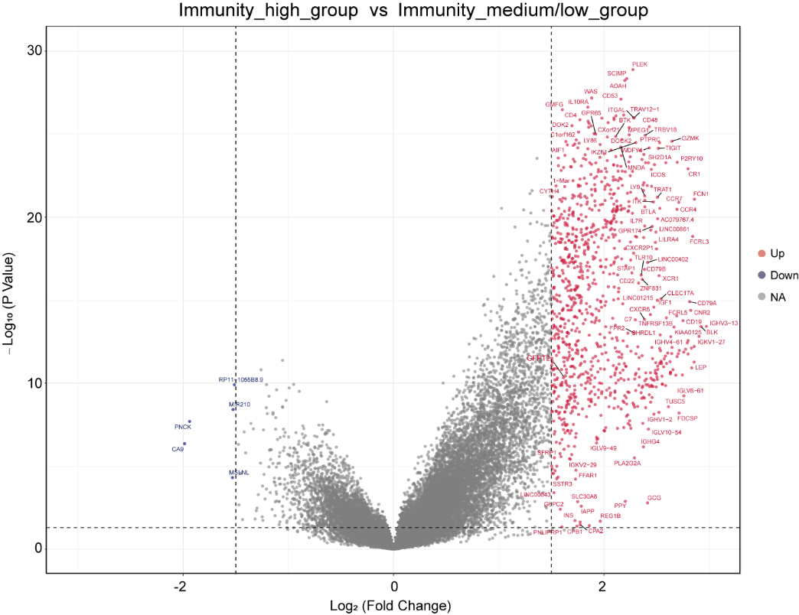
Supplementary Figure 1. GFPT2 was an immune-related prognostic gene in pancreatic cancer. Volcano map showed differences in gene expression between groups with high or low levels of immune cell infiltration (log₂(Fold change) >1.5 or < -1.5).
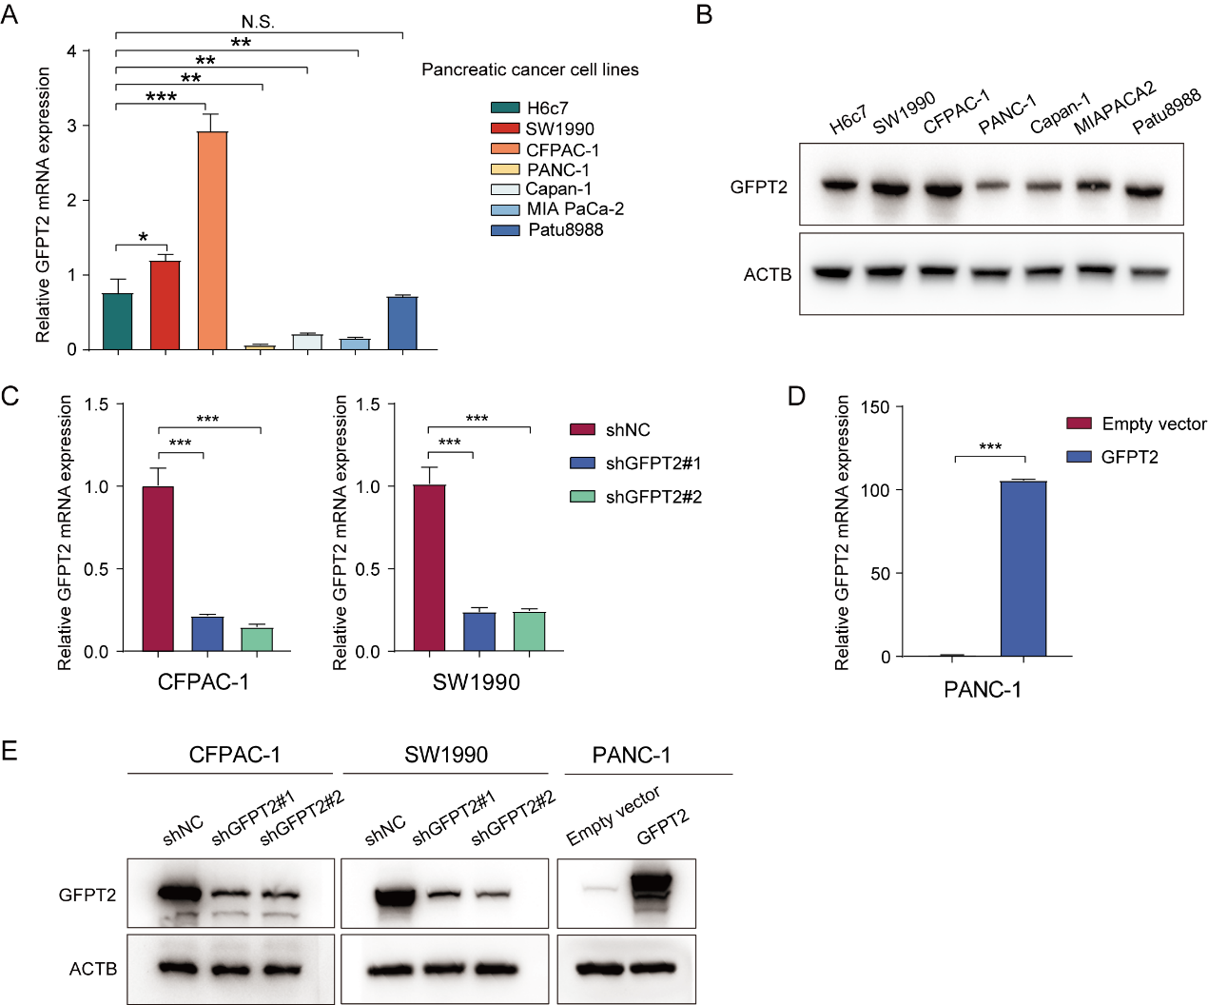
Supplementary Figure 2. GFPT2 overexpressing pancreatic cancer cells promoted macrophage M2 polarization. (A) GFPT2 mRNA of pancreatic cancer cell lines and H6c7 were detected by qRT-PCR. (B) GFPT2 protein levels of pancreatic cancer cell lines and H6c7 was measured by western blotting. (C-D) GFPT2 mRNA level was detected by qRT-PCR in SW1990, CFPAC-1 and PANC-1 stable cell lines. (E) GFPT2 protein level was measured by western blotting in SW1990, CFPAC-1 and PANC-1 stable cell lines.
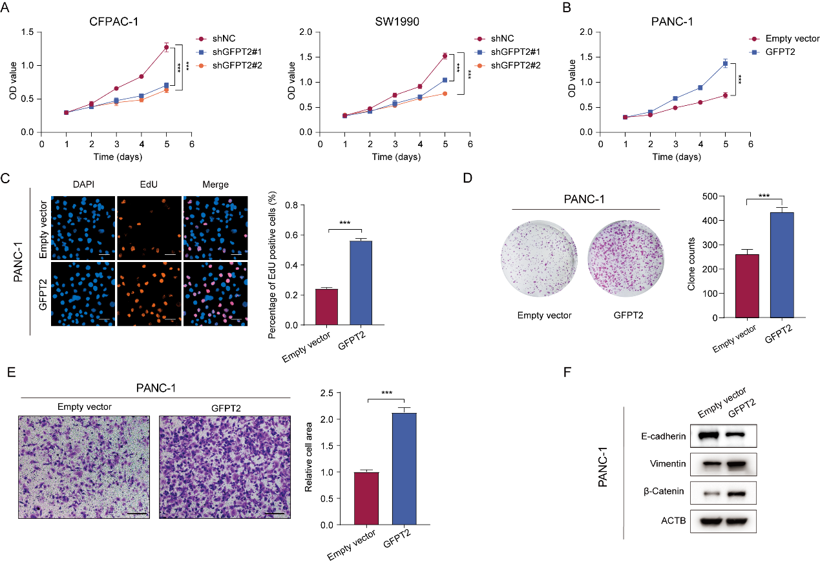
Supplementary Figure 3. GFPT2 promoted the proliferation and migration of pancreatic cancer cells. (A-B) CCK-8 assay was used to detect the proliferation of SW1990, CFPAC-1 and PANC-1 stable cell lines. (C) 5-Ethynyl -2’- deoxy uridine (EdU) was used to detect the proliferation of PANC-1 stable cell lines. Scale bars, 50 μm. (D) Colony formation assay was performed with PANC-1 stable cell lines. (E) Transwell assay was used to detect the migration abilities of PANC-1 stable cell lines. Scale bars, 200 μm. (F) The protein levels of E-cadherin, vimentin and β-catenin were detected by western blotting in SW1990 and CFPAC-1 stable cell lines.
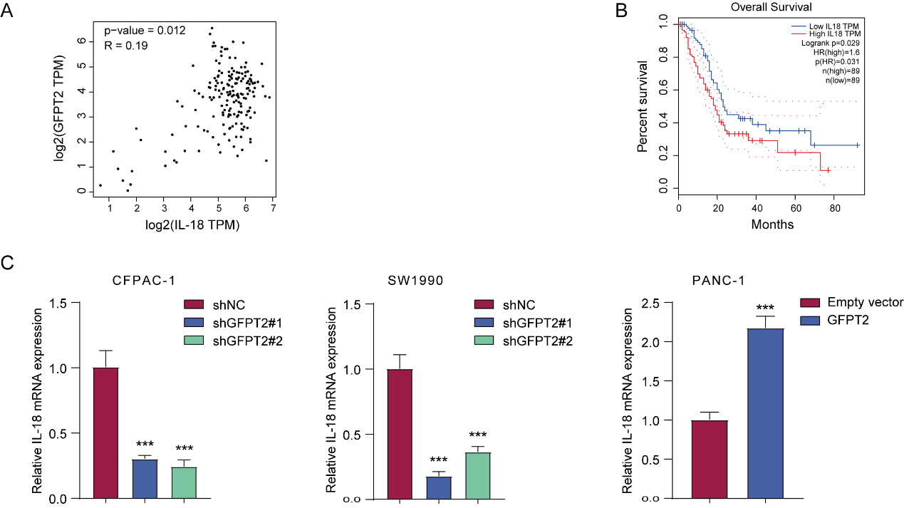
Supplementary Figure 4. GFPT2 promoted the synthesis and secretion of IL-18 in pancreatic cancer. (A) The correlation between GFPT2 and IL-18 in TCGA data was shown. (B) Kaplan-Meier survival curve of IL-18 expression in PDAC tumor tissues from TCGA database were shown. (C) mRNA levels of IL-18 were detected by qRT-PCR.
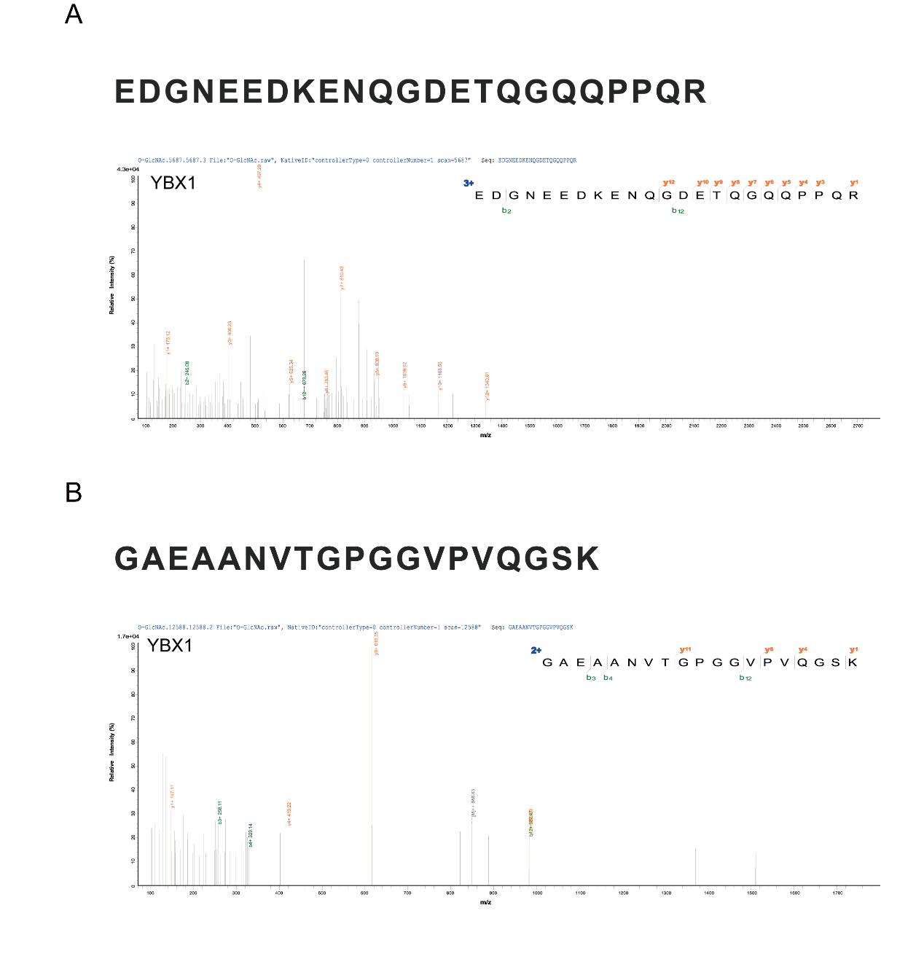
Supplementary Figure 5. GFPT2 promoted the O-GlcNAcylation and nuclear translocation of YBX1. (A) Representative tandem MS spectrum of the EDGNEEDKENQGDETQGQQPPQR peptide from YBX1 as determined by IP-Mass Spec. (B) Representative tandem MS spectrum of the GAEAANVTGPGGVPVQGSK peptide from YBX1 as determined by IP-Mass Spec.
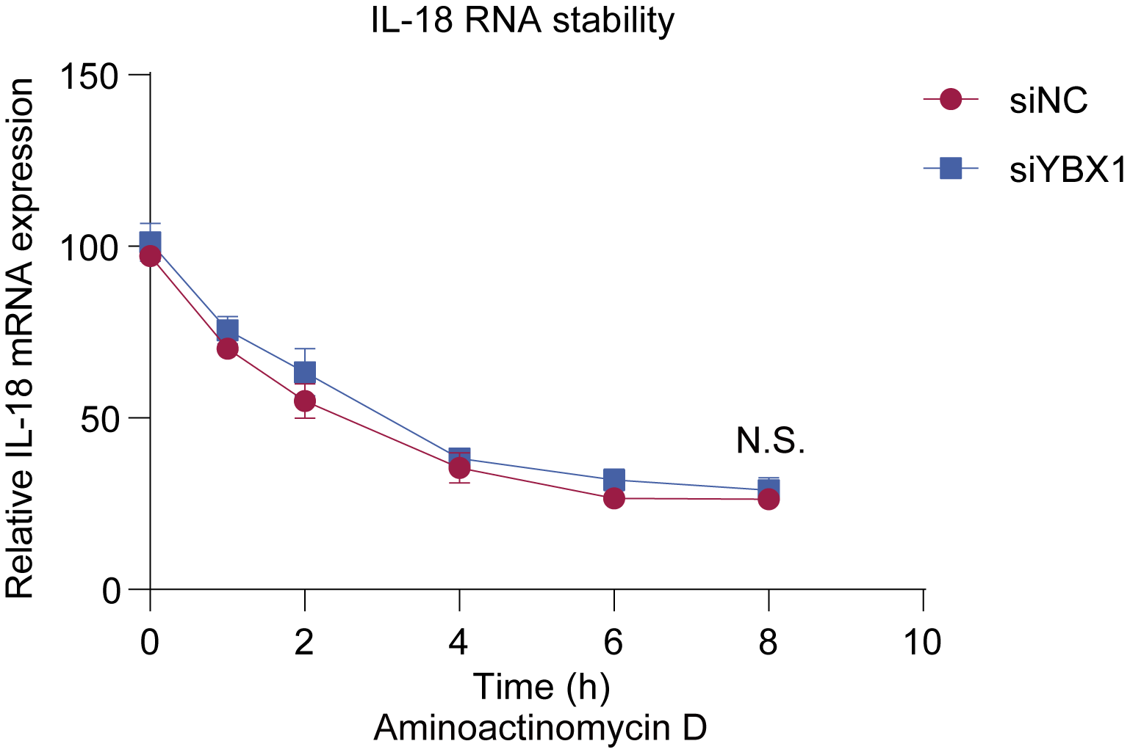
Supplementary Figure 6. YBX1 nuclear localization promoted IL-18 transcription. SW1990 cells were pretreated with aminoactinomycin D for the indicated time and then qRT-PCR was performed to detect IL-18 mRNA changes.

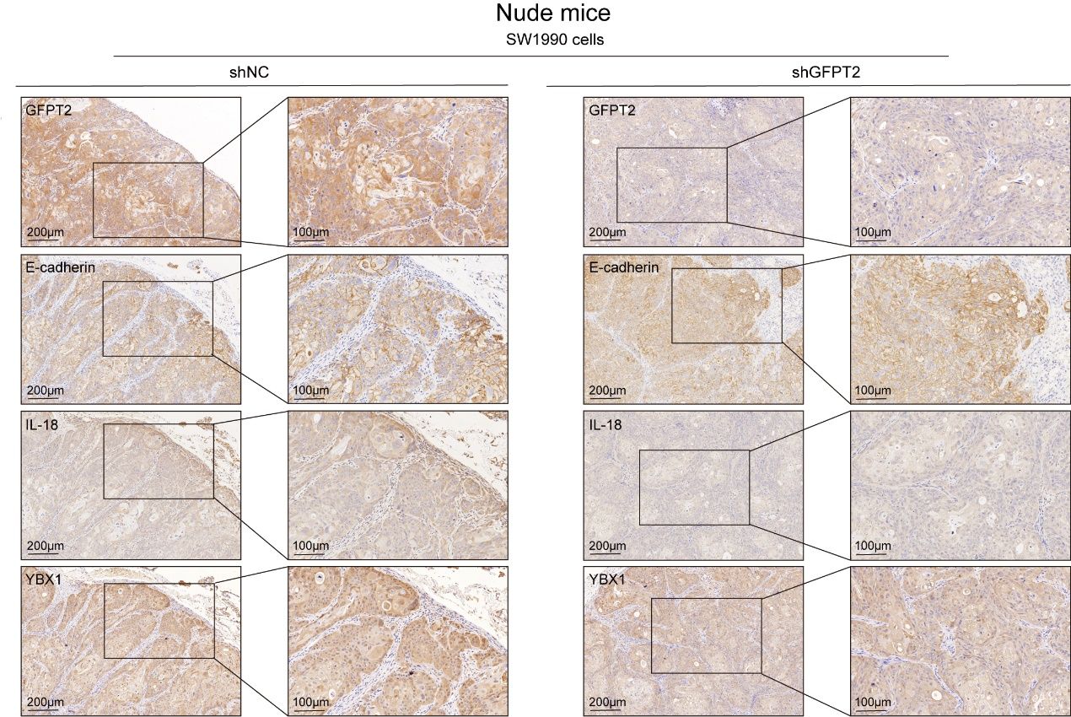
Supplementary Figure 7. The GFPT2-YBX1-IL-18 signaling was further confirmed in vivo experiments. Immunohistochemical assay to detect the expression of GFPT2, YBX1, IL-18 and E-cadherin in subcutaneously implanted tumor tissues of nude mice.

