SUPPLEMENTARY MATERIAL
Supplementary Table 1. Primer sequences used for quantitative RT-PCR
Target | Primer | Sequences
Human Beclin 1 | Forward  Reverse | 5′-GAG CTG GAA GAC GTG GAA AAG A-3′  5′-GCC TGG ACC TTC TCG AGA TTT-3′
Human LC3B | Forward  Reverse | 5′-GGC GCT TAC AGC TCA ATG C -3′  5′-ATG CTG TGT CCG TTC ACC AA-3′
Human p62 (SQSTM1) | Forward  Reverse | 5′-GAG CGG CTC TGG ACA CCA T-3′  5′-TGG GCA AAA GTG GTC ACA AC-3′
Human ATG5 | Forward  Reverse | 5′-TGA CAA AGA TGT GCT TCG AGA TG-3′  5′-ATA GTA TGG TTC TGC TTC CCT TTC A-3′
Human E-cadherin | Forward  Reverse | 5′-GGC CTG AAG TGA CTC GAT ACG A-3′  5′-CAG CCG CTT TCA GAT TTT GAT C-3′
Human Fibronectin | Forward  Reverse | 5′-CCA AGA AGG GCT CGT GTG A-3′  5′-GGC TGG AAC GGC ATC AAC-3′
Human NOX1 | Forward  Reverse | 5′-TGC CTA GAA GGG CTC CAA AC-3′  5′-ACA TTC AGC CCT AAC ACA AC-3′
Human NOX2 | Forward  Reverse | 5′-AGG GTC AAG AAC AGG CTA AGG A-3′  5′-TTC TCC ACC TCC AAC CCT CTT T-3′
Human NOX4 | Forward  Reverse | 5′-AAG CCA GTC ACC ATC ATT TCG-3′  5′-CTT TGA CCA TTC GGA TTT CCA-3′
Human P22phox | Forward  Reverse | 5′-ACTTTGGTGCCTACTCCATTGTG-3′  5′-TGTCCCCAGCGCTCCAT-3′

Supplementary Figure S1.
Figure S1. Effect of ATG5 gene silencing on TGF-β1-induced autophagy activation and EMT in HPMCs. (A, B) ATG5 gene silencing suppressed the TGF-β1 (2 [siATG5+T2] and 5 [siATG5+T5] ng/mL)-induced autophagy activation, which was confirmed via Western blotting analysis with a decrease in the ATG5, Beclin 1, and LC3B levels and an increase in the p62 levels. Protein levels of the mesenchymal markers (fibronectin and α-SMA) were decreased by ATG5 gene silencing in TGF-β1-treated HPMCs. The data are presented as the mean ± standard error (SE); n = 4 per group. *P < 0.05 vs. control small interfering RNA (siCon); **P < 0.01 vs. siCon; ***P < 0.001 vs. siCon; #P < 0.05 vs. siCon+TGF-β1 2 ng/mL (siCon+T2); ##P < 0.01 vs. siCon+T2; ###P < 0.001 vs. siCon+T2; ⁺P < 0.05 vs. siCon+TGF-β1 5 ng/mL [siCon+T5]; ⁺⁺P < 0.01 vs. siCon+T5; and ⁺⁺⁺P < 0.001 vs. siCon+T5.

Supplementary Figure S2.
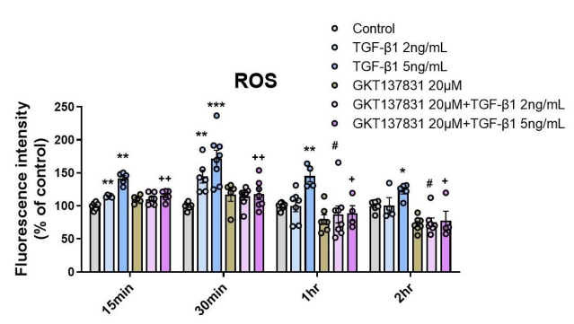
Figure S2. NOX4 inhibition ameliorates TGF-β1-induced ROS generation in HPMCs. TGF-β1 treatment (2 and 5 ng/mL) increased the generation of ROS at 15 min, 30 min, 1 h, and 2 h in the HPMCs. The GKT137831 co-treatment (20 μM) reduced the ROS assessed using DCF-DA. The data are presented as the mean ± standard error (SE). *P < 0.05 vs. control; **P < 0.01 vs. control; ***P < 0.001 vs. control; #P < 0.05 vs. TGF-β1 2 ng/mL; ⁺P < 0.05 vs. TGF-β1 5 ng/mL; and ⁺⁺P < 0.01 vs. TGF-β1 5 ng/mL.

Supplementary Figure S3.

Figure S3. Autophagy inhibition by ATG5 gene silencing inactivates the Smad2/3, PI3K/AKT, and ERK pathways in HPMCs. ATG5 gene silencing decreased the TGF-β1 (2 [siATG5+T2] and 5 [siATG5+T5] ng/mL)-induced phosphorylation of Smad2/3 signaling for EMT (A, B), PI3K and AKT signaling for autophagy (A, C), and ERK and P38 signaling of the MAPK pathway (A, D). The data are presented as the mean ± standard error (SE); n = 4 per group. *P < 0.05 vs. control small interfering RNA (siCon); **P < 0.01 vs. siCon; ***P < 0.001 vs. siCon; #P < 0.05 vs. siCon+TGF-β1 2 ng/mL (siCon+T2); ##P < 0.01 vs. siCon+T2; ⁺P < 0.05 vs. siCon+TGF-β1 5 ng/mL (siCon+T5); ⁺⁺P < 0.01 vs. siCon+T5; and ⁺⁺⁺P < 0.001 vs. siCon+T5.

