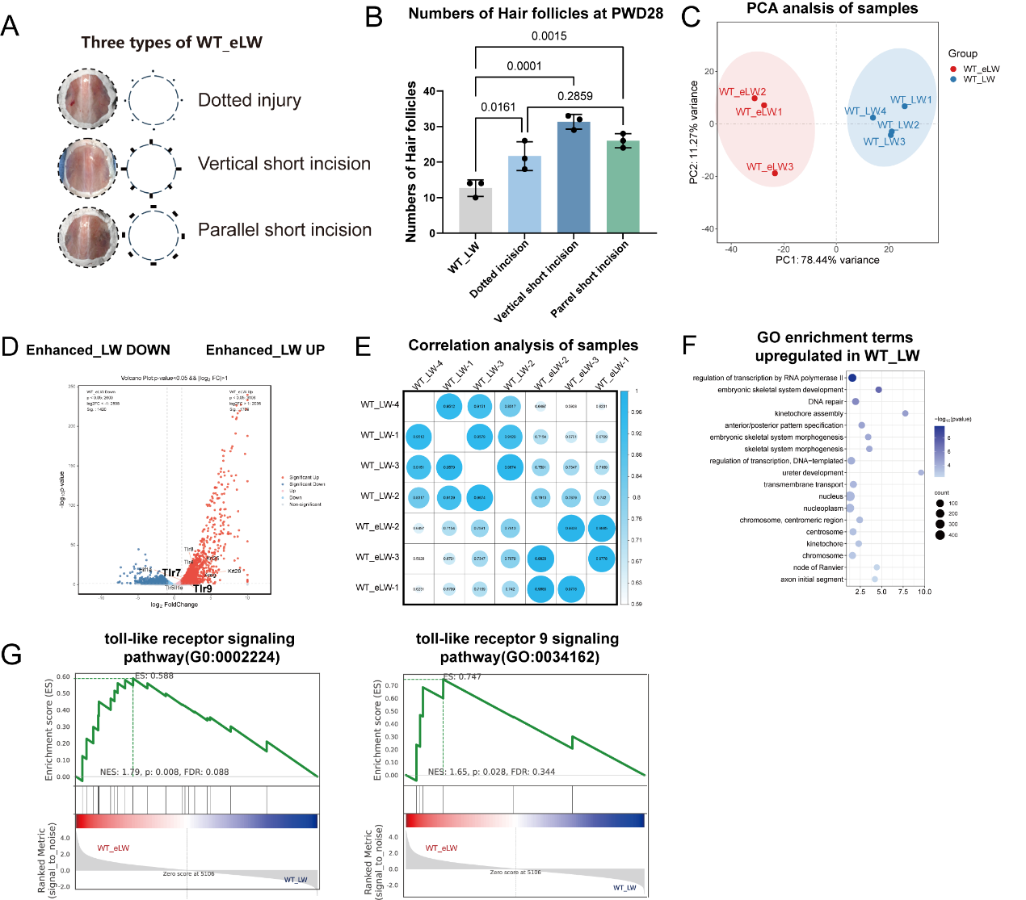
Fig S1. Evaluation of the wound healing process with WT_eLW. A) The three types of WT_eLW and the wound models. B) Number of regenerated hair follicles in PWD28. Statistical analysis was performed using one-way ANOVA with Dunnett’s multiple comparisons test. n=3 for each group. C) The PCA analysis of bulk-RNA sequence samples. D) The volcano plot showing the genes expressed in WT_eLW and WT_LW. The threshold for screening differential genes was p-value<0.05 and |log2FC|>1. E) Correlation analysis heatmaps of WT_eLW and WT_LW. F) GO terms enriched in WT_LW. G) The GSEA enrichment analysis of toll-like receptor signaling pathway and toll-like receptor 9 signaling pathway. All error bars ±SD.

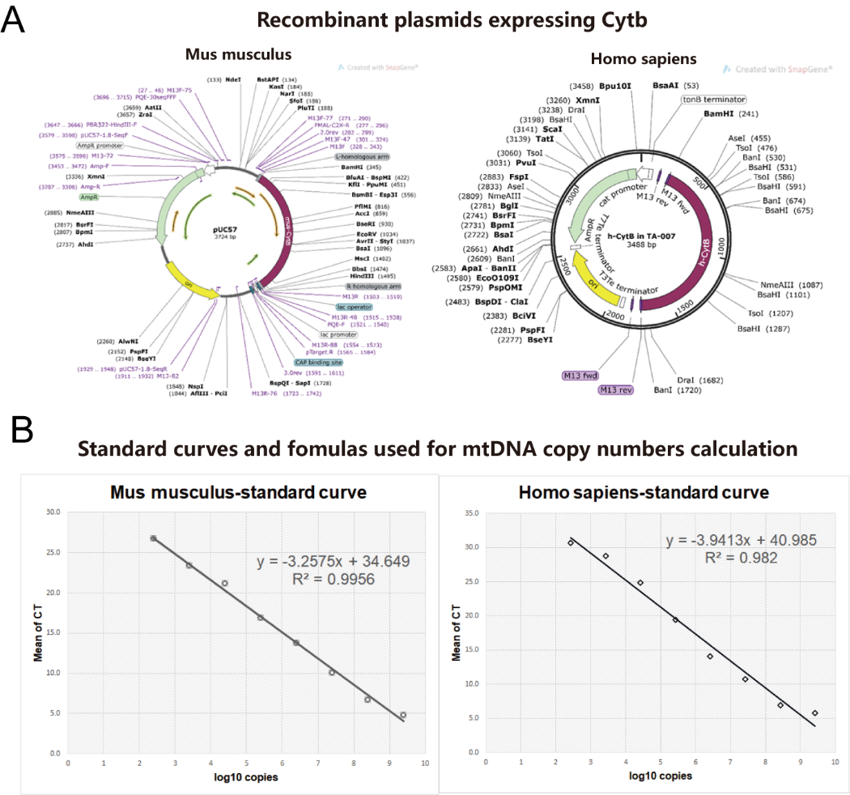

Fig S2. A) The recombiant plasmids expressing cytb of mus musculus and homo sapiens, respectively. B) Standard curves and formulas between CT number and copy numbers calculated by plasmids standards.
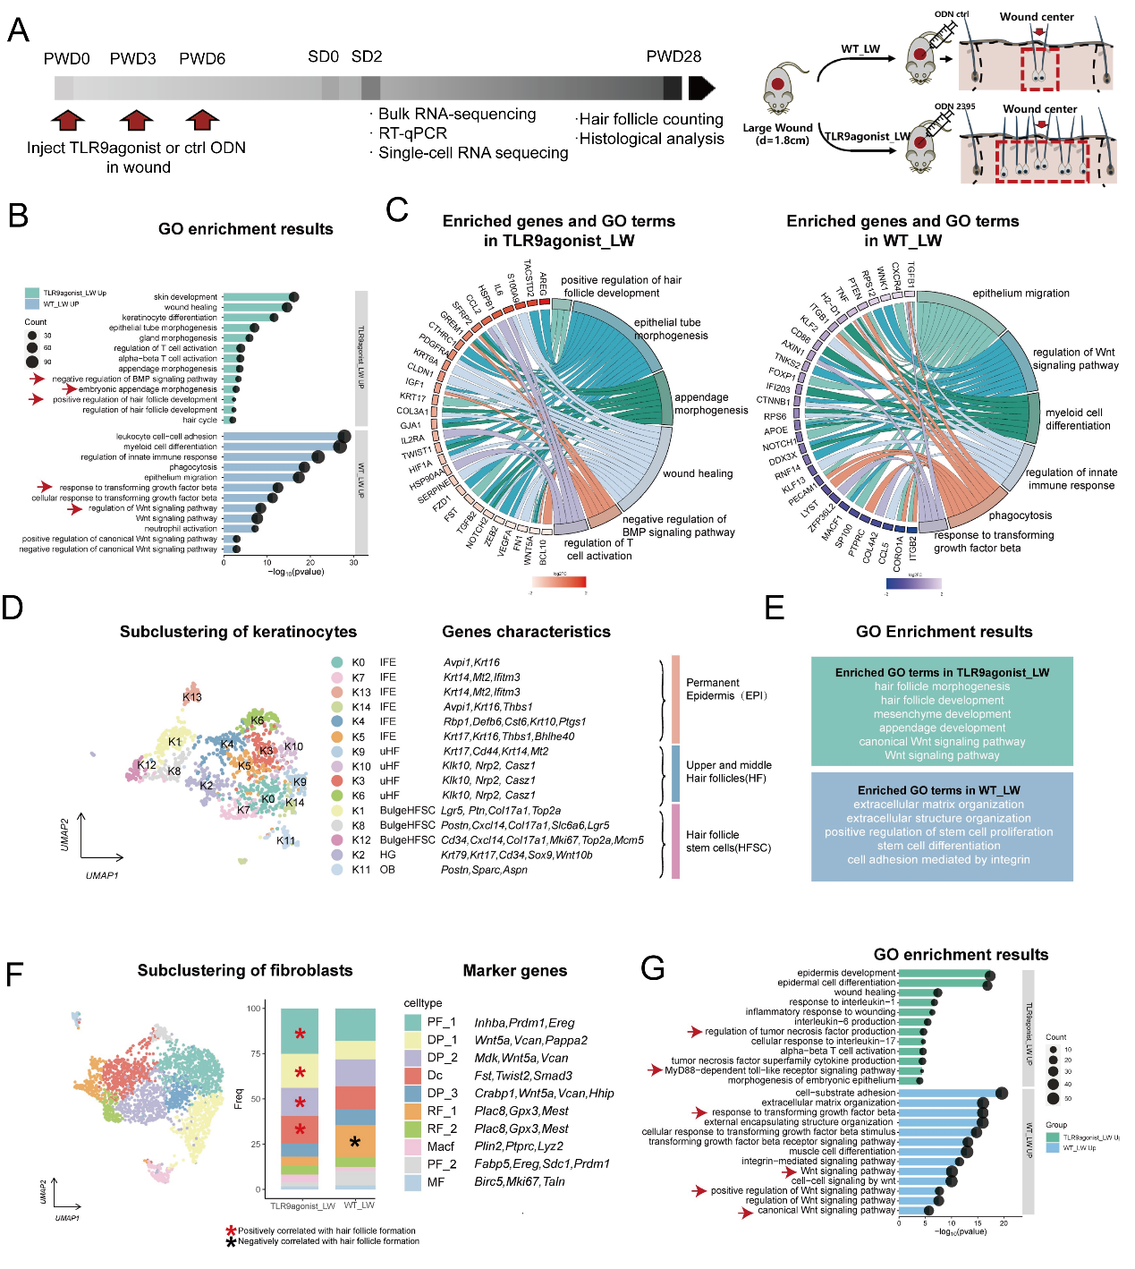
Fig S3. The subcluster and analysis of neutrophils and macrophages. A) Workflow for evaluating the function of TLR9 and mtDNA in large-scale wound healing. The second day after scab detachment (SD2) was chosen as our observation time for hair follicle neogenesis. B) The subclustering of neutrophils and relative cell ratios and marker genes. C) The subclustering of macrophages and dendritic cells. D) The annotations and marker genes of macrophages and dendritic cells. E) The KEGG enrichment terms for every subclusters. F) The expression of phagocytosis related genes in macrophages and dendritic cells. And the genes in wnt pathway of all cells and fibroblasts. G) The expression of inhibitors of wnt pathway in all cells.
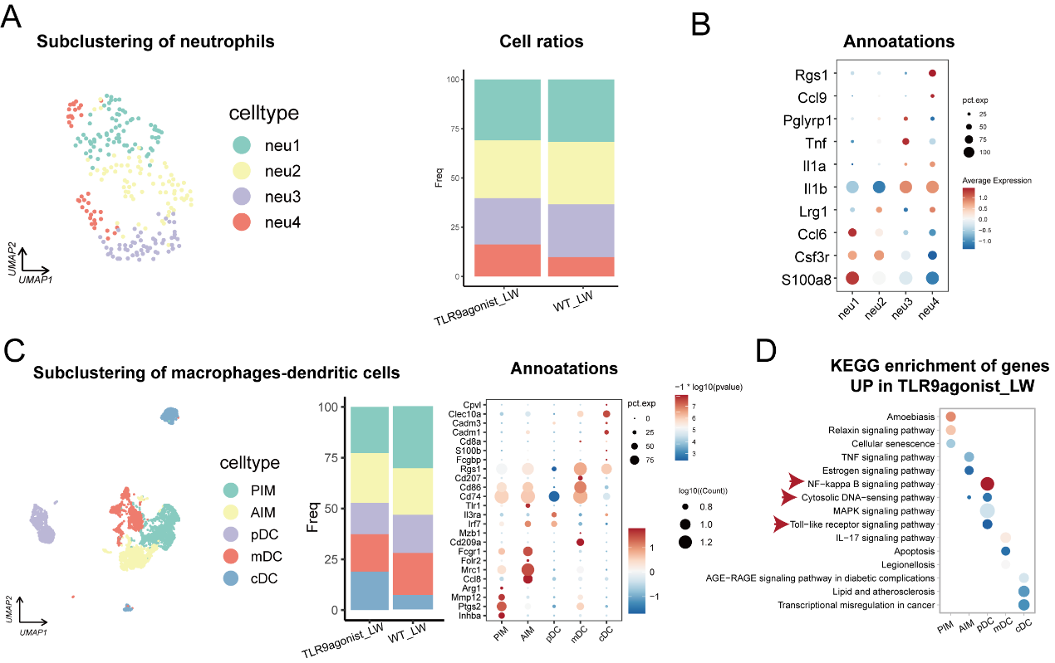
Fig S4. The subcluster and analysis of neutrophils and macrophages. A) The subclustering of neutrophils and relative cell ratios. B) Marker genes used for annotations of neutrophils. C) The subclustering, annotations and marker genes of macrophages and dendritic cells. D) The KEGG enrichment terms for every subclusters.

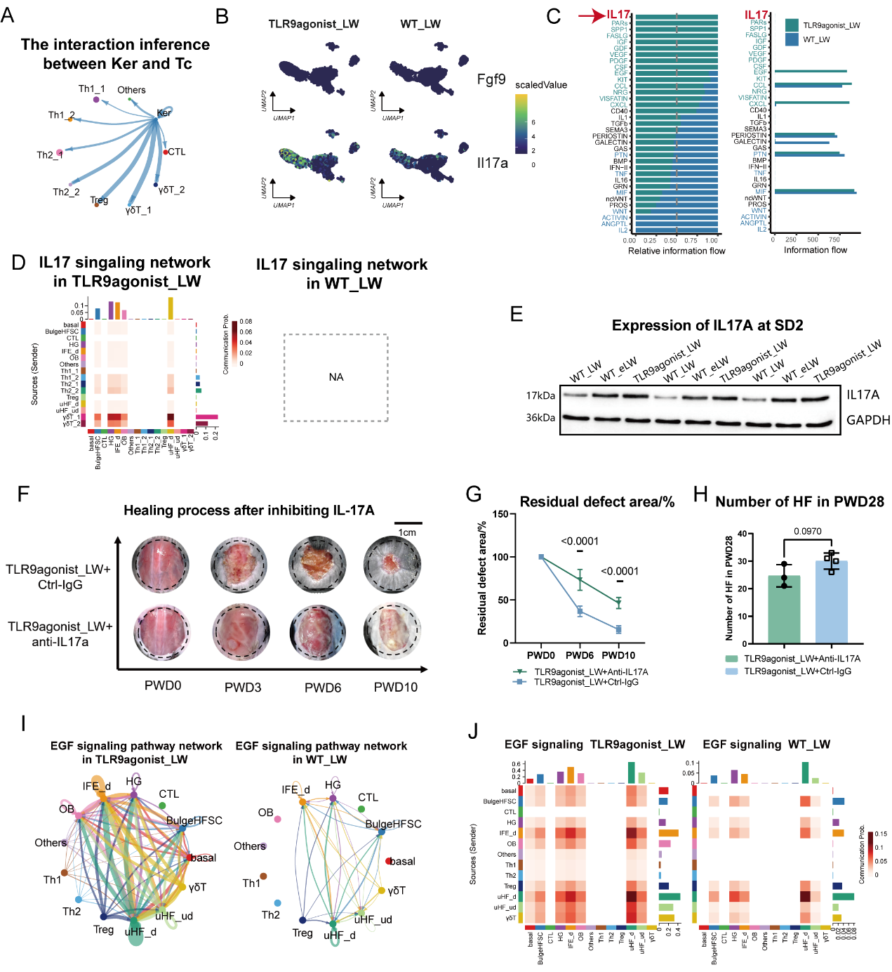
Fig S5. The function of γδT in promoting WIHN is not dependent on IL-17A. A) The chord graph showing the interaction inference between Ker (keratinocytes) and Tc (T cells). B) The expression of Fgf9 and IL-17a in scRNA data. The feature plots showing the expression of IL-17a in T cells were mainly in γδT cells and the expression levels were different in TLR9agonist_LW and WT_LW. C) The differential interaction pathways in TLR9agonist_LW and WT_LW. D) The IL-17 interaction networks between T cells and keratinocytes in TLR9agonist_LW and WT_LW. E) The expression of IL-17A in WT_LW, WT_eLW and TLR9agonist_LW at SD2 was detected by western blotting. GAPDH was used as loading control. F) The photos of wounds in TLR9agonist_LW injected with Ctrl-IgG (30000-0-AP, Proteintech), or anti-IL-17A (10μg per time per mouse. PAB30184, Bioswamp). Pictures were taken from same mice in the time span. G-H) The changes of healing speeds and regeneration outcomes after injection of anti-IL-17A or Control-IgG into the wound bed at PWD 0,3,6. n=3-4 for each group. I) The chord plots showing the EGF signaling pathway network between T cells and keratinocytes in TLR9agonist_LW and WT_LW. The interaction of EGF pathway between T cells and keratinocytes was mostly between γδT cells to uHF_d, IFE_d, OB and HG. J) The heatmaps showing the EGF signaling pathway network between T cells and keratinocytes in TLR9agonist_LW and WT_LW.

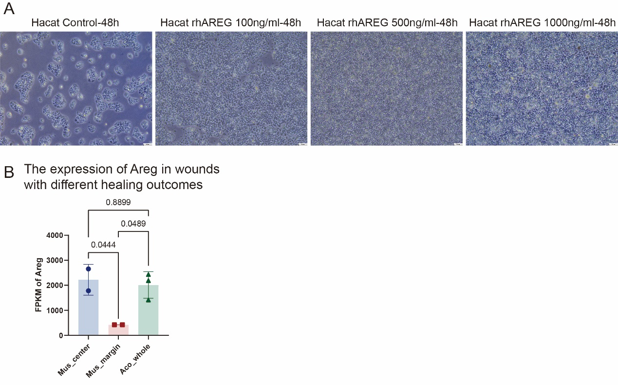
Fig S6. The effect of recombinant AREG to Hacat after 48h. A) The differential appearance of cells growth after being cultured with mouse recombinant AREG protein (100ng/mL, 500ng/mL, 1000ng/mL) (P15514, novoprotein) in the culture medium for 48h. B) The FPKM (fragments per kilobase of transcript per million fragments) of Areg in wounds with different WIHN outcomes from GSE159939. The wound center at PWD14 in Mus musculus (high-WIHN) and the whole wound at PWD14 in Acomys spiny mice (high-WIHN) have higher expression level of Areg than the wound margin at PWD14 in Mus musculus (low-WIHN).

Table S1: Primers used for RT-qPCR:
Gene symbol | Species | Forward (5’-3’) | Reverse (3’-5’)
Cytb | Mouse | TGAGGGGGCTTCTCAGTAGA | CTGTTTCGTGGAGGAAGAGG
Cytb | Human | ATGACCCCAATACGCAAAAT | CGAAGTTTCATCATGCGGAG
Tlr9 | Mouse | TGTGAGCTGAAGCCTCATGG | GGACAGGTGGACGAAGTCAG
Tlr9 | Human | CTGCGTTTTGTCGAAGACCA | CCCACCTGTCACTCAAGTACA
Areg | Human | TGAGATGTCTTCAGGGAGTG | AGCCAGGTATTTGTGGTTCG
Wnt10b | Human | CATCCAGGCACGAATGCGA | CGGTTGTGGGTATCAATGAAGA
Ctnnb1 | Human | CATGCACCTTTGCGTGAGCA | CCCCCTCCACAAATTGCTGC
Twist1 | Human | GTCCGCAGTCTTACGAG | CACGCCCTGTTTCTTTG
Twist2 | Human | AGAAGTCGAGCGAAGATG | CCTGGTAGAGGAAGTCTATG
Bmp6 | Human | CAGCCTGCAGGAAGCATGAG | CAAAGTAAAGAACCGAGATG
β-actin | Mouse/Human | CCAACCGTGAAAAGATGACC | ACCAGAGGCATACGGGACA

