Supplementary Tables and Supplementary Figures

Supplementary Table 1 List of Zn+-dependent JAMM deubiquitinases
MYSM1 | MPND | COPS6 | PRPF8 | EIF3H
COPS5 | STAMBPL1 | BRCC3 | STAMBP | PSMD7
PSMD14

Table S2 Relationship between STAMBP expression and clinicopathological features.
Parameters | n | STAMBP expression |  | P value
Parameters | n | Low (N=45) | High (N=83) | P value
Age (years) |  |  |  | P=0.3581
≤65 | 50 | 20 | 30
＞65 | 78 | 25 | 53
Sex |  |  |  | P=0.3319
Female | 58 | 23 | 35
Male | 70 | 22 | 48
Tumour size (cm) |  |  |  | P=0.007
＜5 | 85 | 23 | 62
≥5 | 43 | 22 | 21
Tumour stage |  |  |  | P=0.0035
T1-T2 | 49 | 22 | 28
T3-T4 | 79 | 13 | 55
Distant metastasis |  |  |  | P=0.9253
No | 90 | 30 | 60
Yes | 38 | 13 | 25
Histologic grade |  |  |  | P=0.2547
High | 45 | 19 | 26
Low to medium | 83 | 27 | 57
Differentiation |  |  |  | P=0.0127
Well | 55 | 26 | 29
Moderate/poor | 73 | 19 | 54

Table S3. Univariate and multivariate analyses of overall survival in PC patients

Parameters | Univariate analysis |  |  | Multivariate analysis
 | HR | 95%CI | P value | HR | 95%CI | P value
Age  (≥65 vs ＜65) | 1.532 | 0.652-1.735 | 0.755 | — | — | —
Sex  (Female vs Male) | 1.751 | 0.792-2.034 | 0.539 | — | — | —
Distant metastasis  (No vs Yes) | 1.369 | 0.539-2.865 | 0.391 | — | — | —
TNM stage  (T1-T2 vs T3-T4) | 1.831 | 1.385-3.122 | 0.081 | — | — | —
Tumor size  (＜5 vs ≥6) | 1.799 | 1.551-3.866 | 0.016* | 1.378 | 1.107-2.325 | 0.043*
Histologic grade  (High vs Low to medium) | 2.834 | 1.636-4.339 | 0.003* | 1.651 | 1.389-3.531 | 0.011*
Differentiation  (Well vs Moderate/Poor) | 1.839 | 1.365-3.312 | 0.039* | 1.110 | 0.895-2.241 | 0.308
STAMBP expression  (High vs Low) | 5.037 | 3.045-5.039 | 0.001* | 2.245 | 1.851-3.695 | 0.005*

Table S4. 2D image of FDA small molecules and interaction forces obtained through STAMBP protein screening
No. | Compound name | CAS | Docking  score | Structure
1 | Avatrombopag | 570406-98-3 | -8.616 | 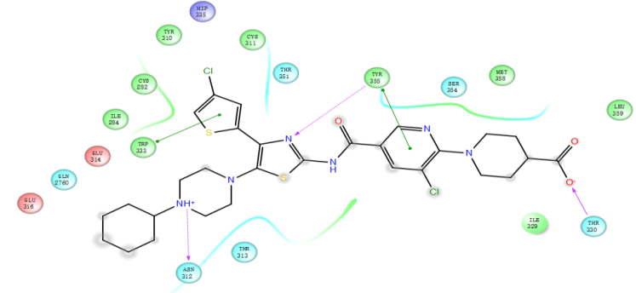
2 | Entrectinib | 1108743-60-7 | -7.957 | 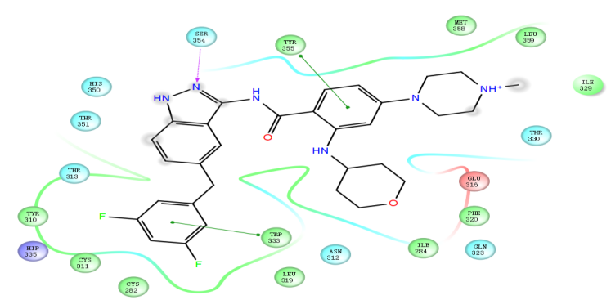
3 | Ranolazine | 95635-55-5 | -7.770 | 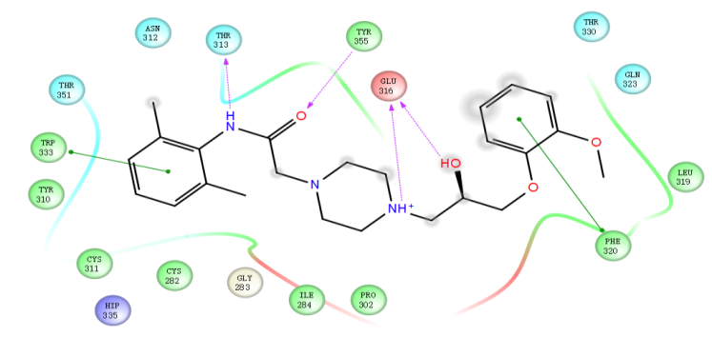
4 | DCC-2618 | 1442472-39-0 | -7.389 | 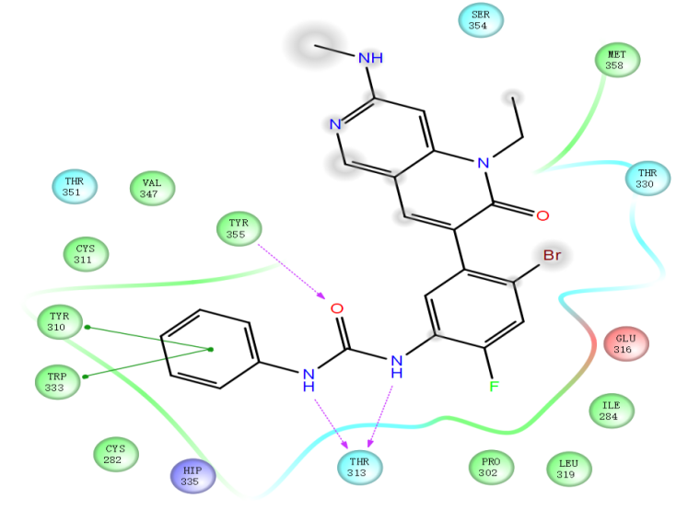
5 | Olmutinib | 1353550-13-6 | -7.272 | 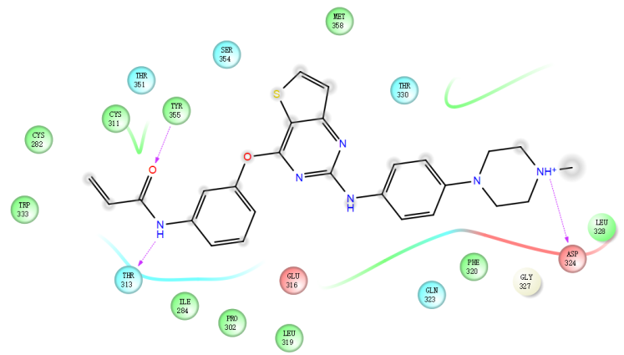
6 | Levonebivolol | 118457-14-0 | -7.178 | 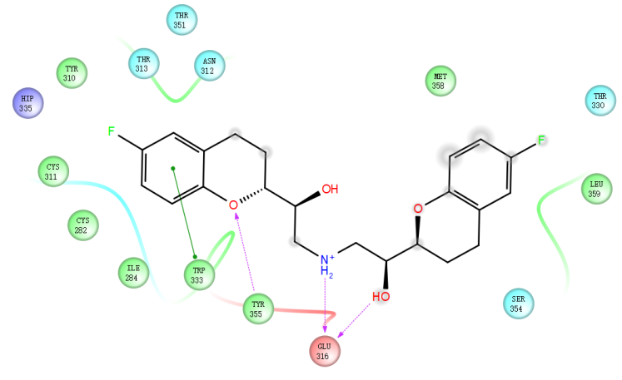
7 | Dasatinib | 854001-07-3 | -7.168 | 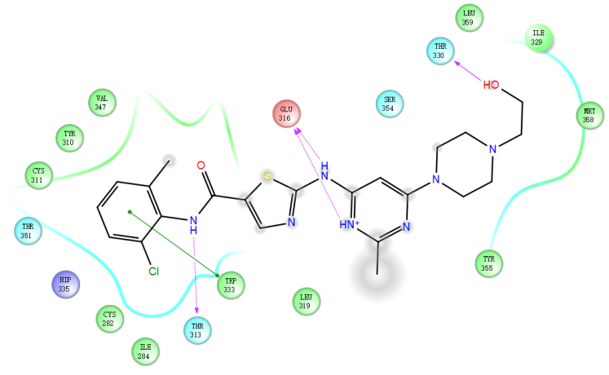
8 | Ivosidenib | 1448346-63-1 | -7.157 | 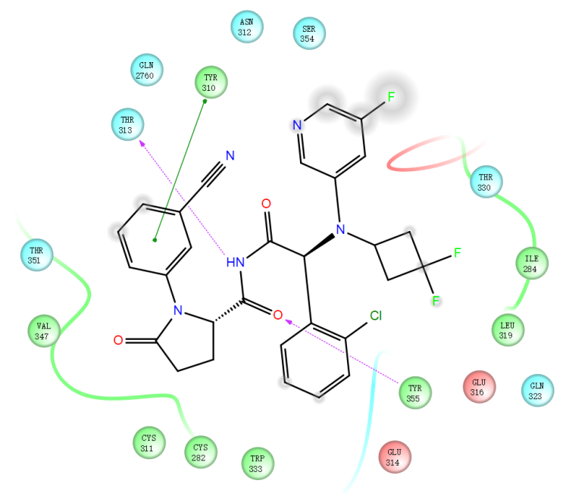
9 | Desfesoterodine | 207679-81-0 | -7.150 | 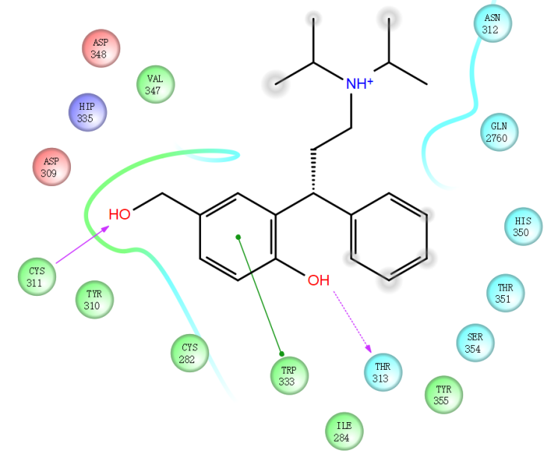
10 | Dasatinib | 302962-49-8 | -7.149 | 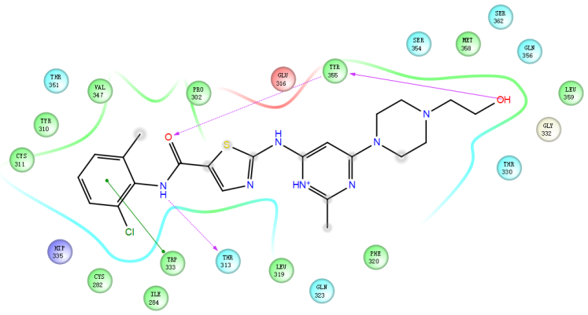
11 | Zanubrutinib | 1691249-45-2 | -7.048 | 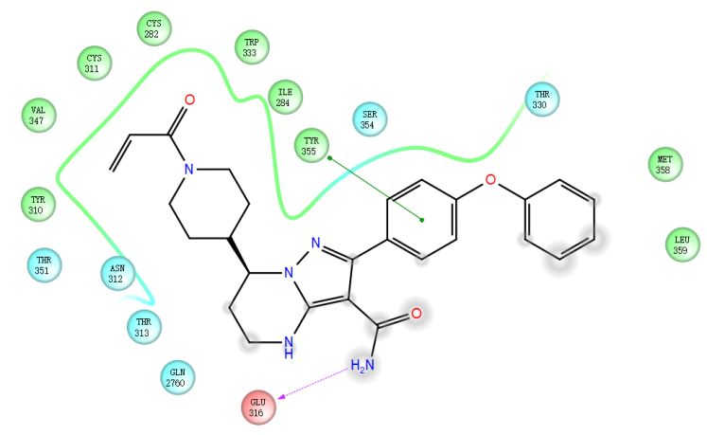
12 | Vilazodone | 163521-08-2 | -7.006 | 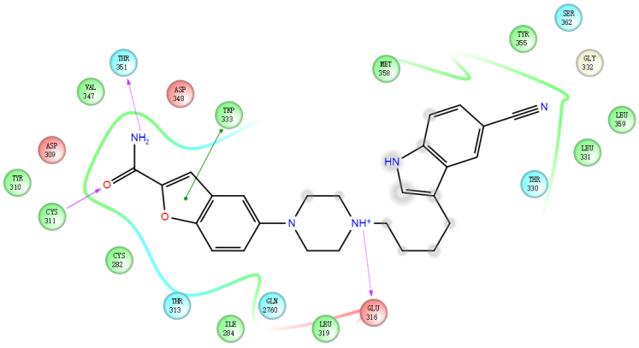
13 | CB-5083 | 1542705-92-9 | -6.961 | 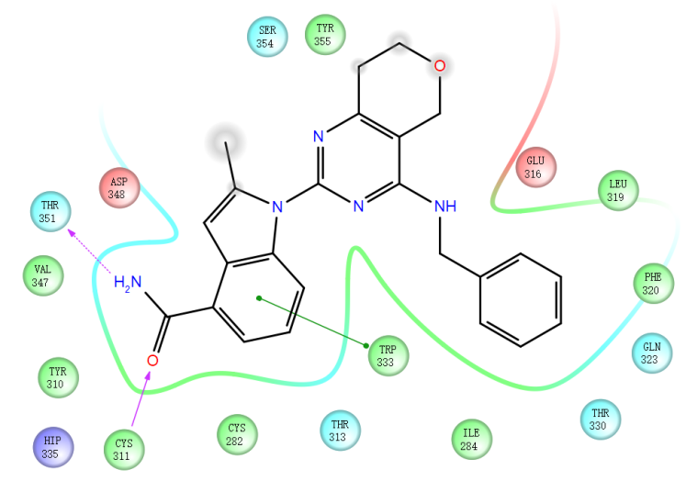
14 | Frovatriptan | 158930-09-7 | -6.949 | 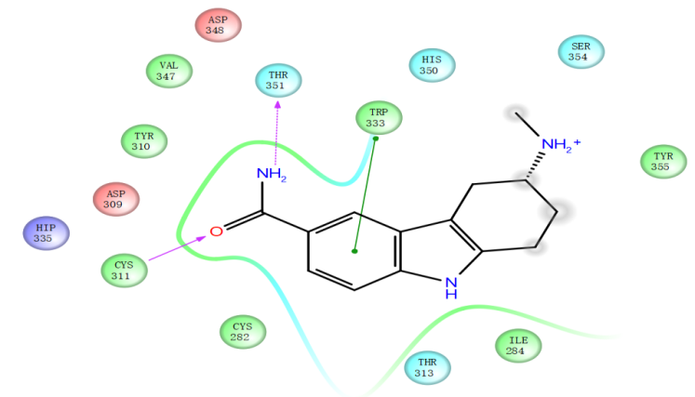
15 | Nilotinib | 641571-10-0 | -6.821 | 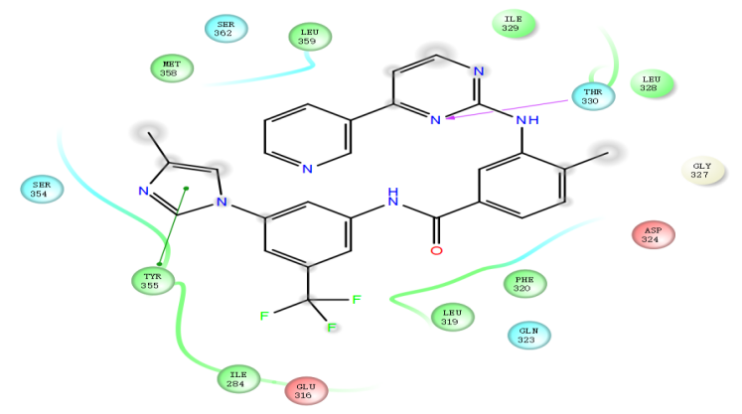
16 | Brigatinib | 1197953-54-0 | -6.810 | 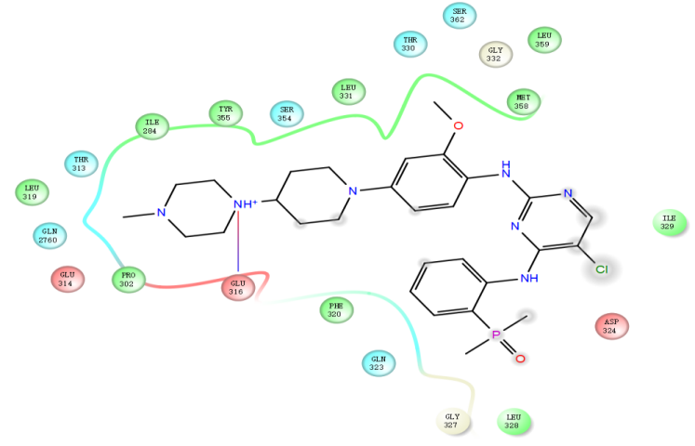
17 | Canagliflozin | 842133-18-0 | -6.770 | 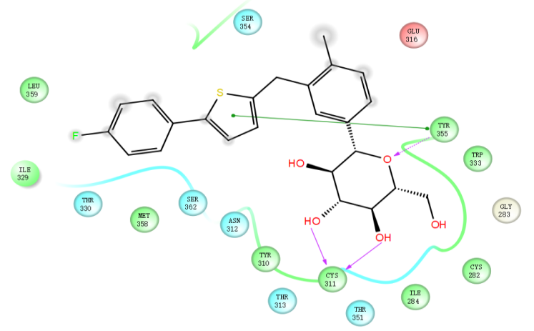
18 | Nicarbazin | 330-95-0 | -6.766 | 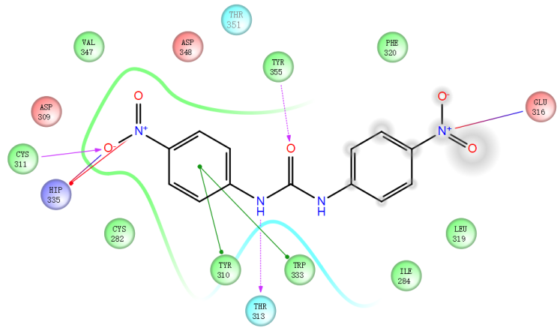
19 | Baricitinib | 1187594-09-7 | -6.756 | 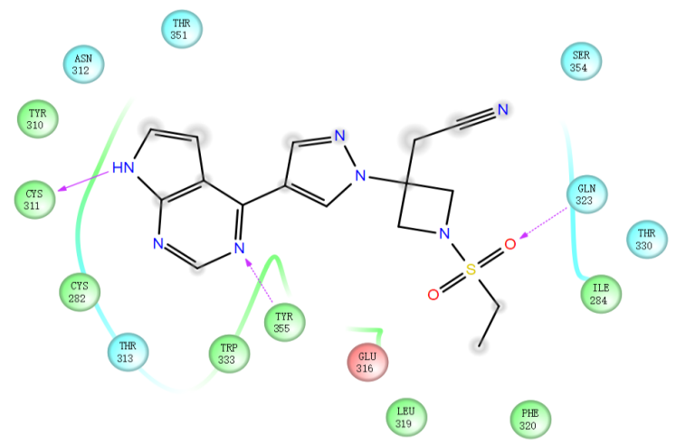
20 | Plerixafor | 110078-46-1 | -6.754 | 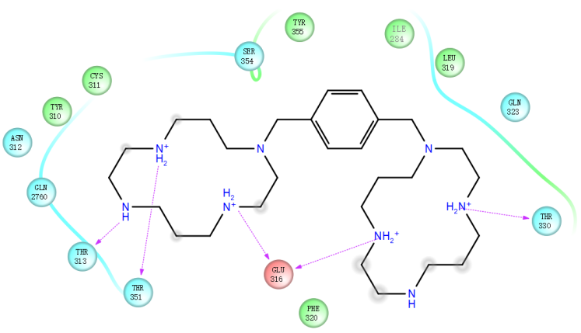

Supplementary Figures

Supplementary Figure 1. STAMBP may serve as a valuable new prognostic factor for human PC. A, Analysis of the 11 differentially expressed Zn⁺-dependent JAMM deubiquitinases in PC tissues and the normal tissue from the TCGA-PAAD dataset. ***P<0.001. B, Expression of STAMBP progressively increases with the increase of PC grades. **P<0.01. C, The CNV variation frequency of Zn⁺-dependent JAMM deubiquitinases in TCGA-PAAD cohort. The height of the column represented the alteration frequency. The deletion frequency, blue dot; The amplification frequency, red dot. D, The location of CNV alteration of Zn⁺-dependent JAMM deubiquitinases on 23 chromosomes using TCGA-PAAD cohort.

Supplementary Figure 2. Knockdown STAMBP does not affect other proteins in the Zn+-dependent JAMM deubiquitinases family
A, The mRNA levels of the Zn+-dependent JAMM deubiquitinases family in the PANC-1/shSTAMBP cells were detected by qRT-PCR. ***P<0.001. B, The protein levels of the Zn+-dependent JAMM deubiquitinases family in the PANC-1/shSTAMBP cells were detected by western blot.

Supplementary Figure 3. Upregulation of STAMBP decreased the chemotherapy sensitivity of PC to GEM. A, western blot showing the protein expression of STAMBP in gemcitabine-resistant (GR) PC cells following transfected with vector or Flag-STAMBP. Tubulin was a loading control. B, qRT-PCR assay showing the mRNA level of STAMBP in gemcitabine-resistant (GR) PC cells following transfected with vector or Flag-STAMBP. **P<0.01. C and D, IC50 value of gemcitabine in BxPC-3/GR (C) and SW1990/GR (D) cells transfected with vector or Flag-STAMBP by the CCK-8 assay. E and F, the quantification of cell apoptosis assay in PANC-1/GR (E) and Capan-2/GR (F) cells transfected with or without shSTAMBP by flowcytometry, under gemcitabine treatment (2 µM, 48 h). G, Kaplan–Meier survival curves for the shNC+GEM and shSTAMBP+GEM group.

Supplementary Figure 4. STAMBP enhanced aerobic glycolysis in PC cells. A, G6P levels, glucose uptake, the production of lactate and ATP production were measured in Capan-2/shSTAMBP or SW1990/Flag-STAMBP cells. *P<0.05. B and C, ECAR data showing the glycolytic rate and capacity in Capan-2/shSTAMBP cells. **P<0.01. D and E, OCR results showing the basal respiration and maximum respiration in Capan-2/shSTAMBP cells. **P<0.01. F and G, ECAR data showing the glycolytic rate and capacity in SW1990/Flag-STAMBP cells. **P<0.01. H and I, OCR results showing the basal respiration and maximum respiration in SW1990/Flag-STAMBP cells. **P<0.01.

Supplementary Figure 5. E2F1 is a transcription factor of PDK1 in PC cells. A, Co-IP assay showing that endogenous STAMBP and PDK1 were not directly bound in BxPC-3 cell. B and C, the protein (B) and mRNA level (C) of E2F1 and PDK1 were detected in Capan-2/shE2F1 cells. Tubulin was a loading control. ***P<0.001. D and E, the protein (D) and mRNA level (E) of E2F1 and PDK1 were detected in SW1990/His-E2F1 cells. Tubulin was a loading control. ***P<0.001. F and G, Full-length PDK1 promoter luciferase construct was transfected into the Capan-2/shE2F1 cells (F) and SW1990/His-E2F1 (G) cells. Transcriptional activation was analyzed with the dual luciferase reporter assay. ***P<0.001 vs control group.

Supplementary Figure 6. E2F1 mRNA levels did not influence the variation in STAMBP expression in PC cells. A, the mRNA levels of STAMBP and E2F1 in the Capan-2/shE2F1 cells were detected by qRT-PCR. ***P<0.001. B, the mRNA levels of STAMBP and E2F1 in SW1990/His-E2F1 cells were detected by qRT-PCR. ***P<0.001.

Supplementary Figure 7. Entrectinib increased GEM sensitivity in PC by inhibiting the activity of STAMBP. A and B, ECAR data showing the glycolytic rate and capacity in Capan-2 cells following treatment with the entrectinib. **P<0.01. C and D, OCR results showing the basal respiration and maximum respiration in Capan-2 cells following treatment with the entrectinib. *P<0.05. E, the protein levels of STAMBP, PDK1, and E2F1 in Capan-2-G/R cells were detected after treatment with the entrectinib. F and G, Representative images (left) and quantification (right) of PI-positive cell population in the indicated cells. **P<0.01. H, tumor wight in PDXs treated with entrectinib, gemcitabine, or both. **P<0.01. I, Representative images of H&E, STAMBP, E2F1, PDK1, and Ki-67 staining of the tumor tissues in PDXs treated with entrectinib, gemcitabine, or both. Scale bar, 50 μm.

