Supplementary information for

The NRF2-CARM1 axis links glucose sensing to transcriptional
and epigenetic regulation of the pentose phosphate pathway in gastric cancer

Miaomiao Ping, et al.

Supplementary Figure 1
A
B

73 kDa
20 kDa
30 kDa
45 kDa
GCLC
SOD1
Glc (mM)
25
2.5
25
2.5
25
2.5
NQO1
β-actin
MGC-803
Glc (mM)
GCLC
SOD1
NQO1
β-actin
73 kDa
20 kDa
30 kDa
45 kDa
12
2.5
12
2.5
12
2.5
AGS
C
D

Supplementary Figure 1. Glucose starvation results in cellular ROS accumulation and activation of NRF2. A. Cellular ROS was measured in MGC-803 and AGS cells with the indicated concentration of glucose incubated for 18 h using the ROS-sensitive fluorescent dye CM-H₂DCFDA and flaxstation3. B. Quantitative PCR analysis of the expression of NRF2 target genes in MGC-803 and AGS cells after glucose deprivation. C, D. MGC-803 and AGS cells were exposed to glucose deprivation as indicated for 18 h. Levels of GCLC, SOD1 and NQO1 protein expression were analyzed by Western blotting. β-actin was used as a loading control. All data are shown as mean±SEM. The P values were determined by two-tailed t-tests, and values of P<0.05 were considered statistically significant. ns, not significant; *, P<0.05; **, P<0.01; ***, P<0.001.

Supplementary Figure 2
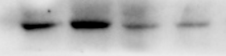
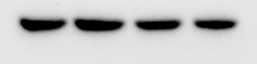
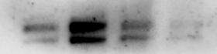
AGS
+
Lenti-V₂
-
-
+
NRF2-sg
NRF2
CARM1
β-actin
H₂O₂ (1mM)
100 kDa
62 kDa
45 kDa
-
Lenti-V₂
MGC-803
+
-
NRF2
CARM1
β-actin
+
H₂O₂ (1mM)
NRF2-sg
100 kDa
62 kDa
45 kDa
C
B
A

Supplementary Figure 2. The upregulation of CARM1 induced by glucose starvation is dependent on ROS. A. MGC-803 cells and AGS cells were treated with the indicated concentration of glucose and supplemented or not with 1 mM NAC for 18 h prior to measurement of ROS. B, C. CARM1 and NRF2 levels were analyzed in MGC-803 and AGS cells with parental NRF2 (Lenti-V₂) or NRF2 knockdown (NRF2-sg) after treatment or not with 1 mM H₂O₂ for 0.5 h. β-actin served as the loading control. All data are shown as mean±SEM. The P values were determined by two-tailed t-tests, and values of P<0.05 were considered statistically significant. ns, not significant; *, P<0.05; **; P<0.01.

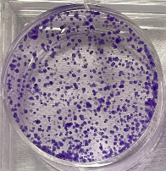
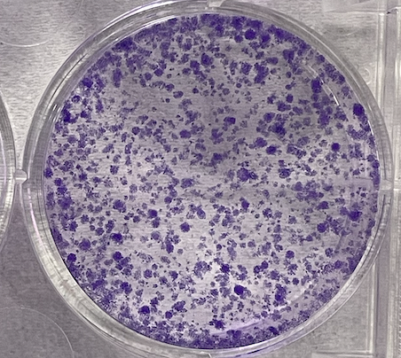
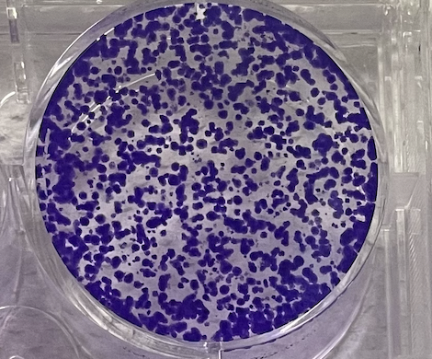
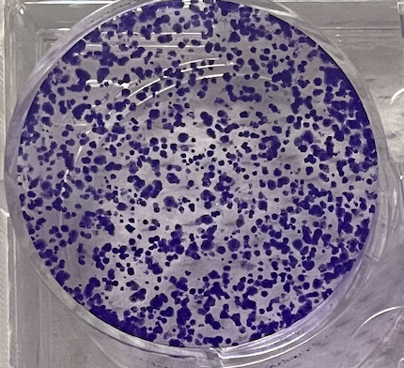
Supplementary Figure 3
A
B
C
D
E

Supplementary Figure 3. Under normal glucose conditions, CARM1 knockdown has a less pronounced impact on the malignant behavior of gastric cancer cells compared to low glucose conditions. A. The proliferation of MGC-803 and AGS cells with parental CARM1 (Lenti-V₂) or stable CARM1 knockdown (CARM1-sg) was evaluated under normal glucose treatment (Normal Glc) by cell counting. B, C. Colony formation assays were performed for MGC-803 and AGS cells with Lenti-V₂ or CARM1-sg under normal glucose conditions. D. MGC-803 and AGS cells with Lenti-V₂ or CARM1-sg were cultured under normal glucose conditions, then harvested, fixed, and stained with propidium iodide for DNA content analysis using flow cytometry to determine the percentages of cells in the G1, S, and G2/M phases. E. MGC-803 and AGS cells with Lenti-V₂ or CARM1-sg were cultured in 6-well plates and exposed to normal glucose for 18 h, followed by treatment with EdU for 2 h and staining with the Apollo reaction cocktail for 30 min to visualize EdU-labeled replicating cells using fluorescence microscopy. All data are shown as mean±SEM. The P values were determined by two-tailed t-tests, and values of P<0.05 were considered statistically significant. ns, not significant; *, P<0.05; ***; P<0.001.

Supplementary Figure 4
C
B
A
E
D

Supplementary Figure 4. CARM1 inhibits apoptosis induced by glucose starvation. A. MGC-803 and AGS cells with parental CARM1 (Lenti-V₂) or stable CARM1 knockdown (CARM1-sg) were deprived of glucose or not (as indicated) for measurement of ROS. B, C. The GSH/GSSG ratios (B) and levels of NADPH (C) were measured in MGC-803 and AGS stable cells with Lenti-V₂ or CARM1-sg under low glucose conditions. D. Apoptosis was measured by Annexin-V/propidium iodide assays for MGC-803 and AGS cells with or without CARM1 knockdown under low glucose conditions as indicated. Percentage of cells with apoptosis normalized against total cell number. E. Cell proliferation as determined by counts of MGC-803 and AGS cells with Lenti-V₂ or CARM1-sg treated with or without 10 μmol/L of H₂O₂.

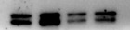
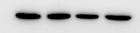
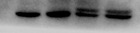
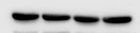
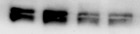
Supplementary Figure 5
A
B
C
D
F
E
MGC-803
AGS
Lenti-V₂
Glc (mM)
25
25
NRF2
G6PD
β-actin
2.5
NRF2-sg
2.5
PGD
59 kDa
45 kDa
52 kDa
100 kDa
Lenti-V₂
12
2.5
NRF2-sg
2.5
12

Supplementary Figure 5. Glucose deprivation induces an increase in the expression of metabolic enzymes involved in the PPP. A, B. qPCR results of glucose metabolism–related genes in MGC-803 and AGS cells under low glucose (Glc) conditions. C, D. Intracellular ATP levels (measured using HPIC-MS/MS and ATP assay kits) in MGC-803 and AGS cells with parental CARM1 (Lenti-V₂) or stable CARM1 knockdown (CARM1-sg) incubated under glucose starvation conditions or not. E, F. Western blot analysis was performed on MGC-803 and AGS cells with control (Lenti-V₂) or NRF2 knockdown (NRF2-sg) treated with low glucose for 18 h (E). Protein expression of G6PD and PGD observed using ImageJ software (F). Data are shown as mean±SEM with multiple replications. ns, not significant; *, P < 0.05; **, P < 0.01; ***, P < 0.001.

Supplementary Figure 6
A
B
C
D

Supplementary Figure 6. Effects of NRF2 knockdown on ROS, GSH/GSSG ratio, NADPH content, and intracellular ATP level in MGC-803 and AGS cells.
A. MGC-803 and AGS cells with parental NRF2 (Lenti-V₂) or stable NRF2 knockdown (NRF2-sg) were deprived of glucose or not (as indicated) for measurement of ROS. B, C. The GSH/GSSG ratios (B) and levels of NADPH (C) were measured in MGC-803 and AGS stable cells with Lenti-V₂ or CARM1-sg under low glucose conditions. D. Intracellular ATP levels (measured using ATP assay kits) in MGC-803 and AGS cells with parental NRF2 (Lenti-V₂) or stable NRF2 knockdown (NRF2-sg) incubated under glucose starvation conditions or not. Data are shown as mean±SEM with multiple replications. *, P < 0.05; **, P < 0.01; ***, P < 0.001.

Supplementary Figure 7
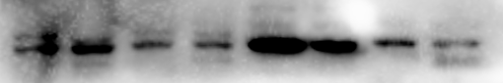
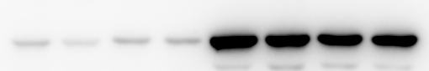
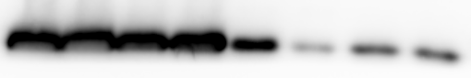
B
C
CARM1
H3
GAPDH
12
2.5
12
2.5
12
2.5
12
2.5
CARM1-sg
Lenti-V₂
CARM1-sg
Lenti-V₂
Glc (mM)
Nucleus
Cytoplasm
AGS
CARM1
H3
GAPDH
CARM1-sg
Lenti-V₂
Glc (mM)
25
2.5
25
2.5
CARM1-sg
Lenti-V₂
25
2.5
25
2.5
Nucleus
Cytoplasm
A
MGC-803

Supplementary Figure 7. CARM1 protein levels in the nucleus are increased after glucose starvation. A, B. MGC-803 and AGS cells with parental CARM1 (Lenti-V₂) or stable CARM1 knockdown (CARM1-sg) were treated with various concentrations of glucose (Glc) for 18 h as indicated for nuclear isolation, followed by Western blotting for CARM1, GAPDH, and Histone H3. Results are representative of three independent experiments. Data are shown as mean±SEM with multiple replications. ns, not significant; *, P<0.05, **, P < 0.01.

Supplementary Figure 8
A
B
G6PD
CARM1
β-actin
Lenti-V₂
CARM1-sg
Mouse NO.
1 2 3
1 2 3
62 kDa
59 kDa
45 kDa
H3R17me
H3
17 kDa
17 kDa

Supplementary Figure 8. 6-AN inhibits NADPH production and cell growth by suppressing the PPP. A. MGC-803 and AGS cells were treated with different concentrations of glucose and supplemented or not with the indicated concentration of 6-AN for measurement of NADPH. Results are representative of three independent experiments. Data are shown as mean±SEM with multiple replications. *, P<0.05, **, P<0.01, and ***, P<0.001. B. Protein expression of G6PD, CARM1, and H3R17me2 in collected tumors as determined by Western blot analysis.

