Supplementary Information
Supplementary Figure 1
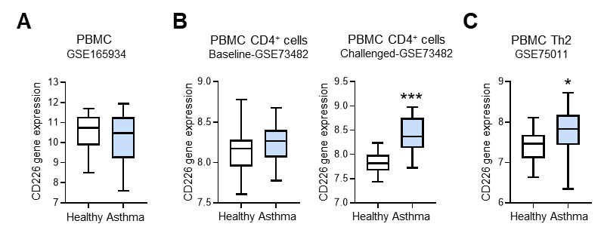

Suppl. Fig. 1. CD226 is upregulated in CD4⁺ T cells from patients with asthma based on bioinformatics analysis. (A) GSE165934 database analysis for CD226 mRNA expression of PBMCs from patients with asthma and healthy subjects (asthma: n = 10; healthy: n = 9). (B) GSE73482 database analysis for CD226 mRNA expression of peripheral blood CD4⁺ T cells from asthma patients allergic to house dust mite and from healthy subjects (asthma: n = 22; healthy: n = 23); “baseline” refers to the gene expression data obtained immediately after separation of CD4⁺ T cells from patient blood without any additional treatment while “challenged” refers to the gene expression data measured following in vitro stimulation with allergen. (C) GSE75011 database analysis for Cd226 mRNA expression of peripheral blood Th2 cells from asthma patients and healthy subjects (asthma: n = 40; healthy: n = 15). * P < 0.05, *** P < 0.001 vs. healthy. PBMCs: peripheral blood mononuclear cells; Th: helper T cells.

Supplementary Figure 2
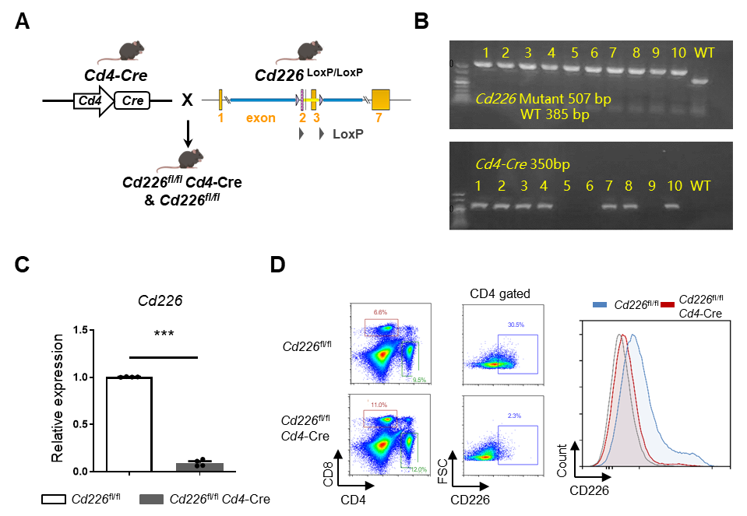

Suppl. Fig. 2. Generation and identification of conditional CD4⁺ T cell-specific deletion of Cd226 mice. (A) Schematic representation of the strategy used to target the exons encoding Cd226. (B) Genotyping of Cd226^{fl/fl}Cd4-Cre mice. (C) Cd226 mRNA levels were assessed via qPCR analysis of CD4⁺ T cells from Cd226^{fl/fl}Cd4-Cre and Cd226^{fl/fl} mice. CD4⁺ T cells were isolated from splenocytes using a Dynal mouse T cell negative isolation protocol. Each dot represents an individual mouse. (D) Knockout efficiency of Cd226 in CD4⁺ T cells was determined using FCM analysis. Data are shown as the mean ± SEM, n = 3 ~ 4 per group. *** P < 0.001.

Supplementary Figure 3
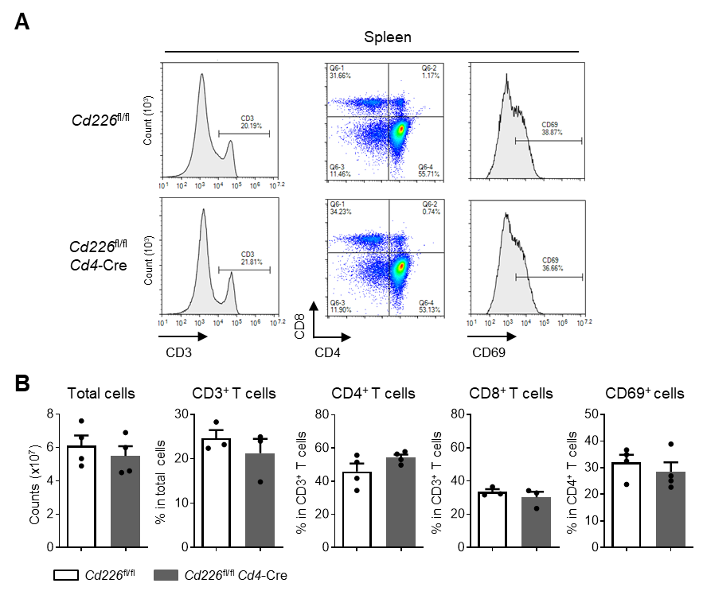

Suppl. Fig. 3. CD226 deficiency in T cells did not affect T cell development in normal mice. (A) FCM analysis and quantification for evaluating total CD45⁺ leukocyte number, CD3-, CD4-, or CD8-, and CD69-positive populations in the spleen out of Cd226^{fl/fl}Cd4-Cre or littermate Cd226^{fl/fl} mice. All displayed FCM plots are CD45⁺ gated. CD4 and CD8 expression is shown as a percentage gated of CD45⁺CD4⁺ splenocytes. CD69 expression is shown as a percentage gated of CD45⁺CD3⁺CD4⁺ splenocytes. Total cells quantification was determined by CountBright Absolute Counting Beads. (B) Quantitative data of FCM analysis. All data are mean ± SEM, each dot represents an individual mouse.

Supplementary Figure 4
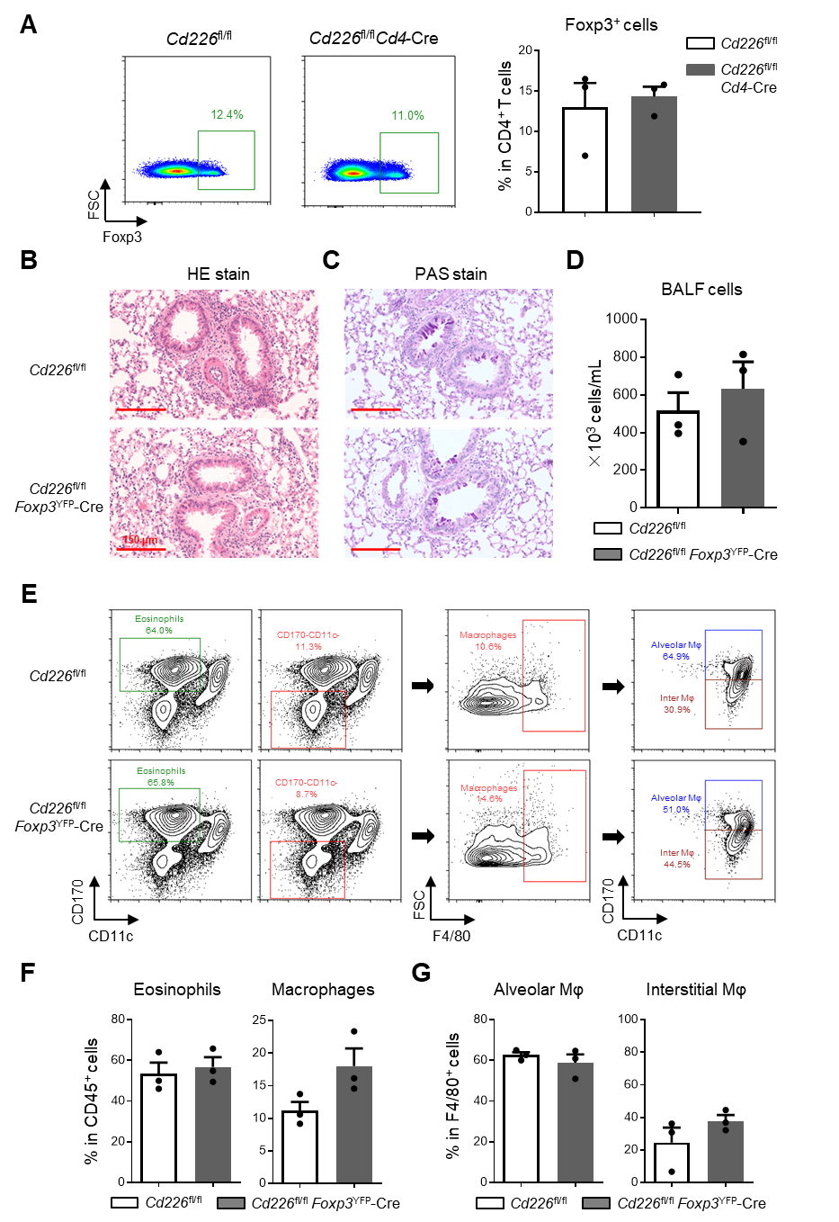
Suppl. Fig. 4. Lack of CD226 on Treg cells did not affect OVA-induced asthmatic mice. (A) FCM analysis of Foxp3⁺ Treg cells in the spleen of OVA‐challenged Cd226^{fl/fl}Cd4-Cre and Cd226^{fl/fl} mice. (B) H&E staining of lungs from Cd226^{fl/fl}Foxp3^{YFP}-Cre and littermate mice (Cd226^{fl/fl}). (C) Lung tissue sections were PAS stained; scale bar = 150 μm. (D) Total cell number in BALF was counted in Cd226^{fl/fl}Foxp3^{YFP}-Cre and Cd226^{fl/fl} mice. (E) Representative FCM histograms depicting the frequency of eosinophils (CD11c⁻CD170⁺) and macrophages (CD11c⁻CD170–F4/80⁺) in BALF; macrophages are further divided into exudate alveolar macrophages (F4/80⁺CD11c⁺CD170⁺) and interstitial macrophages (F4/80⁺CD11c⁺CD170–). Displayed FCM plots are CD45⁺ gated. (F) Quantitative data of FCM analysis for eosinophils and macrophages. (G) Quantitative data of FCM analysis for exudate alveolar and interstitial macrophages in BALF. All data are mean ± SEM, each dot represents an individual mouse. Treg: regulatory T cells; OVA: ovalbumin; H&E: hematoxylin and eosin; PAS: periodic acid–Schiff; BALF: bronchoalveolar lavage fluid; FCM: flow cytometry; Mφ: macrophage.

Supplementary Figure 5
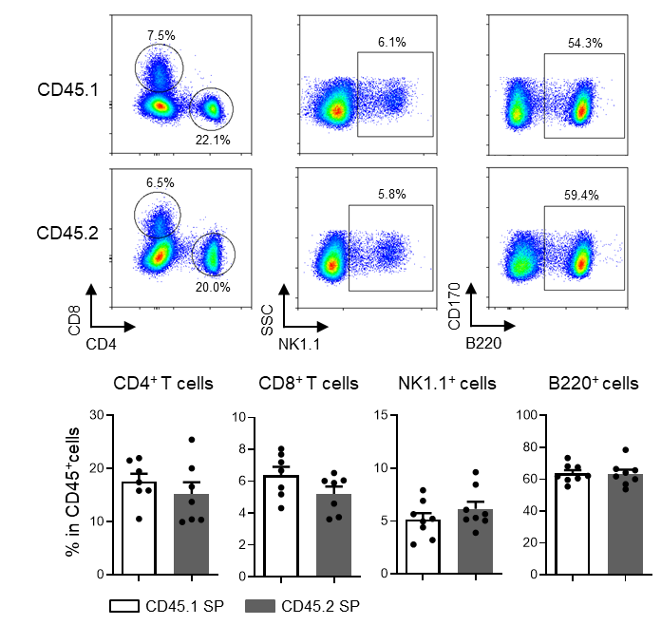

Suppl. Fig. 5. CD226 deficiency in T cells did not affect T cell development in normal mice. FCM was performed to assess B, NK, CD4⁺, and CD8⁺ T cells among CD45.1 (WT) or CD45.2 (KO) splenocytes from bone marrow chimera mice. FCM plots are CD45⁺ gated. All data are mean ± SEM, each dot represents an individual mouse. FCM: flow cytometry.

Supplementary Table 1. qPCR primer sequences
Gene | Forward (5ʹ–3ʹ) | Reverse (5ʹ–3ʹ)
Il2 | GCGGCATGTTCTGGATTTGACTC | CCACCACAGTTGCTGACTCATC
Il4 | ATCATCGGCATTTTGAACGAGGTC | ACCTTGGAAGCCCTACAGACGA
Il5 | GATGAGGCTTCCTGTCCCTACT | TGACAGGTTTTGGAATAGCATTTCC
Il13 | AACGGCAGCATGGTATGGAGTG | TGGGTCCTGTAGATGGCATTGC
Il17a | CAGACTACCTCAACCGTTCCAC | TCCAGCTTTCCCTCCGCATTGA
Ifng | CAGCAACAGCAAGGCGAAAAAGG | TTTCCGCTTCCTGAGGCTGGAT
Cd226 | CAGACATTGGCATCTACTCCTGC | GACATCTTGTCCAGGTTCTGCAG
β-actin | CATTGCTGACAGGATGCAGAAGG | TGCTGGAAGGTGGACAGTGAGG

