Supplementary Materials

Table S1 The details of reagents and antibodies used in this study
REAGENT or RESOURCE | SOURCE | IDENTIFIER
Chemicals, Peptides, and Recombinant Proteins
Phorbol 12-myristate 13-acetate (PMA) | MedChemExpress | Cat# HY-18739
Lipopolysaccharides (LPS) | MedChemExpress | Cat# HY-D1056
MG132 | MedChemExpress | Cat# HY-13259
Clodronate Liposomes | Yeasen | Cat# 40337ES08
3-Methyladenine (3-MA) | MedChemExpress | Cat# HY-19312
Chloroquine | MedChemExpress | Cat# HY-17589A
NH4Cl | MedChemExpress | Cat# HY-Y1269
Wortmannin | MedChemExpress | Cat# HY-10197
Thioglycolate sodium | MedChemExpress | Cat# HY-W115724
Protease inhibitor cocktail | MedChemExpress | Cat# HY-K0012
2,6,4-trinitrobenzene sulfonic acid | Sigma-Aldrich | Cat# P2297
M-CSF | PeproTech | Cat# 315-02
Dextran sulfate sodium (DSS) | MP Biomedicals | MFCD00081551
Lipofectamine 3000 | Invitrogen | Cat# L3000015
Puromycin | Selleck | Cat# S7417
Mouse TNF-α ELISA Kit | Boster | Cat# EK0527
Mouse IL-1β ELISA Kit | Boster | Cat# EK0394
BCA Protein Assay Kit | Beyotime | Cat# P0010S
RIPA buffer for Western and IP | Beyotime | Cat# P0013
Fetal bovine serum | Gibco | Cat# A5670701
Alcian Blue Periodic Acid Schiff (AB-PAS) Stain Kit | Solarbio | Cat# G1285
Hematoxylin-Eosin (HE) Stain Kit | Solarbio | Cat# G1120
Hoechst33342(Hoechst) | Polysciences | Cat# BLI894A
Protein A/G Agarose | Bio-linkedin | Cat# L-1008
RNAiso | Takara | Cat# 9109
Maxima First Strand cDNA Synthesis Kit | Thermofisher | Cat# K1642
PowerTrack™SYBR Green Master Mix | Thermofisher | Cat# A46111
Antibodies
Mouse monoclonal IgG | Santa Cruz Biotechnology | Cat# sc-2025; RRID: AB_737182
Rabbit polyclonal Tollip | Santa Cruz Biotechnology | Cat# sc-59720; RRID: AB_2303699
Rabbit monoclonal IgG | Proteintech Group | Cat# 30000-0-AP; RRID: AB_2819035
Beclin 1 Polyclonal antibody | Proteintech Group | Cat# 11306-1-AP
ATG12 Polyclonal antibody | Proteintech Group | Cat# 11264-1-AP
Anti -Ly6g Rabbit pAb | Servicebio | Cat# GB11229
Anti-Ly6C Rabbit pAb | Servicebio | Cat# GB115601
Ly-6G Rabbit mAb | Cell Signaling Technology | Cat# 87048
Anti-LY6C antibody | Abcam | Cat# ab317272
Mouse monoclonal GAPDH | Proteintech Group | Cat#60004-1-Ig; RRID: AB_2107436
Mouse monoclonal β-actin | Proteintech Group | Cat#66009-1-Ig; RRID: AB_2687938
Mouse monoclonal GFP-tag | Proteintech Group | Cat# 66002-1-Ig; RRID: AB_11182611
Rabbit polyclonal GFP-tag | Proteintech Group | Cat# 50430-2-AP, RRID: AB_11042881
Rabbit polyclonal Myc-tag | Proteintech Group | Cat#16286-1-AP; RRID: AB_11182162
Mouse Monoclonal Myc-tag | Proteintech Group | Cat# 60003-2-Ig, RRID: AB_2734122
Mouse Monoclonal Flag-tag | Proteintech Group | Cat# 66008-4-Ig; RRID: AB_2918475
Rabbit polyclonal HA-tag | Proteintech Group | Cat# 51064-2-AP; RRID: AB_11042321
Mouse polyclonal HA-tag | Proteintech Group | Cat# 66006-1-Ig, RRID: AB_2857911
Rabbit polyclonal CD31 | Proteintech Group | Cat# 28083-1-AP; RRID: AB_2881055
Rabbit polyclonal MPO | Proteintech Group | Cat# 22225-1-AP; RRID: AB_2879037
Rabbit polyclonal Tollip | Proteintech Group | Cat# 11315-1-AP; RRID: AB_2256373
Rabbit polyclonal p62 | Proteintech Group | Cat# 18420-1-AP; RRID: AB_10694431
Rabbit polyclonal LC3 | Proteintech Group | Cat# 14600-1-AP; RRID: AB_2137737
Rabbit polyclonal ATG7 | Proteintech Group | Cat# 10088-2-AP; RRID: AB_2062351
Rabbit polyclonal ATG5 | Proteintech Group | Cat# 10181-2-AP; RRID: AB_2062045
Mouse monoclonal S100A8 | Proteintech Group | Cat# 66853-1-Ig; RRID: AB_2882193
Rabbit polyclonal Ki67 | Proteintech Group | Cat# 27309-1-AP; RRID: AB_2756525
Rabbit polyclonal CD11c | Cell Signaling Technology | Cat# 97585; RRID: AB_2800282
Rabbit polyclonal F4/80 | Cell Signaling Technology | Cat# 70076T; RRID: AB_2799771
Rabbit polyclonal CD68 | Affinity | Cat# DF7518; RRID: AB_2841017
Rabbit polyclonal S100A8 | Affinity | Cat# DF6556; RRID: AB_2838518
Rabbit polyclonal RNF128 | Affinity | Cat# DF14658
Rabbit polyclonal RNF128 | Abcam | Cat# ab72533; RRID: AB_1270351
Rabbit polyclonal S100A8 | Abcam | Cat# ab180735
Rabbit polyclonal Tollip | Abcam | Cat# ab187198; RRID: AB_3101868
Mouse polyclonal α-SMA | Abcam | Cat# ab7817; RRID: AB_262054
Rabbit polyclonal CD3E | Abclonal | Cat# A19017; RRID: AB_2862509
Rat Monoclonal Flag-tag | BioLegend | Cat# 637301
Rabbit polyclonal RNF128 | Cell Signaling Technology | Cat# 71590
HRP-conjugated Goat anti-Rabbit IgG (H+L) | Abclonal | Cat# AS014;
HRP-conjugated Goat anti-Mouse IgG (H+L) | Abclonal | Cat# AS003;
HRP-conjugated Goat anti-Rat IgG (H+L) | Abclonal | Cat# AS028
CoraLite488-conjugated Goat Anti-Rabbit IgG(H+L) | Proteintech Group | Cat# SA00013-2; RRID: AB_2797132
CoraLite594–conjugated Goat Anti-Mouse IgG(H+L) | Proteintech Group | Cat# SA00013-3; RRID: AB_2797133

Table S2 The siRNA sequences
Genes | Sequence (5’→3’)
siBECN1 | GGAGGAAGAGACUAACUCAGG
siATG12 | GCAGCUUCCUACUUCAAUUGC

Table S3 The primers for plasmid construction in this study
Genes | Primer sequence (5’-3’) | Primer type
RNF128-Flag | CAAGCTTGCGGCCGCGAATTCATGGGGCCGCCGCCTGGG | Forward
RNF128-Flag | CAGGGATGCCACCCGGGATCCTTAAGATTTAATTTCTCGAACAGCAGT | Reverse
RNF128-Flag₁₋₂₇₆ | CAAGCTTGCGGCCGCGAATTCATGGGGCCGCCGCCTGGG | Forward
RNF128-Flag₁₋₂₇₆ | CAGGGATGCCACCCGGGATCCTCAACTATCTCCATCAGGGCCA | Reverse
RNF128-Flag₂₇₇₋₄₂₈ | CAAGCTTGCGGCCGCGAATTCATGTGTGCTGTGTGCATTGAATT | Forward
RNF128-Flag₂₇₇₋₄₂₈ | CAGGGATGCCACCCGGGATCCTTAAGATTTAATTTCTCGAACAGCAGT | Reverse
S100A8-GFP | TCGAGCTCAAGCTTCGAATTCTGTTGACCGAGCTGGAGAAAG | Forward
S100A8-GFP | ATGGTGGCGACCGGTGGATCCCTCTTTGTGGCTTTCTTCATGGC | Reverse
S100A8-GFP₁₋₄₆ | TCGAGCTCAAGCTTCGAATTCTGTTGACCGAGCTGGAGAAAG | Forward
S100A8-GFP₁₋₄₆ | ATGGTGGCGACCGGTGGATCCGATATACTGAGGACACTCGGTCTCTAGC | Reverse
S100A8-GFP₄₇₋₉₃ | TCGAGCTCAAGCTTCGAATTCTGAGGAAAAAGGGTGCAGACG | Forward
S100A8-GFP₄₇₋₉₃ | ATGGTGGCGACCGGTGGATCCCTCTTTGTGGCTTTCTTCATGGC | Reverse
pLenti-RNF128-Flag | ATAGAAGACACCGACTCTAGAATGGGGCCGCCGCCTGGG | Forward
pLenti-RNF128-Flag | TTTGTAGTCAGCCCGGGATCCAGATTTAATTTCTCGAACAGCAGTCTC | Reverse
Flag-p62 | CAAGCTTGCGGCCGCGAATTCATGGCCATGTCCTACGTGAAGG | Forward
Flag-p62 | CAGGGATGCCACCCGGGATCCTCACAACGGCGGGGGATG | Reverse
Flag-NIX | CAAGCTTGCGGCCGCGAATTCATGTCGTCCCACCTAGTCGAGC | Forward
Flag-NIX | CAGGGATGCCACCCGGGATCCTCAGTAGGTGCTGGCAGAGGG | Reverse
Flag-NBR1 | CAAGCTTGCGGCCGCGAATTCATGGAACCACAGGTTACTCTAAATGT | Forward
Flag-NBR1 | CAGGGATGCCACCCGGGATCCTTAGAACCAGGAGAATGCTTCACTC | Reverse
Flag-OPTN | CAAGCTTGCGGCCGCGAATTCATGTCCCATCAACCTCTCAGCT | Forward
Flag-OPTN | CAGGGATGCCACCCGGGATCCTAAATGATGCAATCCATCACGTG | Reverse
Flag-NDP52 | CAAGCTTGCGGCCGCGAATTCATGGAGGAGACCATCAAAGATCC | Forward
Flag-NDP52 | CAGGGATGCCACCCGGGATCCTCAGAGAGAGTGGCAGAACACG | Reverse
Flag-Tollip | CAAGCTTGCGGCCGCGAATTCATGGCGACCACCGTCAGC | Forward
Flag-Tollip | CAGGGATGCCACCCGGGATCCCTATGGCTCCTCCCCCATCT | Reverse
S100A8_{K7R}-GFP | ACCGAGCTGGAGAGAGCCTTGAACTCT | Forward
S100A8_{K7R}-GFP | AGAGTTCAAGGCTCTCTCCAGCTCGGT | Reverse
S100A8_{K36R}-GFP | GATGACCTGAAGAGATTGCTAGAGACC | Forward
S100A8_{K36R}-GFP | GGTCTCTAGCAATCTCTTCAGGTCATC | Reverse

Table S4 The shRNA and sgRNA sequences
Genes | Primer sequence (5’-3’) | Primer type
shRNF128- #1 | CCGGTCTTAACGTGCAACCATATTTCTCGAGAAATATGGTTGCACGTTAAGATTTTTG | Forward
shRNF128- #1 | AATTCAAAAATCTTAACGTGCAACCATATTTCTCGAGAAATATGGTTGCACGTTAAGA | Reverse
shRNF128- #2 | CCGGAGAGACTGCTGTTCGAGAAATCTCGAGATTTCTCGAACAGCAGTCTCTTTTTTG | Forward
shRNF128- #2 | AATTCAAAAAAGAGACTGCTGTTCGAGAAATCTCGAGATTTCTCGAACAGCAGTCTCT | Reverse
sgATG5 | CACCGTCCATGAGTTTCCGATTGA | Forward
sgATG5 | AAACTCAATCGGAAACTCATGGAC | Reverse
sgATG7 | CACCGAAATAATGGCGGCAGCTACG | Forward
sgATG7 | AAACCGTAGCTGCCGCCATTATTTC | Reverse

Table S5 The primers for mice genotyping
Primer | Sequence (5’→3’) | Primer type
P1 | GTTCTCGACACAGAGGGGTC | Forward
P2 | AACCCACAAGGTGGAAGGAG | Reverse
P3 | TCTCGACACAGAGGGGTCAT | Forward
P4 | TGAAATAGCCCACGGTTGCT | Reverse

Supplementary Figure 1 (A) Volcano map of a portion of the differential genes in IBD tissues and control tissues in GSE4183. Significantly upregulated/downregulated genes (adjusted p < 0.10) were marked in red and blue, respectively. (B) The heatmap showed the mRNA change of RNF128 in IBD tissues compared with healthy controls in GSE4183. (C) Analysis of RNF128 mRNA expression in IBD patients compared with healthy controls in GEO database (GSE92415, GSE38713, GSE51785, GSE59071, GSE73661 and GSE87466). * P < 0.05, **** P < 0.0001. (D) Analysis of Rnf128 mRNA expression (normalized to GAPDH RNA levels) in colon tissues from control and DSS-induced colitis mice. *** P < 0.001. (E) Representative images of Rnf128 (green) and nuclei (Hoechst 33342, blue) staining in control and DSS-induced colitis mice. Scale bars, 50 µm. (F) Representative images of immunofluorescence co-staining for Rnf128 (green) with macrophage markers F4/80 (red) in colitis tissues from DSS-induced colitis mice. DAPI (blue) labels the nuclei. Scale bars, 10 μm.
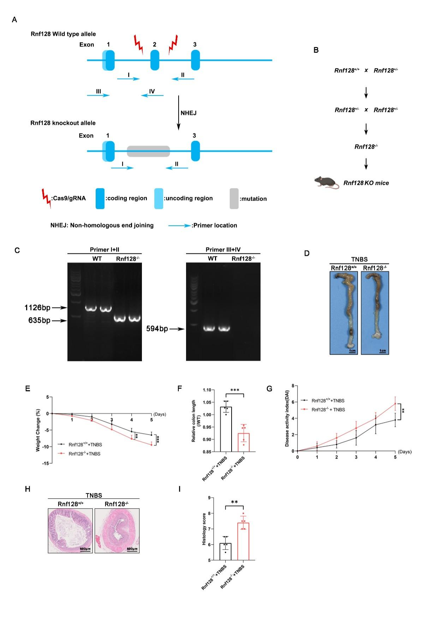
Supplementary Figure 2. (A) Gene-targeting strategy for generating Rnf128 knockout mice by CRISPR/Cas9 system. Blue boxes with numbers denoted Rnf128 exons. Red arrowheads showed Cas9/gRNA sites. (B) Crossing strategies for constructing Rnf128^{-/-} mice. (C) The genotyping of Rnf128^{+/+} and Rnf128^{-/-} mice was identified by PCR. (D) Rnf128^{+/+} (n =5) and Rnf128^{-/-} mice (n = 5) were exposed to 2.5% TNBS for 5 days, representative images of colon were shown. Scale bars, 1 cm. (E) Rnf128^{+/+} (n =5) and Rnf128^{-/-} mice (n = 5) were exposed to 2.5% TNBS for 7 days and bodyweight of mice were measured daily. (F) The colon length in (D) was measured and analyzed. Statistical data are presented as mean ± SD. *** P < 0.001. (G) Disease activity index score in (D) were shown (n = 5). Statistical data are presented as mean ± SD. ** P < 0.01. (H) Representative H&E-staining images of colon sections from mice in (D). Scale bar, 500 μm. (I) Histopathology score in (H) were measured. Statistical data are presented as mean ± SD. ** P < 0.01.

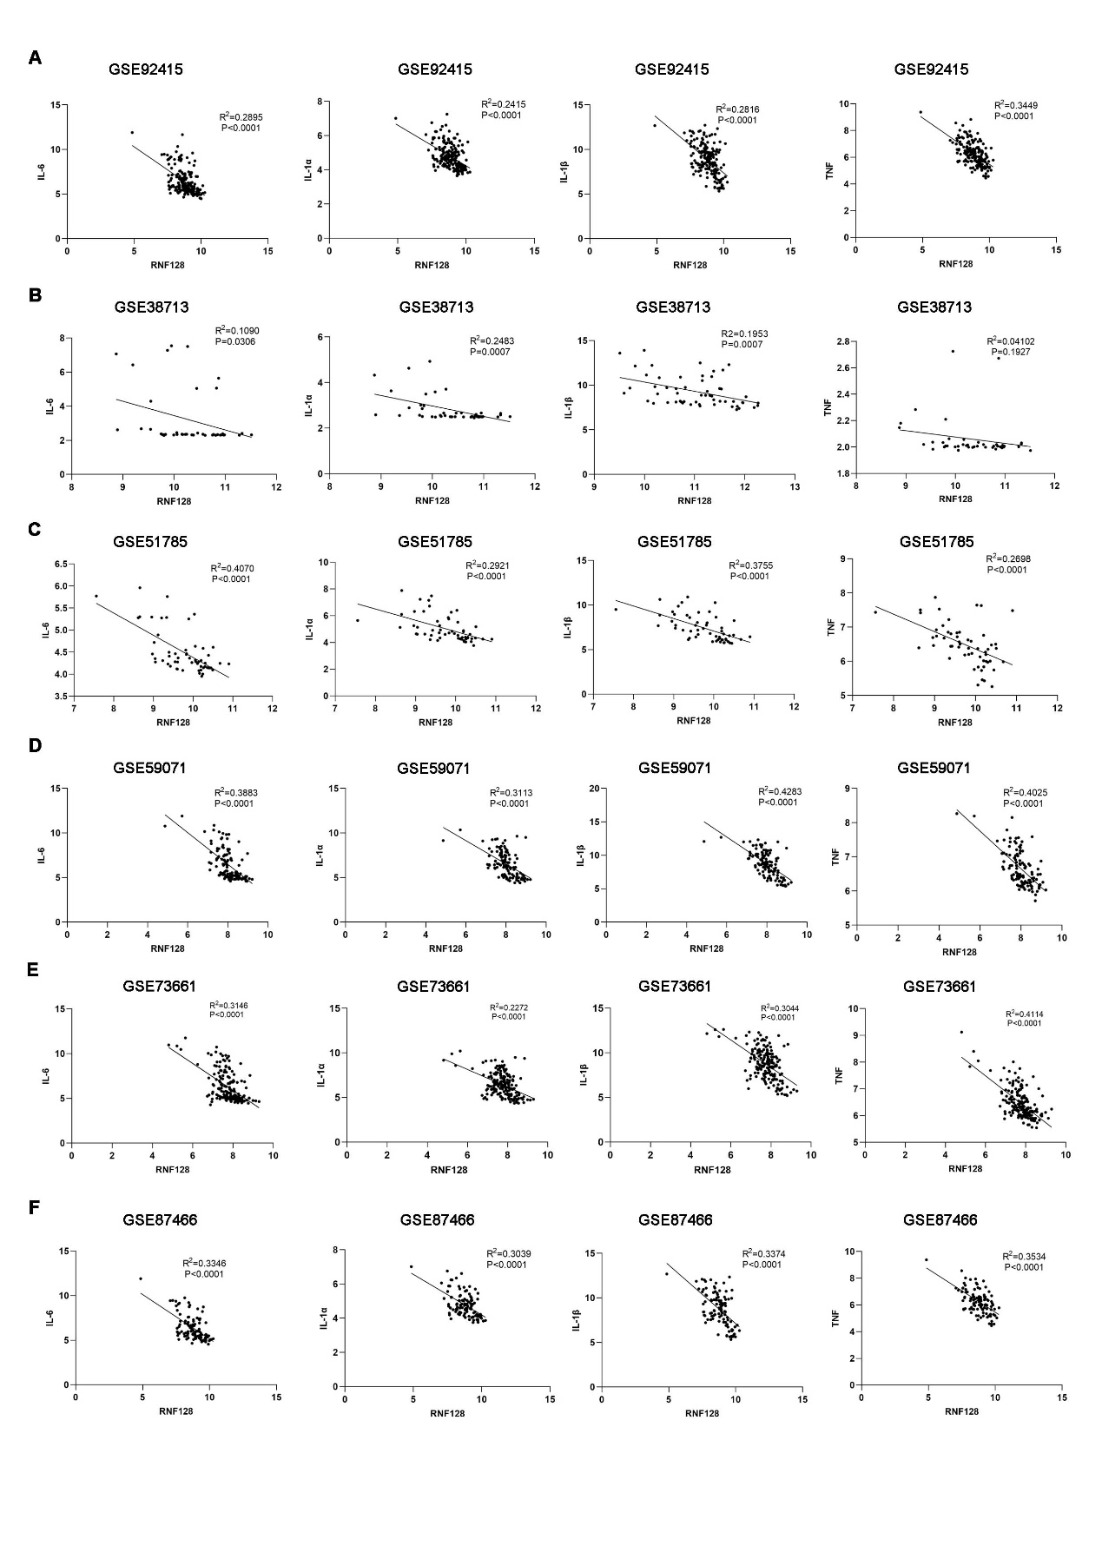
Supplementary Figure 3. (A-F) The correlation between the mRNA expression of RNF128 and IL-6, IL-1α, IL-1β, TNF-α in GSE92415 (A), GSE38713 (B), GSE51785 (C), GSE59071 (D), GSE73661 (E) and GSE87466 (F).
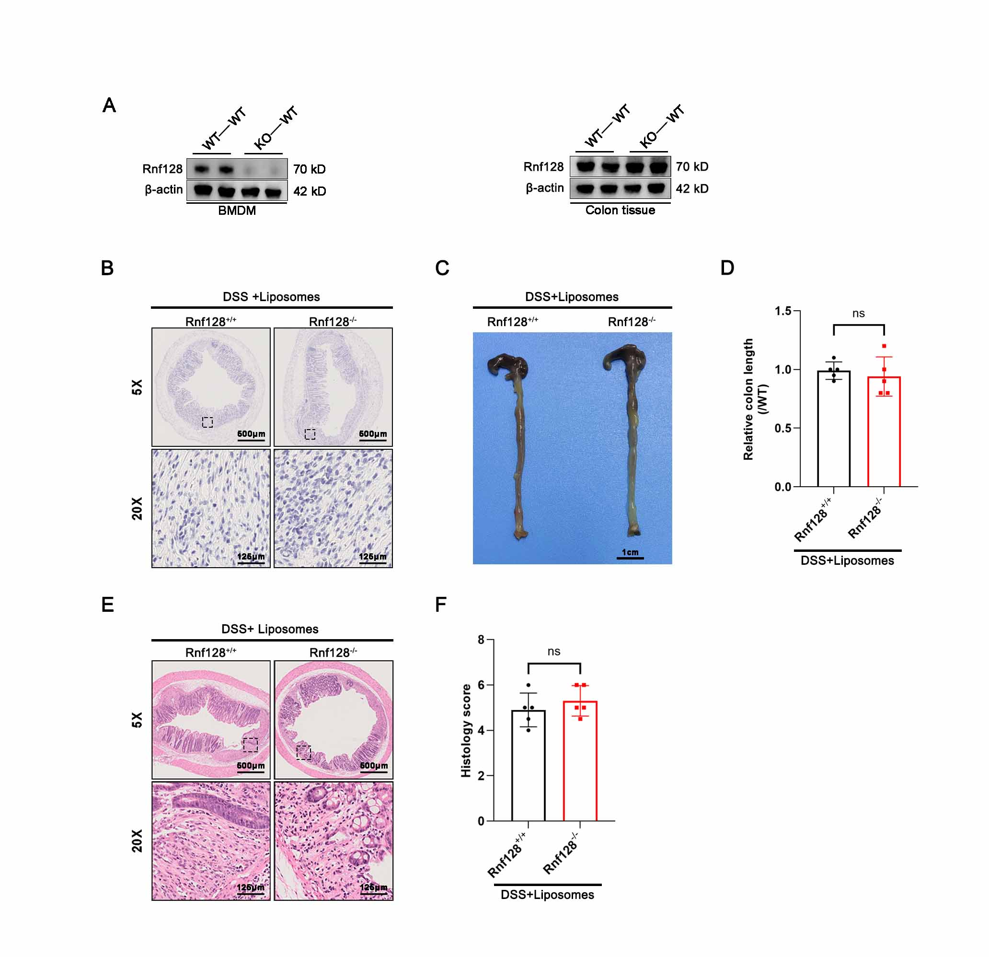
Supplementary Figure 4. (A) Bone marrow derived macrophages (BMDMs) and colon tissues were obtained from chimeric mice 7 weeks after the transplantation of bone marrow cells. (B) Representative F4/80 staining images of colon sections from mice. Scale bar, 500 μm. (C) Rnf128^{+/+} (n =5) and Rnf128^{-/-} mice (n = 5) were treated with Liposome for 3 times before exposing to 2.5% DSS for 7 days. Representative images of colon were shown Scale bars, 1 cm. (D) The colon length in (C) was measured and analyzed. Statistical data are presented as mean ± SD. ns, nonsense. (E) Representative H&E-staining images of colon sections from mice in (C). Scale bar, 500 μm. (F) Histopathology score in (E) were measured. Statistical data are presented as mean ± SD. ns, nonsense.

Supplementary Figure 5. (A) Enriched GO terms of proteins interacting with RNF128. (B) KEGG pathway analysis of proteins interacting with RNF128. (C) AlphaFold model of the RNF128 (cyan) bound to the S100A8 (green). (D) The surface image of binding conformation between RNF128 (cyan) and S100A8 (green). The blue and red areas are the binding region. (E) Electrostatic potential mapped on to the surface of the RNF128 bound to the S100A8. (F) PyMol software for the visualization of amino acid residues in the interaction of RNF128 (cyan) with S100A8 (green).

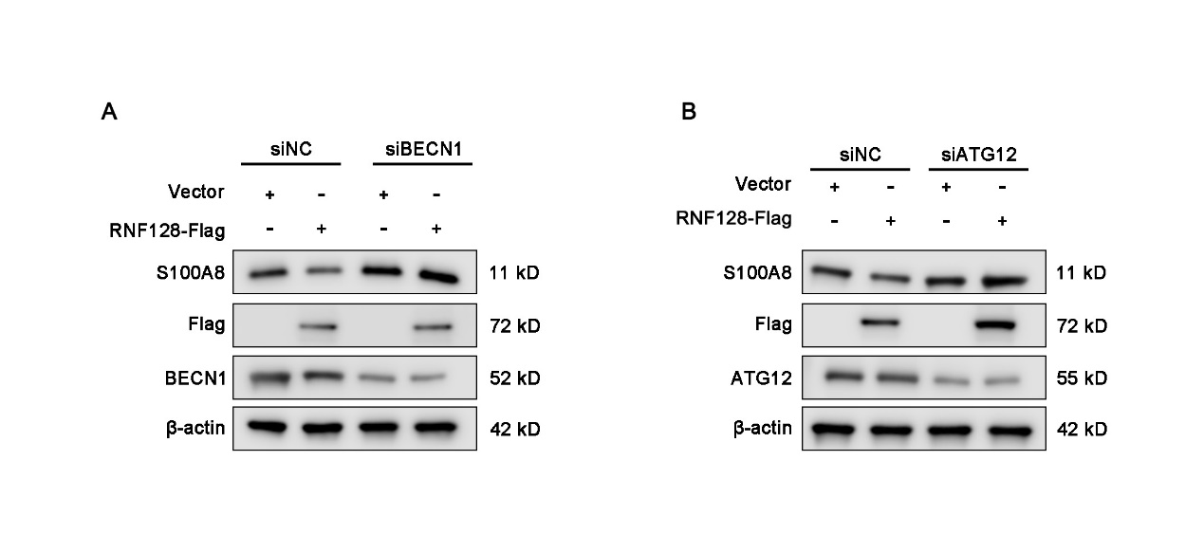
Supplementary Figure 6. (A) Control siRNA or BECN1 siRNA were transfected into RNF128 overexpressing THP-1 cells for 48h. The expression of S100A8 was measured by western blot. (B) Control siRNA or ATG12 siRNA were transfected into RNF128 overexpressing THP-1 cells for 48h. The expression of S100A8 was measured by western blot.

Supplementary Figure 7 (A) 293T cells were co-transfected with HA-ubiquitin (Ub), S100A8-GFP and RNF128-Flag plasmids for 48h, and then treated with CQ (50 nM) for another 4 h. Total lysates were immunoprecipitated with anti-GFP antibody. The immunoprecipitation complex was analyzed by GFP and HA antibody. (B) 293T cells were co-transfected with HA-ubiquitin (Ub), S100A8-GFP and different concentration of RNF128-Flag plasmids, and then treated with CQ (50 nM) for another 4 h. The total lysates were immunoprecipitated with anti-GFP antibody. The immunoprecipitation complex was analyzed by GFP and HA antibody. (C) Control or RNF128 stably knockout THP-1 cells were transfected with HA ubiquitin (Ub) and S100A8-GFP plasmids for 48h, and then treated with CQ (50 nM) for another 4 h. Total lysates were immunoprecipitated with anti-GFP antibody. The immunoprecipitation complex was analyzed by GFP and HA antibody. (D) 293T cells were transfected with HA-ubiquitin mutants (K6, K11, K27, K33, K48, or K63), S100A8-GFP, and RNF128-Flag plasmids for 48h, and then treated with CQ (50 nM) for another 4 h. Total lysates were immunoprecipitated with anti-GFP antibody. The immunoprecipitation complex was analyzed by GFP and HA antibody. (E) Alignment of S100A8₁₋₄₆ amino acid sequences in Human, mouse and rat. Highlighted amino acids indicate conserved lysine (K) of S100A8₁₋₄₆. (F) 293T cells were transfected with HA- ubiquitin (Ub), S100A8-GFP mutants (K7R, K36R) and RNF128-Flag plasmids for 48h, and then treated with CQ (50 nM) for another 4 h. Total lysates were immunoprecipitated with anti-GFP antibody. The immunoprecipitation complex was analyzed by GFP and HA antibody. (G) THP-1 cells were transfected with RNF128-Flag and S100A8-GFP WT or S100A8 mutants (K7R, K36R). The expression of S100A8-GFP were analyzed by western blot.

