Original image for Figure 1
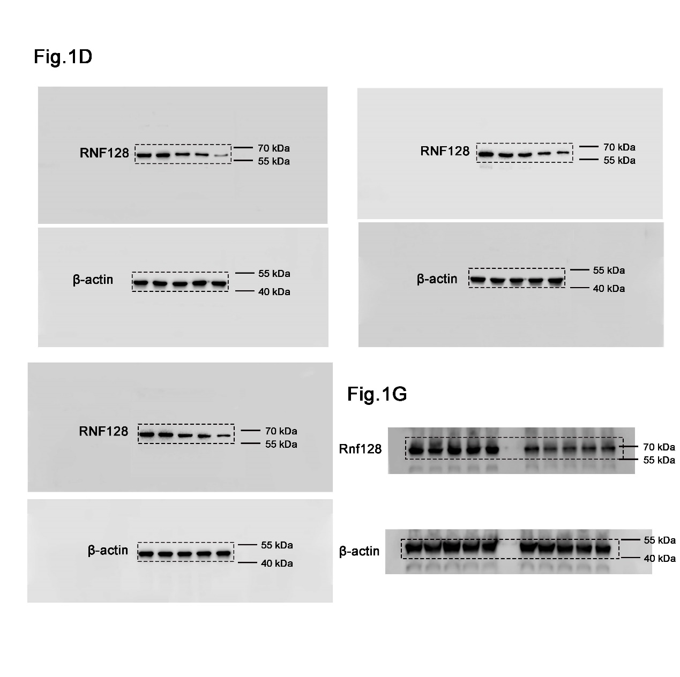

Original image for Figure 5

Original image for Figure 6

Original image for Figure 7

Original image for Figure S4

Original image for Figure S6

Original image for Figure S7

